Amy Wolpert
Spring 2021
GEOG 375

Finding Your Perfect Place: A Tool for Homebuyers and Agents

Summary
I look to create a tool that can be utilized by home buyers or realtors to narrow down potential areas to buy a home based on the buyers wants and/or needs. Most agents can easily locate a property with a certain style including, but not limited to, the number of bedrooms, bathrooms, home square footage, lot size, and city, but can rarely suggest homes in the unique, ideal area of the home buyer. What I aim to create should be able to locate where in the city would be most ideal for that unique buyer with their wants/needs. Some real estate Apps (sites), such as Zillow(.com), Trulia(.com), or Realtor(.com) can help a buyer create a saved search for the home itself including the county or city but cannot reduce it down to be able to select areas of areas. Finding a way to integrate these further such options would benefit both the home buyer and realtor.
Background and Intent
In late 2020 I became a potential home buyer. Through some ups and downs in finding the right home for myself and family, I began to think about ways that would make the home buying process easier, accessible, efficient, and not be so much of a burden on time.
As many home buyers, I began my search for a home on Apps such as Zillow, Trulia, and Realtor. Each offered ways to customize a search for a home based on a city or county, then narrowing down your search by allowing you to place minimums and maximums on select features of a home such as bedrooms, bathrooms, lot size, price, or square footage, for example. The apps also provided ways to have a “must include” option for air conditioning, pools, walk-in closets, and more. However, there is nothing a buyer can do to limit searches to specific areas of the city selected. Having this option could provide many benefits in the home buying process. The largest benefit for me would be getting back the amount of time I spent looking at homes that may have been the right size or price range but were not in the right areas of town or near specific features that were important to me. For example, the buyer and realtor do not waste time viewing properties that are too far from school, parks, shopping centers, public transportation which may be of importance.
With this script, I intend to make it easier to find the near perfect “where” that a buyer should be looking at properties. After the script runs, a PDF file will be saved of a map highlighting the specific block groups a buyer should be looking at to view properties.

Data Acquisition
The majority of the data for this project were files I had on hand. The files on hand were U.S. hydrology, U.S. block groups, U.S. schools, U.S. major highways, and U.S. recreation. The flood risk and median home prices/crime index were found by doing a simple search in the ArcGIS Online Portal. The base map used comes directly from ESRI preloaded when creating an ArcGIS Pro Project.
First was to look at the different data I had available to me and begin randomly selecting criteria that this project would be based on. I randomly selected:
- Within 0.25-mile of a high school
- Within 1-mile of a water feature (such as lake/reservoir or river/creek)
- Within 0.50-mile of a park
- Within 1-mile of a major highway
- Out of a flood risk area
- Average home price in area is 400K
I then manually clipped all layers (included items spanning the entire U.S.) to be of the greater Sacramento, California area. This may allow the processing of the tasks to cut down significantly. In the script, the layers will be clipped even further to focused on the area the buyer is interested in.

Geoprocessing Tasks
- Create Workspace. A workspace is created as a default location where all inputs and outputs live while running tools. Here the path is where I am keeping data. To use this tool the path will need to be changed to live on a c: drive. At the same time, I create an outpath variable where all output files will be directed, unless otherwise specified.
This is placed at the beginning of the script.
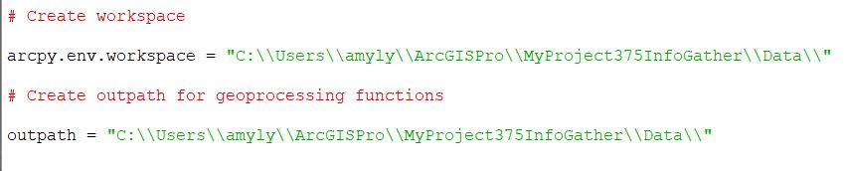
Later in the script an alternate path is used for saving files to an ArcGIS Pro project.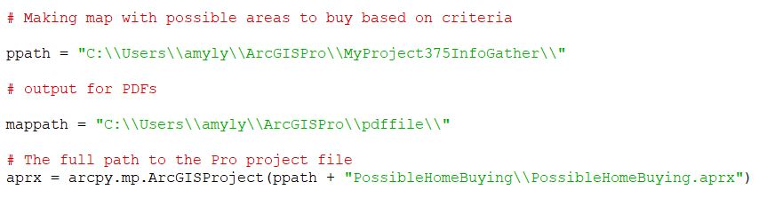
- Clip. The files I have are larger than what is needed. Here I clip each shapefile to a more appropriate size to work with. For each, I identify the shapefile to work with, the premade clipping polygon, and the output name. This will create a manageable, focused area for our property search. Below is an example of the script for two of the layers. Notice each time I set the variables, changing for each specific shapefile.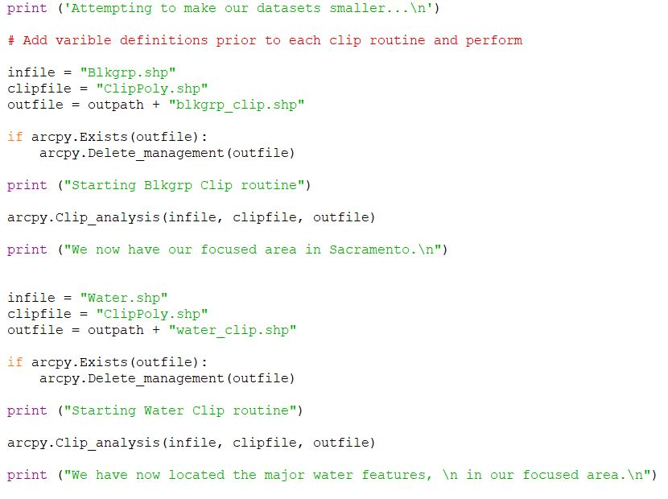

A screenshot is taken before clipping, and after (clipped area outlined in red).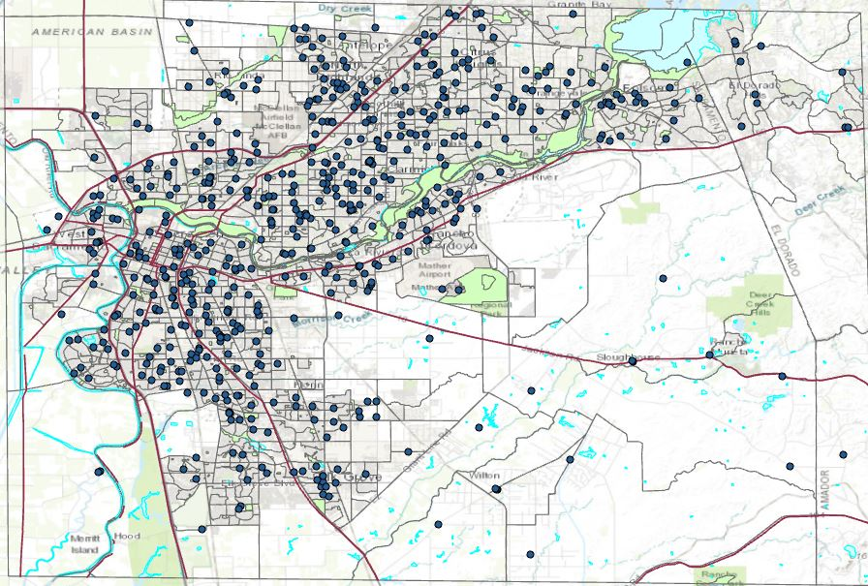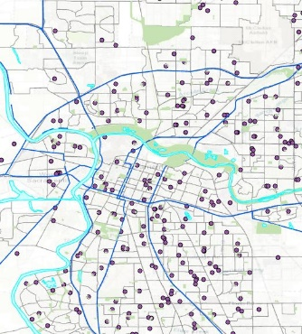

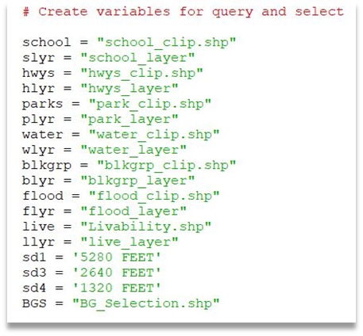
- Make Feature Layers. First, you need to set the variables for shapefiles, output layers, and (in this script) variables for different distances. These variables will be used throughout the script.
No query will be made while making the feature layers. The script will check to see if the output file already exists and, if it does, it will delete existing file. A record count will be taken at the start and end, after making the feature layer to ensure no data has been lost.
Below is an example of making a feature layer.
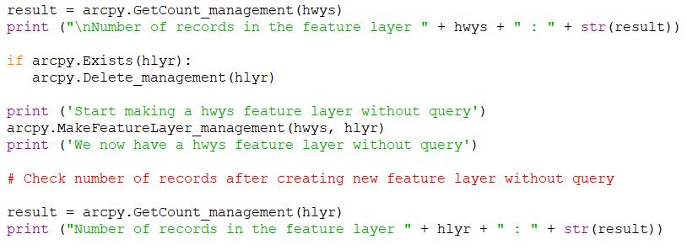
Below is the result after running this portion of script.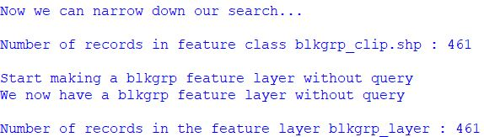
- Select Layer by Attribute. The majority of layers will be selected by proximity (Select Layer by Location), but a few will first need to be narrowed down even further by selecting only the attributes that fall within the criteria decided. Here, the schools layer includes elementary, middle, and high schools. For this section I am only interested in the high schools. I will perform a selection by attribute on the “LEVEL” field from the attribute table of the school layer. Only schools that have a “LEVEL” of “HS” will be selected. Before and after the query is performed a record count will be performed. This geoprocessing task will also be used later in the script.
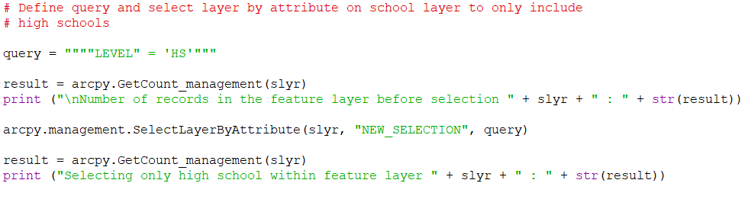

After performing, the total high schools in the area are counted.

- Select Layer by Location. In this section, the blockgroup layers are selected based on their proximity to the features of different layers. After one selection by location is performed, the results are then used to perform the next select layer by location task. The number of records in the blockgroup layer to start is 461. By the end of the select layer by location tasks, the total record in the blockgroup layer is 12.

Below shows a section of script for the select layer by location task. Notice the first proximity selection shows as a “NEW_SELECTION”, while all subsequent are “SUBSET_SELECTION”. Each proximity selection is “WITHIN_A_DISTANCE”, the distance searched is a variable, with each variable defined in the above section (3).

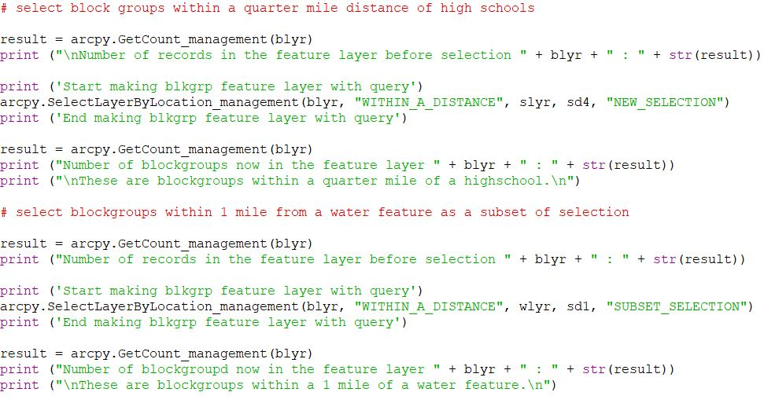
Below is the results from the select layer by location, narrowing down blockgroup areas to 12 based on criteria seached.

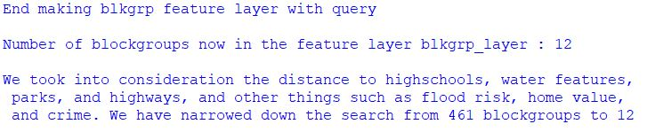

- Convert Feature Layer to Shapefile. In order to use these results in a map that will be created in the next few steps, I used the Feature Class to Feature Class Conversion tool. Here I convert my blockgroup to a usable file in ArcGIS Pro where the map will be made. Through trial and error, I found the outpath must be to a folder for the shapefile to be made. After the conversion, the record count is checked to ensure no loss of data.

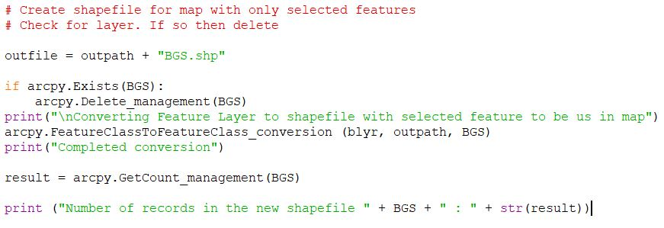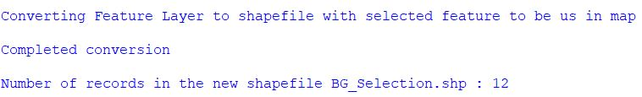

- Map Production. I intend to create a printable map to shop the results of my project. For this step, an ArcGIS Pro project must be created in advance to house the layers of the map within a geodatabase. The Pro project was given certain elements that can be changed through script for differing searches, such as the title, subtitle, date, scale and legend.
The paths to Pro project created and variables defined.
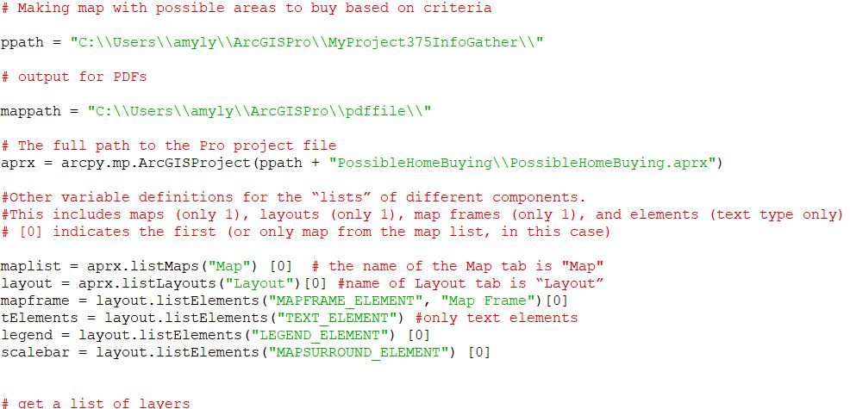

Create a loop to alter text elements within the Pro project. After the text elements were altered, the legend and scale were added, and the map was zoomed to the blockgroup layer extent. The print statements confirm each “if” was performed.
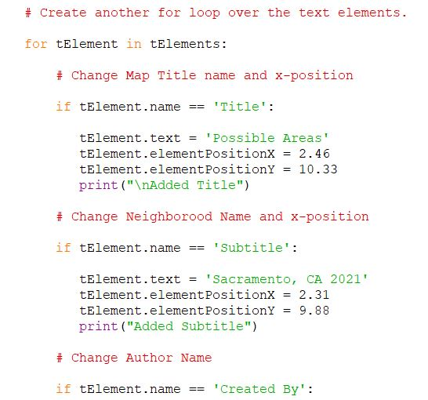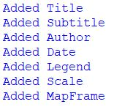
Finally, the project is ready to be exported as a PDF.
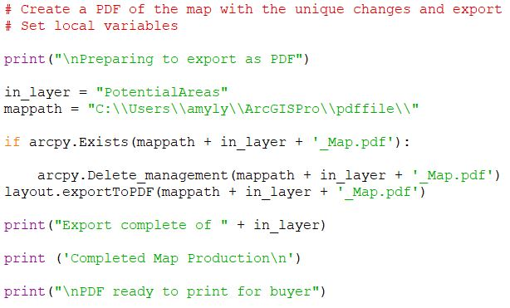

The result is sent to a file outside the geodatabase and can be viewed or printed.

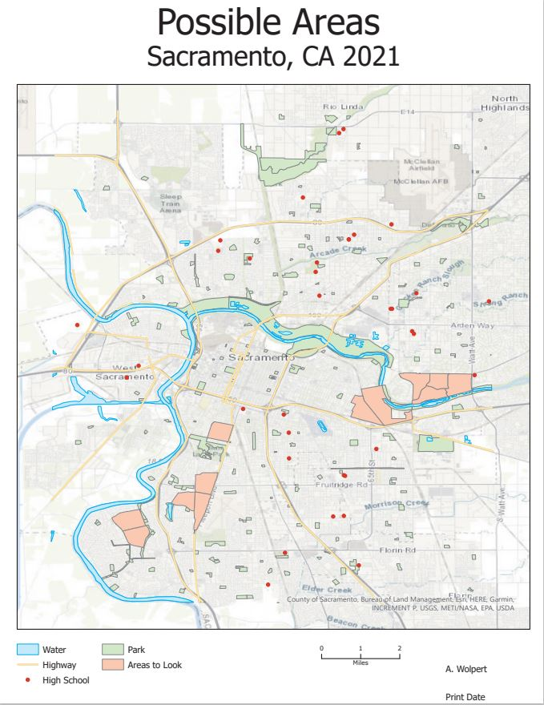

Issues
There were quite a few issues that I encountered while writing this script. Becoming more familiar with the syntax would have eliminated fifty percent. Simple things such as leaving off a close parenthesis, incorrect indentation, or missing a quotation mark, made me question whether I had the patience and/or smarts to be able to do this project, almost resulting in me changing my entire project to something simpler. In the end, I am glad I stuck with it. I learned so much and am much more comfortable with the workflow (certainly referring back to recorded lectures, videos from jenningsplanet.com, forums, and “help” on ESRI help a great deal as well).
The specific issues I had with this project I was successfully able to work through. They included:
Invalid syntax. in multiple cases were due to leaving out a close parenthesis in the print statement prior.
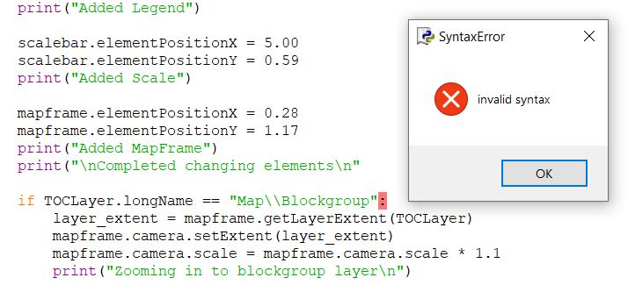
Table Relate. In a previous version of this project in order to find the specific areas where crime was higher/lower, I had a feature layer showing the police “beats” and a table showing different crimes reported by “beat”. In attempt to relate these tables, I decided to throw it away and found another source with a livability index that was determined crime. I opted to use this data instead. Here is a screenshot of my attempted relate table in script.
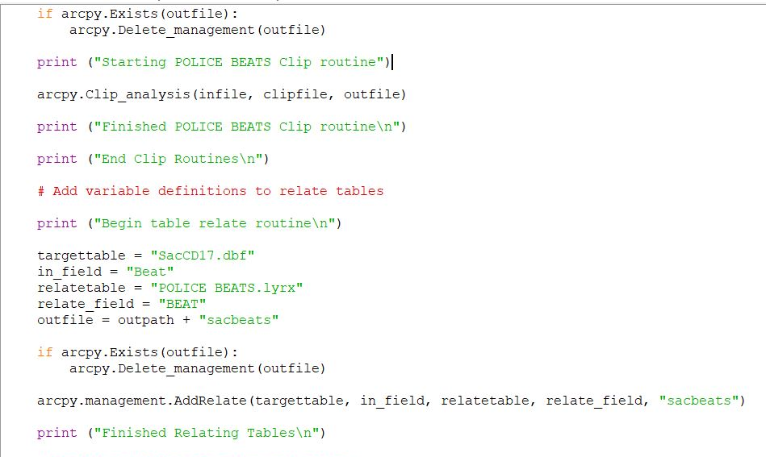

Select Layer by location then invert. With the flood layer in my project, I could not get the results to be inverted. Turns out that that after spending hours correcting this problem, I believe the dataset had zero records near my subset of records from the block group layer, so either way I was not going to get results from this.
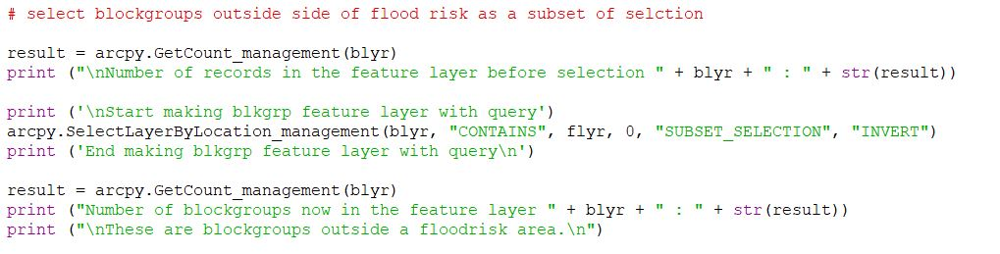
Indentation. I do not have a photo example of this. Keeping mind of where I am at in the script and what type of task I am doing will help ensure my indentation is correct. I found where the error was that was causing my script to fail and, as soon as I realigned, things ran smoothly.
Map Production. My overall goal was to be able to create a map to print. I could not understand why my results were not living in my project. After days, I realized I needed to export the results to a file folder where it could then be put into the project.

Conclusion
My intent was to make a tool to find the near perfect “where” that a buyer should be looking at properties. Then a PDF file will be saved of a map highlighting the specific block groups a buyer should be looking at to view properties. I believe I have done that on a beginner level.
In this script I had data sets that spanned over a multiyear period from 2010 to 2016. It was difficult to find matching dates with the data I had available to me. To have this tool work better for the home buying process, the most recent data for all buyer criteria needs to be utilized. With the information I had available to me, the areas selected were in the La Riviera, Land Park and Pocket areas. I feel the results may be similar with current datasets.
This script can be easily changed for the select by location geoprocessing task by adding additional variables for different distances. I have included variables for a quarter mile, half mile, one mile, and 2 miles. Additional layers can be added, such as fire stations, hospitals, public transportation stations and more. The same process can be used to determine proximity to those new features.
I was successful in creating a tool for potential home buying areas. I believe this tool could be used on a much larger scale and would benefit homebuyers everywhere. I would be interested to see if where I just purchased a home would fall into my near perfect “where”.

Contact: amylynnwolpert@yahoo.com

