GEOG 375 Introduction to GIS Programming
Python Project

Search Cursors: Lakes and Zones of Desolation Wilderness

John Welsh
May 19, 2020
Summary
Desolation Wilderness is an area that I frequent every year in the Spring and Summer. To get an early jump on the season, I remotely monitor the snow cover in this wilderness area to determine how soon I can safely use the trails for backpacking. The two Search Cursor scripts I created for this Python Project are tools that simplify the backpacking permit and lake destination planning process.
Because a Lakes feature class or shapefile for Desolation Wilderness is not publicly available, I created a feature class with Attribute Table information for this project. A total of 81 Lakes were created using ArcGIS Pro. Attribute Table data added includes the Lake Name, Zone Number, Zone Name, and a field that concatenates the Zone Number and Zone Name fields, labeled ZoneNumber_ZoneName.
To backpack in Desolation Wilderness, you must acquire a permit for the number of days you plan on backpacking within the wilderness area. The permit requires you to identify the specific Zone Number that you will camp at on the first night. There are no restrictions on where you can camp thereafter during the remainder of your trip.
Desolation Wilderness is divided into 45 zones (see Table and Map below). Most zones contain one or more lakes. Each zone has a Total Daily Quota and a Reservable Quota. The Total Daily Quota is the maximum number of permits allowed for a specific zone on any given day. The Reservable Quota is the maximum number of permits that can be reserved online through the permit reservation system. My favorite lakes exist within many different zones. A constant challenge is that I can never remember those zone numbers which is why I created two scripts for the Python Project. The purpose of these Search Cursor scripts is described in more detail in the next section.

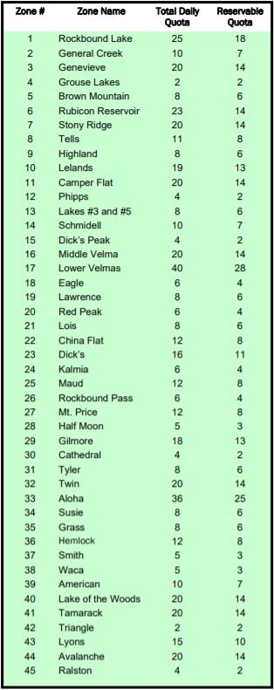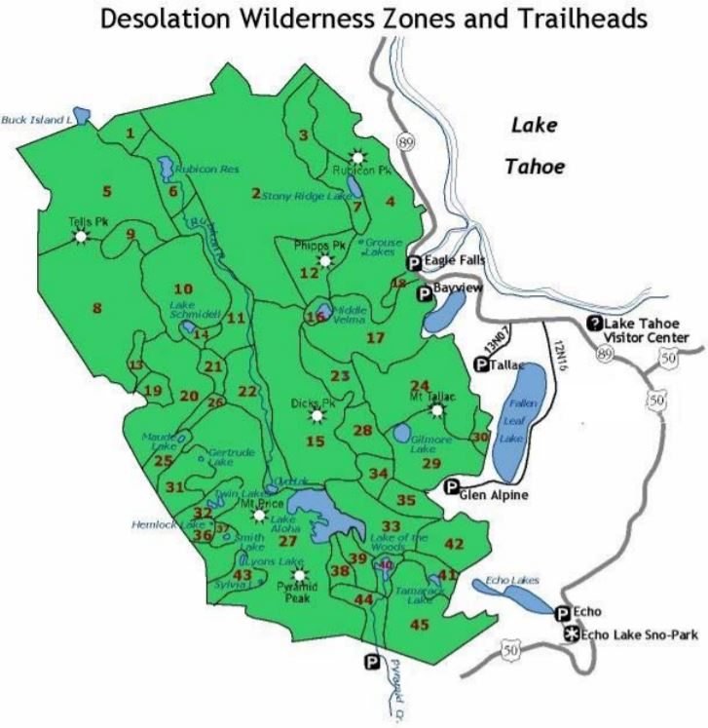

Purpose
Search Cursor 1 – Identifying Lakes within a Zone Number
Search Cursor 1 allows the user to query a Zone Number to determine which lakes reside within the zone. More specifically, the script will produce (1) the Lake Name, (2) the Zone Number, and (3) the Zone Name. An additional and indirect result of this query is that I can see how many lakes exist within a specific zone.
The end user that benefits from this query is the backpacker who wants to determine what lakes fall within a zone. A backpacker can query a desired Zone Number so he/she can figure out what lakes they have the option of camping at within the designated zone. This is important for determining the appropriate zone number to reserve with a permit.

Search Cursor 2 – Identifying a Lake’s Zone Number and Zone Name
Search Cursor 2 allows the user to query a Lake Name to determine which Zone Number and Zone Name the lake resides within. Search Cursor 2 is achieved with a modification of the query statement from Search Cursor 1.
The advantage of this script is if a backpacker has a favorite lake they like to camp at, he or she can perform a query of the Lake Name which will produce the Zone Number and Zone Name for which he/she will need to acquire a permit.

Description of Geoprocessing Tasks
Search Cursor 1 – Identifying Lakes within a Zone Number
A Search Cursor is used to read values in a data table and then produces a result. The Search Cursor 1 script searches the data table of the Lakes feature class and produces the results of two Fields in the Lakes Attribute Table: Lake_Name, and ZoneNumber_ZoneName. The following Python script is for Search Cursor 1 – Identifying Lakes within a Zone Number.
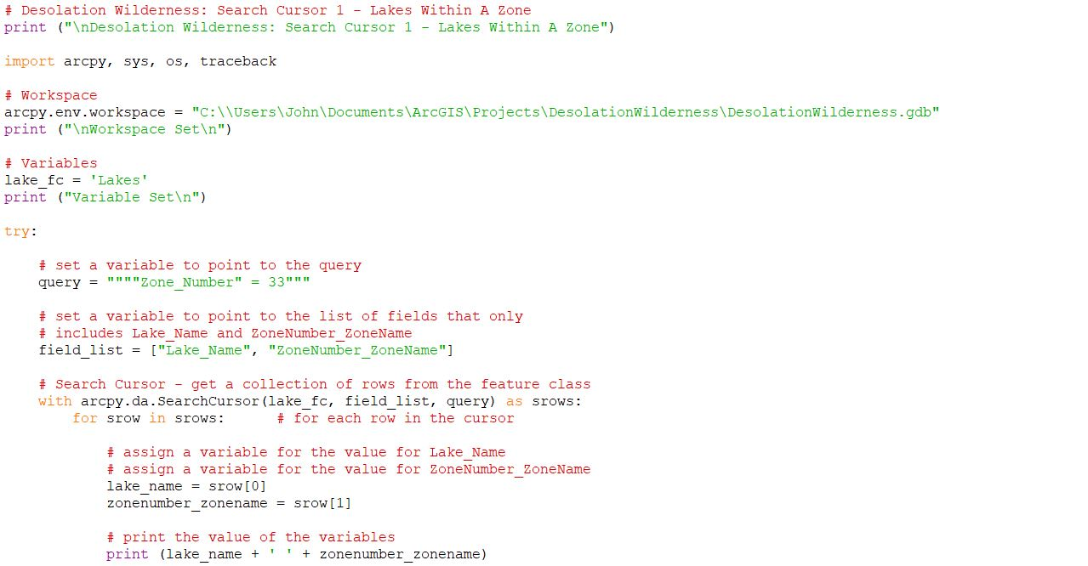
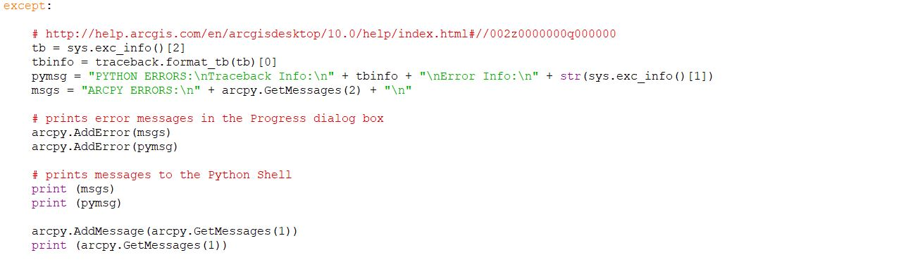

The Search Cursor 1 script above produces the following results.

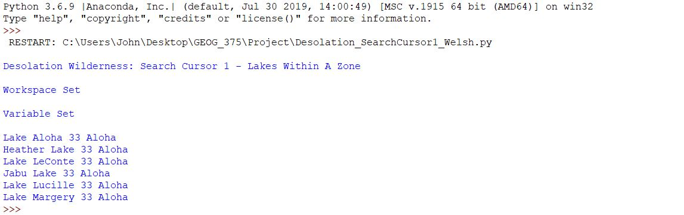

As a reminder, the search results provide three pieces of information: (1) the Lake Name, (2) Zone Number, and (3) Zone Name. In the example above, Zone Number 33 is named Aloha. This zone contains the following six lakes: Aloha, Heather, LeConte, Jabu, Lucille, and Margery.
To validate the Python script results, an Attribute Query was performed on the Lakes feature class in ArcGIS Pro. The Attribute Query for Zone Number 33 produces the same six lakes as shown in the Attribute Table below.

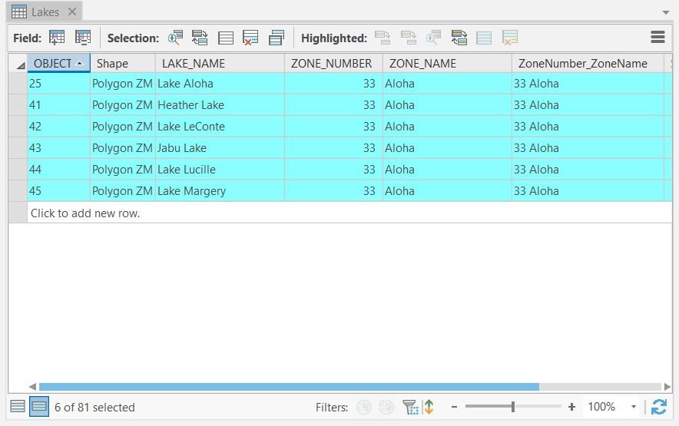

Search Cursor 2 – Identifying a Lake’s Zone Number and Zone Name
As mentioned earlier, Search Cursor 2 requires adjusting the query statement of Search Cursor 1. Instead of querying a Zone Number, Search Cursor 2 queries a Lake Name to determine what Zone Number the lake resides within. Only one line in the script requires modification, the query statement. The following examples demonstrate how the query statement is changed.
Search Cursor 1 Query Statement
query = """"Zone_Number" = 33"""

Search Cursor 2 Query Statement
query = """"Lake_Name" = 'Lake Zitella'"""

Notice the three changes to the query statement. First, the Zone_Number Attribute Field changes to Lake_Name because we want to query a lake and determine the zone in which it resides. Second, the zone number value is changed to a specific lake name. Third, single quotes must surround the specific lake name being queried because it is a character string and not a number. Only these three changes are necessary so that Search Cursor 2 reads the records of a different Field in the Attribute Table, Lake_Name instead of Zone_Number. The results of Search Cursor 2 yield data from the same two Fields as Search Cursor 1, Lake_Name and ZoneNumber_ZoneName. Below is the entire script for Search Cursor 2 – Identifying a Lake’s Zone Number and Zone Name.

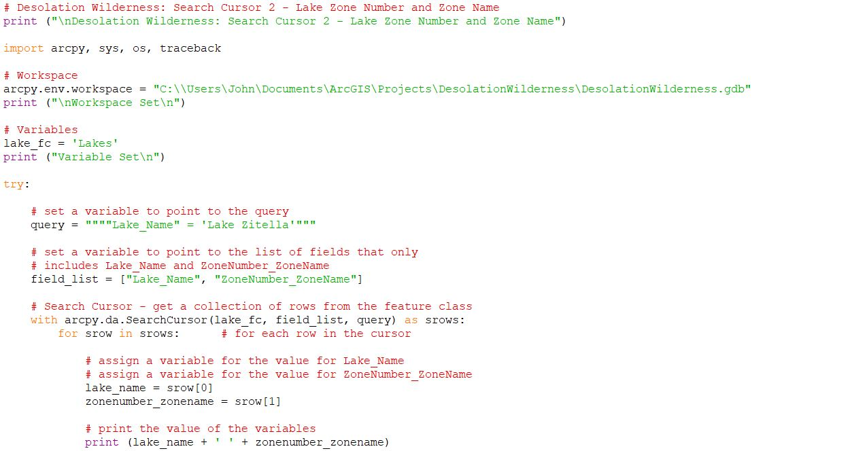

The Search Cursor 2 script above yields the following result.

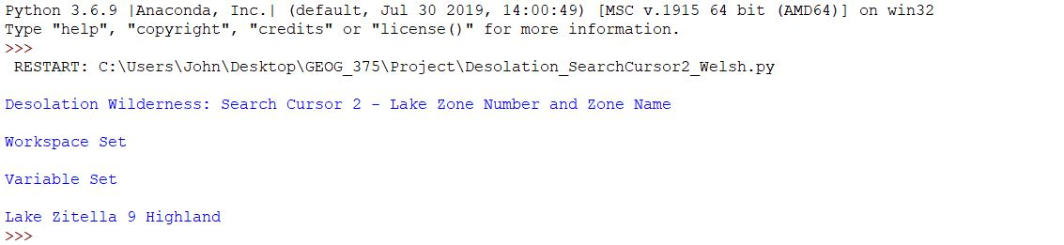
Like Search Cursor 1, the search result above is comprised of three components: (1) the Lake Name, (2) Zone Number, and (3) Zone Name. In this case, Lake Zitella exists within Zone 9, whose Zone Name is Highland.
To validate this Python script result, an Attribute Query is performed on the Lakes feature class in ArcGIS Pro. The Attribute Query where the Lake_Name is equal to Lake Zitella also results in Zone 9 and Zone Name Highland, as shown in the Attribute Table below.

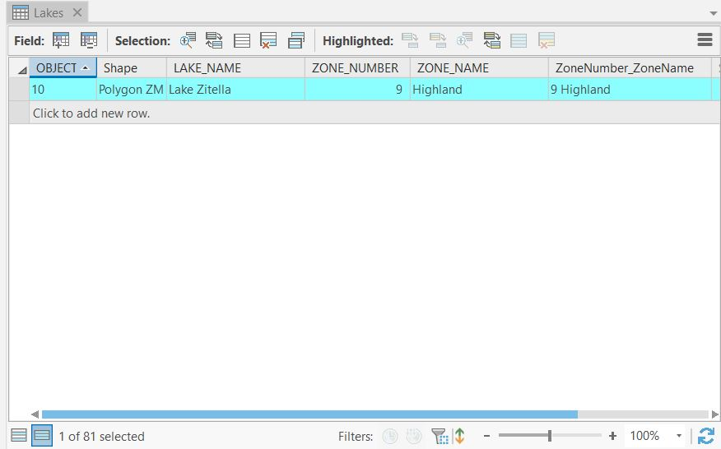

Challenges and Solutions
Challenges
Only one programming error, shown below, was experienced when creating the script for this Python Project.

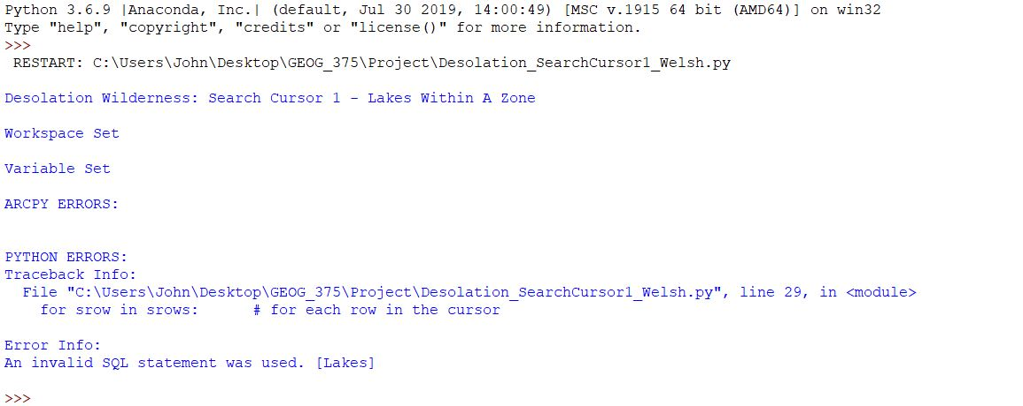

As indicated by the error, I began by reviewing my script around line 29. I did not see any obvious errors in the Search Cursor statement or the srow section. Therefore, I turned my attention toward the other part of the error message stating "Error Info: An invalid SQL statement was used. [Lakes]." My interpretation of this error message was that the script cannot locate the Lakes feature class. I started troubleshooting with the following steps:
- Workspace File Path – I verified the Lakes feature class is in the DesolationWilderness.gdb. In ArcGIS Pro, I right clicked on the Lakes feature class, and selected Properties. In the Source tab, I confirmed the correct file path within the Data Source section and Database field.

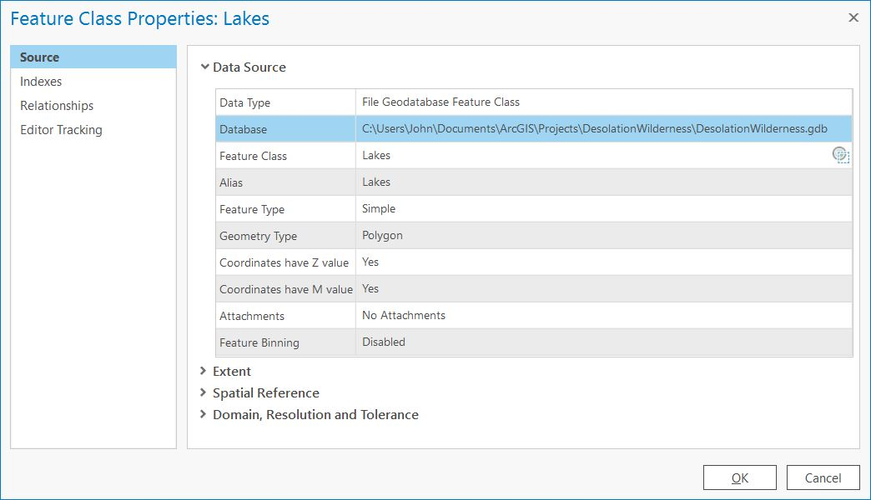

- File Explorer – After confirming the Lakes feature class resides within the file geodatabase, I checked to confirm its existence in File Explorer. I did not see a Lakes file when the project and the ArcGIS Pro application was closed. I was not certain if that was to be expected or not. On the other hand, when the project was open and running ArcGIS Pro, I did notice a Lakes file. The file appeared as a LOCK File type as shown in the image below. To me, this suggests that the Lakes feature class is there in some form.

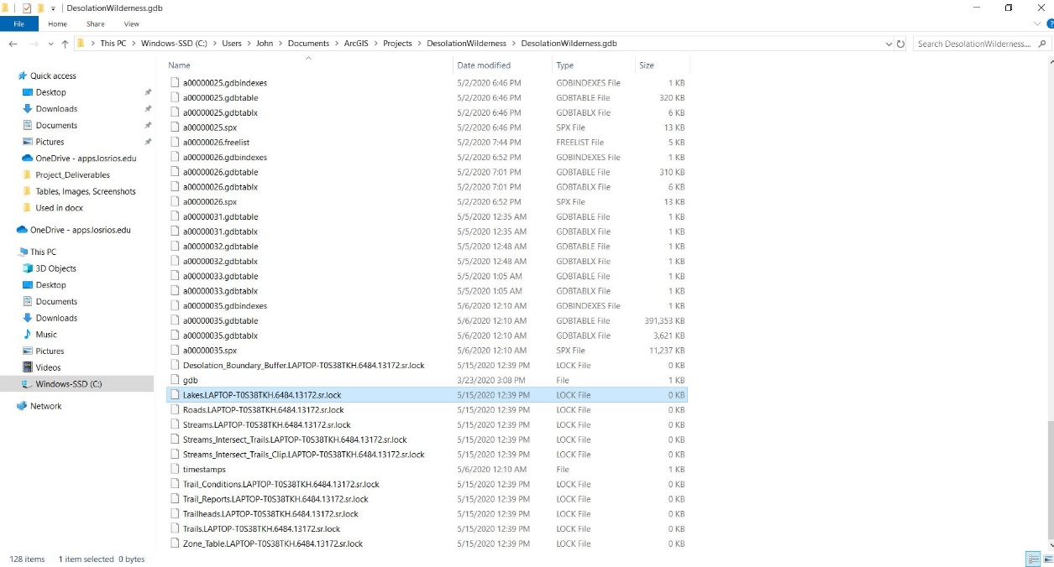

- Typos – After confidently ruling out an incorrect file path as the cause of the error, I double-checked the entire script for typos.
- Syntax – I reviewed my entire script a second time and the syntax seemed accurate.
- Print Statements – I utilized print statements to help isolate the error to a more exact location within the script.
- Indentation – I also verified the indentations.
- Break Time – Having exhausted all my known troubleshooting options, I decided to give my eyes and mind a rest and walk away from the script. I was hopeful that a mental break and additional time to reflect would help me determine the solution.
- A Different Set of Eyes – After reviewing the script one last time, I ran out of problem-solving ideas. I asked a friend to review my script. A sincere thank you to Professor Nathan Jennings for helping me identify the syntax error.

Solution
The script error was in the query statement. I had forgotten that single quotes are used for character strings. My error was caused by the single quotes around the zone number value of 33 in my query. Eliminating the single quotes allowed my Search Cursor 1 script to work successfully.
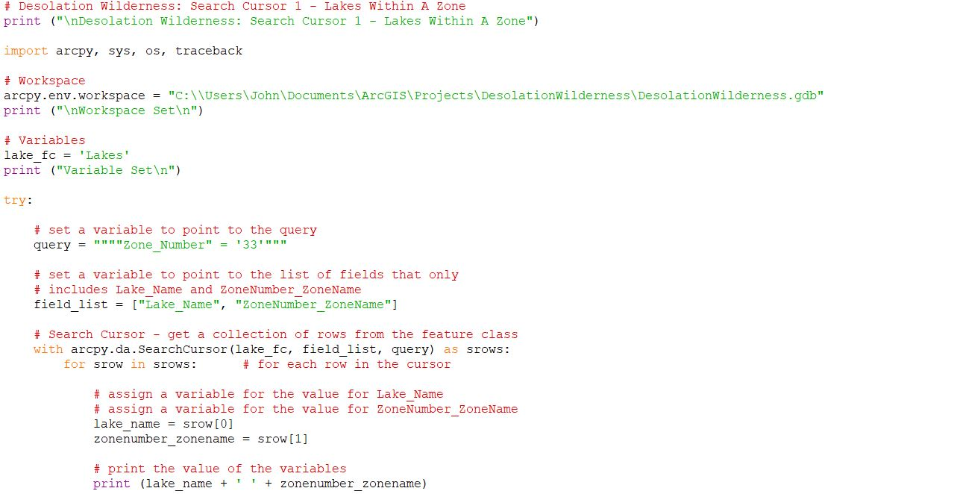

After the syntax error was identified, editing the query was simple to come up with Search Cursor 2 - Identifying a Lake’s Zone Number and Zone Name. As a reminder, the following is the query statement for Search Cursor 2:
query = """"Lake_Name" = 'Lake Zitella'"""

Because the lake name being queried is a string, Lake Zitella in this example, single quotes must be used for the script to work properly. In conclusion, this syntax rule was my most important lesson from working on this Python Project.

