Kevin Starr
Geography 93
Professor Jennings
5-23-19
Final Project Paper

Project Summary:
The purpose of this project was to create a long term vision for soft surface, single track trails for the Truckee Donner Land Trust. The Land Trust manages an extensive network of trails already and has several trail projects that are in progress. The overview map and series of maps generated in ArcGis Pro will allow staff to have a clear, concise vision of the work ahead on a programmatic level of planning with the ability to be scalable for each individual project.

Purpose:
The maps will be a living document for trail projects with the added benefit of being in a common platform to track progress and share data within the Land Trust along with partner agencies.

Process Description:
Most of the trail files that I have traditionally been working with were put together in either CalTopo or Google Earth and needed to be exported (Figure 1) and converted into a format compatible with ArcGis Pro or ArcMap. The ArcGis Pro allows an individual to drag and drop .kml files (Figure 2) right into the table of contents while ArcMap makes you perform a conversion geoprocess first.

Figure 1 Export from CalTopo
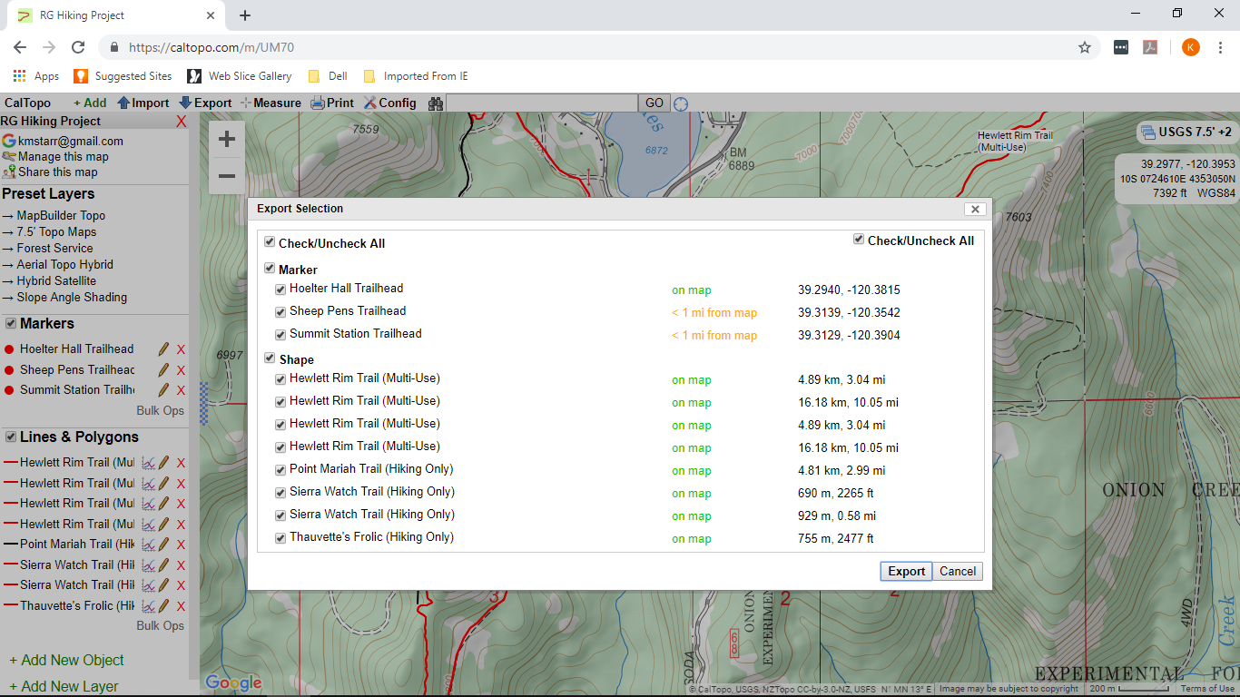
Figure 2 Drag and Drop .kml file into ArcGis Pro Table of Contents
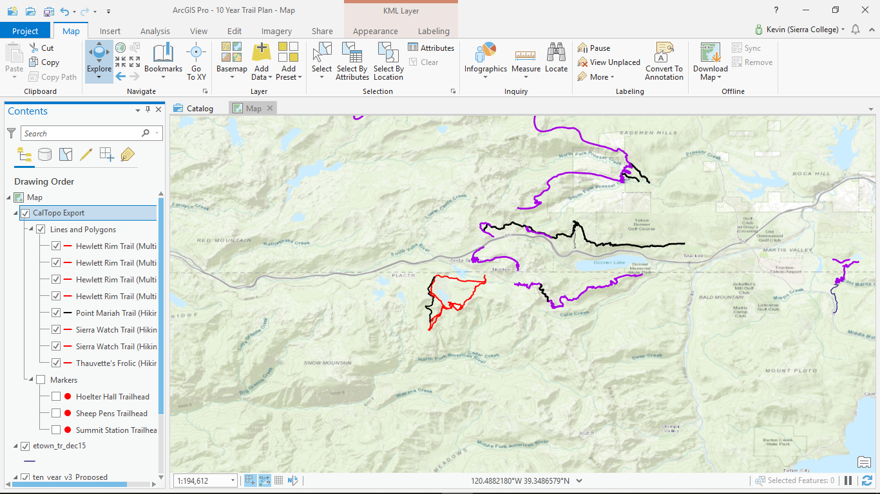

Whether in ArcMap or ArcPro, the conversion process (Figure 3) is more or less the same and can be navigated with a geoprocess found in the “Tool Box” under the “Analysis” tab.

Figure 3 .kml to Feature Class
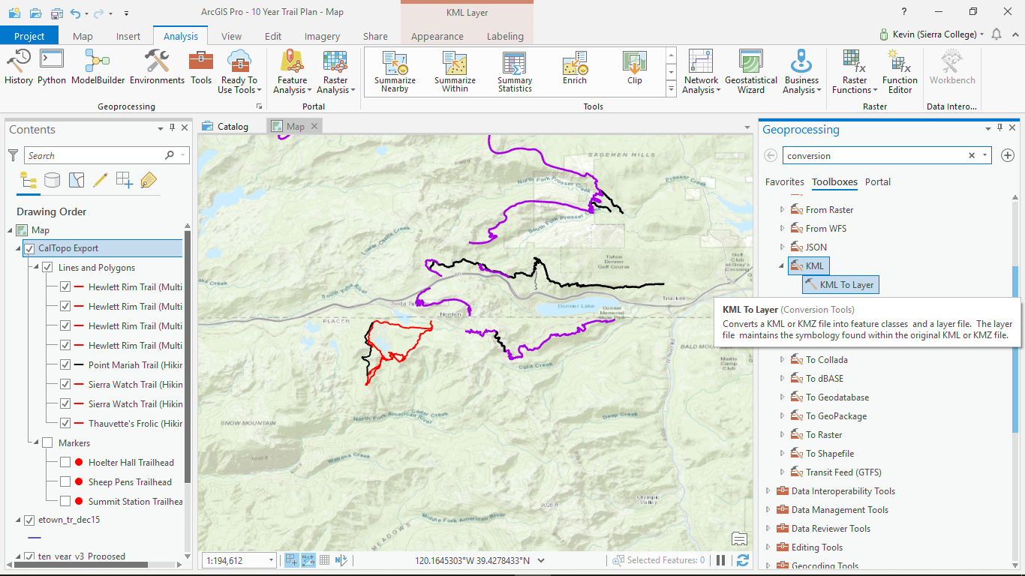

You can also convert .shp files into feature classes to go into geodatabase which allow you to create domains more easily. (Figure 4,5).

Figure 4 Shape File to Geodatabase
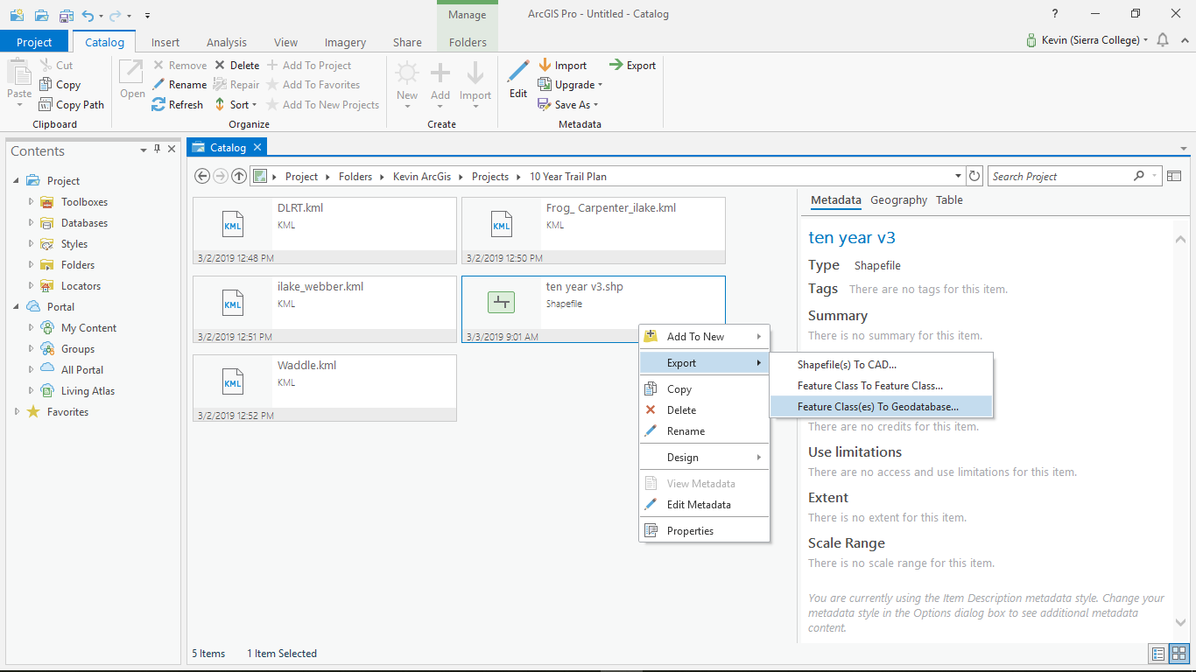

Figure 5
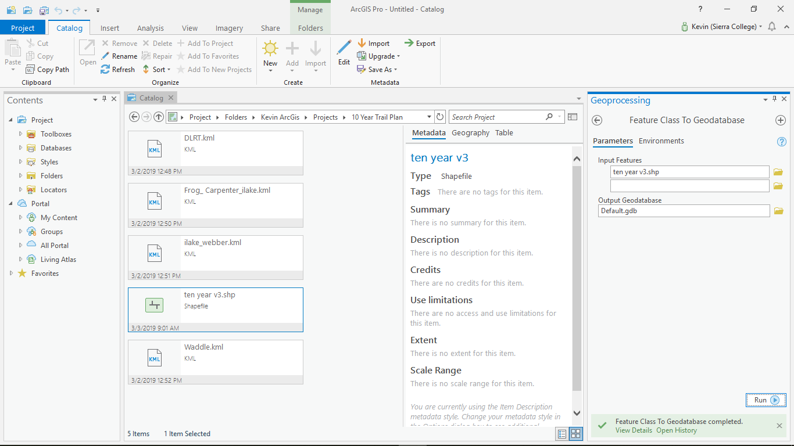

I brought in what I thought were all of the trail files and started the symbolization process. As I progressed, I soon realized that certain trails were left out and I had to bring in new files several times. I wanted all of the trails in one attribute table, so I waited until the end and I merged them all into my original trails feature class (Figure 6). This would have been much easier if I had known about the “Append” tool.
Figure 6
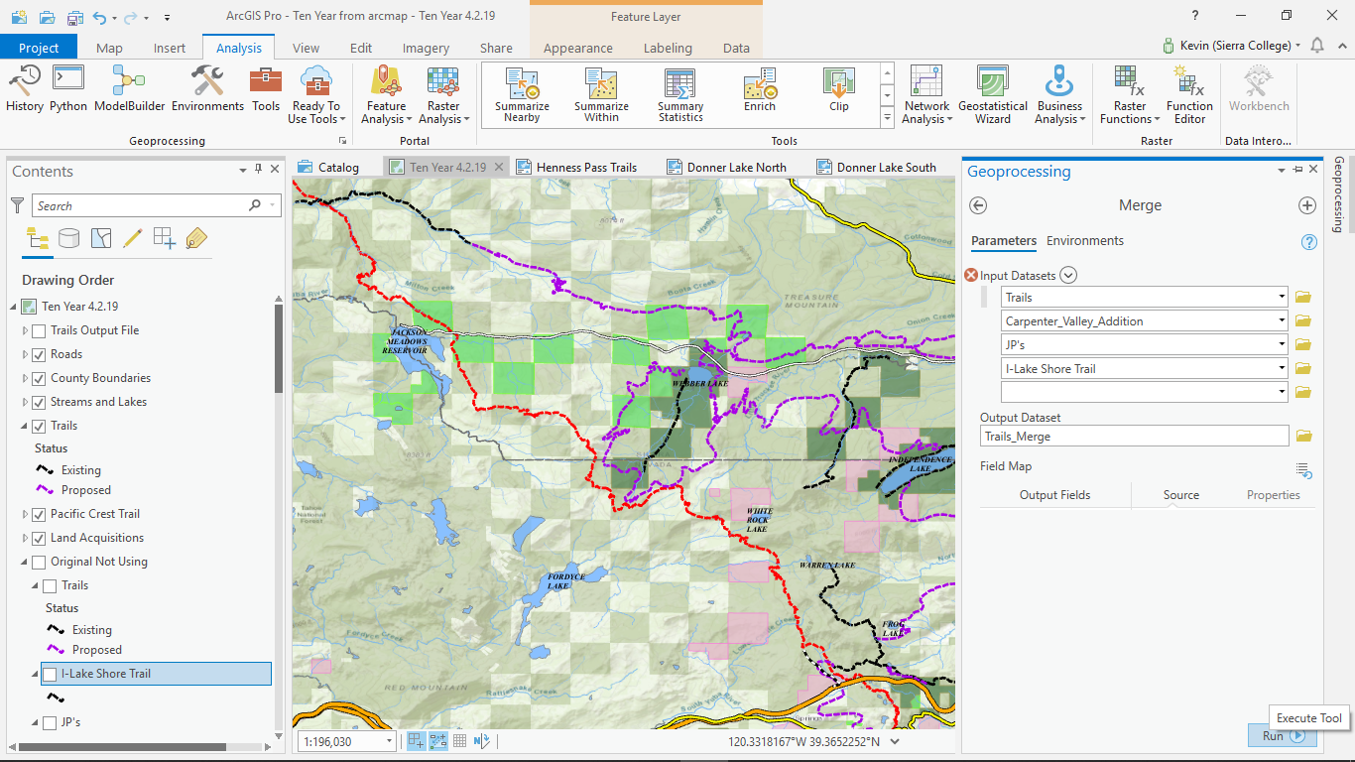

I symbolized the trails mainly through the attribute table and creating a column called “Status” where I could then add, “Existing” or “Proposed”. I then used “Display Filters” (Figure 7) to show just the two options I outlined. The Pacific Crest Trail was its own layer and used mainly for geographical reference.

Figure 7 Display Filters
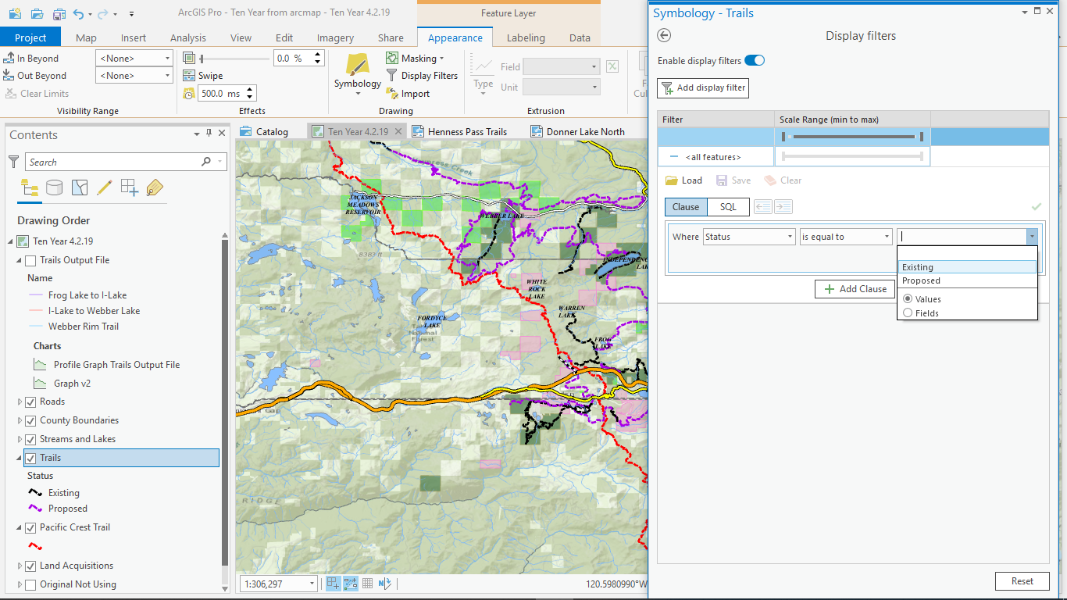

Other relevant information I added in the attribute table were things like “Trail Length” and “Property Ownership” which the trail traversed through. To find the length of a trail: open the attribute table and create a column labeled “Length”, type in “Double” for the “Data Type”, and “Numeric” for the “Number Format”. Right click the “Length” column and press “Calculate Geometry Attributes” (Figure 8,9); “Target Field” should be the line feature class you are working in; pick “Length Geodesic” from the “Property” drop down menu; “Coordinate System” will be the maps frame that you are currently working in and hit “Run”.

Figure 8 Calculate Geometry
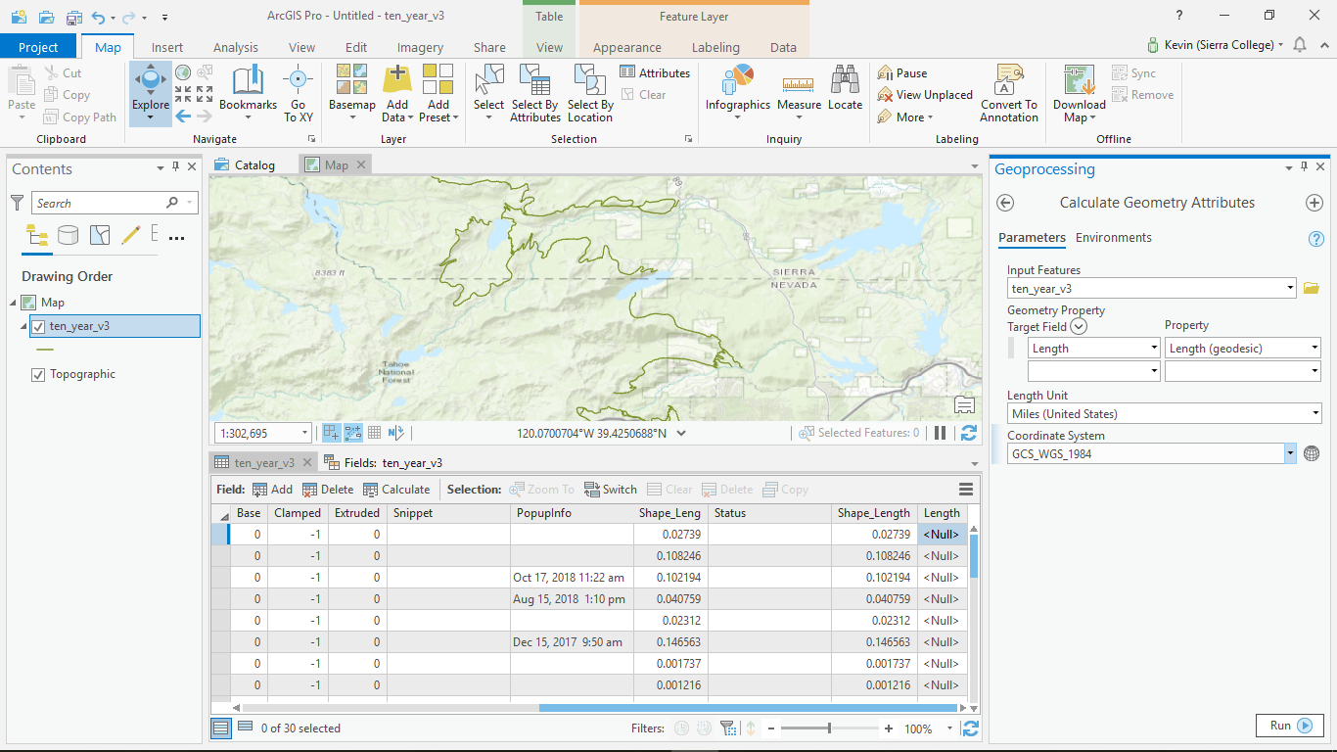

Figure 9 Calculate Geometry
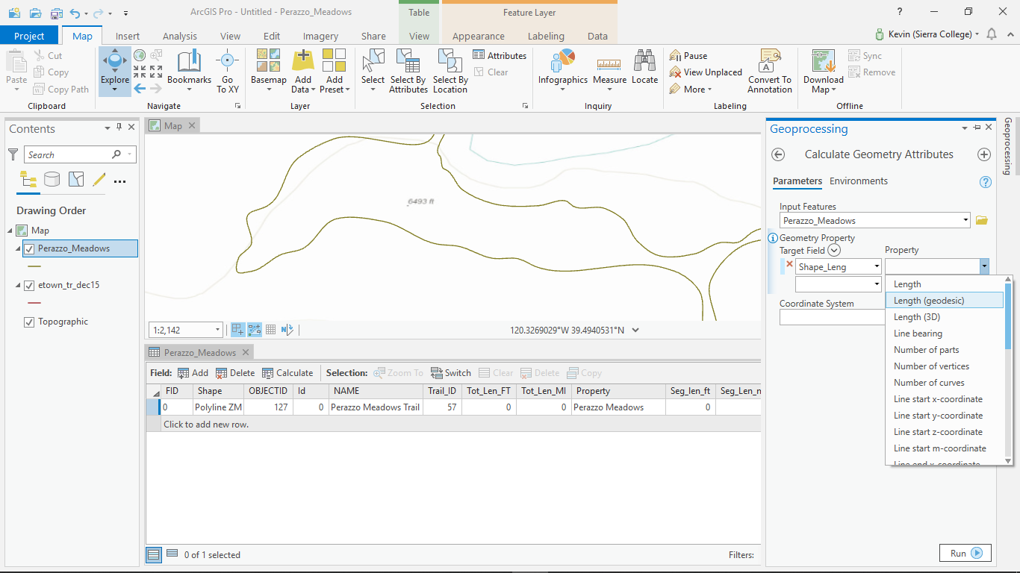

When this project was first conceived, I wanted to show many different layers like sensitive species, soil types, and vegetation cover. As the project progressed though, I quickly realized the project was more of a broad overview and I needed to uncheck those layers from my table of contents to reduce visual clutter on the maps. I did bring in other layers like property ownership, state and federal protected areas, roads, and hydrology in the form of lakes and streams.
What I did end up doing for future reference though, was to create several layers from analysis for the most relevant threatened species that I have to deal with in terms of trail planning- the Sierra Nevada Yellow Legged Frog(SNYLF).
I loaded two layers from the Department of Fish and Wildlife(Figure 10,11,12). One that showed a broad, geographic polygon of critical habitat for many different species and another fine-tuned polygon specifically for SNYLF. I used the “Intersect” tool from the “Analysis” tab and performed several functions from there that showed how my proposed trail alignments would pass through any habitat. The main trigger point was where the proposed trail alignment would intersect with both layers- critical habitat and suitable habitat.

Figure 10 Trails with Sensitive Species and Suitable Habitat Polygons
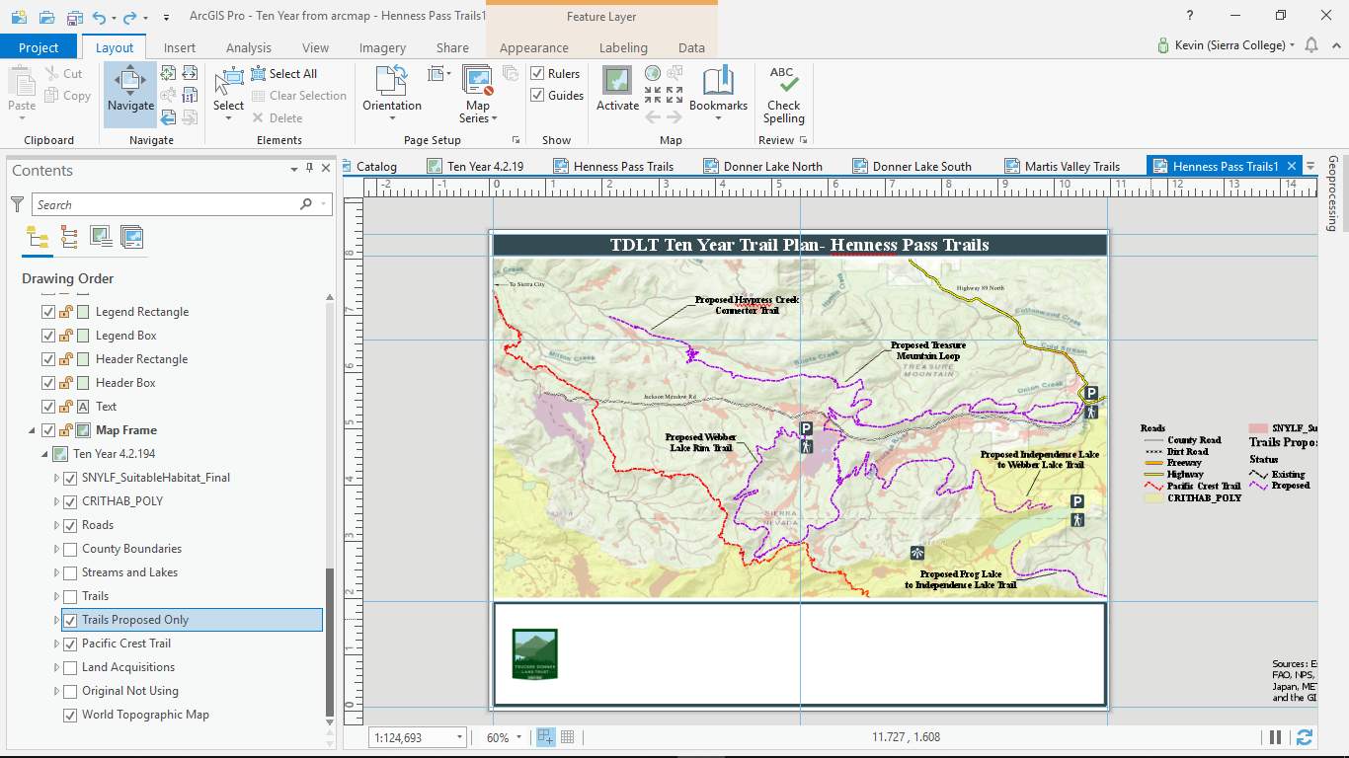

Figure 11 Intersect Tool
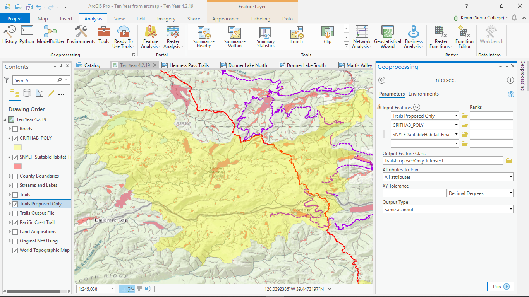

Figure 12 Intersect of Trails and Suitable Habitat/Critical Habitat
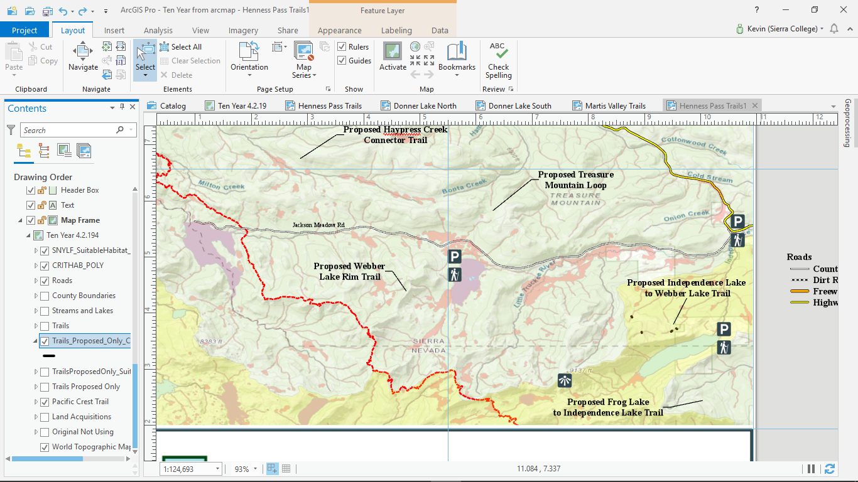

To better show these areas of concern and how they interact with the proposed trails, I went ahead and made a buffer around these small areas (Figure 13).

Figure 13 Buffer Around Areas of Concern
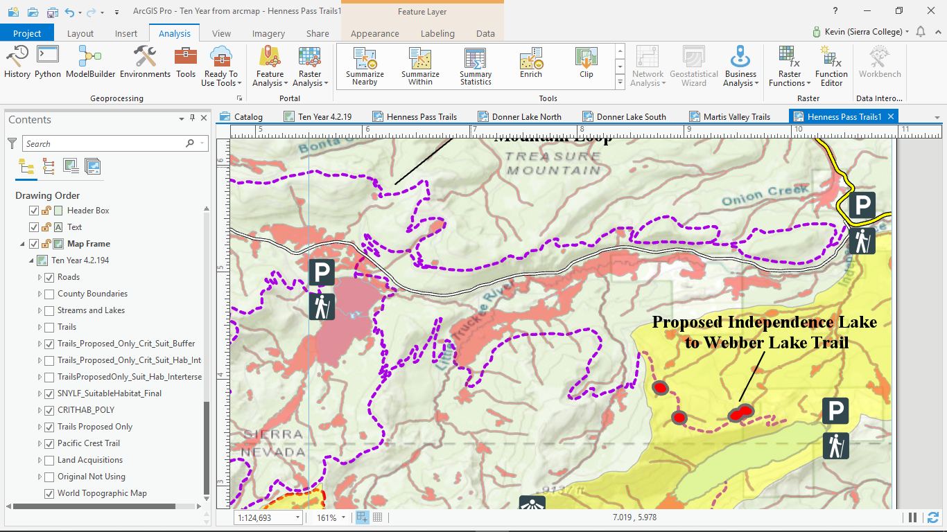

Symbology for the roads and hydrology layers was a challenging, but fun exercise. For the road layer, I wanted to focus on main arteries or roads that would give the map user a good geographical reference. I used definition queries to single out the features to be displayed and then made a new column in the attribute table called “Type”. I was then able to symbolize (Figure14,15 ) the roads based on a class size.

Figure 14 Road Symbology
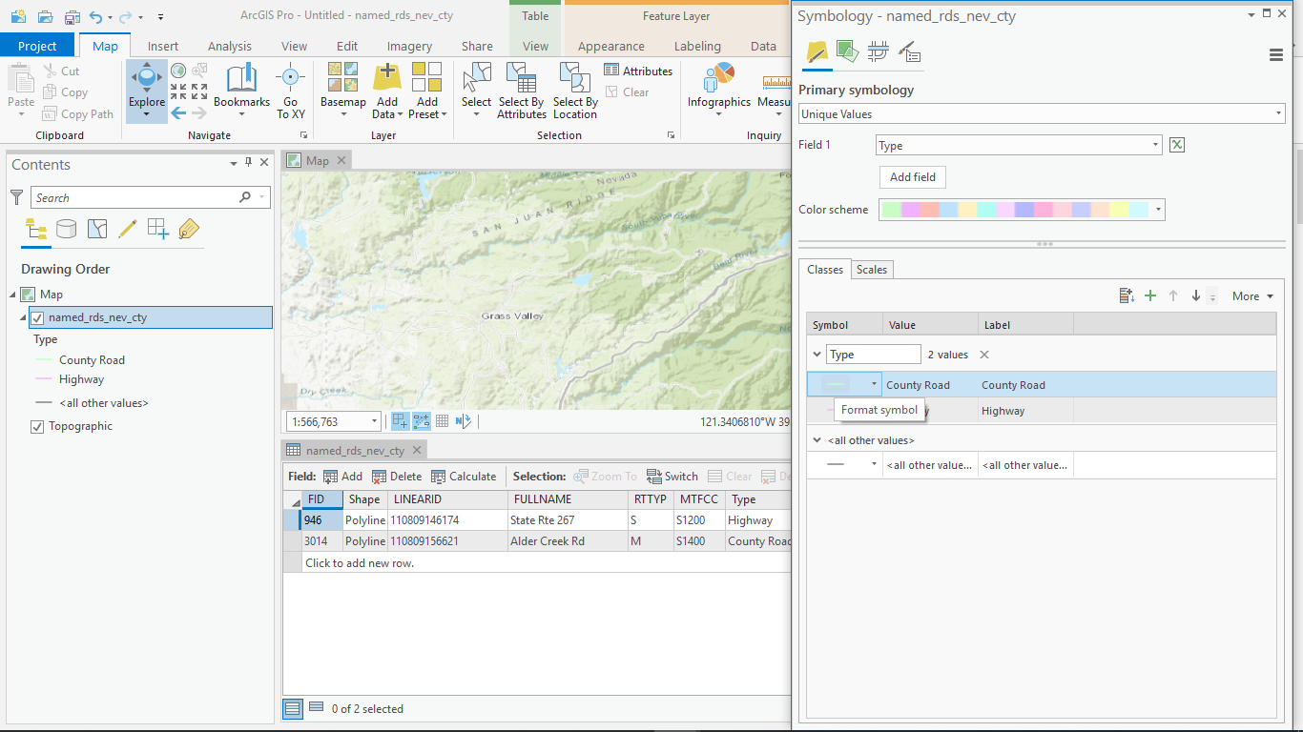
Figure 15 Symbology Road Classification
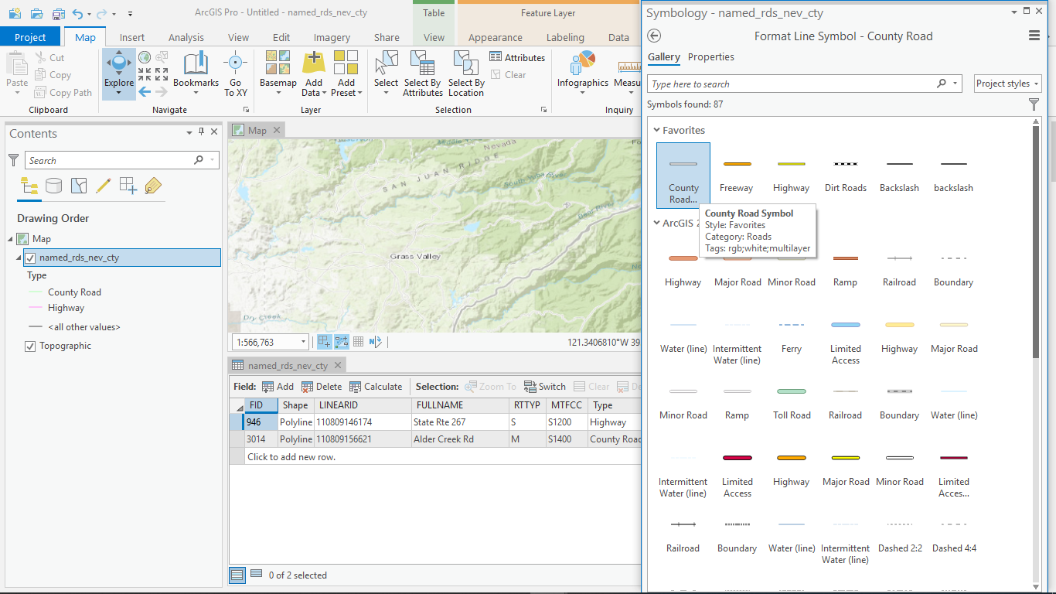

The other contributing layers were a mix of public data from the California Protected Areas Database (CPAD), data from different counties, and property data from within my organization. The CPAD data really showcases the checkerboard pattern of Northern California that displays how land was granted to the Railroad to help facilitate the building of the transcontinental railroad.
From there it was time to start making maps and after the first one was complete, I made a layout template (Figure 16) of it. From there I was able to make several other maps that referenced the original data frame.

Figure 16 Save Layout File
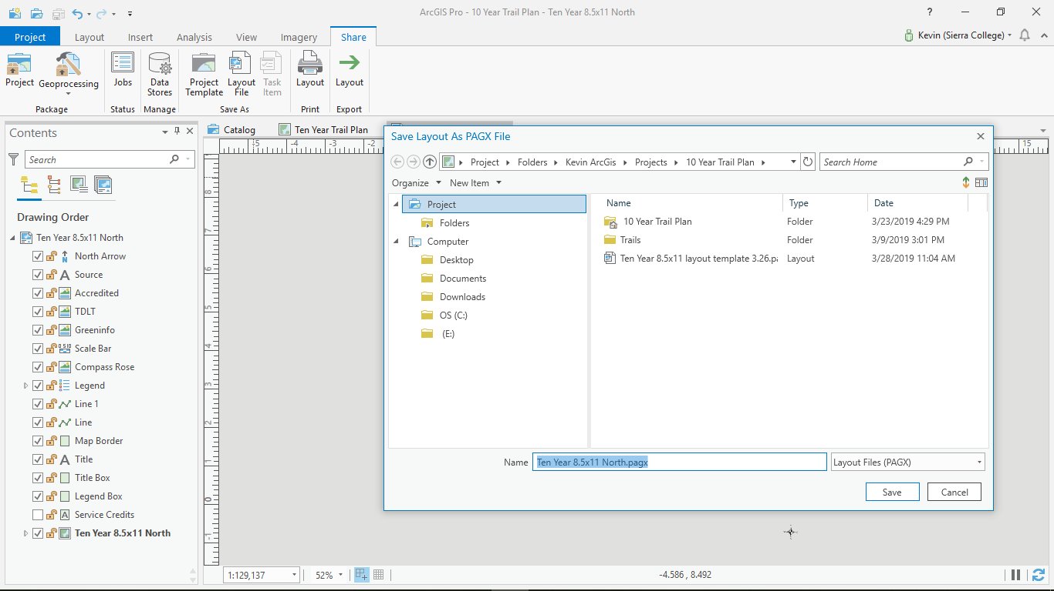

The final steps to the map making were adding text annotation where needed on the maps and putting all of the elements together in the legend so that it all made sense.

Figure 17 Final Overview Map
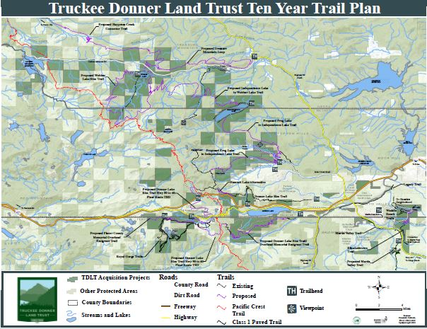

Figure 18 Henness Pass Trails
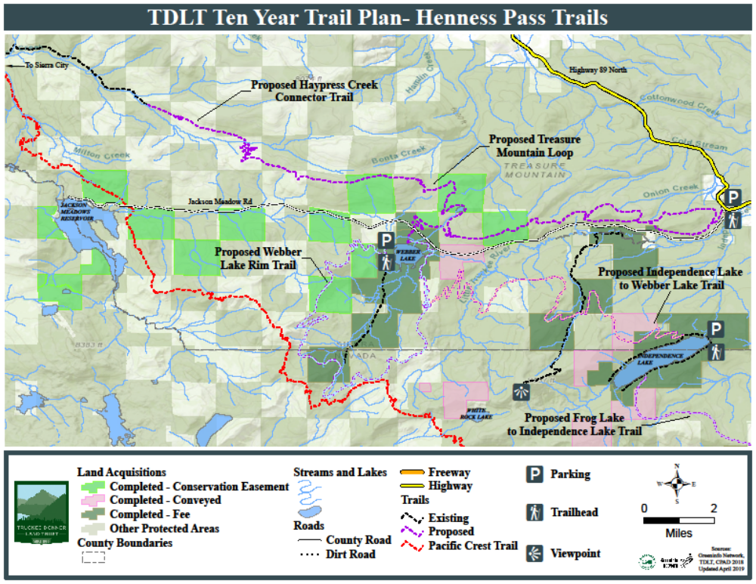

Figure 19 Donner Lake Trails North
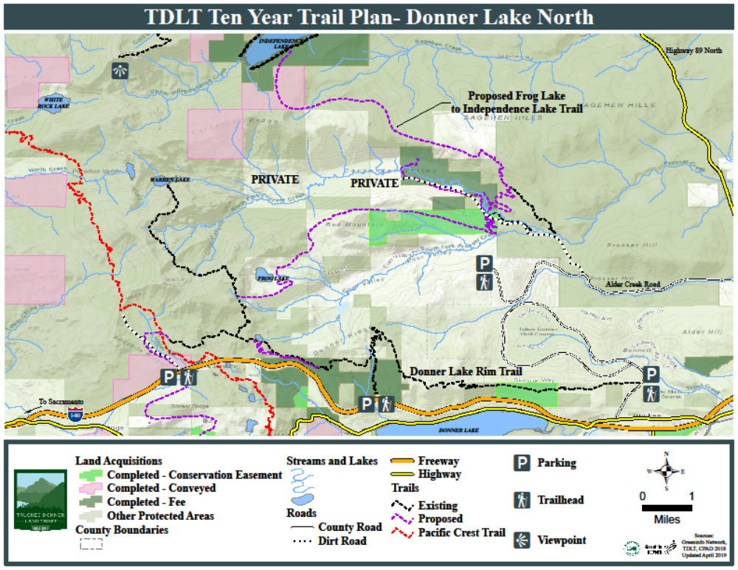

Figure 20 Donner Lake Trails South
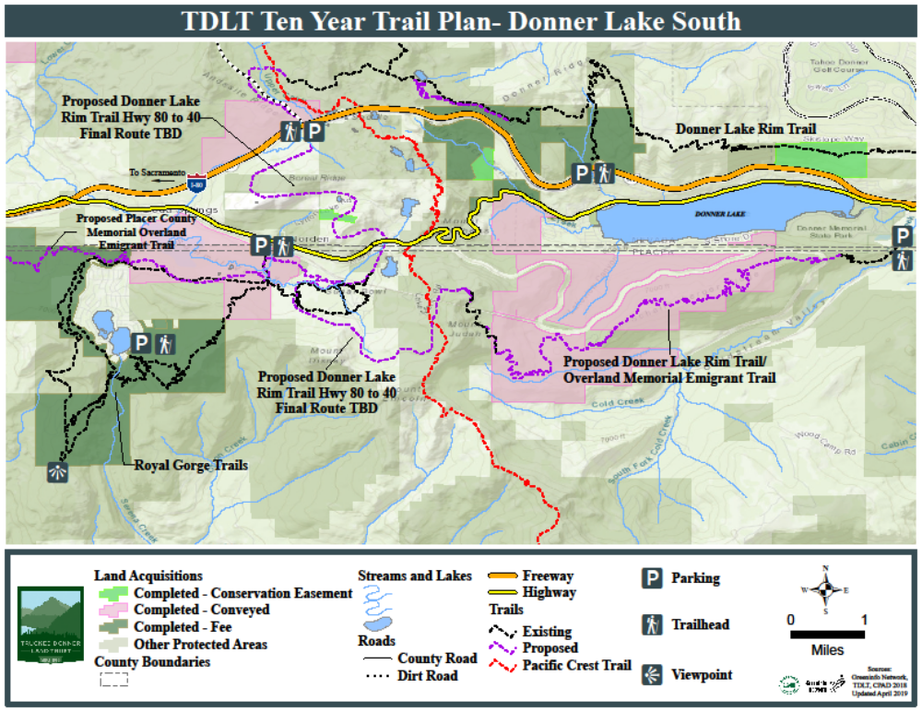

Figure 21 Martis Valley Trails
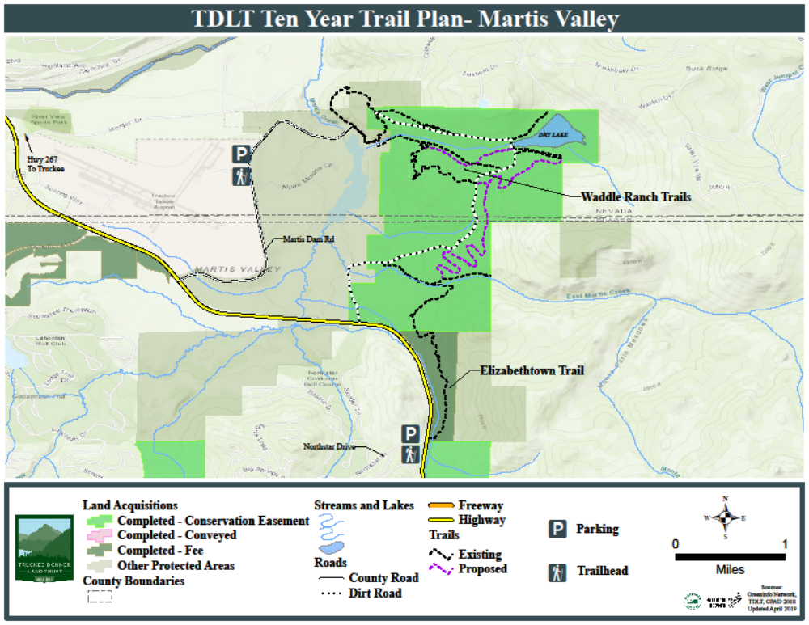

After the maps were completed and symbolized to satisfaction, I wanted to experiment with creating trail profiles for certain trails. You must first create a 3D version of the line feature by going to the “Analysis” tab and clicking “Profile” under the “Ready to Use Tools” tab.

Figure 22 Create 3D Line Feature
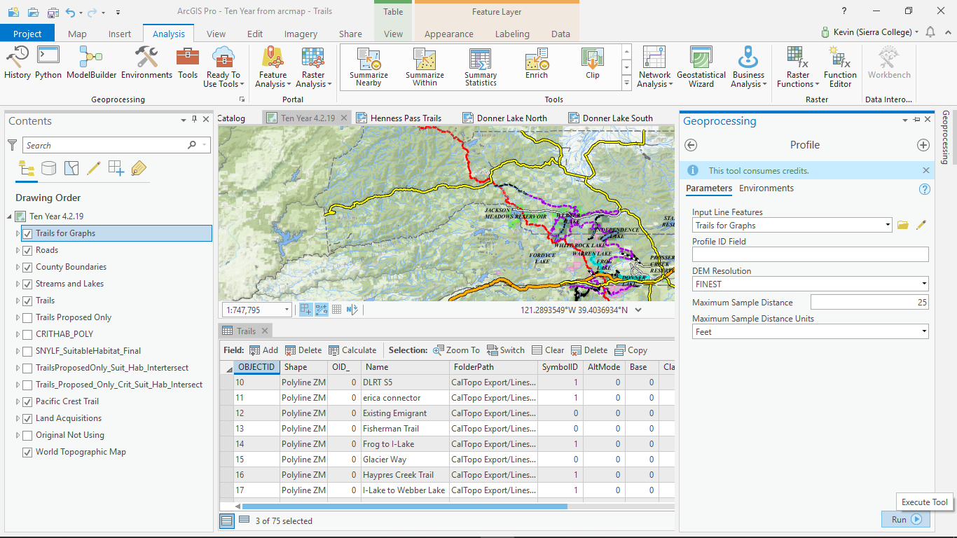

From there you can now right click on that new line feature and create a graph of your choosing.

Figure 23 Graph Created
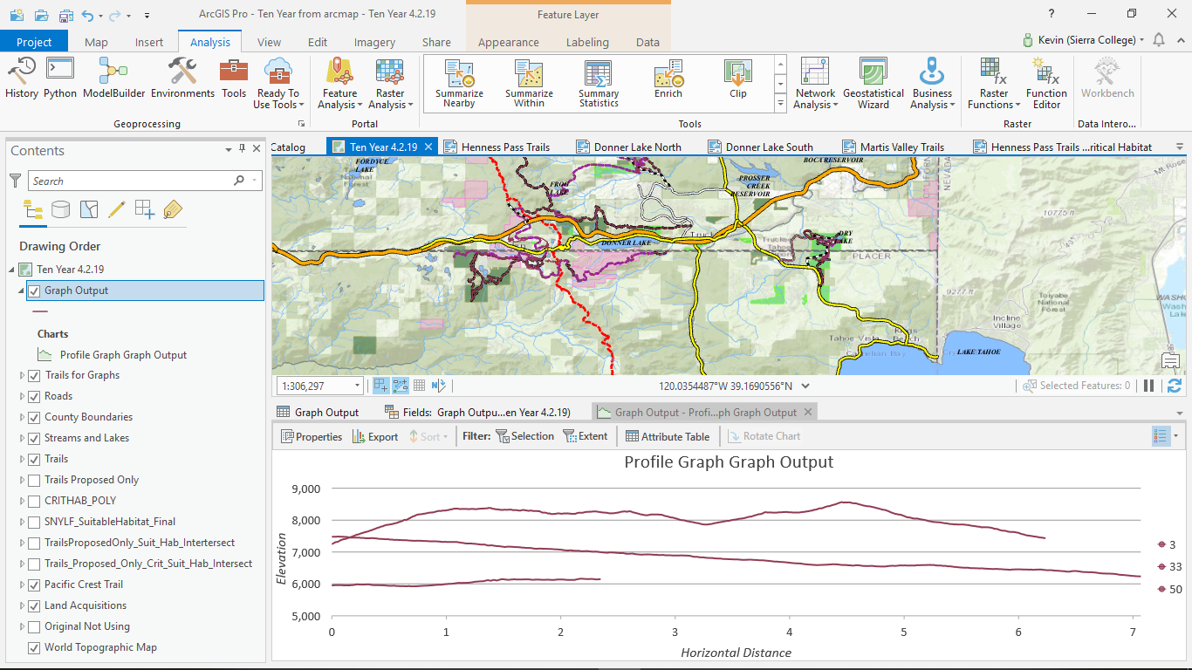

Through several process you can edit the graph’s features, but I had to resort to using a Snipping tool to create my final version.

Figure 24 Final Graph
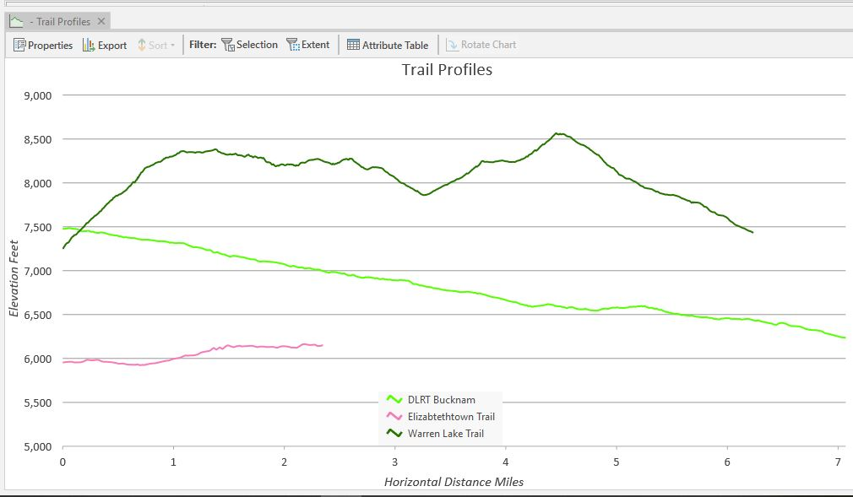

Overall, this project went smoothly, but wasn’t without its share of frustration. The highest hurdle came when the whole ArcGis Pro program froze on my system and would not reboot without crashing the program. No matter what I tried. The fix came in the form of deleting and re-installing the whole program and starting the project from scratch.
I would say that my biggest improvement came with symbolizing features and using different methods to achieve my goals. Display filters, graduated symbology, and definition queries all became much more easy to negotiate by the end of the project and hopefully the maps I created will showcase that.

