Ryan Soulier
Nathan Jennings
Advanced GIS
11 May 2021
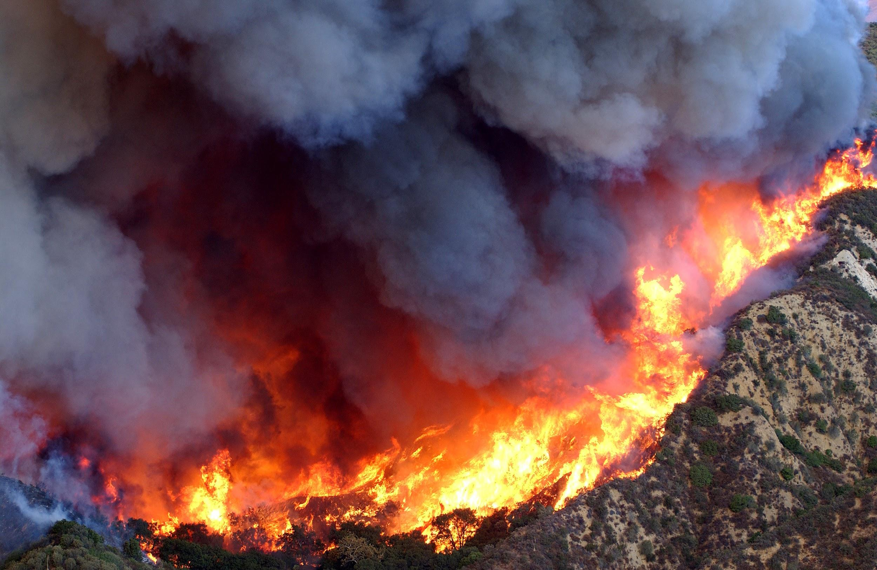
GEOG-0093 Final Project Paper

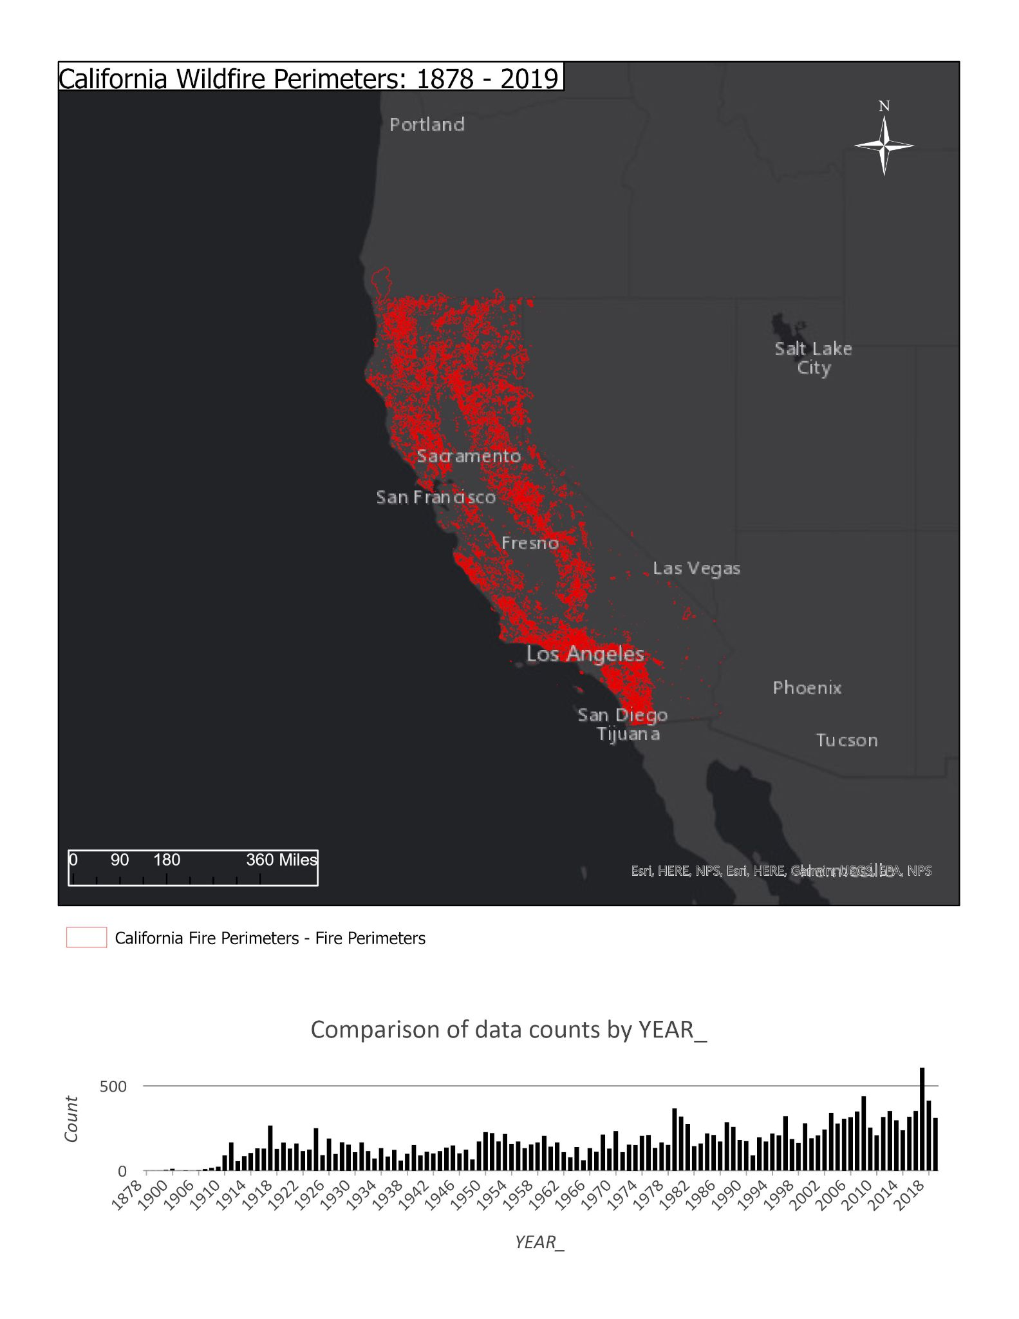
The object of my Geog-0093 Final Project was to outline where, why and how California’s pernicious wildfires have burned, identify what ignites, and showcase preventative methods through GIS procedures and approaches. I was able to do just that through various maps styled with cartographic methods, built with data from ArcGIS online and file geodatabase functions, and clipping, exporting and utilizing data to my needs to discover more about California’s significant fire history as well as the extensive and functional ArcGIS software.
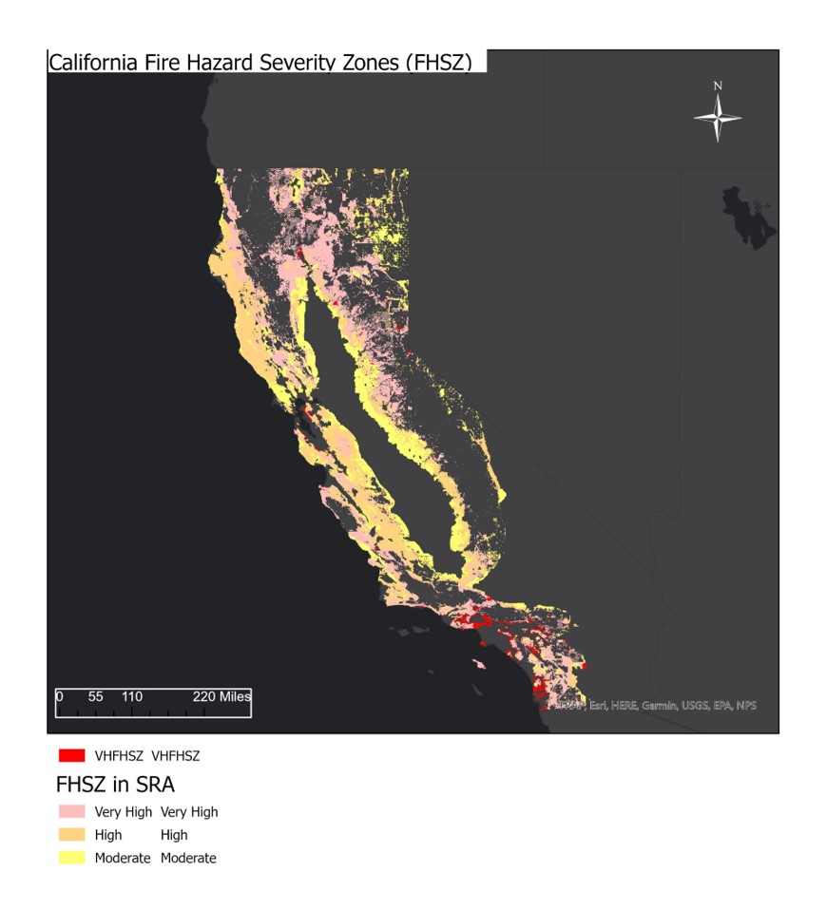
What I hoped to accomplish with this project was to be able to assist map viewers and audience participants to view firstly where California’s wildfires have raged in the past nearly one hundred fifty years (the map is shown above). The extent of the uncontrolled flames occurring yearly can be staggering when first analyzing any wildfire maps, especially of over a century of wildfire history. Having straightforward and sensible map styling and creation was key to this being impactful. My presentation on wildfires included where they have burned and where fires are inclined to burn through my ArcGIS Web Map Application on Californian vegetation and fire hazard severity zones (FHSZs) layout as illustrated below. I also displayed local past fires and fire prevention methods that are being implemented and have been implemented. The intent behind all of my effort was to convey the severity of wildfires and deepen the understanding of wildfires of those that will view my maps and applications. My most notable purpose of this project however, was to become more adept and able on the GIS software through learning from personal experience with the software and especially learning from my professor and practicing with the addition of recorded zoom sessions which were extremely helpful. I absolutely think my abilities on the software were heightened and enlarged thanks to this fantastic learning opportunity and professor.

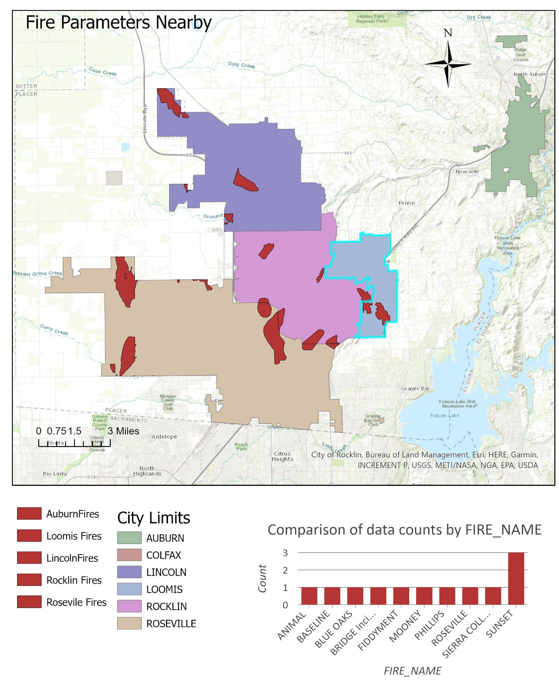
I was able to manage the GIS data found on ArcGIS Online, create my maps, style those maps effectively and execute the requirements for this class and project surprisingly better than I thought I might in foresight. Data was definitely an issue for me while I started and later finished this project. I found more useful data on an ArcGIS online web map portal than the portal on ArcGIS Pro, so I saved the data as an ArcGIS Pro project in order to use it in my project. The data I sorted through was extensive to say the least, with dozens, if not hundreds of options of layers to choose from. I eventually identified the specific layers I wanted to use to convey my project and information as best possible. I then put them into layouts to save into what format I found was best, JPG files. I changed my base maps on ArcGIS Pro multiple times in order to find what would show the data the clearest and most obviously, and I found the dark grey canvas base made the vivid reds and oranges of the fire maps pop and emphasize the best. This is why most of my various maps for this project include this same basemap. I had to change the color of other essential map elements (layouts, scale bars, titles, etc.) to combat this differing background to compensate but it was worth the effort. I included two chart frames in two of my map layouts as well, in order to be able to add another layer of information to my data, displaying dates and names to supplement my layouts which was a learning experience that was very worthwhile and useful. Moreover, I was especially dogged being certain my cartography was to the best of my ability, specifically being assured my maps were simple, effective, and not confusing or oversaturated. I executed this same method while creating my web map application covering California’s diverse vegetation, again being sure it was unconfusing and informative. I managed my data with one or two file geodatabases, as I used multiple map template tabs, especially for clipping, unionizing, buffering (but I did not end up using buffering in any of the maps), and adding points, lines and polygons. Selecting by location and attribute was additionally very helpful in this endeavor.
Difficulties I encountered while working on this project were, as aforementioned, largely centered around data. While I was grateful I did not have any issues finding data, I was slightly overwhelmed by the sheer amount of data I had at my fingertips. I did not know where to start or how to include the data I was flooded with. After scanning through the many, many layers, I found what I needed. The reason behind my high number of map layouts is due to the confusing nature my maps contained when they were very oversaturated with confusing and bulky wildfire data which I started out with after discovering so much data. Consequently, I separated the data and information between layouts so I could successfully present my findings and creations. This was a difficulty I am thankful I could eventually overcome. I also did my best to implement the functions taught in this class in the ArcGIS Pro software for this project, but not all of them were effective or needful for me. One more supplemental problem I experienced during my work on this project was finding the right format to export my layouts in to input them into my slides. I was able to figure this one out as I tried new formats when I saved the layouts many times in a successful attempt at generating my slide presentation.
In the duration of this project, I feel I have learned a significant amount, both about California’s, may I say, wild wildfire seasons, distant and recently past, and the ArcGIS software and its many functions and useful secrets and abilities. I learned how destructive wildfires can be, and how far reaching their flickering heat can burn across a state, and how it leaves it’s charred path behind on the physical ground, and also reflected on the virtual surface in historical map form. I have further learned many new operations of ArcGIS, both online and on the installed software, from creating and styling constructive ArcGIS online web map applications and it’s widgets, data, functions, and cartography, and new processes for heightened assignments and projects on ArcGIS Pro. I have learned to buffer, union, clip, create diverse chart frames, query, select, analyze, design, find superior data, and much more. I know what I learned in this class will help me in the future and be invaluable as I continue to learn about and use ArcGIS and I am very grateful for it, challenges and all.

