Poole_Summary
Due May 19, 2019

Automation of Quarterly Homeless Stats
Summary
Our goal is to automate from beginning to end the entire process of the Quarterly Homeless Stats. Specifically, create automation to retrieve data, process data, output data to a final product, and email product to recipients on a quarterly basis.

Automation will improve efficiency and accuracy of the following processes for homeless stats.
- Homeless Stats project is initiated automatically once a quarter
- Data retrieval of all raw data for the quarter
- Retrieving the attributes used to define the homeless
- Identifying the number of homeless in each district
- Creating a final product which consists of a map document for each district, a count of the homeless for each district, and the top ten homeless calls for service Refer to Figure 1.
- Upon completion, product is emailed to recipients
Figure 1
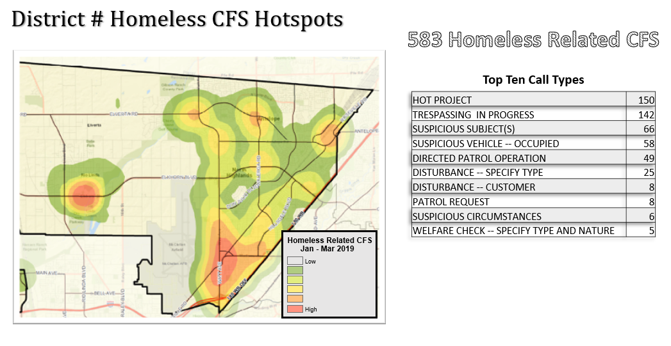

Purpose
The purpose of this project is to build python scripts to automate the required data and create maps to be used for the final product.

Build scripts to complete the following:

- Select calls for service, by attribute, for the homeless which is the study flag “TP”.
- Determine the number of homeless within each district.
- Count the Type of Calls for Service for each type.
- Put in descending order to determine the top ten calls for service
- Select only the top ten calls for service, create a chart and write to final product.
- Map the homeless calls for service location in each district
- Build a script to process a kernel density of the data, and write to final product.
- Build a script to automate the map creation for each district which includes a legend.

Description of Geoprocessing Tasks
MakeFeatureLayer_management – used prior to the SelectLayerByAttribute and the SelectLayerByLocation.
SelectLayerByAttribute – selected the “TP” attribute from the Study_Flag column, providing me with only data related to homeless calls for service.
Statistics_Analysis – counted the number of Call Types.
CopyRows_management – copies the selected data to an out file.
Query – used to perform a query on the Original Data Layer and the Sheriff Districts Layer.
KernelDensity – perform a kernel density on selected data, in this case the Original Data.
MakeRasterLayer – to make a layer from a .tif/raster file
ApplySymbologyFromLayer_management – applies the symbology from an already created layer to the newly created layer
ListLayers – lists the layers in the .mxd
ListLayoutElements - lists the elements from the layout page
Arcpy.SearchCursor – searche thru my district layers creating a collection of records to be used in the next step
Dataframe.extent – accessing only the extent of the district layer
Difficulties/issues and how I resolved them
SelectLayerByLocation and Query - My first difficulties were trying to decide which processes to use based on my end result. Knowing which processes to use and the order in which to process them will come with more practice.

At first I was torn between the SelectLayerByAttribute or a Search Cursor. I opted for the SelectLayerByAttribute because the following step that made sense is the SelectLayerByLocation.

At first, I wrote the code to include the Select by Layer Location. It didn’t work! So I chose the approach, as suggested by the professor, ensuring one process at a time worked. Select By Layer Attribute worked fine. The SelectByLayer didn’t work. At this point I created a working file where I would perform only the section of the script I was working on.
I still could not get SelectByLayer to work, then I decided to work backwards.
I tried the query on the sheriff district layer and I found the query on the layer wasn’t working. What did I do to resolve this, searched the internet, you tubed it, I was in search of friends who know python and I tried all kinds of ways to make it work.

Summarize – Since the SelectLayerByAttribute worked, the next step I needed to perform was a summary on the CallTypes. I ran thru the steps within ArcMAP. There wasn’t an obvious tool for this at first. In fact I thought there was no tool for this. I searched Code Academy, Stack, You Tube, then I remember try Model Builder. No luck there either. So I decided I could do a combo attribute and it may work. I had problems with the combo attribute. Again, I searched, reached out friends to see if any knew python. Part of my problem was what to call this function. In the end, I went back to the Analysis Toolbox and opened Summary Statistics. I had looked at this function previously, but then my instructor mentioned it so I took another look at it. After looking at it another time, I realized there was an area where you can put in the type of statistic. So I put in COUNT and it worked!
I used this in Model Builder, exported the script and it worked.

File Maintenance and Naming – Keeping files organized and named properly is very important. I had separate files for various sections and I had a file that worked. And on top of it, I had files on my work computer as well. To make it easier, I created the same file structure for both computers.

CopyRows_management: My issues with this was again naming and placing items in the right folders. In this case, the out_TP_attributes were not going to where I intended them to go. With help from my instructor, I was able to fix this, however, I cannot seem to figure out why my .tif file is NOT going to my data.

Delete_management and Processing Order – Some simple but very important coding that I forgot a few times was the delete_management. After a while, a few of these steps come a lot easier such as the GetCount, DeleteManagement and print statements.

