Poole_Summary
Due May 19, 2019

Automation of Quarterly Homeless Stats
Summary - Our goal is to automate from beginning to end the entire process of the Quarterly Homeless Stats. Specifically, create automation to retrieve data, process data, output data to a final product, and email product to recipients on a quarterly basis.
Automation will improve efficiency and accuracy of the following processes for homeless stats.
- Homeless Stats project is initiated automatically once a quarter
- Data retrieval of all raw data for the quarter
- Retrieving the attributes used to define the homeless
- Identifying the number of homeless in each district
- Creating a final product which consists of a map document for each district, a count of the homeless for each district, and the top ten homeless calls for service Refer to Figure 1.
- Upon completion, product is emailed to recipients
Figure 1
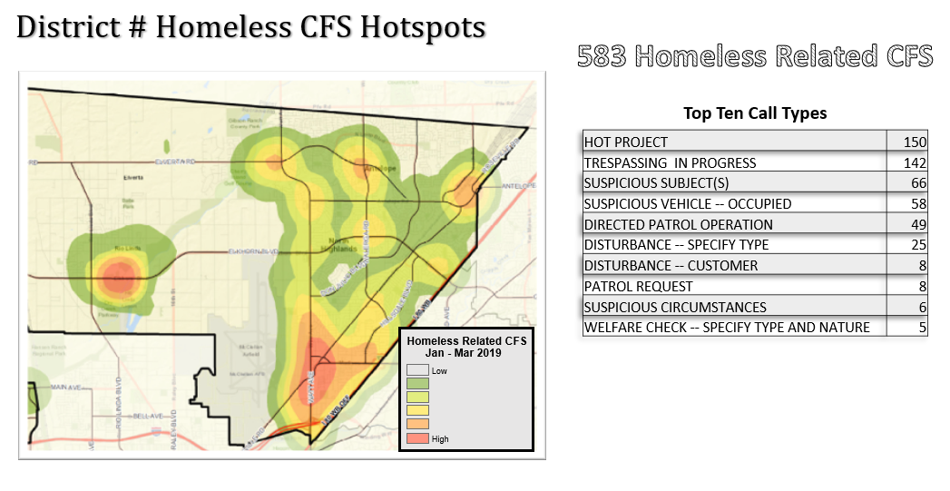Current Status – Phase one is complete! Please review Poole_ppt. for specifics. Second Phase – resolve all outstanding issues.

