Justin Murphy
Professor Jennings
GEOG 342
May 18, 2021

I grew up in Yuba City which is about fifty minutes north of Sacramento. When I was younger there was pretty much nothing but rice fields from Barry Road till you got to Richards Boulevard. This has obviously changed dramatically. Especially around the Sacramento Airport. My plan was to study the land changes around the area of the airport. I downloaded satellite images and compared the changes that have occurred by means of supervised classification in ArcGIS Pro.
The purpose of this project to is to classify the land changes that have occurred along I-5 around the vicinity of the Sacramento Airport. I can see these changes with my own eyes. A new distribution center is east of the airport along with other buildings contained in the Metro Air Park. North Lake, a master planned community which will include a man-made lake and about three thousand homes is in development. New construction of an overpass and roads are being done to accommodate the influx of new home owners. By taking Landsat 8 images I hope to show the changes in this region during an eight-year period from 2013 to 2021.

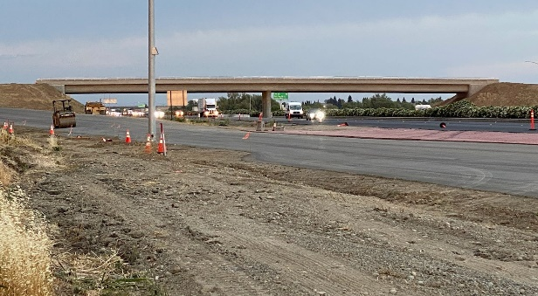

Using Earth Explorer, I searched for Landsat 8 images from 2013 and 2021. Using the map as my coordinates function, I looked for images without cloud cover and added them to my basket for downloading. Once the files were received, I used 7zip to extract the bands from the file.
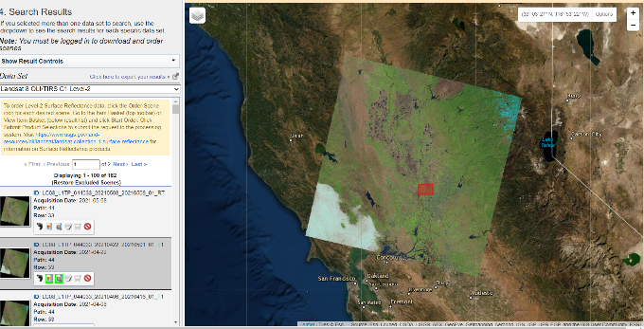
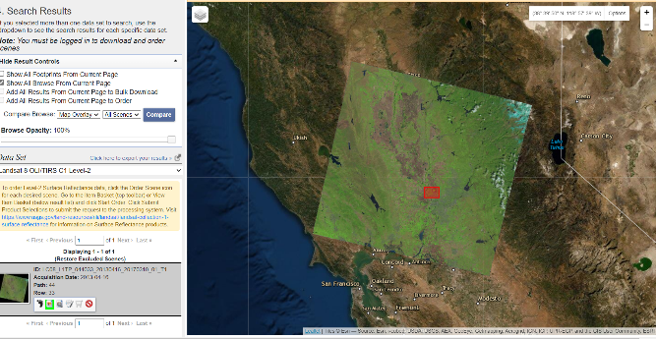
2013 2021

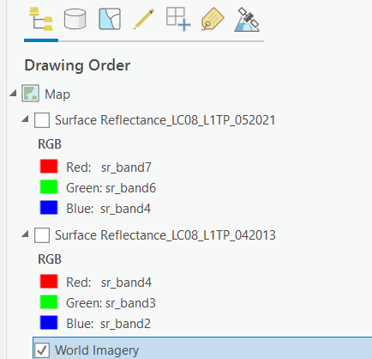
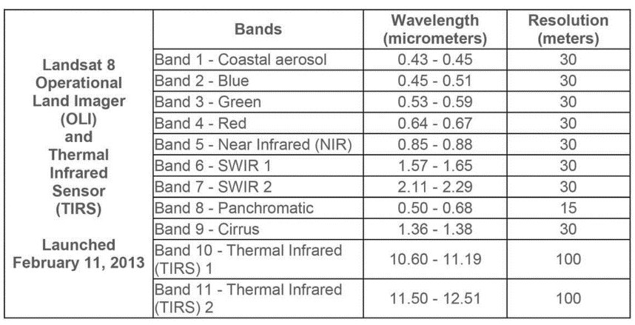
I added the files to my project in ArcGIS Pro. Using symbology, I changed the bands to give me the most favorable image. The 2013 image was very bright and looked good so I just used 4,3,2 for natural color. The 2021 image seemed very dark so I used different bands to get a better perspective. I chose bands 7,6,4, for shortwave infrared.

I created a polygon which I used to clip the raster image to the area of study. The polygon was created based on roads which existed as a natural border. I-5, Highway 99, and Elverta Road. The polygon was approximately ten square miles or 6,400 acres. I changed the base map on Pro to satellite imagery, and made the raster image more transparent to aid in the process.
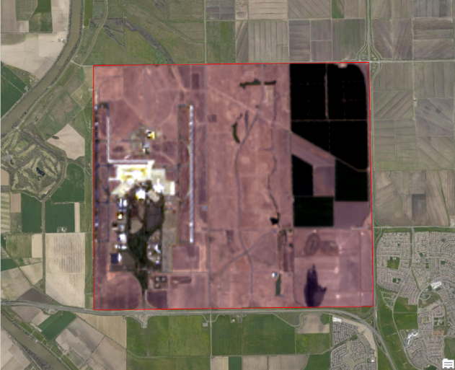
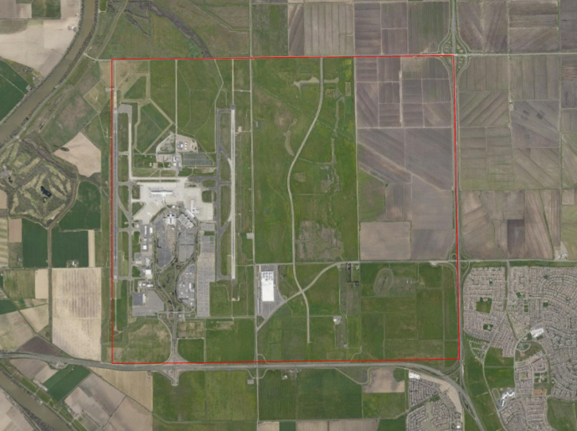
New Polygon Feature Class Clip Raster Image

Next, I used the segmentation image classification tool and the default settings for both dates.
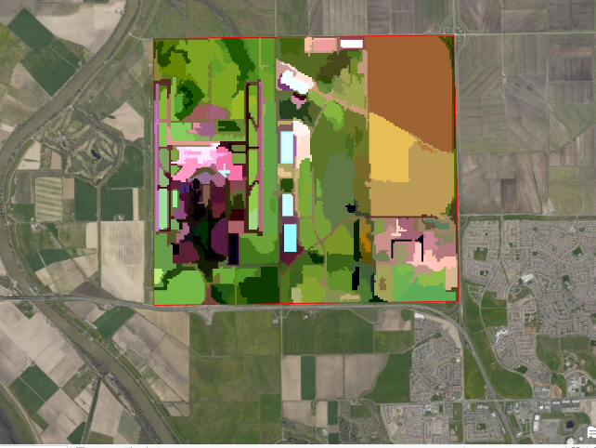
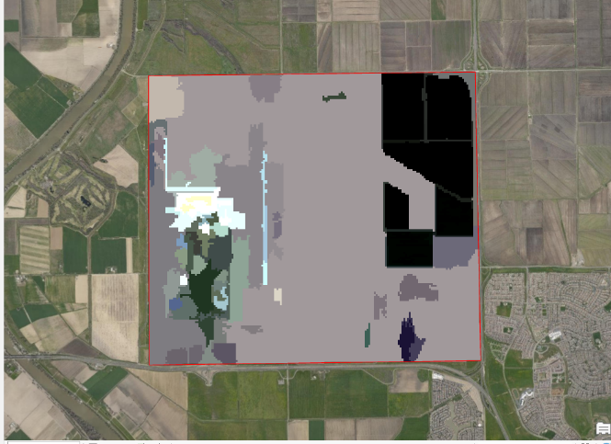
2013 2021

I was surprised by all the barren land in my 2013 segmentation image. I assumed it would be planted/cultivated. I was not sure what the definition for barren land was so I looked it up.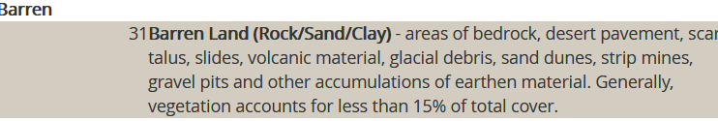
While the land might have been barren at the moment it normally is planted/cultivated. I thought the reclassification of barren land should be no problem since this if the whole point of the exercise. I will just change the classification during the next process step of using the classification wizard.
I used the NLCD 2011 schema but changed the classification to four class types.
- Water
- Developed
- Barren
- Planted/Cultivated
Based on visual observation and what my objective was I thought limiting the selections to four would make the process easier.
Using the training samples manager and the segment picker tool I selected polygons for every class. I thought I had classified every single polygon for the 2013 image that was available to ensure accuracy. However, once I ran the classification to get a preliminary image result was totally different than I thought it would be. I went back and reclassified four times until Pro decided that was enough and would not let me make any more changes. This seems to be some kind of bug in the software or possibly user incompetence. I accepted the results that was I given for 2013 and moved on to the 2021 image.
The 2021 image was better, but still not perfect. For this classification training I only selected up to 12 training polygons for each class and let Pro decide what was right. This was a better result in my opinion but still not correct. Since I only had four classes, merge was not needed.

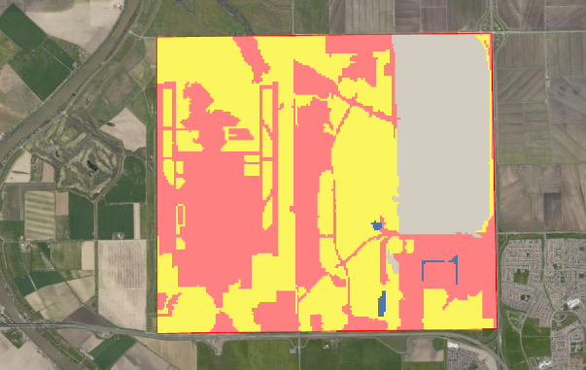
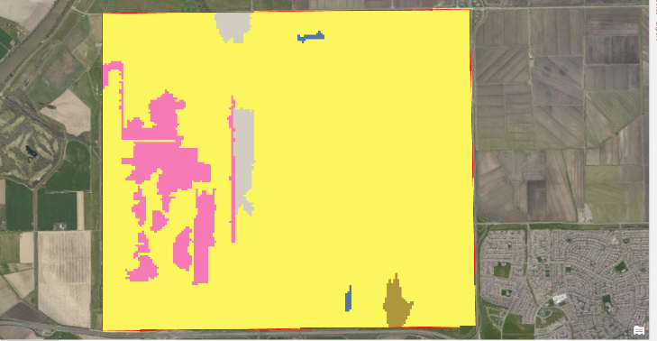
2013 2021

The reclassified image from 2021 is the most accurate of the two. The airport runways are distinct while in 2013 they just disappeared. The graded house pads for Northlake really didn’t show up as I hoped in the 2021 reclassified image, and somehow the buildings which were obvious in the segmentation disappeared and became one big developed area. For comparison I have added historical images of Google Earth images which compare the actual changes that happened during the eight-year period. I circled the most noticeable changes in the area.
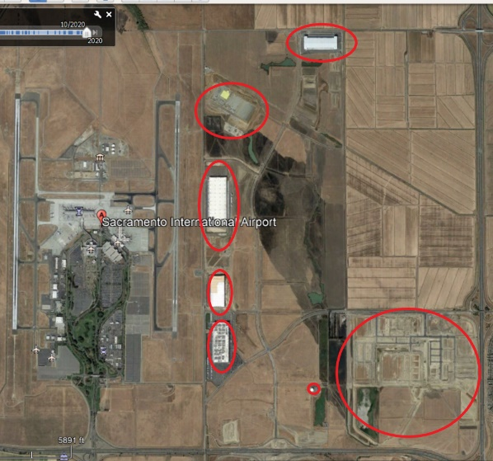
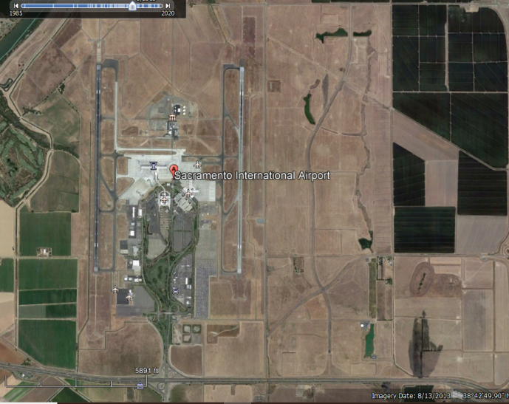
2013 2021

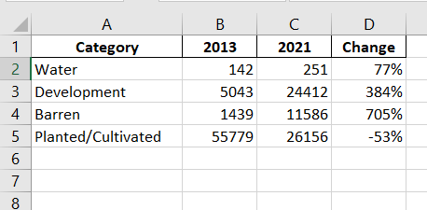
For numerical data from the ArcGIS Pro reclassified images, I used the Zonal Geometry as Table tool and calculated the changes of land usage in acres.

The numbers provided by the tool do support my supposition that farmland is being developed around the airport but most likely not in the amount indicated.
I experienced a few difficulties in performance of this project. Firstly, what I see as a changing landscape before me, is in the eyes of the satellite was seen as not so much. With the resolution provided from Landsat 8 the changes appeared to be minimal at best. The new buildings showed up well in segmentation but not so much in reclassification. The graded land for new home construction was classified as barren or planted/cultivated as it still just technically undeveloped land with no permanent structures yet. I could not differentiate the new overpass at all. In hindsight I would have chosen an image with a better resolution to assisting in my classification and also one that assured farmland was green with plants and not barren. An image taken during the time of the year when crops were growing would have been better overall.
I also had some issues with the software itself. I had a 99999 error which I had to figure out. That turned out be user error. Also, after the fourth reclassification of the 2013 image Pro would not let me make any more changes so I had to accept a substandard reclassified image for 2013.
I am certain that most of my issues stemmed form lack of experience, but would get better over time. The classification process was somewhat confusing especially with all the new additions it adds to the contents pane. Good labeling of the output is a must to avoid any confusion if you are unexperienced with the process. Familiarity with the area you are to classify is desirable if you are to accurately classify an image so I did go onsite to see for myself how it appeared. It did appear to be quote barren at this time and the canal on the left photo was not correctly classified as water I discovered.
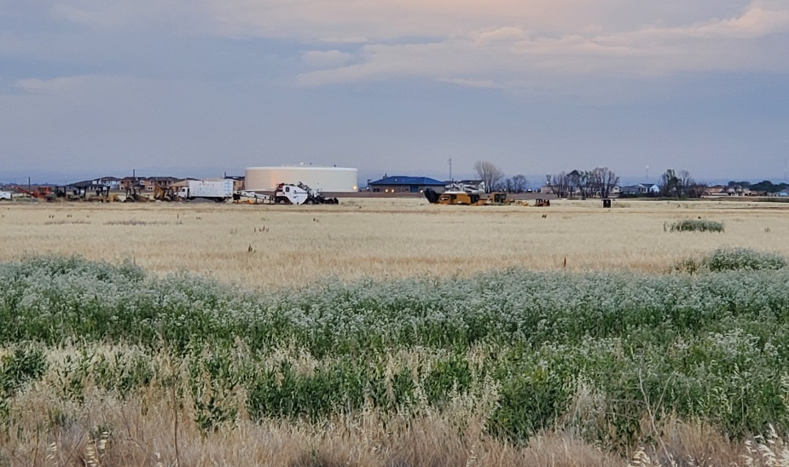
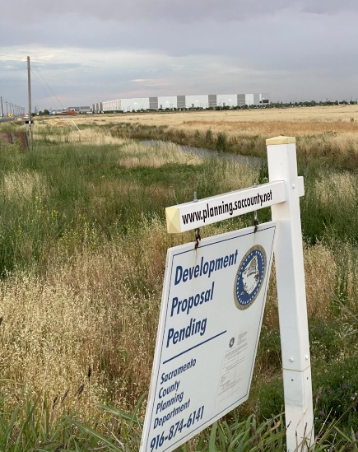
Canal & Building Water Storage & Construction Vehicles

Overall, the project did not go as I would have liked it to. I would have preferred to have shown a much more accurate change of the area than I did by the classification method. However, limitations in operator ability and maybe the image choice itself led to a less than desirable classification process. I feel with more experience I could become more proficient in supervised land classification and hope I have the opportunity to do so.

