2015 Rocky Fire Impact on Cache Creek Wilderness

The Rocky Fire burned nearly all of Cache Creek Wilderness in 2015. The goal of this project is to analyse the effect of the fire on the vegetation by comparing Normalized Difference Vegetation Indexes (NDVI) to pre fire levels. Landsat 8 imagery was used to produce the NDVIs which were then remapped into 3 vegetation categories. Using Zonal Statistics as table we can get pixel counts and area so we can compare not only visual changes to the Remapped NDVI maps but statistical changes after the fire.

This project’s purpose is to analyse the effects of the Rocky Fire in 2015 and see how the vegetation in the Cache Creek Wilderness is recovering.

First, clear Landsat 8 images needed to be selected for years 2015, 2017, and 2020. With the images for each year falling sometime in the month of July for seasonal consistency across the different years. 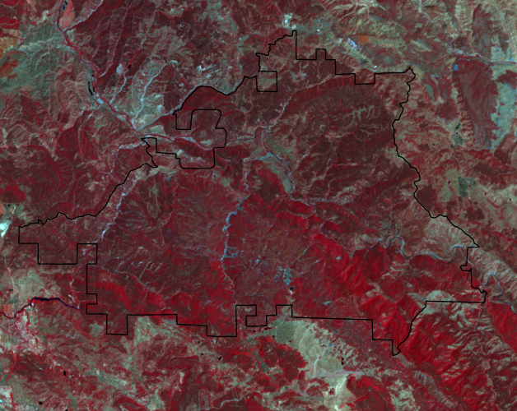
Then each image is clipped down to the Cache Creek Wilderness boarders.
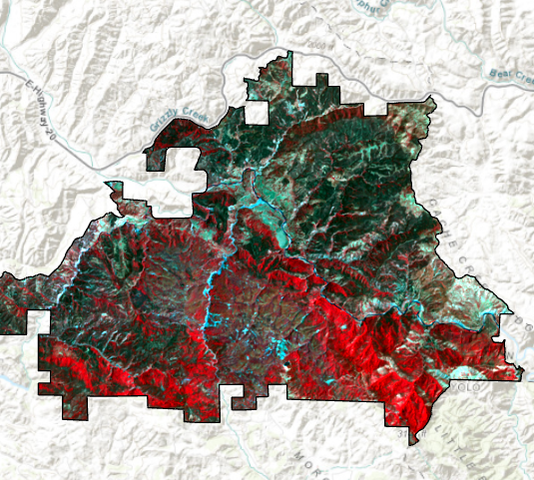
From here the NDVI raster function is run and outputs for each year are produced.
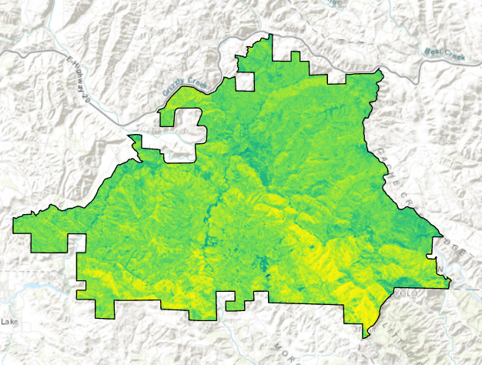
Now each NDVI is remapped into 3 categories of vegetation. Barren / Low category is for NDVI values under 0.2, Sparse category has 0.2 to 0.6 values, and Dense category has values above 0.6.
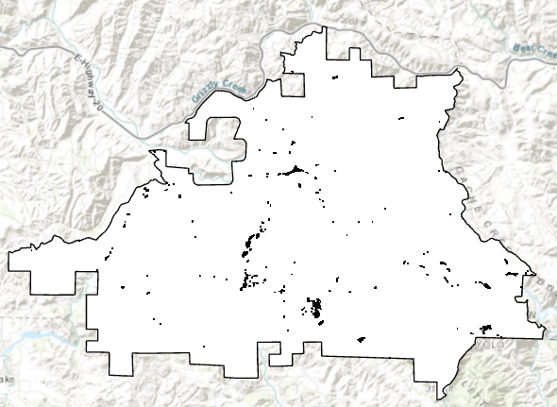
After this the remapped NDVI is exported to fix some data type and pixel issues. Then the symbology is changed to better display our three categories of vegetation. 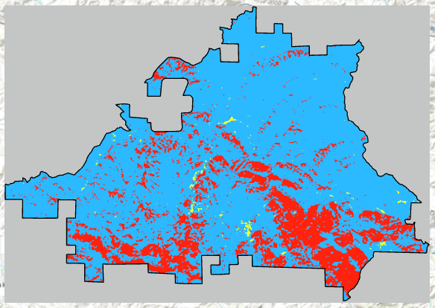
Barren / Low = Yellow
Sparse = Blue
Dense = Red
Now we are ready to run Zonal Statistics as a table which gives us pixel count and area for each category.
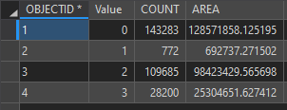
Square meters are converted to acres and percent change is calculated.

Category | 2015Acres | 2017Acres | 2017%changefrom2015 | 2020Acres | 2020%changefrom2017
Barren/Low | 171.17 | 359.87 | +71 | 240.36 | -40
Sparse | 24320.95 | 27591.32 | +12 | 27506.39 | -0.3
Dense | 6252.91 | 2793.85 | -76.5 | 2998.29 | +7

Foolishly I did not begin with clipping down the rasters to Cache Creek Wilderness, instead I was trying to do the clip after the NDVI was produced. This led to delays as I tried to figure out why I was not producing accurate NDVIs. The problem was a small amount of cloud cover on the eastern side of my Landsat image which I did not notice because I was tunnel visioning on the Cache Creek Wilderness Area. Once I clipped them down before the NDVI production everything went much smoother.

Normalized Difference Vegetation Index can be defined as NIR - RED / NIR + RED. Using this formula, the density of vegetation at a given point in the image is equal to the difference between the intensity of the reflected light in the infrared and red range is divided by the sum of the intensities. The index generally produces values from -1.0 to 1.0, higher values meaning more and healthy vegetation and lower values meaning less or no vegetation. Cache Creek Wilderness has little to no development so almost all the values are from natural processes (no farming which can give high values, no human development which can give low values).

The main impacts on vegetation from the fire where on the Barren / Low category and the Dense category with the former increasing sharply and the latter decreasing dramatically. This is to be expected after a large fire, but I was expecting to see more change in the Sparse category.

