Jon Koenig
GEO 93
5/23/19
Final Project
Finding Viable Sites for Vernal Pools in Roseville
A) Summary
Vernal pools are a form of temporary wetlands that form during heavy rains in the winter, support large amounts of animal and plant life over the spring and then dry up and lie dormant through the summer. These habitats have been in heavy decline due to agricultural and urban development, along with modifications to the hydrology of surrounding areas. While preserving the existing habitats is important, another spet that can be taken is by creating new vernal pools in viable areas.

B) Purpose
The purpose of this project will be to find parcel located within the city of Roseville that could serve as sites for the creation of new vernal pool habitats. This will be accomplished by using parcel data along with environmental data such streams, existing vernal pools and elevation contours. The environmental data will be buffered and merged and he erase function can be used to find whatever locations are outside of the buffers. After that a spatial join can be used to combine the erase layer and the parcel layer to find only parcels that are viable. Then an attribute query will be performed to filter out parcel types that would not make good sites, such as industrial areas or single residencies. This will show only the most viable sites for the creation of vernal pools.

C) Development Process

Step 1) data retrieval
- Data retrieved from Placer County open data portal
- http://gis-placercounty.opendata.arcgis.com/
- Data Includes:
- Parcels
- Placer County boundary
- City limits
- Vernal pools
- Streams
- 20ft elevation contours
Unused data was also retrieved, including:
- California geology map from USGS
- https://mrdata.usgs.gov/geology/state/
- Soil Survey for California
- https://gdg.sc.egov.usda.gov/GDGOrder.aspx?order=QuickState
- Sacramento County boundary from SACOG
- http://data.sacog.org/search?tags=boundary
Step 2) Clipping
- Retrieved data then began clipping to within county boundaries.
- At this point the intent was to perform an analysis on Sacramento and Placer counties.
- Also performed attribute query on streams layer to remove any seasonal streams.

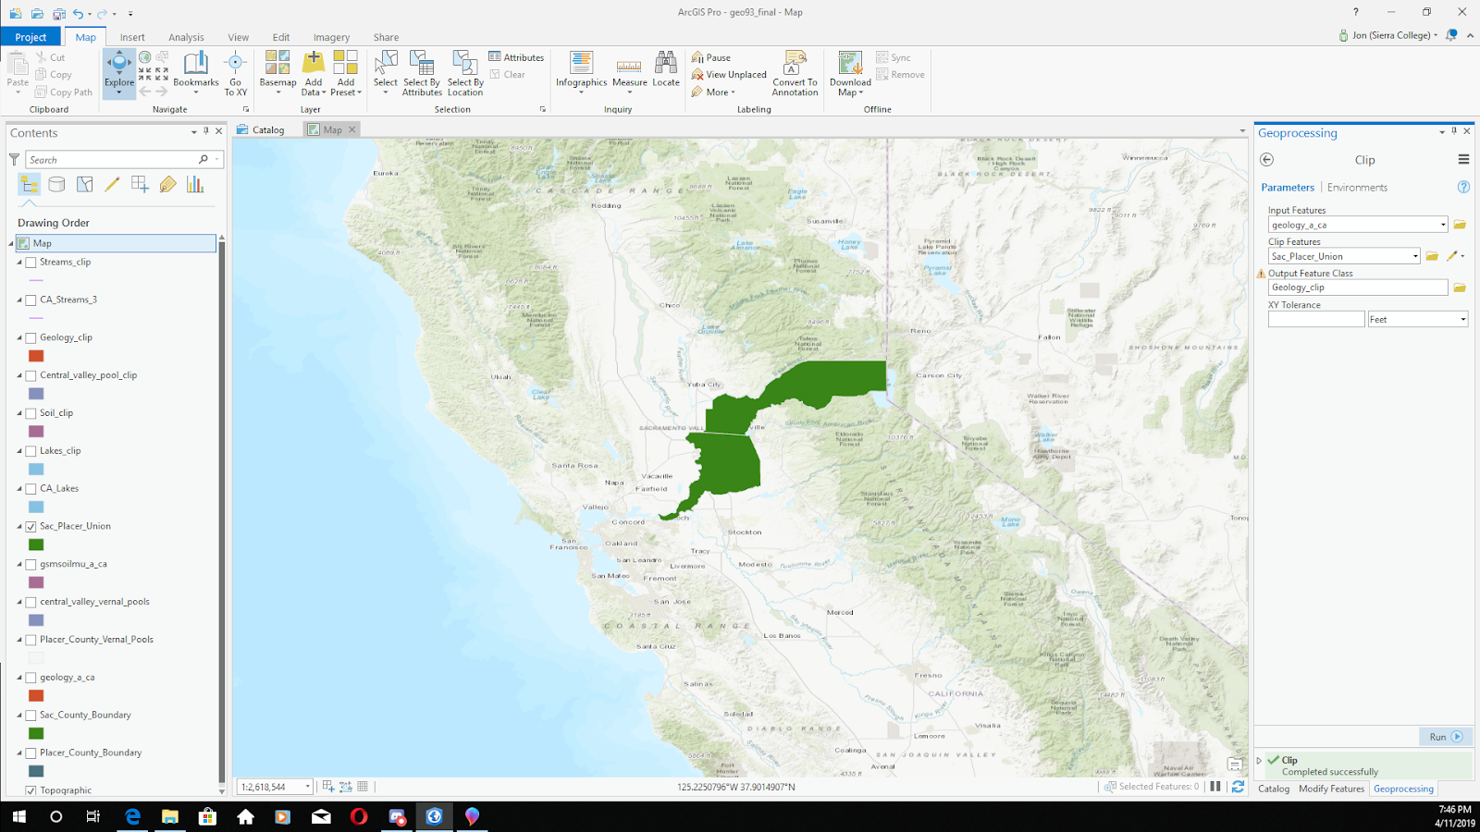

Step3) Buffers
- Created 1000ft buffers for vernal pools, streams and contours.
- This was done to ensure vernal pool sites would be in a flat area away from streams.
- Creating buffer on the contour layer very time consuming.
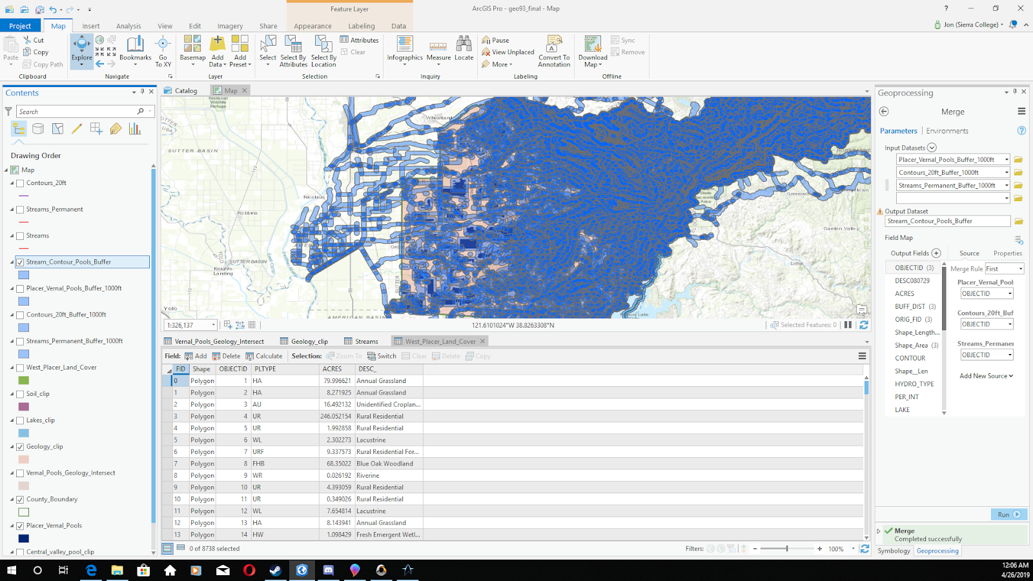
Step 4) Merges and Dissolve
- Merged the various buffers into single layer, then performed a dissolve.
- At this point in the project the focused had shifted to only Placer county.

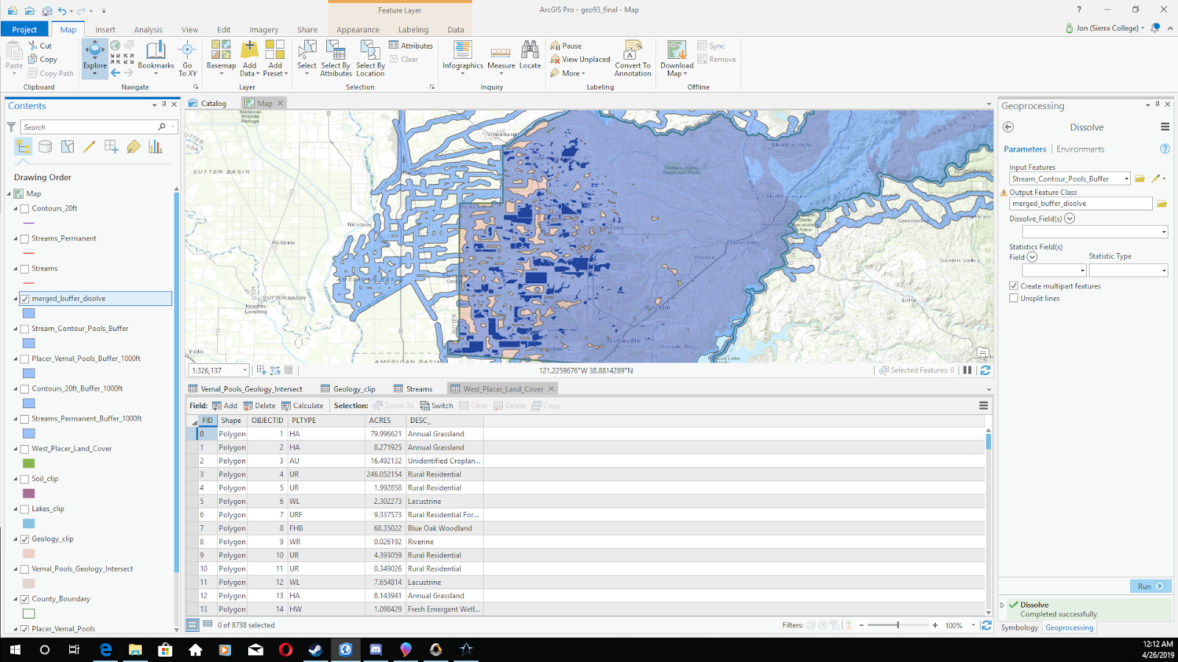
Step 5) Using Erase tool
- Used the erase tool to find any pieces of land outside of the dissolve layer.
- Reveal the areas best suited for vernal pool habitats.
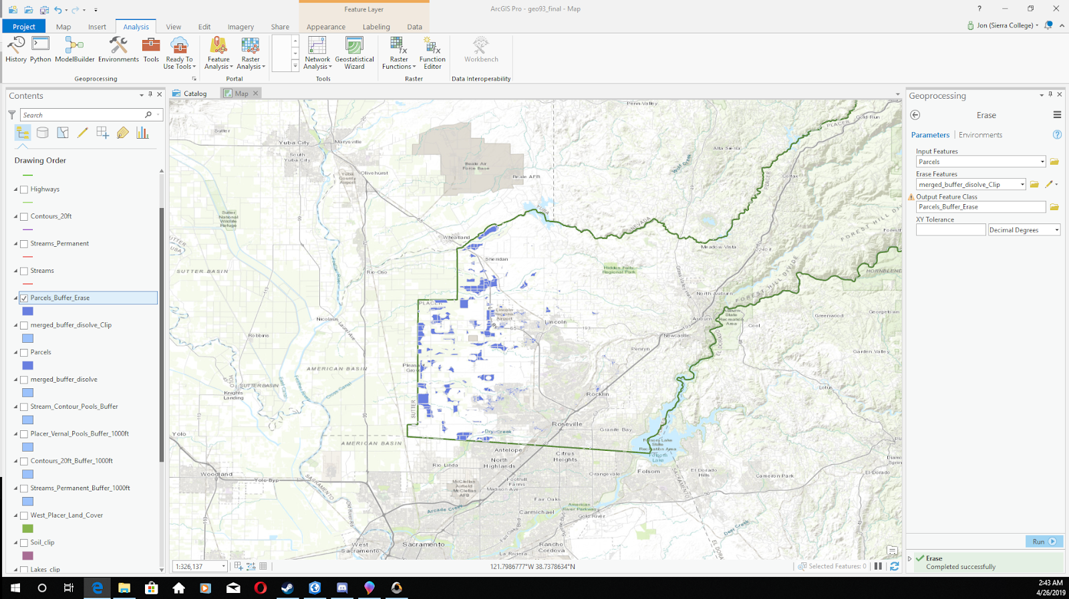
Step 5) Spatial Joins
- It is at this point that the project was shifted to focus on only Roseville.
- Spatial join performed on the erase layer and the parcel layer.
- Join created a list of parcel which contained the data found by the erase tool.
- Manual deletion of parcels mostly outside of Roseville.
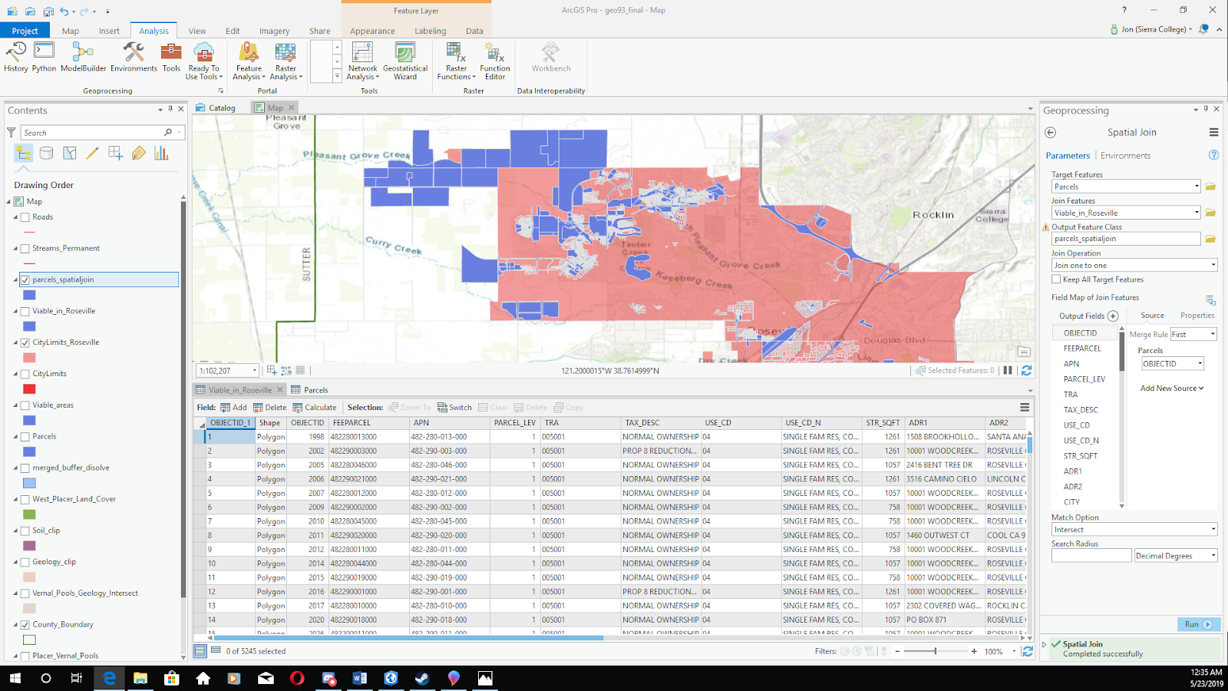
Step 6) Attribute Queries
- Performed an additional attribute query to select parcels based on zoning.
- Then performed a series of queries to sort parcel by number of acres.
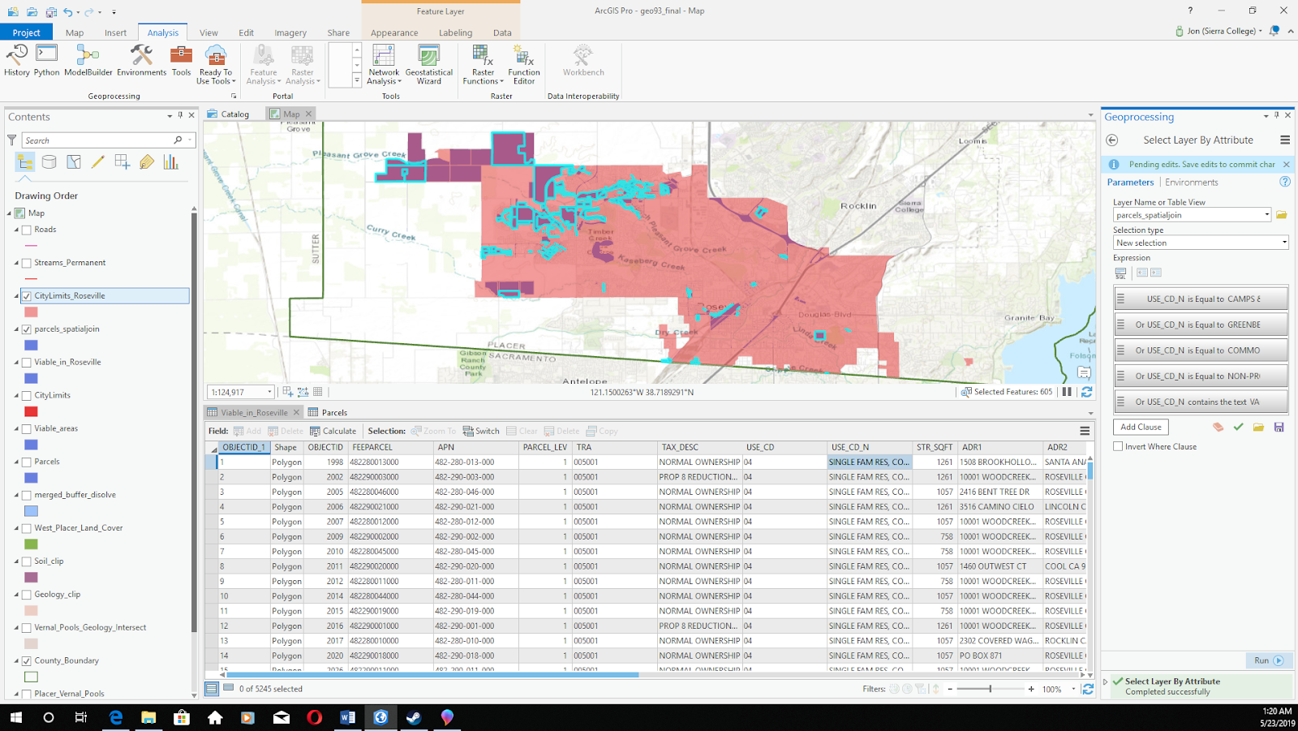

Step 7) Symbology and Layout
- Created two separate map layouts for the acre and zoning map.
- Used unique value symbology on the zoning map.
- Adjusted colors for the zoning and acre map.
- Inserted legend, scale bar and north arrow into both maps.
Final map 1) Parcels by Size
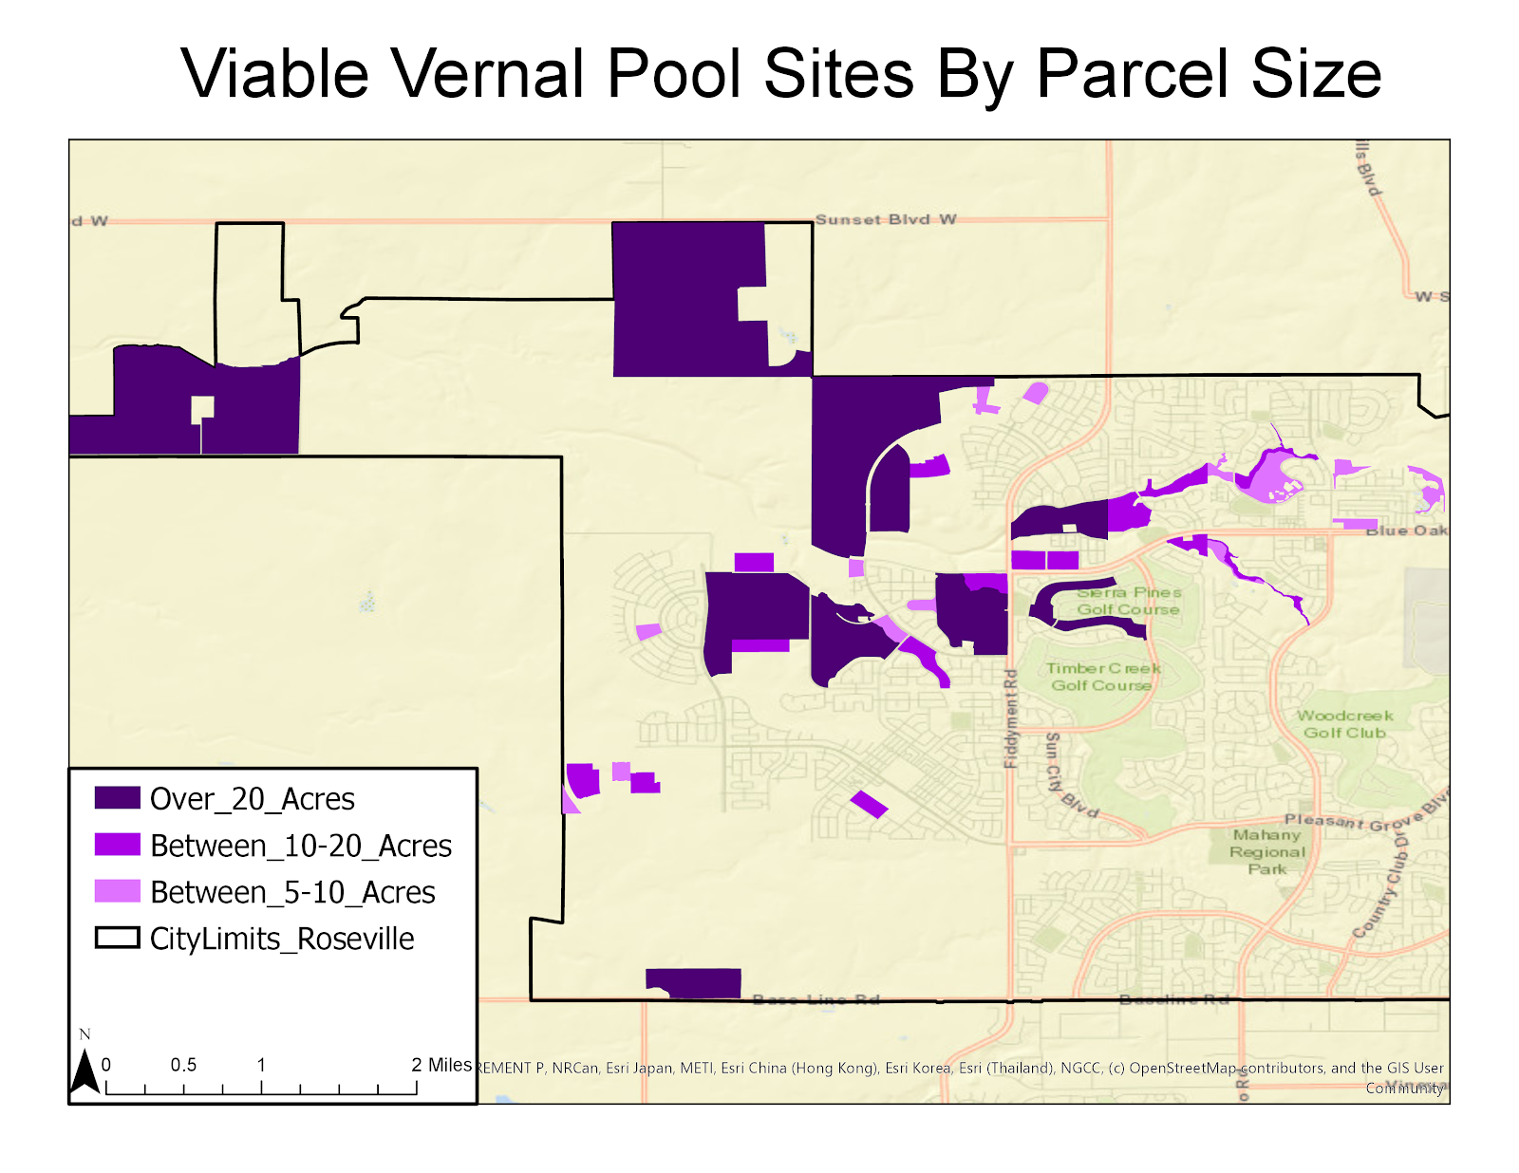

Final map 2) Parcels by Zoning
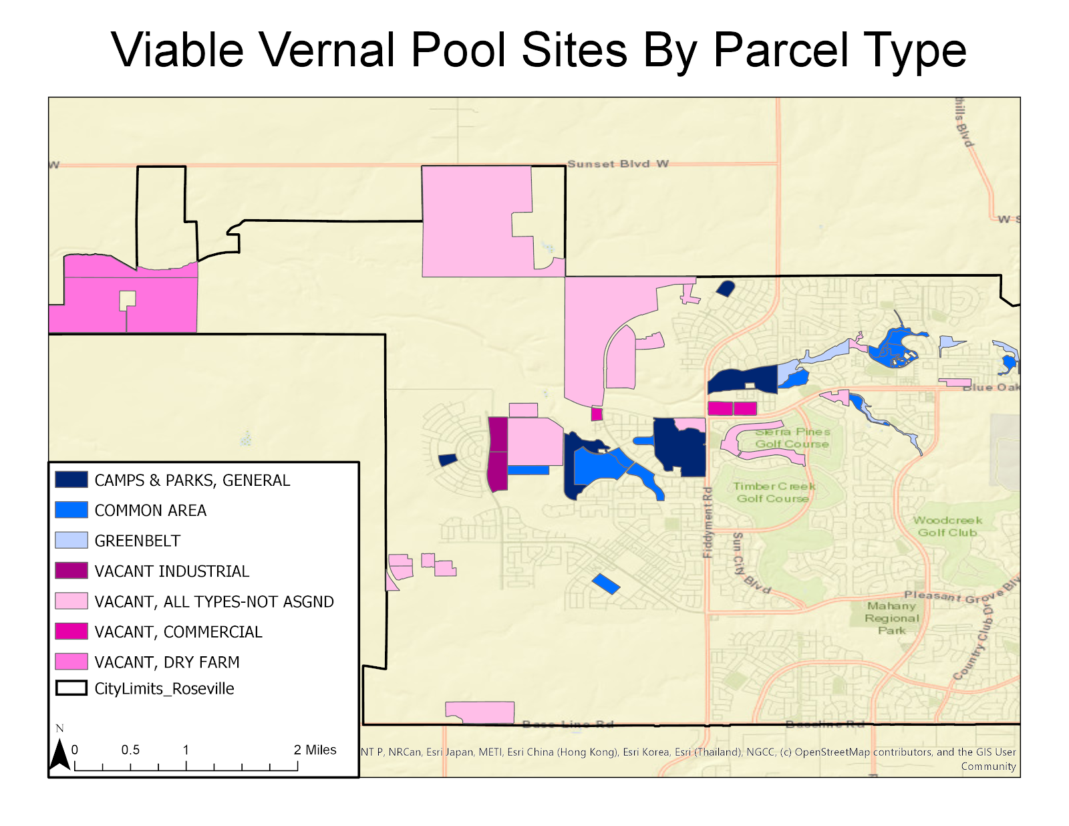

Challenges
My biggest challenge in the project was having too large of a focus early on. My initial plan was to perform site analysis for all of Placer and Sacramento counties, however I realized after my initial clips that this would not be a viable plan as ensuring all the data was consistent across both counties proved difficult and that creating clear and easy to read map would be difficult over such a large area. My plan to only use Placer county also proved difficult and so I decided to reduce my scope even further to only Roseville. Another difficulty I encountered in planning my project was to have multiple maps highlighting various physical aspects of Placer county. For example I was in the process of clipping and joining vernal pool data with geologic and soil survey data. I ended up scrapping this part of the project as the data they provided was not particularly useful or interesting as Placer county was largely uniform in both it’s geology and soils. While these tangents took time away from the main project, they were a useful learning experience and helped my become more familiar with ArcPro.

