Tyler Harris
Geog342
Final Project

Project Summary

Using California NAIP CIR imagery, my project will focus on a Land Cover Classification output for Carmichael Park. This data was fairly easy to obtain and I think, in light of the circumstances I’ve faced, the project should go fairly smoothly. I should have no trouble performing the Classification and giving a solid Accuracy Assessment.

Project Purpose

To utilize the skills covered in class to create a Land Cover Classification output from acquired data. I chose the location as it is a familiar area and a park I enjoy visiting. I’m interested in discerning the land cover types in the area of and around the park.

Methods

To begin the project I first needed to recover some imagery of the site in question. I utilized the search function within the Catalog view in ArcGIS Pro and was able to search for and find NAIP 2020 CIR (Color/Infrared) for California. After finding the Imagery Layer, I was able to Export the raster via the ‘Export Raster’ process from the Contents pane. I set the Clipping Geometry to the Current Display Extent, containing the area of Carmichael Park, and ran the tool. The output generated was a satisfactory representation of the park for my Land Cover Classification idea.

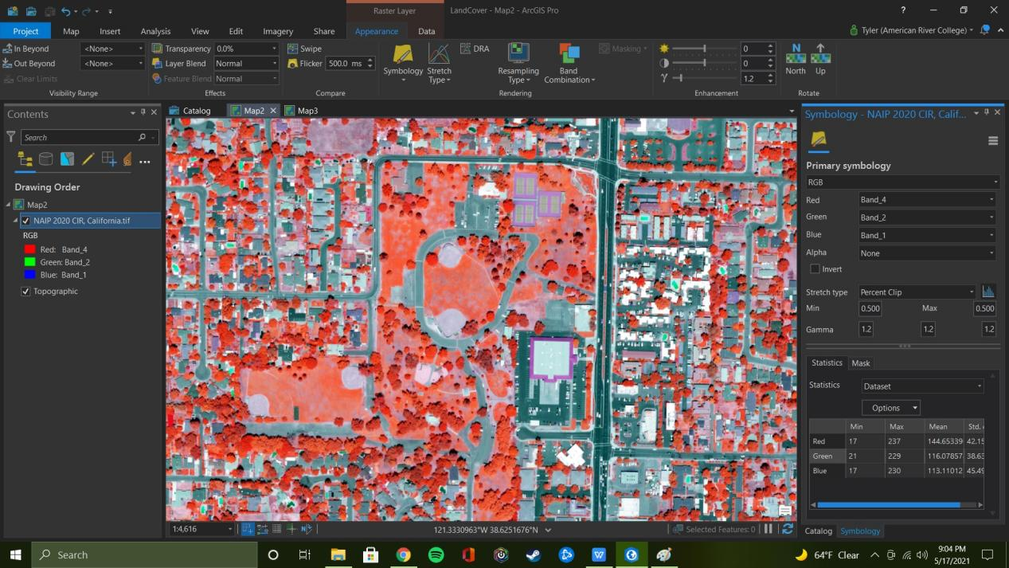

Being satisfied with my first output image, I changed the image bands (Red: Band 4, Green: Band 2, Blue: Band 1) and began the process of Image Segmentation. This was my first hurdle. I ran into ERROR: 001921 Unsupported Format. A quick search showed me that all I had to do was to add the .tif file extension to the end of the Output Dataset file path.

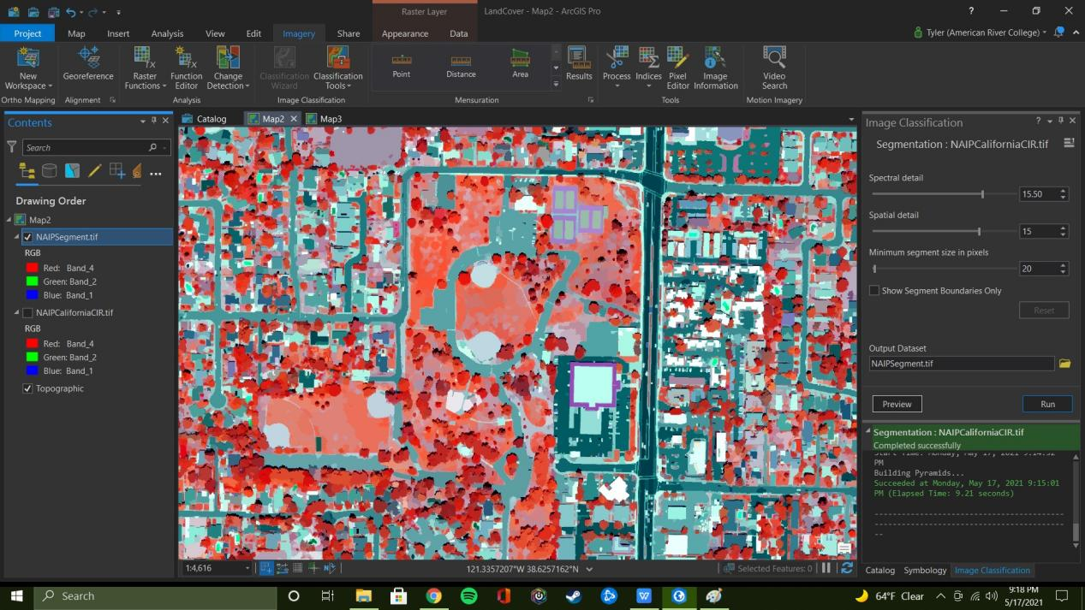

Having my Segmented Image, I then began making my Training Sets. The area is fairly sparse where actual vegetation is concerned but a good number of selections were made based on the imagery.

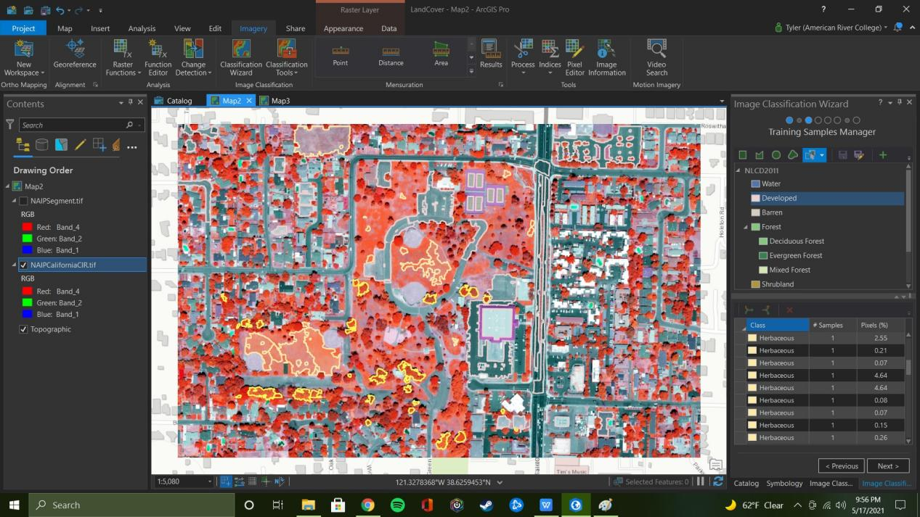

After designating Training Sets, the tool was run. The first preview output is as follows.

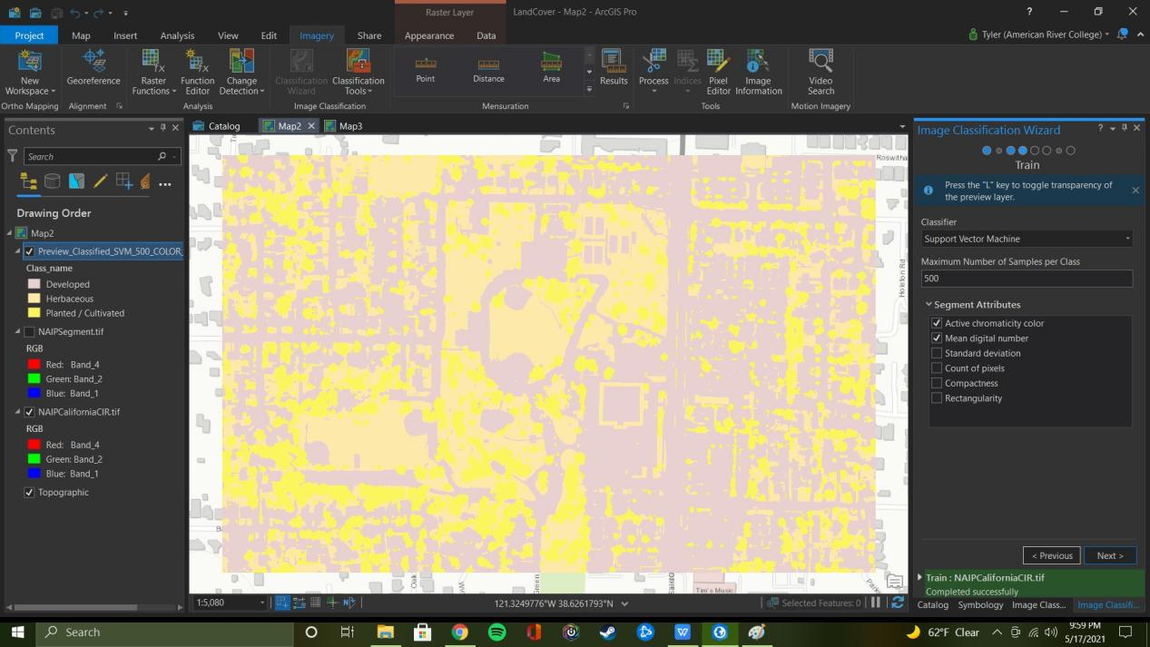

To add contrast, the Symbology was changed.

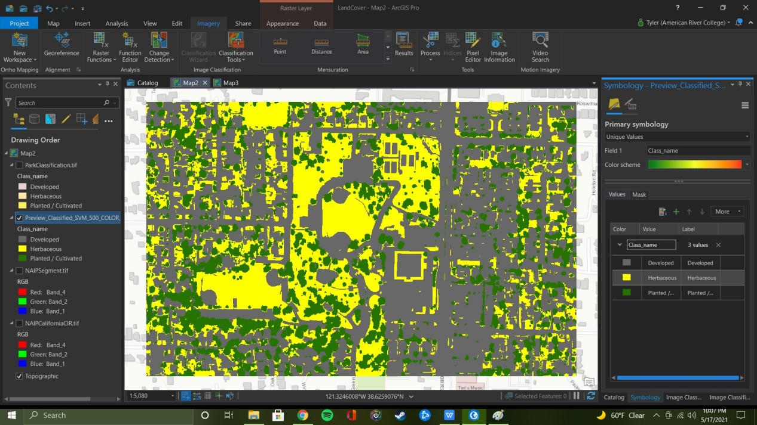

As can be seen, there are some areas that were misclassified as Herbaceous when they are clearly developed plots of land. Namely, the giant yellow square…

So manual Training Sets were added and the image classification was re-run.

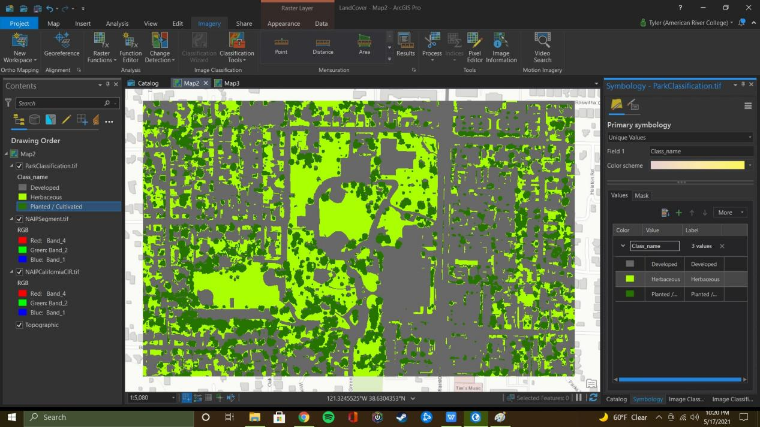

This image shows a much better representation of the area.

The Classification Wizard was run to completion and the final output Land Cover Classification Image was produced.
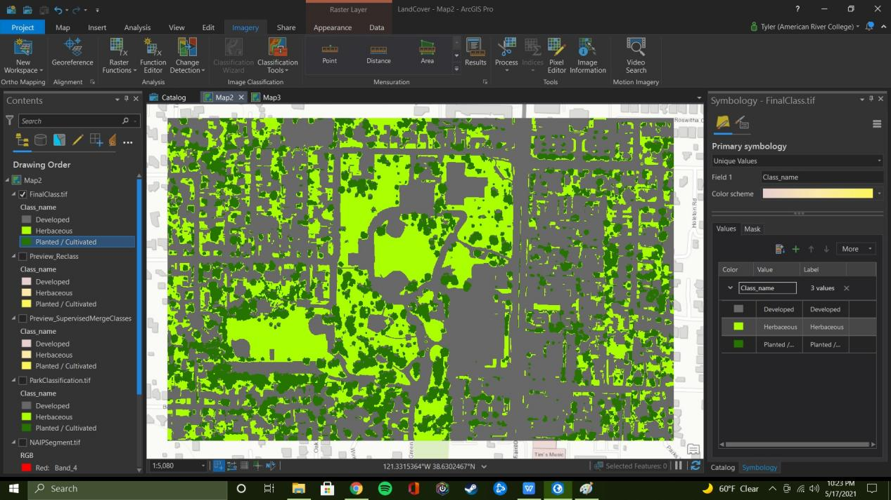

The final output is satisfactory for my purposes. Symbology shows good contrast and land cover accordingly.

Next I conducted the Accuracy Assessment process. This was straightforward and caused no issues. Below is a sample of the Training Sets.

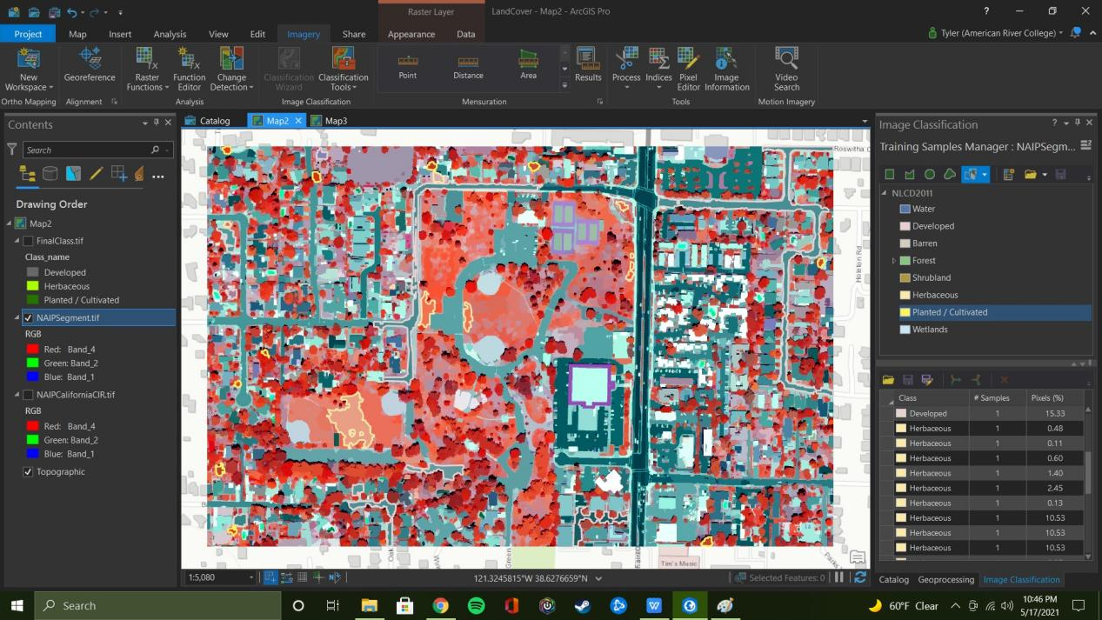

After going through all the requisite steps, unfortunately, I was greeted with the following error code:

ERROR 001791: Classified raster must have 1 band and no more than 16 bpp.
Failed to execute (CreateAccuracyAssessmentPoints).
Failed at Monday, May 17, 2021 10:52:52 PM (Elapsed Time: 0.20 seconds)

After adjusting the Training Samples and verifying the Classification Schema, my final Accuracy Assessment is as follows:

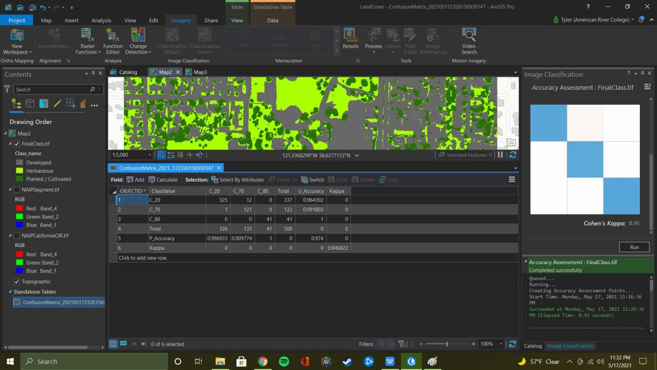

As an add on challenge, I created the Zonal Statistics Table from the final output .tif file.

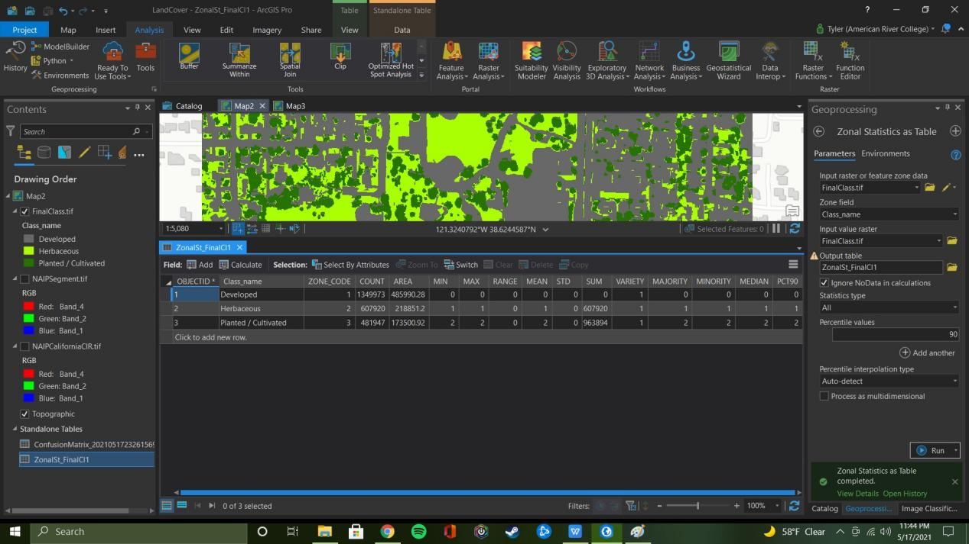

Challenges And Conclusion

All in all this project (aside from my loss of previous effort and machine) was good exercise and ended up being very satisfying. The few challenges I ran into were pretty easily overcome with the help of ArcGIS Help and some Google. Given the time constraints and work put in, I feel like I accomplished what I set out to. Thank you, Professor. For your time, advice, and understanding.

