COVID-19 Testing Locations in California Map Series

Project Summary

This project produces a series of maps highlighting the locations of COVID-19 testing sites throughout California. During the period in which this project was developed—April to May 2020—the first testing sites available to the public began opening, and hundreds became operational soon after. As of May 17, 2020, a total of 755 operating testing sites have been documented in California. The number of operating testing sites has doubled since the beginning of May. Information pertaining to the location, status, operating hours, and contact information for each testing site is maintained by GISCorps. The python script in this project draws from the data published by GISCorps and displays the testing locations that are within and around each 3-digit zip code area in California. Each map in the series utilizes the same layout template and zooms into a 3-digit zip code area.

Purpose

The purpose of this project is to provide California citizens with a series of useful maps. A user could access a published PDF map for a chosen 3-digit zip code area and use the map to identify nearby COVID-19 testing sites. Because California is one of the largest states by area, producing a map one at a time for each subarea would be very time-consuming. Doing so would also risk inconsistencies in symbology and labeling. Using this script allows for any desired number of maps to be produced using a single layout as a template. As a result, this project saves time while ensuring consistency between each map in the series. It also minimizes potential errors in manually typing in the title for each map subarea. This script would ideally be run on a regular interval, as new testing sites may open or close on any given day.

Description

This map incorporates testing site location data published by GISCorps. After downloading their dataset, an ArcGIS Pro project was created to serve as a template for all maps in the series. The ArcGIS Pro project was populated with the testing sites layer, as well as major roads, counties, water features, 3-digit zip codes, states, and countries serving as background information. The added layers were symbolized and labeled as desired. For the testing sites layer, only the operational class of locations was symbolized since the script uses a definition query to only show operational sites.
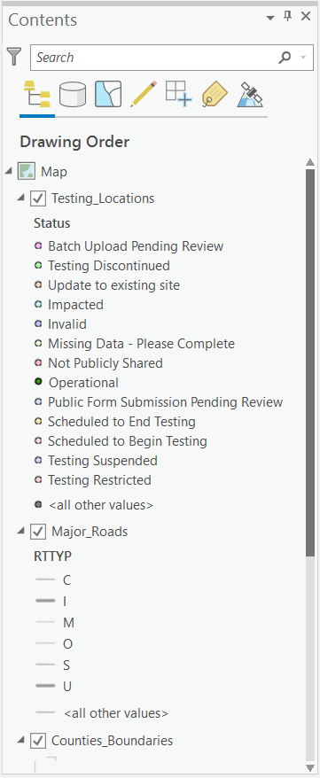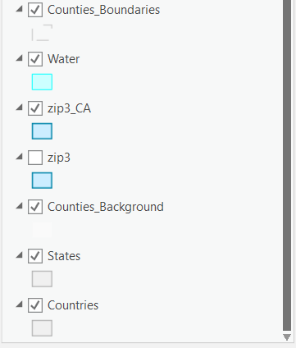
Layers in the table of contents symbolized for map production

Next, an 11”x17” layout was created with a map frame. Map elements including a title, zip code area subtitle, publishing date, author, note, north arrow, and scale bar were added. Some of these map elements are referenced and modified in the script.
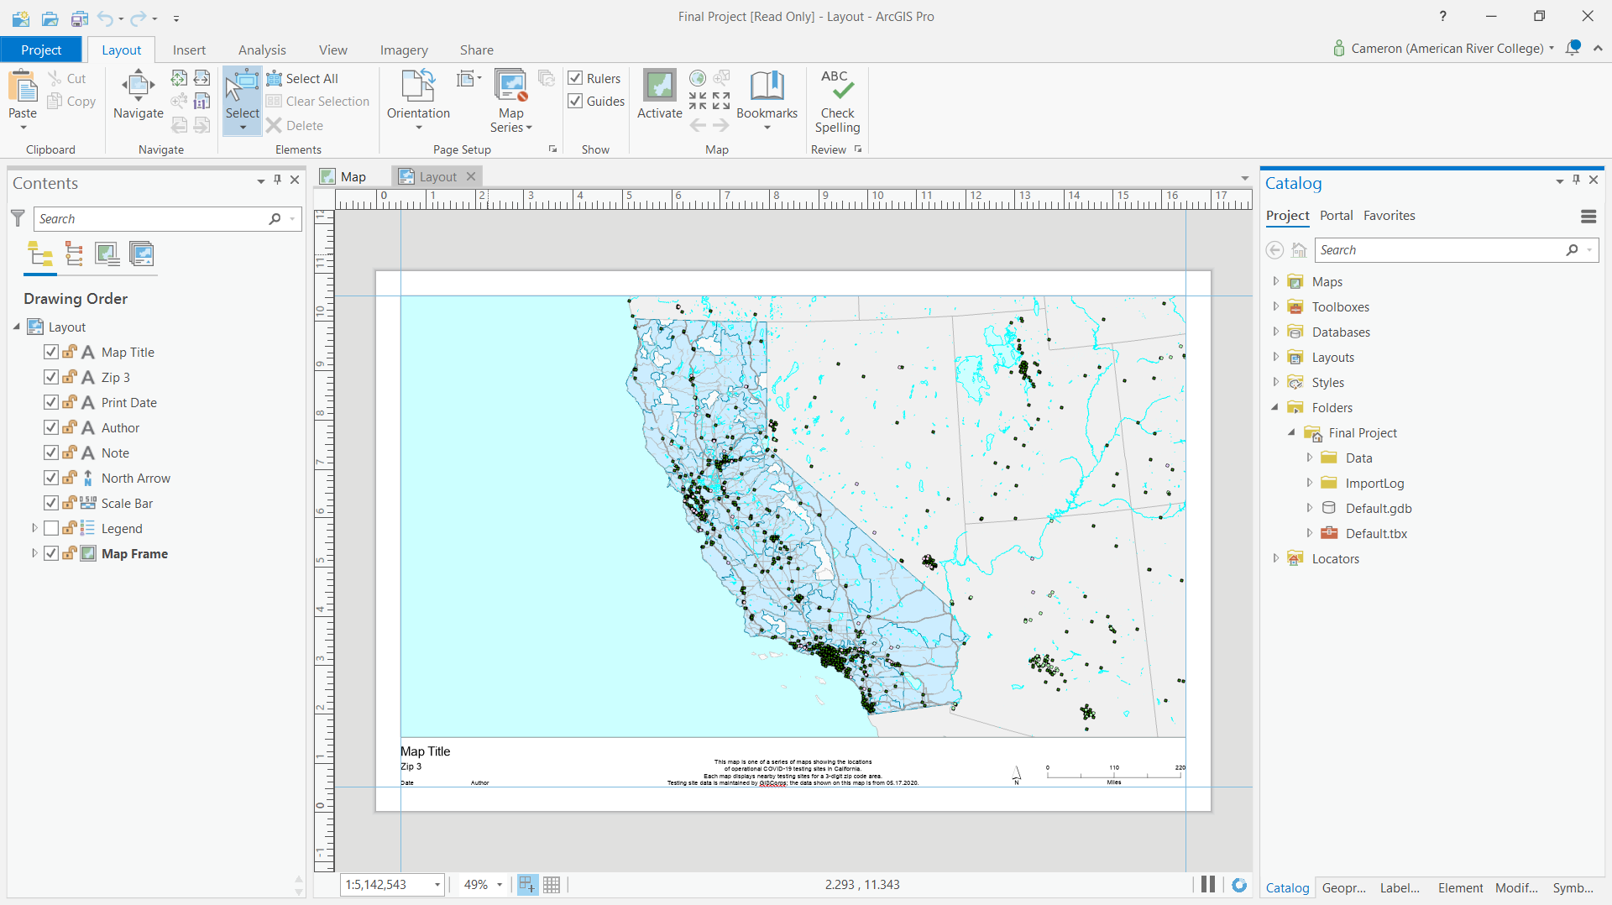
Layout template with added map elements

Once the map and map layout were set up in the ArcGIS Pro project, a python script was developed which references the project file. The first sections of the script also reference a data folder since the Copy Features tool is used later on. A separate folder for exporting the PDF maps is defined as well.
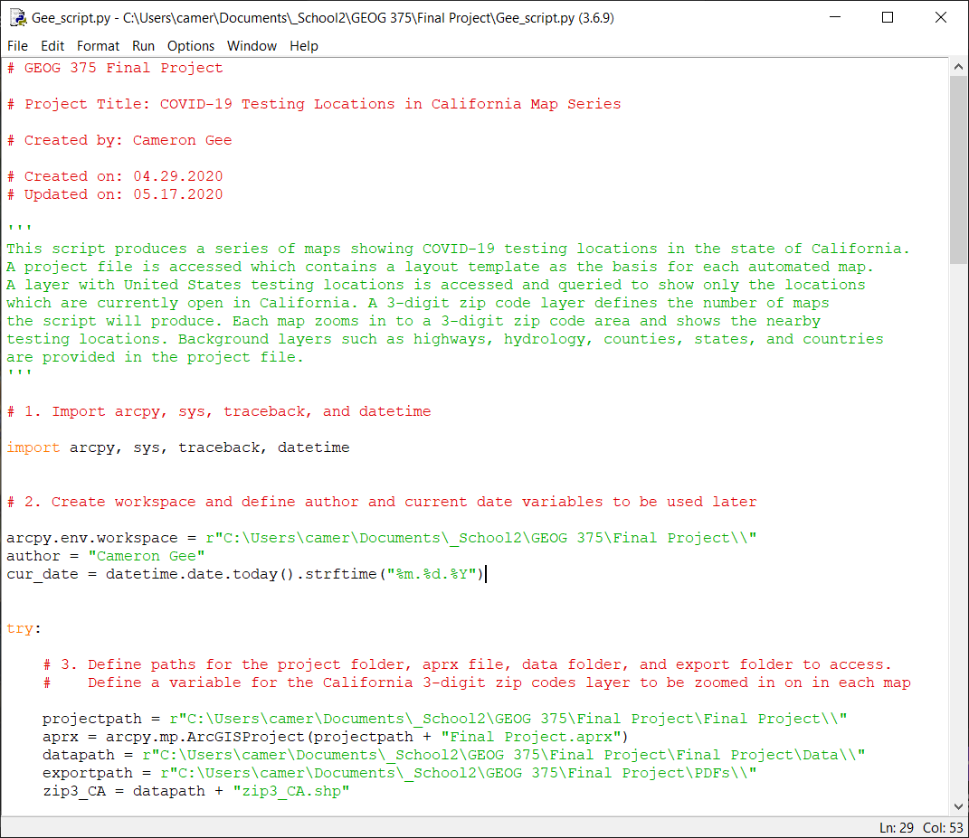
Importing modules and establishing path variables
The script then accesses the map, layout, and map frame within the ArcGIS Pro project. It accesses the layers in the table of contents and iterates through the layers until it reaches the testing locations layer. Because the testing locations layer includes data for the entire United States, the script performs the Select Layer by Attributes tool to select only the testing locations in California, as well as the testing locations which are operational. Including this tool in the script minimizes the effort in updating the location data; the only operation after replacing the testing locations layer is importing the old layer’s symbology. The script uses the two selection queries to perform a definition query, hiding the testing locations that are both outside of California and currently closed. The testing locations layer’s labels are turned on to show the name of each testing site.
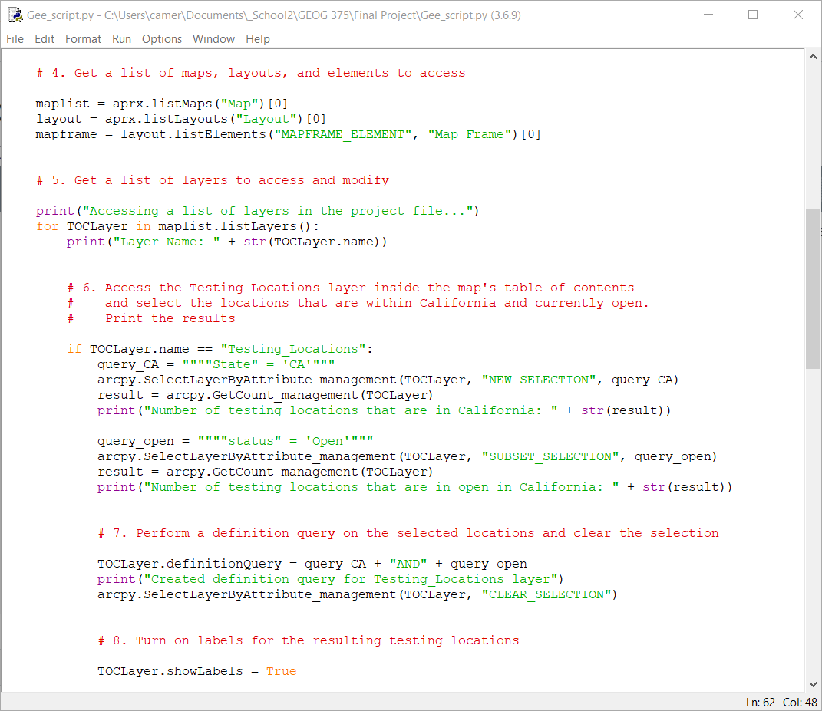
Accessing the maps, layouts, elements, and layers in the project and performing the Select Layer by Attributes tool to establish a definition query

Once the script reaches the 3-digit zip codes layer in the table of contents, it performs another Select Layer by Attributes tool to select only the 3-digit zip codes in California. It prints the number of 3-digit zip codes in the state, which determines the number of maps to be produced. The selected features are copied to a new shapefile, which is then defined as the layer that will participate in the following search cursor.
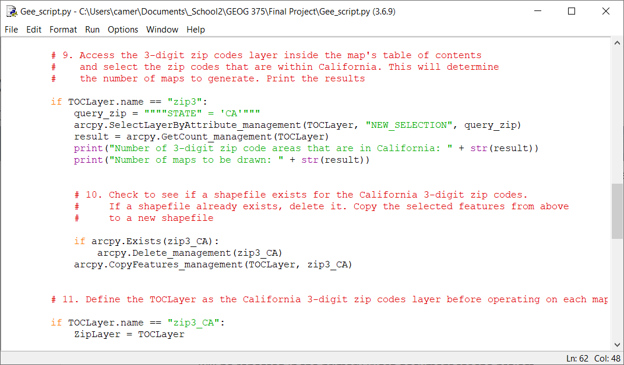
Performing a Select Layer by Attributes tool on the 3-digit zip codes layer and copying the selection to a new shapefile to be referenced later

The search cursor accesses a list of the resulting California 3-digit zip codes. A for loop iterates through the list, generating a unique map for each zip code row. For each zip code row, the script sets the map frame extent and titles the map with that zip code. The script modifies other basic map elements before exporting the layout as a PDF. Once the script runs this process through all the zip code rows in the list, the script is complete.
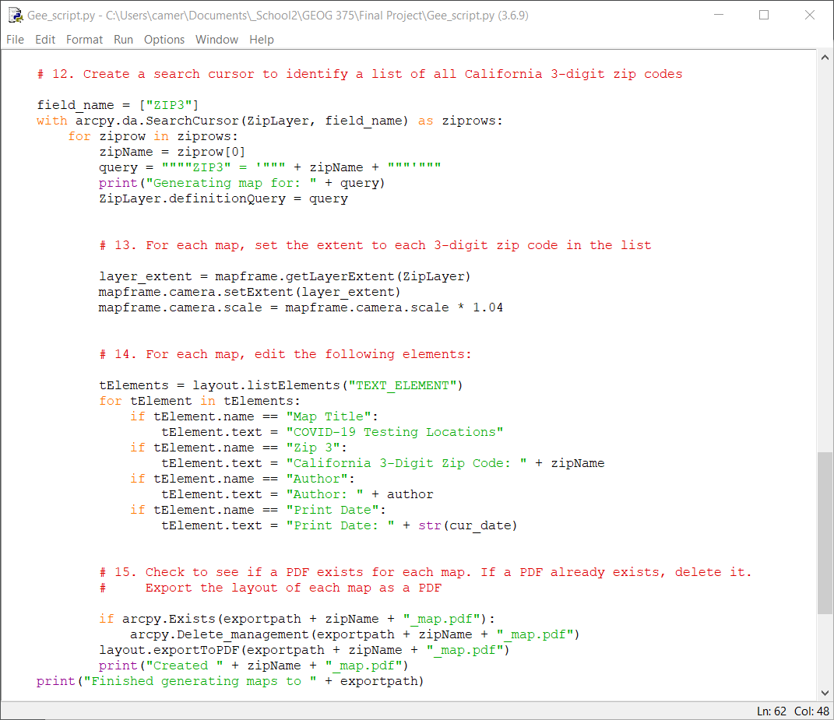
The search cursor section of the script which produces a unique PDF map from each California 3-digit zip code.

Results

A few maps produced by the script are shown below.
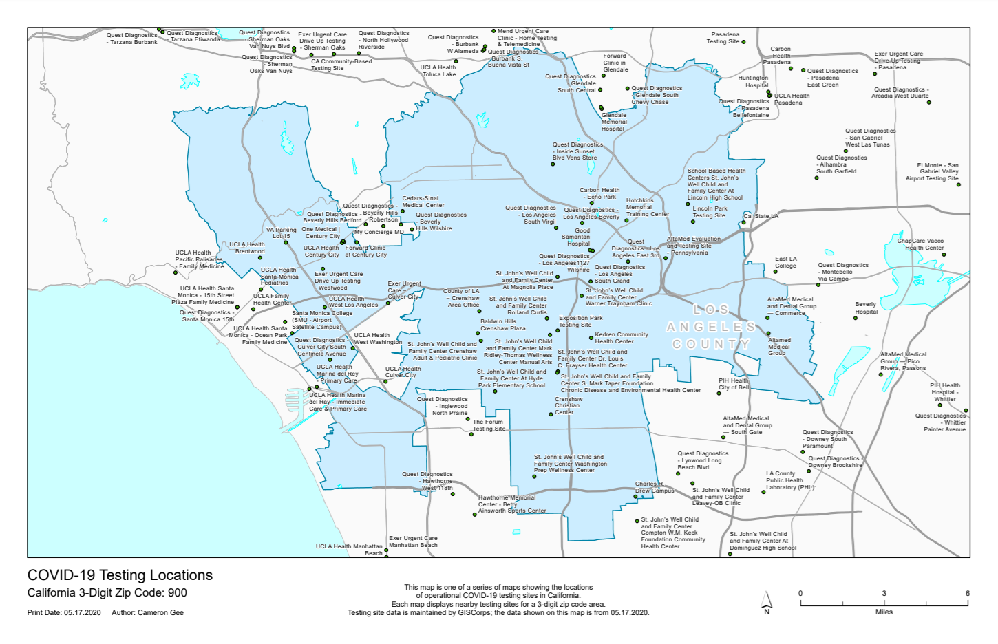
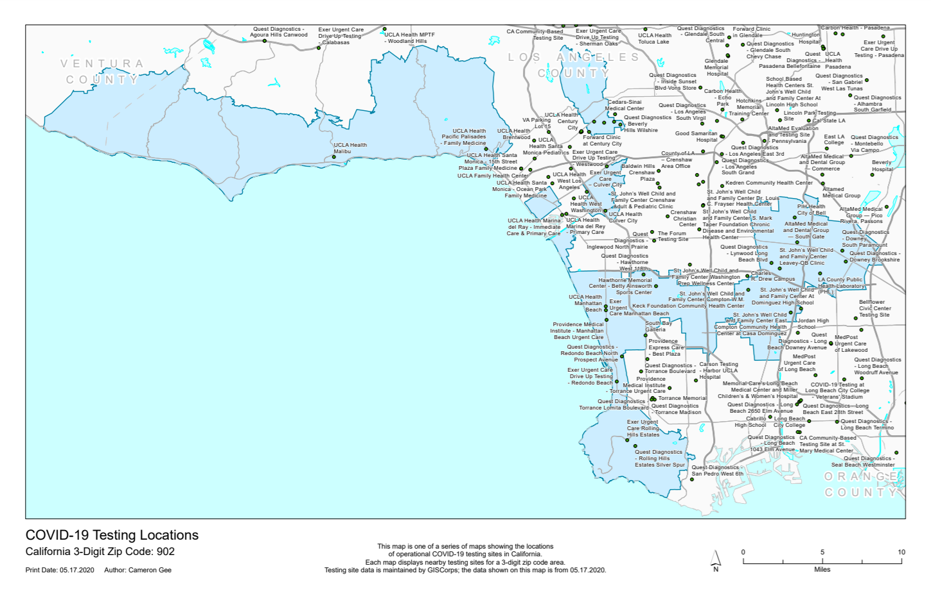
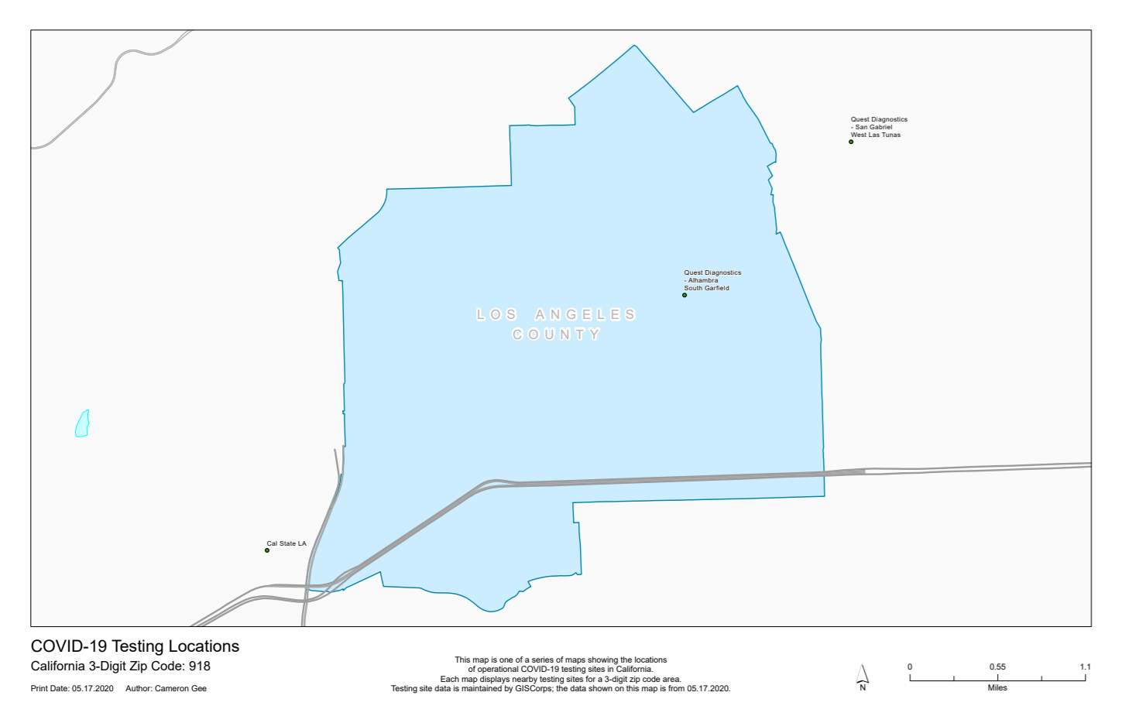
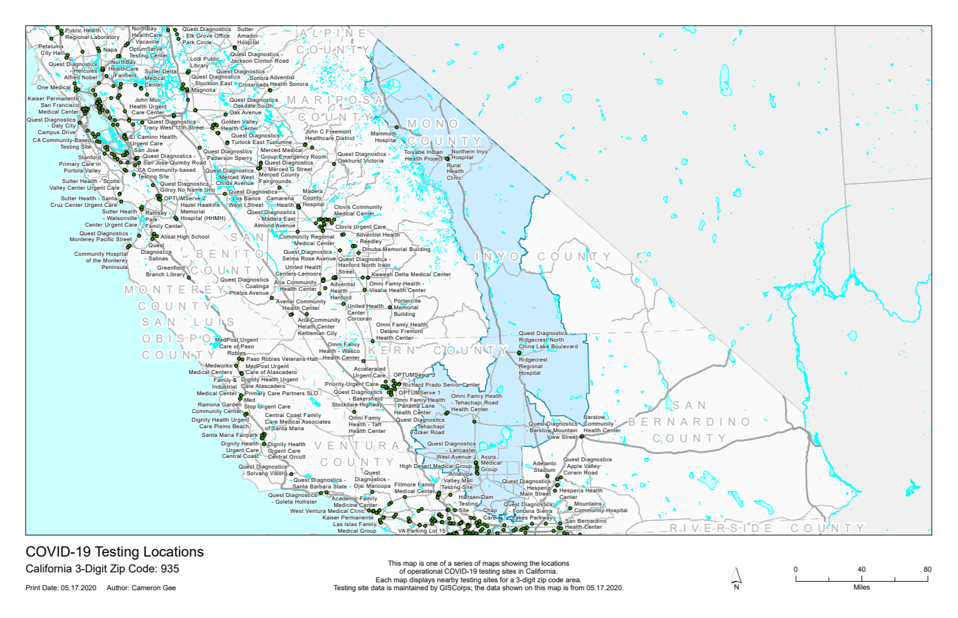
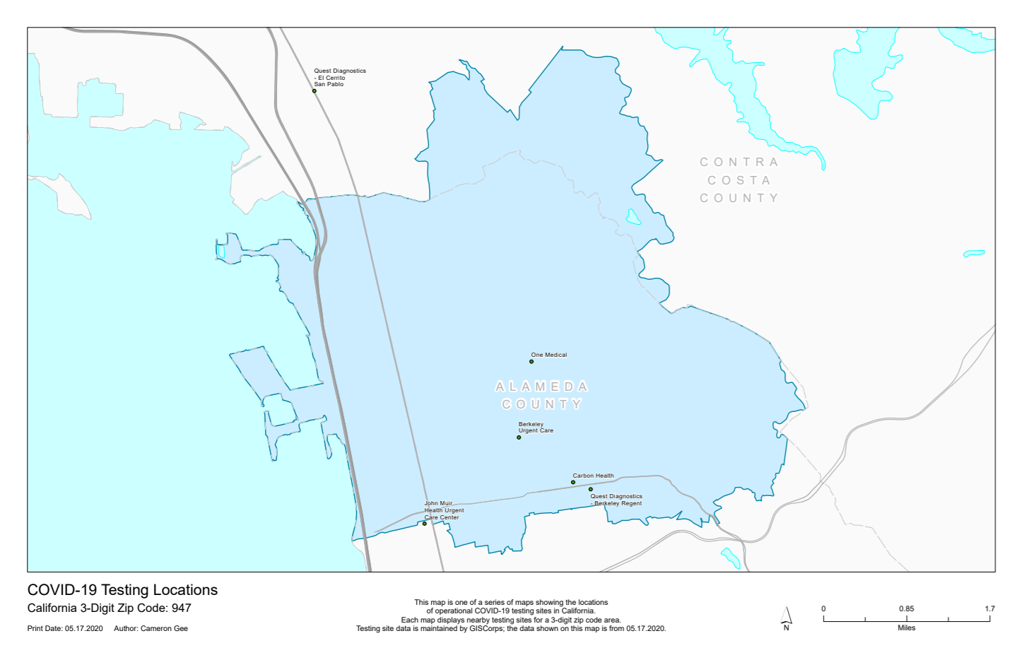
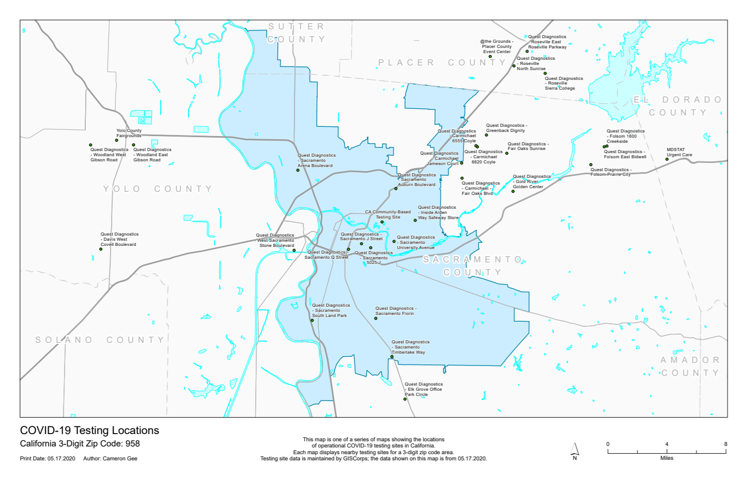

Difficulties

There were a few obstacles during the development of the script. I initially did not use a separate shapefile for the California 3-digit zip codes, and as a result, the script produced a series of maps that did not zoom into each zip code area. I am unsure why this was the case. One thing I noticed was that since some zip code areas include unpopulated islands far from the coast (e.g. the Farallon Islands off San Francisco), some maps were zoomed out unnecessarily. To solve this, I exploded the multipart zip code features, merged just the mainland features, and deleted the islands.

Lessons Learned and Future Improvements

Something I was unable to do in this script was hiding testing locations that are beyond a certain distance outside of each zip code area. Due to the various shapes and sizes of some zip code areas, a few small-scale maps were produced (zip code 935 shown above). As a result, these maps show testing sites that are very far from the zip code area and would not be useful knowledge for someone in that zip code. The small scale also limits how many testing sites are labeled with their name. Other zip code areas are much smaller (918 and 947 shown above) and their maps would benefit from higher resolution background features such as roads, parks, or other landmarks. Some maps reach quite an effective balance between scale, population size, and population density (typically correlated to the number and density of testing sites—900 and 958 shown above). However, the most populated areas such as zip codes within Los Angeles have too many testing sites for all of them to be labeled (902 shown above). One solution to the zip code area variability might be to create a grid index feature and only show the testing sites within each grid cell in California. However, it would take longer for a user to determine which grid they are in, and then choose the corresponding map to view. One’s own zip code is common knowledge, making it a good choice as an administrative boundary, but an effective balance may be achieved with another type of boundary in the future.
Ideally this script would download and add a new testing sites dataset to the map at a regular interval to ensure accuracy. Retrieving the dataset from the GISCorps website from within the script is beyond the scope of this course but could possibly be implemented in the future.
The python script in this project is a good start to providing California citizens with a series of maps showing nearby COVID-19 testing locations. Because of how important testing is in managing the spread of COVID-19, a map series such as this one would be useful to many people seeking available testing sites.

