Austin Demshar
Geography 375 Final Project
ARC Spring 2020

Final Project: Summary, Documentation and Issues

Summary and purpose

The goal of this project was to create a Python (v3) program for ArcGIS Pro that will allow a user to query an address as an origination point and receive information on hiking trails within the Folsom State Recreation Area and the Auburn State Recreation areas (SRAs). These areas contain many hiking trails and it is of interest to me and possibly some use to others to have a program that can provide details on these trails as well as information relating to a user’s point of origin (address).
The geoprocessing and ArcGIS functions for this project bring together information which include distance from starting point to many trails within the SRAs, within a specifiable variable distance from the starting point, the length of those trails, distance to the nearest major river from the trails as well as distance to the nearest major lake from the trails. The original intent was to create a table that could be printed off by the user within ArcGIS Pro. However, for ease of access or the savvier GIS user, the output Information was reported via an excel spread sheet as well as geodatabase feature class and a geodatabase standalone table.
The data for this project come from the California State Geoportal (recreational routes), the National Hydrography Dataset (California major rivers and major lakes/reservoirs) and Sacramento County GIS Open Data (Sacramento county addresses). The assumption for this project was that this data is complete and accurate enough in order to perform the basic geoprocessing tasks and retrieve the information desired. Unfortunately, some of the recreational routes data does appear incomplete and a bit messy for this purpose, as there appear to be missing trail segments, and some trail routes are counterparts to others with slight name variations. Data citations are located at the end of the Summary.
The end result of this project was to have a somewhat flexible code so that somebody could adjust some of the script variables and receive trails information and determine accessibility for their situation based on various parameters set within the code. The script was not designed to relate to an ArcGIS custom toolbox for dynamic parameter input. The future of this program would be to create a custom toolbox that would allow for the custom input of a user’s parameters and derive useable data.
ArcGIS geoprocessing, python function and overall workflow
The general workflow order of this script is as follows:
- Import appropriate modules
- Setup folder and geodatabase workspaces
- Define primary variables to be used within the script
- Project all datasets to the same projected coordinate system (transform datum if needed)
- Query trails by attributes to narrow selection to the Folsom/Auburn units
- Query trails by location from the point of origination (address)
- Dissolve trails to consolidate records in the parks data
- Spatial join both river and water body information to the trails data
- Run near tool to determine distance from point of origination to “start” of dissolved trails
- Create a table with only the most appropriate fields for the purpose defined above
- Create search and insert cursors to populate this table from the geoprocessed layers
- Create a new geodatabase feature class that will reflect the same information as the table
- Create an excel file that will also reflect the information above (for ease of access)
The general idea behind the geoprocessing workflow was to first to filter out via query the unwanted trail systems within the parks data for analysis. The dataset was quite large and contained more than just trails, but also roadways and other park types. For our region, I stuck with the Folsom/Auburn SRAs. Once the queries were set, the next step was to join the appropriate rivers and lakes information. Since there are many rivers, I stuck with the major rivers dataset, as a user of this region would likely just want to know about the American River system (North Fork, South Fork, central, etc.). The same idea goes for the lakes data, there really is only one of interest here, which is Folsom Lake (also minimally, Lake Natoma). The idea was to obtain distances to the lake so that the user might have a better idea of where a trail lies around water. Throughout the script, fields were added and calculated to report mile (or feet) distances based on the feet measurements that the State Plane projection reported back upon geoprocessing. Then, this information was linked to the near tool to determine distance from the user’s point of origin, within 30 miles. Subsequently, a feature class, table and excel file were created and exported.
Due to the size of the datasets, it may have been feasible to narrow the data prior to performing projections and queries on them. However, I determined that it made more sense to start with total data, perform projections on all of it, and then perform queries and narrow down information. I felt that narrowing data to what I wanted, then performing projections didn’t make as much intuitive sense, and may possibly have introduced measurement errors (though possibly in the GIS realm this may be the efficient way to go).
Originally, I had an idea in mind of how the processing would go, but some of the tools needed to be moved around. For instance, in my mind intuitively the near tool would be up front, but this ultimately came last in my script, after all other querying and joins were completed. Related to the order of geoprocessing was the placement of variables. I chose to place some of the more prominent variables up front prior to the ‘try’ block, such as the projected datasets, layer output, feature classes and final outputs. Other variables such as ‘query_a’ and ‘query_b’, field mappings and field listing I kept confined to the area where they were used, as this seemed to make more intuitive “local processing” sense.
Issues and resolutions
During the course of the script writing, numerous errors were encountered. Syntax errors relating to ArcGIS tools occurred the most, and were usually always resolved by referring to the ESRI ArcGIS Pro website tool documentation for syntax and syntax examples. Oftentimes, Google searches and perusing GIS forums were useful in resolving syntax and parameter issues. Reviewing how other programmers have used geoprocessing tools helped guide me to a working script at times.
Quite a bit of work was performed within ArcGIS Pro to determine what outcome was to be expected while running tools. Additionally, on a few accounts (mostly for add field and calculate field), I setup the tool and ran it in the software, accessed the geoprocessing history to copy the code created by the software to see how it was writing it. Sometimes, it was not useful, other times it was. Looking into software code lines also helped me figure out some of the Arcade code syntax. The goal for me was to learn to properly write it myself, and the software was a useful guide.
When performing some ArcGIS Pro data checks on the script output, I ran into measurement errors. This occurred when using the measure tool on the map comparing the various distances being reflected to the data generated by the script. There were some significant discrepancies, and after some time passed, I realized the data were not all in the same projected coordinate systems (one wasn’t within the NAD 1983 GCS). This was a “soft” road block up front, and I realized that if the data weren’t converted to the same projected coordinate system, the accuracy of the whole project could be called into question. Projection tool parameter research assisted in creating these lines of script.
An inordinate amount of time was spent trying to actually create refined data output and tables, when thinking in comparison to actual geoprocessing and creation of data. The creation of tables, inserting fields and running search and insert cursor process provided multiple errors, but after internet research and multiple runs, eventually worked out (syntax issues). Additionally, the creation of a final feature class that was setup like the table, was more challenging than I anticipated. I went in circles with creating a new feature class and populating with fields, and performing a feature class to feature class conversion, mostly due to parameter issues I couldn’t figure out (with field mapping and coordinate system parameters). Eventually I settled on the feature class to feature class conversion tool and used the final trails join feature class once I realized that I could import the field mappings variable from another feature class or layer. Internet research helped me resolve the field mapping syntax and parameters issues.
Another matter I ran into was field naming. I was keeping to shapefiles since the original data was in shapefile format. However, due to wanting longer more descriptive field names, I had to change over the main file path to the geodatabase and adjust multiple variables throughout the code. Apparently, field aliases are only allowed in geodatabase data types. This was minor, but adjusting something like this required adjustment of many variables throughout the code, causing some trouble.
Overall, the code was enjoyable to create, and with the help of accessing ArcGIS Pro to see what was being generated by the script, most all issues could be resolved.
Output data images
The output data was truncated for the purpose of legibility in this summary. Full images are presented in the PowerPoint presentation.
Excel table: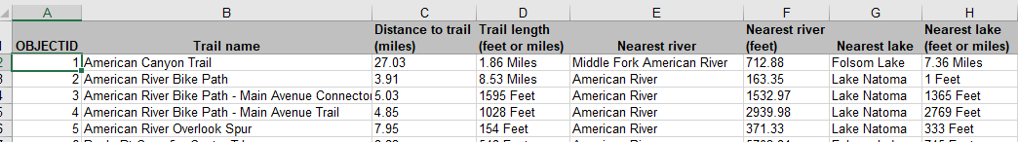

Standalone table in ArcGIS Pro: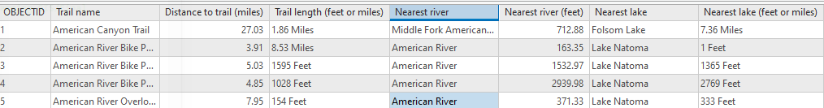

Feature class in ArcGIS Pro as a map (lakes feature class added in for perspective):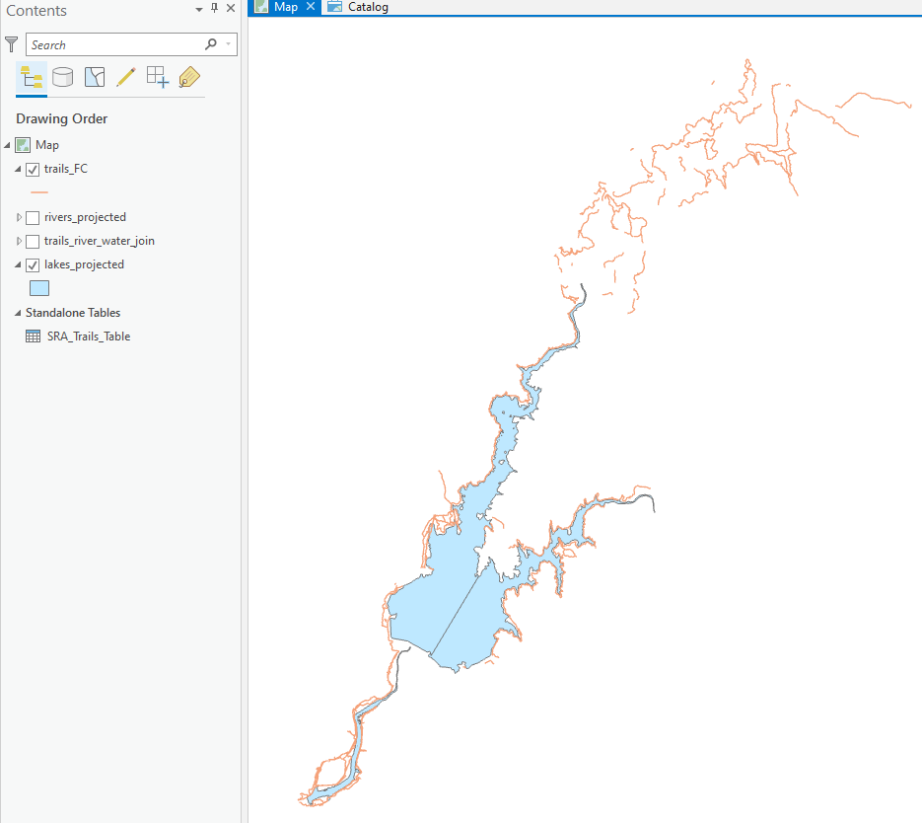

Data citations:
Addresses: Sacramento County Open Data. http://data sacramentocounty.opendata.arcgis.com/datasets/54b1835ffb7b4e728a3506fe1a23618d_0?geometry=-122.049%2C38.479%2C-120.742%2C38.667
Recreational Routes (trails): California State Geoportal. https://gis.data.ca.gov/datasets/csparks::recreationalroutes?geometry=-161.231%2C31.062%2C-77.603%2C43.269
Rivers and Lakes: California DWR (NHD). https://data.cnra.ca.gov/dataset/national-hydrography-dataset-nhd

