Eva Cordtz
5/21/19
Geog 93
Nathan Jennings

Into the Wild

Project Summary
Into the Wild, written by Jon Krakauer, follows Chris McCandless from 1990-1992 from Atlanta, Georgia to just outside Healy, Alaska. McCandless gave away his entire life savings to charity and drove his Datsun west after graduation from Emory University. Little did his family know this would be the last time they would see Chris. Over the two years Chris took various forms of transportation, traveling to three different countries, countless cities, states, and met many people, some of which he would stay in contact with over his 2 year journey. These PDF maps, Story Map, and Web Map seek to give a better understanding of where and how Chris McCandless traveled, people he met, and important points throughout each year of his journey.
Purpose
The goal of this project was to use data digitization and collection with geoprocessing to solve certain issues surrounding current maps based on McCandless’ journey. The problems this map sought to solve was:
- Existing PDF maps do not have a character that reflects Chris McCandless’ journey
- New PDF and web maps alike sought to enable the reader to understand the different ways Chris traveled, and the adaptable sense of his personality
- Existing PDF maps do not give the full sense of Chris’ journey over the 2 years, or allow a breakdown of his journey per year to enhance understanding

Data Management, Creation, cartography tasks and methods used to create output
- First step was creating a file geodatabase
- Then I digitized manually his journey path by year and important points per year. I edited the attributes table to include year, stop number, city, name, Country, Province, notes and transportation mode to include year, transportation type.
- Created Feature class for Important Alaska Points.
- Downloaded data from ArcGIS Online including: Pacific Crest Trail, Important Chris McCandless points for reference and comparison, National Park Service Boundaries, Stampede Trail (Manually digitized Stampede Trail extension since downloaded data did not have additional trail data), USA State Map / Mexico and Canada maps.
- Data Downloaded from websites: Alaska Hydrology Map from Alaska Center for Conservation Science from the University of Alaska Anchorage
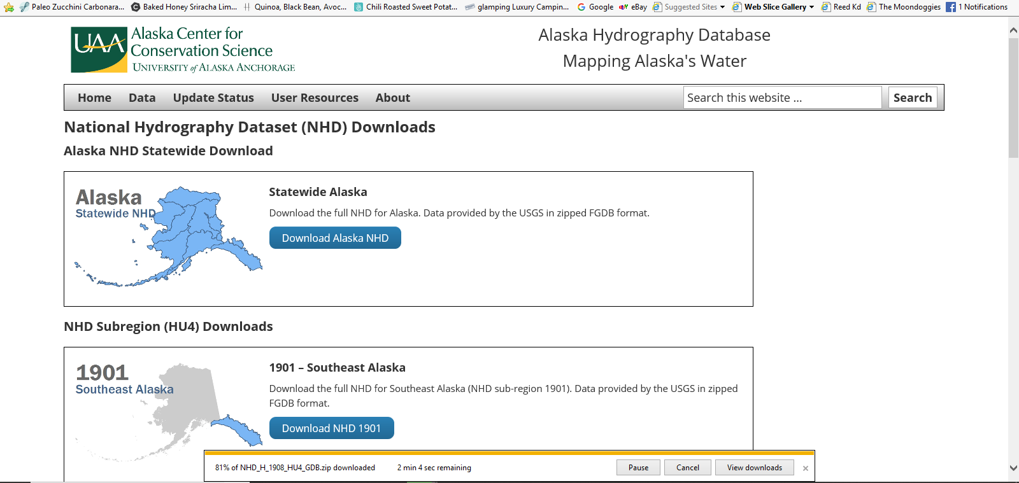
- Started to create journey paths, queried places and transportation types.
- Used Split tool to split pathways at vertices or “OSnap Points” for copy and pasting digization or removal of areas
- At this point I had been making one large dataset that included all years, but ran into problems with overlapping paths, copying paths and points. So at this point I created transportation types for each year and a points file for each year.
- After making the points layer I knew I needed to merge the Alaska points to the 1992 dataset, so I created a common field type of Name (there can’t be identical names inside or they won’t merge correctly).
- Next I ran a buffer to find the exact distance he could have camped out past a certain point. I had my snaps on so the point tool would snap to the buffer ring.
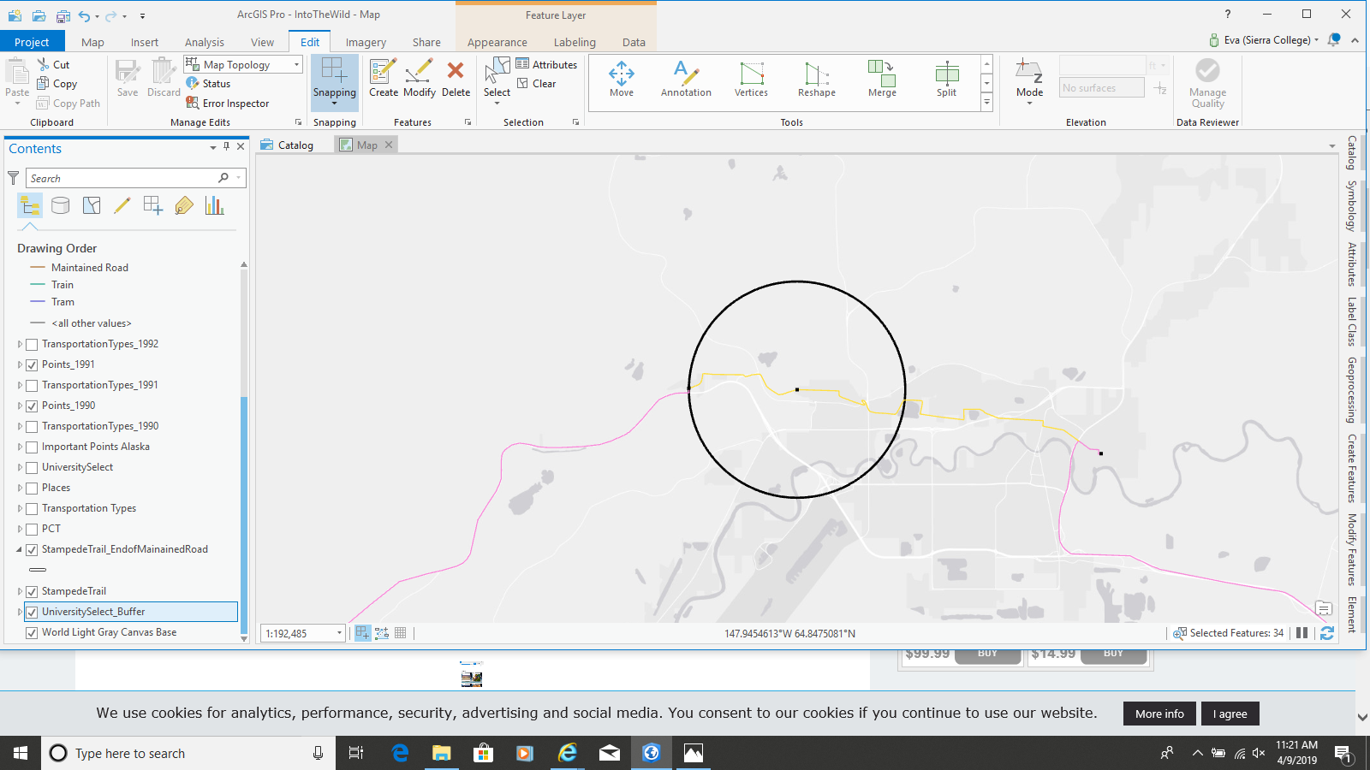
- Then I merged the datasets
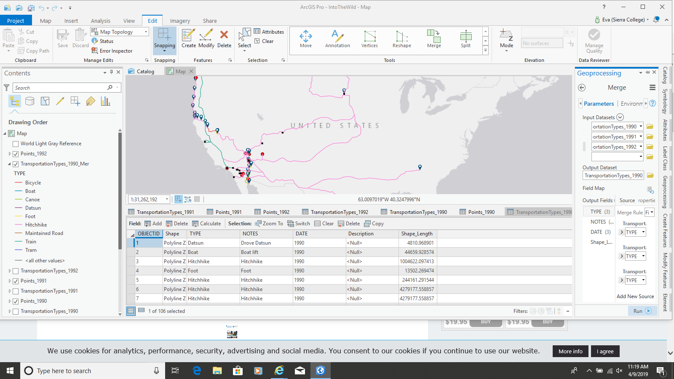
- After I finished this I ran a frequency operation. This gave me a new data layer that told me which cities occurred more than once.
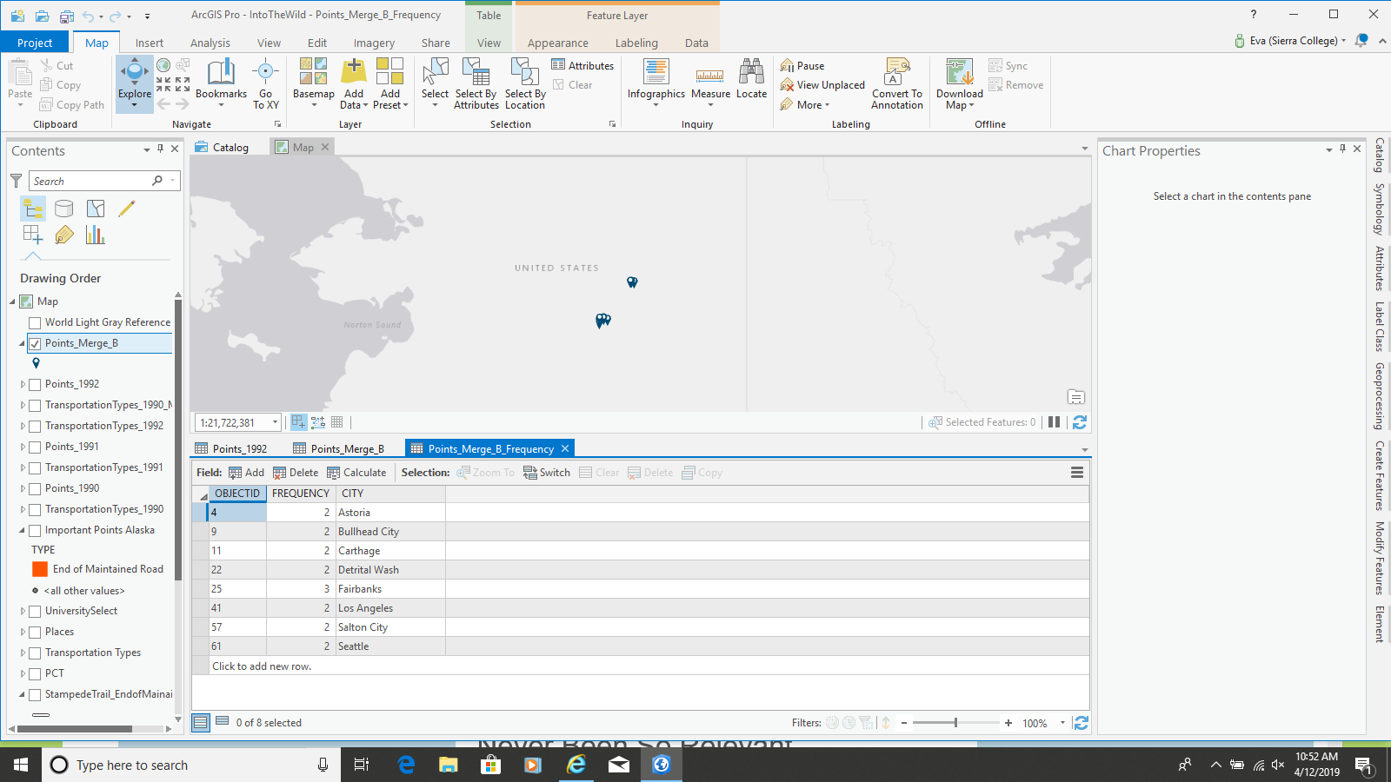
- Then I queried NPS boundary to include Denali National Park, Queried North America to include USA, Mexico, Canada. I also ran a query on the datasets of the merge to upload certain years to ArcGIS online, and the river dataset.
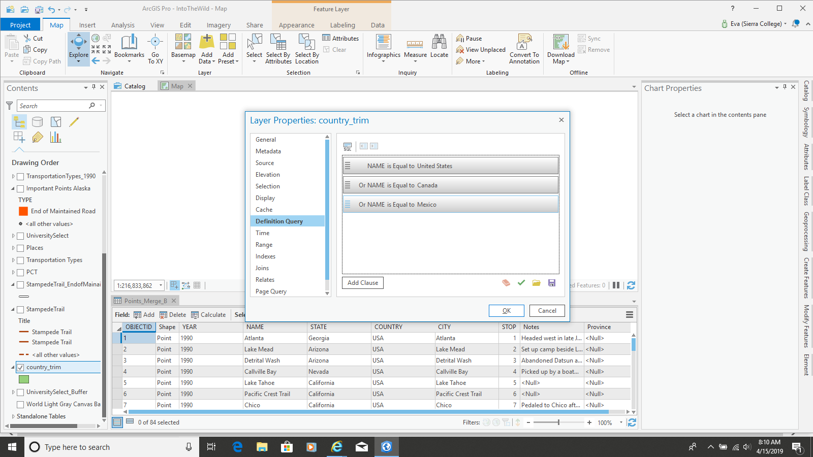
- In order to format the Alaska Points correctly visually, I had to edit the projection to limit distortion from having viewed the overall journey that covered three countries.
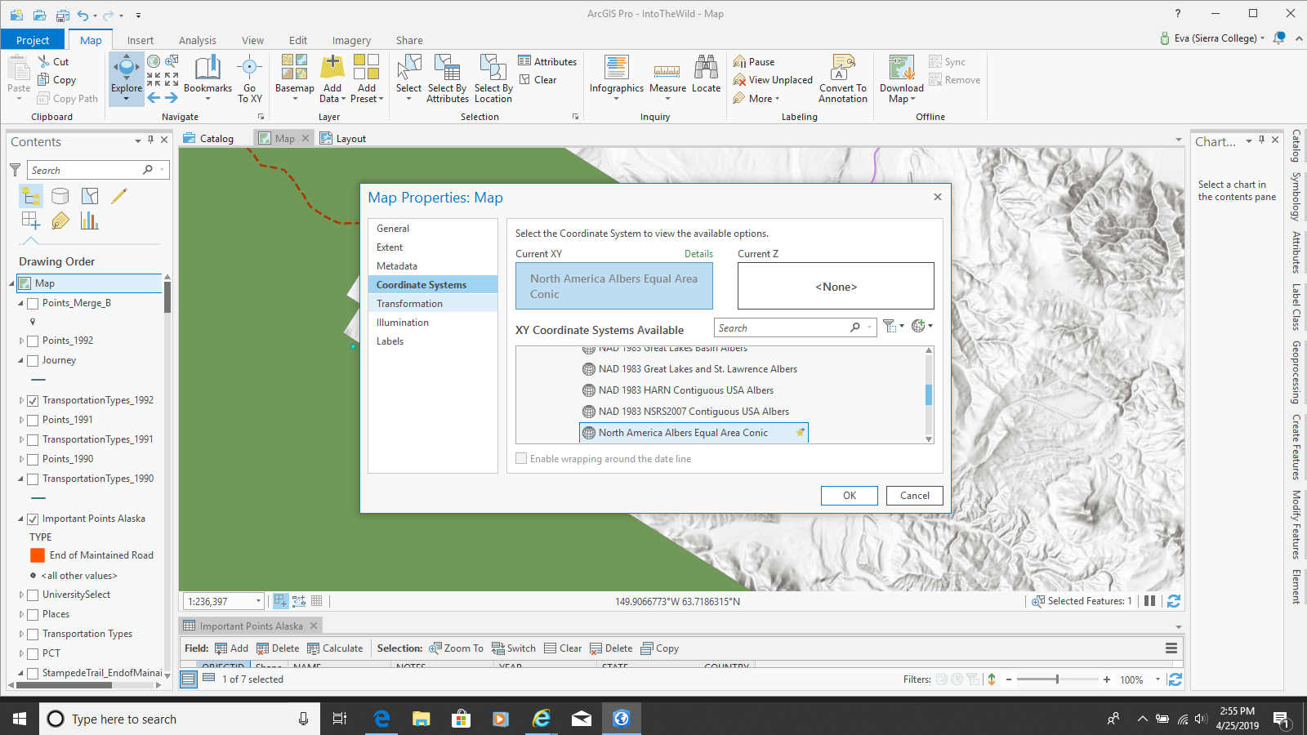
- After finished data processing, I tested out utilizing graphs / charts
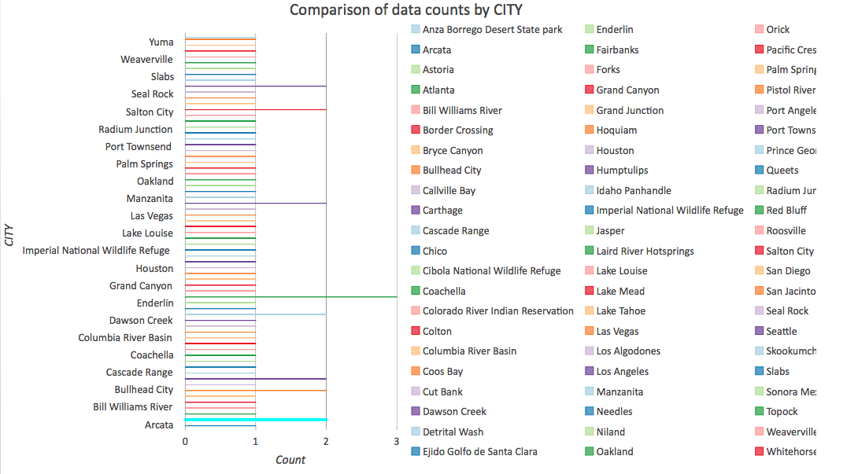
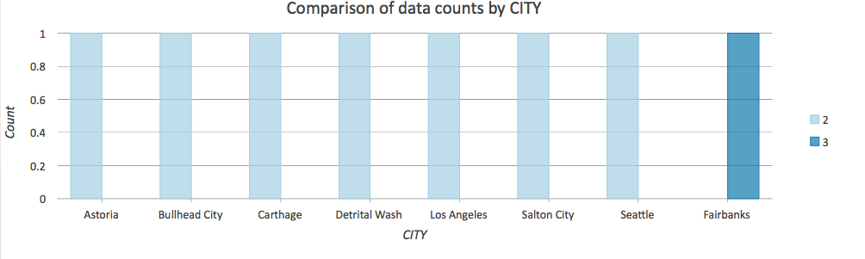Stops at each location, pulled from frequency table
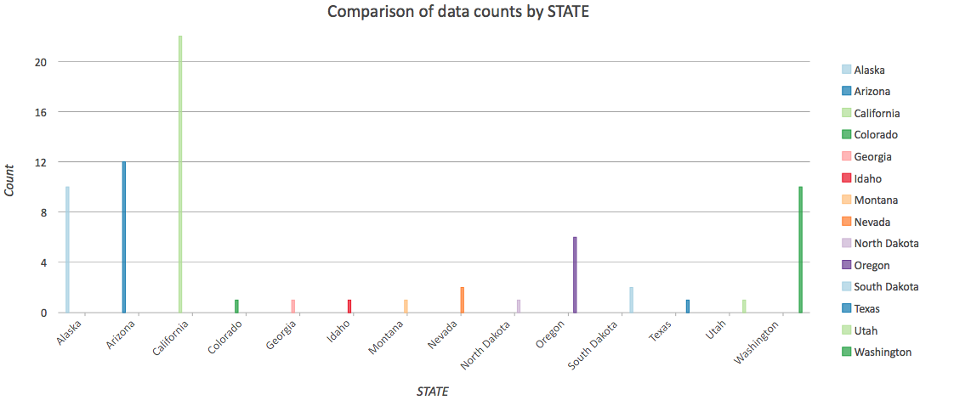
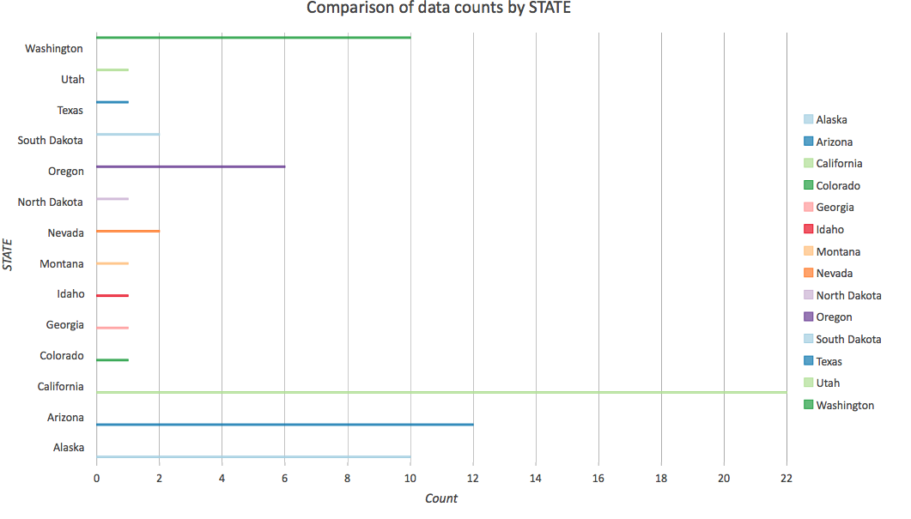
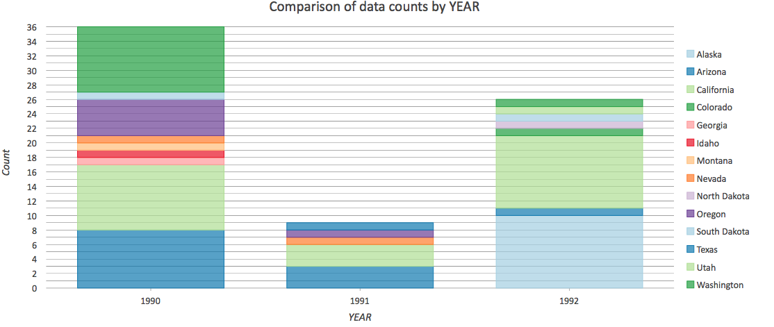
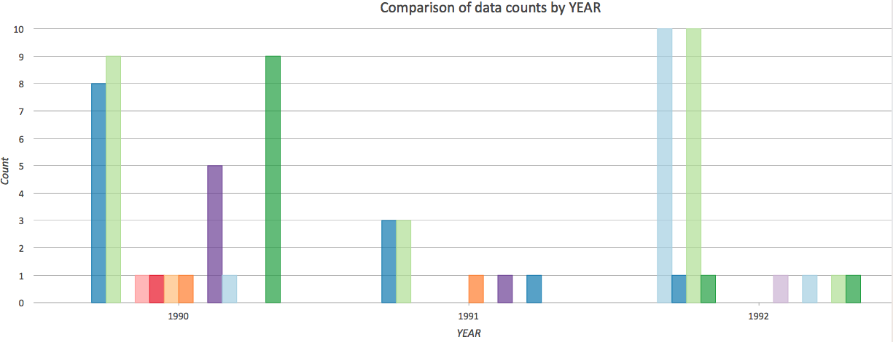
There were too many cities to display each one on a graph. Possible showing cities per year in a single stack works better (possibly the last two) …
- Then I formatted the data, uploaded it to ArcGIS online. Then I created a story map and web map.
Story Map
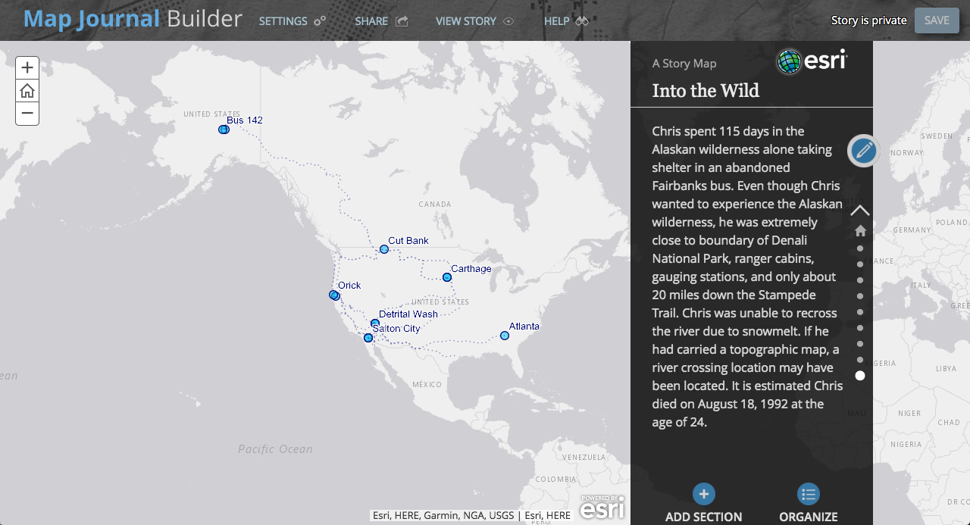
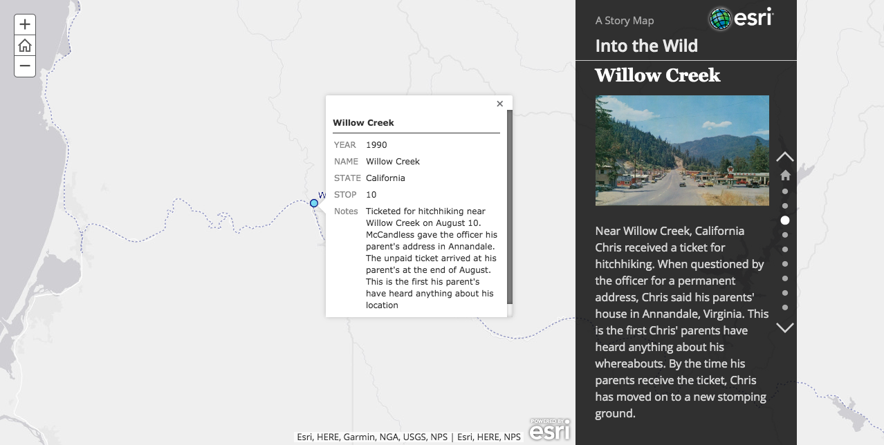Web Map
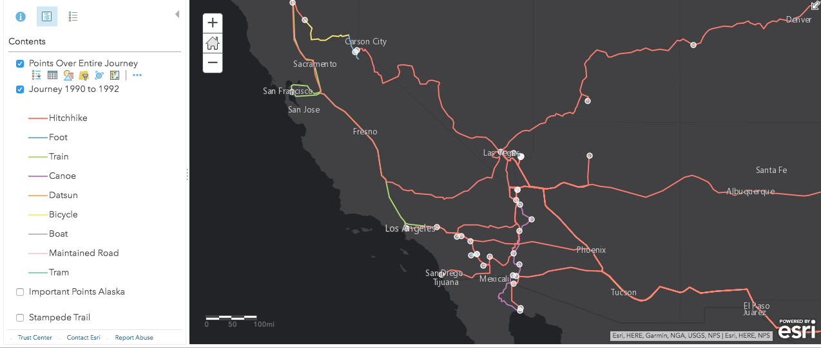
Web Map:
Labeled As Into the Wild Interactive Map
http://sierra.maps.arcgis.com/home/webmap/viewer.html?webmap=b293f494e1584ca681c4f13eb23a0e40
Story Map:
Labeled As: Into the Wild Finalized Story Map
http://sierra.maps.arcgis.com/apps/MapJournal/index.html?appid=68dd27e49f934af290757fa4758b6396

- After I finished this I worked towards formatting and cartography for the two printed maps.
- After working around the export problems discussed in the problems section, I brought my PDFs into illustrator and photoshop to colorize, and do layout. I designed my own north arrow, used a unique typeface, color palette and downloaded illustrations to create a sense of uniqueness to the maps. I utilized light drop shadows and old paper overlay to give a vintage sense. Plus Chris always carried books with him, so it makes sense to use distressed paper.
- I made sure the color palettes were consistent on both maps while each having slightly unique features. The labeling was done manually.

Issues
- ArcPro has gotten rid of export as an Illustrator file. A possible work around was to export as an EPS file, but this EPS file was not able to be read by Adobe Illustrator.
Solution- Export layers as PDFs or PNGs instead. This was a work around, but not an effective work around.
- ArcPro exporting layers as squares, not entire layout.
Solution: Export at a smaller scale by layer so no information gets cut off. Again, a solution, but not one effective for a work flow.
- The paths for the web map overlapped. If there was more than one travel mode for a path over the course of two years (he traveled certain routes multiple times in different ways), the most recent path covered all the other paths.
Solution: I did not find a good one. Perhaps a solution would have been to have a travel method layer for each year instead of one large one and the years be turned on and off to see comparison?
- Exporting graphs / charts did not go as planned. Due to the fact that there were 70+ cities or stops made, it was hard to find a good way to break it down. I did not find a good solution, but the graphs/ charts I did create are included in the presentation for you to look at. This is definitely something I need to play around with more to get a sense of how it works, or play with a smaller dataset.
- The layout for the maps have certain things that need to be improved looking back. The paths on the overall map for the separate years could be better defined. The Alaska section could have had a larger section with less white space around the sides of the hill shade data.
- Lack of customization for ArcGIS Online Story Maps for color choices and font choices. There isn’t an easy color picker way to change the colors or font pick menu. It seems that maybe you have to go in and modify the code?
Learning Experiences
- Due to creating data by hand, I gained a better knowledge of geodatabase creation and how files are nested (also where my points of confusion are in file structure), editing and creating attributes by using a text and numeric field, managing attribute tables, exporting selected data as a new layer in the map.
- I gained a better understanding of cartographic principles, ideal label placement, hierarchy, etc
- I learned about utilizing ArcGIS Online for Story Maps and Web Maps. I was really frustrated with the lack of customization for story map colors, text/ font choice, etc.
Final Map
