Joey Brisson
Geography 93 Final Project Paper
Project Description:
Create an online Story Map about the River Sciences department at the South Yuba River Citizen League. Include information about the different projects within the department and use data provided by the organization to create a more engaging online experience for users.
Project Purpose:
The purpose of this project for me was to create a real-world scenario where I would be asked to create a geospatial tool to solve a problem for a company. In essence, I recreated what it would be like to have my own business and offered my services to an organization. The problem to solve here was how to enhance the online experience of visitors to their website while providing professional GIS capabilities. This project demanded that I have multiple meetings with this organization and required me to brainstorm and problem solve with a variety of people in the organization. In the end I delivered a product that accomplished their goals.
Project Summary:
For the past 4 months I have been working on this project for the South Yuba River Citizens League. The project has gone through a number of changes during this time and the coordination with the organization has been a challenge. However, in the end, I have created what I believe to be a quality product for the South Yuba River Citizens League.
I have created tow online Story Maps using ArcPro, ArcMap, and ArgGIS Online Story Maps. I chose to create two Story Maps so that the organization could decide what style and presentation format they preferred. Although each Story Map contains the same information different processes were used in making them. To create these online Story Maps I spent time learning how to use ArcPro. I had not previously used this product and found that it was a bit difficult to get used to at the beginning. However, throughout the semester I found that ArcPro became rather intuitive to use and offered features that I really liked. I really like that most of what I needed to use was laid out similar to Windows with buttons to select from. It made finding and understanding what I was doing pretty easy. Another great feature is how they have the Project feature. I could create multiple maps and layouts within one project. This made it great for creating a variety of maps that all contained different information.
I found that one style of the Story Map seemed to work better by using jpegs instead of interactive web maps. I decided to recreate my maps in ArcMap for this because I was more familiar with working in the Layout feature of ArcMap. Basically, it was easier for me to create the jpegs exactly the way I wanted them using this product. An added benefit to using ArcMap was that I was gaining more experience using a product that is widely used throughout the GIS industry.
In the end the South Yuba River Citizens league preferred the style of Story Map that included the interactive web maps. I had used ArcPro to create the maps within this StoryMap.

Description of GIS management, creation, cartography, and methods:
This entire process began with receiving shapefiles from the South Yuba River Citizens League. They have been creating maps of their projects for a long time and actually employ two people who have degrees in GIS (One has a masters). However, because of the structure of the organization both employees main focus is on something other than GIS so the amount of time they had to create GIS related products is very limited. I kept all shapefiles received from the organization within a folder titled SYRCL. (SYRCL) is short for South Yuba River Citizens League. Any new shapefiles or maps for this project would be kept within this file so that I always new exactly where to find what I was looking for.
The first tasks I needed to do was to simply take the files that they gave me, import them to ArcPro and analyze their attribute tables to see what it was that each shapefile contained. Below is a list of files that I used within this project, a brief description of each, and what geoprocessing I needed to do with them. For the most my geoprocessing consisted of attribute selections, symbology changes, clippings, and dissolves.
MajorRiversCalifornia.shp: This shapefile contained the major rivers of Northern California. I used an attribute selection to pull out the rivers that I needed for the project. North Yuba, Middle Yuba, South Yuba, and Yuba Rivers. This file was imported onto many maps and the symbology of it was changed from map to map to display at its best with the chosen Basemap. Alternatively I could have lipped the features that I needed for this layer.
Resevoirs.shp: This is a shapefile of all of the reservoirs throughout the state of California. I used the watershed yuba shapefile to clip the reservoirs that were inside the watershed.
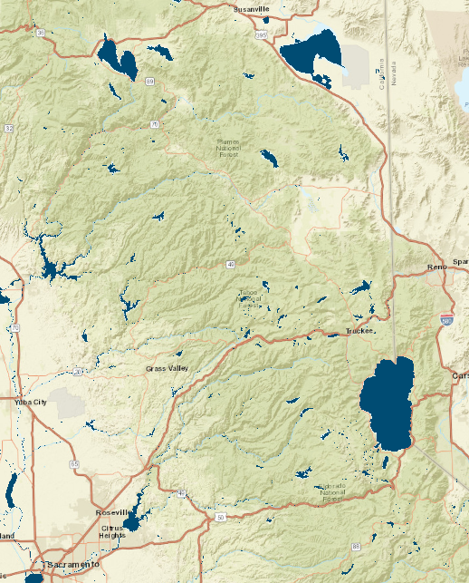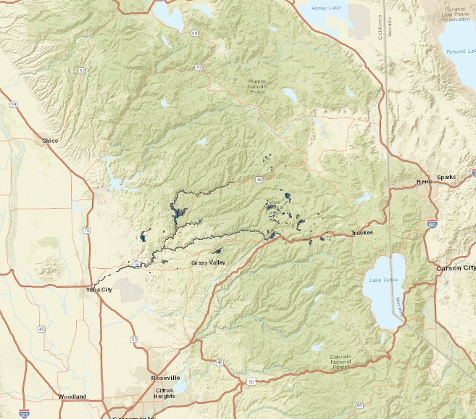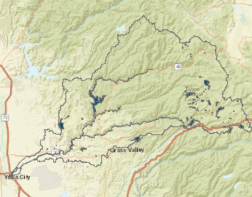
watershedYuba.shp: A simple polygon of the Yuba Watershed. Used in almost every map. Basic symbology changes were made to this layer.
YubaHydro3rdOrder.shp: All hydrology within the Yuba River Watershed of the 3rd order. I only changed symbology of this layer throughout the project.
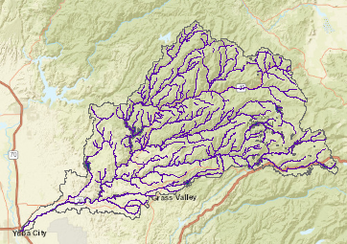

YubaWatershedHuc.shp: Shapefile with subregions included in it. I used this layer with many other to create a basic map of the area that included the major rivers and reservoirs.
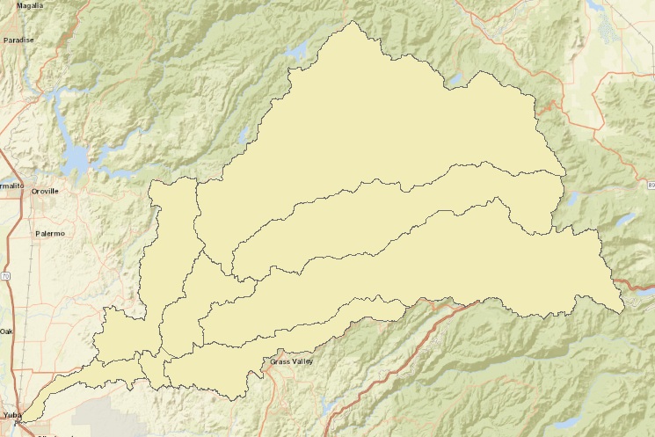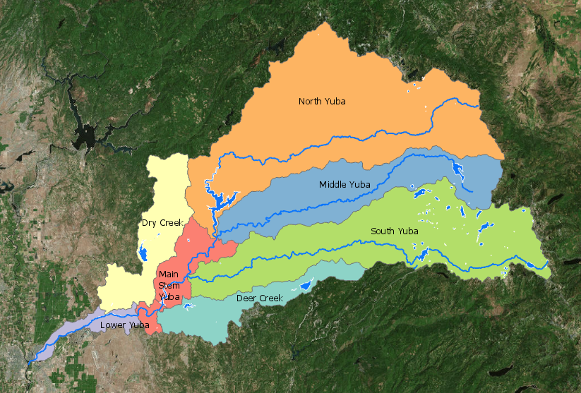
AIS_Reservoirs.shp: Reservoirs that the River Science department has been doing work with. This was imported onto most of the maps mainly because it filled in gaps between the rivers layers and made maps look more complete.
Scotchman_Creek.shp: Basic Lines of a creek. Simply changed the symbology of this layer.
Yuba_hydrology.shp: I didn’t use this layer because it is too busy and took away from the visual appeal of all the maps.
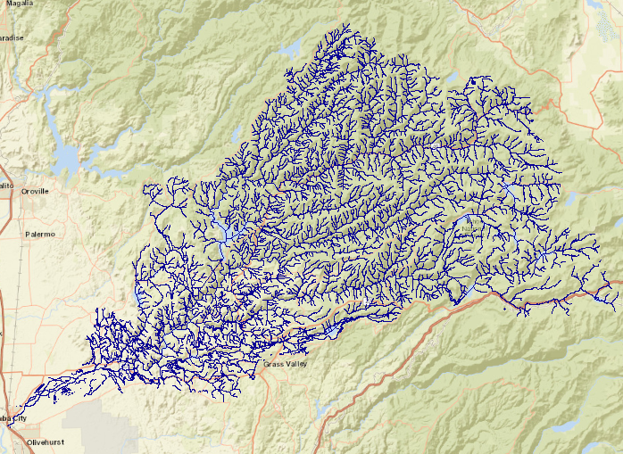
River_Monitoring_Sites.shp: Basic symbology changes were made to this layer to display better within in the map.
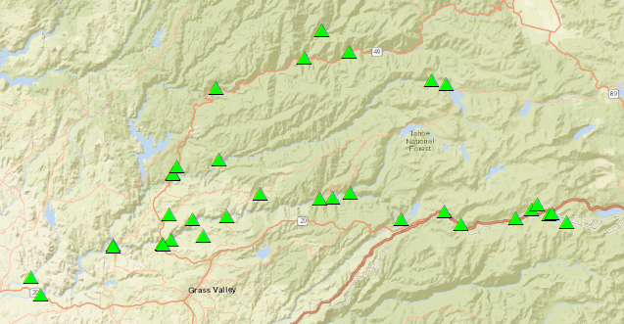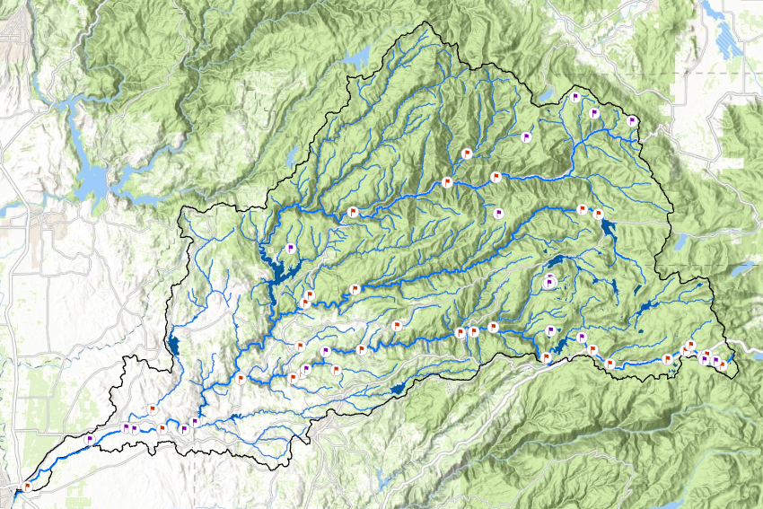

Restoration Project Points.shp: I included this layer in with the project points map to show all the areas where work is being done within the watershed.
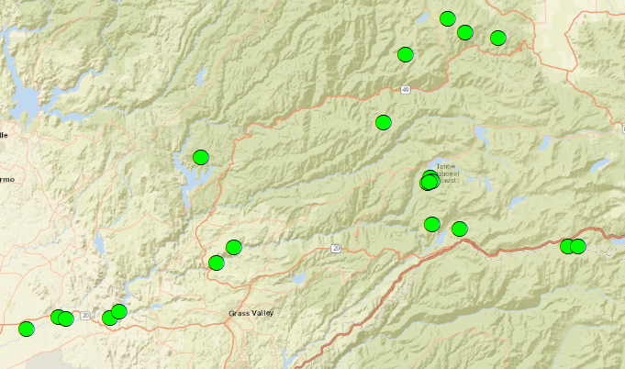

Yuba_MeadowsWatershed.shp: I did and attribute selection here to select out only the meadows that the River Science department was actively working in. I did notice however that some of the meadows consisted of multiple polygons. I had to do a dissolve for on some of these to get them down to one polygon for each meadow so it would display better on a map.
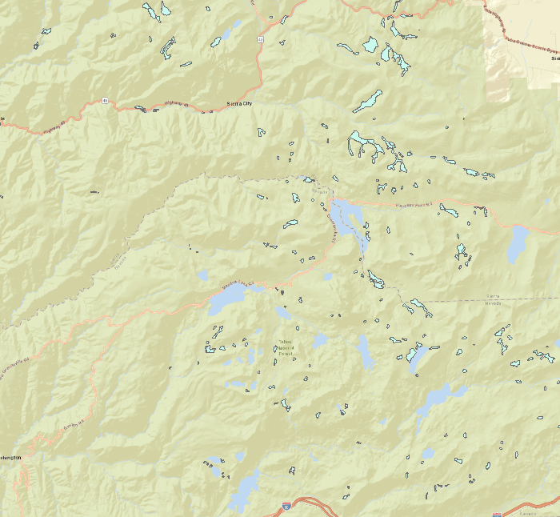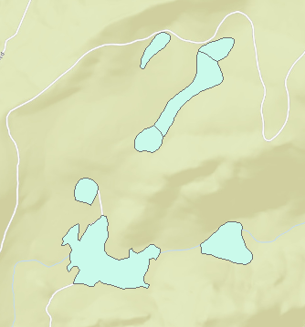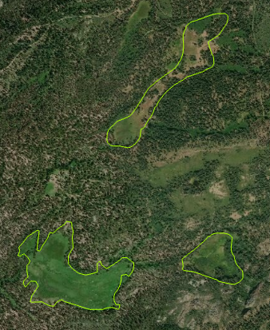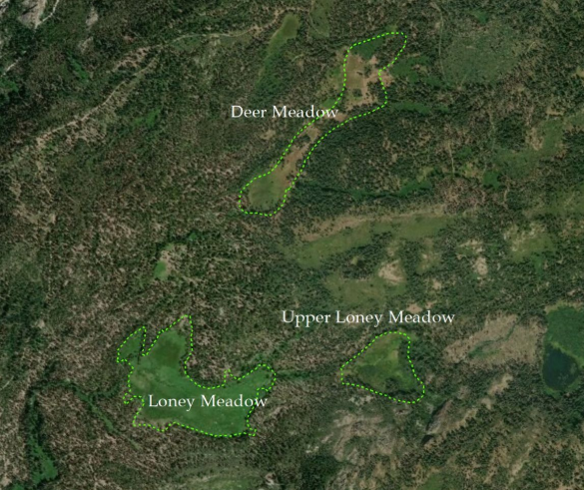

Difficulties:
I did have some difficult times throughout this project. To start I needed to learn how to use ArcPro. I was familiar with ArcMap form into to GIS but I had never used ArcPro before. I enlisted the help of YouTube on multiple occasions and referred to the online PDF’s that were provided for the class. Associated with this was ensuring that what I was creating in ArcPro was going to display nicely in the Story Maps that I was creating. This problem was solved by simple trial and error.
The biggest difficulty of the project was working with another organization. I found it extremely hard to schedule meetings with representatives of the organization and then once those meetings were scheduled it was difficult to make forward progress at each meeting because of the many people involved. I think that the project would have went much smoother had they had a better idea of what it is they wanted out of the project from the start. However, we all worked together and were able to come up with a final project that worked for everyone.
I learned a lot about ArcPro during this project. Like I mentioned earlier, at first I had to struggle through using ArcPro but it became easier and easier to use as I gained more experience with it. I’d now say that I am as comfortable with ArcPro as I am with ArcMap and can use both relatively well.

Examples of the maps made for this project.

Interactive Online.
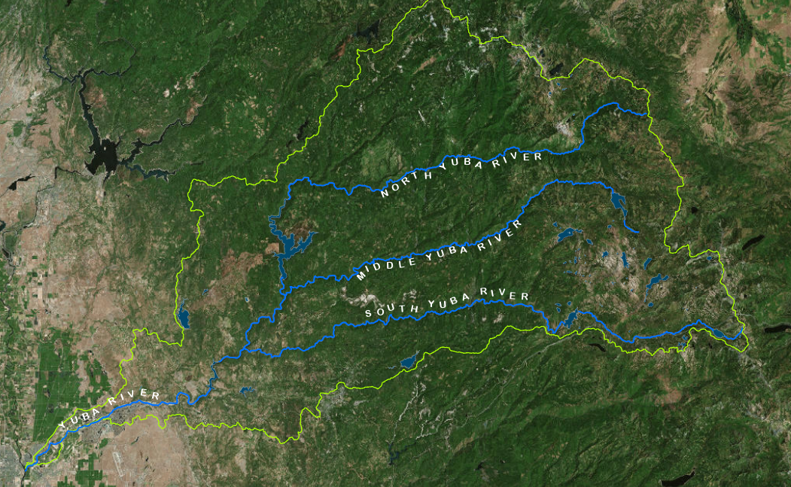

ArcMap. Used as a clickable image in the Story Map
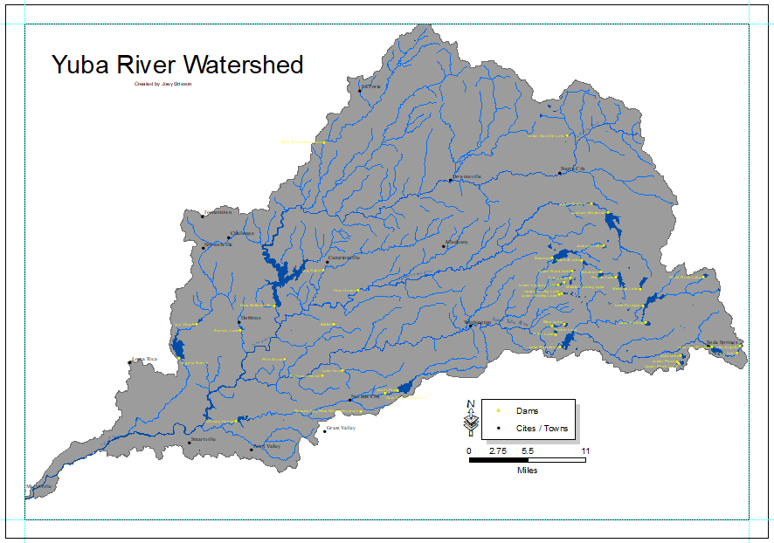

Made in ArcPro but used as a clickable image in the Story Map
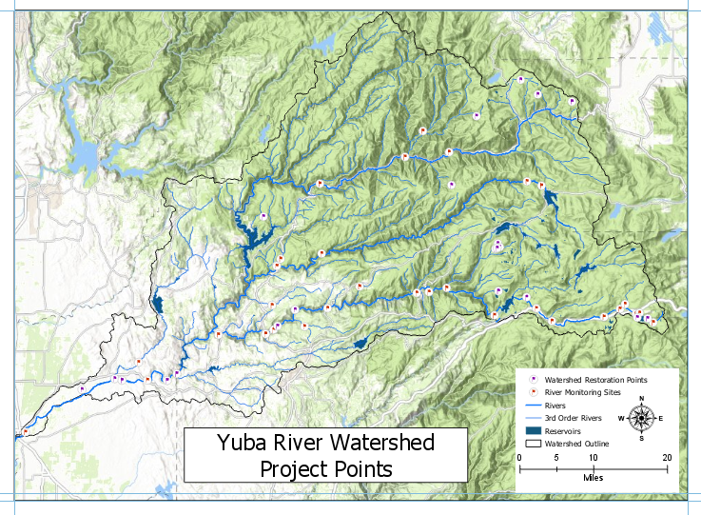
Made with ArcMap. Used as an expandable image in the Story Map.
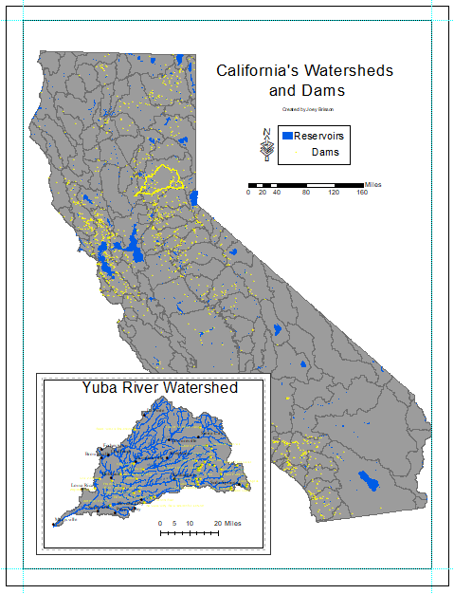

Not used in the Story Map but made as an alternative more for presenting ideas about displaying information to viewers using the Story Map.
