FINAL PROJECT: CRIME / RENTAL UNIT SPATIAL ANALYSIS

PURPOSE:
The City of Citrus Heights wants to determine whether or not higher crime rates are associated with a higher concentration of rental units. If a correlation is shown, they hope to impose an additional fee upon rental property owners in order to raise money to cover the cost of increased police service. They also want to compare single family homes versus multi-unit apartments to see how they affect crime rates. My task is to create a map they can use in a presentation to convince the City Council that an additional fee is justified.

Starting Data:
- ‘2017 RHCC Account Analysis’ An excel file of 6,000+ records that contains data on which homes in the Citrus Heights area are rental units and the number of units per property

- ‘2017 Police Service Calls’ Excel file: Records representing all the police service calls in 2017 acquired from the police department

Reference Data:
- ‘Parcels’ Shapefile: A parcel map of Citrus Heights (used to verify geocoding results)

- ‘Major Roads’ Shapefile: Major roads surrounding the Citrus Heights area

- ‘CH City Limits’ Shapefile: An outline of the city limits

- ‘Streets’ Basemap: Standard Arcmap basemap for reference

Vision:
I want to create a clean and simple ‘heat map’ that overlays rental density on top of police service density. It has to clearly show a correlation between rental units and crime that the City Council will be able easily recognize. I also want to include some reference data, such as arterial streets, to facilitate ascertaining which part of the city is being looked at.

PROCESS:

- Geocoding all the Single Family and Multi-Unit rentals from the ‘2017 RHCC Account Analysis’ excel file
  - First, I cleaned up the excel table. I removed random junk above the table as well as all the special characters in the Column titles
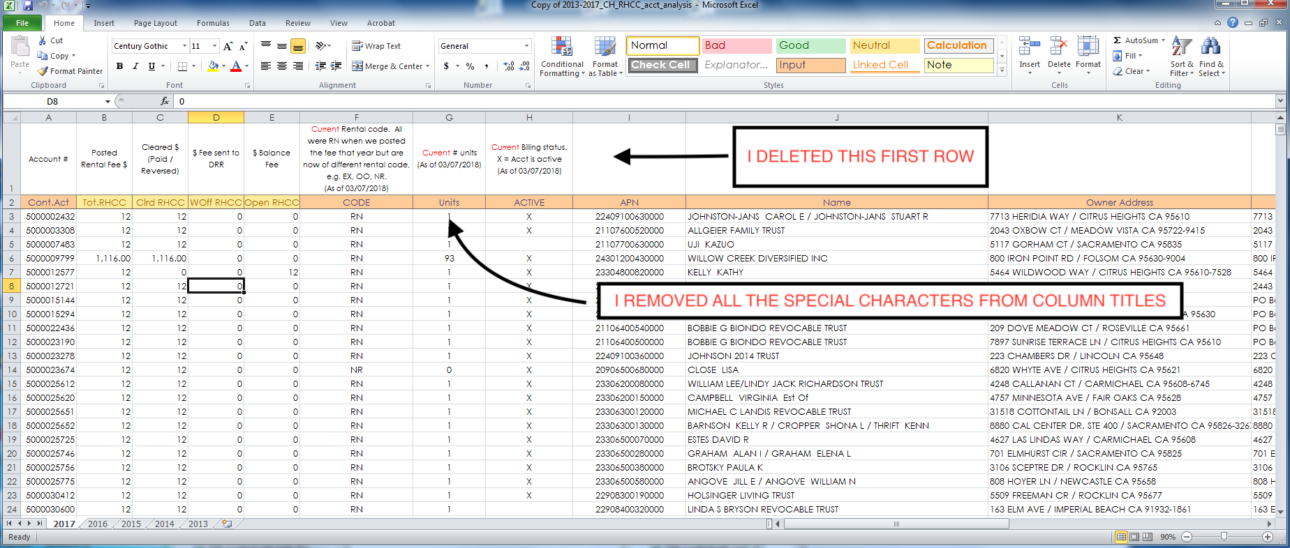
Figure 1: Rental Unit Excel File
  - I then ran ‘Excel to Table’ to bring the data into ArcMap

  - I ran two separate ‘Select by Attribute’ queries to isolate Single Family and Multi-Unit rentals and geocoded each of them to get points
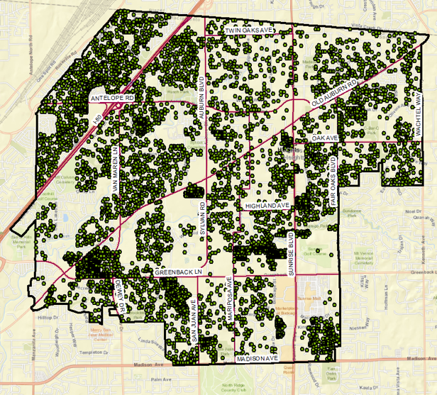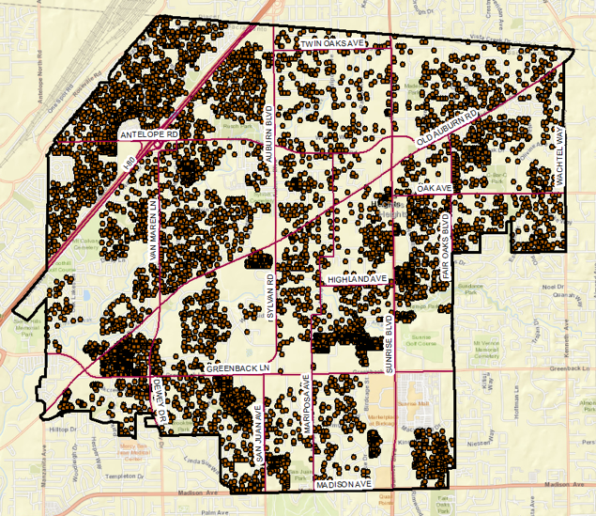
Figure 2: Single Family Points Figure 3: All Residential Units Points
  - This created the ‘All Residential Units’ and ‘Single Family Homes’ layers
  - Geocoded address points were compared against ‘Parcel’ layer for verification
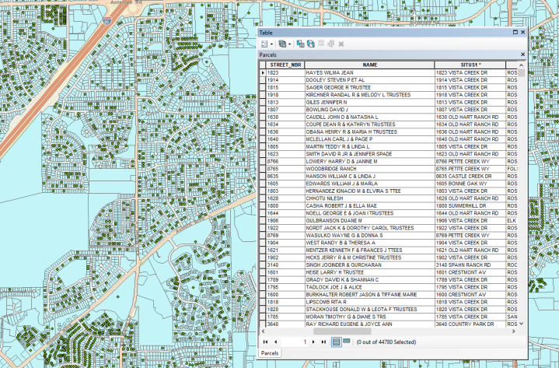
Figure 4: Verification of Rental Unit Geocoding
- Geocoding of ‘2017 Police Service Calls’ Excel File
- a) I started by cleaning up the file as in Step #1

- b) I ran Excel to Table in ArcMap to import the data
- 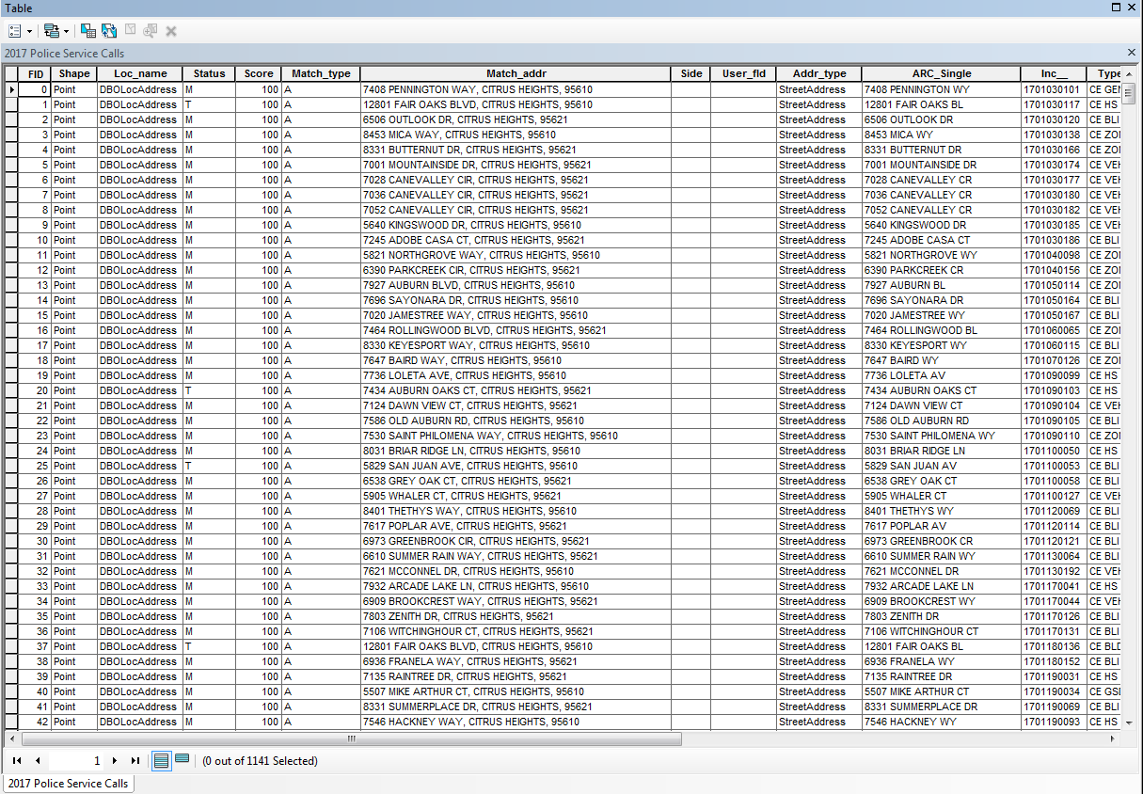
Figure 5: Police Service Data as ArcMap Table

c) I geocoded all records to create a ‘Police Service Points’ layer
- 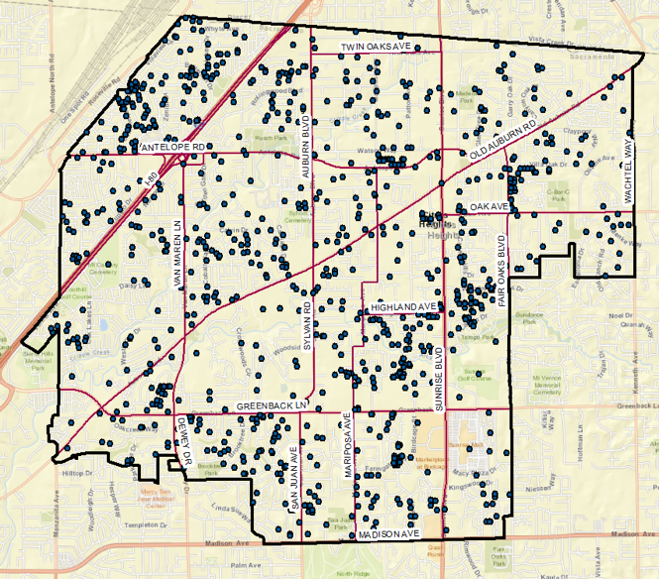
Figure 6: Police Service Call Points
d) I again verified the geocoding results against the ‘Parcels’ layer
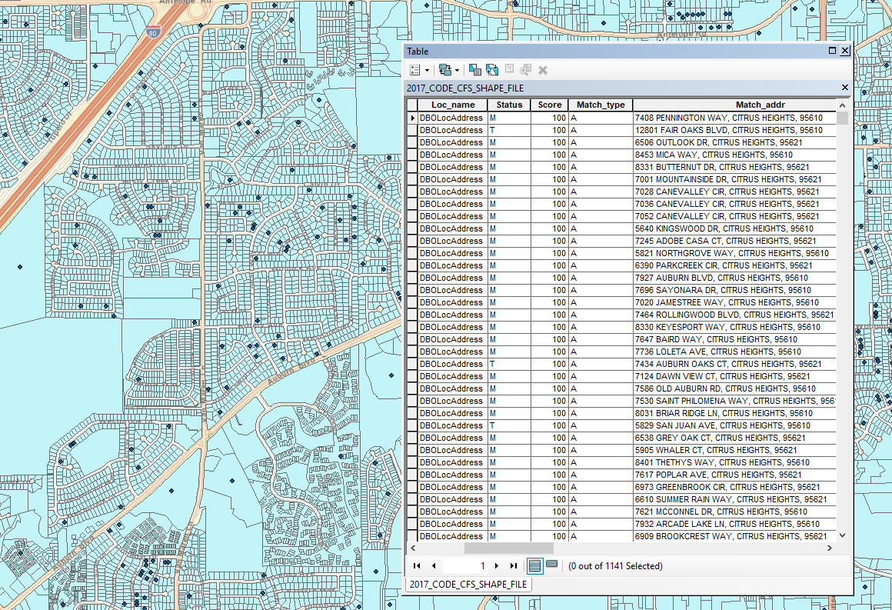
Figure 7: Verification of Police Data Geocoding
- Joining the Rental Unit and Police Service tables in ArcMap
  - I needed to join these layers so I could isolate only the rental units where crime occurred. I would then be able to geocode the addresses of the owners of the rental units
  - I ran the Join tool using the rental situs address fields that were common in both files
  - A Select by Attribute query was used to isolate only rental units where crimes were committed
  - I then created a new feature layer from the selection and used its attribute table to geocode the addresses of the owners of rental units where crimes were committed
  - The city also requested that I add five and ten mile buffers to the Citrus Heights City Limits
Figure 8: Locations of owners of rental units within Citrus Heights
- Performing a Kernel Density Analysis using the ‘2017 Police Service Calls’ shapefile
  - I ran the Kernel Density tool using acres as the unit of measurement
  - I altered the number of classes and the classification ranges to make them easily understandable
  - The color scale was customized to blue, because I knew the police would whine if it wasn’t
  - Bilinear Interpolation was used because it’s so smooth
  - The resulting layer was named ‘Police Service Density’
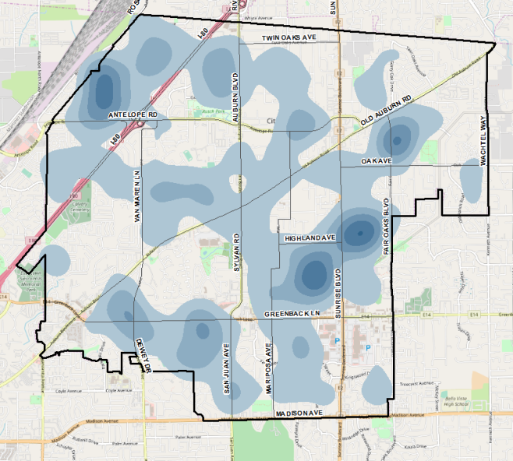
Figure 9: 'Police Service Density' layer
- Performing Kernel Density Analyses on the ‘Single Family’ and ‘Multi-Unit’ layers
  - I ran the Kernel Density tool and used acres again as unit of measurement
  - This time I used the ‘No_of_Units’ column as the Population Field for the Multi-Unit rentals
  - I tweaked with the number of classes and the classification ranges to make them more easily understandable
  - I set the color scale to red (for heat) and used bilinear interpolation again
  - The resulting layers were named ‘All Rental Unit Density’ and ‘Single Family Rental Density’
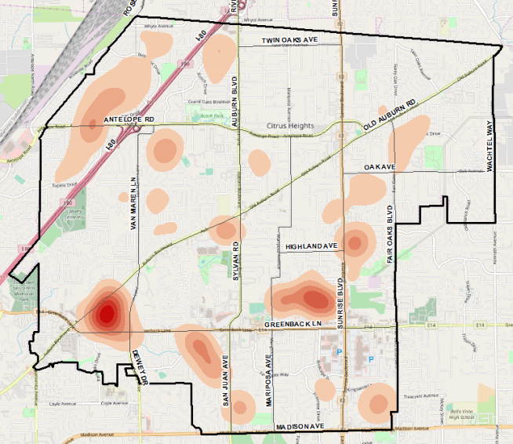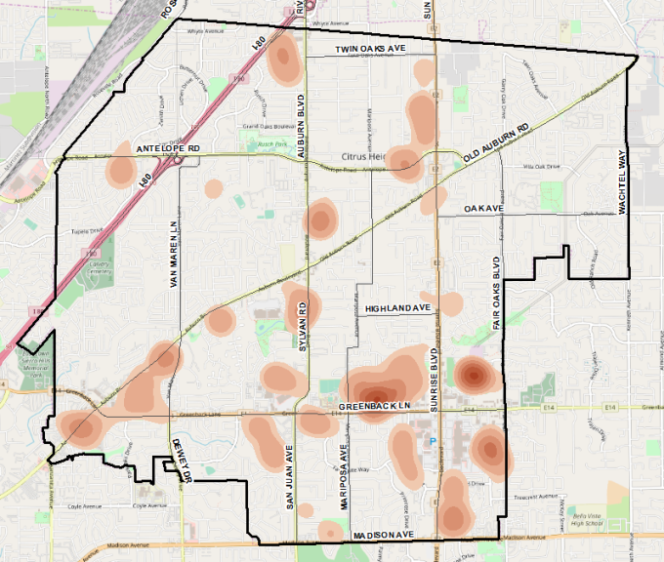
Figure 10: 'Single Family Rental Density' layer Figure 11: 'All Rental Unit Density' layer
- Creating the Layout and Final Maps
  - I used landscape orientation
  - The legend was customized to show only what I wanted, and to suite the visual style of the map
  - I added a customized scale bar as well as a North arrow
  - Of course I had to slap on the new Citrus Heights’ logo
  - I created a colored rectangle and put my title and sub-title in it
  - I played around with the transparency on the density layers so both layers as well as the underlying basemap could be distinguished

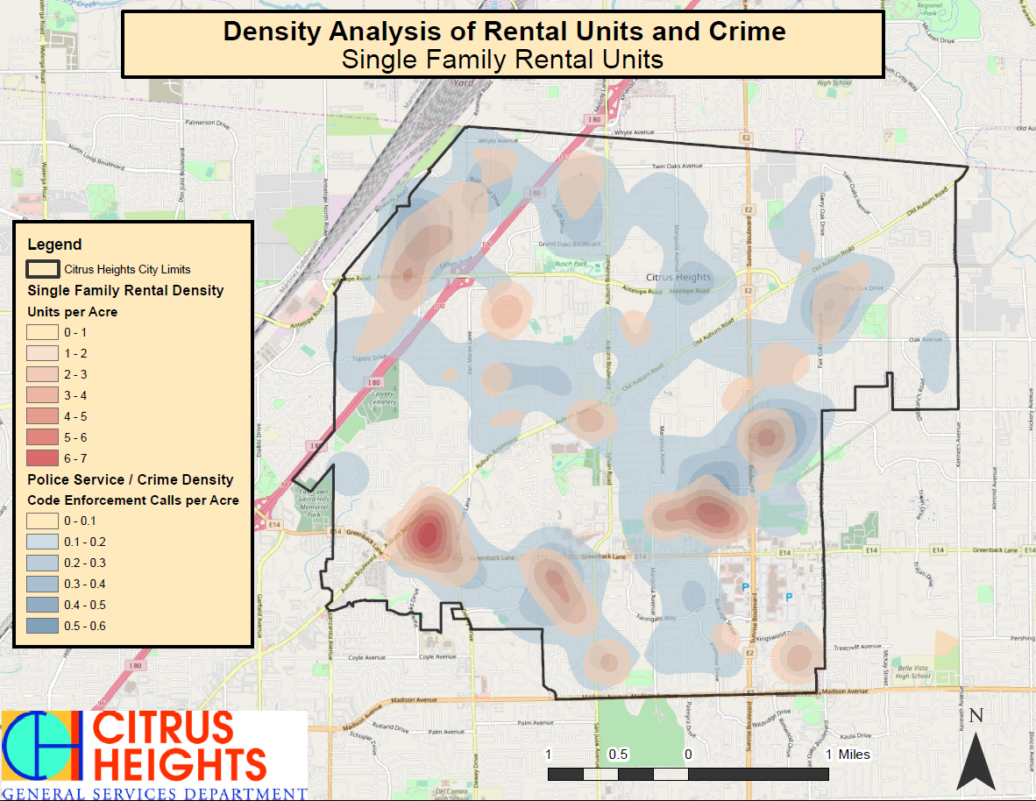
Figure 12: Final Map #1 Single Family / Crime Density Analysis
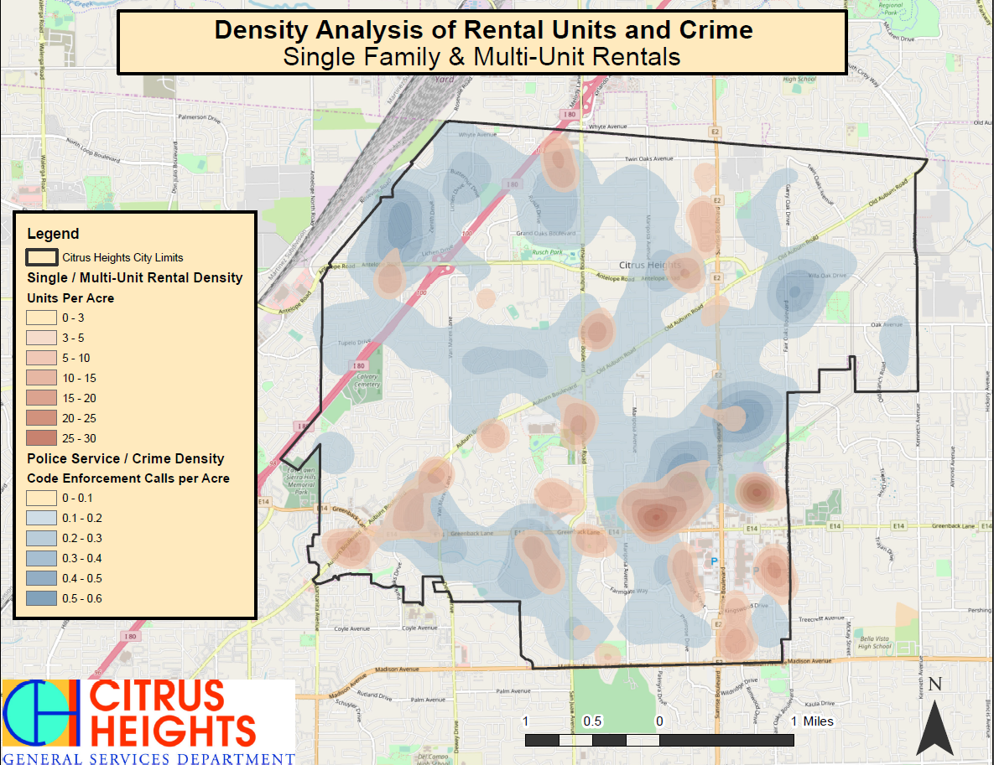
Figure 13: Final Map #2 All Rental Unit / Crime Density Analysis
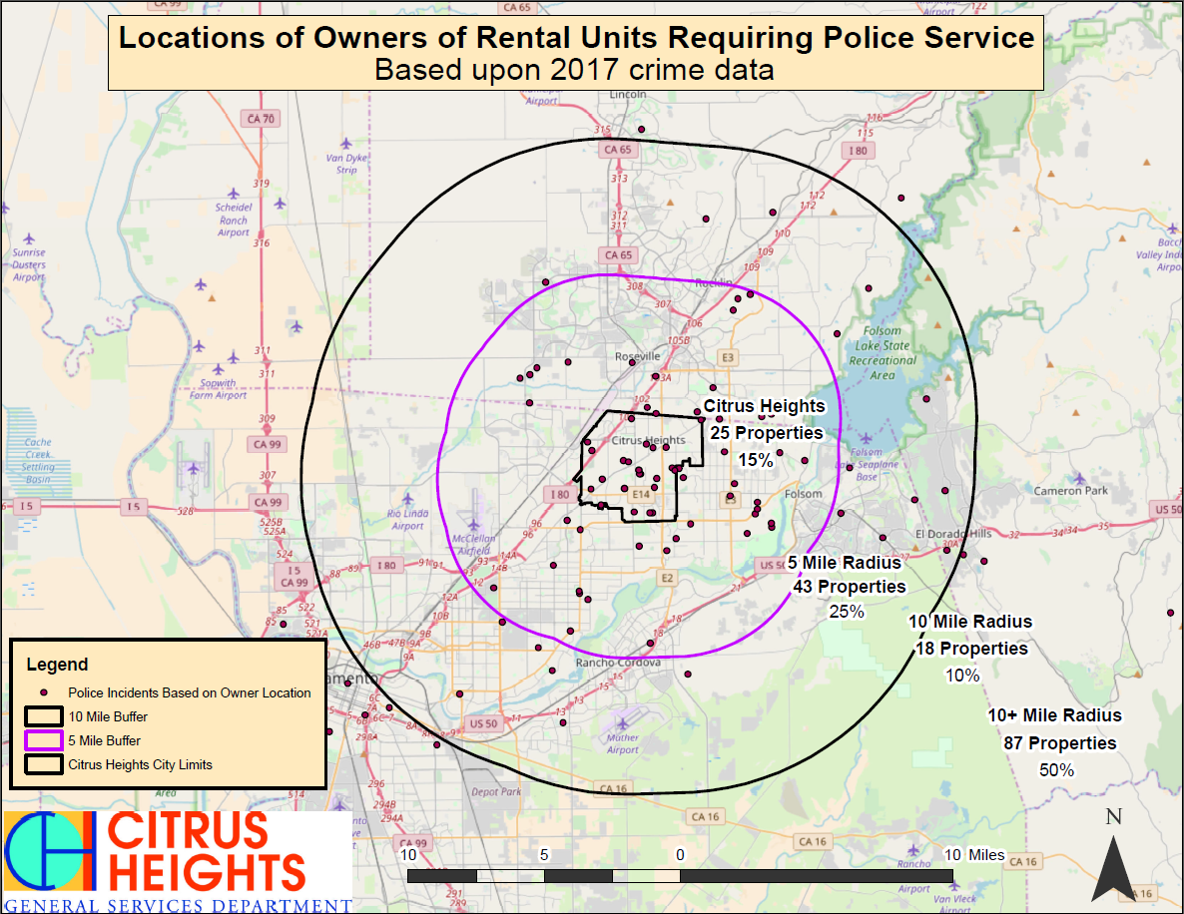
Figure 14: Final Map #3 Owner of Rental Unit Analysis
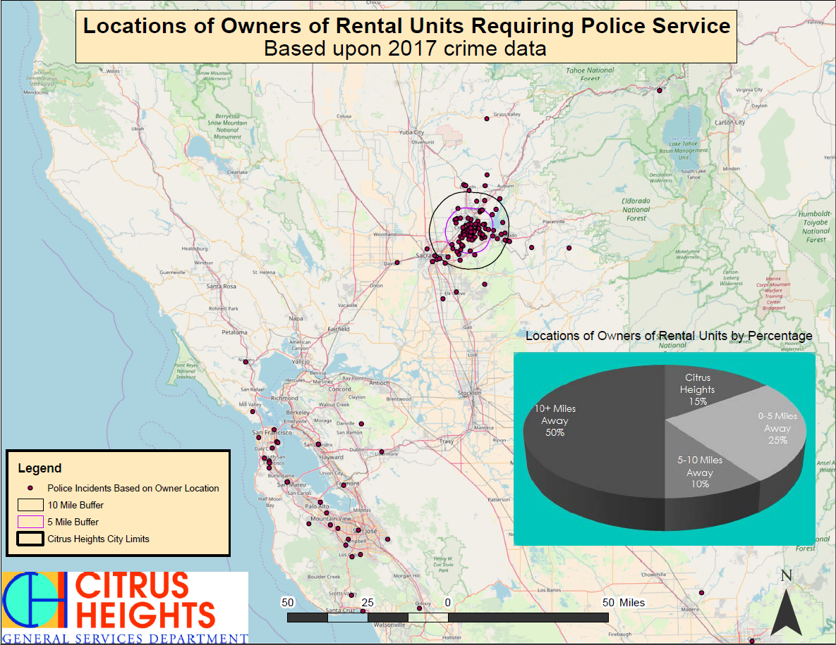
Figure 15:Final Map #4 Owner of Rental Unit Analysis (zoomed out)

DIFFICULTIES ENCOUNTERED

Importing Excel data into ArcMap
I ran into my first problem when I attempted to import the Excel files into ArcMap. I ran Excel to Table, and the resulting table was a total mess. I made several attempts with similar results. After consulting with my professor for help, I was able to get the files imported.

Performing the Join Operation
When I first joined the Rental and Police excel files, the resulting attribute table contained only null values for the joined field. This wasn’t right. When I brought the project to class for assistance, the join performed correctly without issue (of course). I ‘m assuming that I must have left a selection on one of the two attribute tables before performing the join.

Finding time
With a pregnant wife, three young children, part-time work and full-time school, time was really scarce. I had access to Arcmap at work, but they kept me pretty busy. Lots of work done during lunch!

Displaying the Results of the Spatial Analyses
I spent a lot of time playing around with the number of classes and customizing the range of each class. I needed to do this so the data displayed in the legend wasn’t weird numbers. I also spent a bit of time messing with the transparency settings of the overlapping layers. I wanted to be able to see one layer through the other, as well as being able to see the streets beneath both layers.

Storing the data files for my project correctly
When I was moving my project between work and class via USB, I had problems opening my shapefiles. After asking for help in class, I realized I forgot to create a geodatabase for my project to store the geospatial data.

WHAT I’VE LEARNED DURING THIS PROJECT

How to ‘Clean Up’ Excel files
Removing special characters from column titles and deleting any fields that are located above the desired data table helps Excel to Table function correctly

Paying attention to selected records on attribute tables
I ran into problems several times because I neglected to notice that a selection was applied to the features I was manipulating. I learned to clear the selected records when I could remember, and to pay attention for this in general.

How to create geodatabases for storing shapefiles correctly
I’ve done this before, but during this project I learned how essential this really is. Paying attention to how you manage data storage associated with your maps is critical if you want the map to function correctly on other machines.
I also learned how to change the default geodatabase within ArcMap. Several times I accidentally saved data to an undesired default geodatabase, which was causing me problems. So I researched online how to change the default geodatabase so I wouldn’t encounter this issue again. This really helped for me.

Map Design
Throughout the process, I learned that keeping the map simple and highlighting only pertinent data seemed to have the greatest visual effect. It’s really important to have the various elements of a map in a certain kind of balance, where no single element distracts from the others and they all form part of a whole.

How Powerful of a Tool GIS Is
At the end of the project, I realized that I created a powerful piece of visual evidence that represented thousands of pieces of data in a simple and appealing map. If I were a City Council member, the map would easily convince me of the correlation between rental units and crime. The ability to represent complex datasets as simplified visual images is a powerful tool that can be used in so many different ways!

