Delineating Watersheds using ArcGIS
Justin Sena
Sierra College
Geog 93

The following procedure describes how to draw the watershed regions for any specific point. The below procedure describes the process in terms of recreating accepted watersheds in order to verify that the procedure produces sufficient results. It is worth noting that if you know the location of your outlet points ahead of time, you can skip steps 4 and 5. The watershed tool’s inputs are only the flow direction raster and the outlet points.

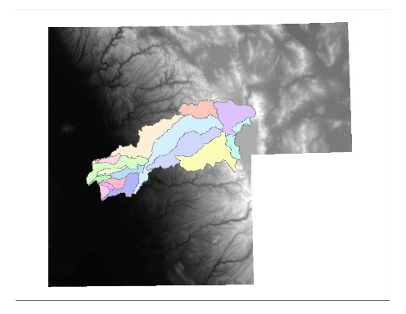
Acquire and Clipping a DEM
- In Order to perform this process, you must have a digital elevation model (DEM) for which all analysis will be based on. One place to acquire a DEM is from the USGS Earth Explorer web service. From the service, you can download a DEM, or multiple if needed of the region you wish to analyze. I required 5 DEMs for my project.
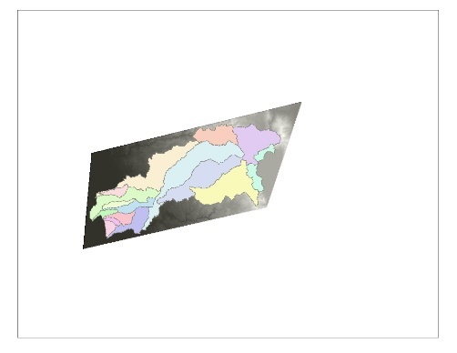
- Having 5 DEMs required that I use the image analysis tools to create a mosaic of the DEMs so that they were one DEM that covered the entire region of study.
- I then clipped the mosaic to the smallest shape appropriate. This reduced unnecessary processing and clearer results.

Fill the DEM
- In order to use the DEM effectively, it needed to be scrubbed of discrepancies.
- Sinks (and peaks) are often errors due to the resolution of the data or rounding of elevations to the nearest integer value.
- Sinks should be filled to ensure proper delineation of basins and streams. If the sinks are not filled, a derived drainage network may be discontinuous.
- The tool can also be used to remove peaks, which are spurious cells with elevation greater than would be expected given the trend of the surrounding surface.
- The output of the tool will look the same as the input.
- Input: DEM
Output: Filled DEM Raster
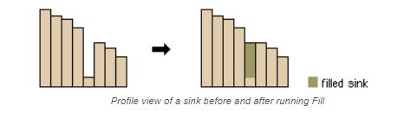
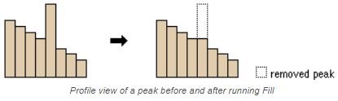

Flow Direction Tool
- One of the keys to deriving hydrologic characteristics of a surface is the ability to determine the direction of flow from every cell in the raster. This is done with the Flow Direction tool.
- This tool takes a surface as input and outputs a raster showing the direction of flow out of each cell.
- Each cell is coded with a value that describes which of its surrounding cells has the lowest elevation value and would therefore take on the flow from itself using the direction coding key below.
- Input: Flow Direction Raster
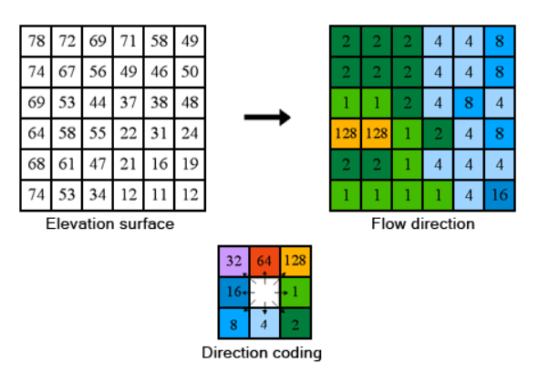
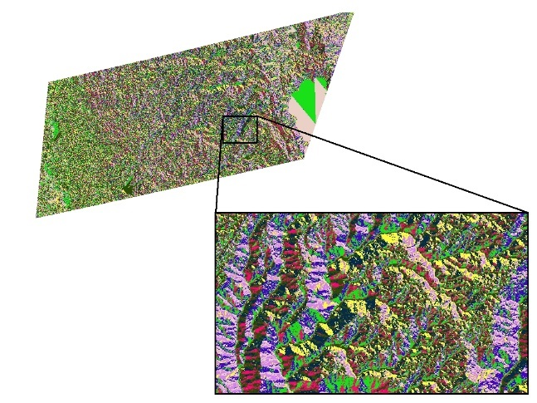
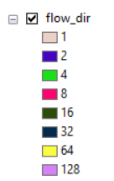
Output: Flow Accumulation Raster

Flow Accumulation Tool
- The Flow Accumulation tool calculates accumulated flow as the accumulated weight of all cells flowing into each downslope cell in the output raster. If no weight raster is provided, a weight of 1 is applied to each cell, and the value of cells in the output raster is the number of cells that flow into each cell.
- Input: Flow Direction Raster
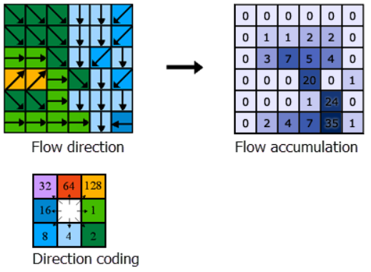
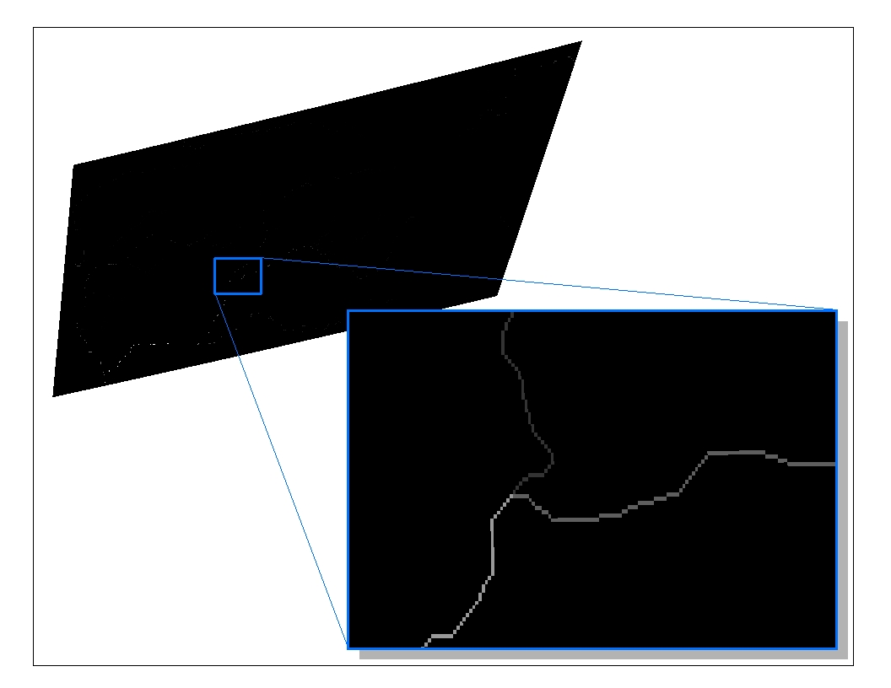
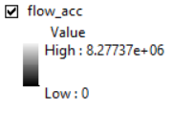
Output: Flow Accumulation Raster

Reclassify the flow accumulation raster into “channel” & “non-channel” pixels
- Using the Reclassify tool under the Reclass toolset (part of the Spatial Analysis extension) you use the flow accumulation raster to create a stream channel raster that displays any cells with accumulation values over a specified amount and assigns “NoValue” to those under that amount.
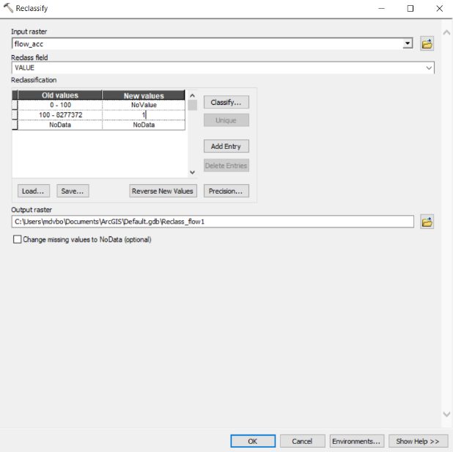
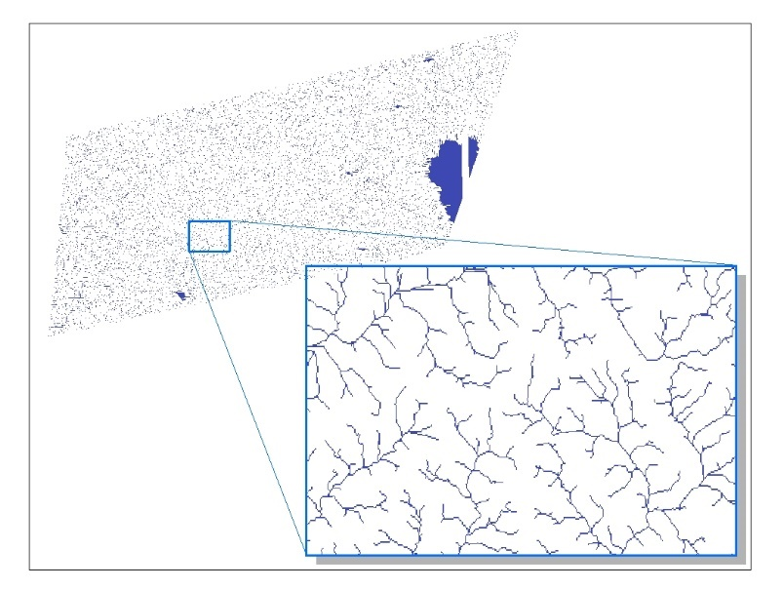
- I chose 100 as my value. This means that any cell that had at least 100 other cells eventually flowing into it would be displayed and any cells with values less than 100 would not.

Establishing Outlet Points
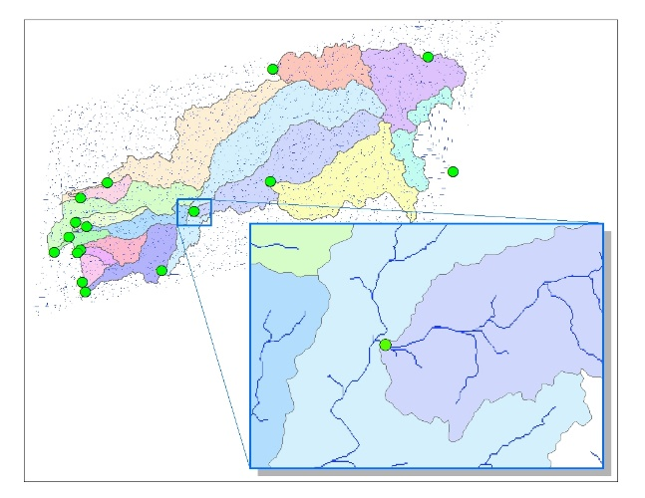
- In order to draw watersheds, you must establish points for which you want to determine the watersheds for. Since my goal was to recreate Placer County’s watersheds, I needed to determine the outfalls for each watershed, which was easier said than done.
- The process I used was to draw graphic markers onto the map at locations that appeared to be where the streams ultimately left each watershed.
- After drawing the marker points, you must convert them to point features by right clicking on “Layers” and selecting “Convert Graphics To Features…”
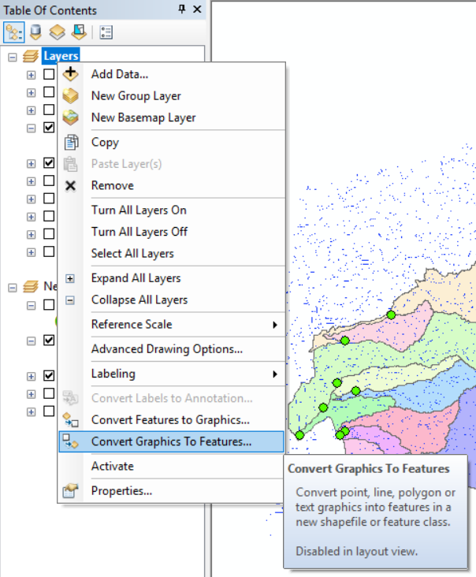
- The output looks the same. There is now a point feature with points at the same position as your graphic markers.

Snap the outlet points to high accumulation pixels
- Use the Snap Pour Points Tool to create a raster that colors the pixels with the highest accumulation value within a specified radius of each outlet point.
- If you zoom into each point, you can see the colored pixel underneath the outlet marker point.
- The outlet points being in raster form is necessary for the watershed tool.
- Input: Outlet Points
Input Raster: Reclassified Streams
Output: Snapped Outlet Point Pixel Raster
Snap Distance: Depends on the study, I used 4.
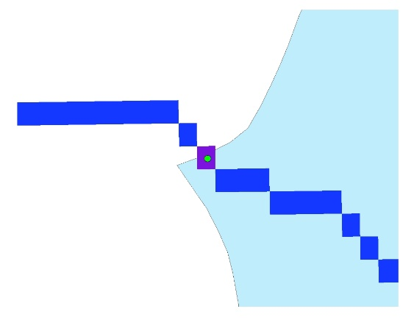
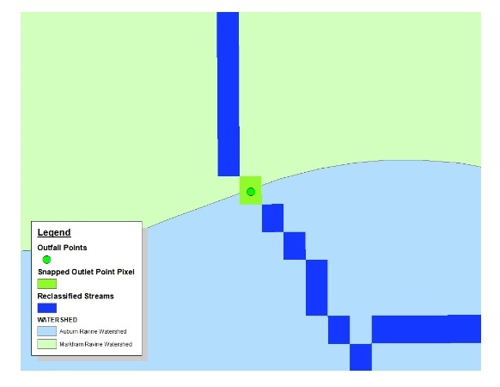

Watershed Tool
- Use the Watershed tool to create watersheds from each specified outlet point utilizing the flow direction raster
- At this point you can convert the raster to polygons using the raster to polygon tool which gives you watersheds as polygons for further analysis.
- Input Flow Direction Raster
Input: Outlet Point Pixel Raster
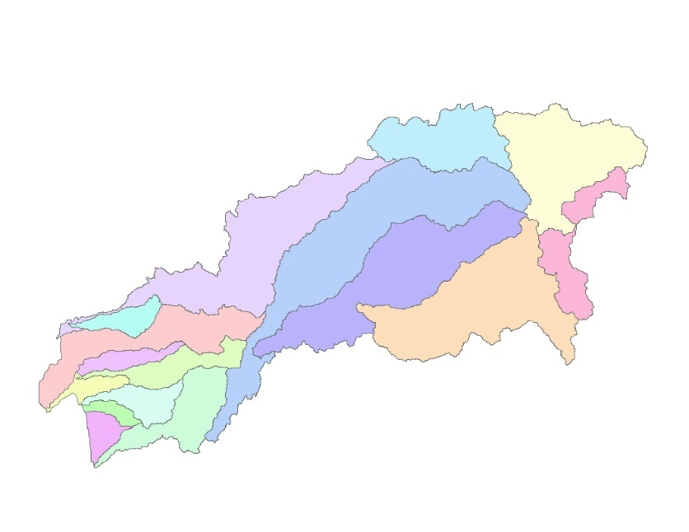
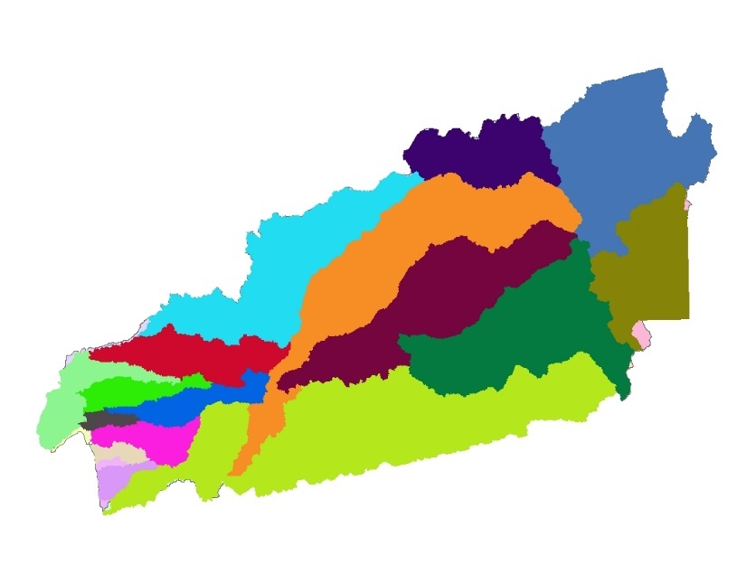
Output: Watersheds Raster
- You’ll see some differences in my results and the accepted watershed shapes. This is primarily due to differences in projected coordinate systems, to some of the watersheds being shaped the way they are due to man-made water streams, and because of lack of precision in the DEM I used to create the watersheds.

Lakes Watersheds
After attempting to recreate the watersheds accepted by Placer County, I went on and used my process to create watersheds for all of Placer County’s lakes that had over 100 surface acres of water. By following the same steps, with outlet points set at each lake’s outlets, I was able to create each lake’s watersheds.
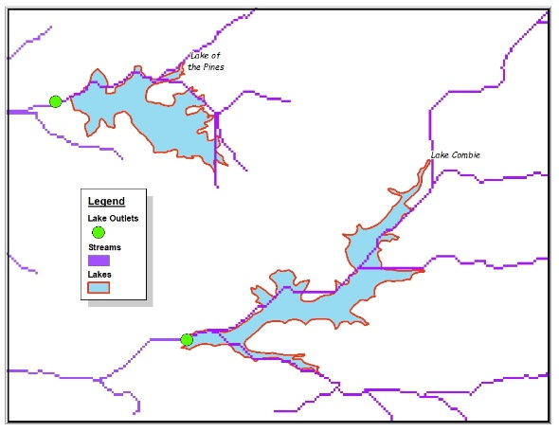

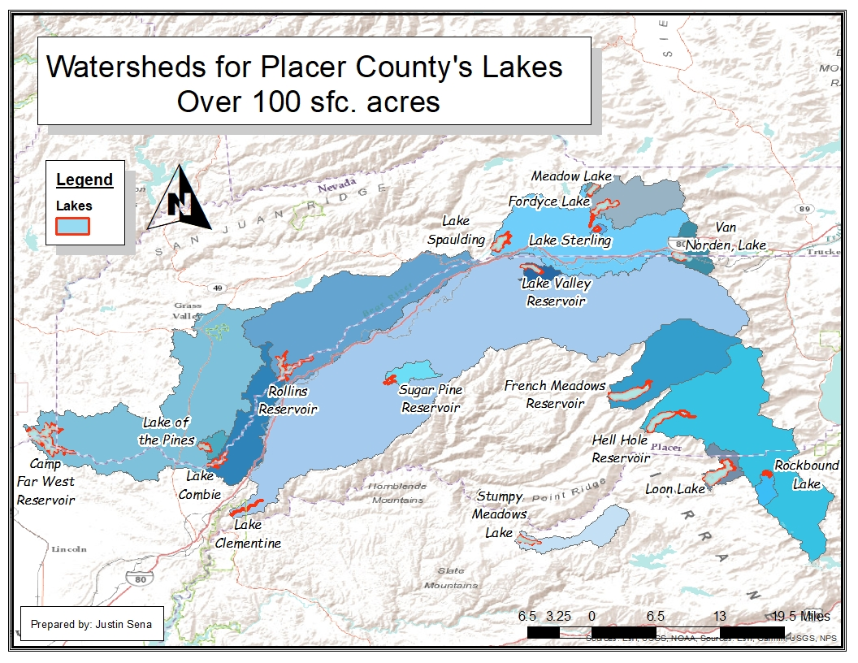

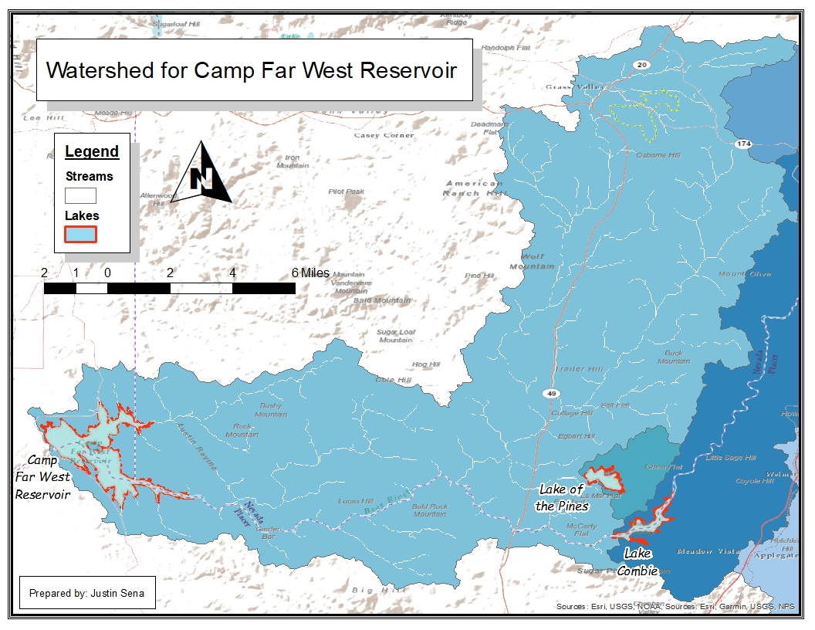

Limitations
- Only analyzes the streams based on the Earth’s elevation. Does not account for manmade channels.
- Improved precision in DEM helps to draw more accurate watersheds.

Takeaways
- Establishing bookmarks and data driven pages on each outfall point was really helpful for navigating between them and working at a closer scale.
- If you know the exact location of the outlet points you wish to analyze, you do not need to undergo the flow accumulation and stream reclassification steps and can go straight to the watersheds tool.

Resources Used
- http://gis4geomorphology.com/watershed/
- http://pro.arcgis.com/en/pro-app/tool-reference/spatial-analyst/an-overview-of-the-hydrology-tools.htm

