Alison Nevins
Geo 93 Project
Spring 2018

My initial intentions with this project was to create a story map of several years of Christmas Bird Count (CBC) data in the Sacramento area. In the end I ran out of time to create a heat map for each year of data that I had since it took me a while to decide how to represent each species and habitat type. I ended up making one map with the habitat types designated within the circle and one heat map of which habitats the birds use most. I also ended up with a two pie charts showing percentage of habitat type and percentage of habitat usage, and a bar graph comparing the two.
The CBC happens every year from December 14th through January 5th. Volunteers join together to count birds in particular areas designated by the National Audubon society. These areas, or circles, are then split up according to the circle leader and volunteers are grouped together to count their own areas in the circle. The data from this count is used in conservation studies and helps scientists to keep track of bird population health across the country.
I originally planned to use the Lincoln area circle since I have actually participated in that count but the data didn’t go back as far as I wanted to go. Therefore I used the Sacramento area count. I got the bird count data from the Audubon’s Christmas Bird Count Data website (Figure 1). The data was downloaded as excel sheets. I downloaded data from 1967-2017 for every five years. The first thing I had to do was combine the data from the 11 years into one excel sheet. To make the map I needed the CBC circle data, which I was able to find in an online map. I then downloaded the data to a desktop version and exported only the Sacramento circle.
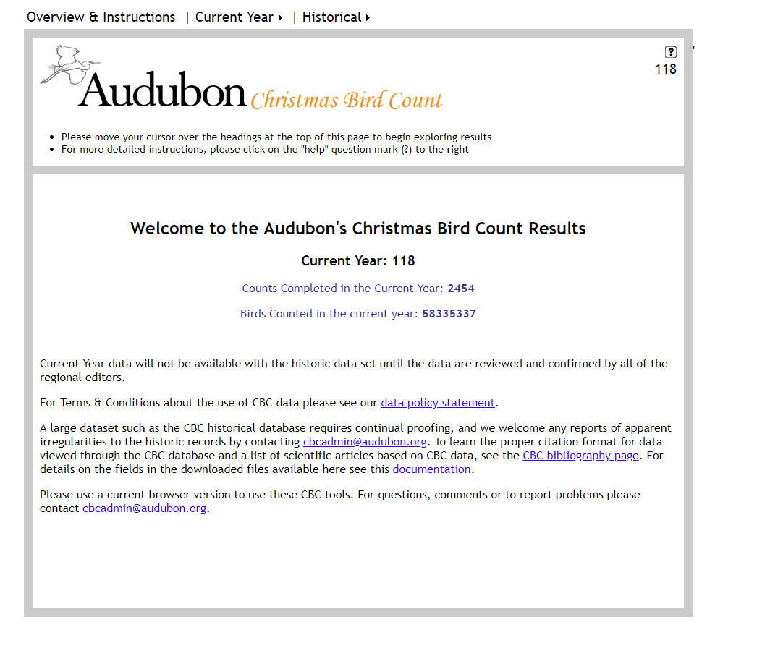
Figure 1
After I gathered the bird and circle data I needed to find the habitat data. This was harder than I expected in to be. I was able to find a habitat layer online which designated several types of farmland, urban areas and water, such as rivers and lakes (Figure 2). I also found a wetland habitat layer online and I used the Sacramento parks and hydro layers from our class canvas site. The first step was clipping the habitat layers by the CBC circle, since that was the only data I needed (Figure 3). In order to get the data to be useful for my purpose I had to mess around with the habitat type, for example there were many different types of farmland which I then represented as just farmland or grazing. To do this I created a new field in each of my habitat layers called Habitat_Ty. I then added in what I was classifying each habitat as. The habitats I chose are:
- Farmland
- Grazing
- Lake
- River
- Park
- Urban
- Wetland
- Canal
- Pond
- Other
- Other water
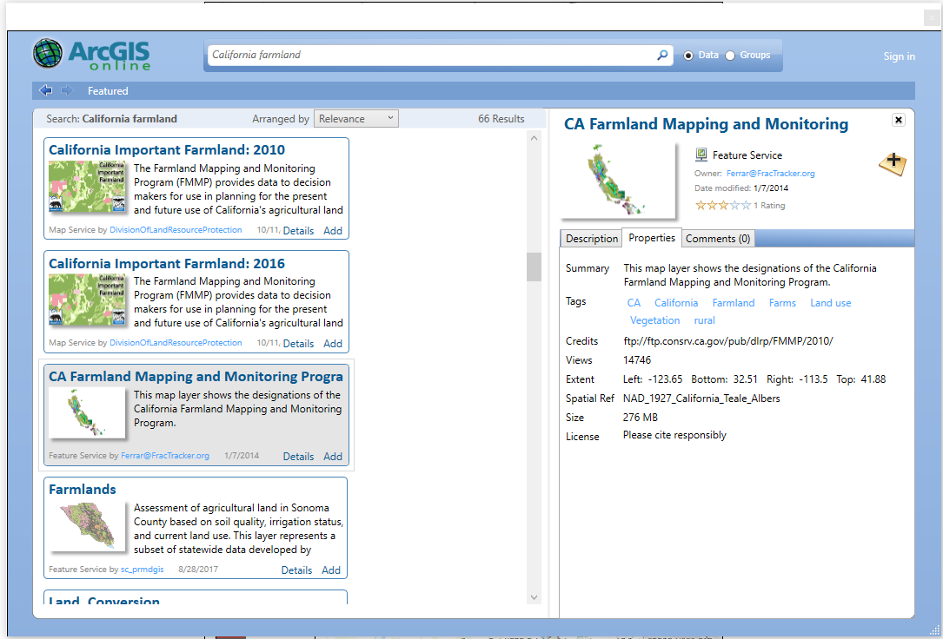
Figure 2
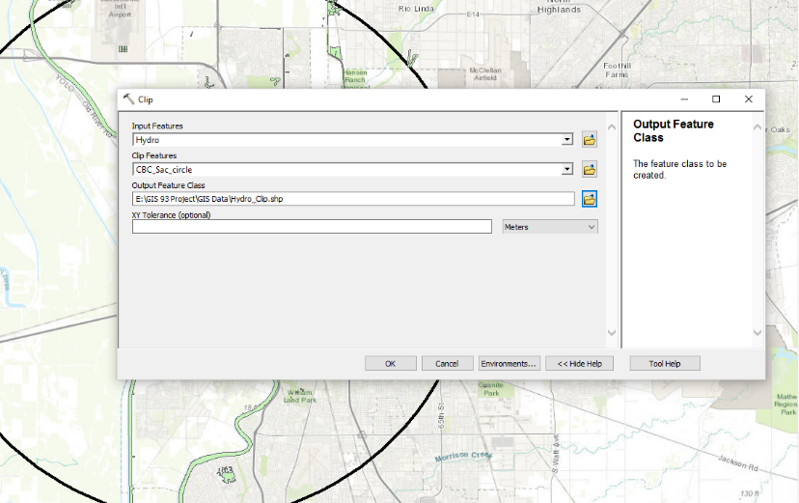
Figure 3
After designating the habitat types I had to work in excel to manage the bird data. As I mentioned previously this took me a little bit of time. There were 218 different species across all years which was too many different types to represent clearly on a map or a graph. I started by grouping species together by taxonomic groups decided in my Sibley Bird book. This worked for some groups that had many species such as swimming water birds, and small forest birds but not so well for some taxonomic groups that had only one or two species. This led me to grouping the smaller taxonomic groups together. I eventually came up with 11 different groups:
- Swimming Water birds
- Wading Water birds
- Raptors (Diurnal and Nocturnal)
- Upland Game/Pigeons
- Hummingbirds (even though this was a small group they didn’t really fit in with anything else)
- Woodpeckers
- Flycatchers and Swallows
- Crows, Ravens and Jays
- Small Forest birds (warblers, wrens, thrushes, etc)
- Sparrows
- Blackbirds
After designated each bird group I realized that some groups occupied multiple habitat types, for example swimming water birds are in lakes, rivers and ponds. I also thought that there were still too many different habitat types to communicate the relationship between species use clearly. Therefore I combined the habitat types for the graphs into:
- Farmland/Grazing
- Lake/River
- Park
- Urban
- Wetland/Pond/Canal/Other water
- Other
I was able to create graphs representing the percentage of habitat used by each species after I combined habitat types. Now the next step was getting the percentage of habitat type to compare with. This also ended up taking me a little bit of time. Before I created my own new field in the attribute table for each of my habitat layers, as mentioned above, I first tried to do a union between all the habitat layers (Figure 4). After the union I turned off the fields in the attribute table that I didn’t need and then added a new field and started editing. I soon realized that there were a lot of records and I was more likely to make a mistake in habitat designation. Instead I went back to the original layers and added the Habitat_Ty field to each original layer. This minimized the possibility of making a mistake and made it easier to get through. After everything was edited I then used the union tool. This turned out to be the wrong tool for what I wanted. I instead used a merge between the land layers: parks and farmland, and the water layers: wetland, and hydro. After that I was able to merge the land and water layers together to create one layer: Habitat.
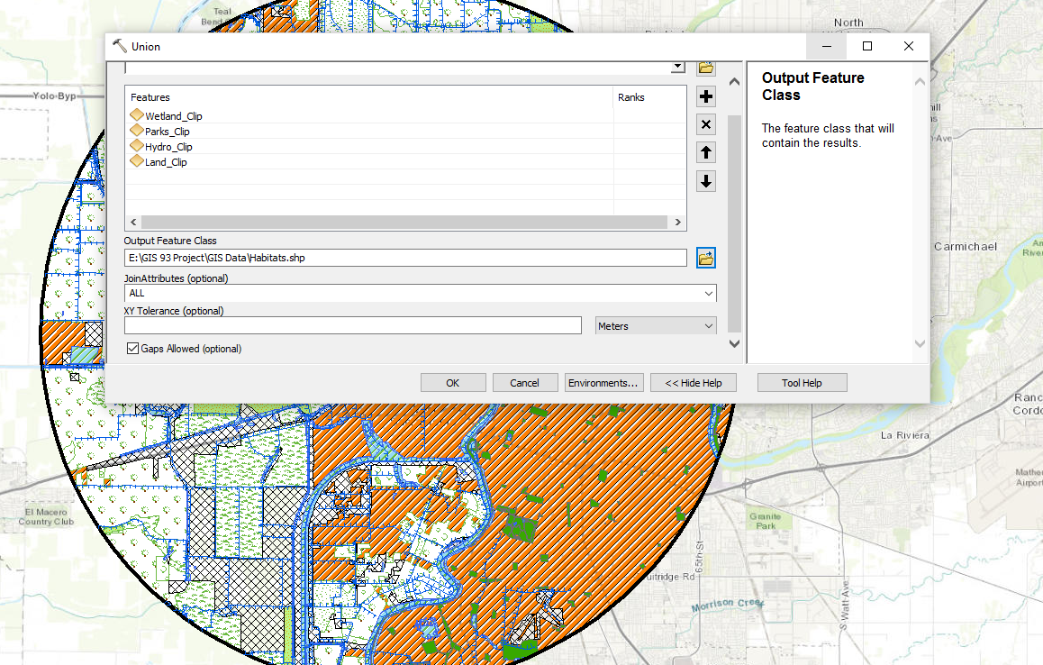
Figure 4
The next step was to determine the percentage of habitat type. I first started with the frequency tool which would have been fine except it only counted the number of polygons not the acreage of each habitat type (Figure 5). In order to figure that out I first had to calculate the acreage, for which I used the field calculator. In order to make adding up the total acreage for each habitat easier and faster I copied the attribute table to an excel sheet and did the calculations there (Figure 6). Then I was able to combine the habitat types into the 6 groups and create several graphs: a pie chart for percentage of habitat, a pie chart for the percentage of habitat use and a graph comparing the habitat type to the habitat usage.
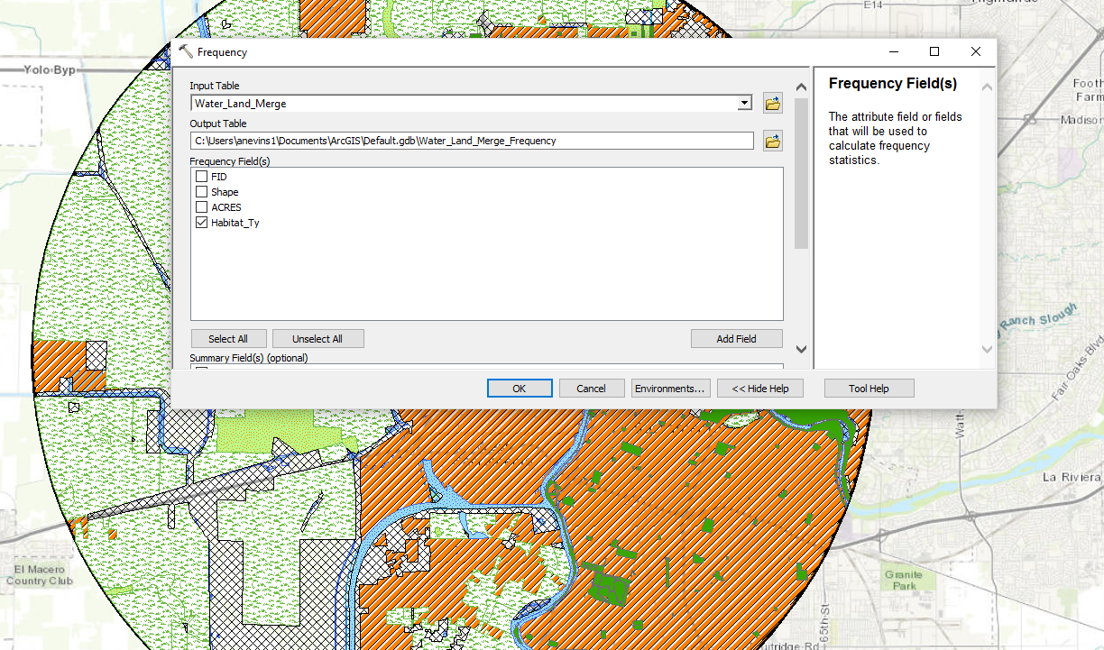
Figure 5
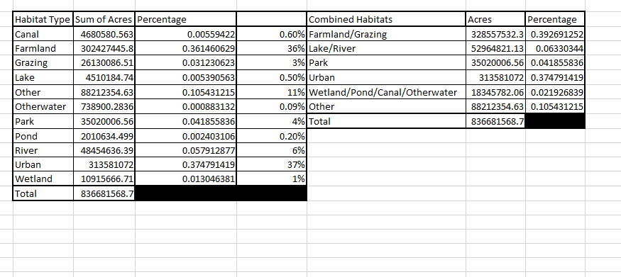
Figure 6
In between my excel work with the bird groups and species I was able to create a habitat type map, choosing different Symbology to represent each habitat type. I also in the end added the percentages of each habitat type to the legend.
In order to create the heat map of habitat use by bird groups I first exported a copy of the habitat layer that I used to create the habitat map. This left me with two copies of the same layer, which allowed me to represent two different things with the same set of data. Since there were a lot of different polygon layers in the habitat data I used the dissolve tool by the habitat type (Figure 7). This made it easier to enter the percent of habitat use since there were only 11 layers instead of hundreds. I ran into a little problem here since the percentages I had already calculated were for the 6 combined habitat types and not the 11 types I now had to represent. Luckily I still had all my earlier data and was able to figure this out fairly easily. After re-doing the percentages for the 11 habitat types I added a new field and edited it. Next I used the Symbology tab to create gradient representation for the percentages (Figure 8).
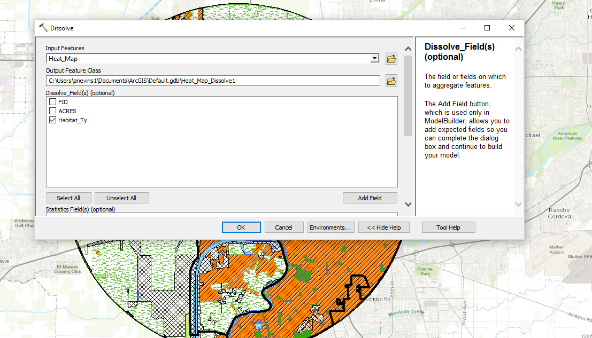
Figure 7
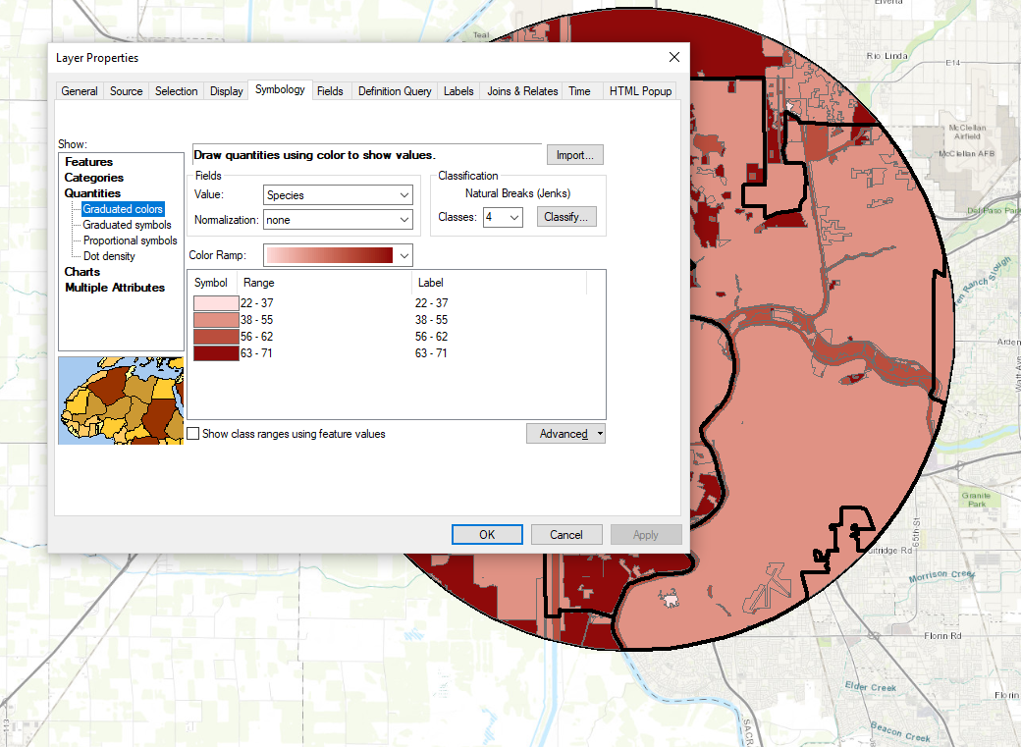
Figure 8
If I had more time it would be interesting to go through for each year I downloaded and show the percentage of habitat use and then you could compare the change over time. Although I am not sure there would be much change since I could not see that much change in the extra graphs and tables I made when I was figuring out how to represent the bird data. I also had a hard time finding habitat data for the different years that I was trying to represent.
During the course of the project I learned how to use the field calculator and frequency tool even though I didn’t end up using the table that the toll gave me. I also learned how hard it is sometimes to come up with a way to represent a complex dataset in a simple and effective way. In addition I learned two different ways to represent the same type of data on the same map.
Final Maps and Graphs:

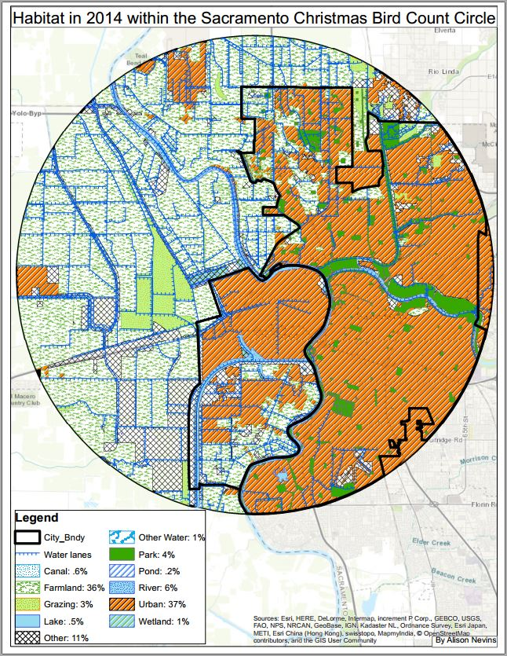
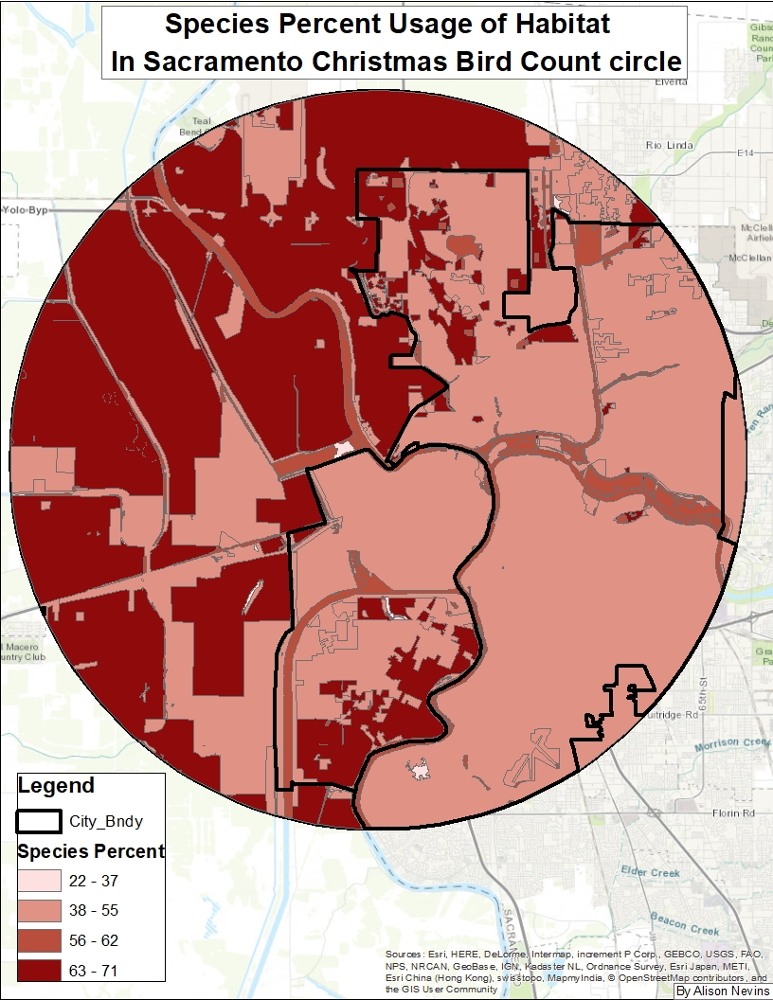

Percentage of Habitat Type vs Species use Percentage per Habitat Type

