Remote Sensing Project
Desolation Wilderness Snow Cover
2018 & 2019

GEOG 342 – Introduction to Remote Sensing
John Welsh
December 15, 2019
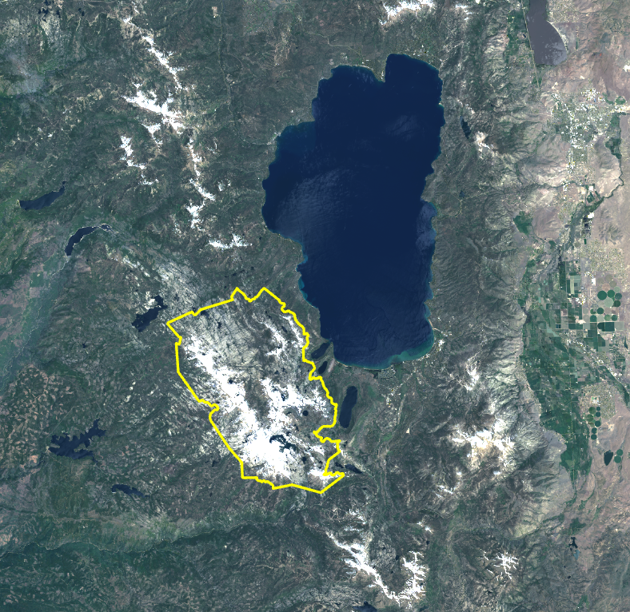

Project Summary
This project will look at the snow coverage changes from the years 2018 to 2019 in Desolation Wilderness. Located west of Lake Tahoe, Desolation Wilderness is approximately 64,000 acres of sub-alpine and alpine forest, granite peaks, valleys, and lakes. For perspective, Desolation Wilderness is over half the area of Lake Tahoe.
Over the past several years, I have observed a trend in the amount of snow that remains well into the Summer season. I frequently hike and backpack in Desolation Wilderness so I thought it would be interesting to compare the snow cover of June 10, 2018 and June 13, 2019. In this project, I use Landsat 8 imagery acquired from EarthExplorer on the United States Geological Survey (USGS) website, for my image analysis and comparison.

Purpose
In this report, the goal is conclude that the snow cover in Desolation Wilderness was greater in the year 2019 than it was in 2018 and to determine the percentage of change.

Imagery Source and Acquisition
As previously mentioned, EarthExplorer was the source of imagery used for this project.
In the Search Criteria tab, the Address/Place entered was “Desolation Wilderness.” Clicking the Show button revealed a hyperlink with details about Desolation Wilderness including, Address, City, State, Zip Code. Clicking on the hyperlink reveals the Latitude and Longitude of the desired location.
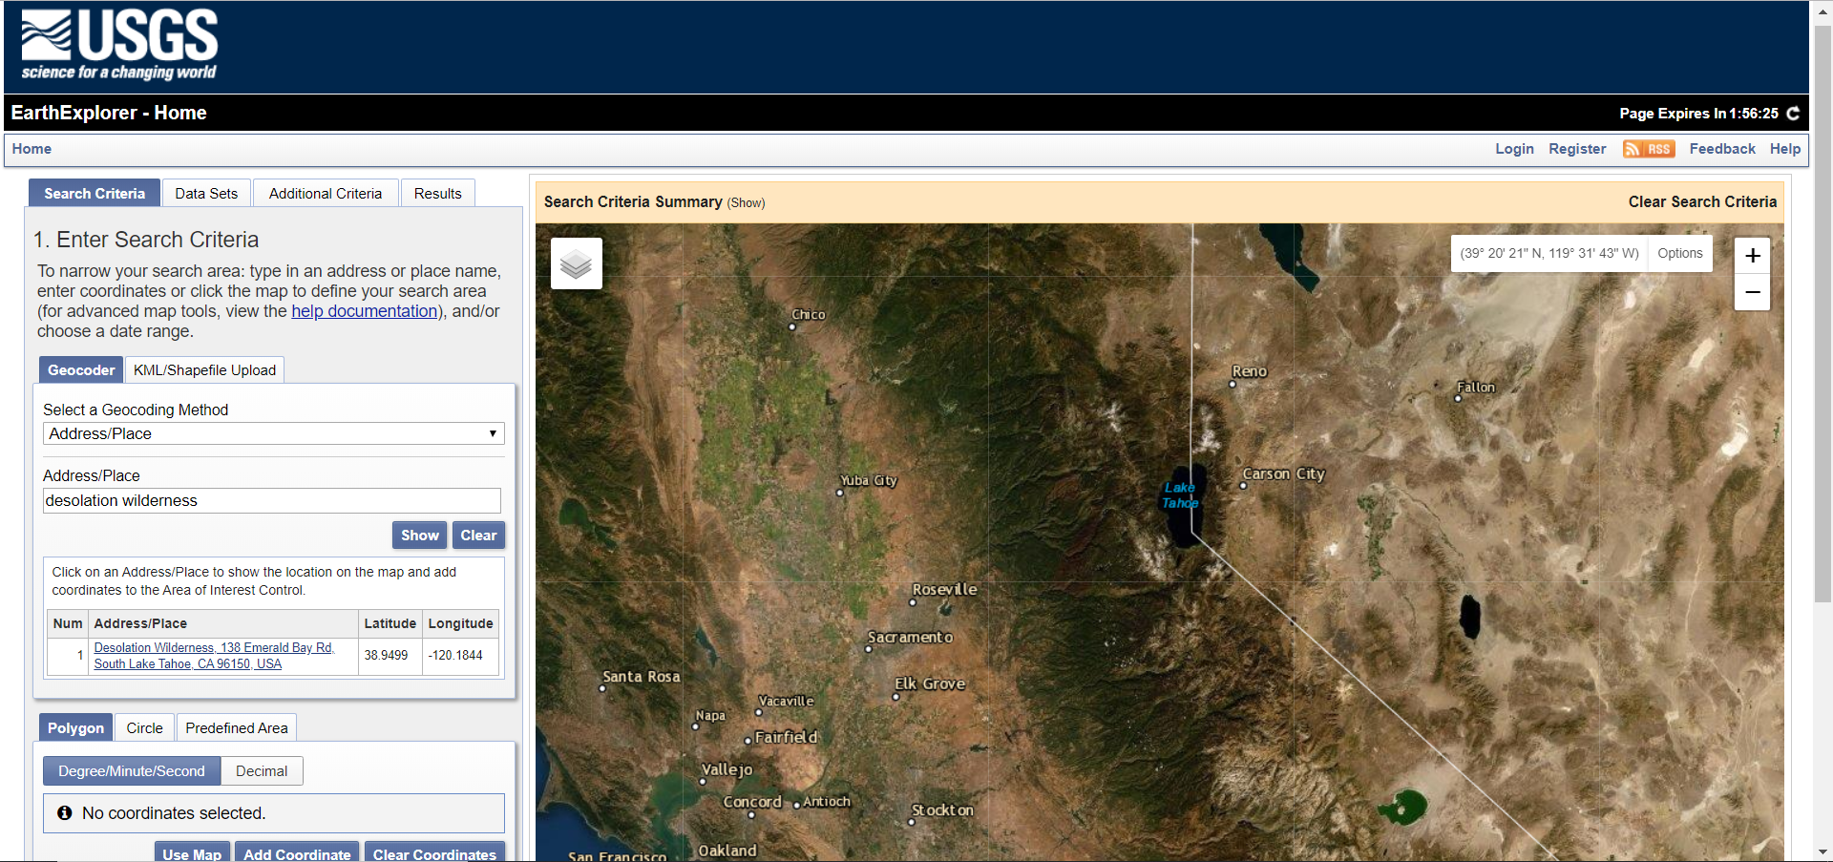
Further below in the Search Criteria tab, the desired Date Range was entered. Clicking on the Data Sets button allowed me to select the specific satellite imagery I wanted. From previous experience using this website, I knew that I wanted “Landsat 8 OLI/TIRS C1 Level-2.”
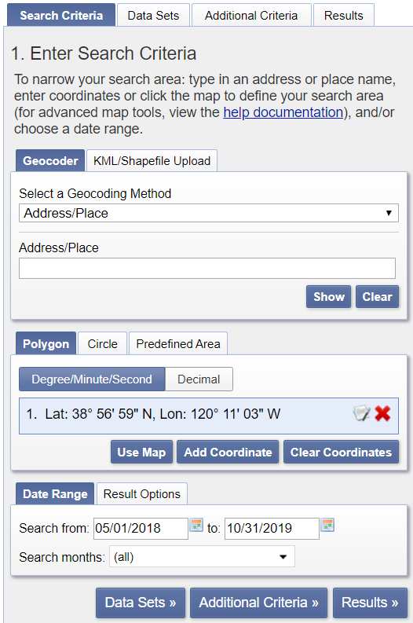
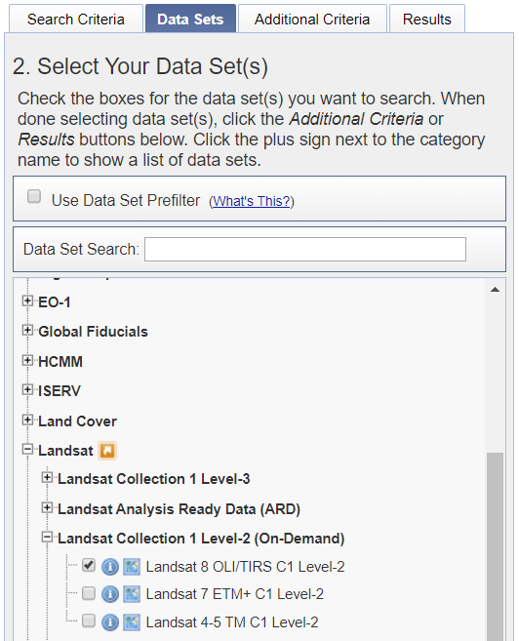

The Results button provided the image results for the date range I entered. By clicking on the thumbnail image, I got a glance of the satellite imagery for a specific date. To be thorough, I ordered images for May through October in 2018 and 2019 so that I could have all the images I might require and not need to go back to request more later.
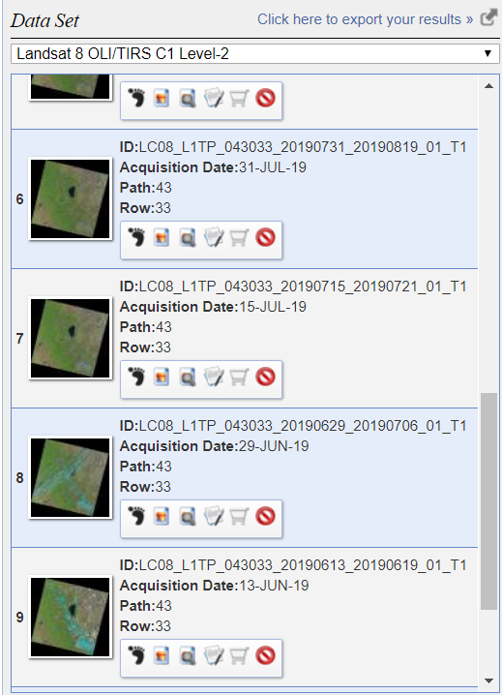

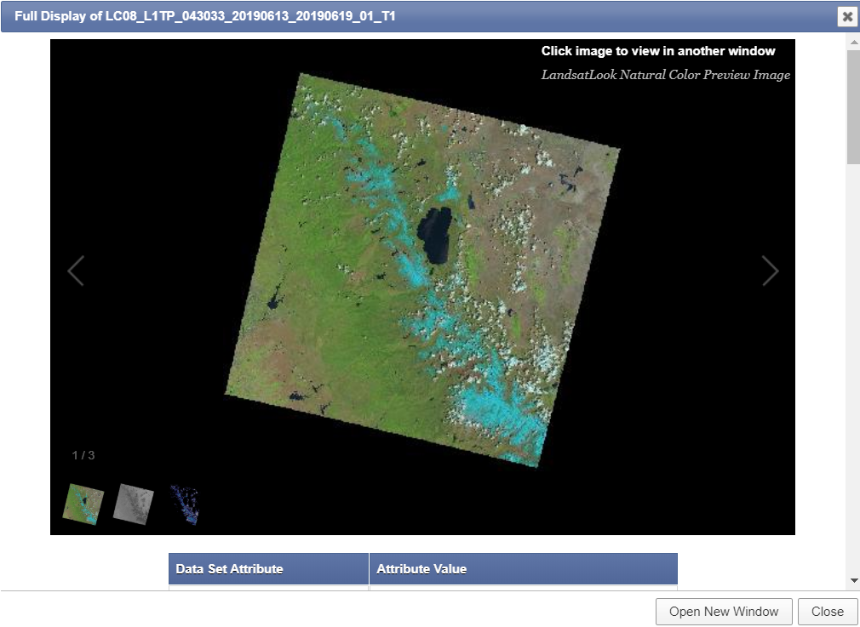

Below is an example of the Order Confirmation that I received for the images that I requested.
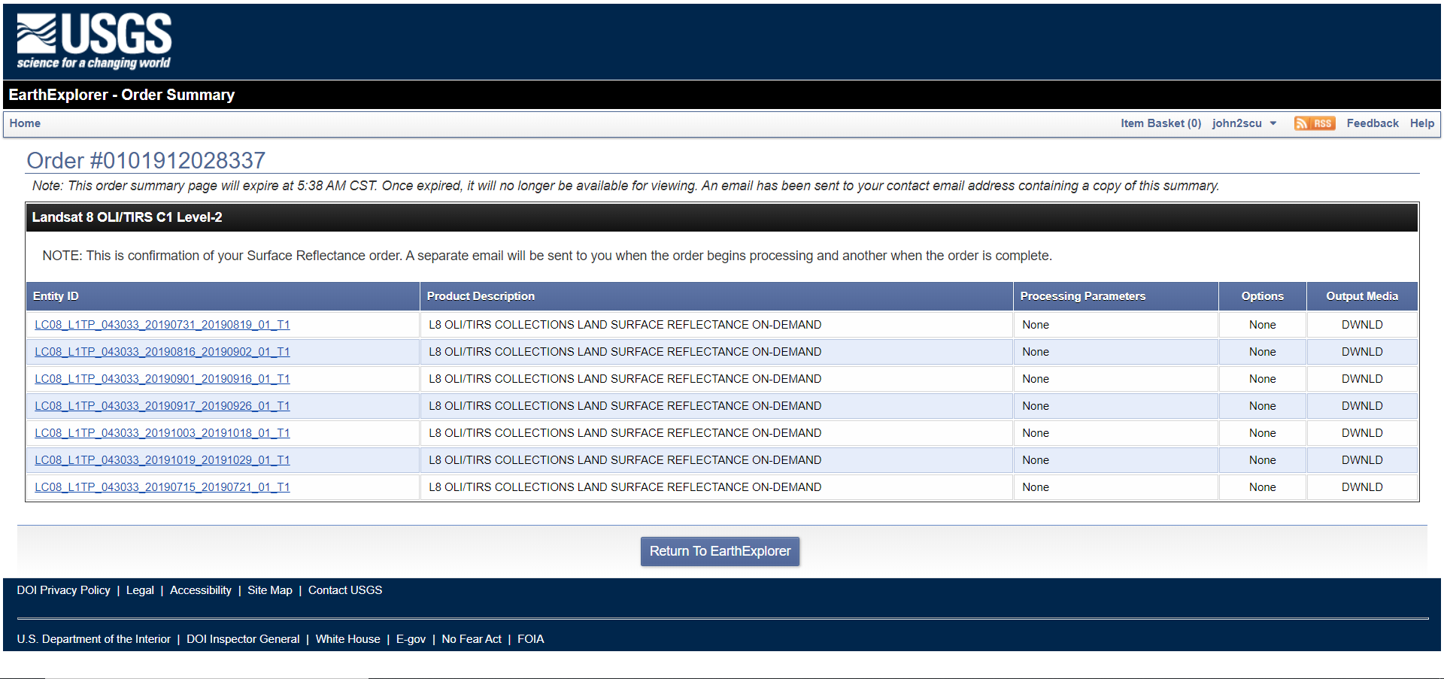

Image Processing Tasks and Methods
After loading the Landsat 8 images into ArcGIS Pro and experimenting with different band combinations, I decided that the Shortwave Infrared (SWIR) band combination of 7,5,4 for the Red, Green, Blue bands was ideal for the purposes of this project. I felt that with the Natural Color 4,3,2 combination the granite and snow colors were too similar. The 7,5,4 band combination achieved the highlighting of the snow that I was looking for. Added benefits of the 7,5,4 combination emphasize the Barren Land (granite), Forest, and Water that I planned on including in my Information Classes.

Natural Color 4,3,2
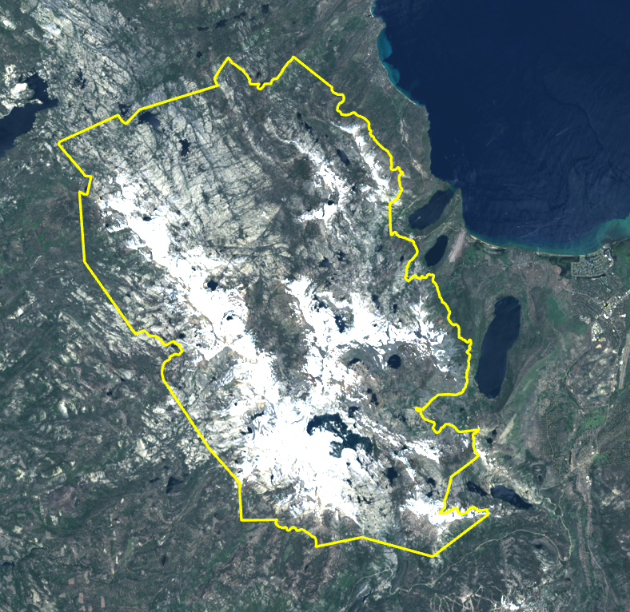

Shortwave Infrared (SWIR) 7,5,4 – SWIR image layer on top of Natural Color 4,3,2 layer to illustrate the differences in color
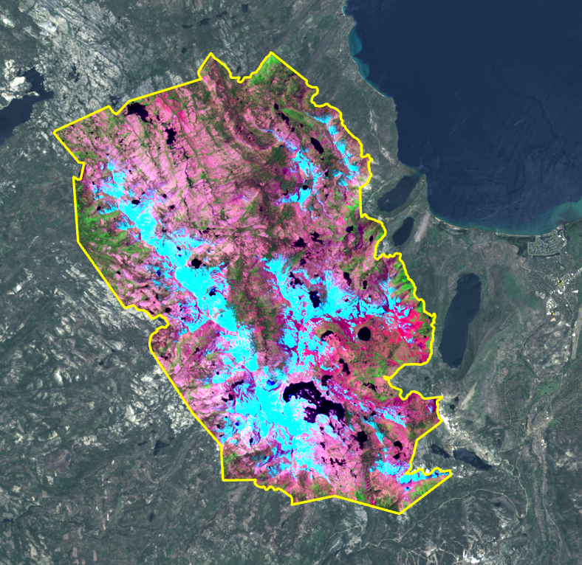

Challenge #1
The first challenge I encountered was that the Clip Raster function performed, using a boundary shapefile of Desolation Wilderness, did not preserve my 7,5,4 band combination colors. It changed them to different colors.

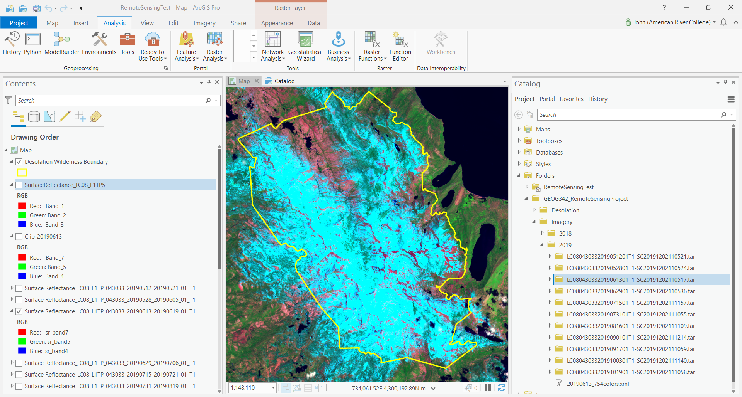

After performing a Clip Raster function, my RGB defaulted to 1,2,3, so I changed them back to 7,5,4 but the clip process introduced new, unwanted colors.

1,2,3 band color default (after Clip Raster)
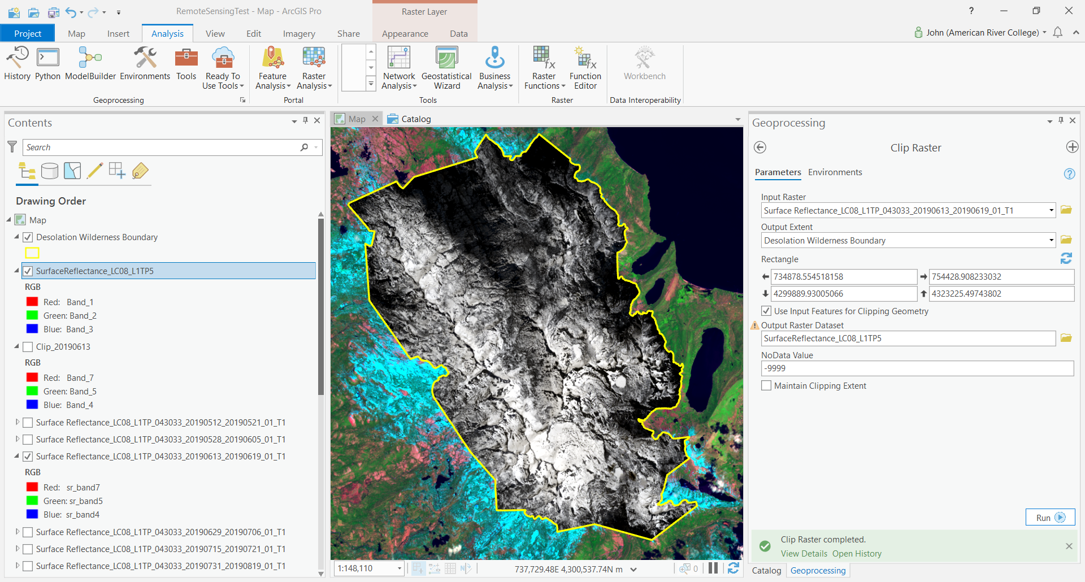

In the top-left corner of the image below, note the color change of the Barren Land from pink to red and the Forest from green to dark green.

Clip Raster 7,5,4 band color layer on top of the Input 7,5,4 band color layer.
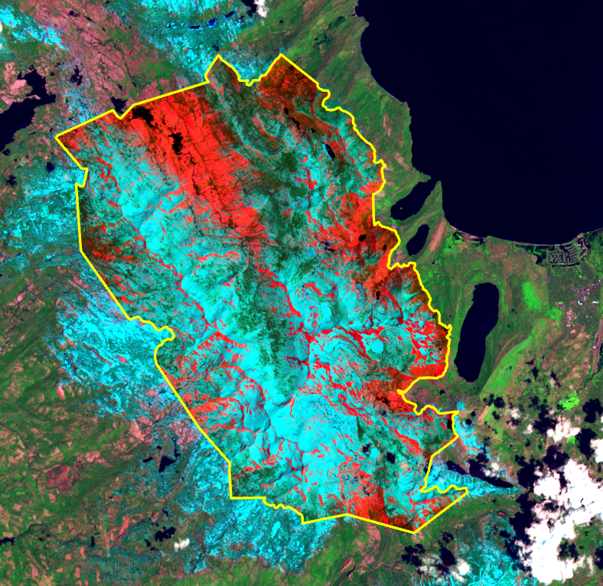

These color changes are also evident when using the Swipe Tool.

Swipe Tool comparison.
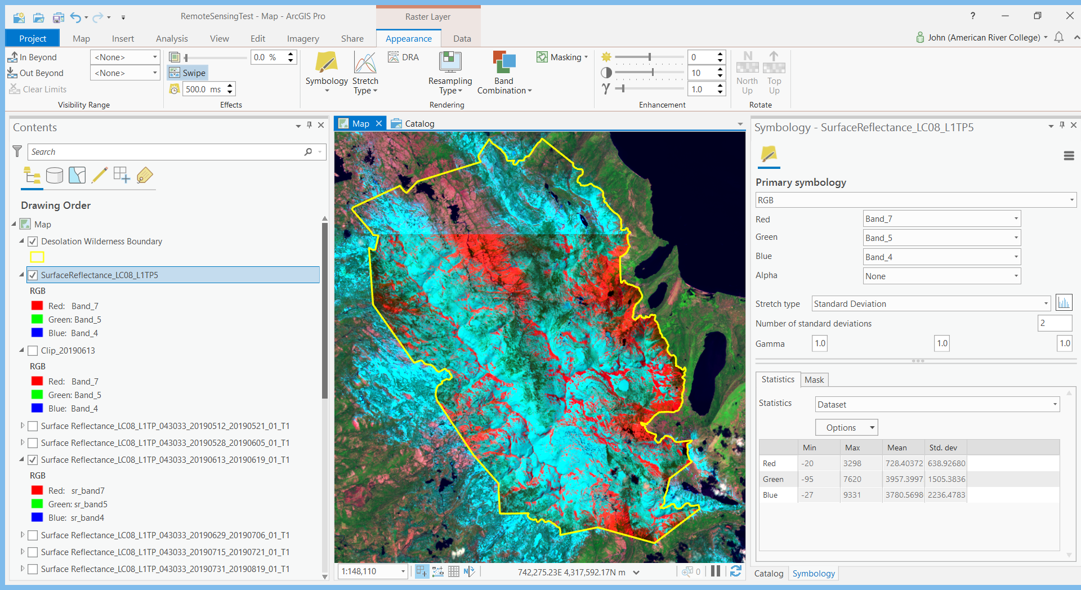

Challenge #1 Solution
After numerous attempts at troubleshooting and much online research, here are the steps used to correct the unwanted band color changes:
In the source (desired) image, right click on Symbology. In the Symbology pane, Statistics tab, click on the Options button. Select Save as XML to save the file with any filename.
Next, select the clipped (unwanted) image in the Contents pane and right click on Symbology. In the Statistics tab, click on the Statistics drop-down field. Select Custom. Click on the Options drop-down field and select Load XML.

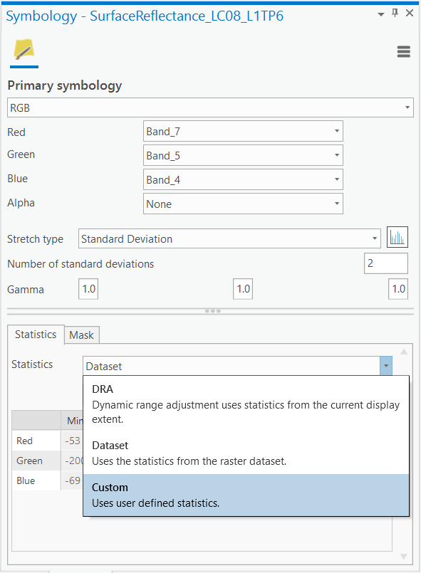
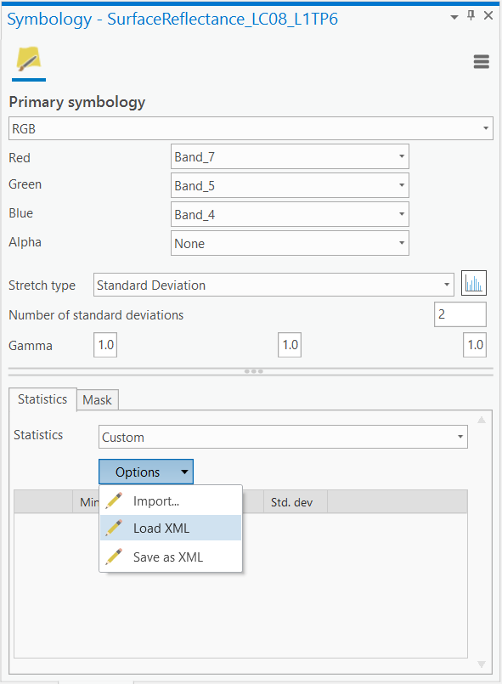

Browse Windows Explorer to locate the XML file that was created earlier from the original (desired) image. Once the file is located, select it and click Open. The colors in the Clip Raster layer with the unwanted colors will change to the desired colors.

Unwanted 7,5,4 band colors
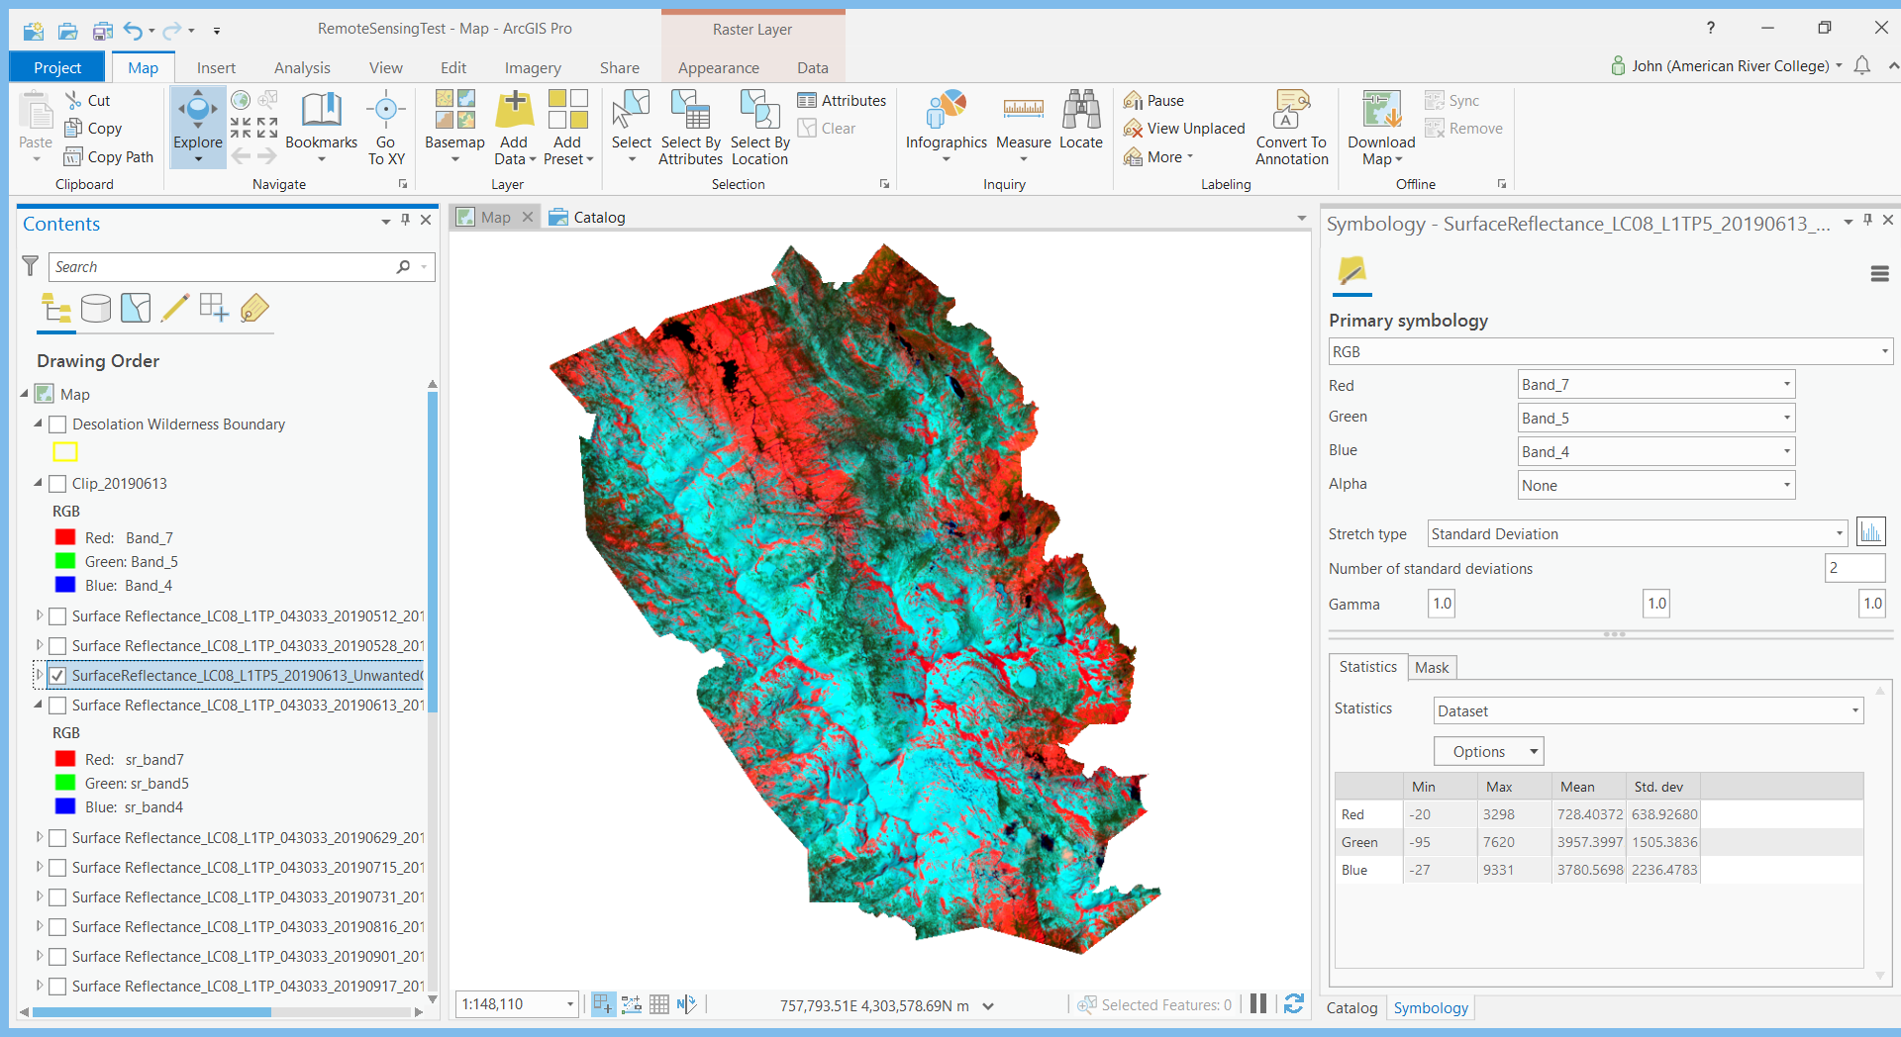

Desired 7,5,4 band colors
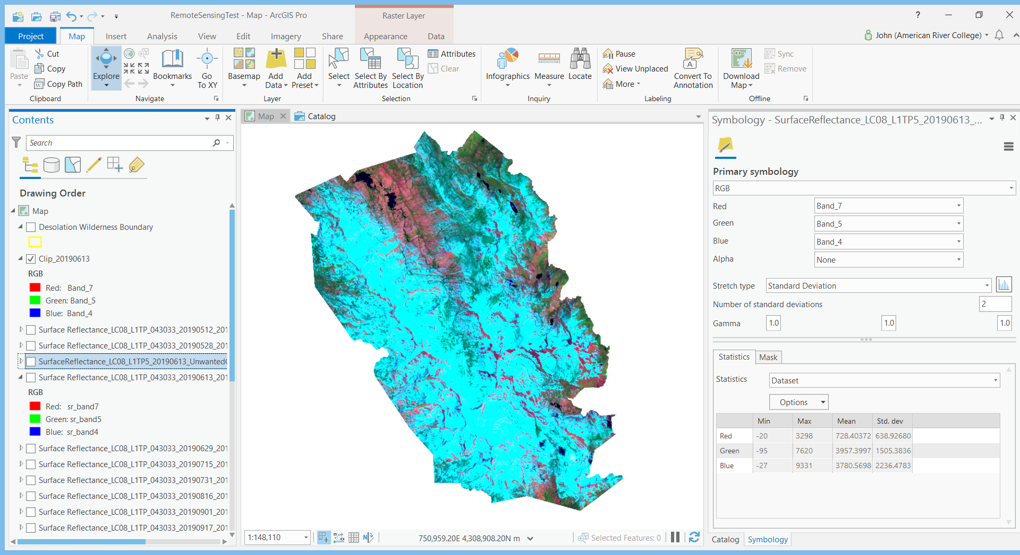

Unsupervised Classification – 2018 Image
Using the Clip Raster layer for 2018 as my Input Layer, I performed an Unsupervised Classification using the Iso Cluster Unsupervised Classification tool.
Number of Classes: 5
Being familiar with the Desolation Wilderness, I chose five Information Classes: Rangeland, Forest, Water, Barren Land, and Snow. The initial results of executing the Iso Cluster Unsupervised Classification tool for the first time were good. The following were my observations:
- Rangeland – Poor results. The tool misclassified Snow areas as Rangeland areas when compared to the input layer. At this stage, I was not sure why this happened. The common theme of areas classified as Rangeland is that they are very bright white sections of snow or granite, using the input layer and higher resolution NAIP (National Agriculture Imagery Program) imagery for comparison.
- Forest – Overall, I was content with the classification results. However, Unsupervised classified more Forest than what is actual; on average I estimate about 10-20% more within a majority of the boundary. There are some spots that are misclassified as Forest at 30-100% more than actual. The bottom right quadrant of Desolation Wilderness is the most misclassified area. Looking at NAIP imagery, it also appears that shrubs got classified as Forest as well.
- Water – Lakes were identified correctly, but the tool classified other areas of water that are not water. There are numerous places that were classified as Water but it is actually dense forest and vegetation when examined closer with NAIP imagery.
- Barren Land – Great classification of Barren Land. A minimal amount of over-classification of Forest that is really Barren Land.
- Snow – Appears very accurately captured with one exception. All the areas that were classified as Rangeland fall within the boundaries of what is snow based on the input layer.

Based on the classification results and further reflection, I realized there really isn't a lot of Rangeland in Desolation with exception to the areas under forest canopies. At this point, I considered using four Information Classes instead of five. I decided to reserve a final decision on this matter until creating more Unsupervised layers with different numbers of Spectral Classes.

Input Layer dated June 10, 2018 (SWIR 7,5,4 band combination)
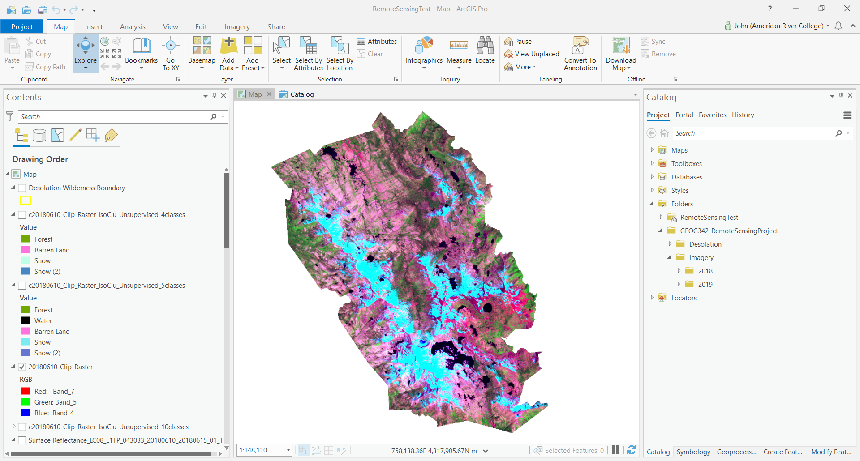

June 10, 2018 Input Image – Zoomed In
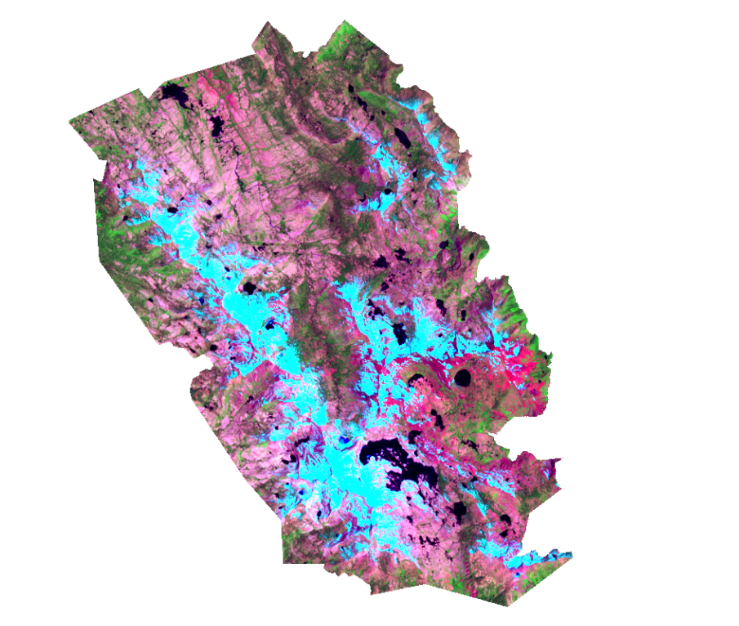

Unsupervised 5-Class Output Image (ArcGIS Pro random color scheme)
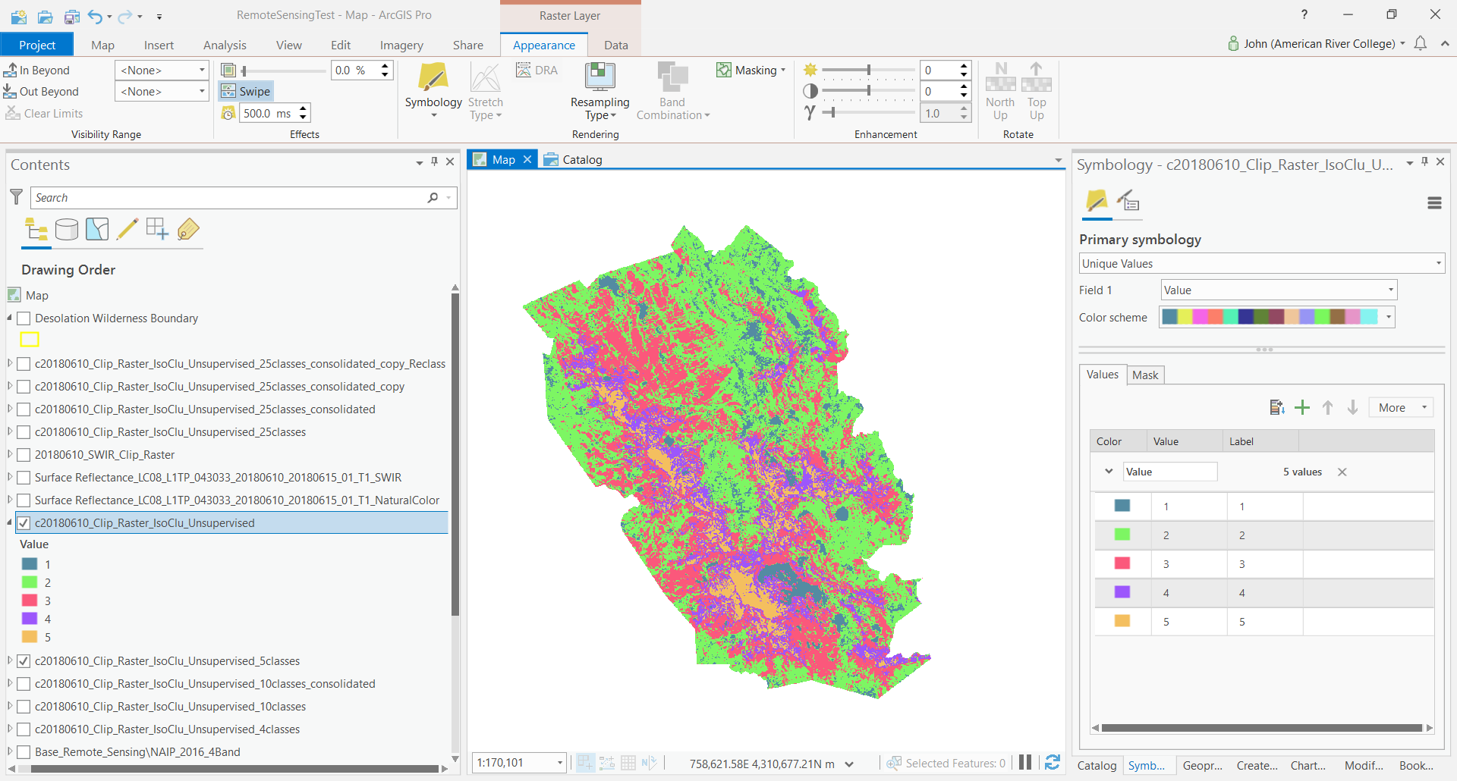

Unsupervised 5-Class Output Image (ArcGIS Pro random color scheme) – Zoomed In
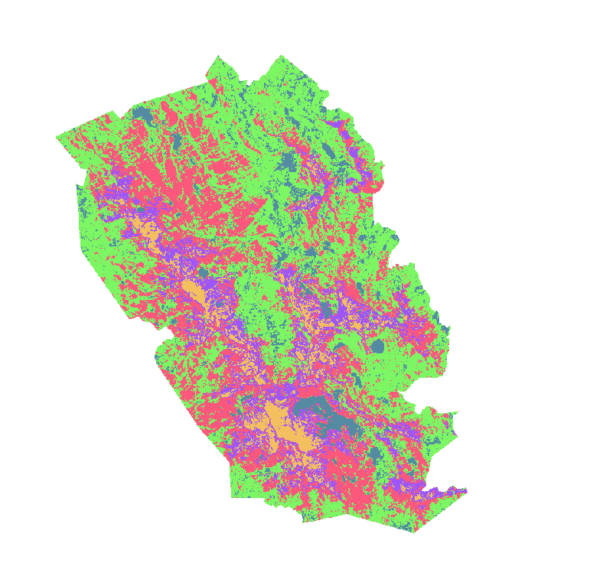

Unsupervised 5-Class Output Image (revised color scheme to resemble 7,5,4 band colors)
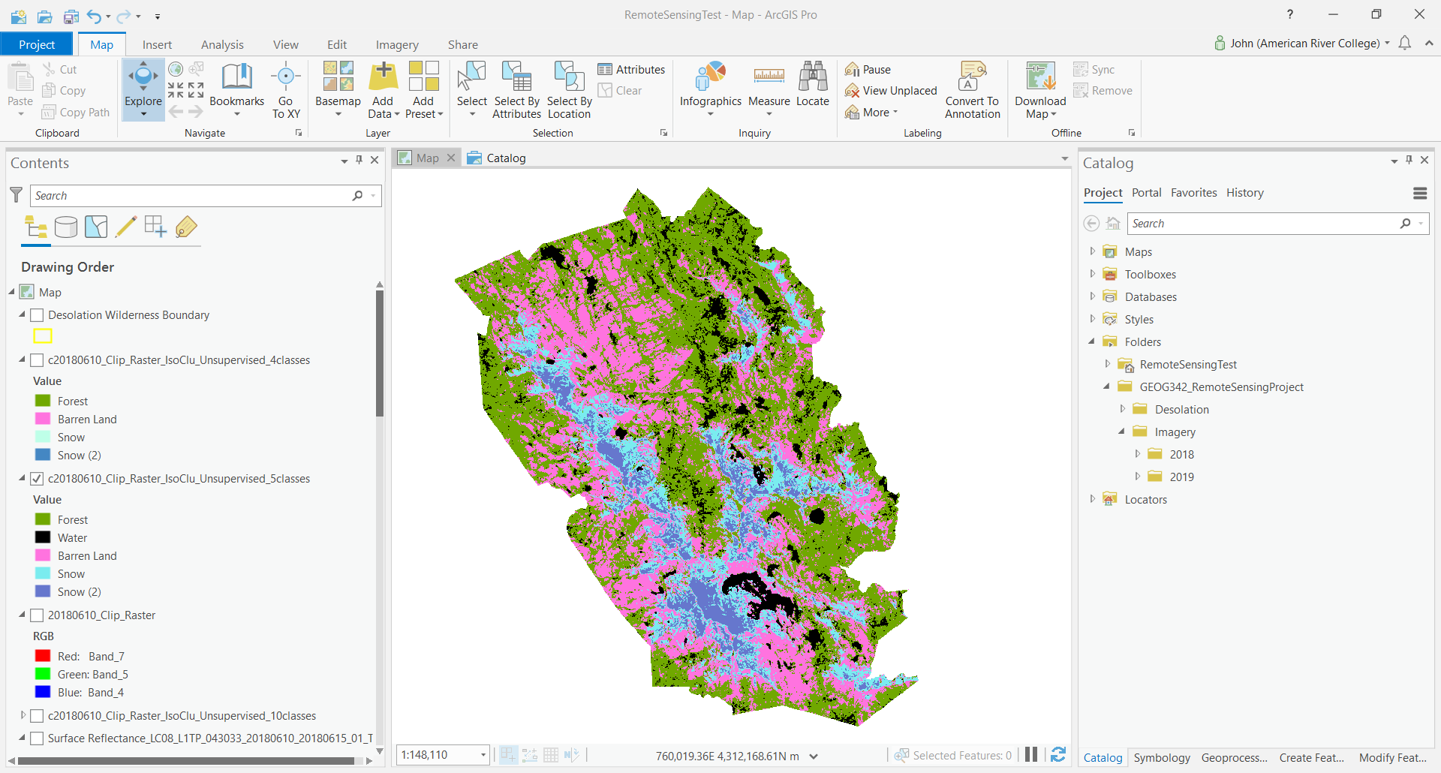

Unsupervised 5-Class Output Image (revised color scheme to resemble 7,5,4 band colors) – Zoomed In
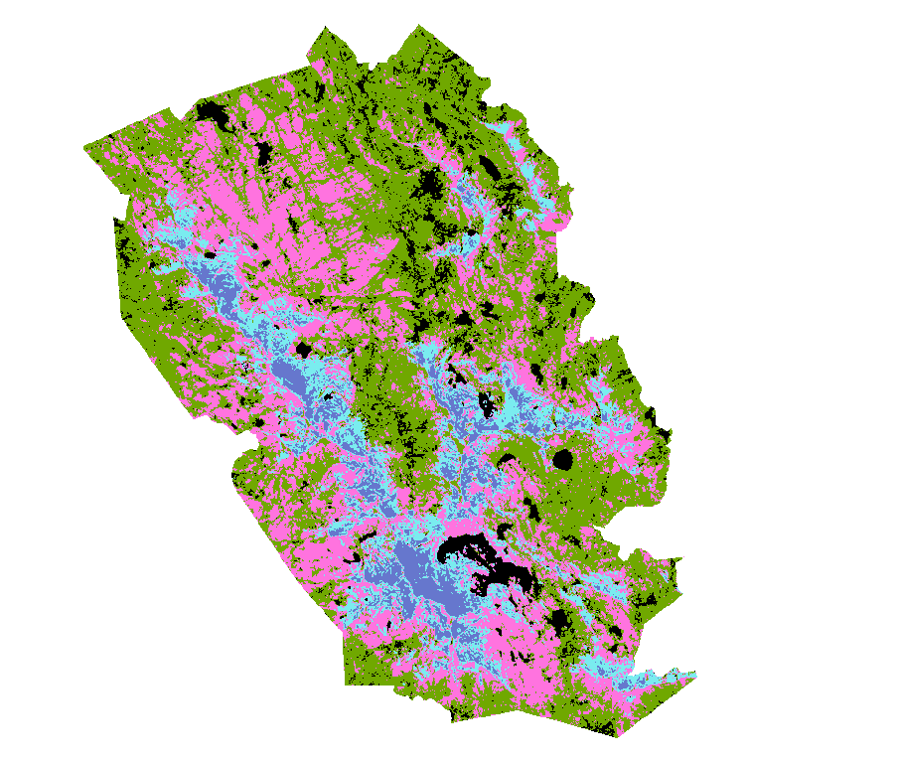

Now that I had a basis for comparison, I decided to run the Unsupervised tool with ten classes using the same Input Layer as before.
Number of Classes: 10
My initial thought was this was too many Spectral Classes. It felt like information overload. However, if I were to consolidate the Spectral Classes, the consolidated classes would more accurately reflect my chosen Information Classes (or land cover categories). In other words, the Spectral Classes would be more spatially accurate and categorized according to the actual land cover when compared to the 5-Class Unsupervised results.

Unsupervised 10-Class Output Image (ArcGIS Pro random color scheme)
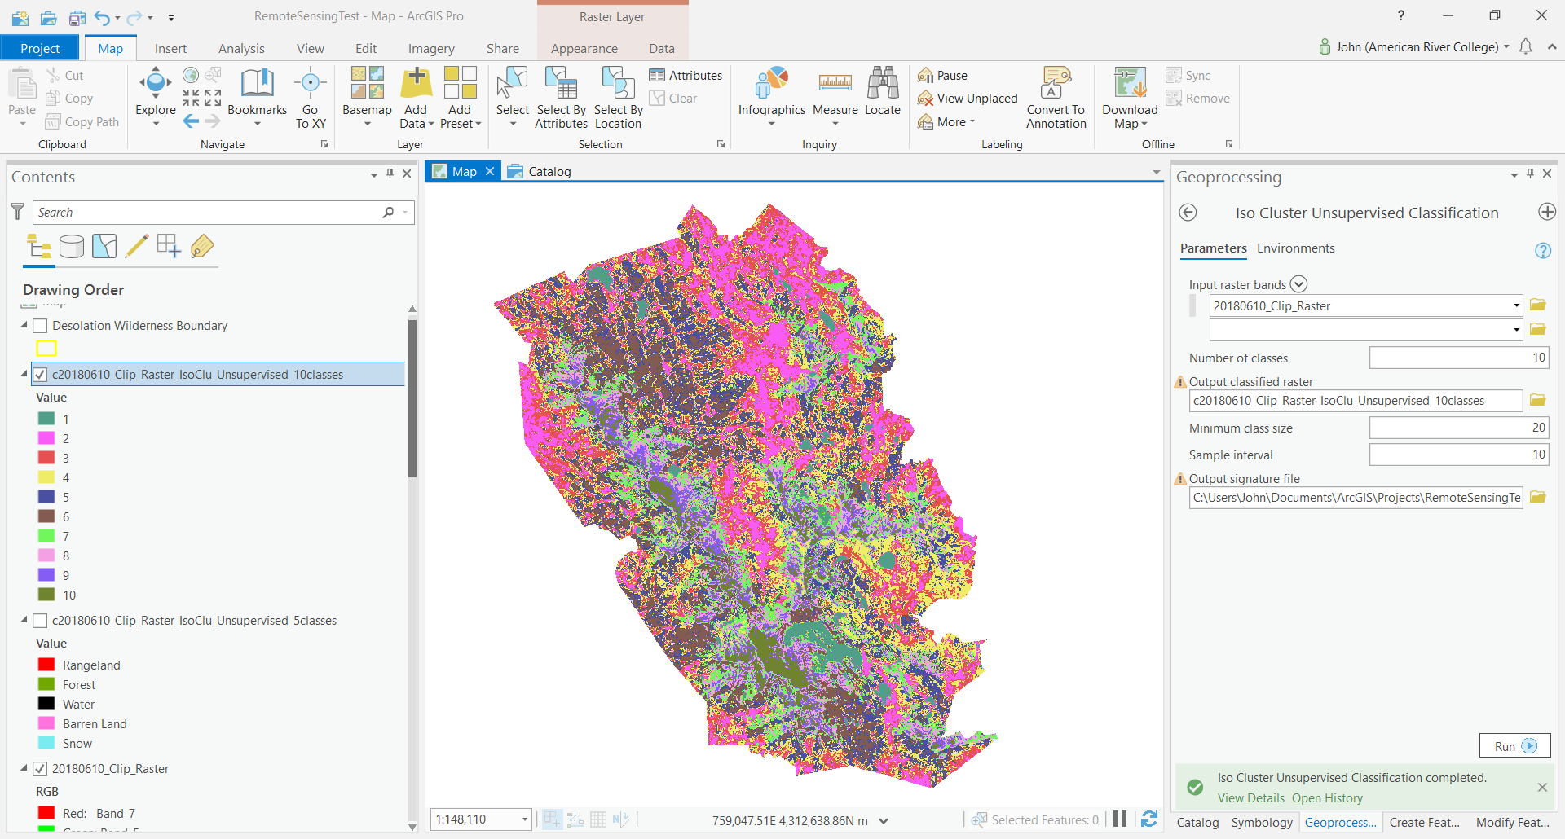

Unsupervised 10-Class Output Image (ArcGIS Pro random color scheme) – Zoomed In
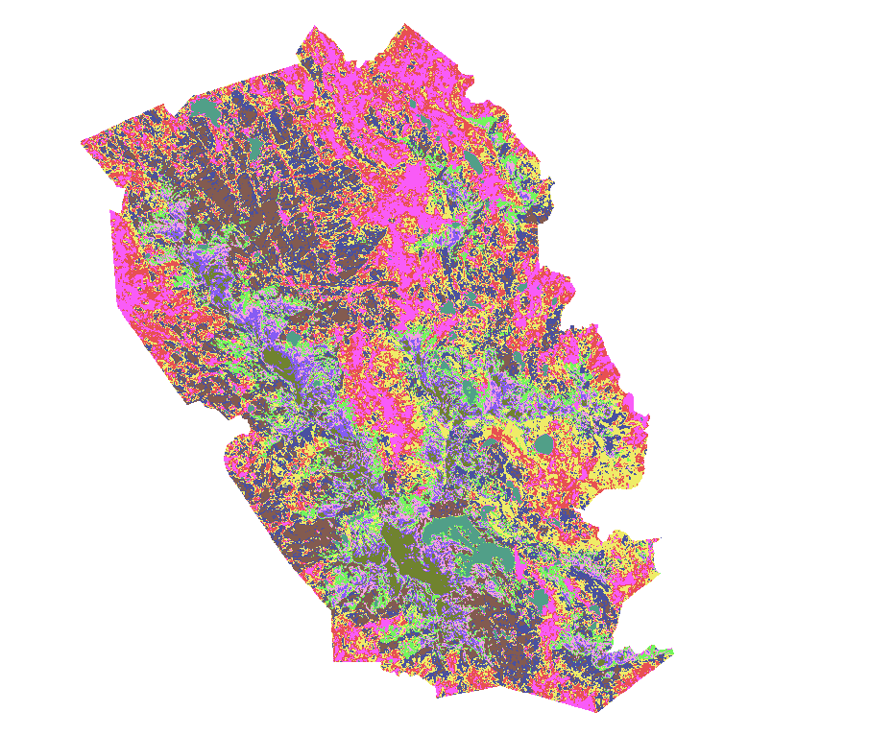
For further comparison, I ran an additional Unsupervised process with 4 classes.
Number of Classes: 4
Pixel location accuracy is great, but Water classification was completely left out. What should have been classified as Water was lumped into the same spectral class as Forest. Furthermore, there are two spectral classes for Snow again. This same issue occurred in the 5-Class results. I concluded that the 4-Class output layer would not be useful for further analysis.

Unsupervised 4-Class Output Image (revised color scheme to resemble 7,5,4 band colors)
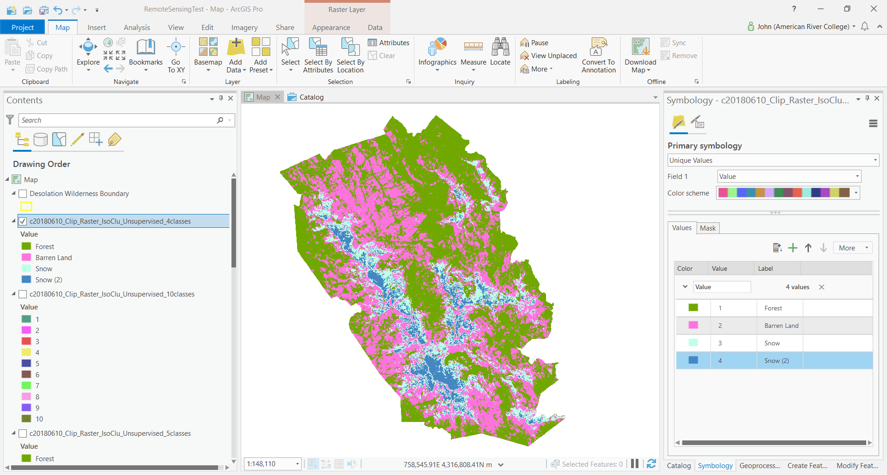

Unsupervised 4-Class Output Image (revised color scheme to resemble 7,5,4 band colors) – Zoomed In
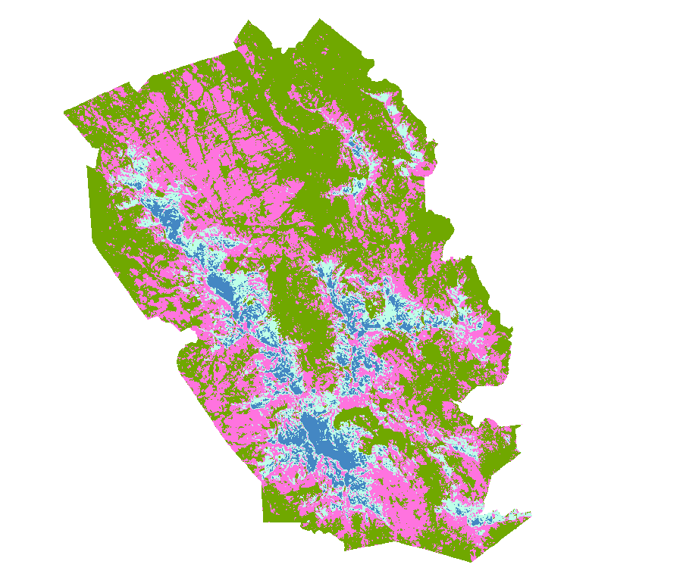
After conducting additional research, I decided to run a 25-Class Unsupervised process. I expected that this would be the ideal number of Spectral Classes to provide the needed level of detail and not be too time-consuming with regard to consolidating the Spectral Classes into my five Information Classes.
Number of Classes: 25
I began my spectral consolidation by starting with the easy classes first, like known lakes (Water). The consolidation process got progressively difficult especially with the last five Spectral Classes. These were classes with the least number of pixels in the output image. It was most difficult to distinguish between Forest, Barren Land, and Snow. The Swipe Tool was invaluable in helping me decide which Information Class to categorize the different spectral pixels. I swiped between the Unsupervised output image, the SWIR input image (7,5,4 band image), and the World Imagery Basemap to categorize each of the 25 Spectral Classes into the appropriate Information Class. The Basemap (World Imagery) layer worked significantly better than the NAIP image because the Basemap loaded much faster.
Pixel validation was performed in several places within the Desolation Wilderness boundary. I did not just rely on the comparison of one cluster of pixels. Identifying Snow became challenging when it bordered Barren Land, or as the snow thinned out on top of trees. When in doubt, I picked one category or another depending on its prominence in several other locations. For example, some Spectral Classes seemed to fall into the Barren category; however, in a majority of other areas sampled it was actually Forest. In situations like this, I made a judgement call and went with the majority, Forest. With more challenging Spectral Classes, I sampled significantly more areas to arrive at a conclusion on the appropriate Information Class.
Ouput 25-Class Unsupervised Layer (before consolidating Spectral Classes)
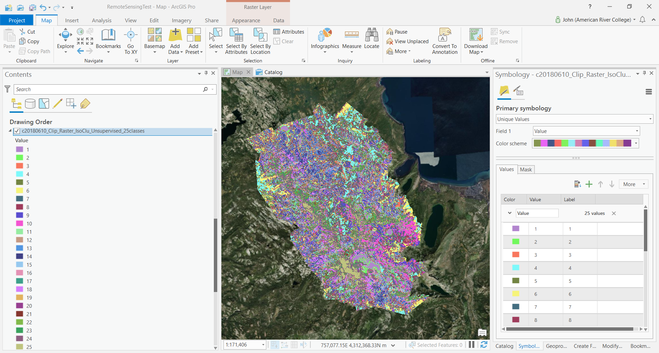

Ouput 25-Class Unsupervised Layer (before consolidating spectral classes) – Zoomed In
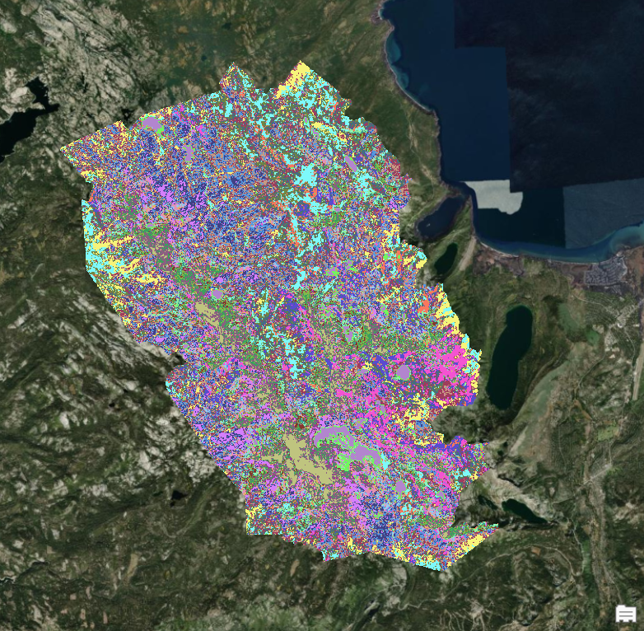

Ouput 25-Class Unsupervised Layer (before consolidating spectral classes) - Isolated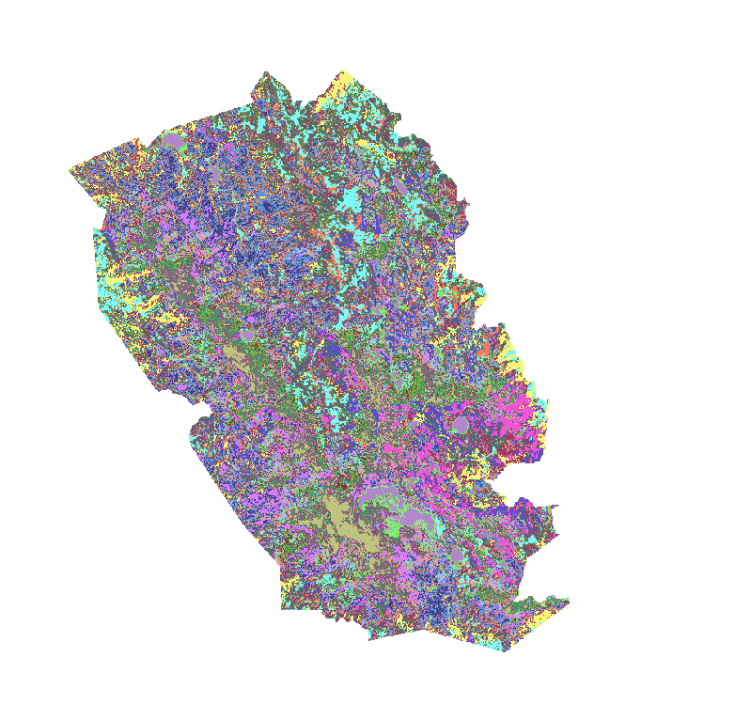

After consolidating 25 Spectral Classes into 5 Information Classes
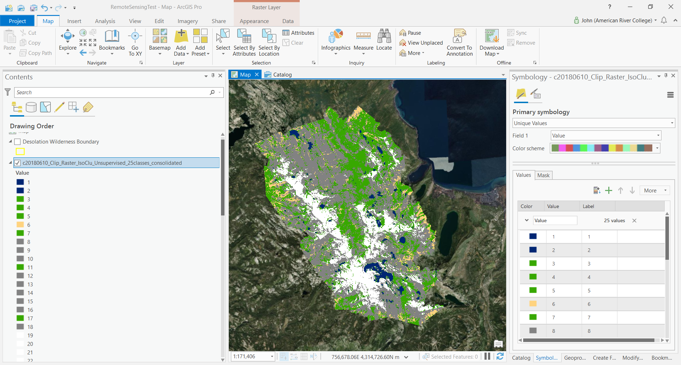

After consolidating 25 Spectral Classes into 5 Information Classes – Zoomed In
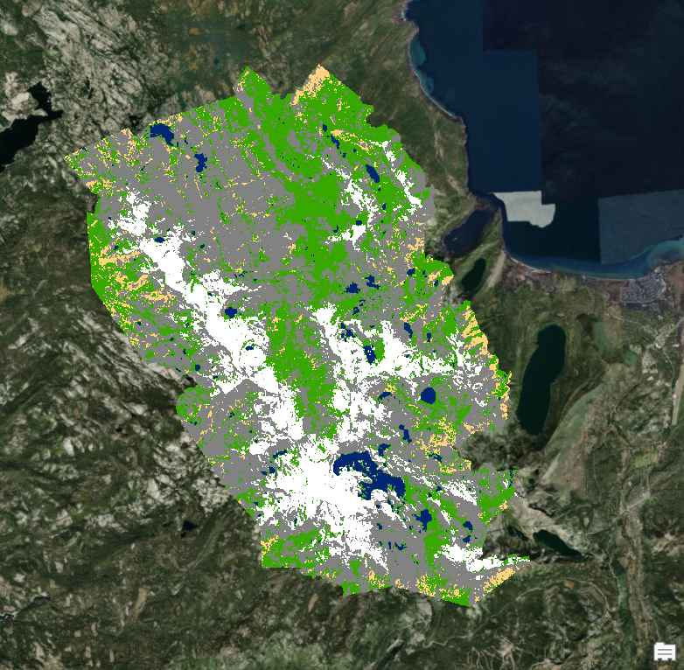

After consolidating 25 Spectral Classes into 5 Information Classes – Isolated
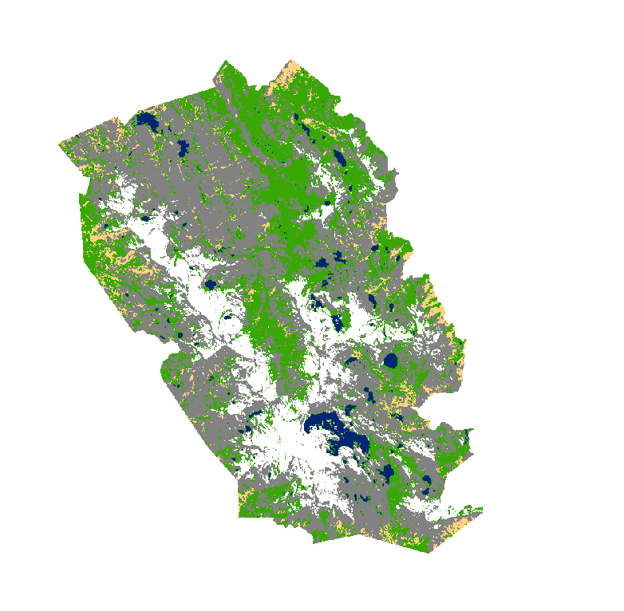

Reclassify 2018 Image
The Reclassify tool reclassifies (or changes) the values in a raster. In this instance, I started with 25 unique pixel colors. After I categorized each of those colors into one of five Information Classes, I used the Reclassify tool to condense those 25 pixel values into 5 categories: Rangeland, Forest, Water, Barren Land, and Snow.

Reclassify Output (ArcGIS Pro random color scheme)
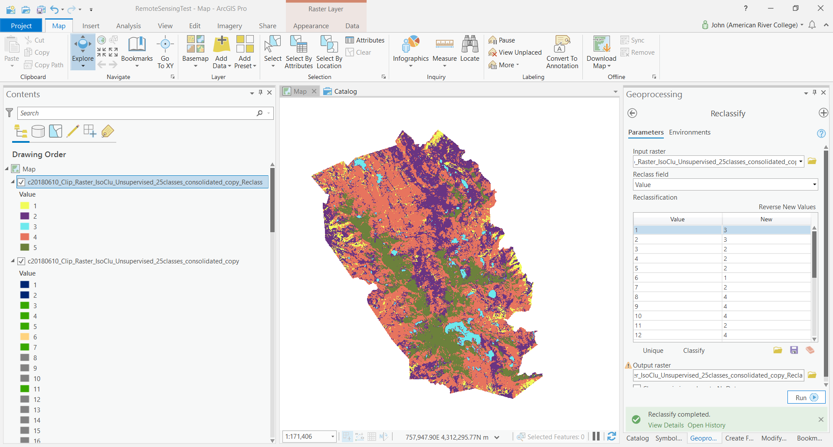

Reclassify Output (ArcGIS Pro random color scheme) – Zoomed In
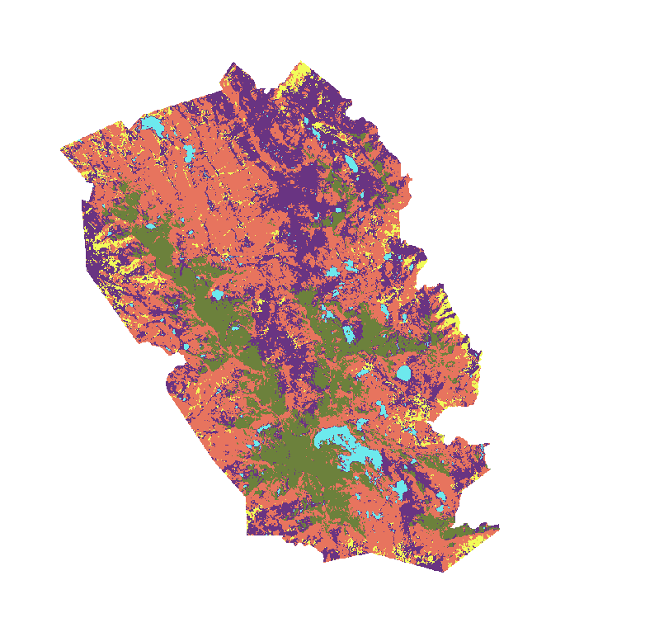

Reclassify Output (USGS Land Cover Color Codes and Names)
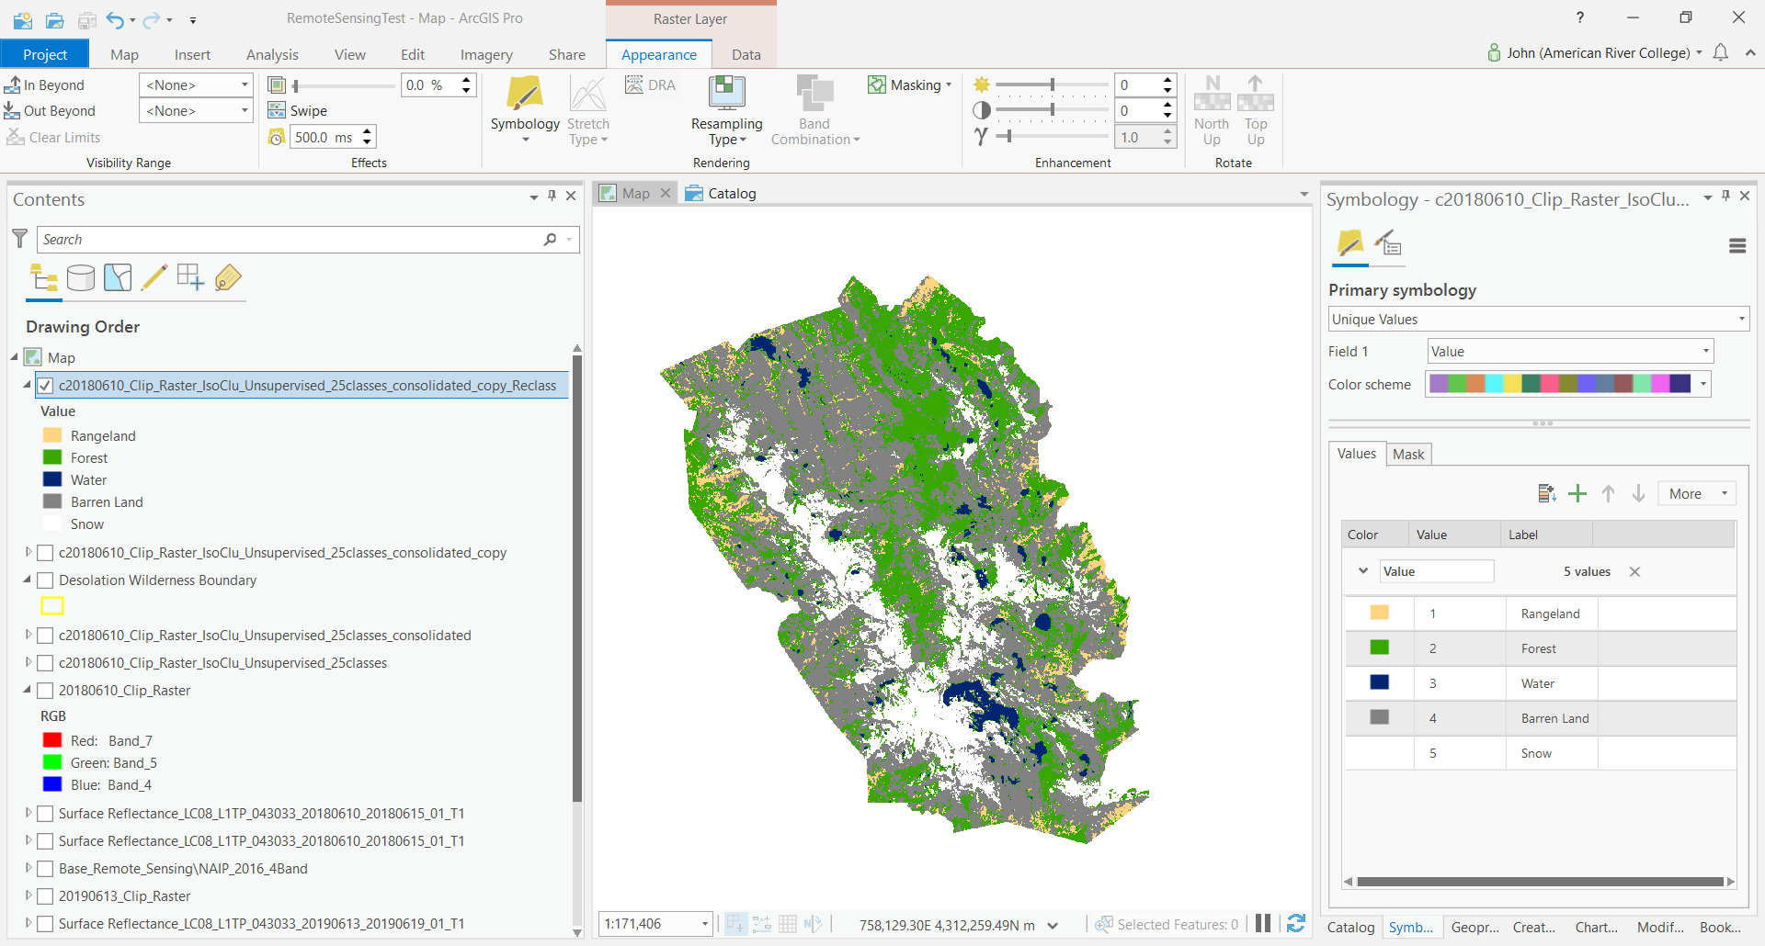

Reclassify Output (USGS Land Cover Color Codes) – Zoomed In

Upon comparing the 25-Class Unsupervised Classification to the original input layer, I was pleased with the accurate categorization of my 5 Information Classes.

Input Layer dated June 10, 2018 (SWIR 7,5,4 band combination) – Zoomed In
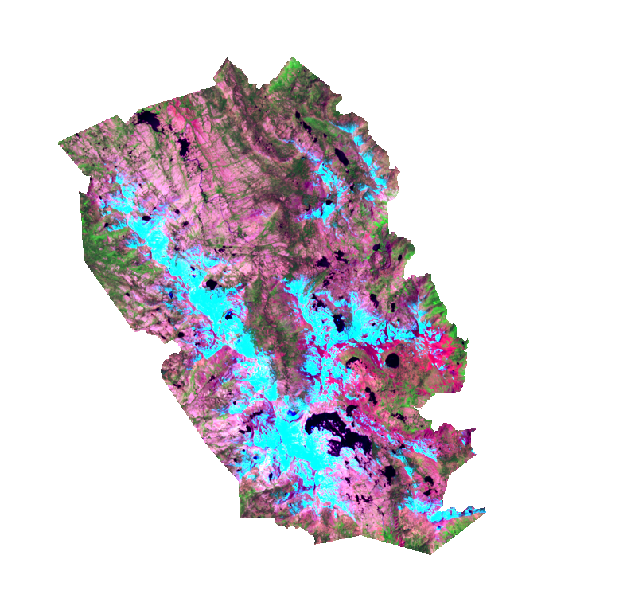

June 10, 2018 25-Class Unsupervised Reclassified into 5 Information Classes – Zoomed In
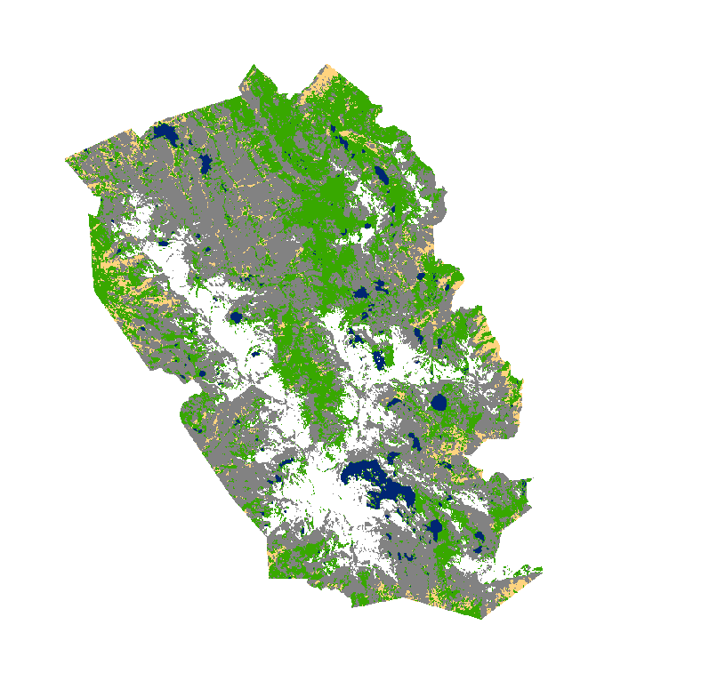

Unsupervised Classification - 2019 Image
Due to the success of my Unsupervised results with the 2018 image, I decided to use the same number of classes to classify my June 13, 2019 Landsat 8 image.
Number of Classes: 25
Input Layer dated June 13, 2019 (SWIR 7,5,4 band combination)
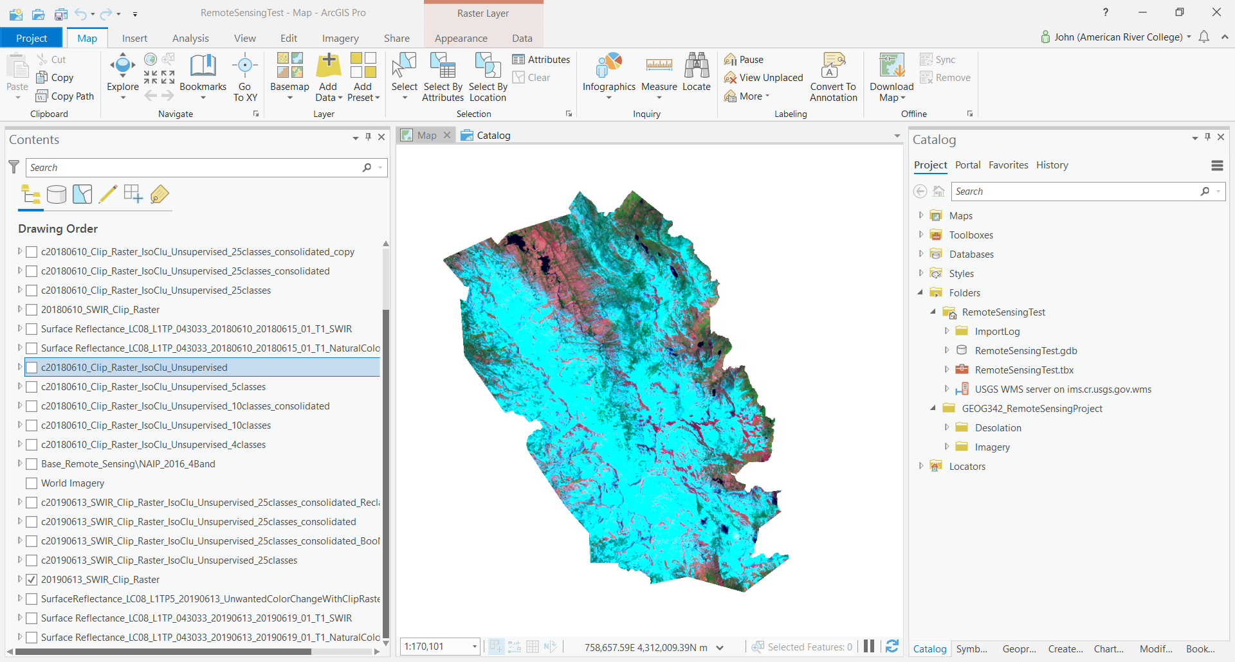

Input Layer dated June 13, 2019 (SWIR 7,5,4 band combination) – Zoomed In
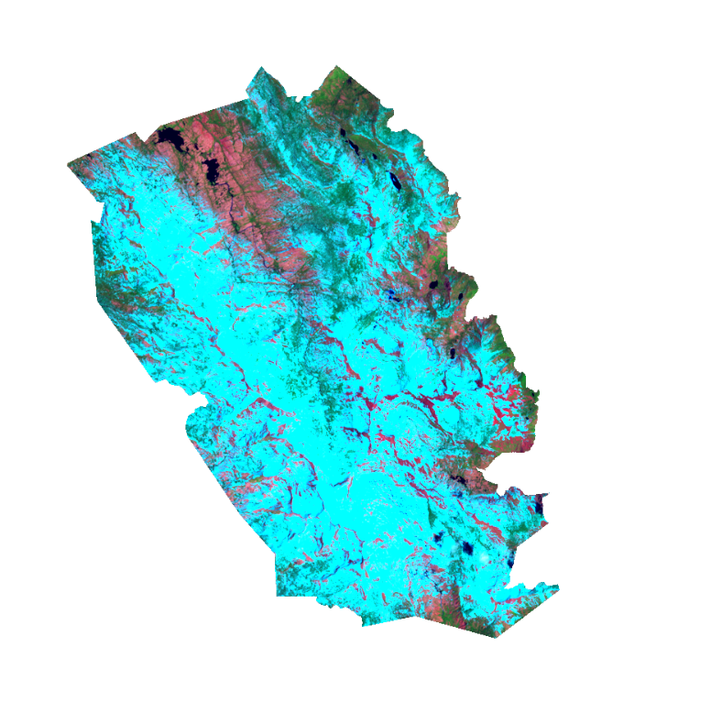

Ouput 25-Class Unsupervised Layer (before consolidating spectral classes)
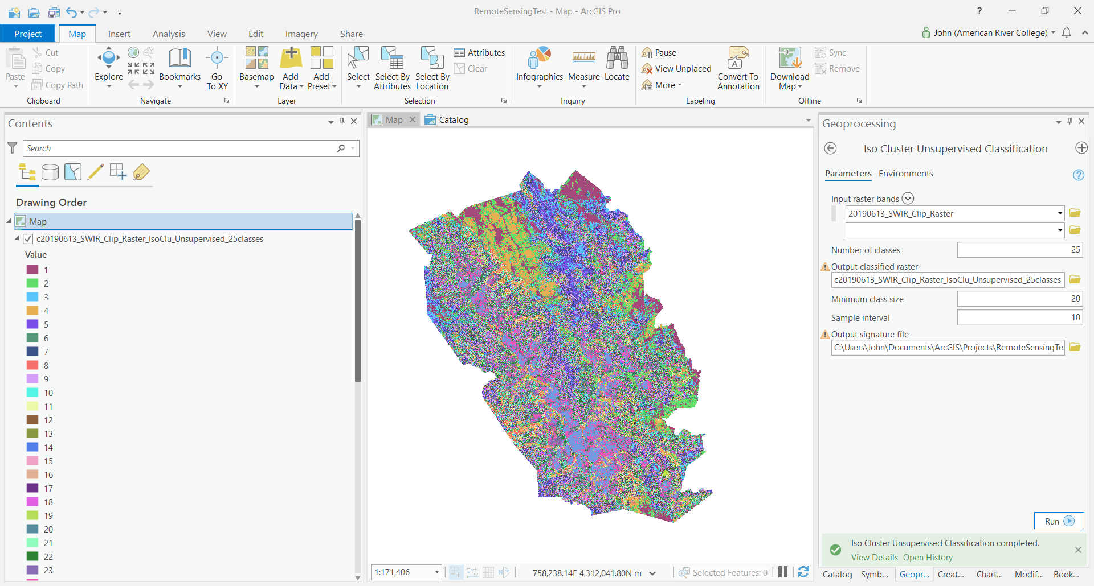

Ouput 25-Class Unsupervised Layer (before consolidating spectral classes) - Isolated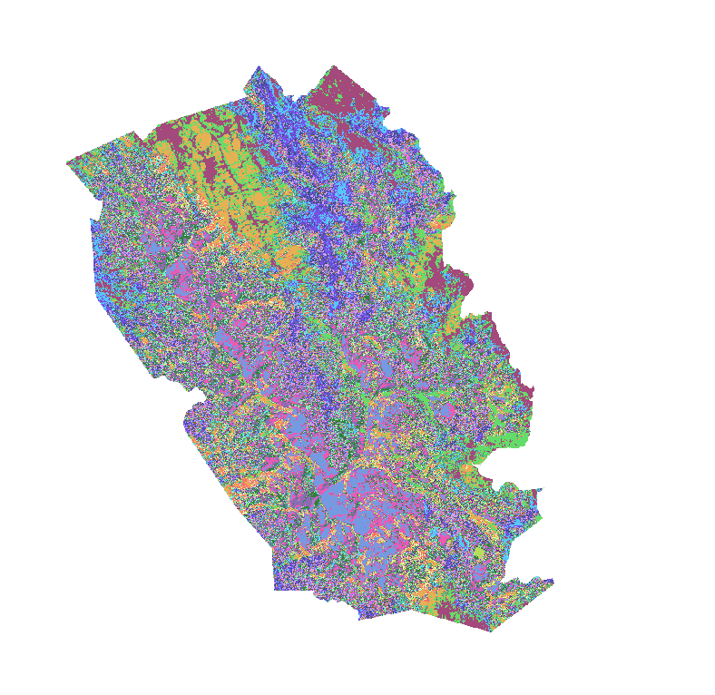
Challenge #2
As soon as I identified the largest spectral class, Water, and changed the color code to dark navy, I noticed that Forest and Rangeland nearby was classified as Water as well by the Unsupervised process. This suggested that I needed to run a new Unsupervised Classification with more classes. See zoomed-in comparison images below.

Output 25-Class Unsupervised Layer (before consolidating spectral classes; after changing a Spectral Class to dark navy color to categorize Water) – Zoomed In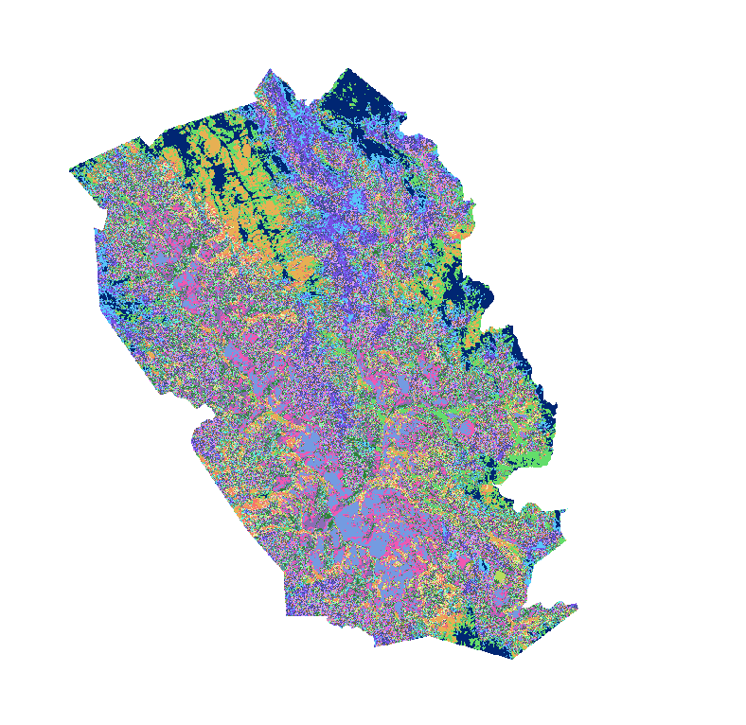

Input Layer (Water and Forest area A)
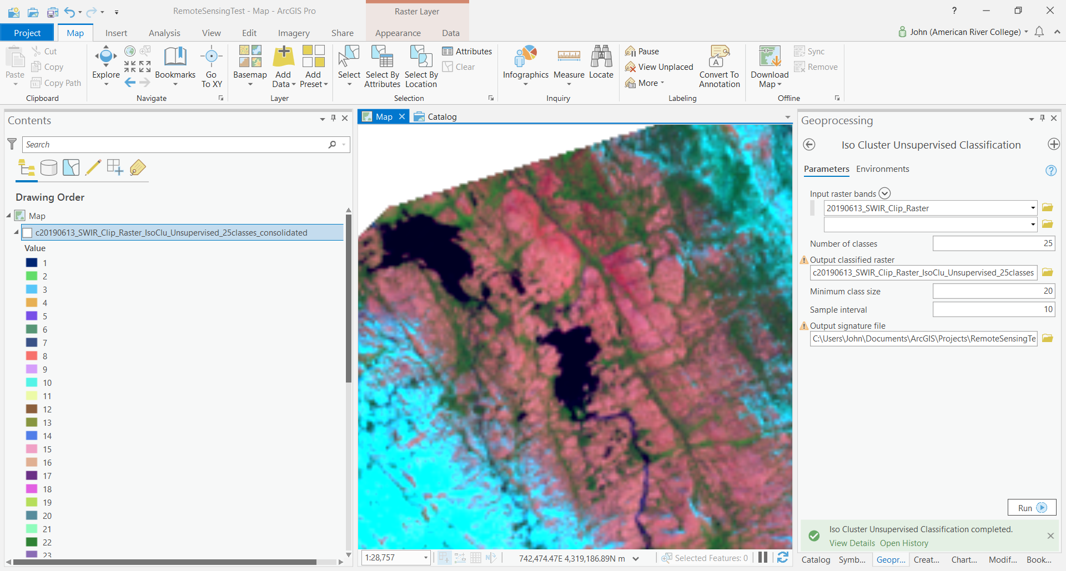

Supervised Output Layer (Water and Forest area A)
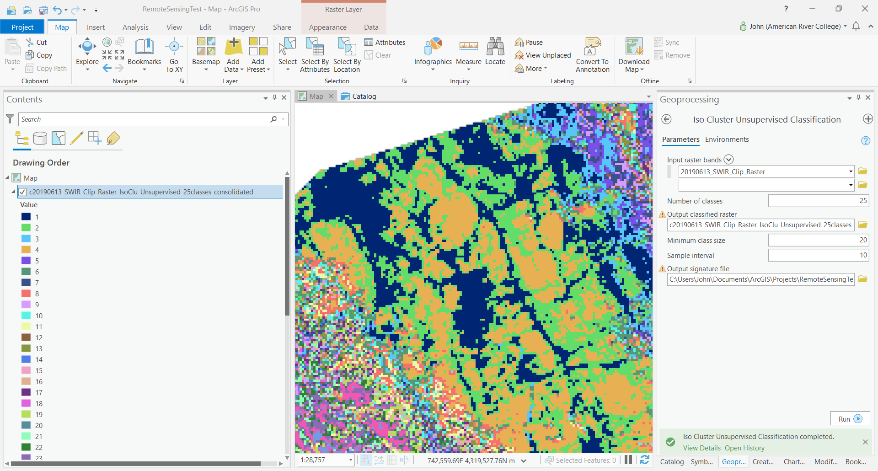

Input Layer (Water and Forest area A) – Isolated
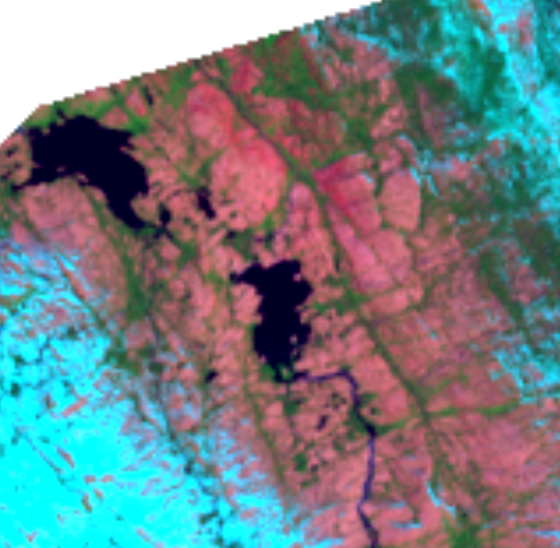

Supervised Output Layer (Water and Forest area A) - Isolated
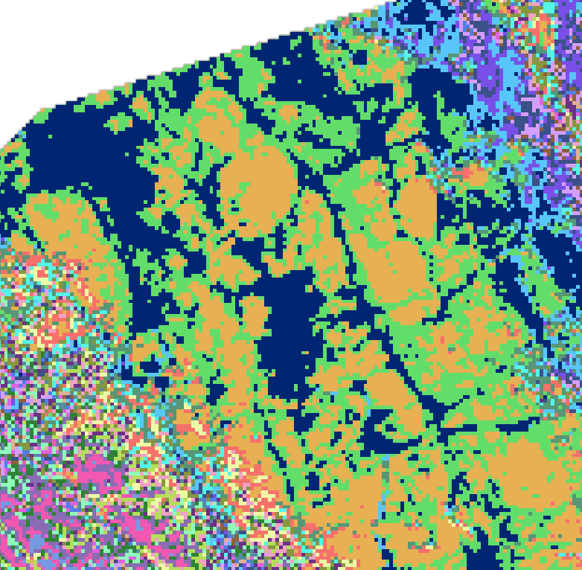

Input Layer (Rangeland, Forest, and Water area B)
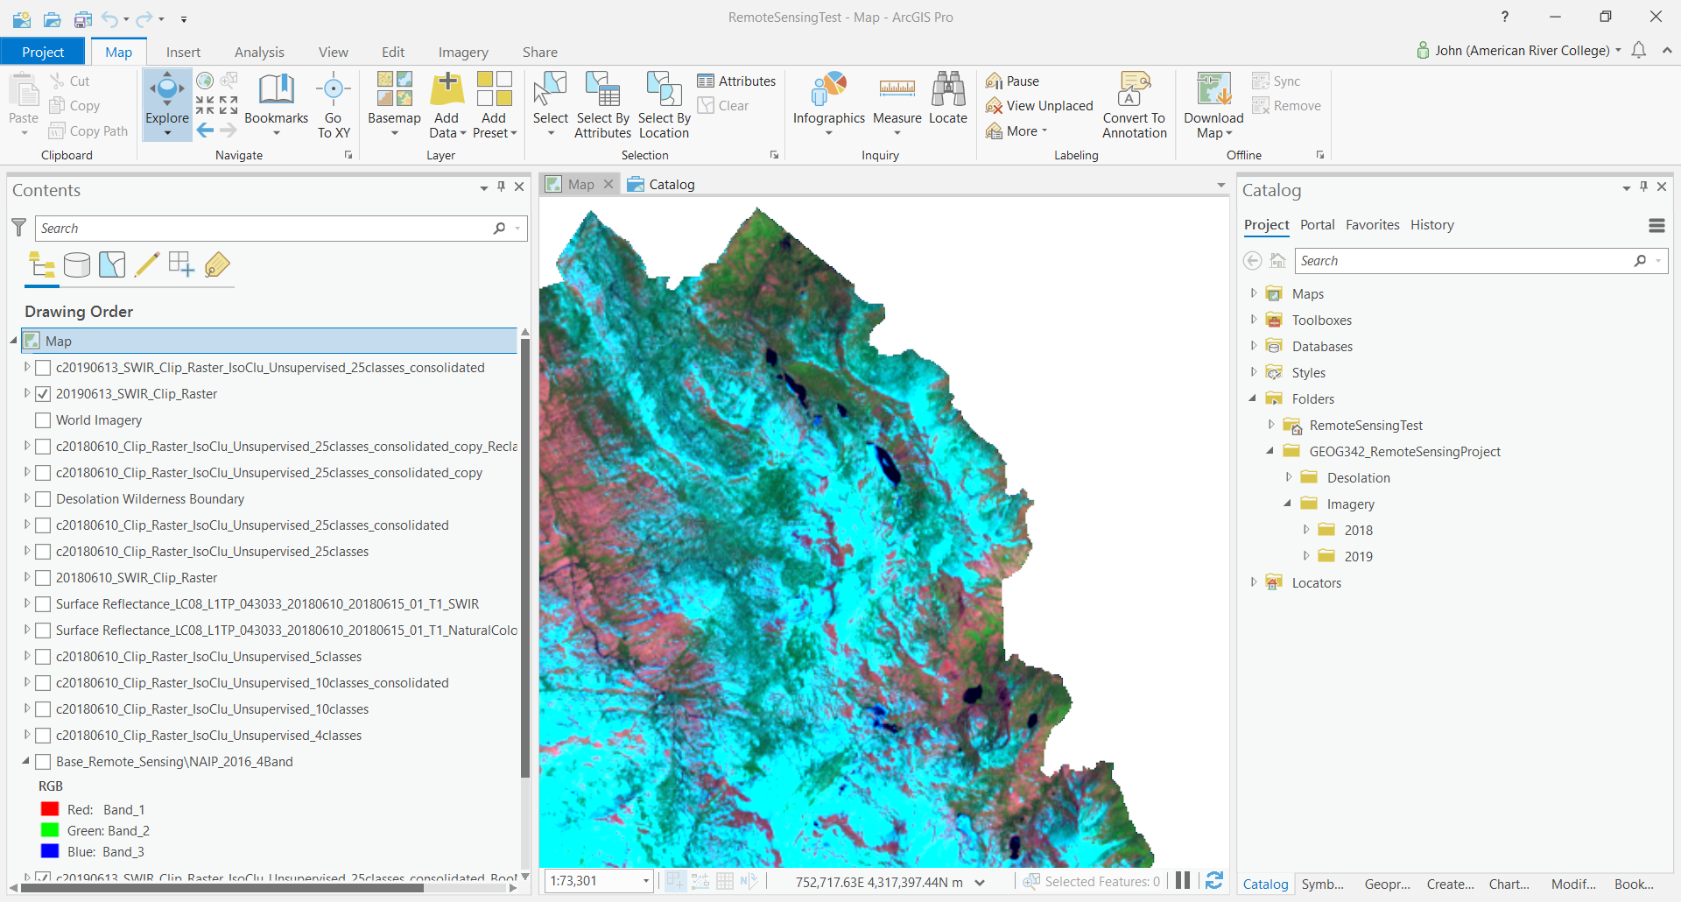

Supervised Output Layer (Rangeland, Forest, and Water area B)
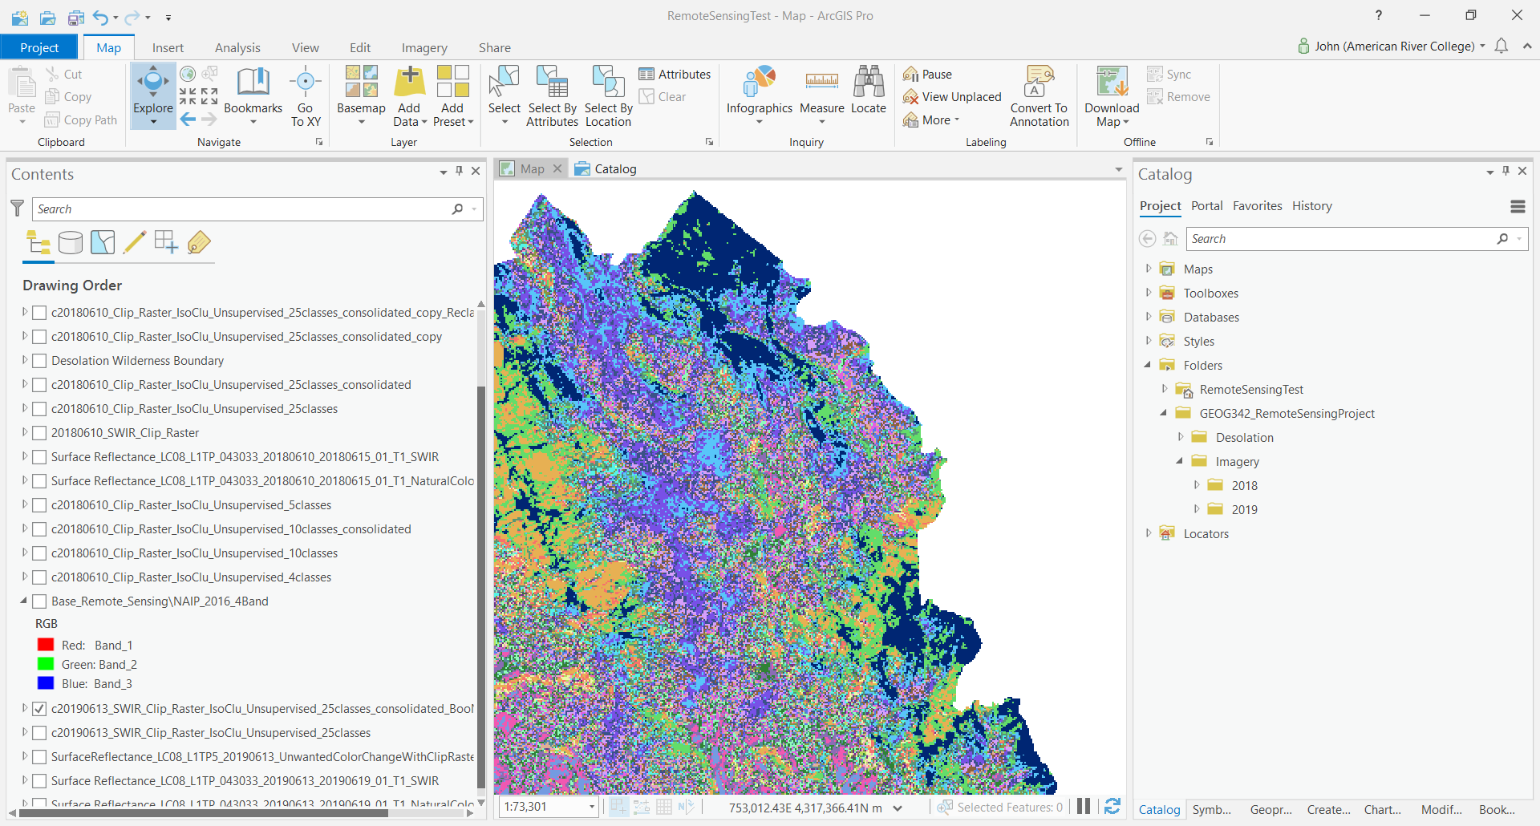

Input Layer (Rangeland, Forest, and Water area B) – Zoomed In
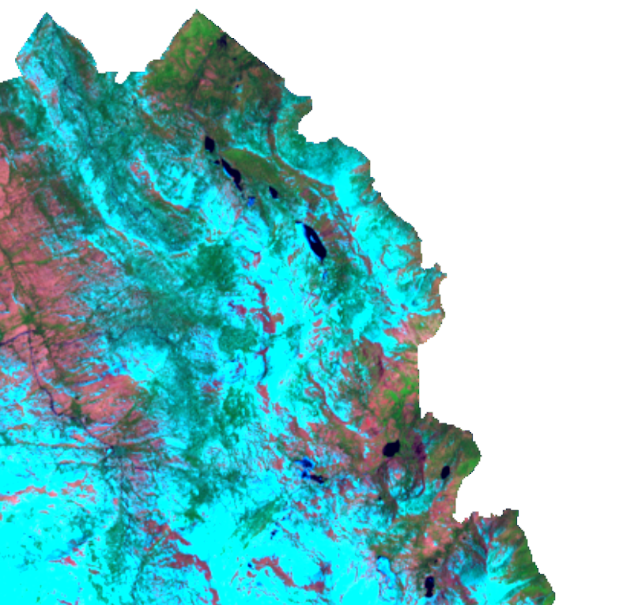

Supervised Output Layer (Rangeland, Forest, and Water area B) – Zoomed In
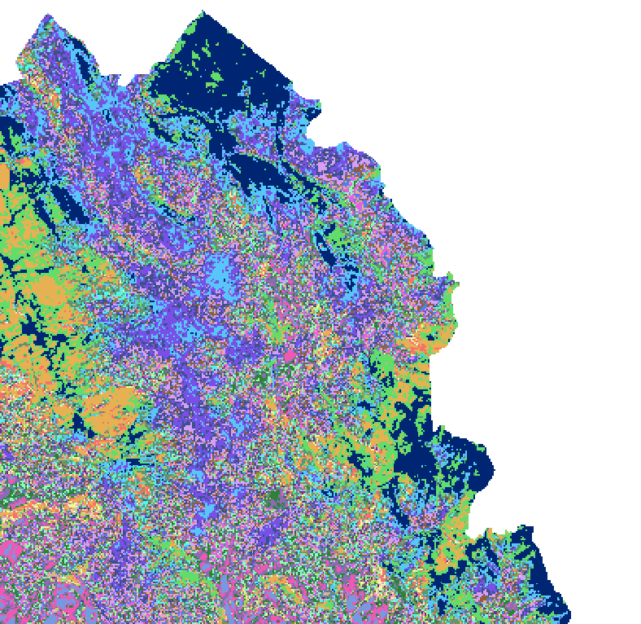
I ran additional Unsupervised processes with 40, 60, and 100 classes. I had the same challenge with all of the outputs. Since the accuracy of the outputs were not significantly better with any of the larger classes, I decided to move forward with analyzing 25 classes as it would take less time to manually consolidate the color classes.

To revisit, the images below show the 25-Class Unsupervised Layer before consolidating the spectral classes.

Ouput 25-Class Unsupervised Layer (before consolidating spectral classes)
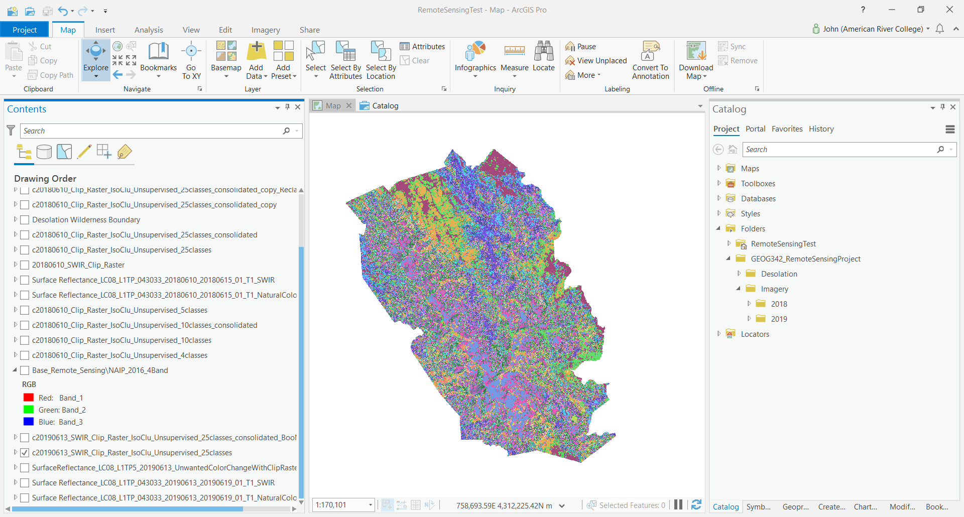

Ouput 25-Class Unsupervised Layer (before consolidating spectral classes) - Isolated

After consolidating 25 Spectral Classes into 5 Information Classes
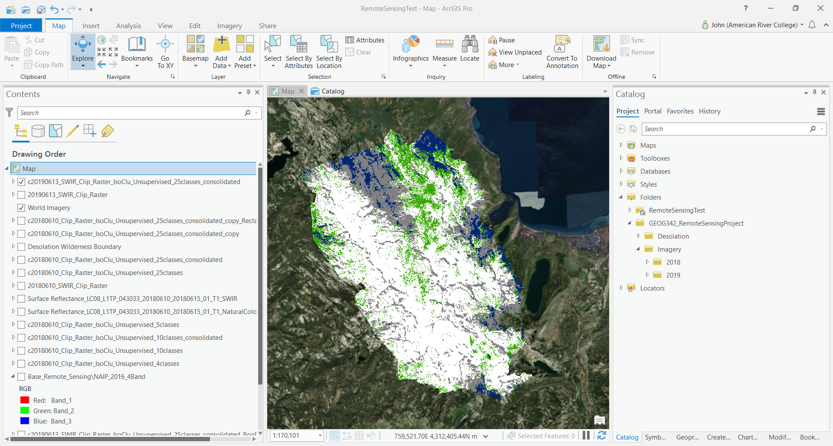

After consolidating 25 Spectral Classes into 5 Information Classes – Zoomed In
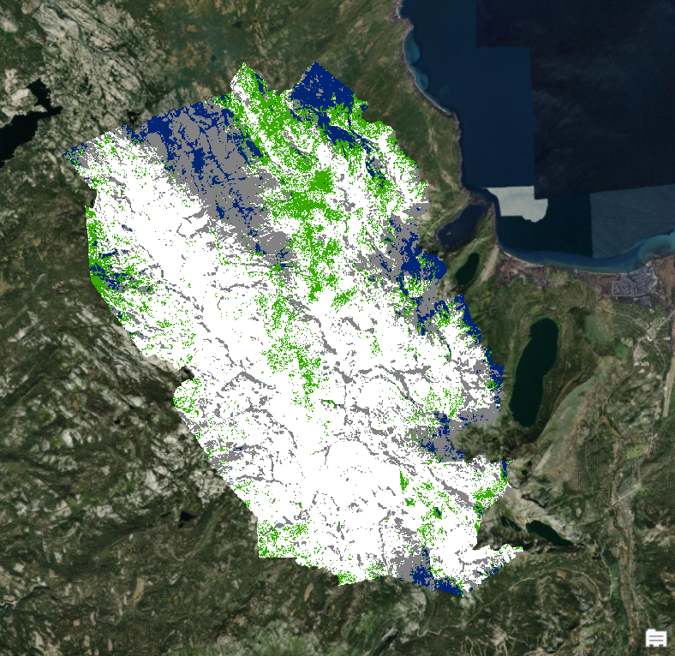

Reclassify 2019 Image
Notice only four Information Classes in the images below. This is because the Unsupervised process did not identify a Rangeland spectral class for some reason. In addition to increasing the number of classes, I retraced my steps, recreated layers, researched online and could not identify a solution for Challenge #2. Fortunately, the classification of Snow, the main objective of this project, did not appear to be affected.

Reclassify Output (ArcGIS Pro random color scheme)
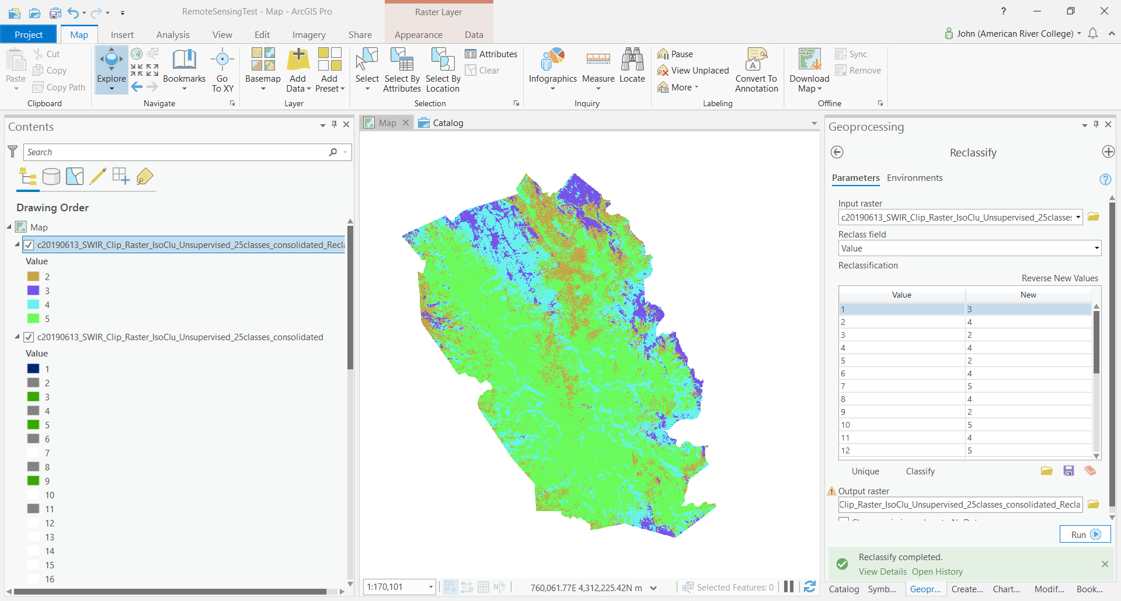

Before color coding and naming the Information Classes
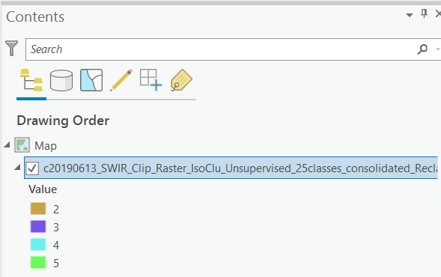

After color coding and naming the Information Classes
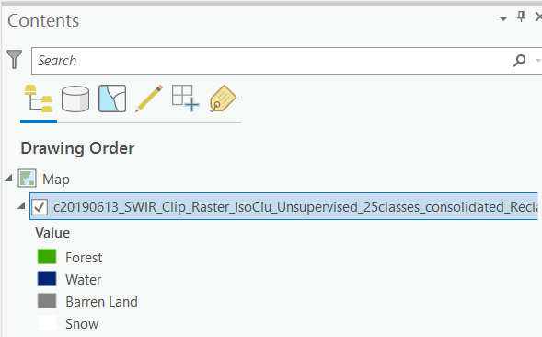

Reclassify Output (USGS Land Cover Color Codes and Names)
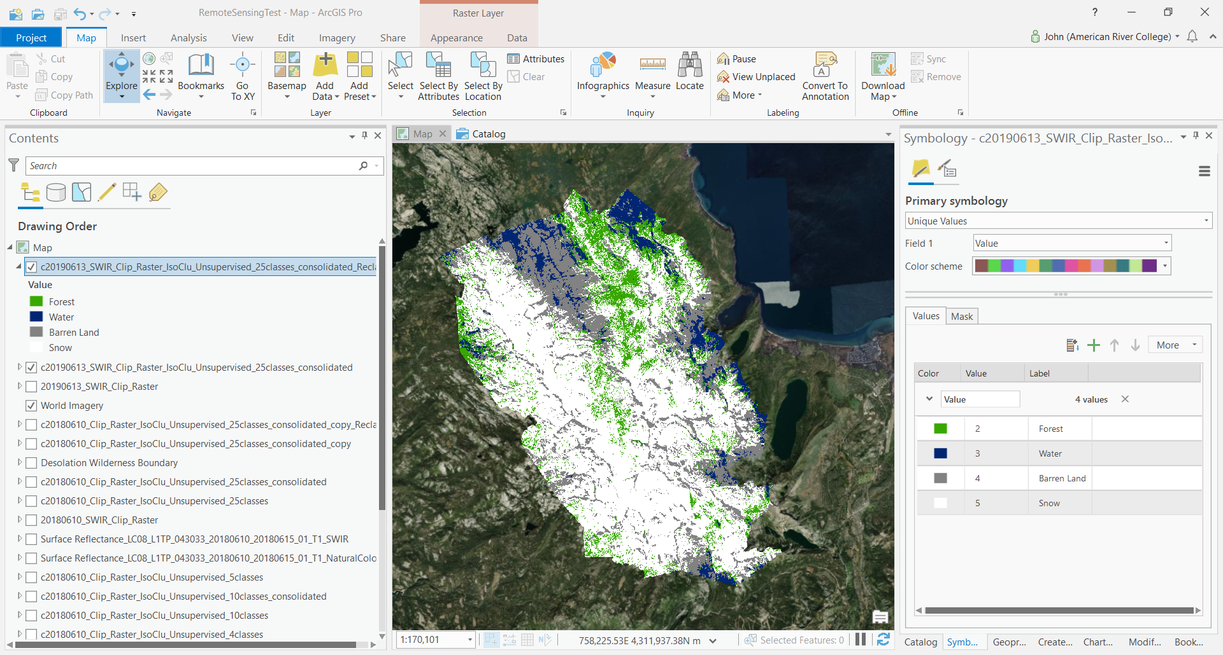

Reclassify Output (USGS Land Cover Color Codes) – Zoomed In

Conclusion
After running the Unsupervised process for 2018 and 2019, I compared the Attribute Information for both layers. The conclusion was that there was significantly more snow in 2019 than in 2018, 59.49% versus 17.61% respectively. This data confirms my belief that there was more snow cover in June 2019 compared to the year before.

2018 Attribute Table
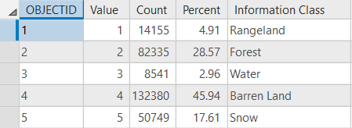

2019 Attribute Table
