Joseph Watkins
GEOG-375: Introduction to GIS Programming
Final Project
May 7, 2018

California Highways – Right of Way Acquisition

Project Summary
Caltrans maintains and improves more than 50,000 lane miles throughout California. While some projects are designed to repair existing roadbed, others increase the footprint by expanding freeways to mitigate traffic congestion. Identifying parcels impacted by future projects is the responsibility of the Division of Design and information is passed on to the Division of Right of Way for acquisition. For my project I wrote a script that allows Right of Way to cross-check Designs work. The script first clipped statewide highways to the Sacramento County boundary, then performed a query to isolate CA 220. A statewide parcel data layer was also clipped to Sacramento County to reduce file size but still allow flexibility for other projects in the area. I created a 250 foot buffer along the CA 220 stretch of highway then ran an interest against the parcels to generate a table of impacted properties. Lastly I generated a map of the project area to accompany the list and saved as a .pdf.

Purpose
With over 300 projects being developed each year, Caltrans is always looking for ways streamline project development while properly vetting each step for accuracy, transparency and record keeping. This project takes an innovative GIS approach that explores alternative methods for quickly ensuring accuracy. Working for Caltrans, this project allows me to showcase some of the more hidden power of GIS and python programming.

Project Development
- Data Acquisition
The California state highways and county boundaries data used for this project were provided in shapefile format by the California Department of Transportation. The parcel data was acquired from the Sacramento County GIS Open Data website. Acquiring the data was easy since both resources are public entities with open data standards. The data was staged in a local file to be used for script writing.
- Python Script Development
My initial step was to write a brief project summary to stay focused on the assignment. I then imported acrpy, os, and sys, allowing the script to perform data analysis, conversion management and map automation of the data. Traceback was used to quickly find any errors buried in lines of code. I created a workspace that pointed to my local drive and folder where I had previously downloaded my data and variables were defined for the outpath, shapefiles, search distance and clipped layers. I also utilized the “# comments” to keep my script well organized.
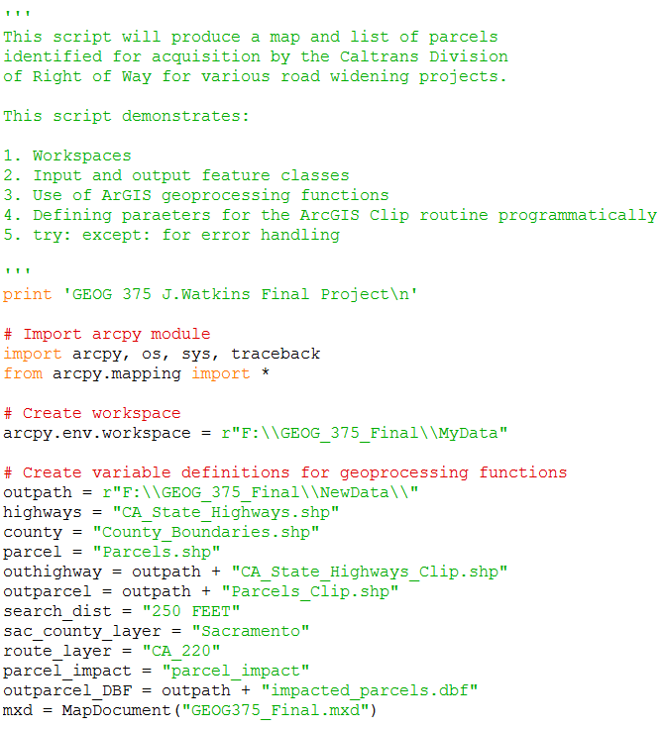
In the try block, I first needed to isolate Sacramento County from the statewide data set and create a new Sacramento County layer. I did this by using the “if” statement to see if the layer existed and to delete if needed. Afterwards I reviewed the data table and identified “SAC” within the “CO” (County) column and ran a query.
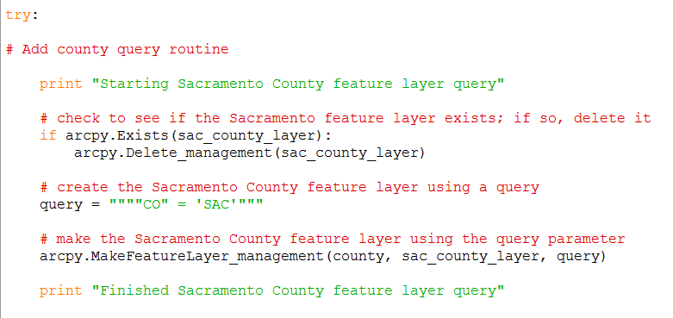
With the County layer created I was able to run a Clip routine on the statewide highway dataset using a similar method as above to generate a layer of highways specific to Sacramento County.
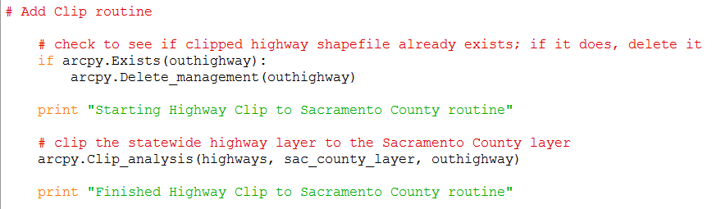

Due to data storage concerns and processing time I did not download a statewide parcel dataset. Since I had predetermined that Sacramento County would be my study area, I instead chose to downloaded the Sacramento parcel shapefile from the Sacramento County GIS Open Data Site; https://data-sacramentocounty.opendata.arcgis.com/. If storage was not an issue the Clip routine for the parcel data would have looked similar to the above routine for highways, or as follows;
# Add Parcel Clip routine
# check to see if the clipped parcel shapefile already exists; if it does, delete it
If arcpy.Exists(outparcel):
arcpy.Delete_management(outparcel)
print “Starting Parcel Clip to Sacramento County routine”
# clip the statewide parcel layer to the Sacramento County layer
arcpy.Clip_analysis(parcels, sac_county_layer, outparcel)
print “Finished Parcel Clip to Sacramento County routine”
My next step was to query a highway route within the newly created “outhighway” layer. This section of code is easily customizable to any given stretch of highway within the county. I continually used the “print” statement as a quick visual confirmation that my script was running properly.
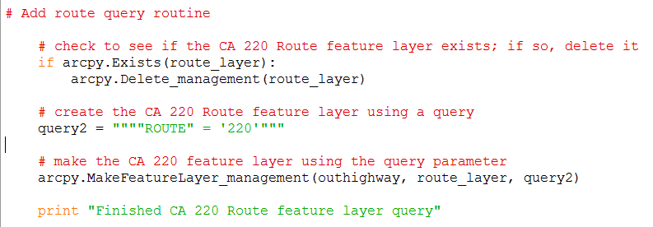
With my subject area identified and data isolated I was able to run the following intersect routine. I used the “select layer by location” command to generate a new selection of parcels that were within 250 feet of the queried highway route CA 220.
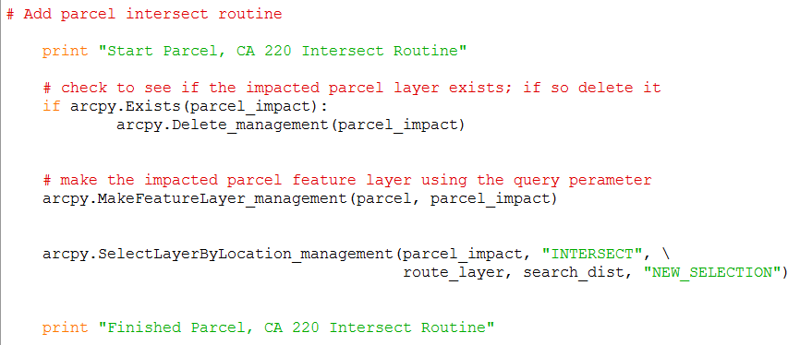

Next I created an outparcel layer of the impacted parcels and saved it both as a shapefile and a .dbf. This allowed me to share the impacted parcels as both a visual map and accompanying list. In the screenshot below you can see some of the script development in generating the .pdf as well.
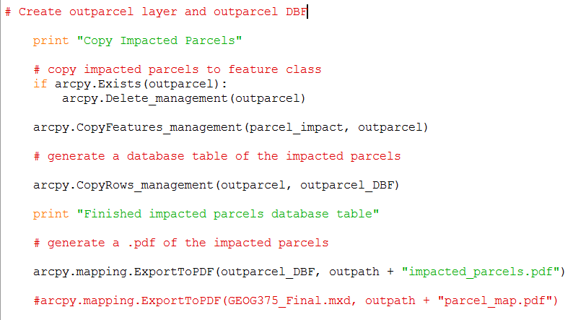

With the impacted isolated data now available, I used ArcMap 10.5 Google Maps to confirm accuracy. I imported the data, created labels and saved the .mxd within “MyData” folder for conversion to .pdf in further scripting. Below are screenshots of the highway system and parcel layers before and after processing my script.

Before:
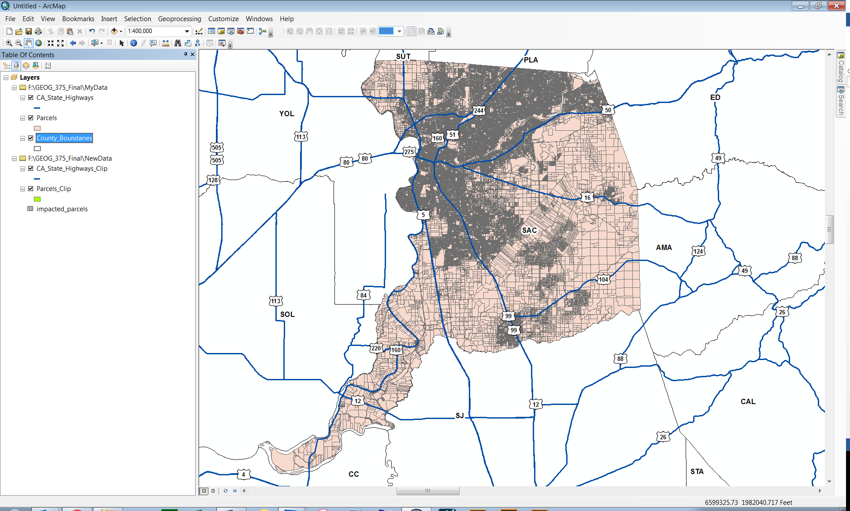
After:
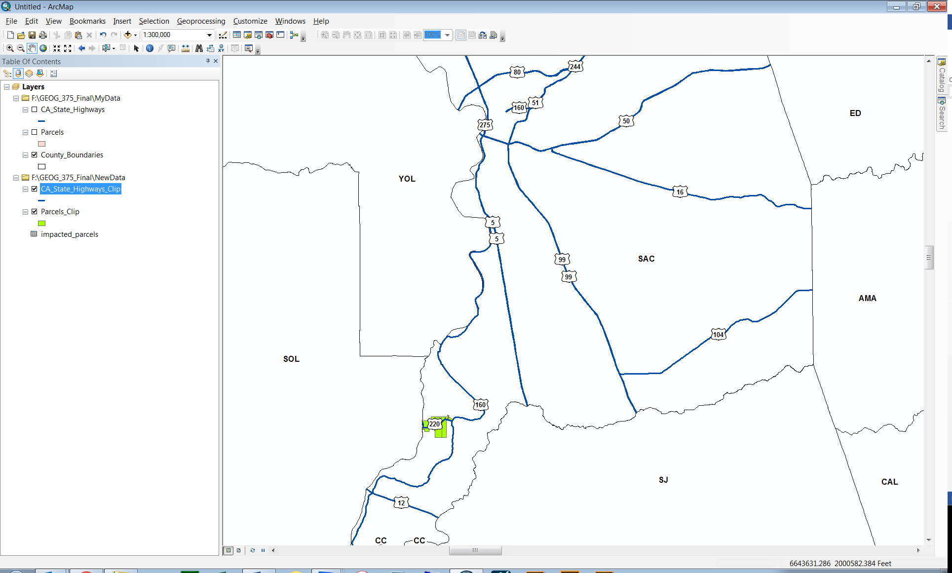

Zoomed in view of subject area:
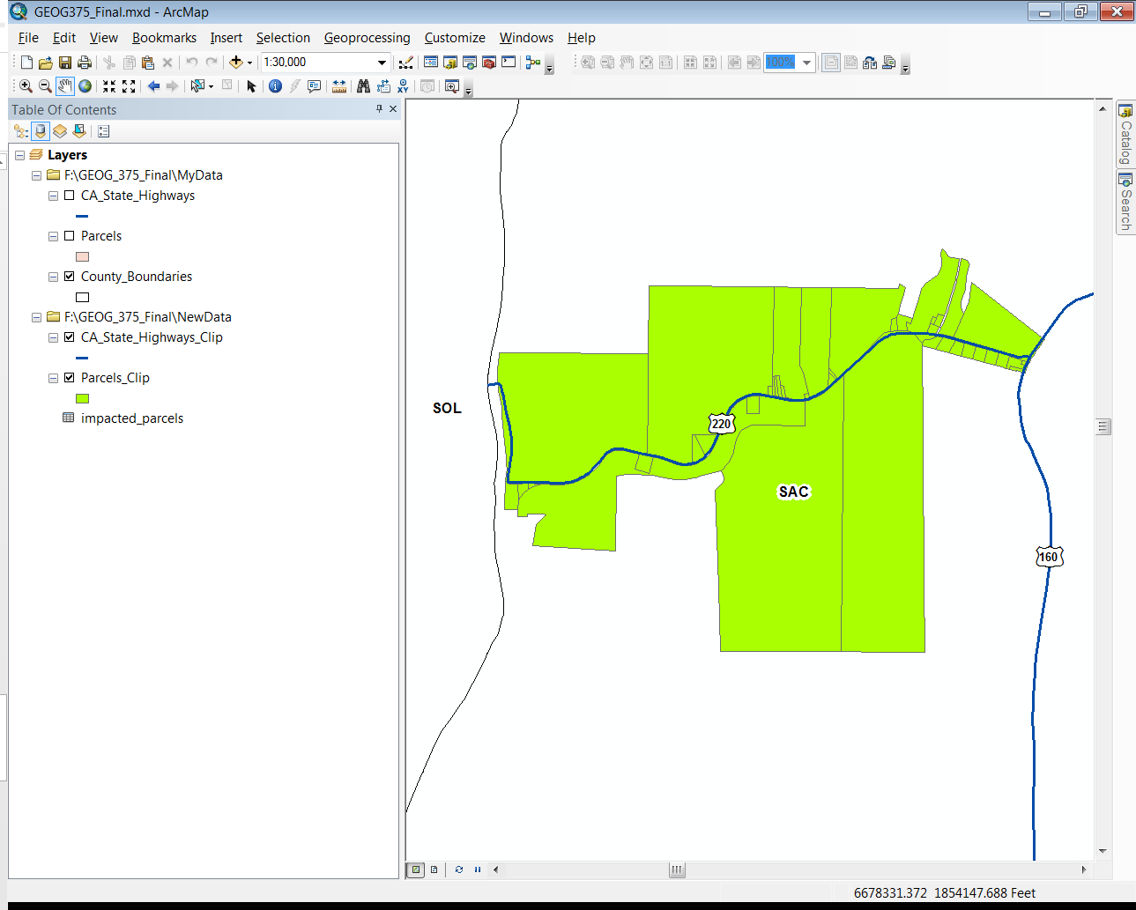

By performing a Google Map search for the addresses listed in the database table, I was able to confirm my script accurately extracted the impacted parcels.
Database Table:
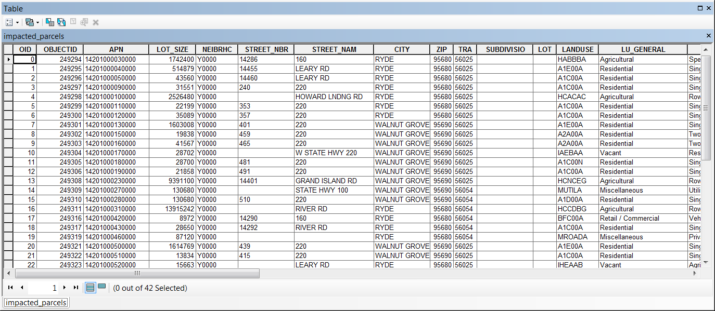
Google Maps Address Search:
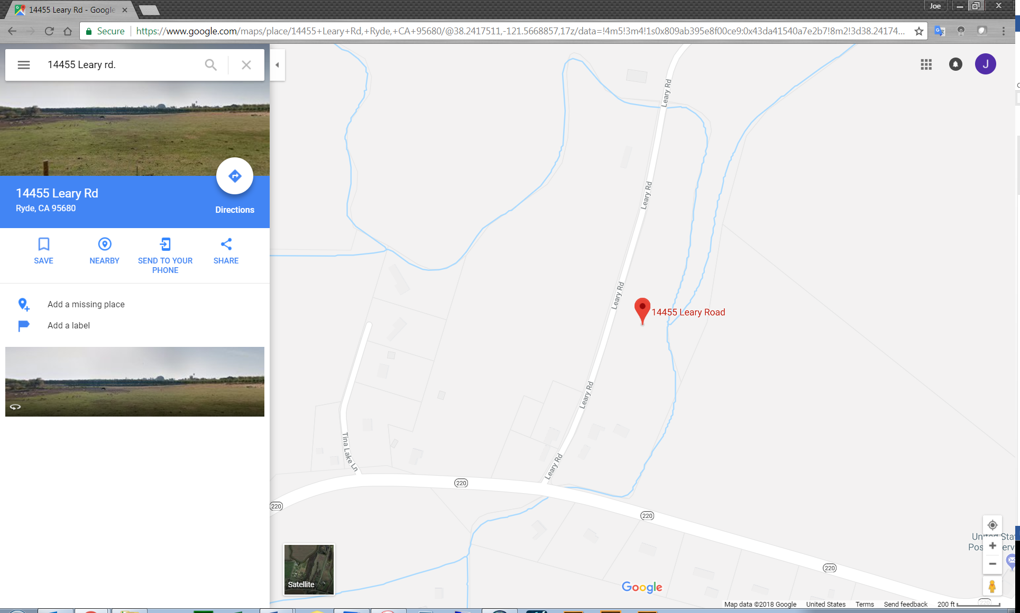

Finally I wrote the script to save my .mxd as a .pdf. The except block was one of the first sections of code written and included as the final component to my script.
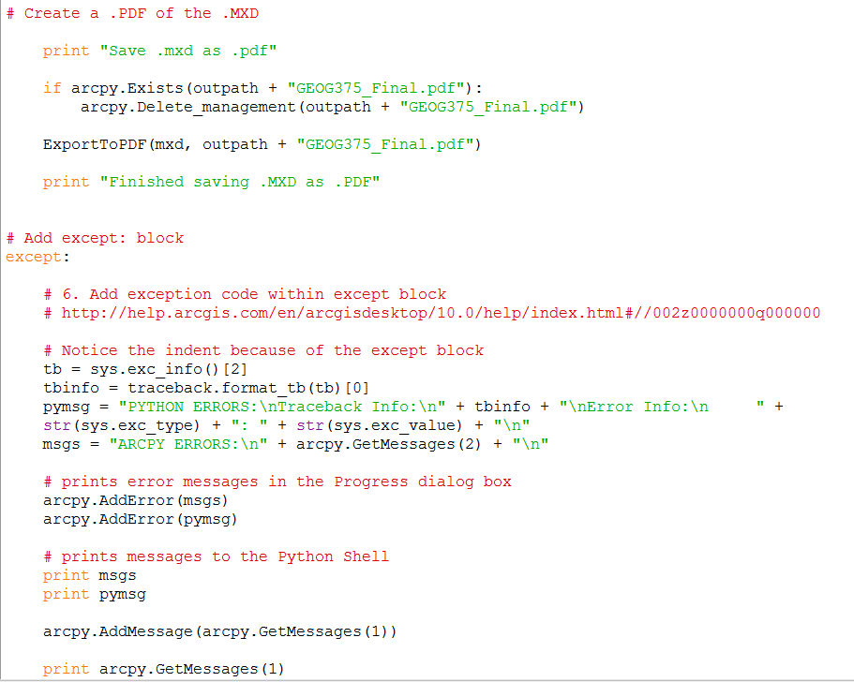
.PDF generated:
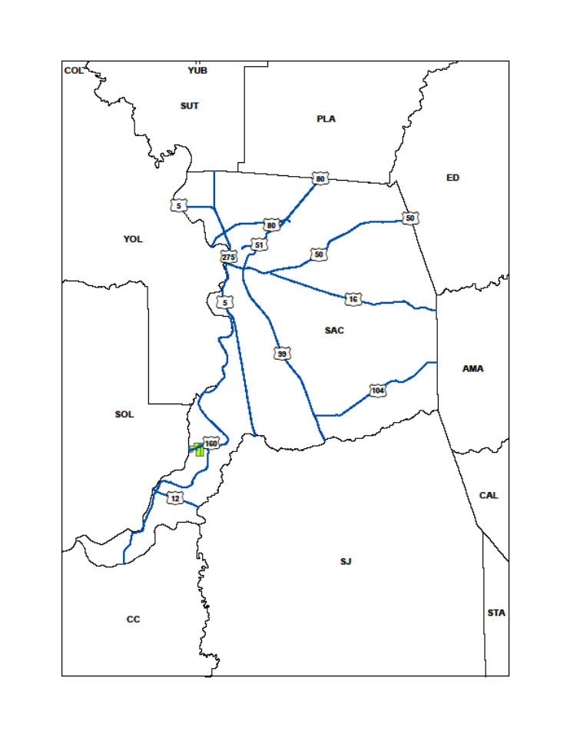
Script run success:
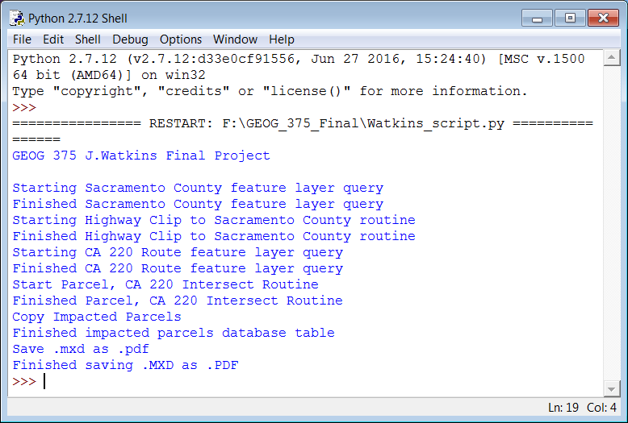
Discussion
Obtaining the data for this project was straightforward. Since I work for Caltrans, the location of the statewide boundaries and highways were already familiar to me. A simple google search for “Sacramento parcel shapefile” brought me to the counties GIS open data page. I found the page easy to navigate and quickly found what I was looking for. Throughout the project I chose various highways to run the routine on. I settled on CA 220 because it was a short section of highway resulting in a more manageable list of parcels. The intersection of parcels and clipped highway required some trial and error to accurately create the impacted parcel feature layer then perform the Select Layer By Location command. I referenced prior class material to complete this task. I found the examples provided in both chapters five and six to be very helpful. I did find myself going back to add the Exists/Delete command on the impacted parcel after having it successfully run, only to error the second time around. Creating the database table was pretty straight forward. I was surprised to see the script successfully run the first time allowing quick turn-around to confirming the accuracy through Google Maps. My biggest obstacle was generating the .pdf’s. I worked on creating the .mxd by writing script and ultimately relied on the one created and saved using ArcMap. My script written to save the .mxd to .pdf was not successful until the last week of class. This was the section I spent a good deal of time trying to perfect. I researched examples provided by ESRI, Gis.stackexchange.com and material from throughout the semester to no avail. I finally reached out to the instructor who provided some feedback and after making some final adjustments to my mxd variable and mapping module, I was successful.
Conclusion
This being an introduction to GIS Programming course, the final product meets my expectations. I was able to successfully write python coding to execute a series of commands which relied on each other to perform properly. The script generates results that are both accurate and malleable. With a few small changes, the script is customizable to any county and any stretch of highway within California, generating a completely new set of impacted parcels. Although I was not able to create a .pdf or excel list of the parcels, I did create a standalone database table and new feature layer that can be joined or related to other layers for future projects. The final component of saving my .mxd as a .pdf made this project a complete package, however if this project was part of my daily workload, the map would need to be fine-tuned to include title, legend, and orientation detail based on the layers created through the script. I’m happy with the results and look forward to refining my script and showcasing the power of python programming in conjunction with GIS.
References
http://www.dot.ca.gov/hq/tsip/gis/datalibrary/Metadata/StateHighway.html Web. 25 Apr. 2018.
https://data-sacramentocounty.opendata.arcgis.com/datasets?q=parcel Web. 25 Apr. 2018.
https://gis.stackexchange.com/questions/82316/export-mxds-files-to-pdfs-using-python Web. 25 Apr. 2018.
https://support.esri.com/en/technical-article/000012420 Web. 25 Apr. 2018.
https://www.google.com/maps/@38.5697883,-121.4970293,15z Web. 25 Nov. 2018.

