Supervised Classification of Landsat 8 Image
Yared Kebede

Project Summary
In this study, a supervised classification on Landsat8 image was conducted to identify the different land features in the Central Valley region of California. Training samples for waterbodies, developed areas, cultivated lands, shrublands, forests, barren land, and wetlands were selected to classify the multispectral image based on the spectral signature of the training samples. Spectral Profile, scatter plot and histogram charts were plotted to assess the quality of the training samples. Covariance and correlation matrices were used to evaluate the relationship between two bands for each land feature. Maximum Likelihood Estimate was used to classify the raster image. The percentage and acreage of the land features were calculated based on the count of cells of the classified image.

Purpose
The purpose of this project was to conduct a supervised image classification on Earth Explorer’s Landsat8 image (GeoTIFF Data) in the Central Valley region of California. Training samples were selected for image classification and statistical analysis were conducted to determine the quality of the image classification process. The percentage and acreage of the land cover types were determined based on the count of the pixels.

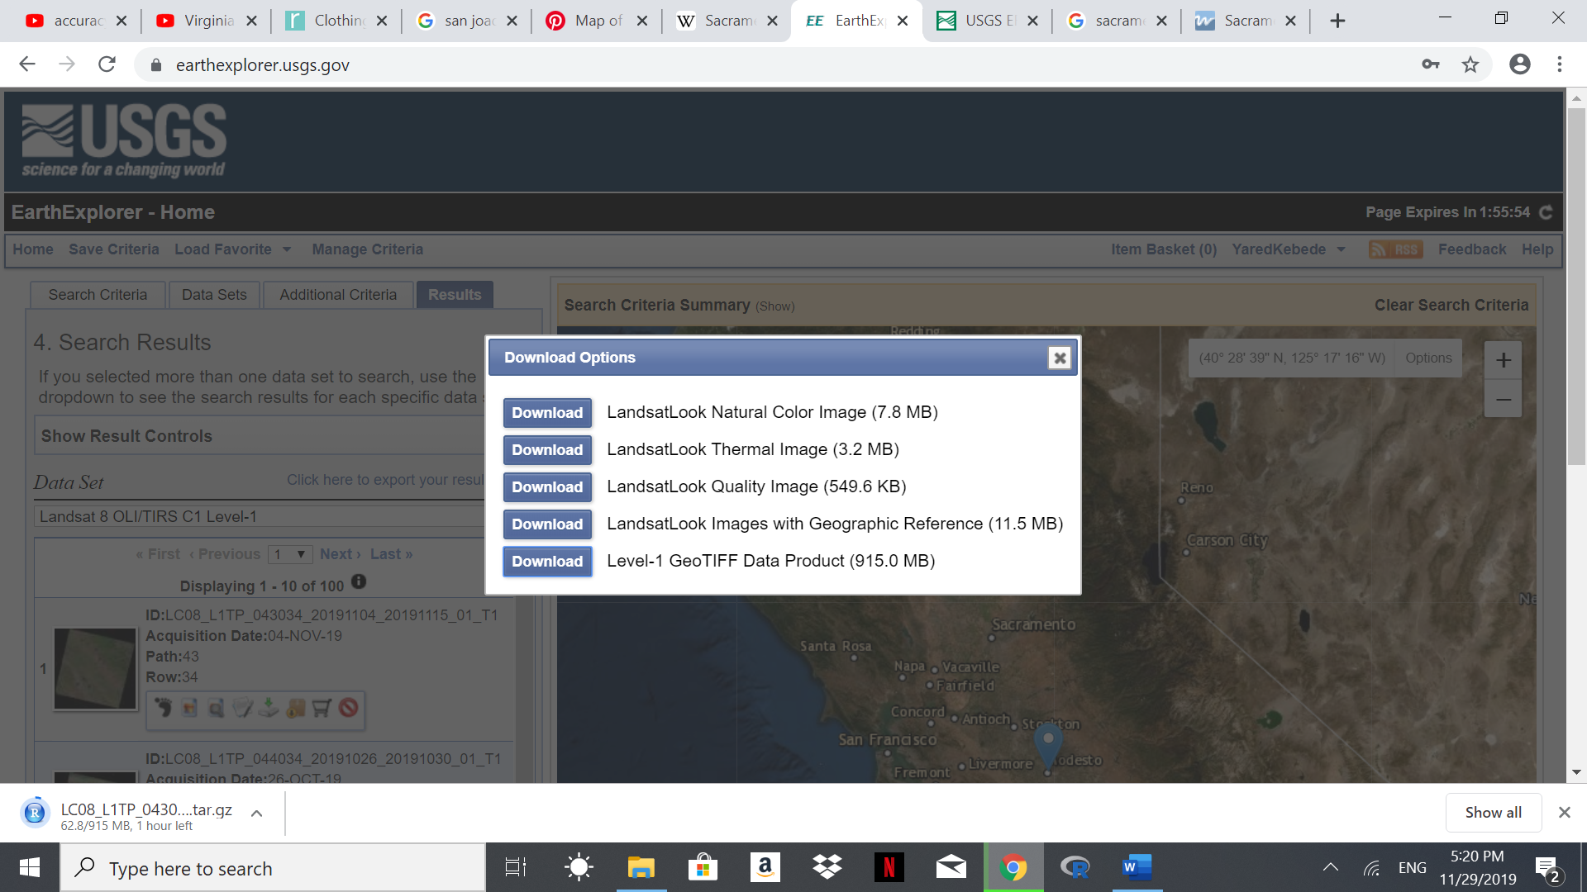
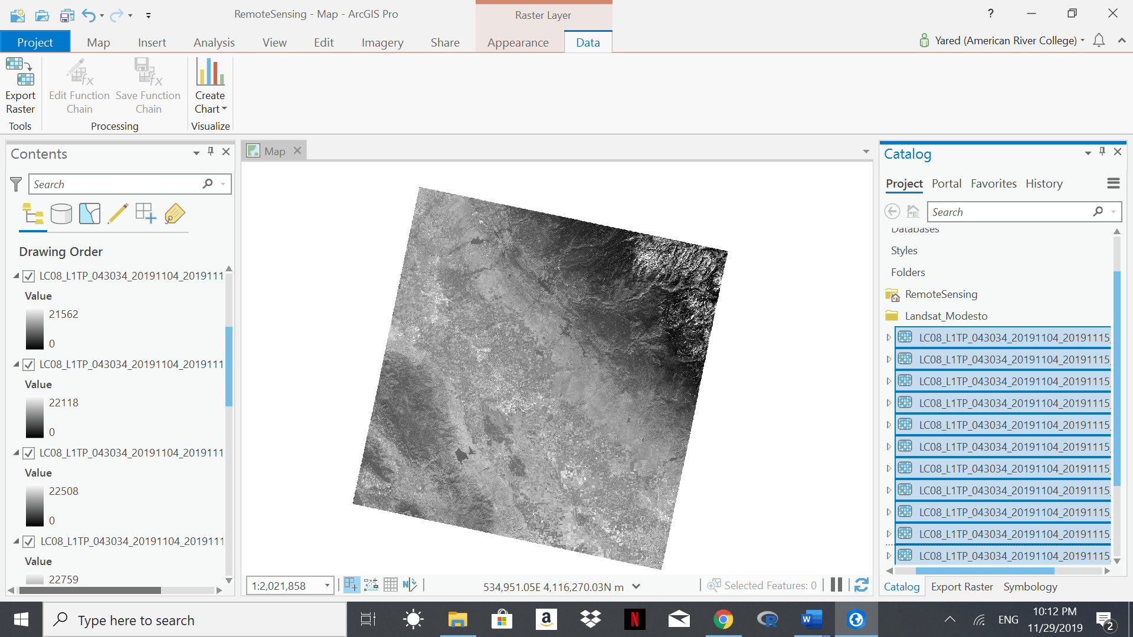

Figure 1. Image Download – Earth Explorer Figure 2. Image Load – ArcGIS Pro

Descriptions of Methods
For this project, ArcGIS Pro was used for image processing and analysis. Landsat image (GeoTIFF Data) was downloaded from USGS Earth Explorer site, and a composite image was created using all the 11 bands. The image was clipped using Image Raster function to an area that extends from Lodi to Turlock (~50 miles). Training Samples Manager was used to select samples used for image classification. Spectral profile, scatter plot and frequency distribution (histogram) charts were used to evaluate the training samples. Maximum Likelihood Estimate (Geoprocessing) was used to classify the raster image. Correlation and covariance matrix were used to evaluate the relationship between the two layers for each land cover type.

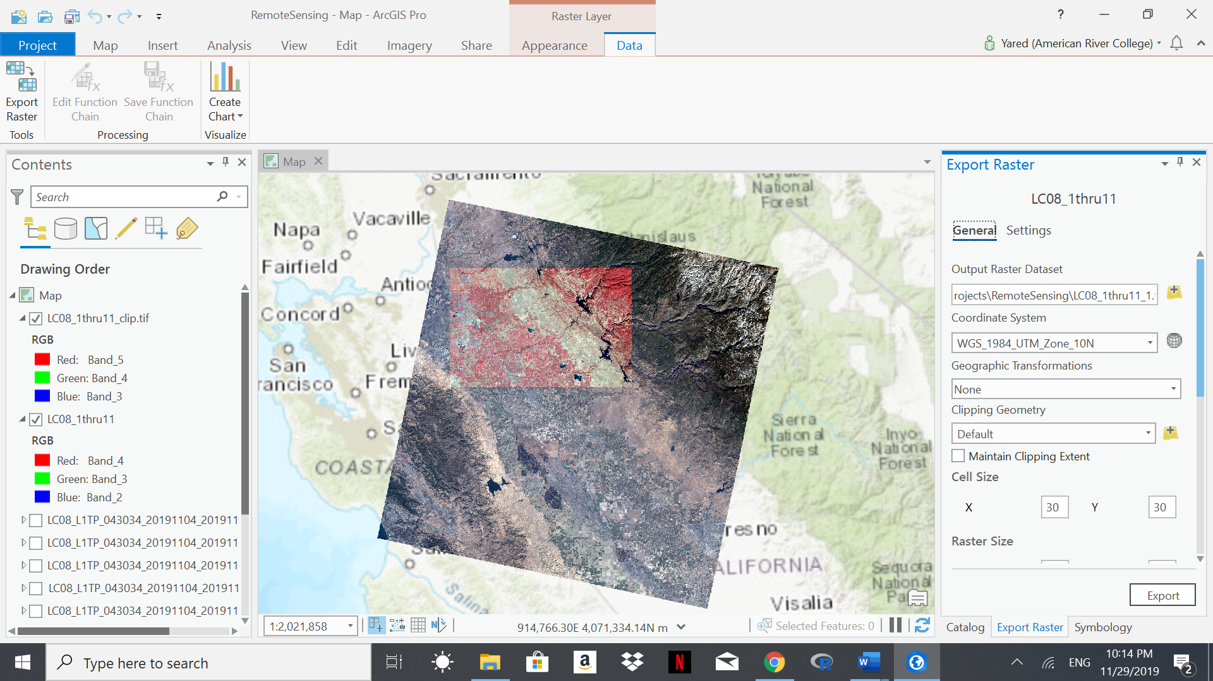
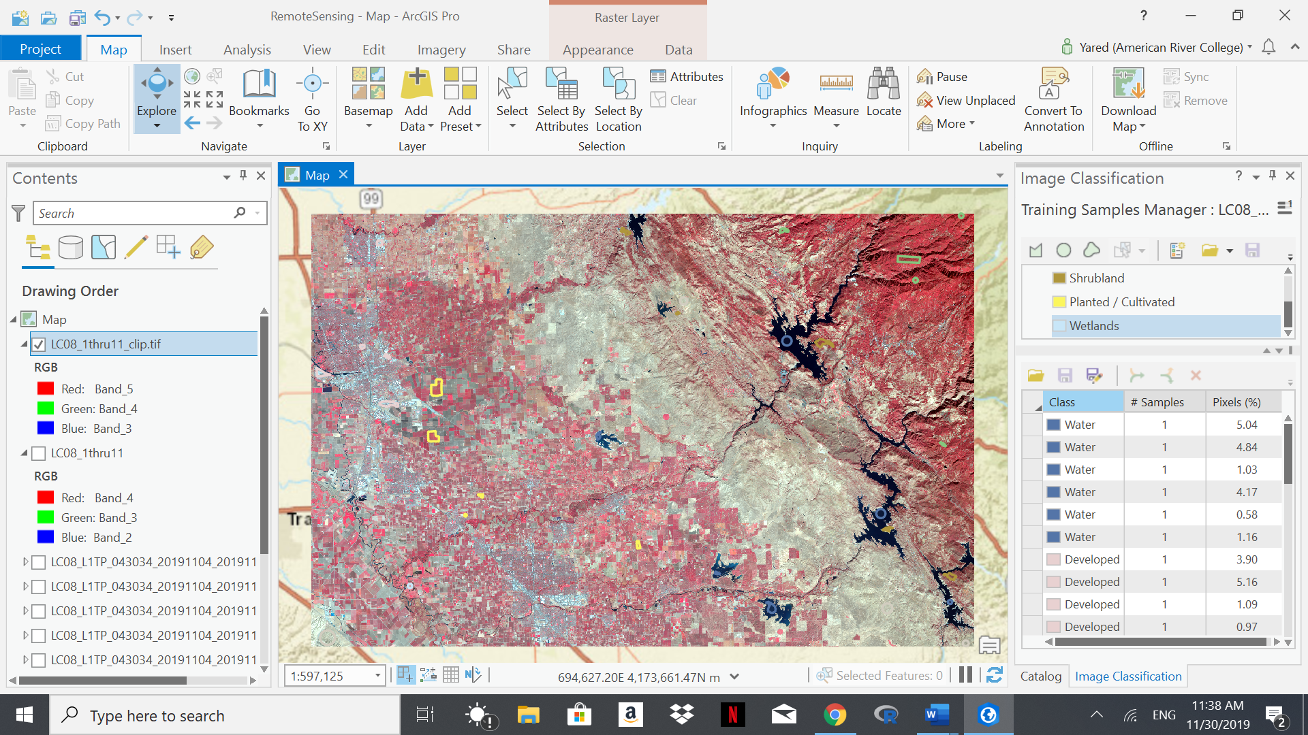
Figure 3. Clipped Raster Figure 4. Training Samples
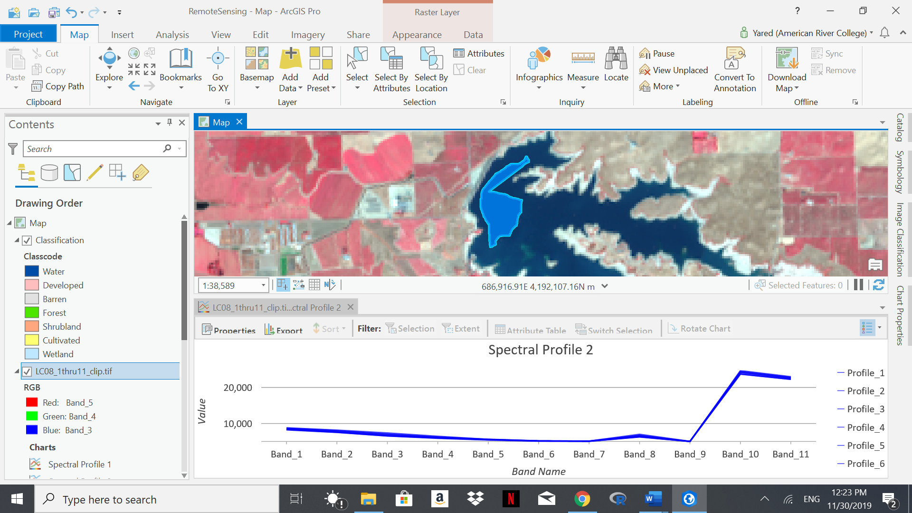
Figure 5. Spectral Profile - Water
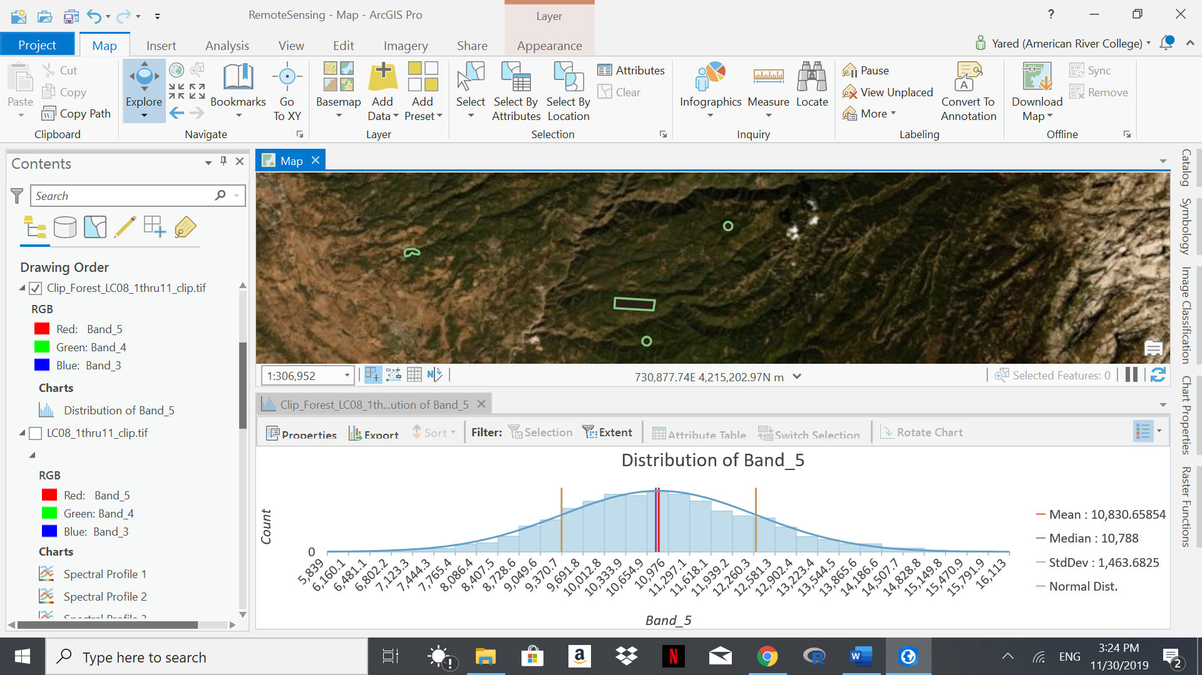
Figure 6. Distribution of Band 5- Forests
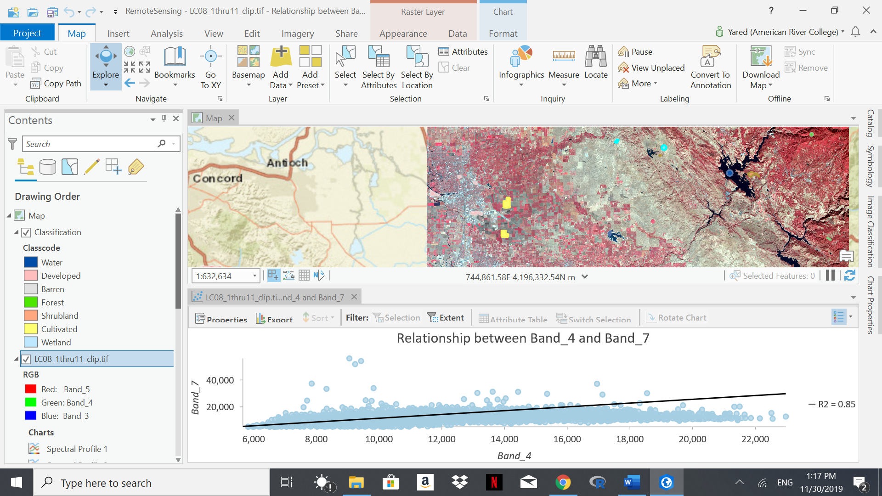
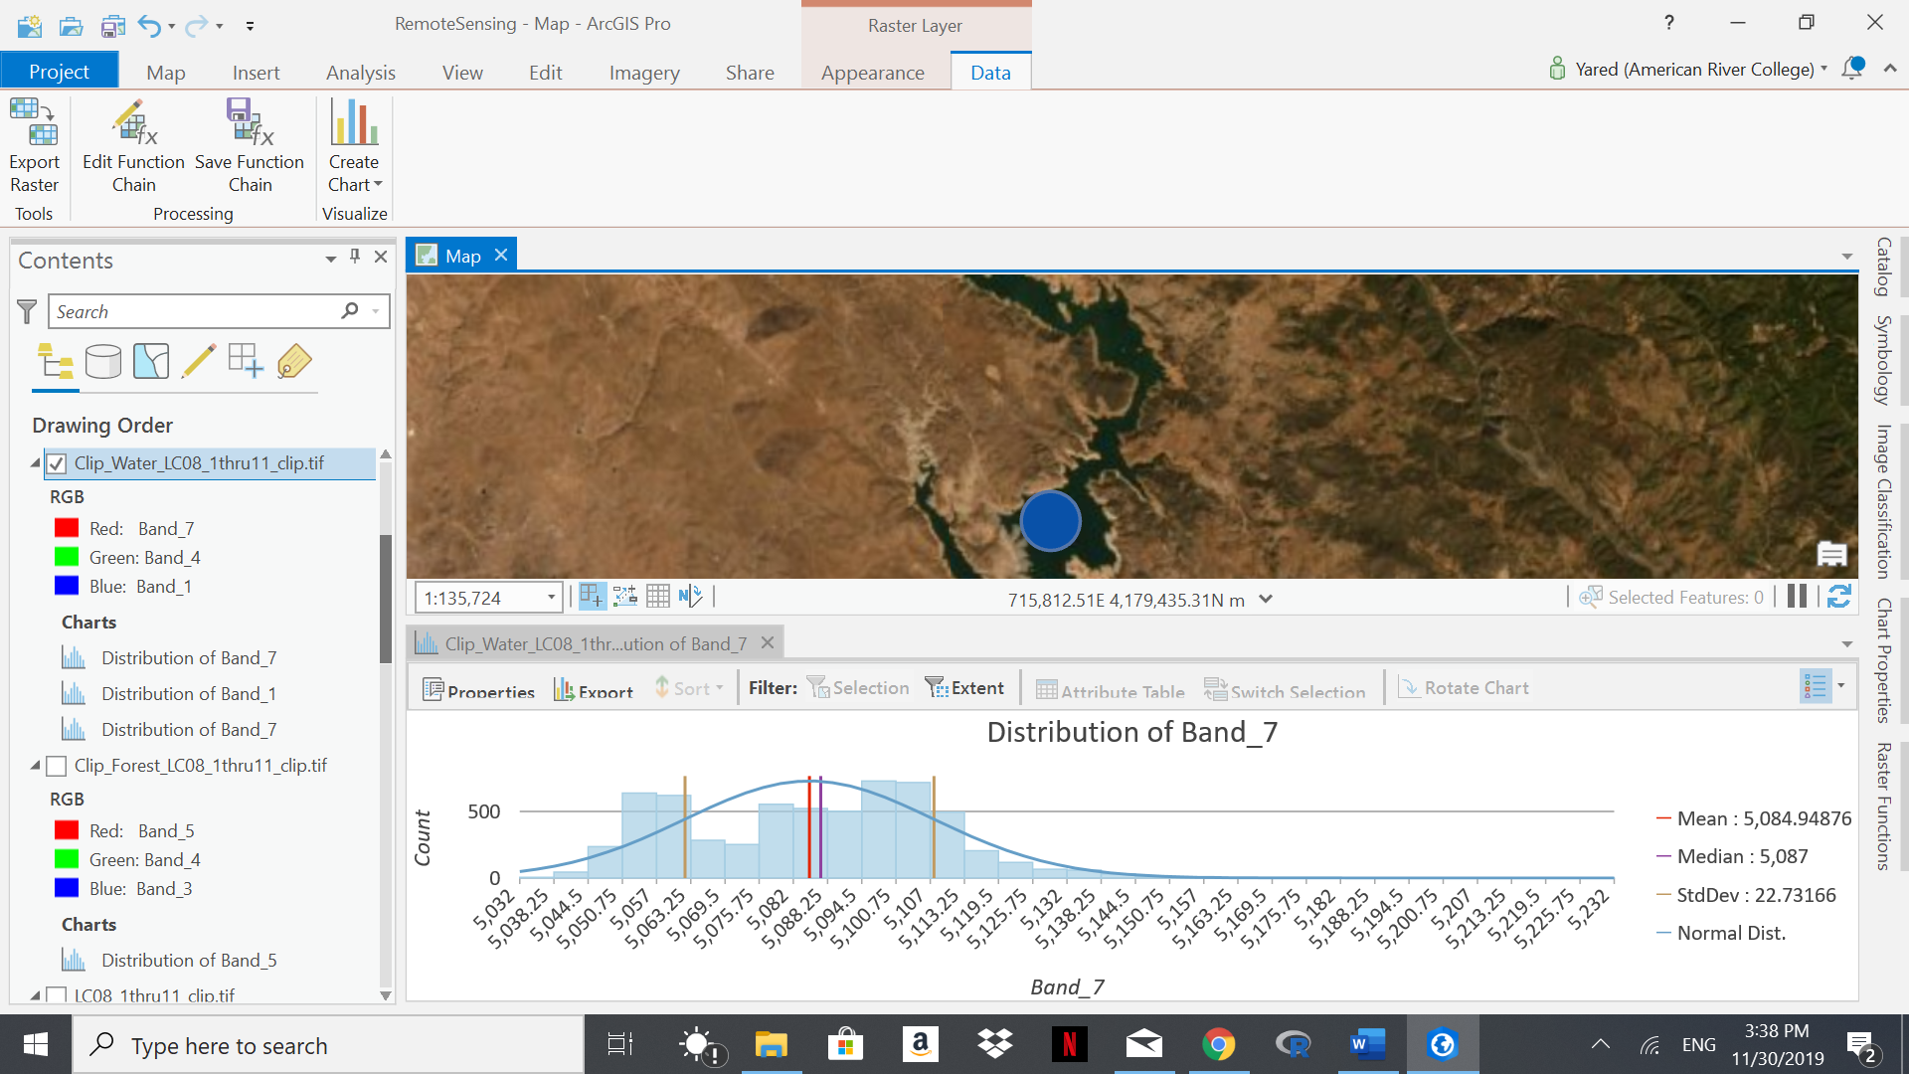

Figure 7. Scatter plot – Barren Land Figure 8. Distribution of Band 7 - Water

Challenges
The main challenge working on this project was use of few training samples for wetlands as their distribution is limited within the study area. I’ve resolved this issue by selecting fewer training samples for wetlands to avoid selecting nearby agricultural fields. Also, selecting appropriate project ideas was challenging - I’ve considered working on land cover changes after incidence of wildfire before deciding to work on this project.

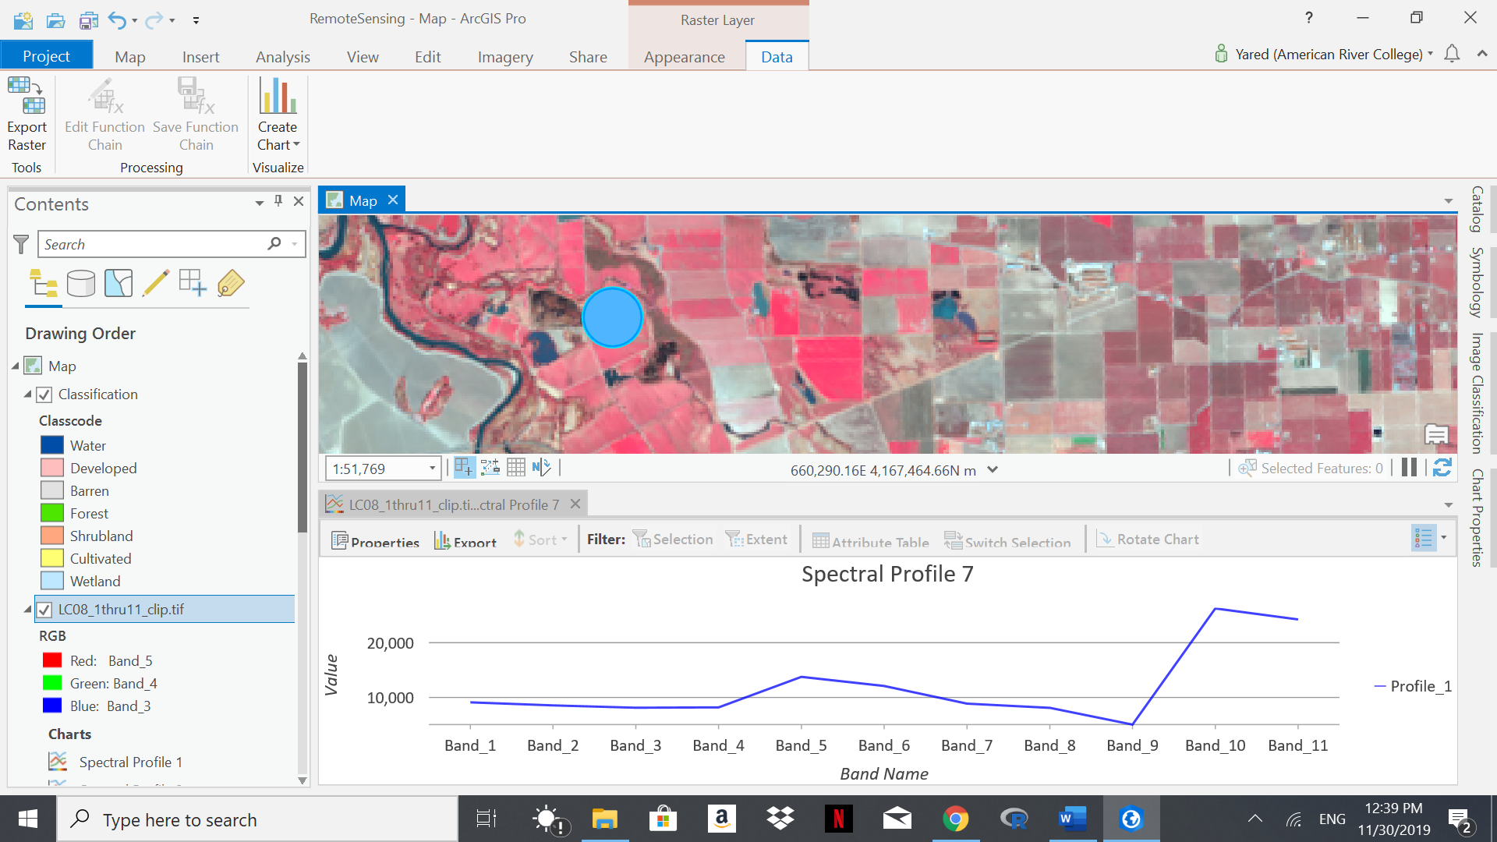
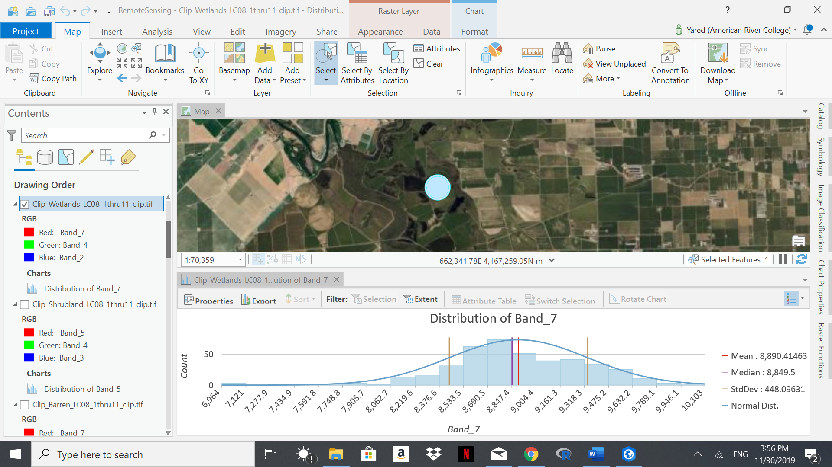
Figure 9. Spectral Profile – Wetlands Figure 10. Distribution of Band 7 - Wetlands

Image Processing and Output
For supervised classification, five training samples were selected for the following land features: Water, Developed, Shrubland, Planted and Wetlands. The spectral profile of the selected features was displayed (Raster layer → Data → Spectral Signature) and overlapping profiles were merged. A correlation coefficient was determined for training samples with varying spectral profiles, i.e., spectral profiles with low correlation coefficients were removed and new training samples were selected. Mean, median, standard deviation, and the frequency of the distribution were calculated to identify the distribution of the band associated with identifying the feature, i.e., normal distribution indicates most of the spectral signature (reflectance) values were captured around the mean (median) value. For example, normal distribution at band 5 for forests indicates 68% of the spectral signature was captured between mean and one standard deviation, while a bimodal distribution for waterbodies at band 7 indicates the two peak values were captured due to differences in the depth of the waterbodies, i.e., low reflectance in the deep waterbodies vs relatively high reflectance in shallow waterbodies. A covariant and correlation matrix were used to evaluate the relationship between any two bands (layers). A Maximum Likelihood Estimate was used to assign the land use classes based on the original (clipped) multi-spectral raster bands. The percentage and acreage of the resulting land uses were added to the attributes of the classified image based on the count of the cell sizes associated with the each feature.
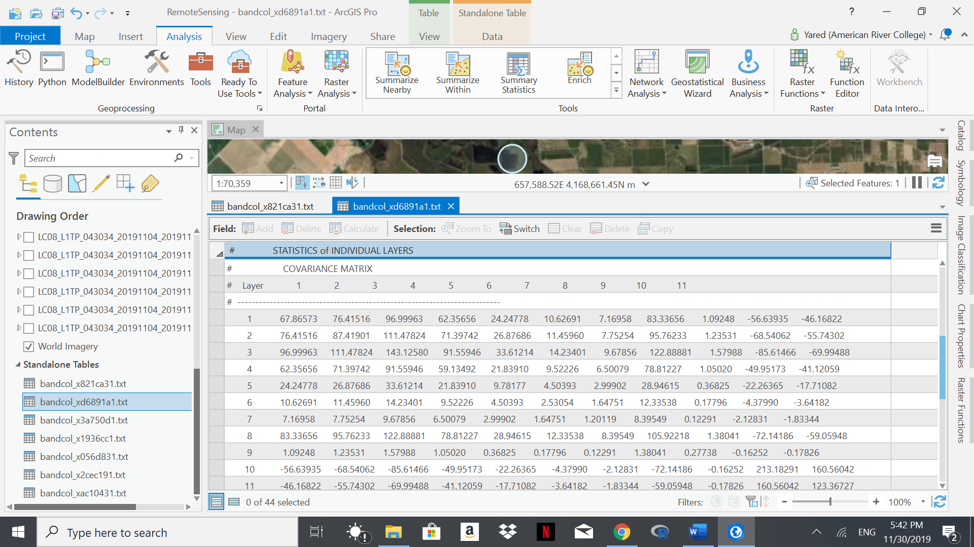
Figure 11. Covariance Matrix - Planted
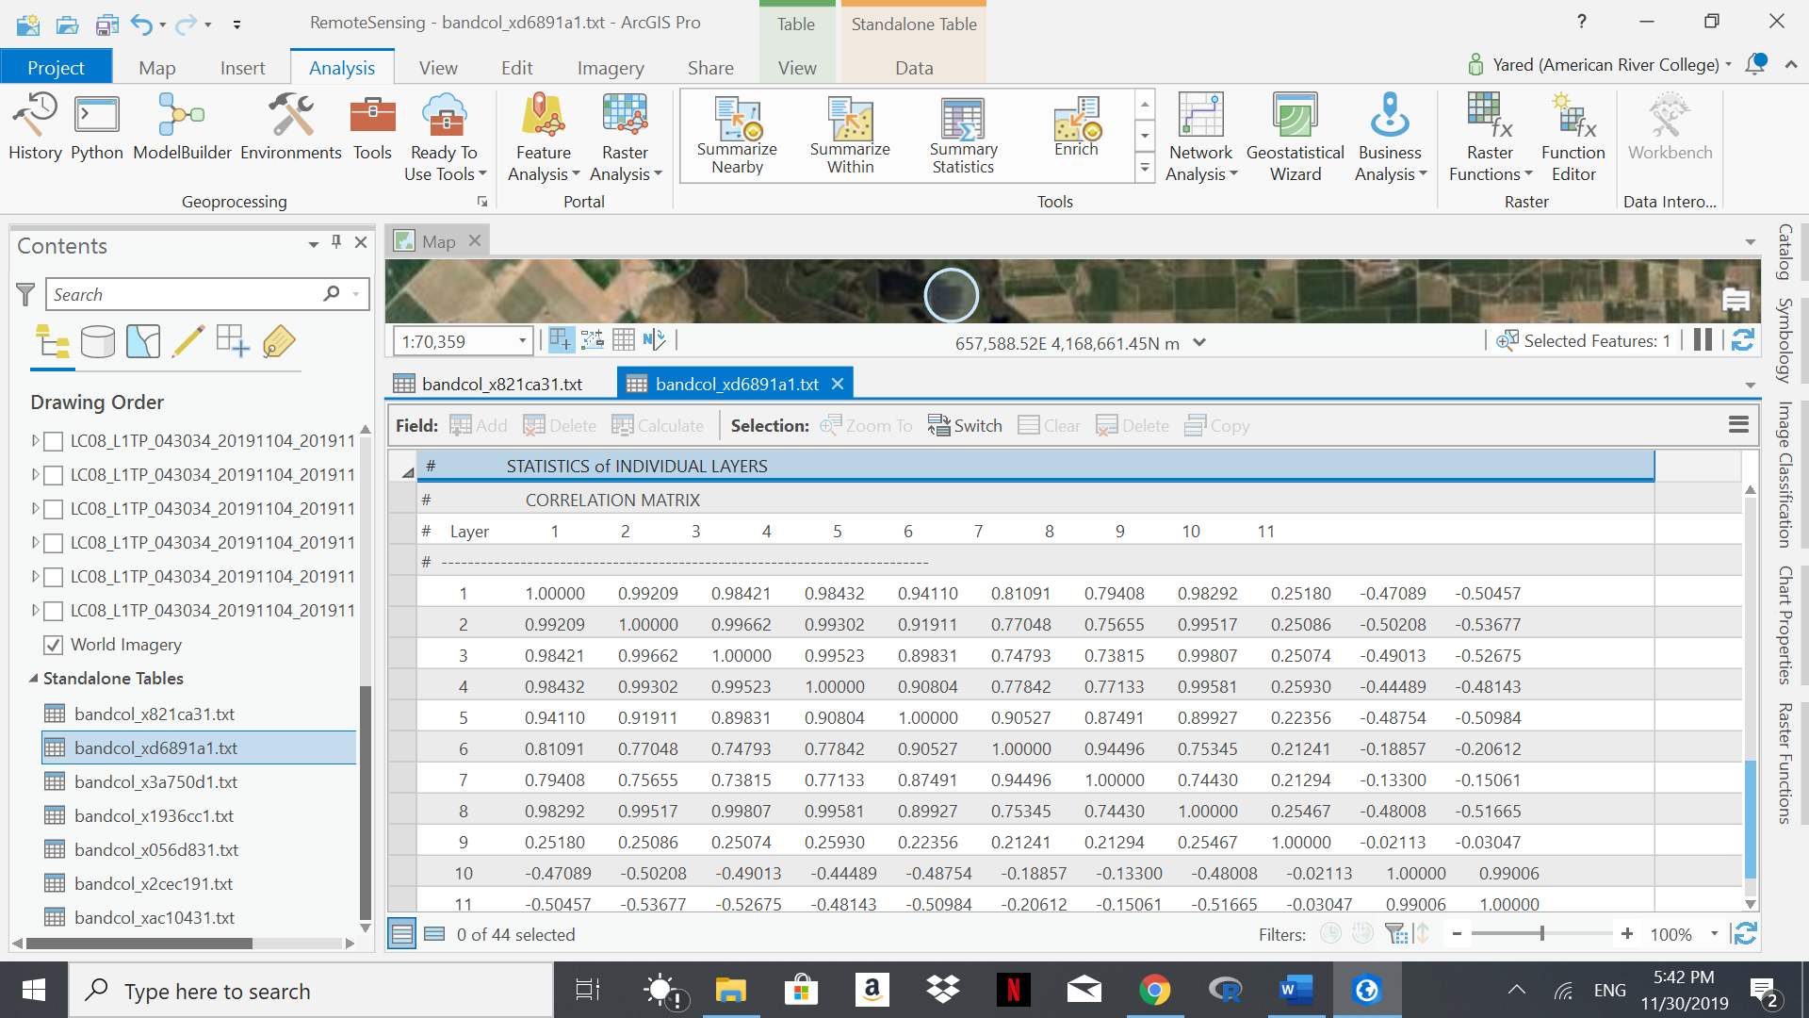
Figure 12. Correlation Matrix - Planted
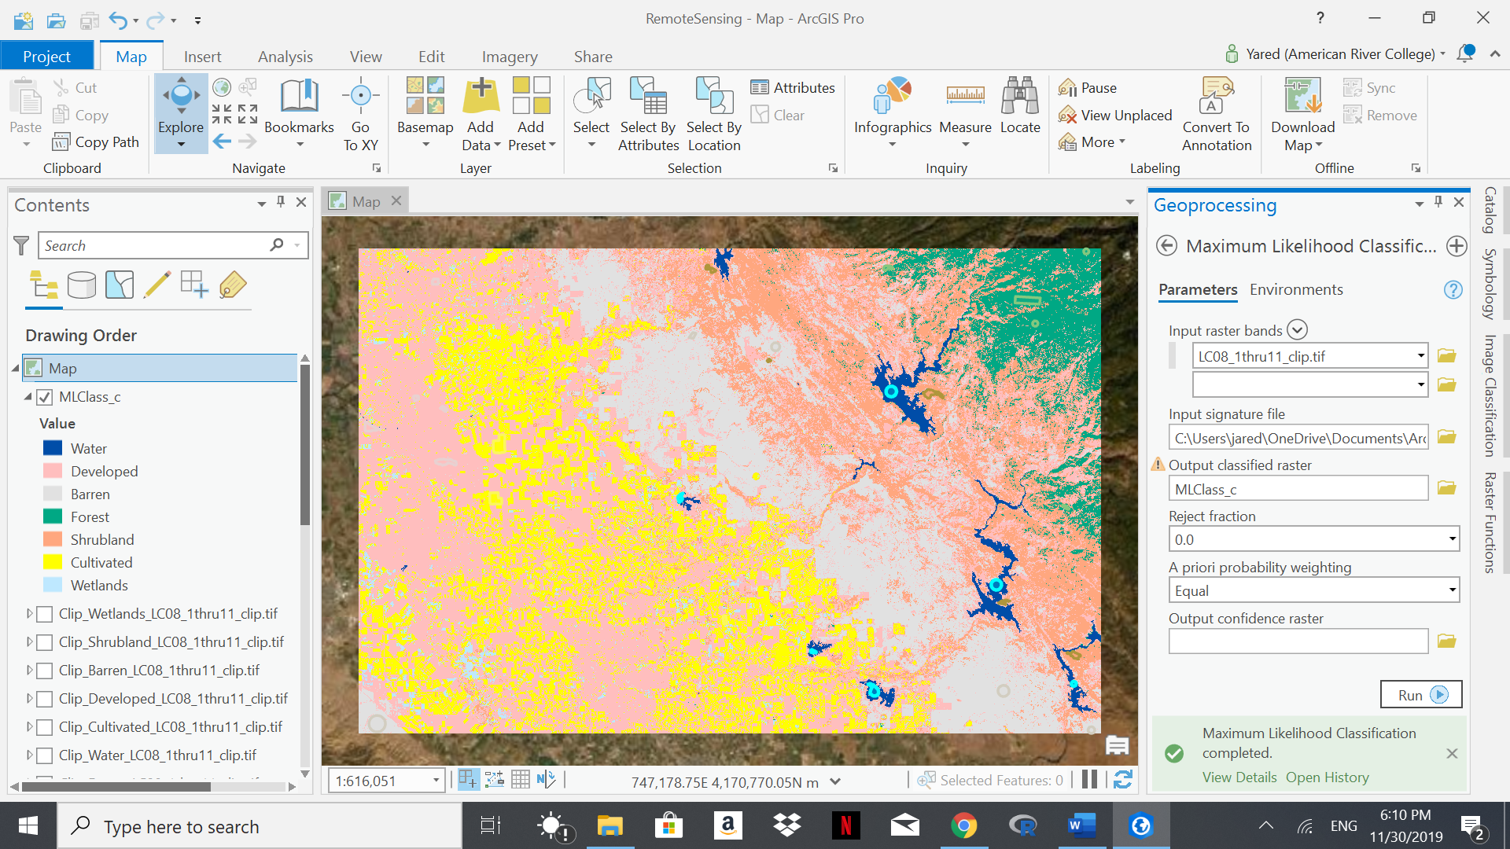
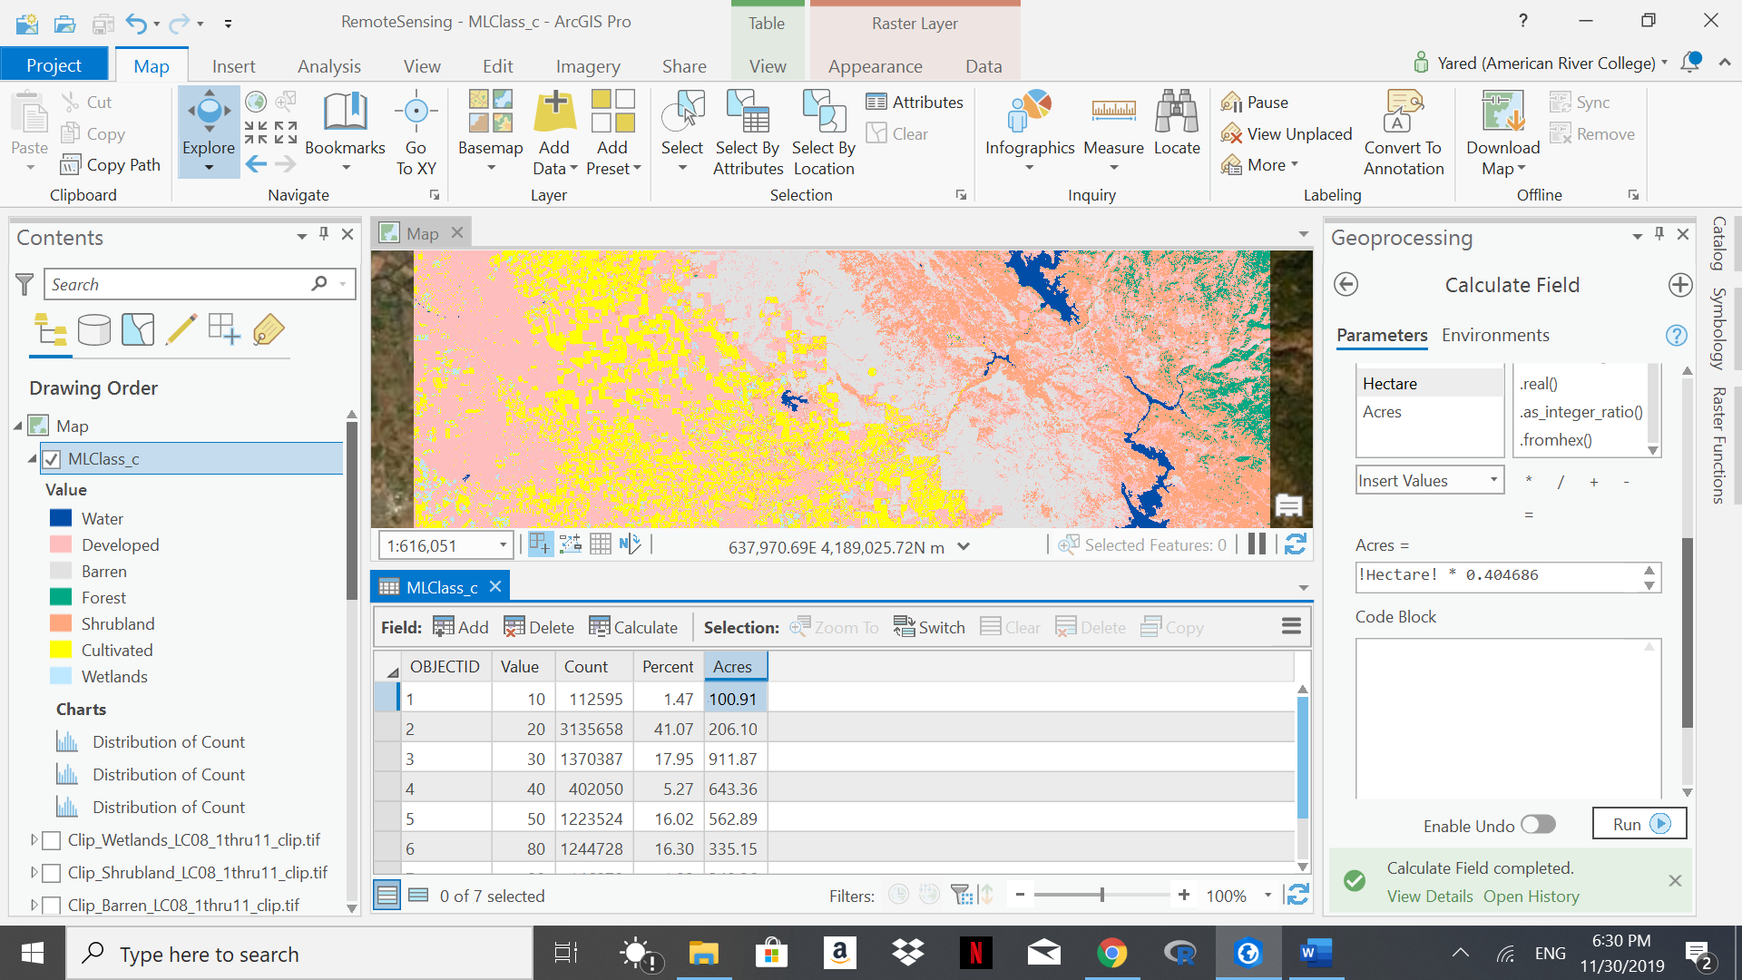
Figure 13. Classification - MLE Figure 14. Percentage and Acreage
Supervised classification is an effective means to utilize remotely sensed image to identify the land cover types. The resulting land classes met my expectation as developed lands were identified on the eastern edge of the image adjacent to agricultural lands, which are the predominant land type on the eastern section of the valley. Shrublands and forests are predominant in the foothills, typical of land features in the Central Valley region of California.
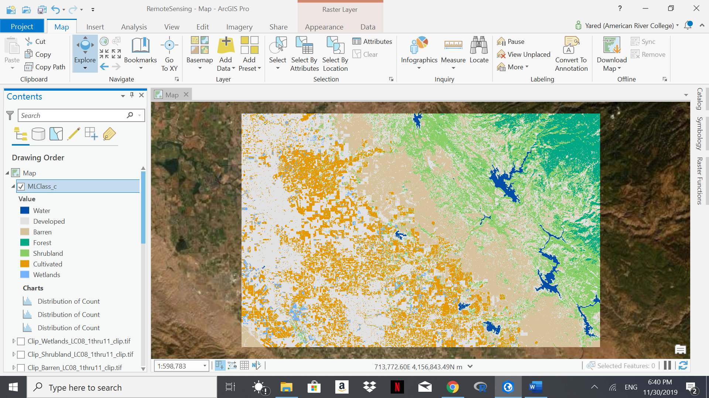
Figure 16. Supervised Classified Image

Conclusion
Step-by-step evaluation of the GeoTIFF image from downloading to classification was a best way to consolidate the steps involved in Remote Sensing image processing and analysis. Also, statistical analysis on the training samples and the image layers were very helpful to assess the quality of image processing and classification process, and to understand the characteristics of the bands that were used to identify the different features.

References
Kevin Butler. Band Combinations for Landsat 8. https://www.esri.com/arcgis-blog. Accessed 28 November 2019.
Parece, T.E., J.A. McGee, and J.B. Campbell. 2019. Remote Sensing with ArcGIS Pro. Virginia Geospatial Extension.
United States Geological Survey. Earth Explorer https://earthexplorer.usgs.gov. Accessed 21 November 2019.

