Detect Coconut Palm Trees Using Deep Learning
Greg Helzerman
Spring 2020

- Project Summary

This project will produce deep learning models to detect coconut trees. Using the coconut tree deep learning models, I will see if it can be used to also detect palm trees around Sacramento’s Capitol Park. Deep learning is training a computer to have an artificial intelligence such as being able to recognize an object that the computer has been trained to detect. Explaining exactly how deep learning is performed mathematically is beyond the scope of this project. Since deep learning in ArcGIS Pro is relatively new and difficult to work with, this project starts out following a tutorial from Learn ArcGIS https://learn.arcgis.com/en/projects/use-deep-learning-to-assess-palm-tree-health/ . The deep learning model type used in this project is a Single Shot Detector (SSD) which is optimized for object detection. In order to utilize deep learning tools in ArcGIS Pro, it was necessary to clone the python environment and install a deep learning python framework. It was also necessary to utilize the image analyst extension. The goal is a trained model able to detect coconut trees and palm trees from aerial imagery using ArcGIS Pro.

- Purpose

This project intends to create a deep learning model that can detect, count, and show locations of coconut trees and palm trees. The model could be used simply to count the number trees in a given image, show locations, show a heat map, or for further analysis. Further analysis tasks (not explored in this project) might be to determine if a tree is stressed or heathy.

- Description of Image Processing Tasks and Methods

I downloaded the aerial imagery for training the model from the Open Aerial Imagery website. The first image processing task for this project was to create a training schema. For this project there is only one schema to create, coconut palm trees. Using this schema, next I created training samples. The training samples were created using the circle tool. The next process is to export the training samples. The export creates small images (about 50 Kb) of each of the samples that were created stored in a folder. The next process was to train the deep learning model. The small images go through the deep learning neural network forward and backward for each epoch. I tried four different models to see if I could improve on results. The table below shows my process times for the steps involved to create a deep learning model.
Process Times for My Deep Learning Models
Model Number | Labeled Samples | Label objects for Deep Learning | Export Training Data | Train Deep Learning Model | Epochs
1 | 952 | About 48 Minutes | 16 Minutes | 10 Hours 33 Minutes | 25
2 | 105 | About 5 Minutes | 2 Minutes | 1 Hour 6 Minutes | 25
3 | 601 | About 30 Minutes | 4 Minutes | 6 Hours 30 Minutes | 30
4 | 1174 | About 1 Hour | 22 Minutes | 12 Hours 10 Minutes | 25
Below is a screen shot of my labeled training samples for my fourth model. I labeled 1174 coconut trees for deep learning.

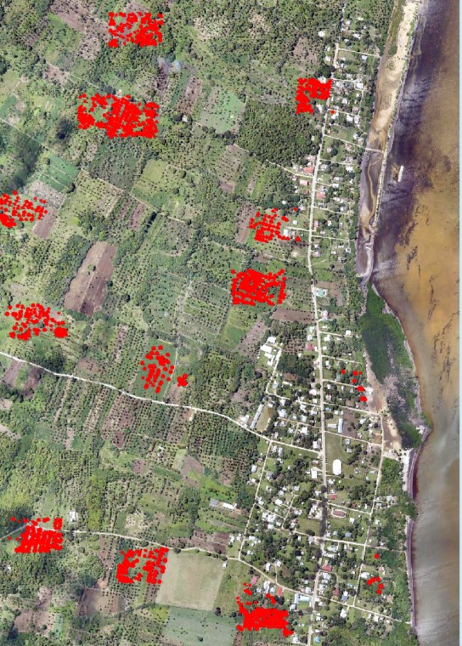

My fourth model took more than 12 hours to train the deep learning model using the geoprocessing tool shown below.
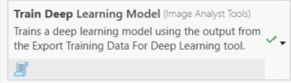
After the models were trained, I used the geoprocessing tool “Detect Objects Using Deep Learning.” Some processing times for the open aerial image (Kolovai in Tonga) used to train the model and the aerial imagery of the Sacramento Capitol are below.

Detect Objects Using Deep Learning Processing Times
Model Number | Kolovai | Sacramento Capitol
1 | 1 Hour 26 Minutes | 33 Minutes
4 | 46 Minutes | 18 Minutes

- Discussion of Difficulties Encountered

Since deep learning in ArcGIS Pro is fairly new, it was a challenge researching ways to implement deep learning. The coconut tree tutorial was the only one I found with which I could have some measure of success. Even figuring out the how to use a provided pre-trained sample model was a challenge. I was able to figure out how to use the pre-trained model and use it as a basis to see how my models compare to it.
For my first and second model I labeled objects for deep learning inconsistent with the tutorial. I labeled some trees here and there not focusing on several sites to label all the trees. For my third and fourth model I tried to label all the trees in certain sections like the tutorial states.
The “detect objects using deep learning” tool has user supplied arguments for the model that the tool uses to alter how it detects objects. The challenge is to find the right balance in those arguments to achieve the best results. This iterative process could take many hours to figure out what parameters are best for the model. Due to time constraints, I did not fully test as many different argument combinations as I would have liked.
I also tried to use the Graphics Processing Unit (GPU) on my computer instead of the Central Processing Unit (CPU), but specifying GPU to train the model did not seem to work for me. The image below shows that the CPU was working at nearly 100% for more than 12 hours for Model 4.

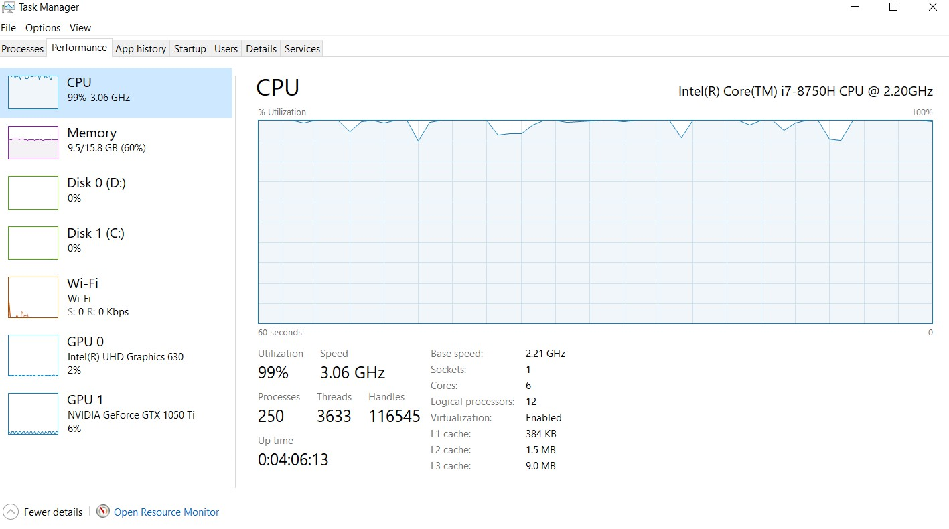
- Discussion of the Output

I determined that my Model Number 4 would be the best to pursue further analysis on. In order for the model to produce the best results, it is necessary to determine the best model arguments to input for the detect objects using deep learning tool. The table below shows the arguments used for trials A through G along with the arguments for the pre-trained model. The arguments that produced the best results for a sample area in the Kolovai Image was Trial F.

Detect Objects Using Deep Learning Model Arguments
Trial | Padding | Threshold | nms_overlap | Batch Size | Non Maximum Suppression | Max Overlap Ratio | Trees Detected in Sample Area
A | 0 | 0.50 | 0.6 | 1 | yes | 0.6 | 224
B | 1 | 0.60 | 0.6 | 10 | no | - | 322
C | 2 | 0.50 | 0.6 | 50 | yes | 0.4 | 263
D | 2 | 0.50 | 0.4 | 50 | yes | 0.2 | 218
E | 3 | 0.55 | 0.3 | 36 | yes | 0.1 | 220
F | 3 | 0.60 | 0.3 | 64 | yes | 0.1 | 237
G | 2 | 0.50 | 0.4 | 81 | yes | 0.2 | 202
Pre-Trained | 64 | 0.60 | - | 1 | no | - | 234

My Model 4 Trial F: Detect Objects Using Deep Learning for sample area

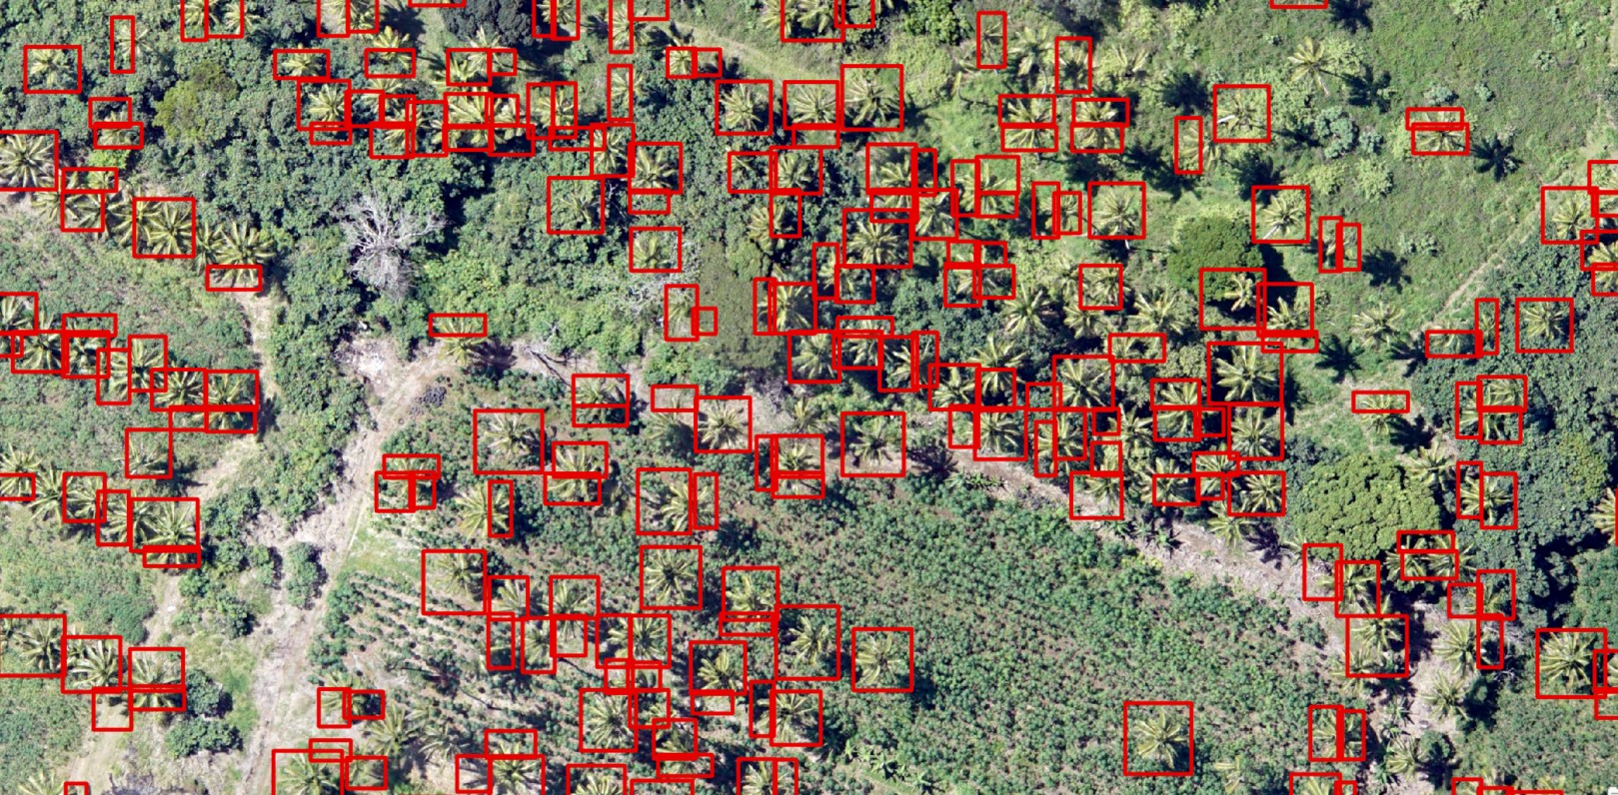

The detect objects using deep learning tool produces a polygon box around where it thinks a coconut tree is. As you can see from the image above the model is not as good as human recognition. It did miss some trees and sometimes detects one tree multiple times. As a comparison below is a screen shot of the pre-trained model from the tutorial in the same area. The pre-trained model produces better results than my model.

Pre-Trained model:

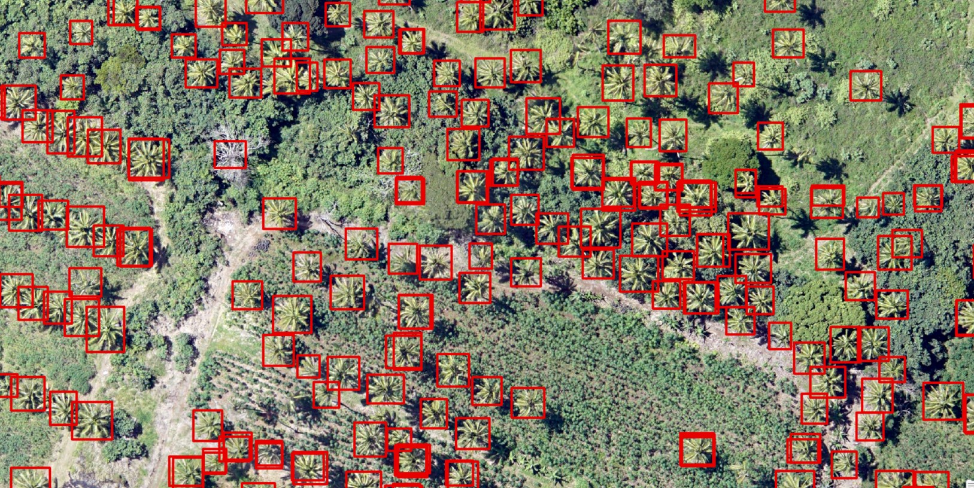

One way to symbolize the results of detecting the trees would be a heat map. Below is a heat map of the point features produced from detecting coconut trees from my fourth model Trial A.

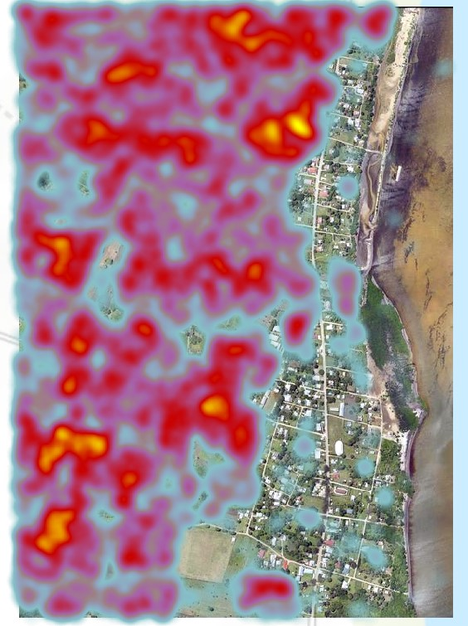
Next I tested if the model will work to detect the palm trees around the Sacramento Capitol. The best I could get one of my models to detect palm trees near the Sacramento Capitol building was not very good.

My Model 4-F (with a lowered threshold to .3)
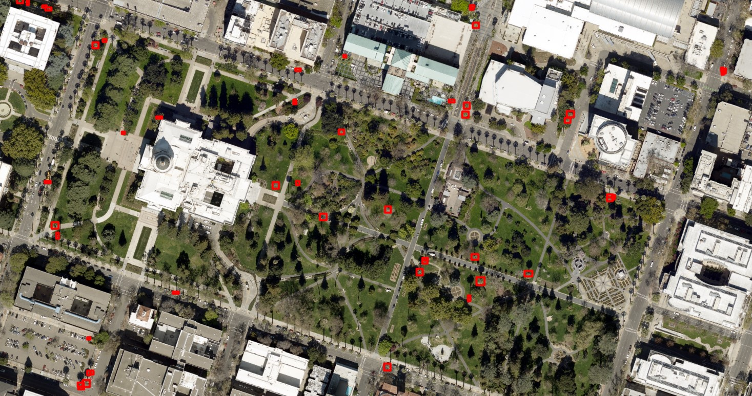

The Pretrained model performed far superior to any of my models.

Pre-trained Model
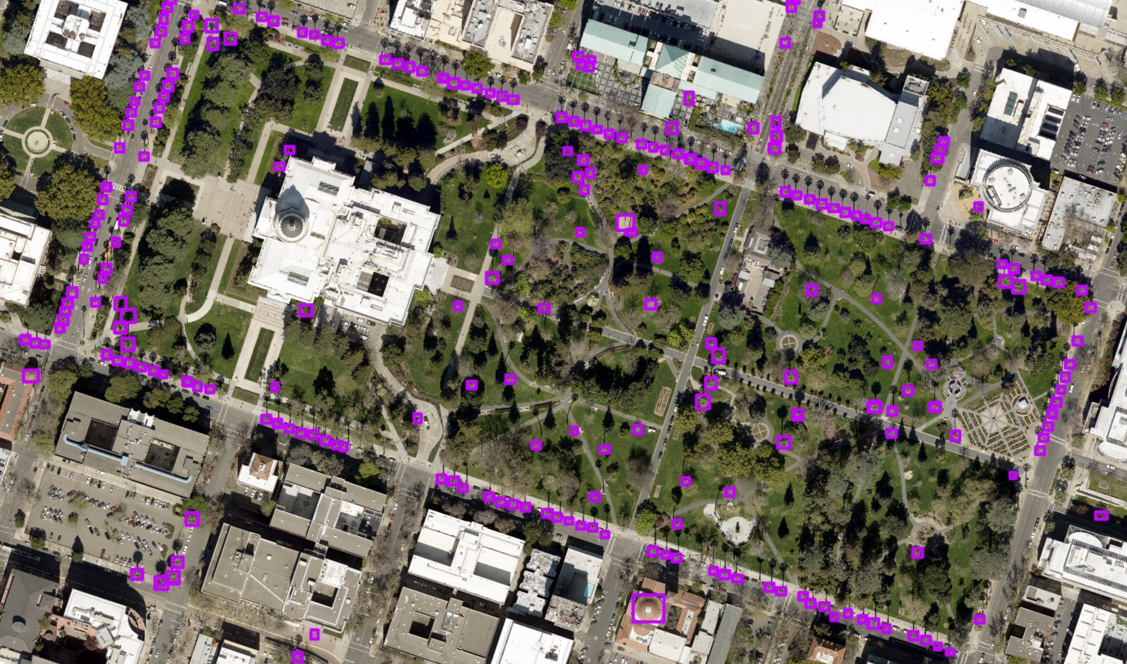
Pre-Trained model (Red Boxes) overlayed with City Maintained Palms (Blue points).
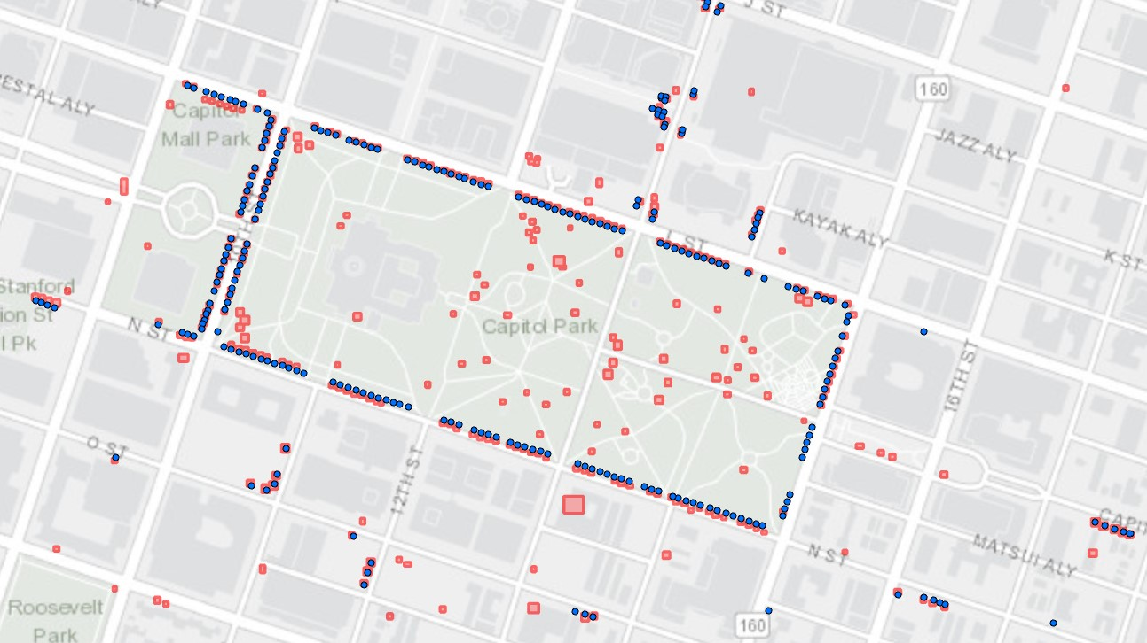

I am unsure why my models could not detect the trees at the Sacramento Capitol as well as the pre-trained model. It could be that the pre-trained model had included more or more accurate training samples. The pre-trained model may have been trained on more than one image or in an environment other than ArcGIS Pro.

- Conclusion

When trying to detect objects using deep learning in ArcGIS Pro there are many challenges to try to cope with: learning the process, the time involved to label training samples, the processing time, and testing various model arguments. Deep learning is a very exciting area of technology that can be used in many different fields. From the technology behind self-driving cars to face recognition deep learning is going to be more and more a part of everyday life. This project aimed to produce a model that could detect palm trees. The model produced detected palm trees fairly well on the image that it was trained on. However, when trying the image around the Sacramento Capitol Park, the model was not very sucessful. An analyst should consider the options of either to make their own model or use a pre-trained model (if available) and decide what would be best to use. In order to improve the models in this project, much more time would have been required.

References:

Use Deep Learning to Assess Palm Tree Health Tutorial
https://learn.arcgis.com/en/projects/use-deep-learning-to-assess-palm-tree-health/

Esri raster-deep-learning/examples/tensorflow/object_detection/coconut_tree_detection/
https://github.com/Esri/raster-deep-learning/tree/master/examples/tensorflow/object_detection/coconut_tree_detection

Deep Learning definition
https://searchenterpriseai.techtarget.com/definition/deep-learning-deep-neural-network

Open Aerial Map
https://openaerialmap.org/

