Prospecting New Winery & Vineyard Opportunities in Amador County

Executive Summary
My python script will generate agriculturally zoned, parcel data for prospective vineyard land purchases near the city of Plymouth in Amador County, CA. Several geoprocessing functions will be performed within my stand-alone python script which is designed to automate processes that could also be used for additional, similar implementation needs. Only minor variable changes would be needed to change the city of interest for additionally needed analysis and data refinement.
Purpose
My project will develop a python script that is designed to ultimately seek out new winery and vineyard availability within Amador County (AC). AC is chosen since there is sufficient unfarmed land within the agriculturally zoned areas that are available for purchase, as opposed to Napa Valley (NV), for example. Premium viticultural areas in NV have been plotted out and developed to near capacity, or have become excessively costly due to the supply and demand issues. Requisite parcel information will be isolated from the script within a buffer zone of the city Plymouth where the macroclimatic conditions are considered ideal. Additionally, the top-rated restaurants are in the Plymouth area which are a draw for wine tourism and business near the wineries. Also, the infrastructure of the neighboring community is becoming more modernized, as opposed to most of the other AC city areas.
AC is on its way to mimic the viticultural explosion seen in NV, however there is still much more undeveloped agricultural land, hence more supply and less demand than NV presently. In particular, Zinfandel production in the area is considered some of the finest in the world which has been growing in market demand significantly over recent years. Also, many other warmer climate favoring varietals, traditionally grown in foothill macroclimates, such as Sangiovese, Barbera, Grenache and Syrah produce exceptional fruit in AC overall. Therefore, prospective winery owners may see a good market opportunity to purchase available agricultural land in the area before the situation balloons as it did in NV.
Geoprocessing Tasks
This script utilized a series of geoprocessing routines to ultimately produce data tables that can be added to an ArcMap with NAIP base map imagery that can show the areas of interest that will reveal undeveloped ag parcels within a buffer zone of the city Plymouth, CA. This area is regarded by viticulturist experts as the top-tier macroclimate region in AC for wine grape production. The market values of the wines produced in this area command the highest prices of AC wines which confirms this high regard.
The geoprocessing routines will include deletion of existing files that interfere with script, making layers, layer definitions, selections by attribute using queries, copying features to new feature classes, a buffer, record counts, and os.path joins. Additionally, the stand-alone script could be used simply for other viticultural areas with a few variable changes.
To begin the project, I created two new file geodatabases. In a folder titled Data, I placed the AmadorCounty.gdb, as my workspace, for the raw data shapefiles to be processed. And in a folder titled My Data, I placed the WinerySiting.gdb, as my outpath, to be available for all my processed output data. Having a separate output location of the file geodatabase from the workspace required the need to set a series of variables that will operate with the os.path.join routine. Without the os.path.join routine, the python program will not be able to locate the data which would return the dreaded <class 'Queue.Empty'>: error message.
In addition to the path join variables, I needed to create variable definitions for many of the subsequent geoprocessing functions. The following python snippet shows an excerpt:
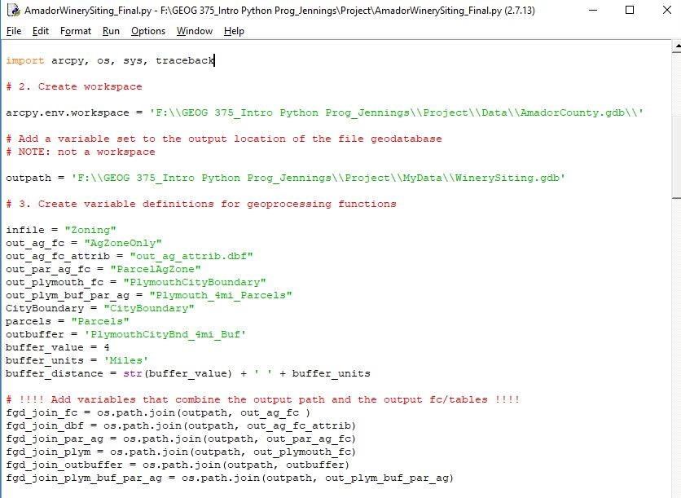
With the variables and path joins in place, most of the geoprocessing routines required the making of layers first; so I also made a list of layer variables that will be required for the python commands to execute successfully. The layers required are shown below:
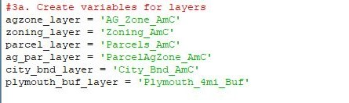
To prevent possible code breakdown, I coded the file deletion routine for all files before recreating a new file of the same name, also to mitigate filename clutter (example):
if arcpy.Exists(fgd_join_outbuffer):
arcpy.Delete_management(fgd_join_outbuffer)
Without this safety net, the program will work once possibly, but not for future iterations.
After making my feature layers needed for geoprocessing I created the variables for my query statements to select the AG field from the Zoning layer, and to select the Plymouth field from the City Boundary layer.
# Create query statements
query = """"Zoning" = 'AG'"""
query2 = """"NAME" = 'Plymouth'"""

With all the variables in place now the parameters can be defined for the Selection by Attribute routine. In order to produce my “AgZoneOnly” feature class, I needed to perform the following geoprocessing:
# Select features by attribute using query
arcpy.SelectLayerByAttribute_management(zoning_layer, "NEW_SELECTION", query)

With this queried selection in place, I was able to perform the Copy Features routine to create my “AgZoneOnly” feature class that will be needed to intersect with parcel data. I also ran the GetCount routine to make sure that the process was working correctly which revealed the expected result: 102 AG Zone polygons in Amador County. The following snippet shows the code:
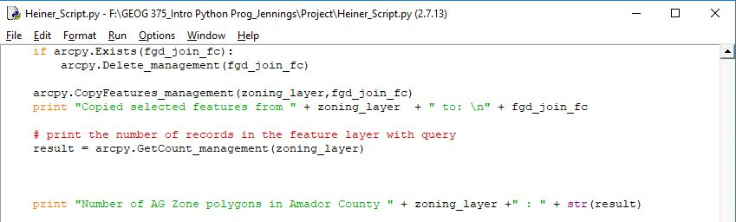
As seen in this above snippet, I coded print commands for all geoprocessing functions to help the user follow which processes were being performed as the python script ran the module. The results will be shown with a later screenshot of the completed script run through the python shell.
Next, I made feature layers for the following geoprocessing process by creating a new layer from my newly aforementioned “AgZoneOnly” feature class. I also needed to create a Parcel layer to intersect the data to isolate just AG Zone parcels. I used the Select Layer by Location routine with these new layers. Rather than using the default “INTERSECT” overlap type, I used the "HAVE_THEIR_CENTER_IN" overlap type. This was chosen because the “INTERSECT” overlap type returned way too many parcel polygons that were not supposed to within my eventual 4 mi. Plymouth buffer zone. I used the Copy Features routine again to create a new output feature class “ParcelAgZone”. The following snippet shows the code:
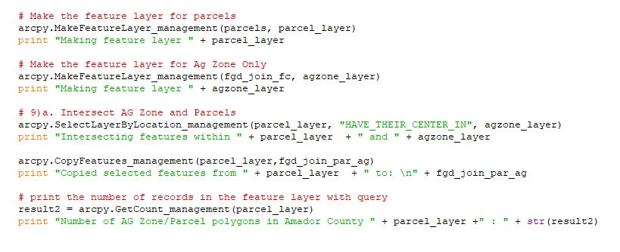
Get Count was used again to confirm the expected return number of AG Zone/Parcel polygons in Amador County of 866.
Next additional layers needed to be created so that a 4 mi., city of Plymouth, buffer can be intersected with the agricultural zone parcels. Then I made a feature layer for City Boundary and performed a Select Features by Attribute using query2. This was set up with the same parameters as the first query but with a different layer input, of course. I used the Copy Features routine again to create a new output feature class "PlymouthCityBoundary”. Get Count was used again to confirm the expected return number of City Boundary polygons for Plymouth of 3. It is 3 because the there are three separate polygons as shown below:
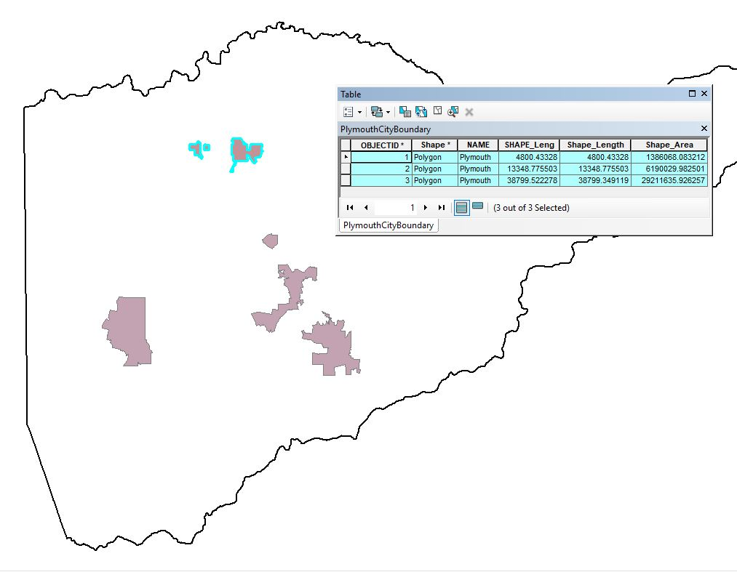
Before I could intersect the layers, I needed to create a buffer routine to get the 4 mi. buffer of Plymouth which is written as follows:
arcpy.Buffer_analysis(fgd_join_plym, fgd_join_outbuffer, buffer_distance)
This created a new “PlymouthCityBnd_4mi_Buf” feature class for which I needed to create a new layer for the final intersection between the Ag parcels and the Plymouth 4 mi. buffer. This also required a new layer for the Ag parcel parameter. This involved additional Select Layer by Location, Copy Features, and Get Count routines. I used the following code to get my ultimate feature class "Plymouth_4mi_Parcels", which contains both the shapefile data and parcel attribute information for the area of interest. The code is as follows:
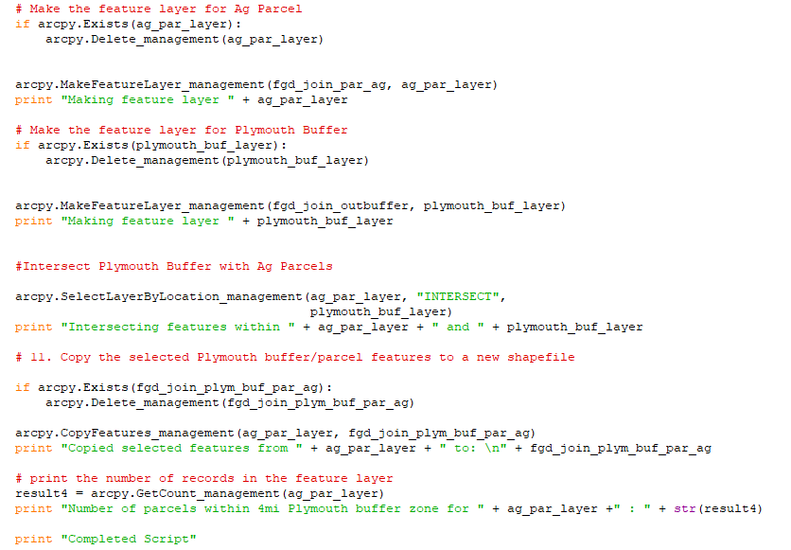
The "Plymouth_4mi_Parcels" feature class created from the ag_par_layer, returned from the Get Count routine, showed the number of parcels within the 4mi Plymouth buffer zone is 310.
This table shows the first 21 records of the 310 that will be of interest to vineyard prospectors:
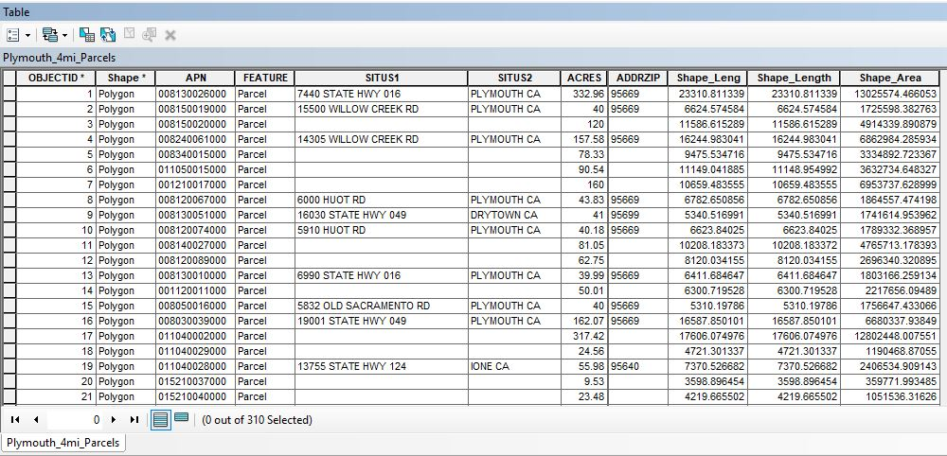

I ran my script through the python shell to display the print statements that are provided for potential client user clarification of the processes underway.

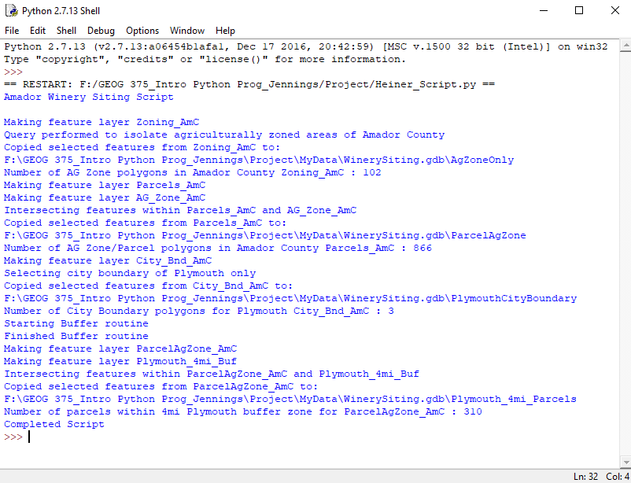

So, the feature classes created in my WinerySiting.gdb output can be used with the NAIP base map in an ArcMap .mxd. The following image illustrates the base map overlaying the "Plymouth_4mi_Parcels" layer:
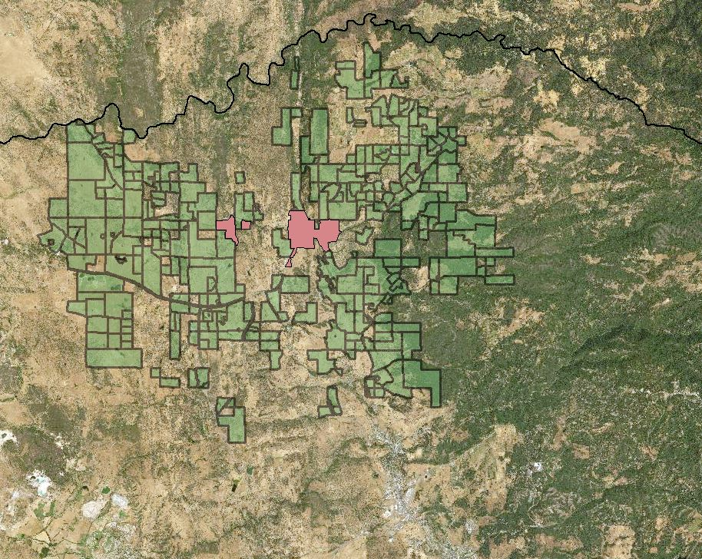
And when this image is zoomed in closely, the land that is Ag parcel zoned can be visually differentiated between agriculturally developed parcels and undeveloped parcels. The data from these parcels can then be identified and pursued for purchase by prospective buyers.
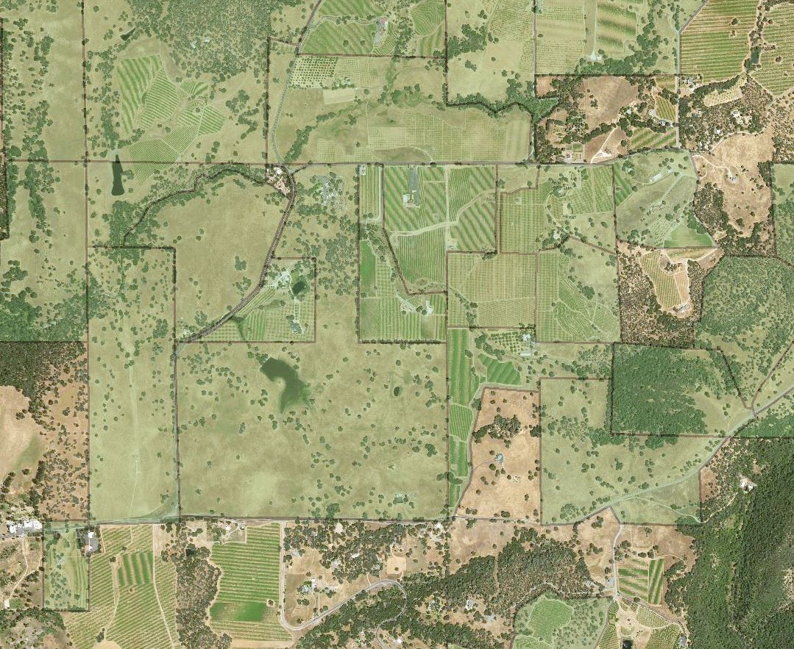
Further Considerations
My script could be added with mapping module functions that could automate map making for prospective client, however at this point the project is focused on mere speculation. But if a client desired and specified a parcel area of interest, the mapping module could be used with the zoom to extent routine, export map routine, etc. This aspect was the original vision of my project end product; however, this next step would be dependent upon client needs and desired locations.
Challenges
Python scripting provides many overall challenges. Most often there is just a simple typo, or missed punctuation or indent. In many respects, python is a bit like learning a foreign language. However, with a foreign language it is possible to still communicate with a few errors. With python there is no tolerance for any errors or else the communication breaks down completely and the code breaks.
Specific challenges I encountered include, for one, I had to reverse my layer placement within the parameters of my Select Layer by Location routine when I was trying to intersect my parcel layer with my buffer layer. If the order is wrong, then the output just returns the features.
Another challenge involved choosing the correct overlap type for another Select Layer by Location routine. When I selected the default “INTERSECT” overlay type, the result returned too many parcels that were merely touching parcels that were not inclusive. The solution was to use the "HAVE_THEIR_CENTER_IN" overlap type.
Lastly, one of my greatest challenges was keeping track of all the variables that were necessary to be created for this script. This required a lot of scrolling up and down the script to refresh my memory. Next time I will print out a copy and keep it next to my computer.

