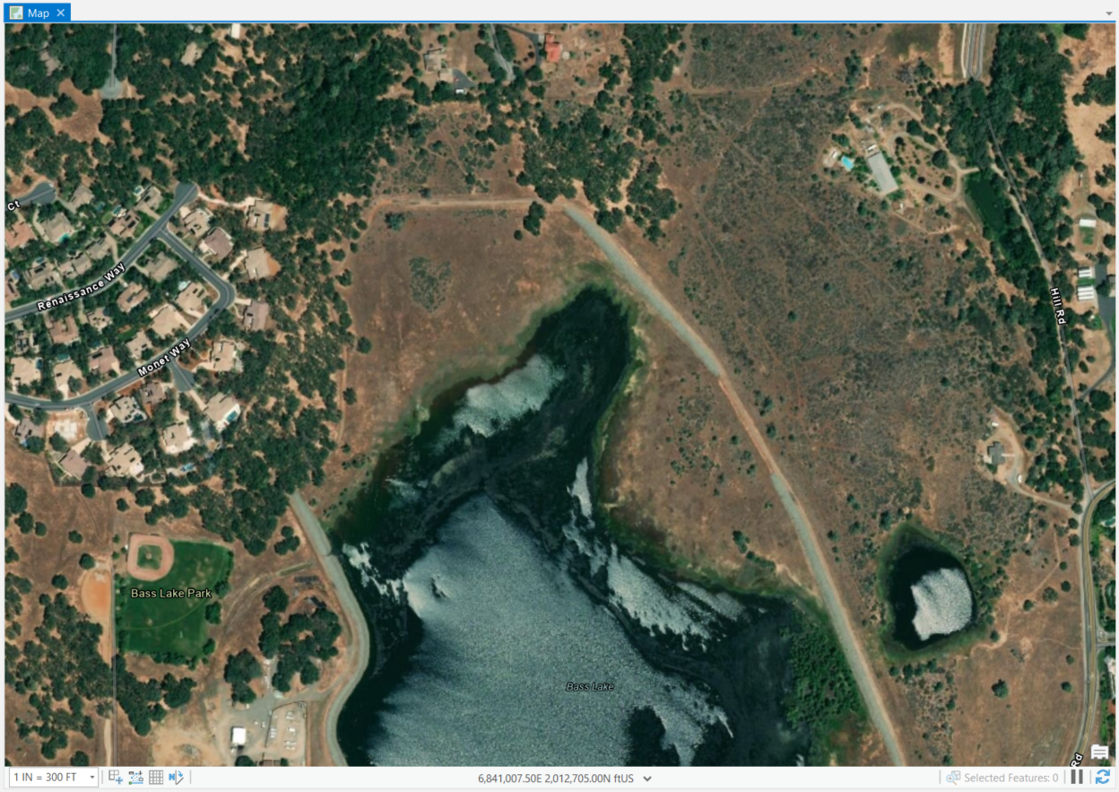  Drone Imagery Processing  Supervised Land Classifications of Northern Bass Lake, El Dorado Hills, California | Abstract  This report was prepared to fulfill requirements of the final project. It documents supervised land classification processing conducted to identify various vegetation and water coverage of the Northern portion of Bass Lake located in El Dorado Hills, California. Drone imagery was collected by LSA GIS Specialist, Greg Gallagher.  Mariko Falke  GEOG342: Remote Sensing and Photogrammetry

PROJECT SUMMARY
Drone imagery was collected on December 9, 2019, for the northern portion of Bass Lake located in El Dorado Hills, California. This high-resolution imagery was imported into ArcGIS Pro and supervised land classification methods were applied. The resulting data is generally accurate after running reclassification of the data, but is highly dependent upon the experience of the analyst with the processing tools.

1.0 PURPOSE
I assisted in drone imagery collection of Bass Lake in El Dorado Hills for a proposed residential development with recreational areas. This report outlines the process and results of performing supervised land classification image processing for the final project.

2.0 TASKS AND METHODS
I created a map and used ESRI Basemap Aerial Imagery of to view the Study Area, area that imagery analysis was conducted for the project. See ESRI Basemap Imagery in Figure 2.1.1, below.
Figure 2.0.1 – The Basemap Imagery of Study Area

2.1 Import Drone Aerial Imagery
Drone imagery taken on December 9, 2019, by GIS Specialist Greg Gallagher (LSA) overlain the ESRI Basemap Imagery depicted in Figure 2.0.1. This imagery was already projected into NAD 1983 StatePlane California II FIPS 0402 (US Feet). This drone imagery is depicted in Figure 2.1.1, below.
Figure 2.1.1 – Imported Drone Imagery
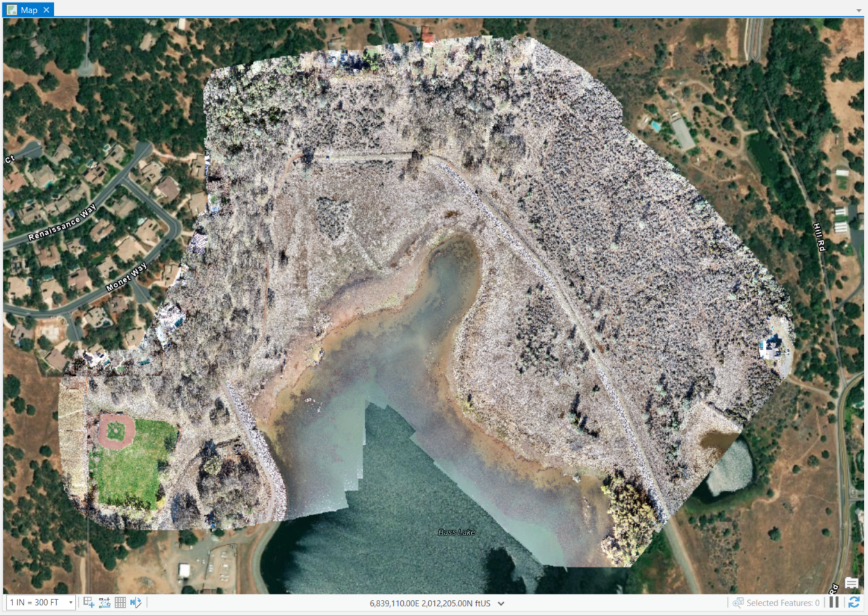

2.2 Segmenting the Imagery
I used classification tools and selected segmentation to segment the image before conducting image classifications. I used default settings and the result id depicted in Figure 2.2.1, below.
Figure 2.2.1 – Segmented Image
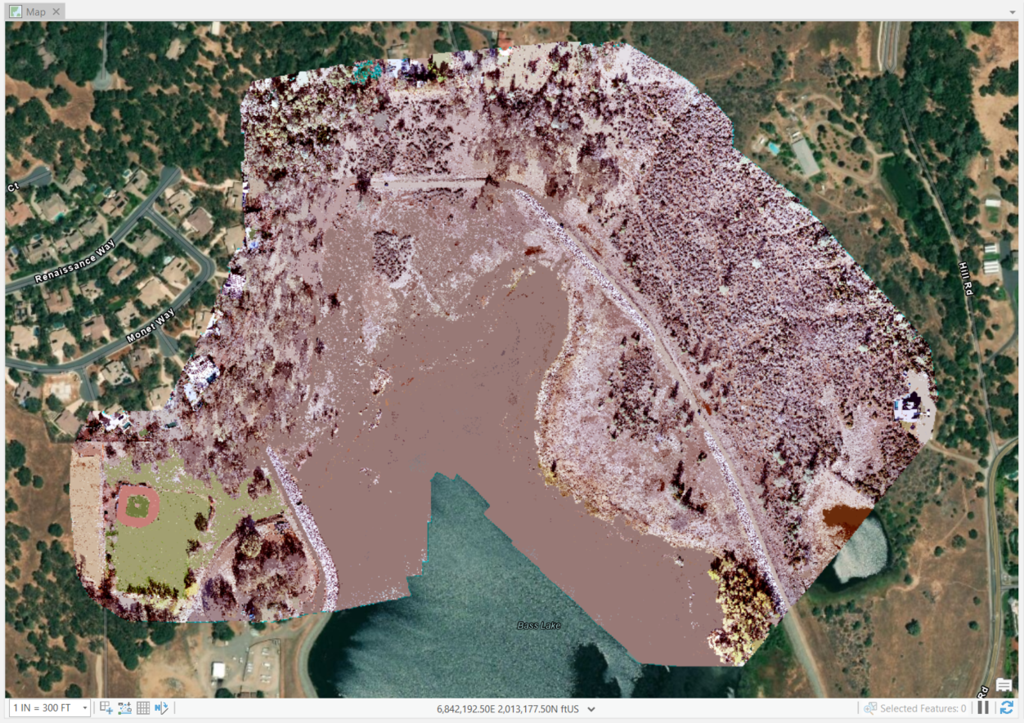

2.3 Configuring the Classification Wizard
I selected the same method that was used in class. When running the wizard, I chose a “Supervised” Classification Method, “Object Based” Classification Type, and “Use Default Schema” to select the NLCD2011 (National Land Cover Dataset 2011) Classification Schema. I then used the Segment Picker to select the Training Samples for each land classification. I noticed in selecting the water, it selected areas that weren’t necessarily water, but may have been wet when the drone imagery was collected. I used the ESRI Aerial Imagery Basemap to determine some areas such as development and shrubland. Classification examples include dirt roads as “Barren”, buildings and concrete areas as “Developed”, pine trees as “Evergreen”, desert shrub areas as “Shrubland”, and the area of Bass Lake which extended into areas that were wet adjacent to Bass Lake was designated as “Water”. The preview based on this training samples classification is depicted below in Figure 2.3.1.
Figure 2.3.1 – Preview Classified
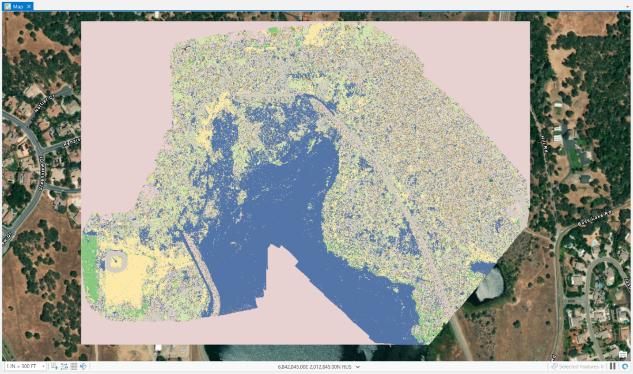

2.4 Generate Classified Image
After previewing the classified image, I generated the classified image. Upon doing so, I noticed that the image didn’t generate like the preview did. The Baseball field which should be herbaceous is classified as “Deciduous Forest”. The water is partially classified as “Mixed Forest”. Lastly, the dirt roadway should be classified as “Barren”. Please refer to Figure 2.4.1 to view the result of generating the classified image.
Figure 2.4.1 – Classified Image
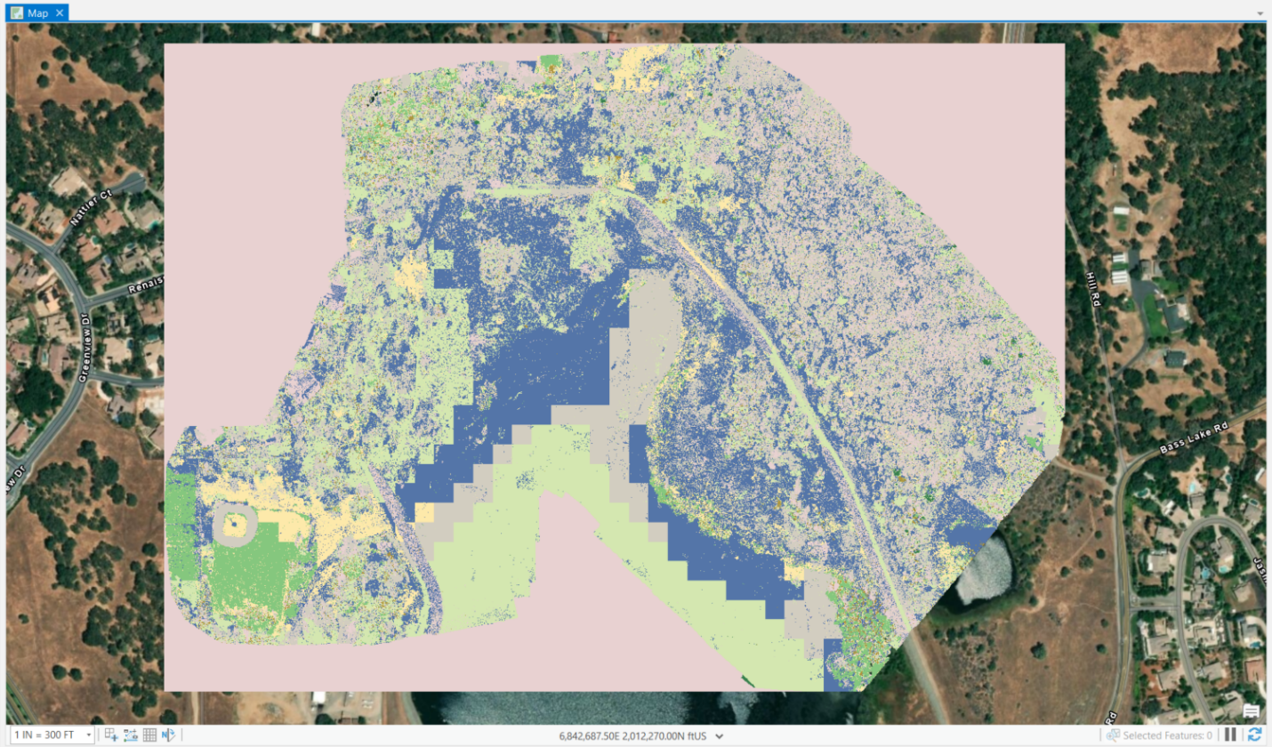

2.5 Image Reclassification
I identified areas that were severely misclassified as mentioned in the previous section: the dirt road, baseball field, and water resource. I used the “Reclassify within Region” to create polygons that reclassify the entirety of Bass Lake as water and the baseball field as herbaceous. The area near the pond I noticed water was identified much further than the extent of the pond based on the high resolution imagery, so I reclassed the water as herbaceous since this area is somewhat grassy. I also made sure that the area east of Bass Lake did not have any developed areas identified, so I reclassified developed areas as barren in that area. The Reclassified Image is presented below in Figure 2.5.1.
Figure 2.5.1 – Reclassified Image
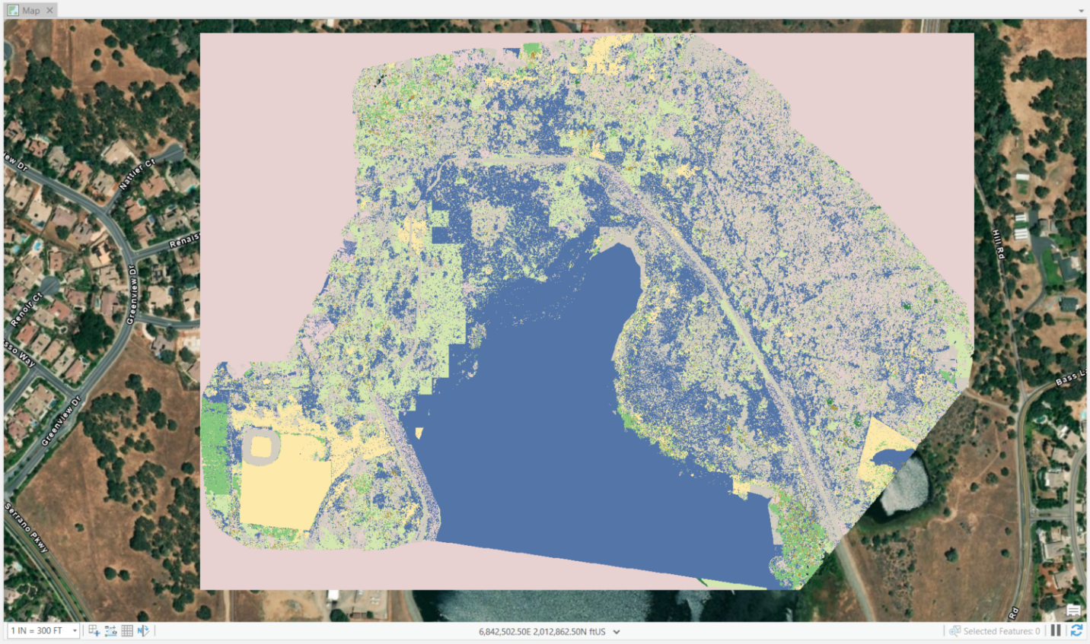

3.0 FINAL OUTPUT
The final reclassified image depicted in Figure 2.5.1 is generally accurate. It is more accurate after the reclassification. If I had more time and generating acreage numbers based on this information, I would have to clip the background that was brought in upon classifying the image. The black area that imported when I brought in the drone imagery into the map was removed by mask the area that had no data. However, this area was classified as developed upon image classification.

4.0 DIFFICULTIES/ISSUES AND RESOLUTIONS
4.1 Importing Drone Imagery
Upon importing the drone imagery into the map, the image contained a black background within the imagery that I had to turn off by masking the area with “no data”. This proved to be unhelpful when conducting image classification since the background was also included in the image classification. This skews the imagery by making it look like the surrounding area is developed when it is not. I didn’t know how to resolve this, but didn’t have time to clip the image. Since the resolution is incredibly high, it also might’ve been easier to classify larger areas with less detailed imagery.
4.2 Segmenting Image
While creating the segmented image, processing took a long time. I had to let it process overnight. There is really no way to troubleshoot this other than wait.
4.3 Image Classification
While creating the testing samples for classification, I had to run the preview of the classified image several times because the first run classified the entire Bass Lake area as Mixed Forest. I had to go back through my testing samples to remove some previous classifications. I did this several times until I got as close as possible to reality. Each sample correction generated a more accurate preview. Even doing so, upon generating the classified image, there were many inconsistencies. At this point, I used image reclassification methods to clean up the generated image.
4.4 Image Reclassification
It was very tedious to reclassify some areas, particularly water which has smooth rounded geometry, but using the “Reclassify with Region” which difficult to recreate the smooth geometry. I also would’ve modified the way I cut around Avery Pond (east of Bass Lake). The squared area identified as herbaceous was initially classified as water and in reviewing this area, that was likely correct. The ground was rather wet since the imagery was collected in December between rain. Generally, this processed cleaned up the imagery a lot by being able to define specific areas such as the baseball field and dirt road.

5.0 INTERPRETATIONS
Generally, the image classification wizard using supervised classification methods was surprisingly accurate particularly post-reclassification. There were some obvious areas that were classified incorrectly, however, these areas were relatively easy to correct in comparison to hand drawing each land cover type. The reclassified image was the most accurate in compared to the intermediate results of supervised land classification. In reviewing the results of this imagery, I was surprised how much water was identified throughout the Study Area. This is likely due to water present on the surface, since drone imagery was collected between rain. My technique using this land classification method could be refined by gaining more experience in using this processing tool. As mentioned previously, in comparison to manually digitizing land classifications particularly over large areas, this method would be relatively accurate as well as save a lot of time.

