Chris Crettol
Geog 375 – Fall 2018
Prof. Jennings
Final Project

CREATING AND EDITING MAP BOOKS USING PYTHON

Background

I work for an agency that updates and maintains property Tax Rate Areas (TRA) throughout the State of California. A TRA is composed of multiple districts such as cities, schools, utilities, agencies, etc., and a portion of a homeowner’s property tax is distributed to those districts annually in return for their services. Each county files TRA boundary changes with my office.

Purpose

The purpose of this project is to automate the production of map books for TRA boundary updates based on 2017 annual data. The general idea is to query 2017 changes from an existing shapefile table for a specified county, to update the data frame and certain text elements within the Layout View in ArcMap, and to save .pdf copies of the final products. These .pdfs can then be used to post our 2017 annual changes for the public to view, or can be printed and distributed to the counties to be corrected and/or verified.

Pre-Geoprocessing Script

Before I started writing the script, I had to create a template for the map book. A majority of our counties are managed using AutoCAD, where the detail map pages are already created and can be converted to .pdf. Since only a few of our counties are set up using ArcGIS, I made a template in one our counties in the Layout View.

(Before: No Template) (After: New Template)
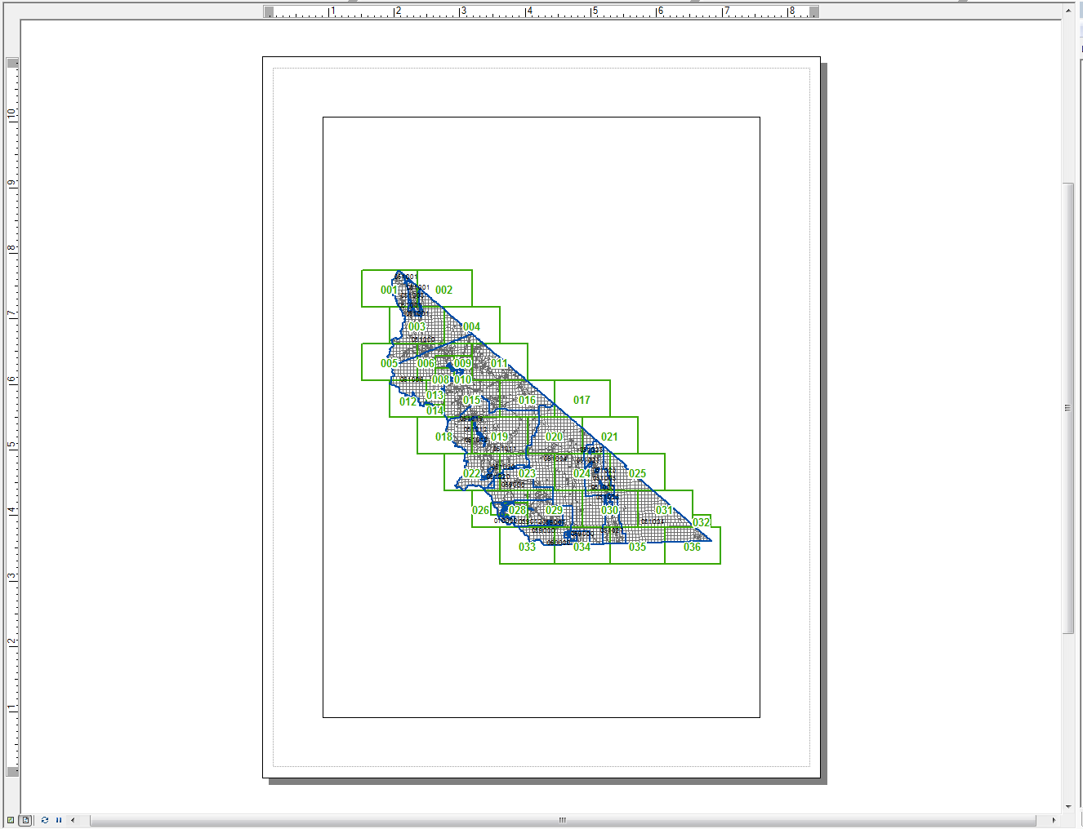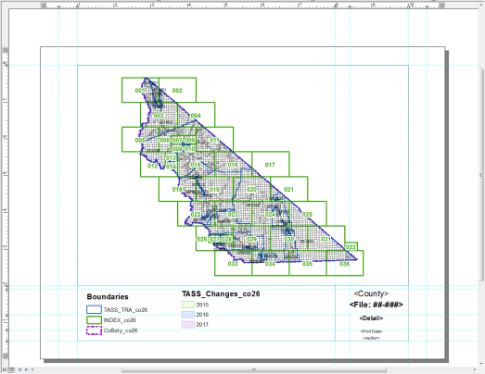

After completing the template, I updated the Layout View element names so that I would be able to manipulate them with the script later.

For the Data Frame Area:
I used the default – Name: Layers

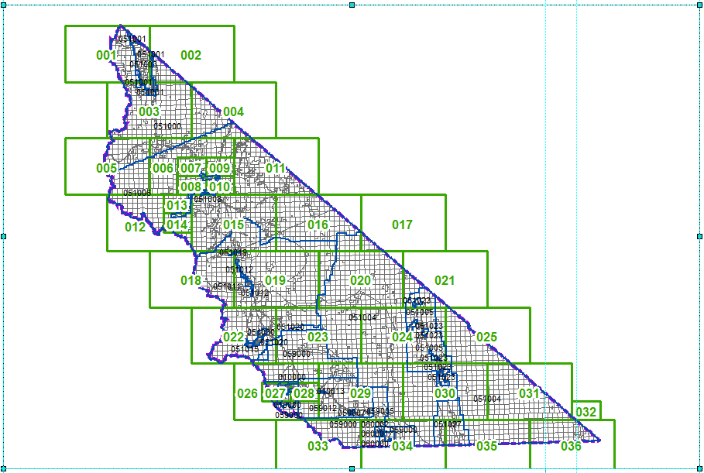
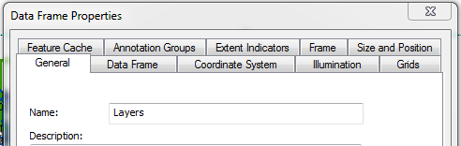

For the Text Element Names:

<County> Element Name: Map Title
(Example provided)
<File: ##-###> Element Name: File Number
<Detail> Element Name: Detail Number
<Print Date> Element Name: Print Date
<Author> Element Name: Author
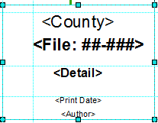

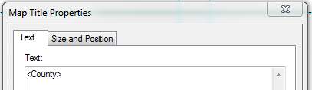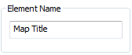

Geoprocessing Script

1. Setup Modules and Global Variables

The first step is to import the appropriate modules into the script. Then set some global variables that will be used throughout the script, including an author name (author) and a standard date format (CUR_DATE).

Next, set the script’s workspace to the data folder to access all of the necessary files and tables, and create another variable for the specific shapefile that would be updated (chg_shp).

(Script)
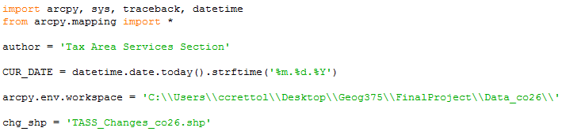

(Windows Explorer Equivalent)
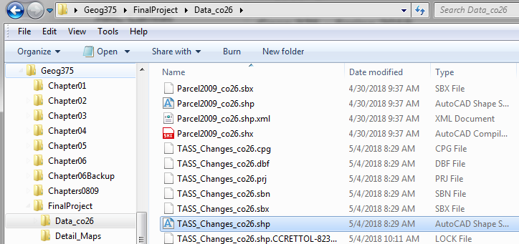

2. Search for Changes and Print Results

Within the try: statement, create a query that would return all of the values in the shapefile (chg_shape) under the “YEAR” column that were equal to “2017.” This would separate out only 2017 changes from all of the other years in the table.

I then created a list variable (field_list) to find the values of additional columns that will be used later in the print statement.

Using a Search Cursor (arcpy.da.SearchCursor), the script searched the shapefile, then searched for the field list values, and used the query to loop through all of the values in the table and collect all of the information related to 2017.

Finally, assign variables (filenumber and notes) to each of the list items and wrote them out to Python Shell with print statements.

The results printed in Python Shell will be used to determine the File Names and Detail Numbers in the map books in future steps.

(Script)
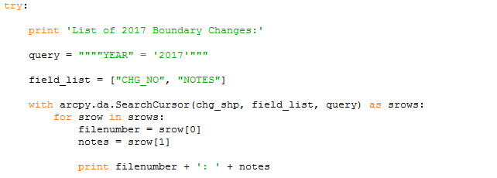

(Python Shell Results)
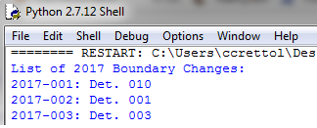

3. Setup Paths

The next step is to create variables to map out all of the paths.

datapath – this will point to my final project folder
mappath – this will point to my folder with all of the map data
pdfpath – this will point to where the .pdfs will be saved to
co_mxd – this will point to the specific map document

A couple of print statements were set up to help order and separate lines out in Python Shell.

(Script)
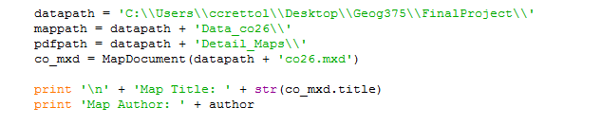

(Windows Explorer Equivalent)
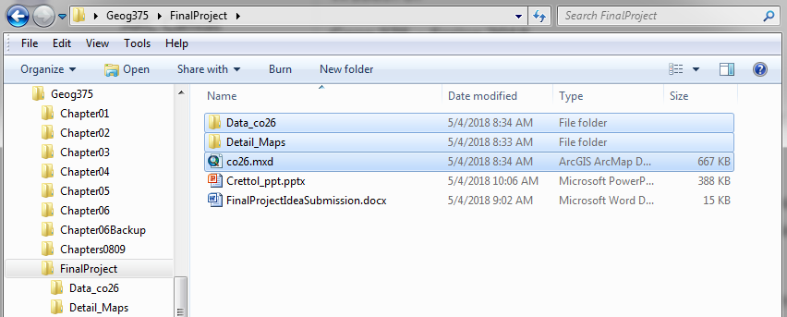

(Python Shell Results)
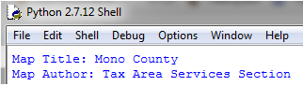

4. Select Data Frame from .MXD

Then, set up the Data Frame area that will be manipulated according to the filings.

Print any relevant data frame information

(Script)

(Python Shell Results)
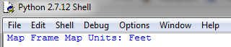

5. List Text Elements from .MXD and Set Global Properties

First create a statement (tElements) to identify all of the elements in the .mxd and collect all of the Text Elements.

Then loop through all of the elements with the for statement, and make any updates to specific element names based on text and position.

(Script)
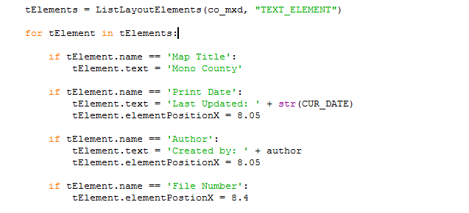

(Before Script on Template) (After Script on .pdf)
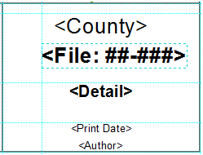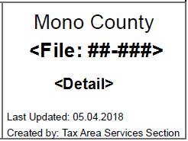

6. List Layers from the Table of Contents and Print For Reference

Get a list of all of the layer names from the .mxd.

Then loop through all of the layers with a for statement.

Print all of the layers name and long names, they will be referenced and updates in future steps.

(Script)
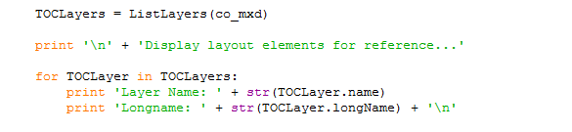

(Python Shell Results)
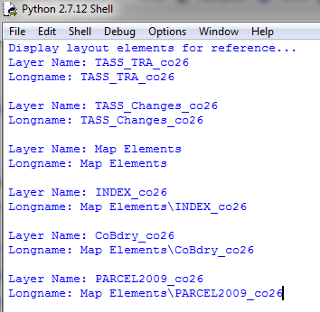

7. Set Global Layer Properties

Modify each layers visibility and transparency if necessary.

(Script)
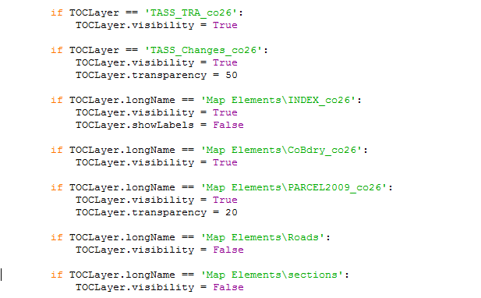

(Template Before Script) (Template After Script)
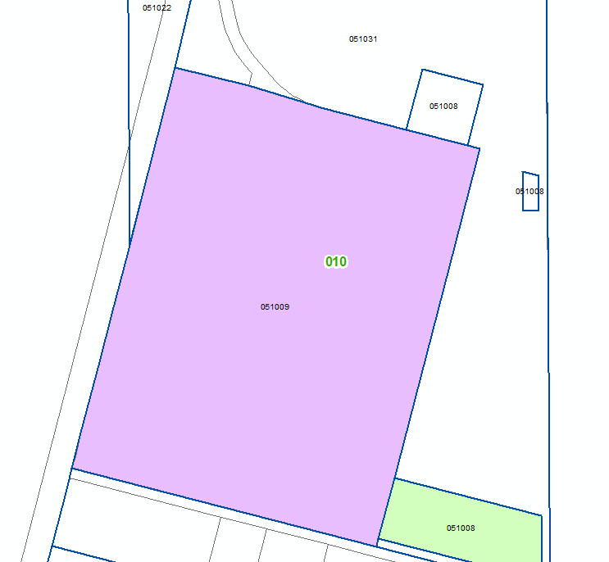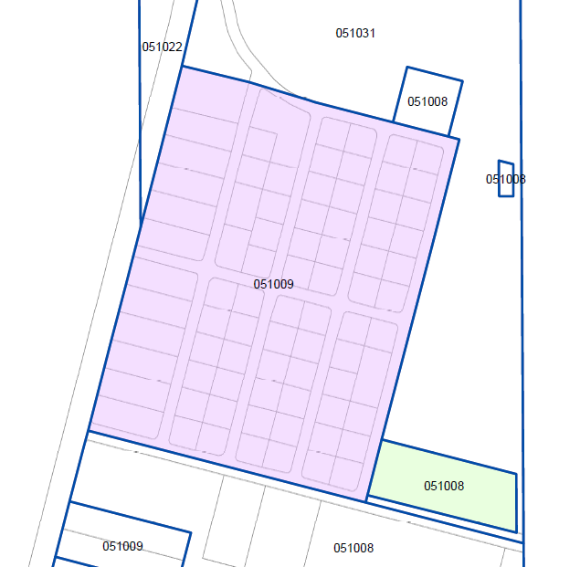

8. Create the First Map Book

First, loop through the list of layer names in the table of contents with the for statement.

Next, search for the desired layer with the if statement.

Then, create a query to search the layer’s table, the column, and then the specific value.

Then, use the SelectLayerBy Attribute using the requirements above.

Modify the Data Frame extents if necessary, remove the selection so it does not appear highlighted in the map book, modify the text elements for the specific File Number and Detail, remove any existing .pdf with the same name, print a new .pdf to the desired folder, and finally create print statements to indicate when each map export is complete.

(Script)
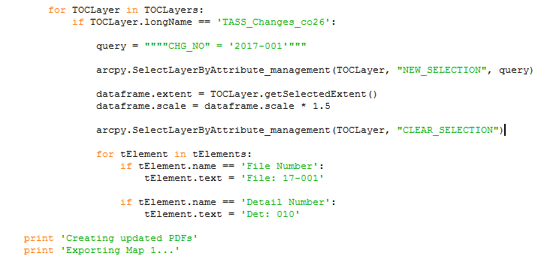

(After Script .pdf) (Python Shell Results)
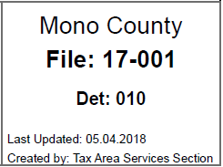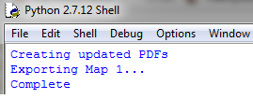

(Map Book 1 Product)
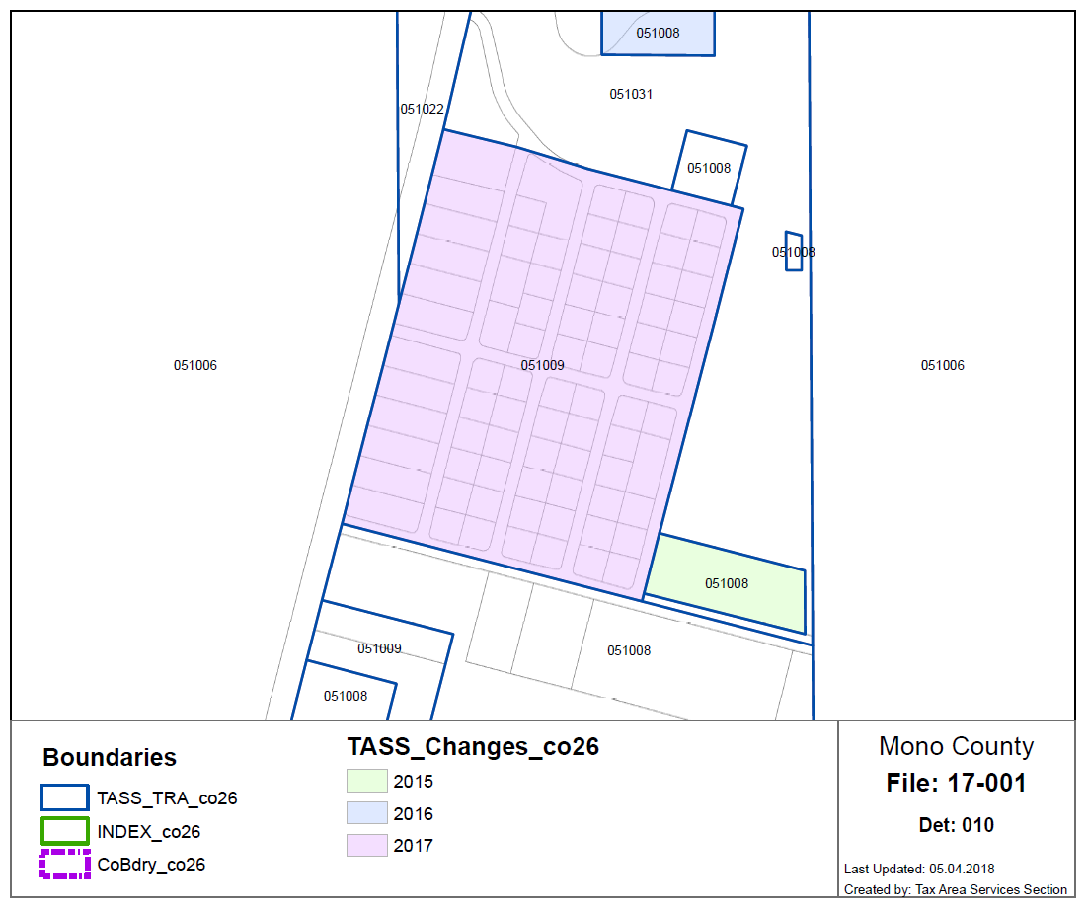

9. Create Remaining Map Books using Steps Provided Above

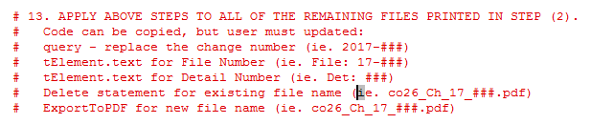

(Script)
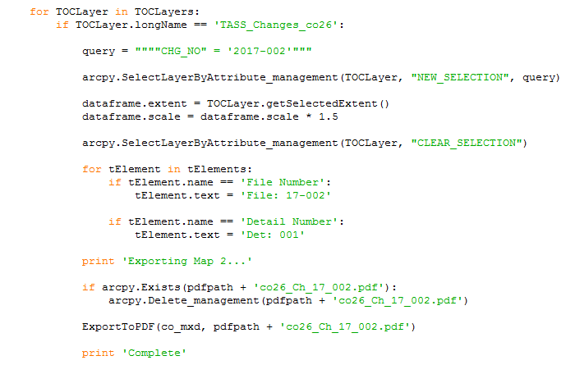

(Map Book 2 Product)
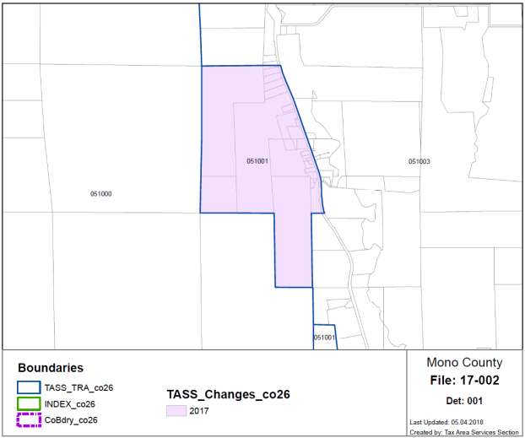

(Script)
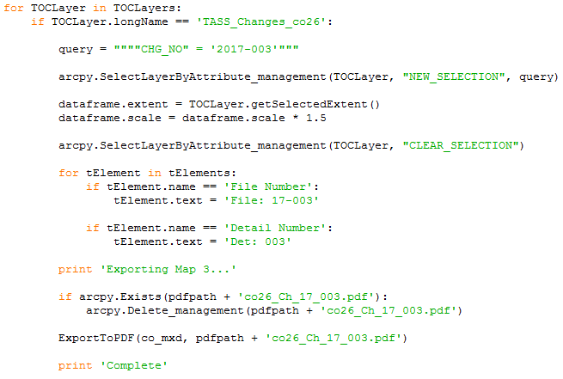

(Python Shell Results) (Windows Explorer Equivalent)
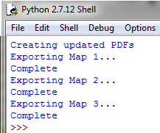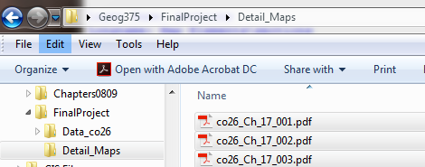

(Map Book 3 Product)
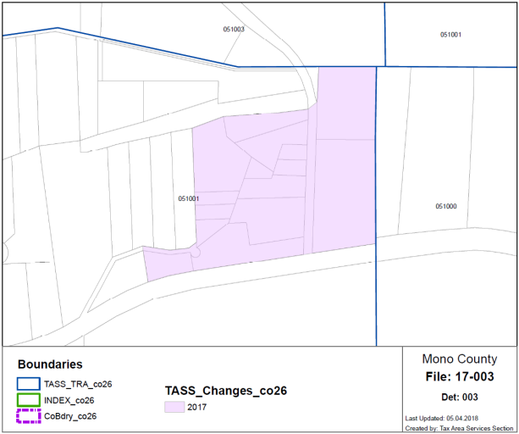

Issues and Resolutions

As with all coding, one of the greatest challenges is typing out the script with exact accuracy. There were dozens of times when I would misspell something, or forget an extra quotation or period, or incorrectly indent. Thankfully, the except: statement error finder at the end of the script helped me find the line of code that had an error, and even sometime helped my discover the underlying problem with my code.

Another issue that I encountered was that my map books were looping after map book one and re-exporting maps 2 and 3. I later discovered that since I had one shapefile and one file geodatabase feature class with the same name in the table of contents, it was searching through both of those when the script ran. So what I did was remove the shapefile from the table of contents and that seemed to resolve the loop issue.

Finally, there were a handful of other tedious things that I worked through by trial and error. One was adjusting the positions of the Text Elements so that they would be centered on the .pdf. Then was deciding whether getSelectedExtent or zoomToSelectedFeatures was a better representation of the Data Frame area. All in all, I obtained the results that I set out for, and am satisfied with the product.

Future Project Ideas

I feel like this is not the cleanest script, and that there should be a way to further automate this process to use the data from the Search Cursor in step 2 to loop through and update the map books in step 8. That may be more advanced than this class, but it gives me something more to look into.

