Elaine Carlton
Geog 375, Spring 2018
5/13/2018
Crime and Marijuana Dispensaries in Sacramento

In November 2017, California State Proposition 64 was passed, making it legal for adults to smoke and possess marijuana starting January 1, 2018. The bill also created the opportunity for marijuana dispensary businesses to open their doors to the public across California. Despite there being strict state laws for these dispensaries to abide by, there are also city ordinances that they must adhere to. Though some cities are still determining the best course of action concerning these ordinances and their respective communities, there is one primary question that seems to repeat itself, “Is there going to be an increase in crime surrounding these businesses?”.
For my final project I chose to focus on 2018 Police Dispatch Calls for Service (CFS) and their proximity to marijuana dispensary businesses located within the city of Sacramento limits. I chose to focus on 2018 data because it provided a more accurate reflection of potential issues that could be occurring at dispensaries since the January 1 kick-off date. The CFS data was narrowed down to within 500 feet of the business address, as a means of focusing on incidents that might be directly related to the dispensary.
The Police Dispatch Call for Service data was collected from the City of Sacramento’s Open Data Portal. The initial shapefile I downloaded had data from January 1, 2018 – March 13, 2018, so to say the analysis conducted in this report reflects a true Year to Date explanation of events would be inaccurate. As will be discussed later in this report, there are also other factors that hindered a thorough analysis of crime related to marijuana dispensaries.
The remaining data I collected for this project included a list of licensed marijuana dispensary businesses obtained from the City of Sacramento’s Office of Cannabis Policy and Enforcement website, and a Centerline shapefile from the Sacramento County Open Data Hub. ESRI’s “World Light Gray Canvas Base” base map was used for geographic reference.
The first hurdle I faced with this project was geocoding the list of marijuana dispensaries into ArcGIS from an excel document. Initially I attempted to write a Python script using the command geocodeAddresses_geocoding, but I received an error. I then used ModelBuilder to geocode the addresses, and was successful, but wanted to import the Python code from ModelBuilder into my script. I received a different error this time, referencing an issue with accessing the Esri World Geocoder Server. After researching the various ways to geocode the businesses and finding that I was not the only person struggling with this process, I decided to focus my attention on other geoprocessing tasks and created a shapefile from the ModelBuilder process for the dispensaries.

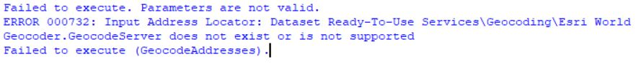
The next step of my process was to create a file geodatabase for all of my files to be stored in. This was based on previous work in this project and having my shapefiles and tables scattered all over the place. I knew that I ultimately wanted to automate two maps and that it would be easier to work out of a geodatabase than file folders.
Once the geodatabase was established, I created a feature layer from the call for service shapefile and displayed the total number of incidents through the current date range. I then created a feature layer for the marijuana dispensaries and used the select layer by location command to select all calls for service within 500 feet of a dispensary, displaying the total number that selection created. I also displayed the number of dispensaries to cross-check against my address list to make sure they were being recognized.
After I conducted my initial queries, I created a new feature class of the selection of calls for service within 500 feet of a dispensary to be saved into the geodatabase. I repeated the same steps described above to select only those calls for service that dispatch marked with “Y” for a report. Another feature class was created for reports within 500 feet of a dispensary.
I created a table for each of the selections (calls for service, reports) and exported both those and the feature classes to the geodatabase.
Some of the challenges I faced while writing these selection processes included learning that a feature layer needed to be created before a feature class could be, and that a table (.dbf) can’t be part of the same conversion process to a geodatabase as a feature class. Each component requires its own process and command.
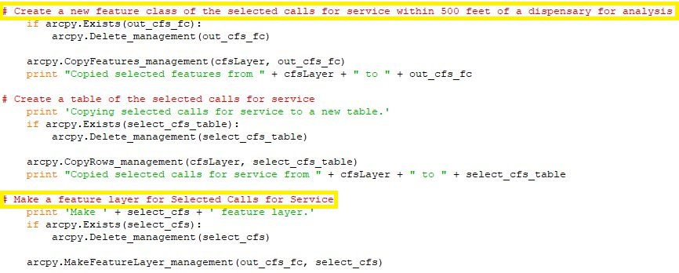
With the selection process complete and the shapefiles I needed to work with saved to the geodatabase, I then moved into creating maps of the two attributes I thought would represent crime at a dispensary the best.
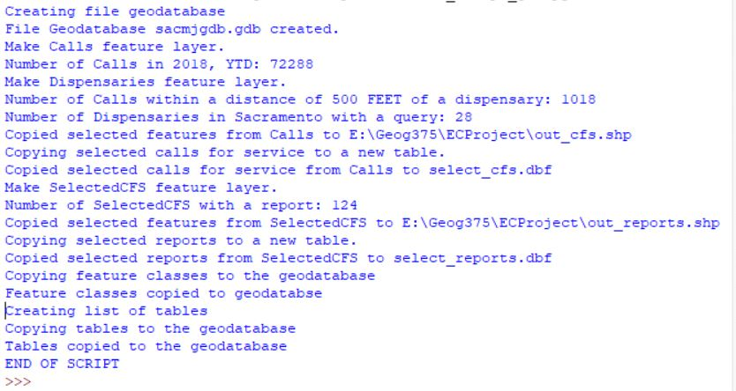
I was not as comfortable creating map documents with Python script as I hoped, and therefore took more time than expected. Using the demo script from our workbooks, I had the map document properties and data frame properties displayed. Once I felt confident the .mxd was being accessed correctly, I started the process of creating a map that showed reports within 500 feet of a dispensary. I displayed the centerlines at 65% transparency over the grayscale basemap and only selected the dispensary locations and reports layers.
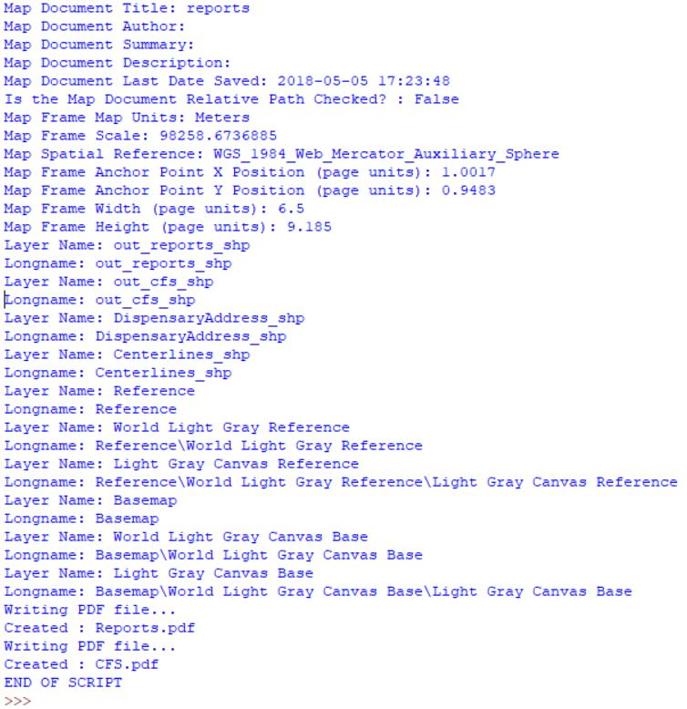

One of the major challenges I had with this part of the script was having the layers respond to the commands. After a great deal of research and modification, I determined the command I was giving was not being recognized because it was named incorrectly.
Incorrect:
if TOCLayer.name == ‘Centerlines_shp’:
TOCLayer.visibility = True
Correct:
if TOCLayer.name == ‘Centerlines_shp’:
TOCLayer.visible = True
I also learned and/or remembered how important it is to indent properly. For the second map I created to display the calls for service within 500 feet of a dispensary, I copied and pasted the script from the first map. In doing this, I inadvertently missed a process and the indentation became skewed.
Once the maps were created and saved into my file folder, I was able to visually see a difference between the two. Though the maps don’t provide the best visual explanation to indicate if there is a problem with crime near marijuana dispensaries, I think there is merit in conducting an occasional analysis of the subject matter. Most of the analysis I was able to conduct was through the tables and totals I displayed at the beginning of the script, but even then, I quickly discovered I didn’t have enough knowledge about the coding used by dispatch for the calls for service or enough information about the report to be able to provide a definitive answer to any correlation between crime and dispensaries.
Based on what I was able to analyze, it appears only 1.4% of all of the calls for service in the time frame of January 1 – March 13, 2018 were within 500 feet of a dispensary. Of those calls for service, there were 124 reports taken, with 23% of those related to traffic incidents. Without knowing the outcome of the call, the specific location where the incident occurred, and having a true geocoding of the dispensaries (not the center of the street), there isn’t an answer to the initial question “Is there going to be an increase in crime surrounding these businesses?”.
Moving forward with this project, I would try to obtain different data sets from the police department with more detailed information, specific to the calls and reports. I would also try to add more automation to my script for the map creation, and change the geoprocessing to a different style, such as hot spot.

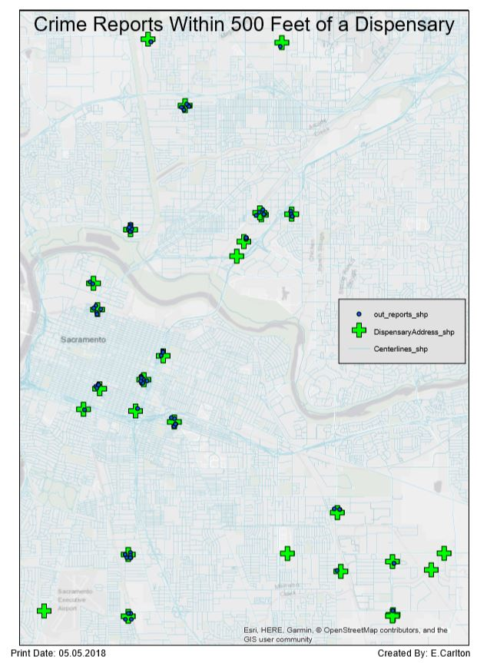
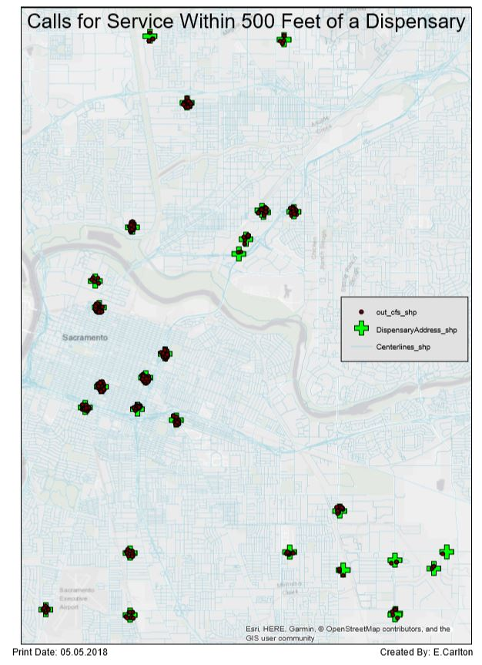

City of Sacramento Open Data Portal, http://data.cityofsacramento.org/,
City of Sacramento Office of Cannabis Policy and Enforcement, http://www.cityofsacramento.org/Finance/Revenue/Sacramento-Marijuana-Information/Business-Information/Dispensaries,
County of Sacramento Open Data Hub, https://data-sacramentocounty.opendata.arcgis.com/,

