GEOG342
Final Project—A Deep Learning Lesson
Joanna Burgess

Project Summary
In Tonga, coconuts and coconut products are an important economic commodity. The plantation in Kolovai (on the island of Tongatapu), Tonga has thousands of trees. Inventorying these trees individually (along with the health of them) would take many hours and people. Now with remote sensing and deep learning there is a way to survey the trees and the health associated with that tree. It must be said that the accuracy is determined by the accuracy of training samples and quality of the trained model.
My final project will be to complete a lesson from ESRI called “Deep Learning to Assess Palm Tree Health”. Overall, it is a lesson using Deep Learning Tools in ArcGIS Pro to: create a training schema (for coconut palm trees); create training samples (using bookmarks for sample areas); train a deep learning model (using ArcGIS API for Python’s arcgis.learn module—Jupyter Lab) or a preexisting deep learning model; and, finally estimate vegetation health calculating the Visible Atmospherically Resistant Index (VARI). This lesson uses the Spatial Analyst and mage Analyst extensions.
Purpose
I was curious because you kept mentioning doing a “Deep Learning” module. After watching the training seminar, and learning that Esri had a training lesson on deep learning, I wanted to acquire the knowledge and practice the use of deep learning tools. Ultimately, I wanted to learn more about deep learning.
Project Steps—Image processing tasks and methods
I learned about the “Gallery Lesson” from a deep learning training seminar given by ESRI: “ArcGIS Deep Learning Tools for Imagery” (esri.com/training).

https://www.esri.com/training/catalog/5d8a8d4155cf937306dba7d9/arcgis-deep-learning-tools-for-imagery/

Here is an image from the training seminar:
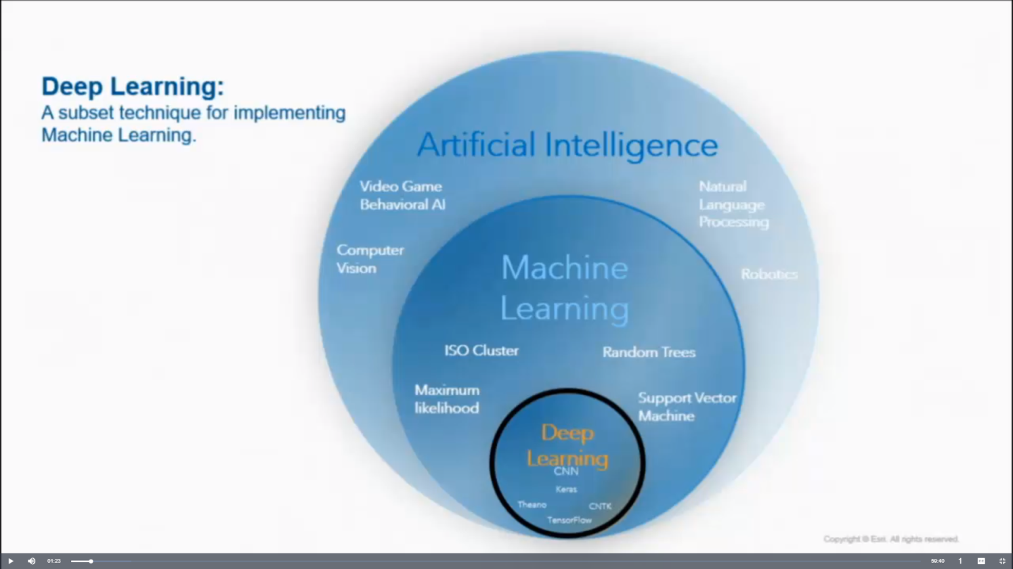
Referring to this image, Vinay Viswambharan says: “AI, machine learning, and deep learning – are linked subsets of each other essentially. AI is when a computer does a task with a certain level of human intelligence. Machine learning, it involves techniques that learn from data. And deep learning, it loosely resembles the human brain.”
Also in this presentation they show the workflow (4-step process) for deep learning. These are the steps that will be taken in the lesson:

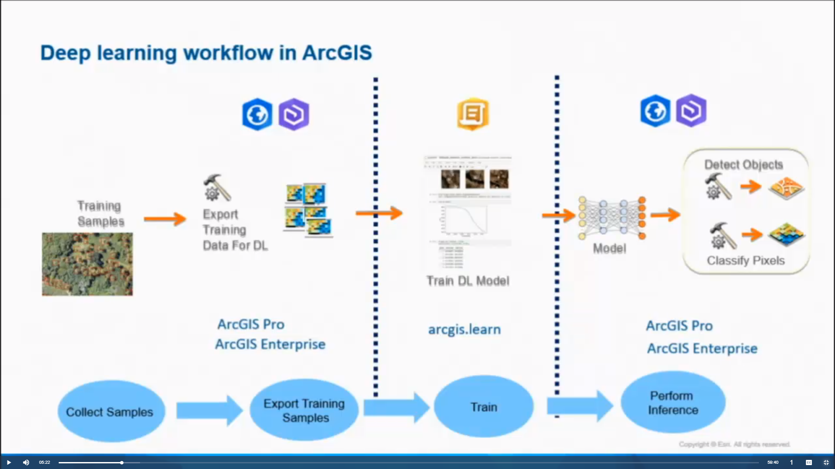

This website was the location of the instructions for the lesson:
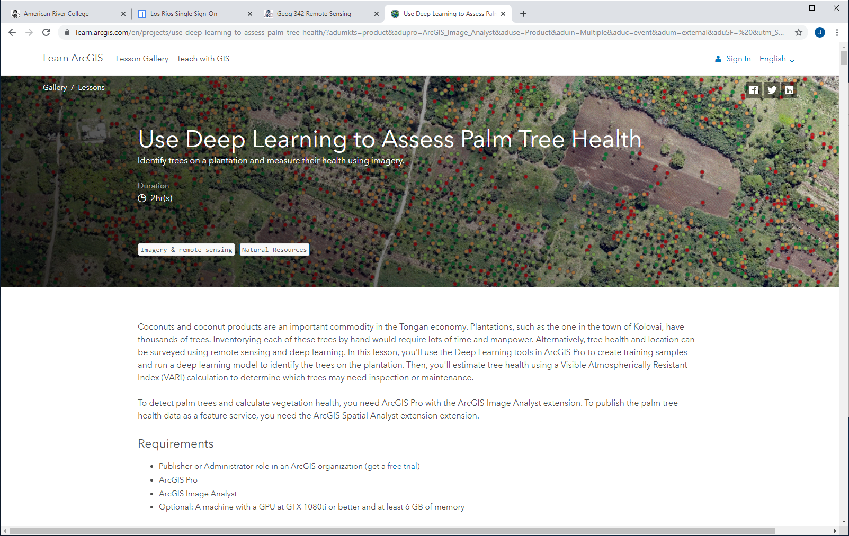
https://learn.arcgis.com/en/projects/use-deep-learning-to-assess-palm-tree-health/?adumkts=product&adupro=ArcGIS_Image_Analyst&aduse=Product&aduin=Multiple&aduc=event&adum=external&aduSF=%20&utm_Source=event&aduca=I&RS&adulb=marketing_sales&adusn=multiple&aduat=webinar&sf_id=701f2000000rmROAAY
This lesson had three basic parts: 1. Create training samples; 2. Detect palm trees with a deep learning model; 3. Estimate vegetation health (using VARI); and, “extra credit” steps.
- Create training samples
The instructions had a “Deep learning file” link download the data for the lesson—it needed to be on the C: drive (so I had Geoff download it—administrator). I did not have a computer that had ArcGIS Pro at home so all my work was done in the Open Lab.
Next step was to get the UAV imagery to be used. The link was in the instructions. Once on the website I did a search on Kolovai to find and download the image needed for the lesson. When I put Kolovai into the search field, I had to hit enter and a drop-down list showed—I selected Kolovai.
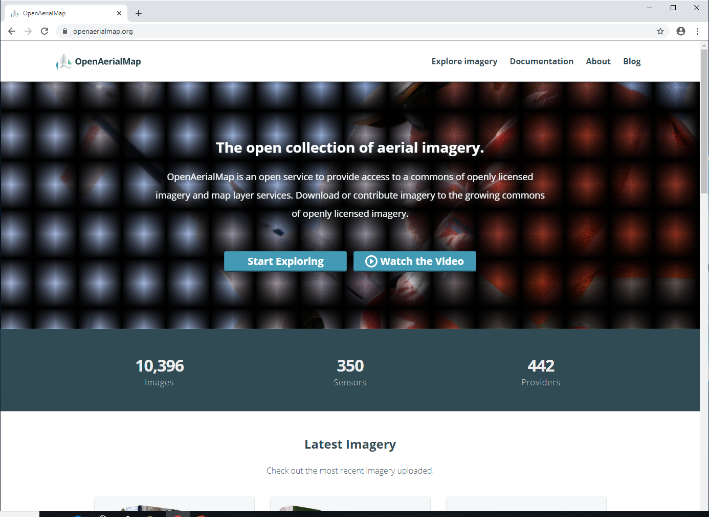
https://openaerialmap.org/
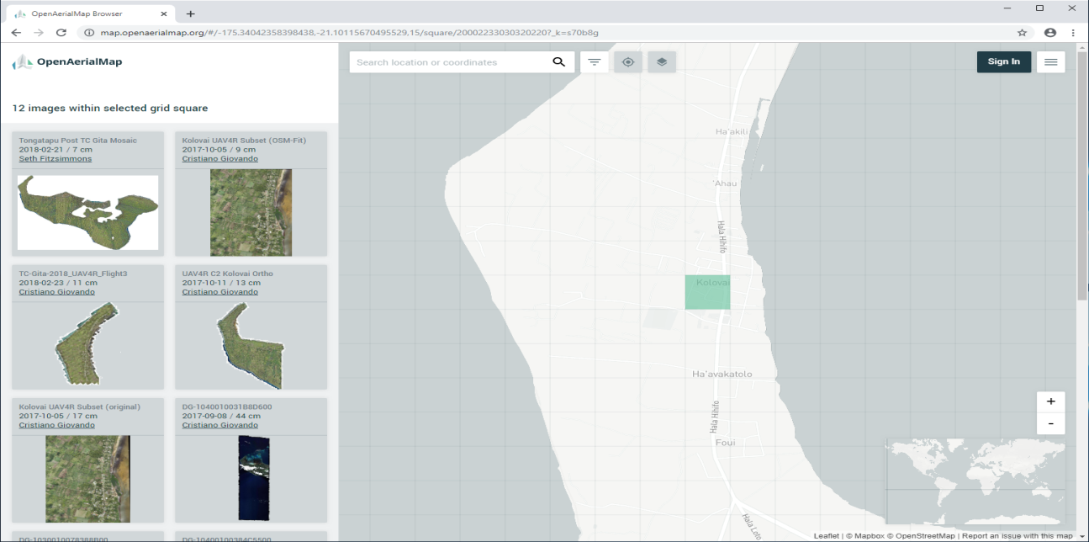
https://map.openaerialmap.org/#/-175.34042358398438,-21.10115670495529,15/square/20002233030320220?_k=s70b8g
The image: resolution 9 cm; sensor Sony ILCE-6000, 138.75 MB; and, UAV.
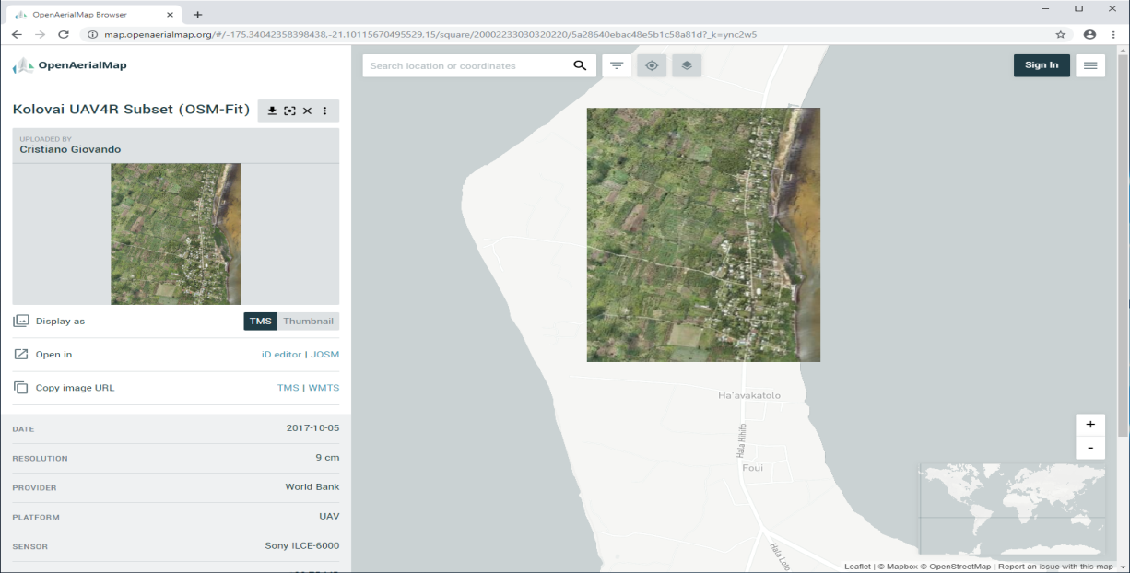
https://map.openaerialmap.org/#/-175.34042358398438,-21.10115670495529,15/square/20002233030320220/5a28640ebac48e5b1c58a81d?_k=ync2w5
Next step was to open a map in ArcGIS Pro and add the image:
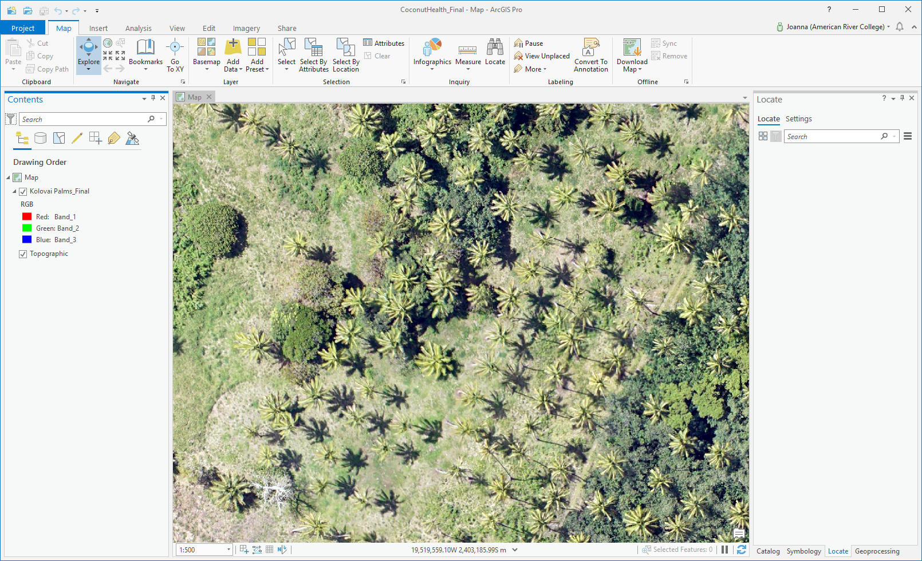
Screen shot of Kolovai image brought into ArcGIS Pro.

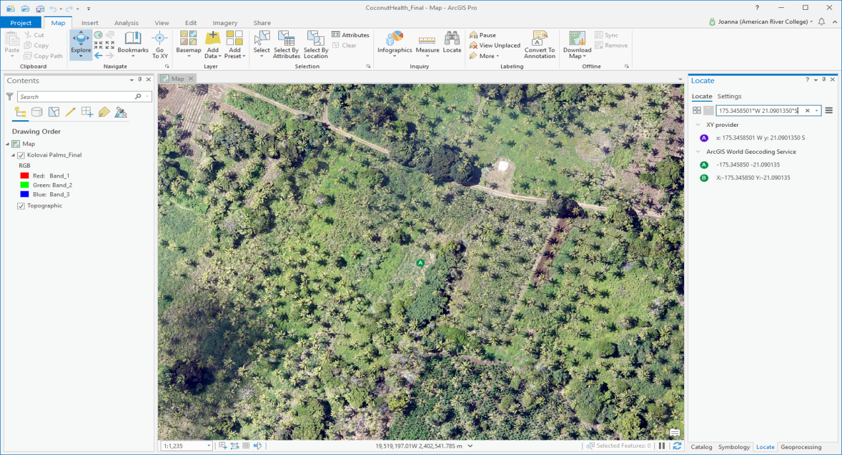
Screen shot of setting of bookmarks for sample sites to create training samples (using Locate).

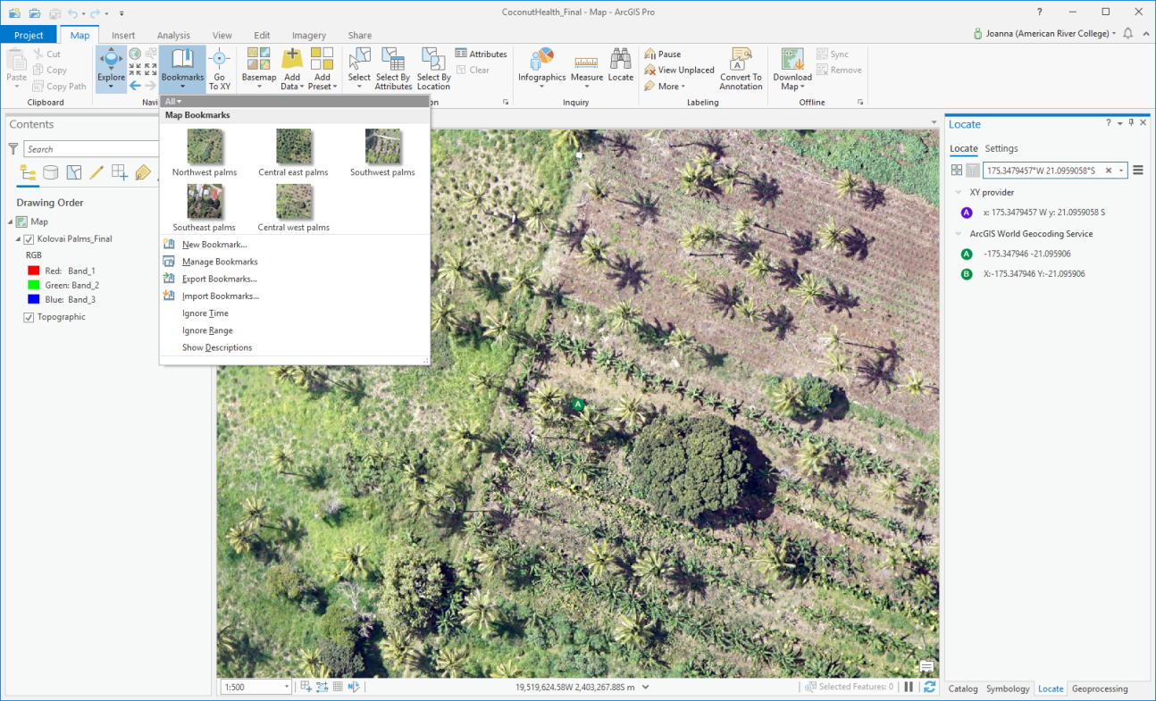
Screen shot showing the five bookmarks for the sample sites. Each sample site is at a scale of 1:500 (customized a setting at the left bottom of map) and I was given the X, Y coordinates to put in the Locate tool (Map tab, Inquiry group, Locate).

Next was to: Create a new Training Schema:
The sample sites have been bookmarked. Now I need to create a new training schema (since I only want the coconut palm trees to be detected). With my raster “Kolovai Palms” selected, I click the Imagery tab, Classification Tools, drop-down select Training Samples Manager. The Image Classification pane opens up on the right side. Since I don’t want the default NLCD2011 schema, I click on Create New Schema button. To make changes I right click and chose properties; name the schema Coconut Palms; gave it a description and clicked save. Once I created the “Coconut Palms” schema, I now add the class that will house my training samples. There were two ways to do this: 1. There is a down arrow that you can click that gives you a “+” (which you click) or “x“; or, 2. Right click on the schema and click add new class. The “Add New Class” pane comes up. The Name and Value fields are the only required fields.

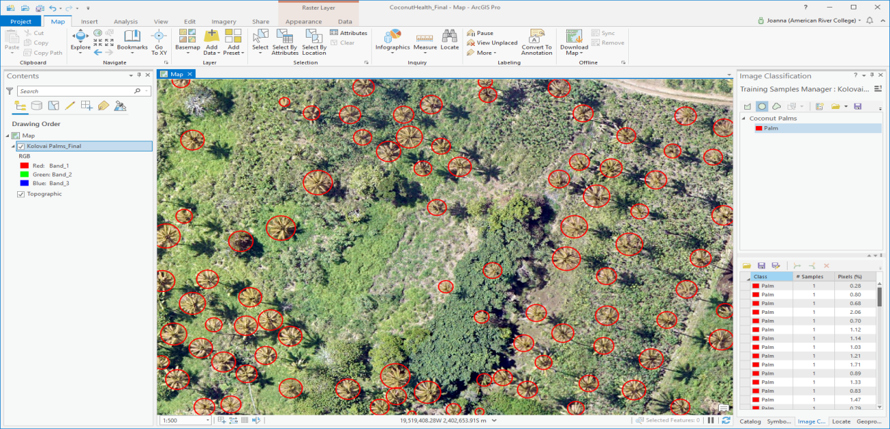
Screen shot of ArcGIS Pro with the training samples: I used the circle tool to capture the Palm tree tops (click in middle and circle outwards). This was very time consuming. I did the five bookmarked sites that I created earlier and clicked save. They were saved as a feature class name “PalmTraining” in a geodatabase.
After creating the training samples, they need to be exported using the Export Training Data for Deep Learning tool—which you find by doing a search in the Geoprocessing pane.
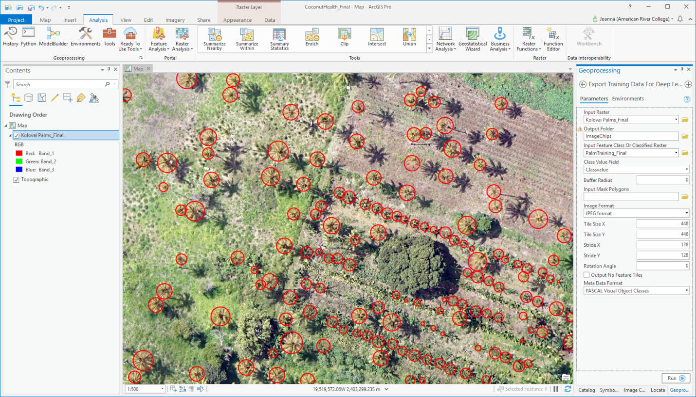
Screen shot of ArcGIS Pro: Export Training Data for Deep Learning pane with attributes.
The training samples are exported out as Image Chips that are the input to either a deep learning model using Python API or in this case I used a pre-defined deep learning model that came with the data. The image format was JPEG and the instructions had me increase the Tile Size X and Tile Size Y to 448 x 448 pixels (instead of leaving it at 256 x 256). This means there would be more image chips created. Stride X and Stride Y are left at 128 x 128 pixels. I think this could have meant palm trees detected where there weren’t any. The Meta Data Format was changed to PASCAL Visual Object Classes.

- Detect Palm Trees with a deep learning model
For this lesson I used the pre-defined model. If I had decided to “Train a deep learning model”, I still would have need to clone and create a new python arcgispro-py3 environment.
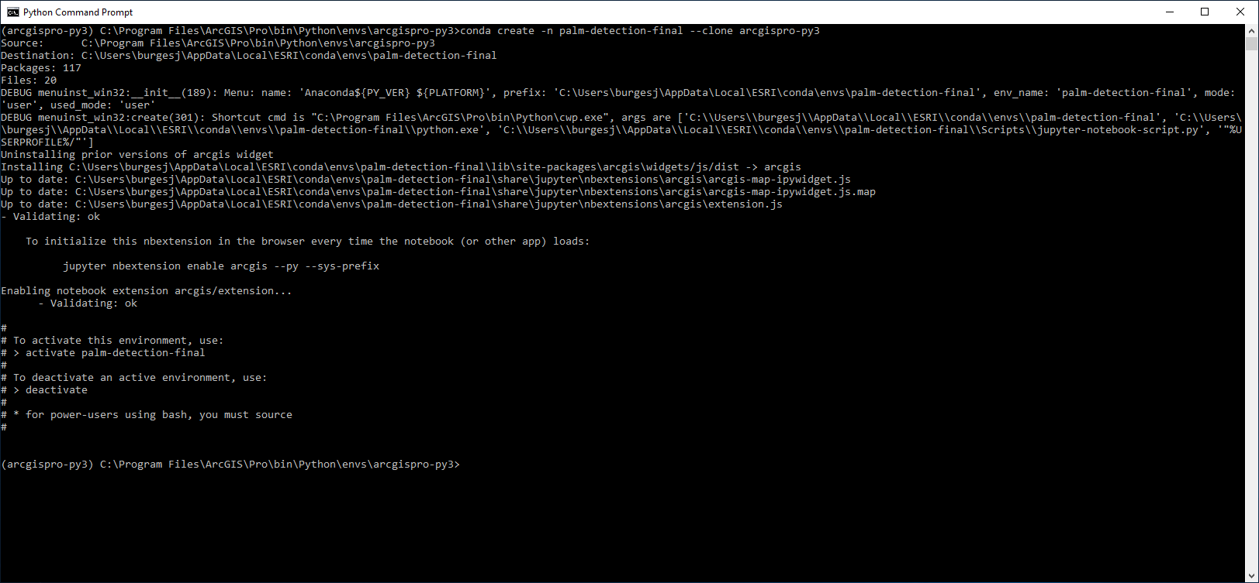
Screen shot of Python command prompt to clone and create a new python environment.
Conda create –n palm-detection –clone arcgispro-py3
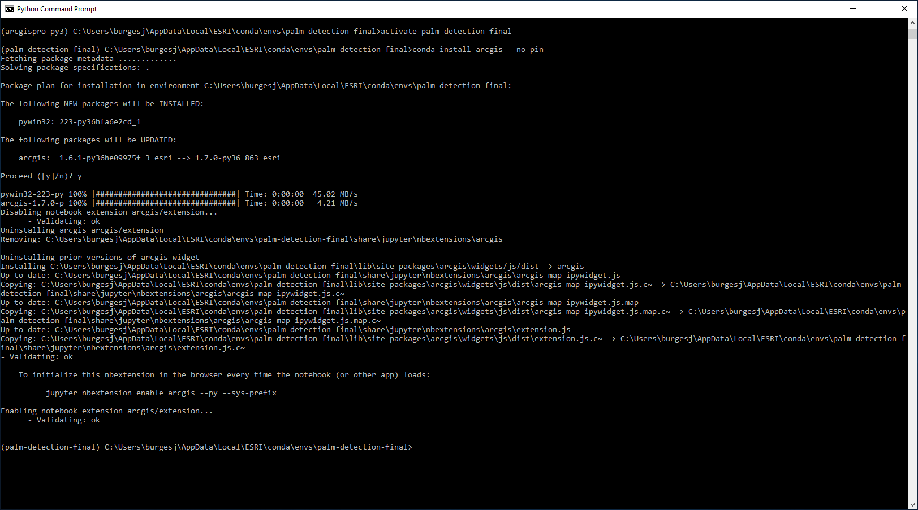
Screen shot: Change to new environment and activate it—also make sure correct ArcGIS Pro installed:
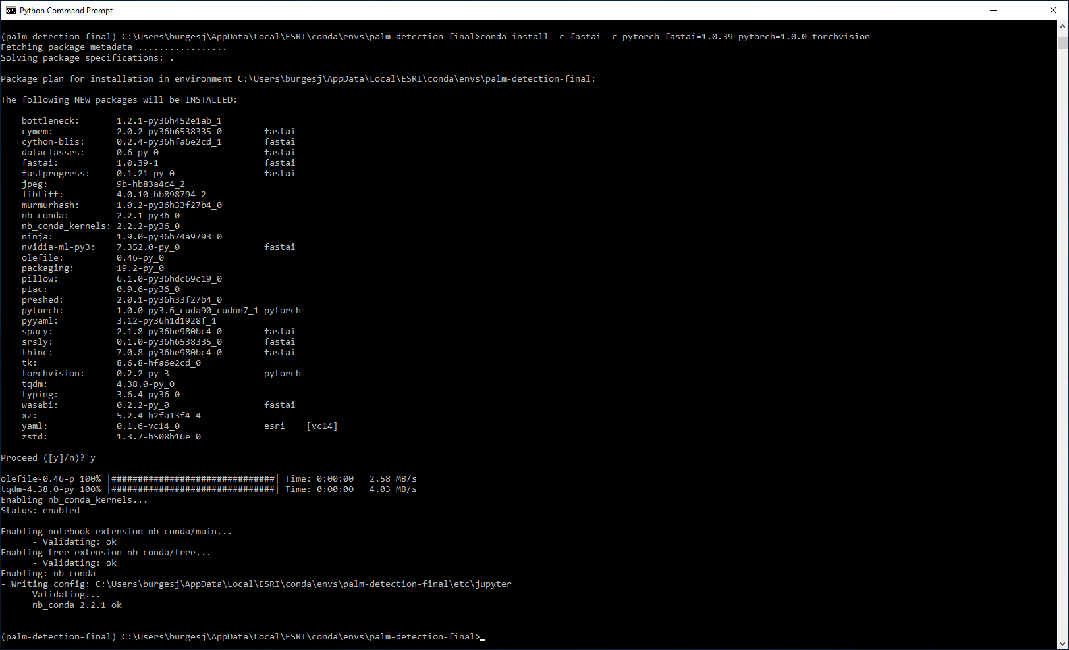
Screen shot of installing deep learning dependencies.

Even though I did not train a deep learning model myself, here is a screen shot of the Jupyter Instance:
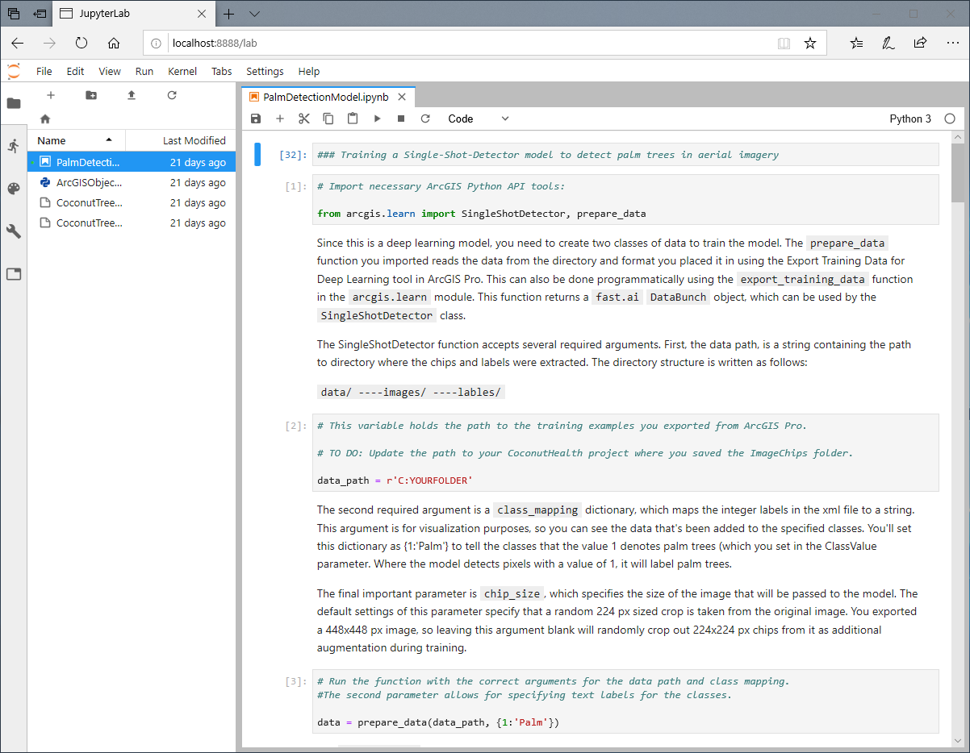

The following is a screen shot of the contents of the image chips folder.
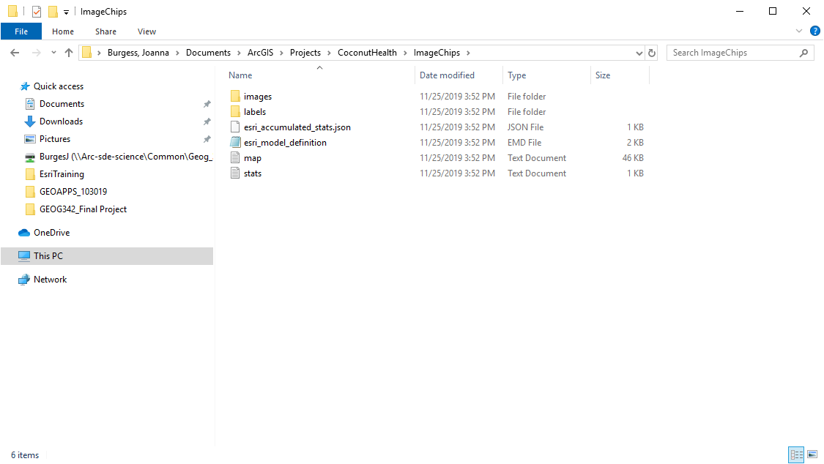
Next step: make sure Python is using the correct environment:
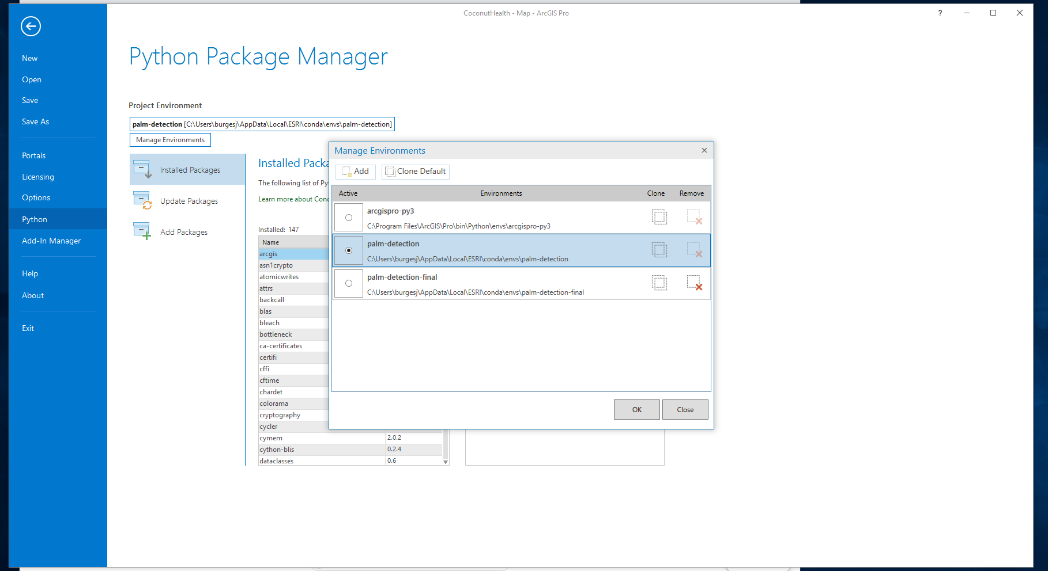

Next step: using a deep learning model, In the Geoprocessing pane find the Detect Objects Using Deep Learning tool.
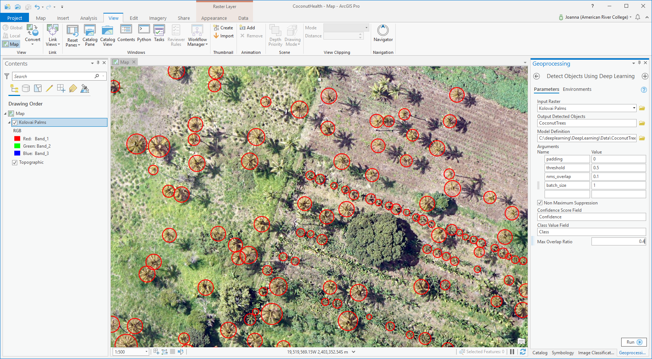
Screen shot: Batch size = 1, check box for Non Maximum Suppression, Max Overlap Ratio = 0.4. The score-threshold argument is the confidence threshold. Padding puts more pixels around images. Click Environments to change how much of the image to use for the run.

- Estimate vegetation health: Since the image used has only the 3 visible wavelengths must use VARI (Visible Atmospherically Resistant Index). The indirect measure of leaf are (LAI) and vegetation fraction (VF) using the reflectance values of the 3 visible wavelengths: Green – Red / Green + (Red – Blue).
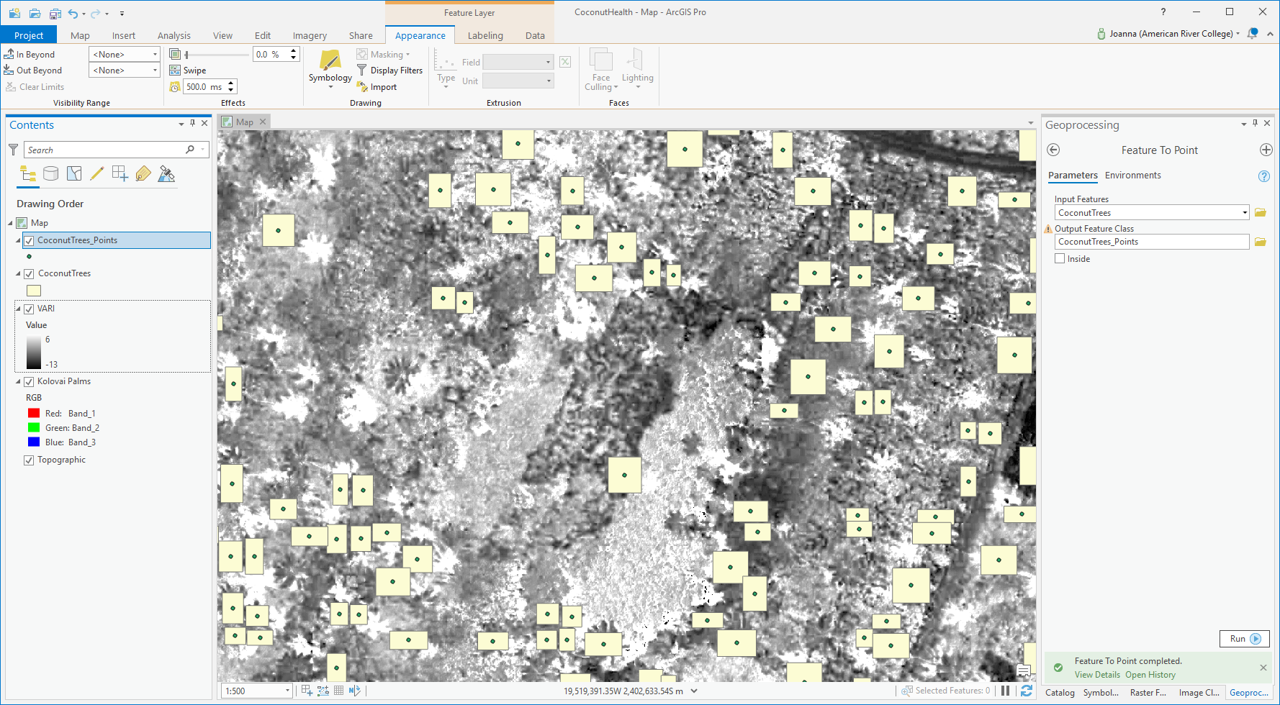

Screen shot: Feature to Point

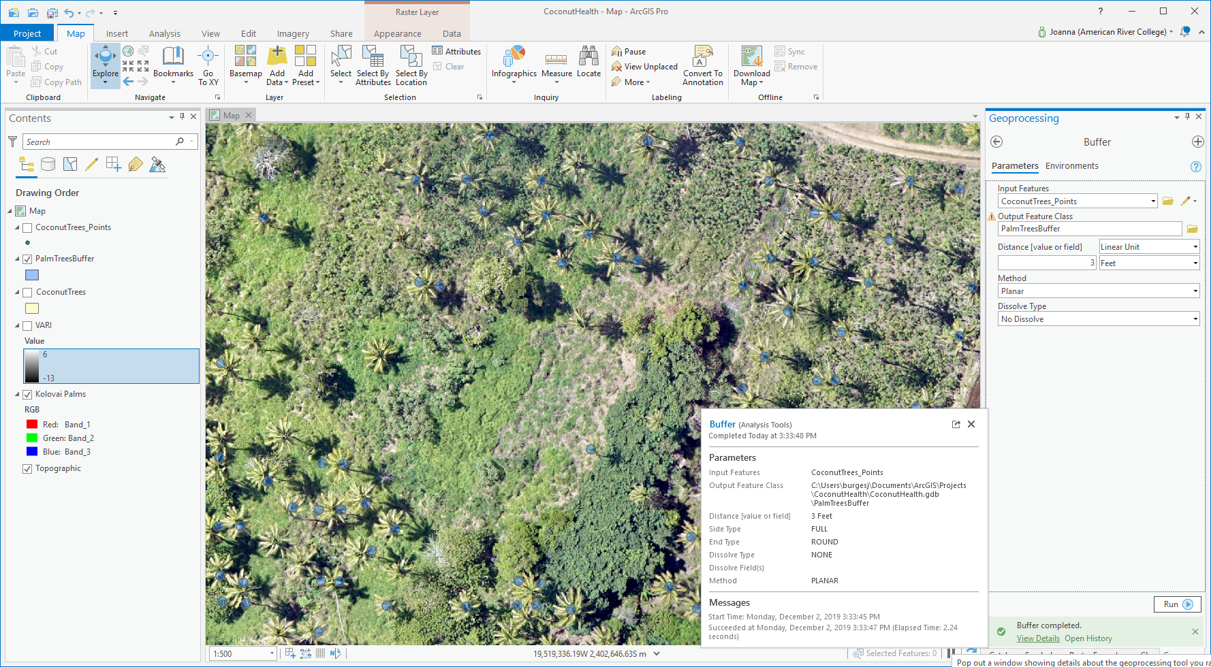
Buffer:

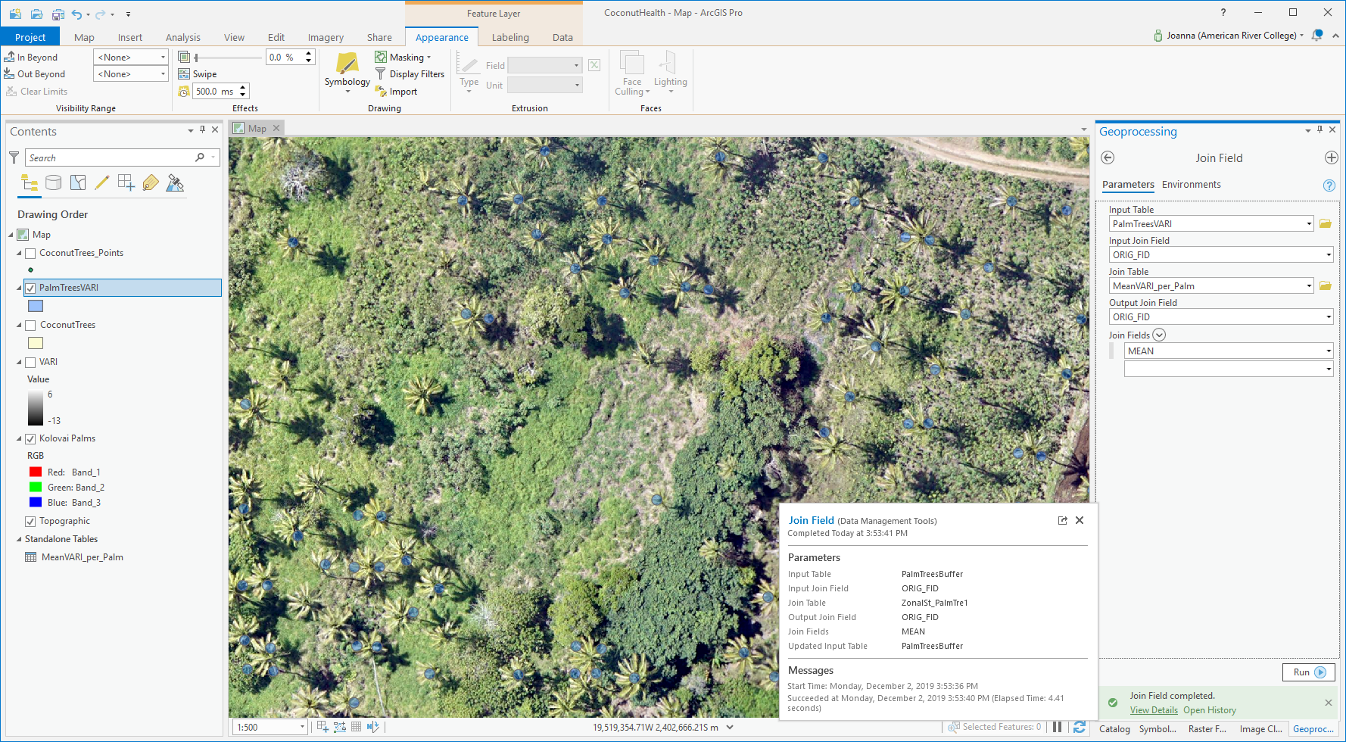
Screen shot: Join

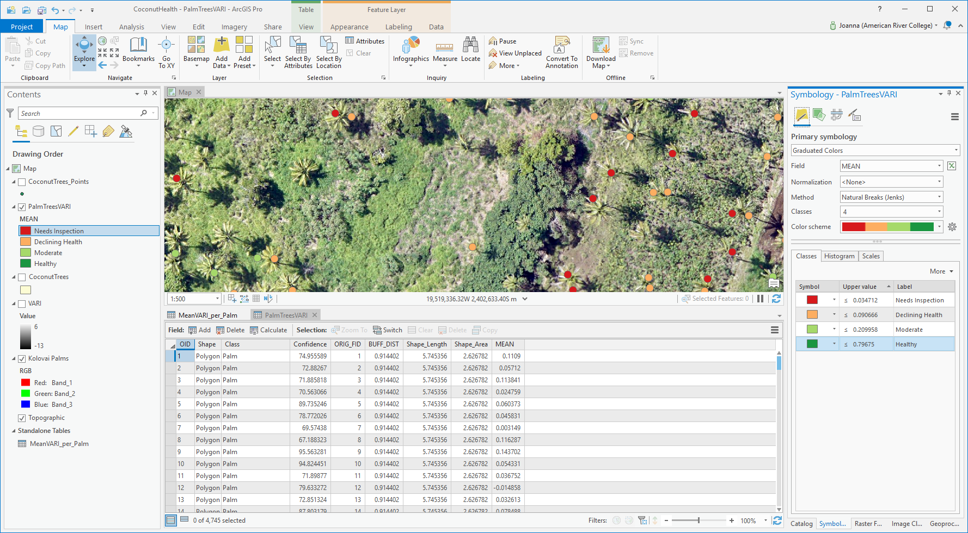

Attribute table: Location, Health, Confidence.

In conclusion I learned a lot about deep learning—what is and how it fits into AI and machine learning. I am currently working on more lessons through Esri.

