AMERICAN RIVER COLLEGE Student: CARMEN BOWEN
Geography 342 / Spring 2020

SPECTRAL ANALYSIS OF THE PARADISE AREA BEFORE AND AFTER THE CAMPFIRE

Background
The Campfire of November 2018 is the most devastating fire in California’s history. An area of 153,335 acres was burned by the fire, approximately the size of Chicago. The fire spread to more than 100,000 acres within the first two days. 18,804 structures were destroyed, the vast majority of them — almost 14,000 — were residences. Around 30,000 people lost their homes and 85 people lost their lives.
Ten of the 20 most destructive fires in California, in terms of structures destroyed, happened in the last four years, according to Cal Fire. Eight of them happened within the last two years. In its strategic plan for 2018 (released before the Camp Fire), Cal Fire noted: “Climate change has rendered the term ‘fire season’ obsolete, as wildfires now burn on a year-round basis across California.
GIS, remote sensing and other technologies are invaluable tools in assessing, managing or mitigating risk for all kinds of disasters. The satellite data, for instance, tell scientists and land managers how fire transforms the land surface as well as enable them to measure how this transformation alters the ecosystem. For example, burned soils resist rainwater infiltration, leading to increased runoff, erosion, land slides and flooding. Satellite data help identify, locate and map those burned areas most susceptible to the increased runoff and erosion. Fire response teams then treat burned sites with a variety of measures to minimize erosion, such as spreading ryegrass seeds to stabilize the soil, and placing straw mulch on hill slopes for ground cover to intercept rainfall before it hits the burned soil. The response depends on the intensity of a fire; some burned areas require more immediate and intensive response efforts than others.
Project Summary
This project uses Landsat 8 imagery and employs various analysis methods to compare the groundcover and urban features before and after the Campfire. The Search criteria for the Landsat imagery included less than 10% cloud cover and daytime imagery. The two datasets selected were: October 29, 2018 (1800 UTC) and March 25, 2019 (about 1800 UTC). Both datasets were Path 044 Row 032, which covered the Campfire area.
Multiple image compilations and analysis were used in this project, from creating a composite image, by combining all 11 bands, to creating BAI (burn area index) images for the region, before and after the fire.

Purpose of Study
This study employs multiple Landsat image processing of two sets of Landsat 8 data, before and after the Campfire, which burned most of the city of Paradise and its surroundings. The “before” and “after” images, rendered by various image processing methods are compared side by side, to emphasize the change in groundcover, loss of vegetation or buildings in the urban perimeter.

- Downloading Data from USGS
The selection criteria used was less than 10% cloud cover and daytime. The footprint and map imagery chosen were October 29, 2018 (just days before the Campfire) and March 25, 2019 (three months after the Campfire was contained). Path 44 and Row 32 covered the entire area of interest.

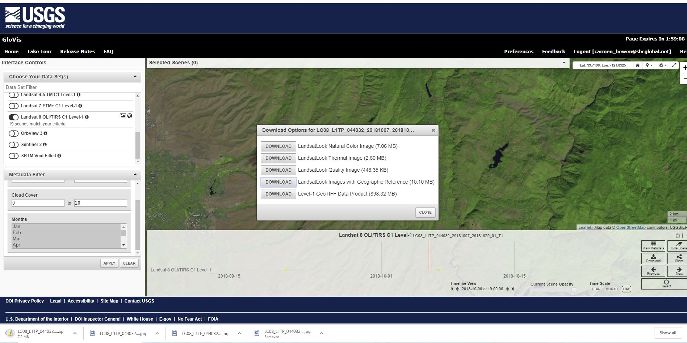

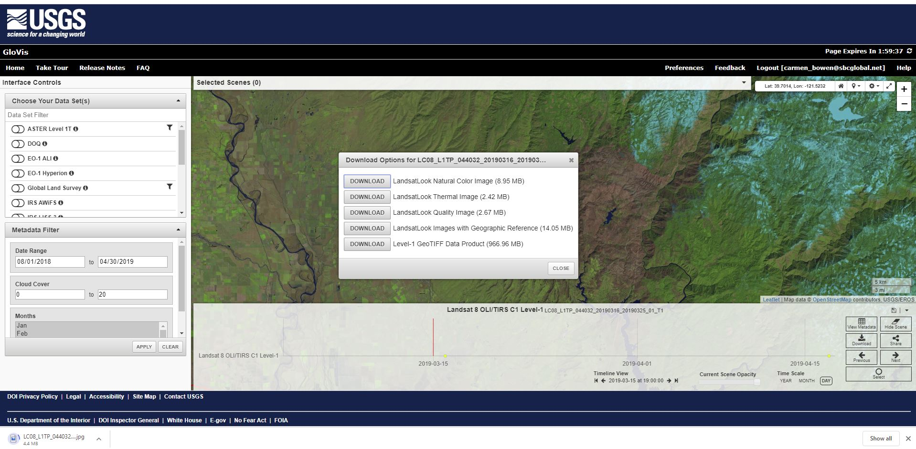

- The author created the Composite Images of Bands 1 through 11 for October 2018 March 2019. The composite images resemble the natural color of the landscape.
Composite image (bands 1 through 11), October 29, 2018

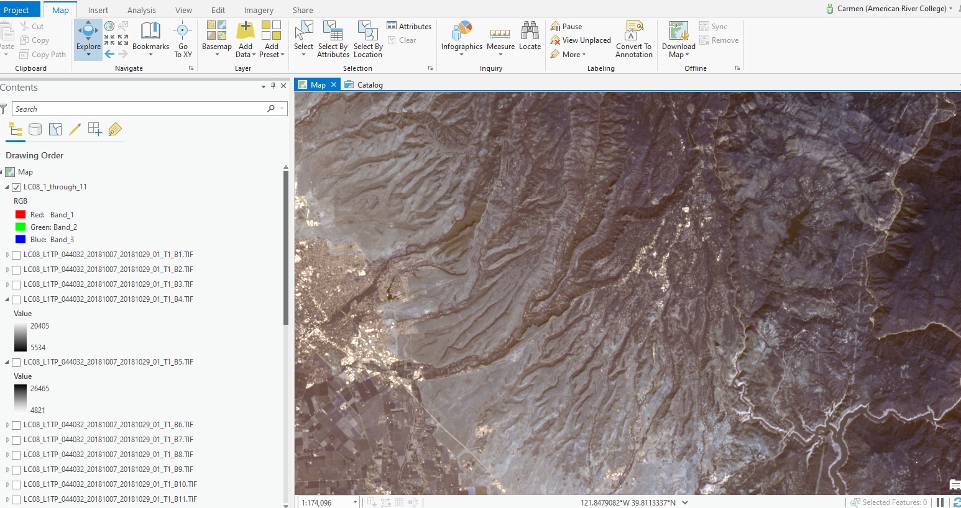
Composite image (bands 1 through 11), March 25, 2019
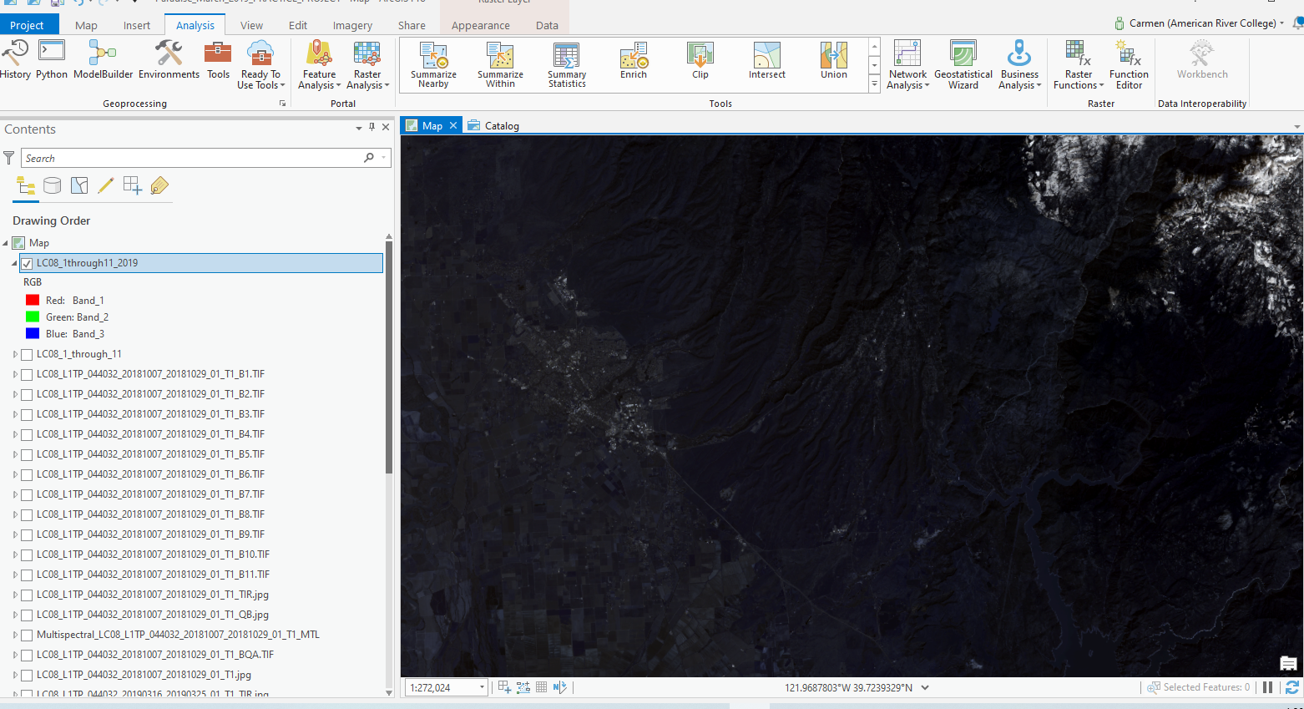
I verified that all 11 bands were captured in the composite image
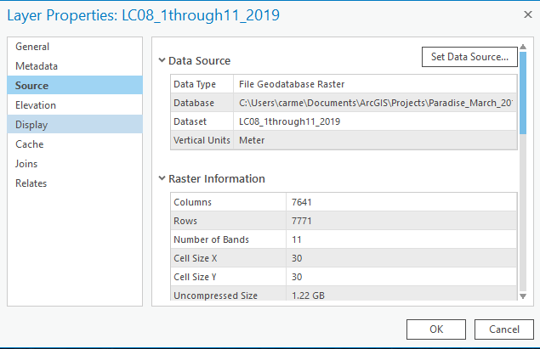
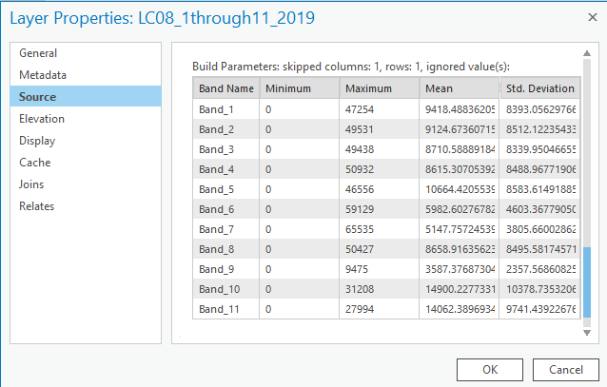

- I changed the composite image to NATURAL COLOR (changed Bands 1 with Band 4, Band 2 with Band 3 and Band 3 with Band 2). The result is an image as seen by the human eye from above.
October 2018 Natural Color image
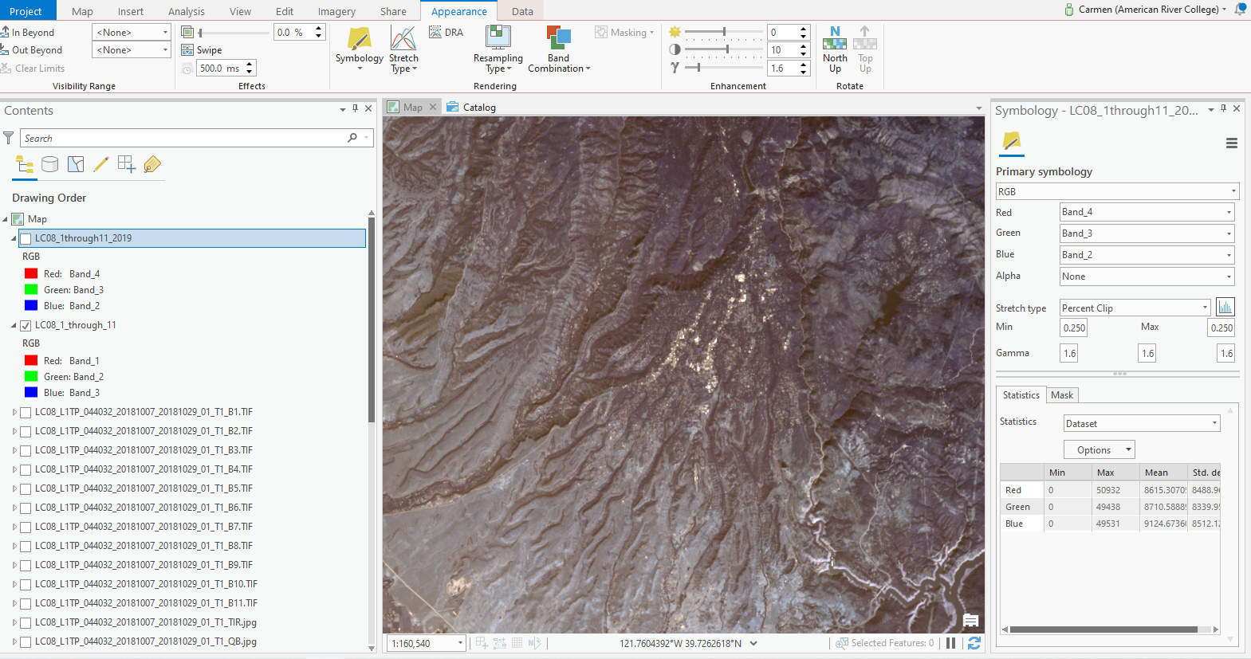
March 2019 Natural Color Image
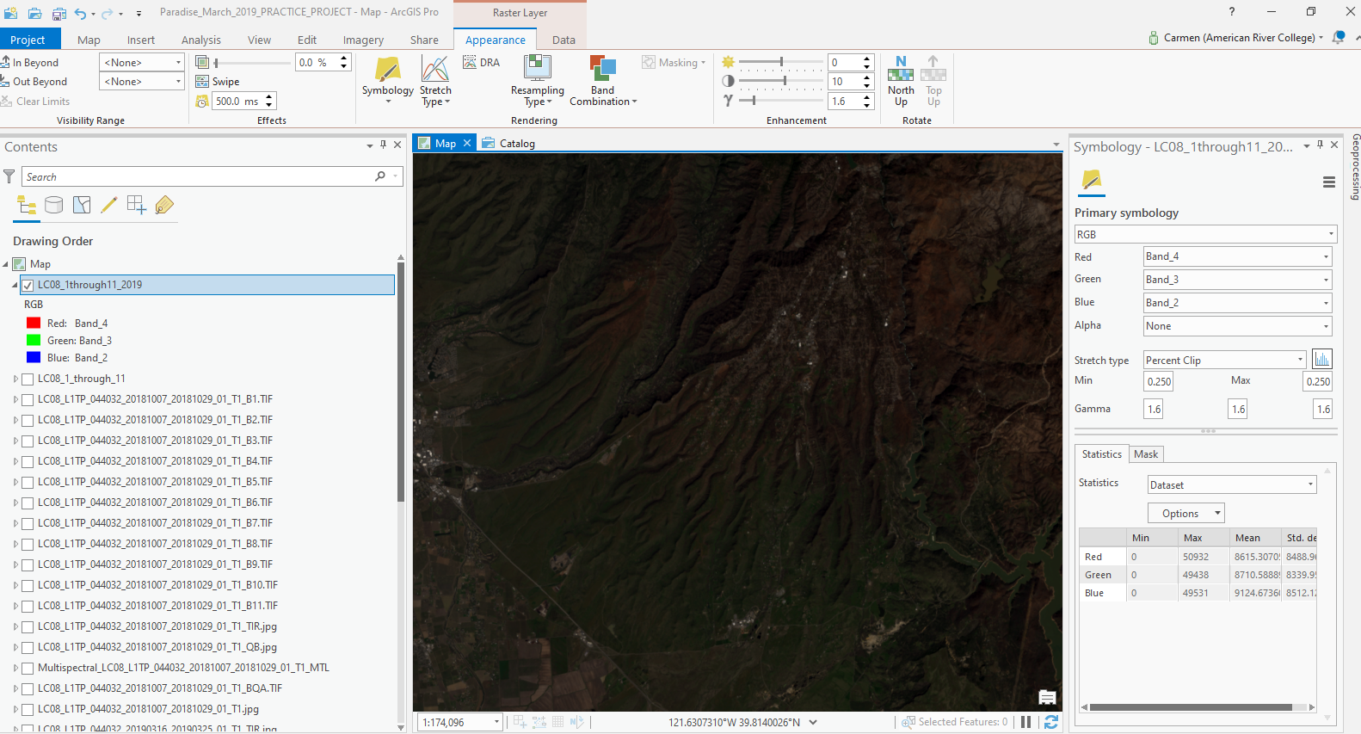

- I Clipped Map to Current Display October 2018
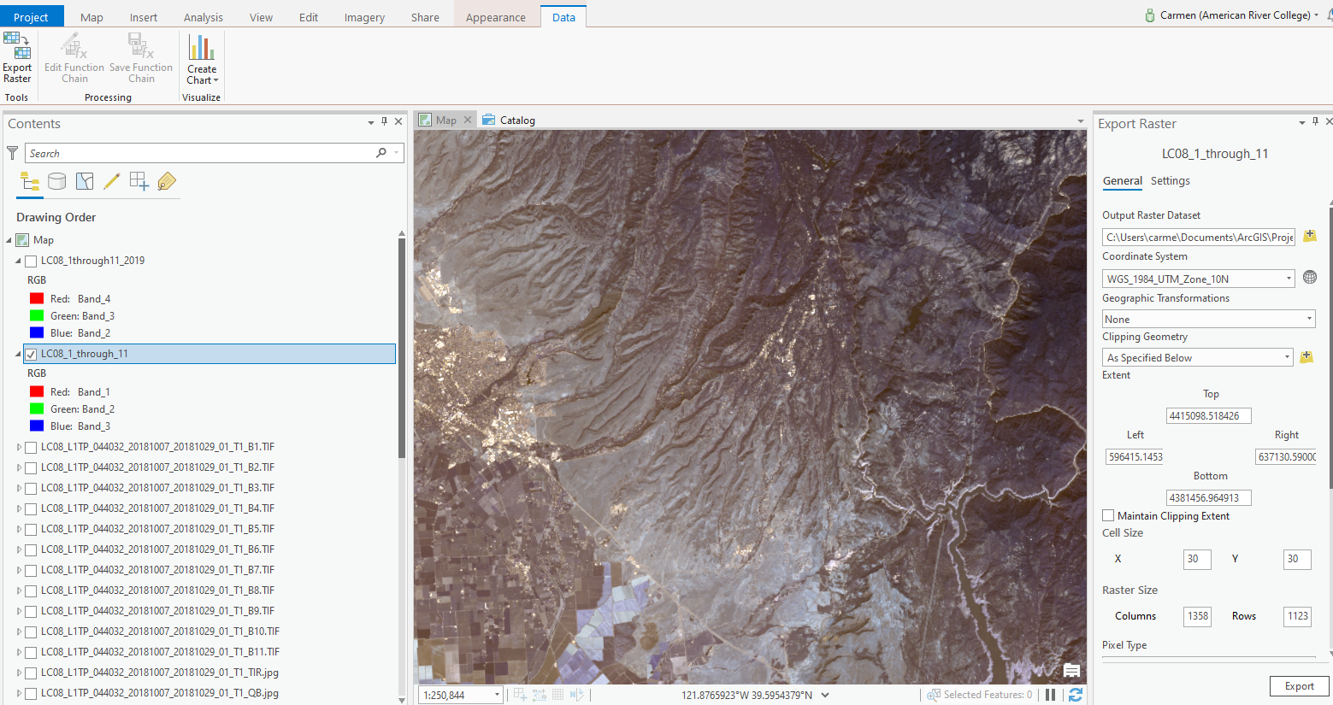
Clipped to Current Display March 2019
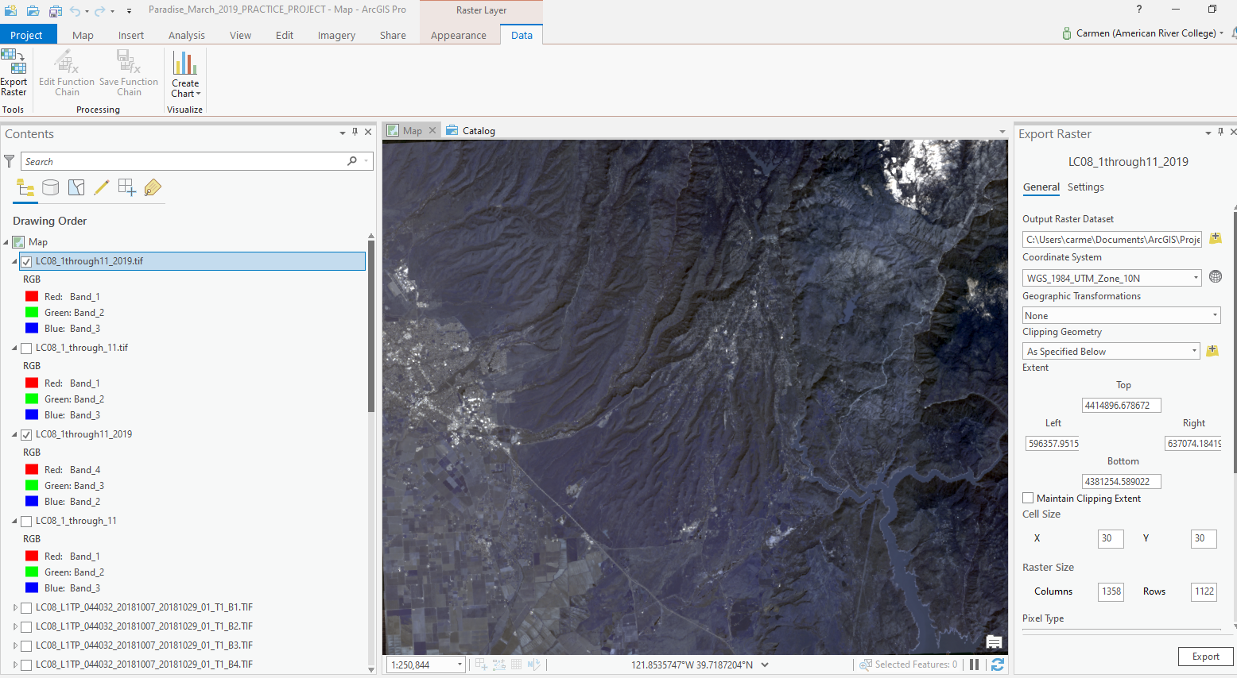

Clipped Image
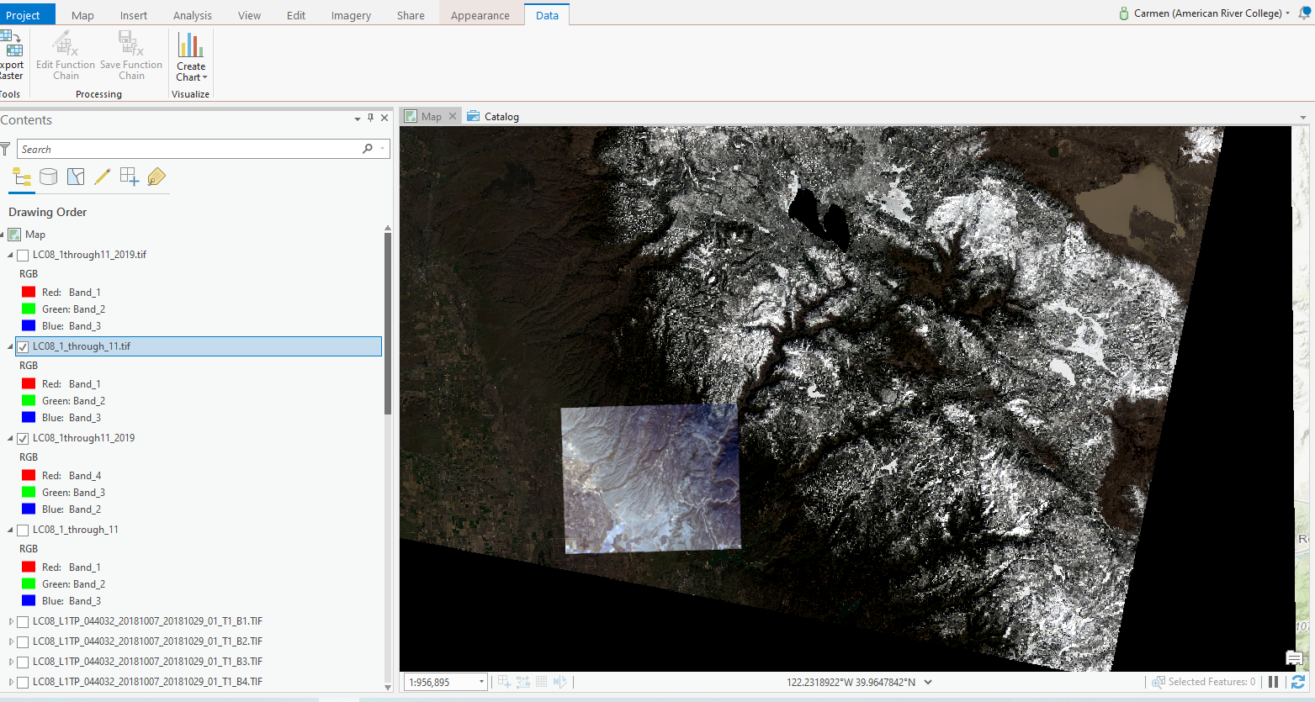
- Creating a Natural Color Band Combination for October 2018 (Input image)
Landsat 8 has Red- Band_4 , Green- Band_3, Blue- Band_2
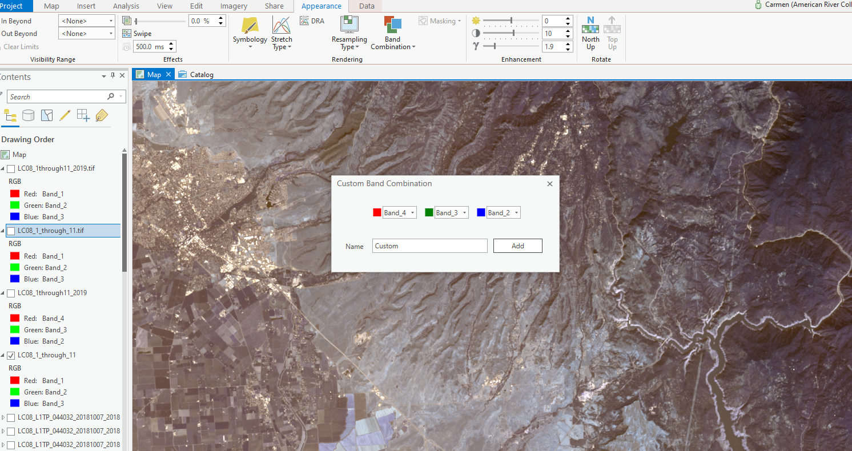

Natural Color Image of Paradise on October 2018 (Output Image)
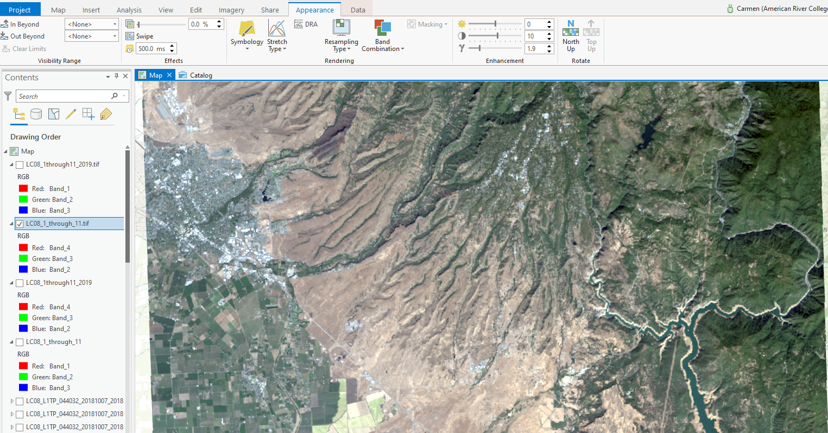

Natural Color Image of Paradise on March 2019
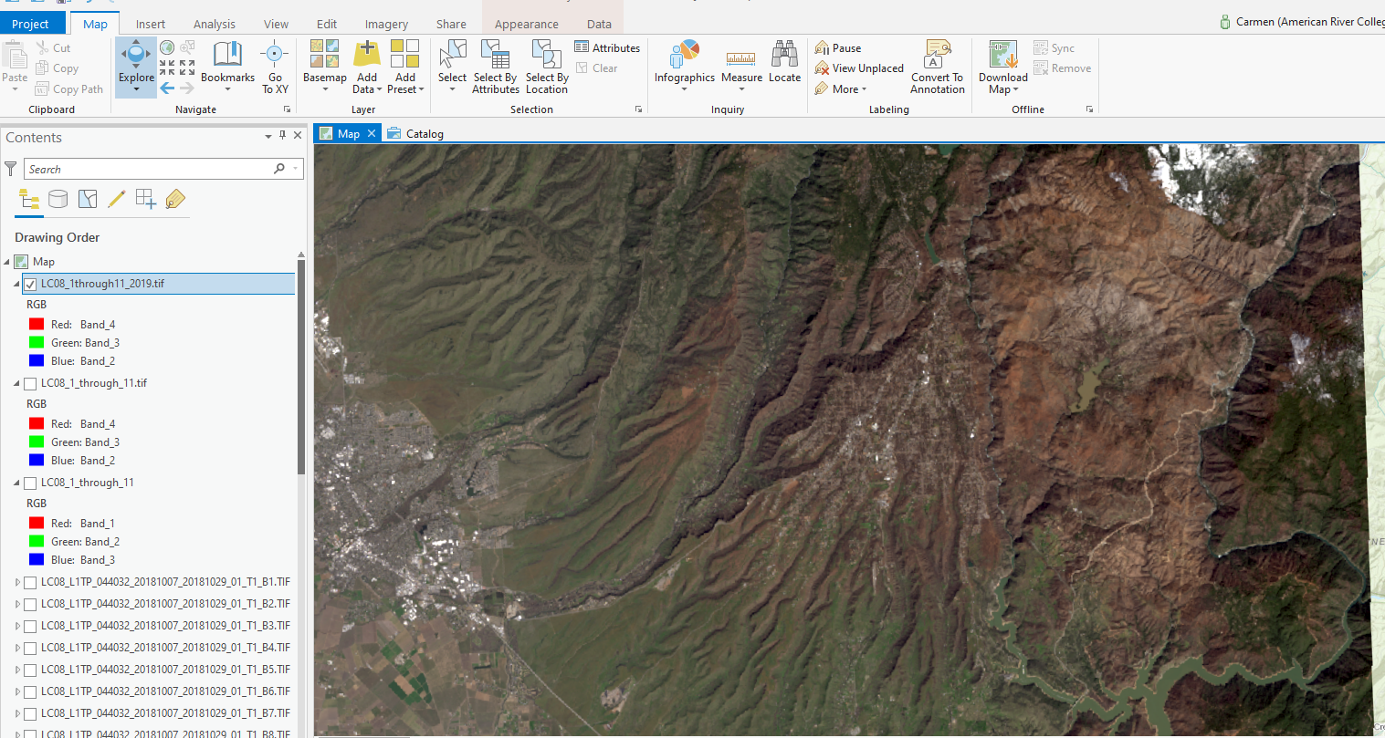
A simple visual assessment of the two images reveals the green vegetation within and around the city of Paradise in October. The March 2019 images shows a significant loss of vegetation in and around Paradise as well as fewer structures in the urban perimeter.
- Creating a Landsat Color Infrared image helps identify the green healthy vegetation, represented by the bright red color. The image is created by preset: Red- Band_5, Green- Band_4, Blue- Band 3
Landsat IR October 2018 (Output Image)
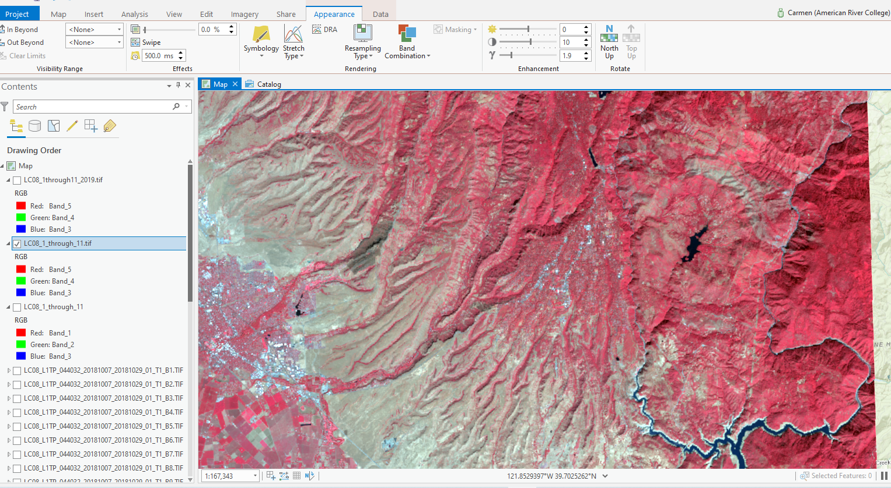
Landsat IR 2019 March 2019 (Output Image)
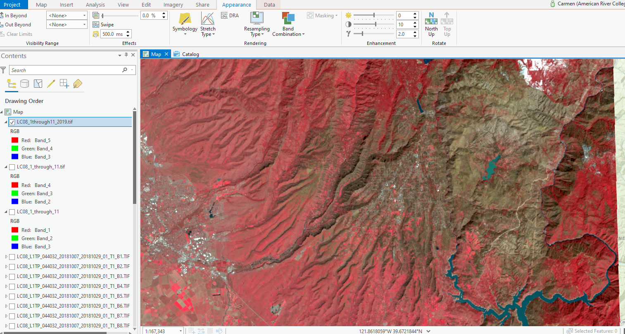
The bright red color indicates healthy, dense vegetation. We must take in account the seasonal differences: in October 2018 the bright red represents the forested area whereas the March 2019 image shows the loss of vegetation in the burned area, but the healthy green vegetation in the south portion of the map is represents green grass, after a rainy season.
The Red and Green bands emphasize vegetation, which can be useful for seeing fires because of the contrast between highly vegetated areas untouched by fire and areas where vegetation has been destroyed by fire. Using another band that emphasizes vegetation, like Near Infrared (band 5), could improve the contrast.
In the infrared image, vegetation appears as red. The fire area appears as dark brown. Compared to the original image, the fire appears more clearly.

- Image Enhancement
In order to better accentuate the contrast between the groundcover before and after the fire, I used some image enhancement methods.

- Radiometric Enhancement
Compare the images before and after Using radiometric enhancement. I chose to change the gamma value for this type of image enhancement. The default value was 1.9 and I changed the value manually to 1.0. The result is increase in brightness of color red, indicating healthy vegetation or the lack thereof. The gamma value controls the amount of contrast between the mid-level gray values of a raster. The intense red is healthy vegetation.
2018- Gamma value = 1 (from 1.9) the red is more intense

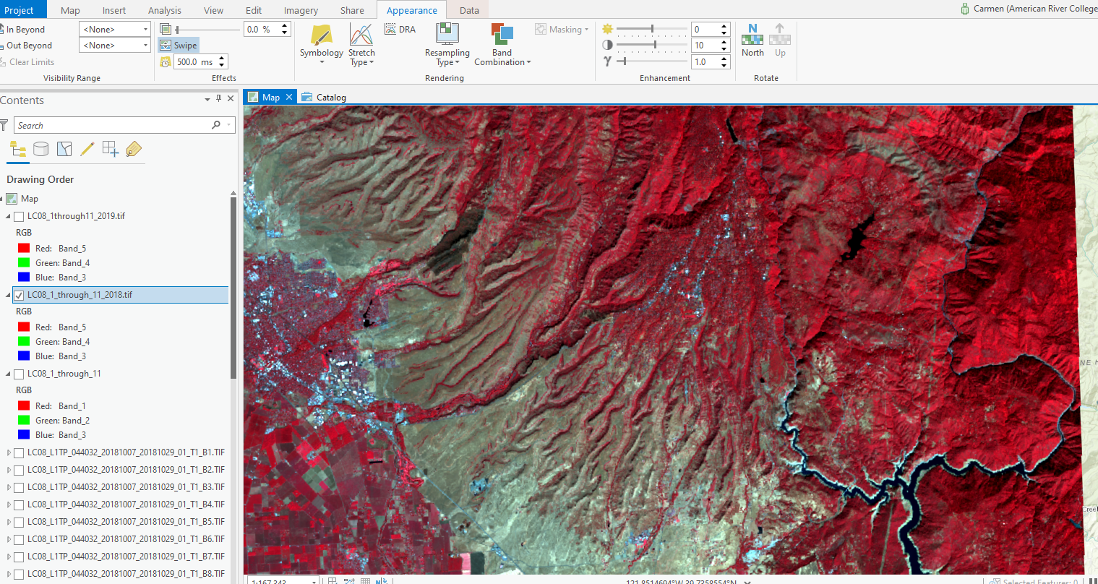
2019- Gamma value = 1 (from 1.9) the red is more intense
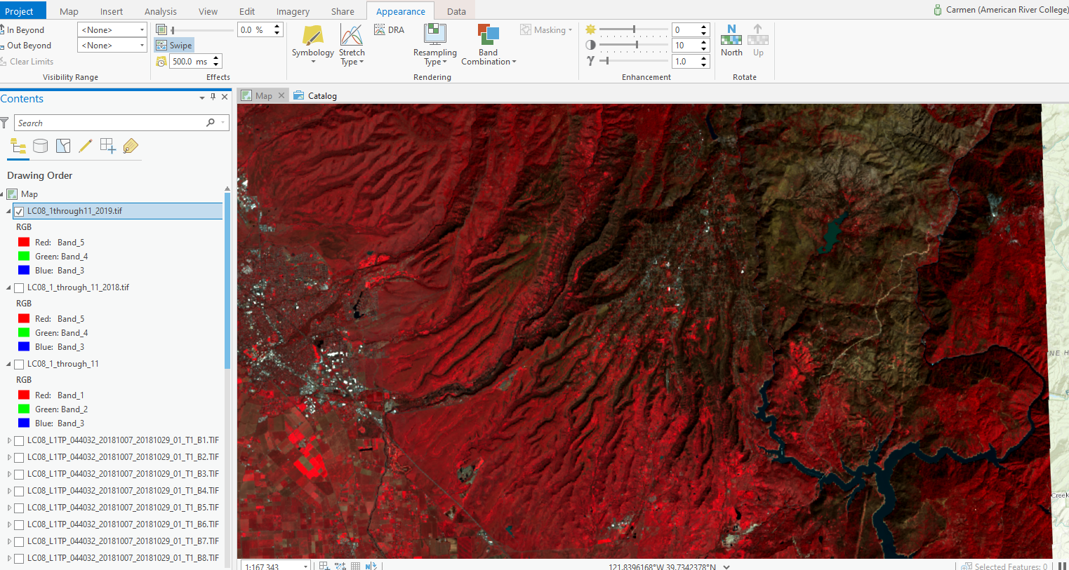
The radiometric enhancement of both images (before and after), accentuates the contrast between the healthy vegetation and the burned area, which appears as a brownish area.

- Spatial Enhancement
Comparing images after using the “FILTER” SPATIAL enhancement analyst tool.
High pass filter enhances images and shows buildings.
2018 High Pass Filter dynamically enhanced image shows many buildings
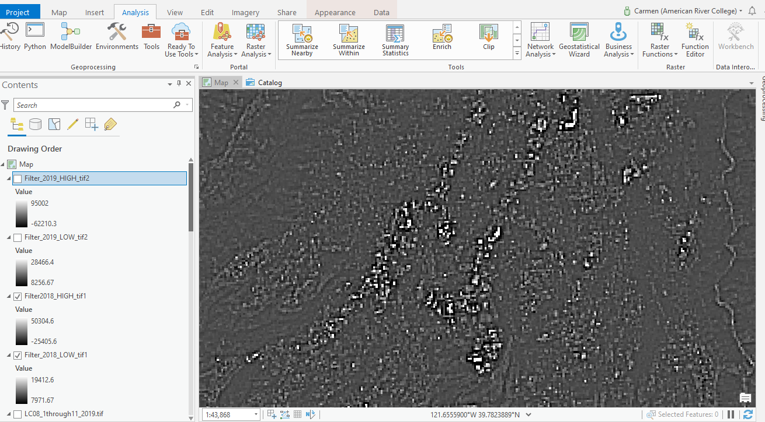
2019 High Pass Filter Dynamically enhanced image shows fewer buildings
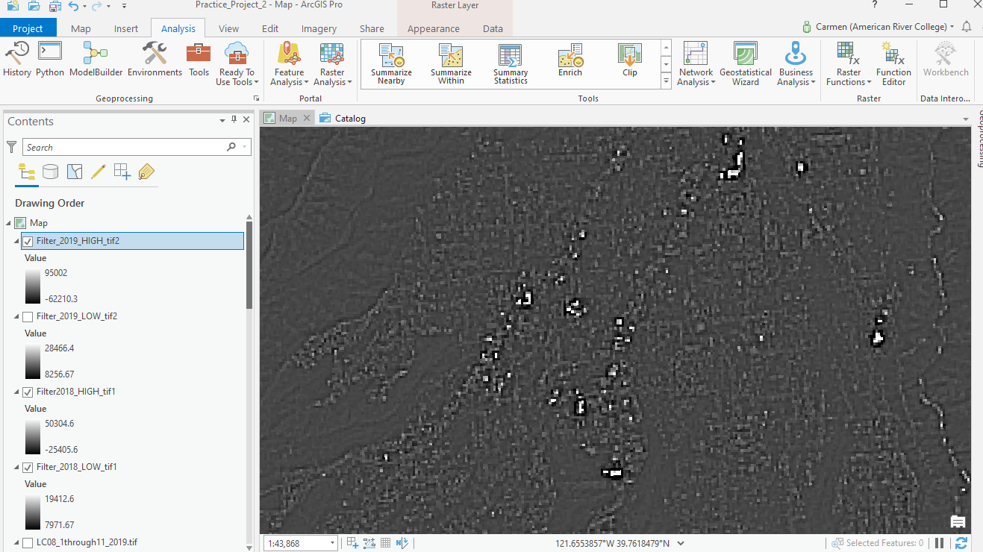
- Spectral Enhancement: NDVI
The normalized difference vegetation index (NDVI) is a standardized index allowing you to generate an image displaying greenness, also known as relative biomass. This index takes advantage of the contrast of characteristics between two bands from a multispectral raster dataset—the chlorophyll pigment absorption in the red band and the high reflectivity of plant material in the near-infrared (NIR) band.
The documented and default NDVI equation is as follows:
NDVI = ((NIR - Red)/(NIR + Red))
- NIR = pixel values from the near-infrared band
- Red = pixel values from the red band
This index outputs values between -1.0 and 1.0.
Input: Natural Color Image of Paradise October 2018
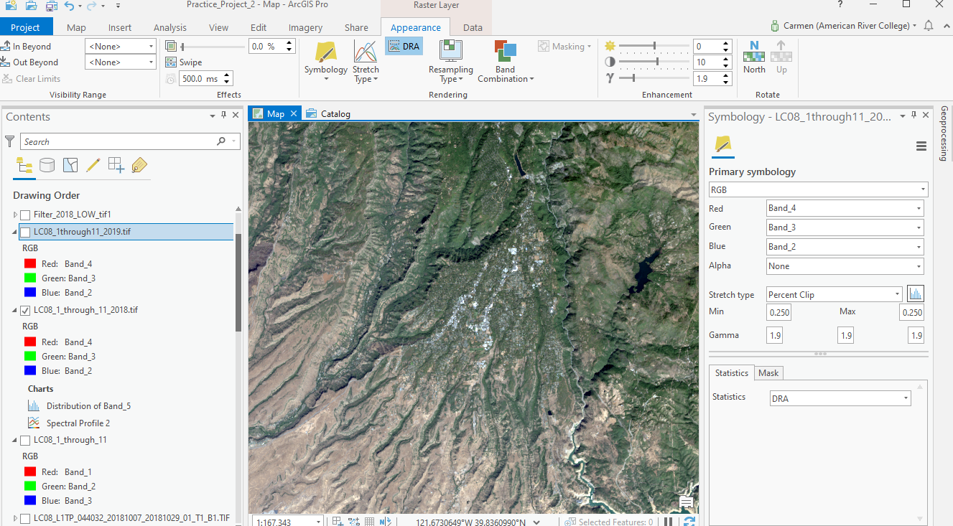

Use Raster Calculator to perform NDVI spectral enhancement (Input)
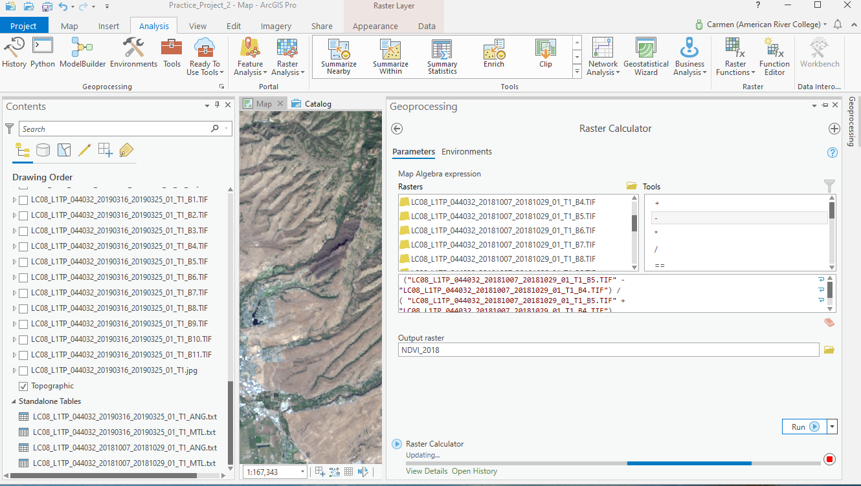
The NDVI result gives pixel values from -1 to +1. The closer to +1, the brighter the pixel. Higher values or brighter images are associated with healthier vegetation.
Analyzing the two images below indicate a healthy vegetation in before the fire, represented by bright, white or very light gray colors. In the post fore image, the dark grays and black indicate the extension of the footprint of the burned area.

October 2018 NDVI image (Output)
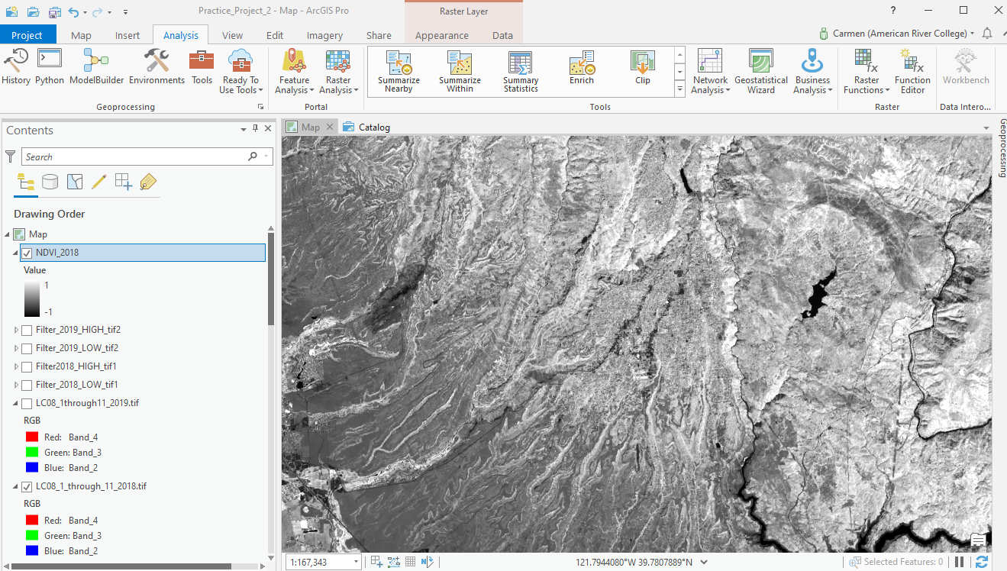
March 2019 NDVI Image (Output)
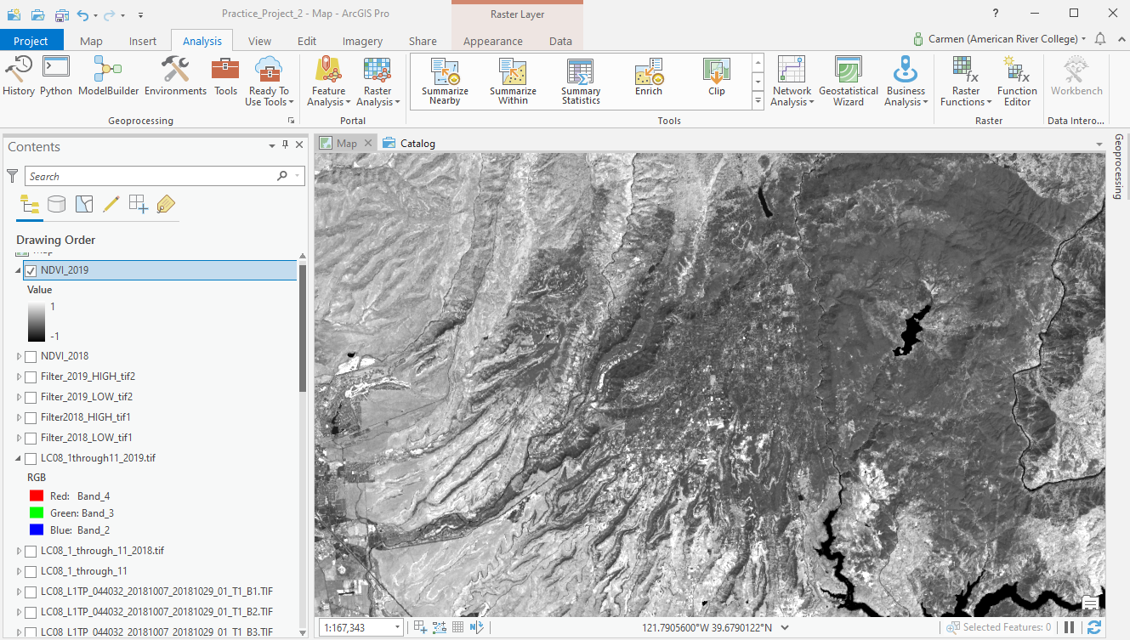
The white in the October 2018 image indicates healthy vegetation and the dark grey in the March 2019 image show the burnt area.
Input for NDVI 2019
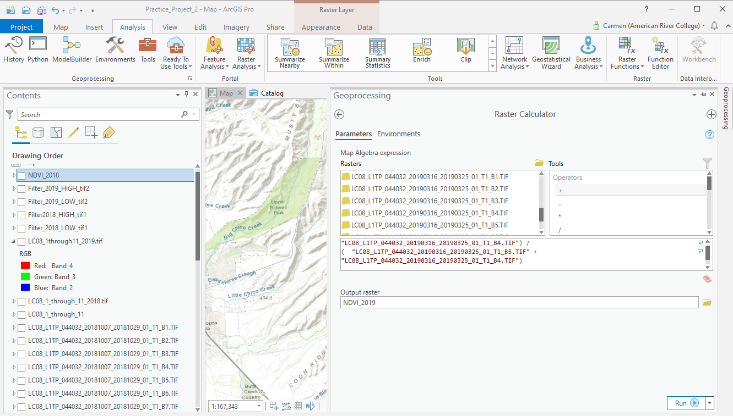

- NBR: Normalized Burn Ratio
In Landsat 8L NBR = (Band 5 – Band 7) / (Band 5 + Band 7).
“The Normalized Burn Ratio is most powerful as a tool to better understand fire extent and severity when used after calculating the difference between pre and post fire conditions. This difference is best measured using data collected immediately before the fire and then immediately after the fire. NBR is less effective if time has passed and vegetation regrowth / regeneration has begun after the fire. Once vegetation regeneration has begun, the fire scar will begin to reflect a stronger signal in the NIR portion of the spectrum because healthy plants reflect strongly in the NIR portion due to the properties of chlorophyll).
For this reason, the NBR ratio works better in areas like the United States where plant regeneration is expected to occur more slowly. In areas like the tropics which are wet and characterized by rapid regrowth, NBR may be less effective.”
(Source: https://www.earthdatascience.org/courses/earth-analytics/multispectral-remote-sensing-modis/normalized-burn-index-dNBR/

NBR: Normalized Burn Index October 2018 Input
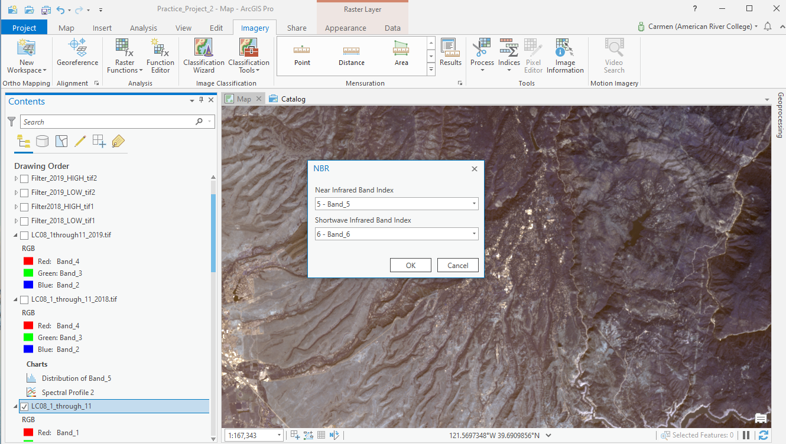

NBR: Normalized Burn Index October 2018 Output
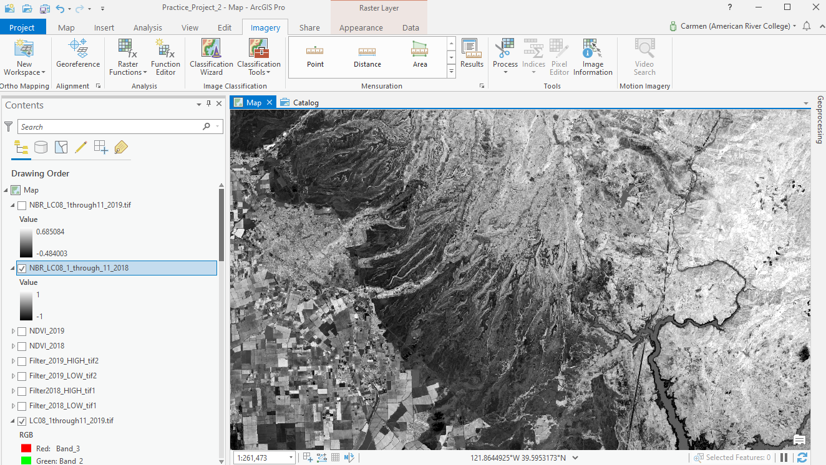
NBR: Normalized Burn Index March 2019 Output
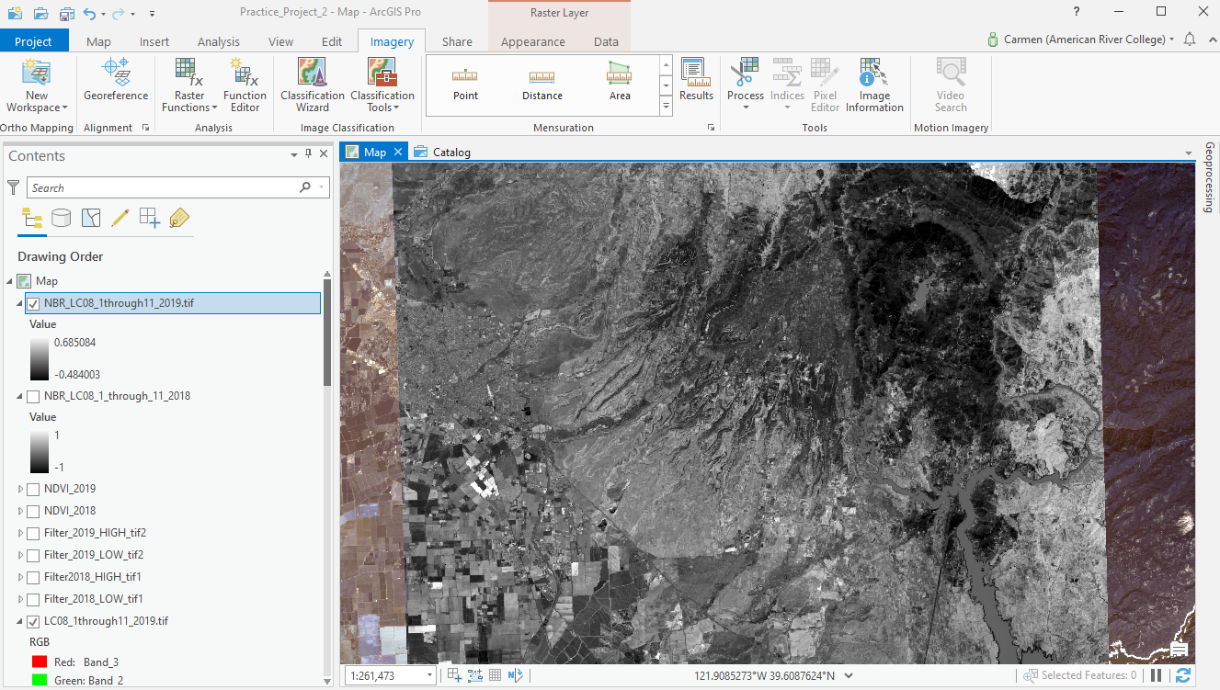

- BAI- Burn Area Index
This index highlights burned land in the red to near-infrared spectrum, by emphasizing the charcoal signal in post-fire images. The index is computed from the spectral distance from each pixel to a reference spectral point, where recently burned areas converge.
BAI 2018 Input:
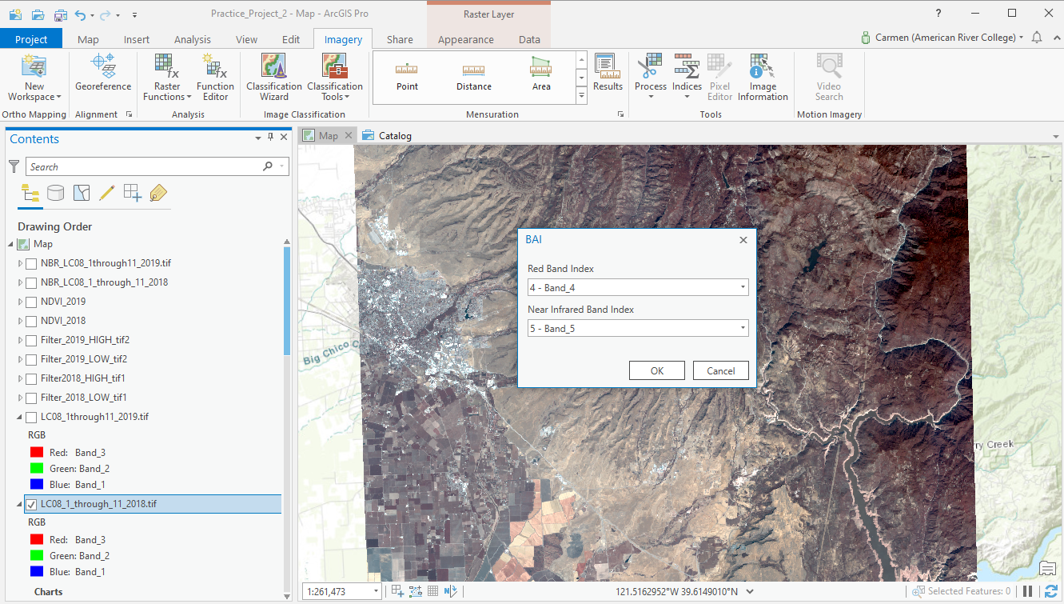

October 2018 BAI Output
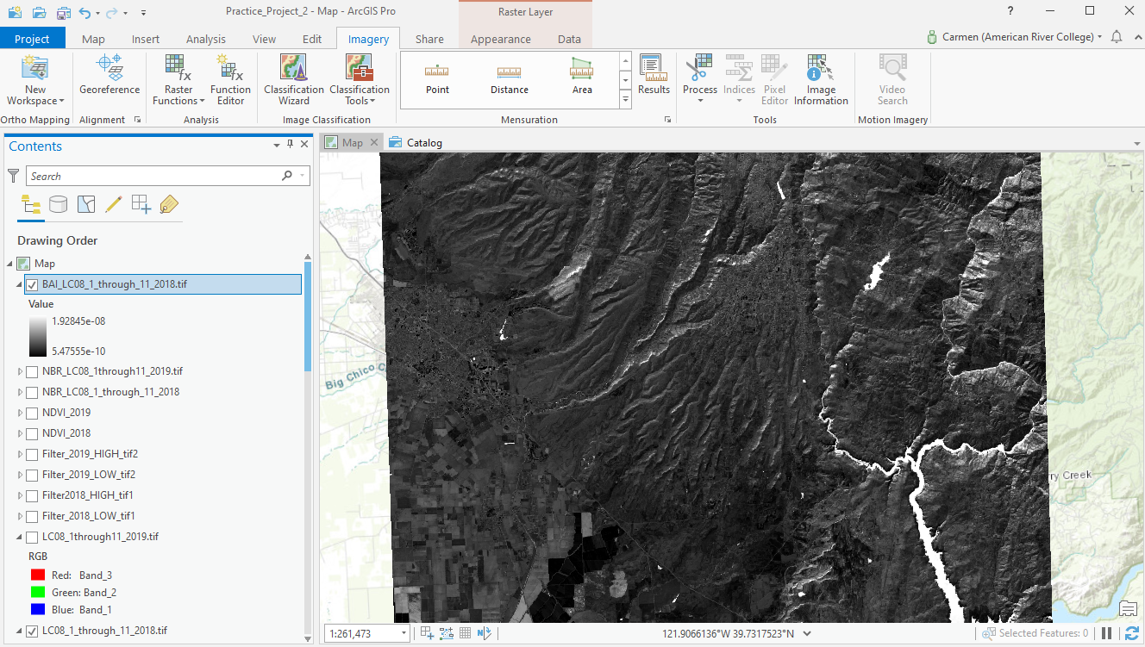
March 2019 BAI Output
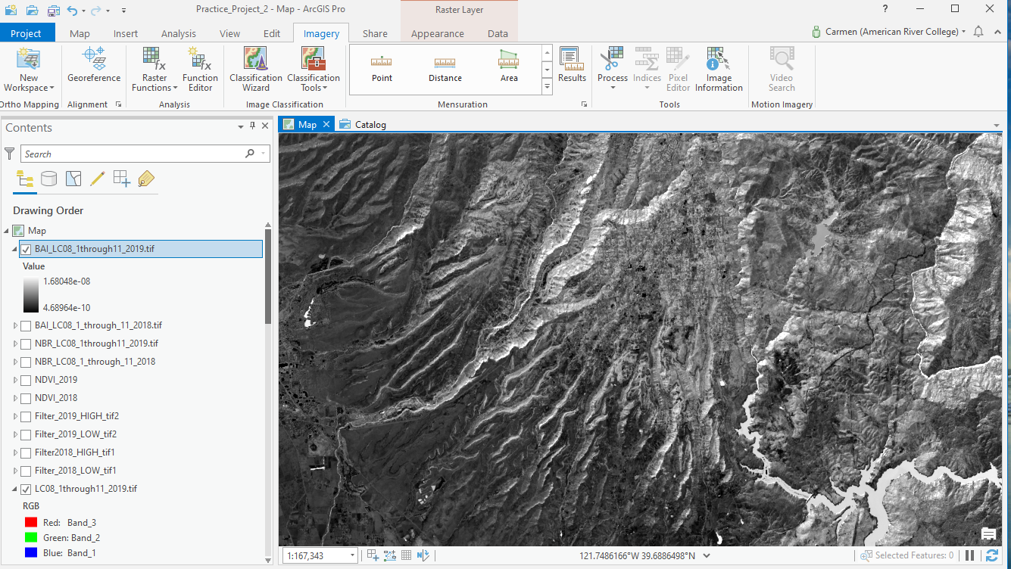

Determine change in NBR (Normalized Burn Ratio)
I used the Raster Calculator tool to calculate the change in NBR between the two images. In doing so, I removed values for areas that were not burned between 2019 and 2018, showing only the burn areas and removing everything else from the image.
In order to find the change, or difference, between the two NBRs, I subtracted the post-fire (2019) NBR from the pre-fire (2018) NBR.

Using Raster Calculator to find the change in NBR
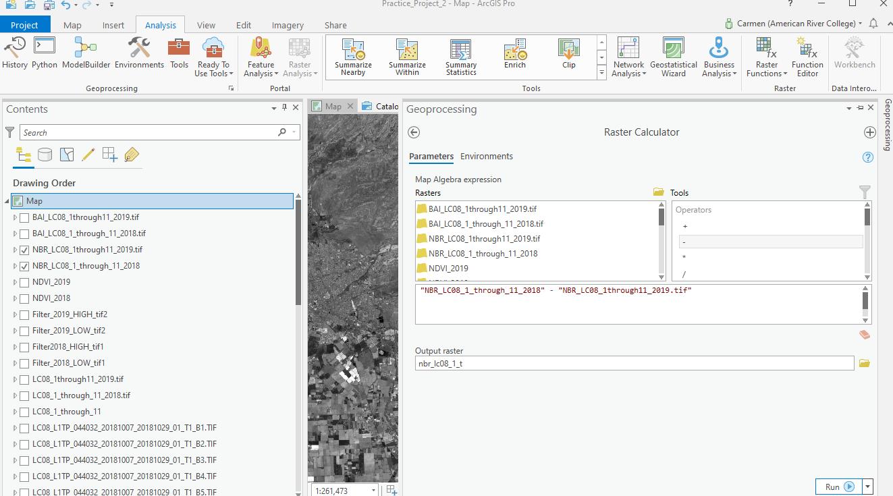

The fire locations now appear almost solid white, contrasting strongly against the gray and black areas around them. The only other white areas are the snowy mountainous areas, which are generally not conterminous with the fire areas. You can heighten the contrast by symbolizing the image.

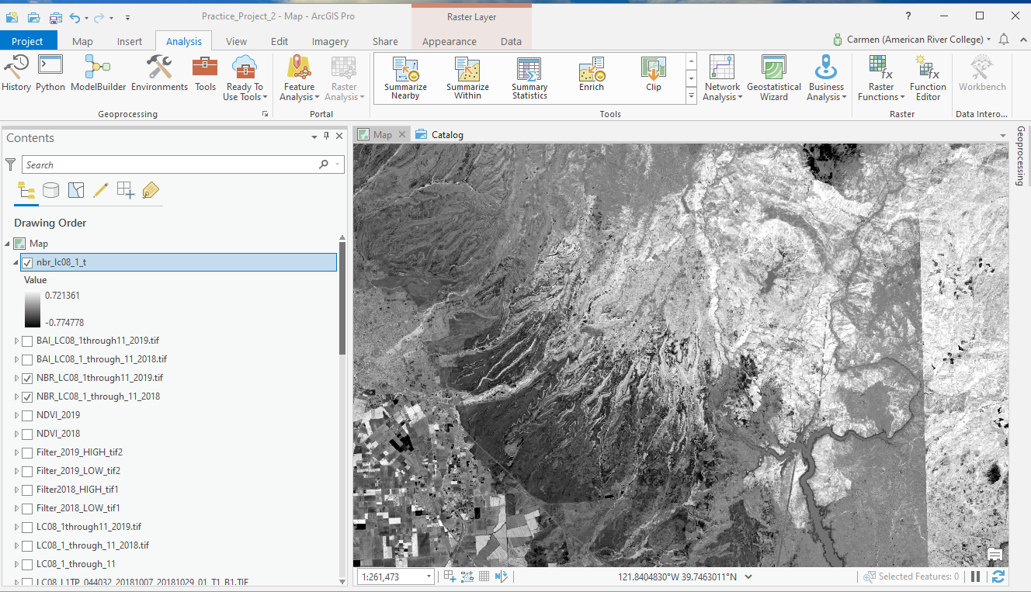
The next step is to change symbology for the map above, by changing the color scheme so the result is easier to interpret. In the Symbology pane, next to Color scheme, I chose the Condition Number (green to red) color scheme.
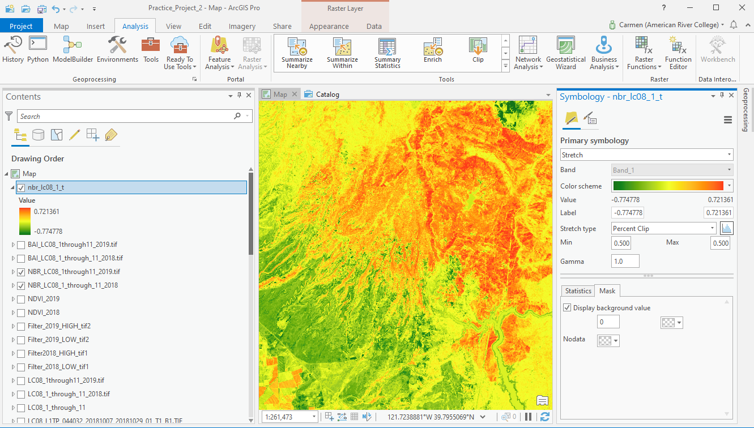
With the color ramp Green to Red, the footprint of the burnt area appears bright red and surrounding areas appear yellow and green.
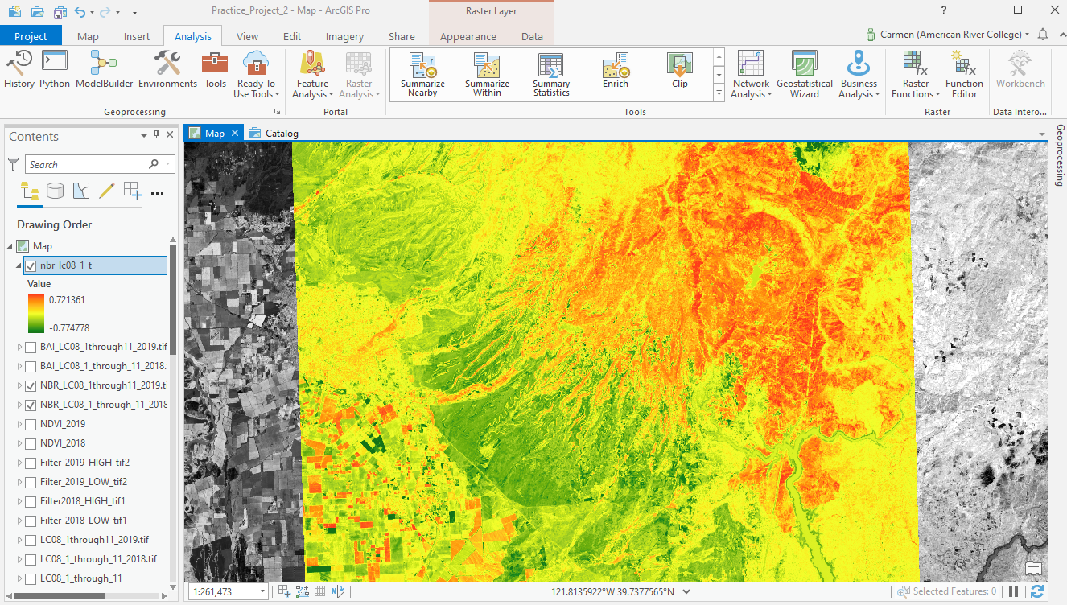

Finding the NBR difference between after the fire and before the fire map : Nbr_2019 – NBR_2018
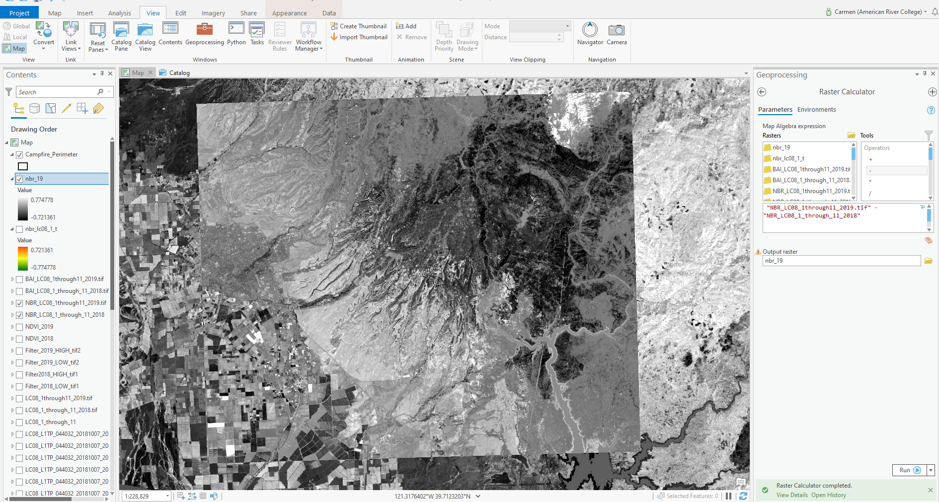
NBR 2019- NBR 2018 image

Digitizing the Burnt Area
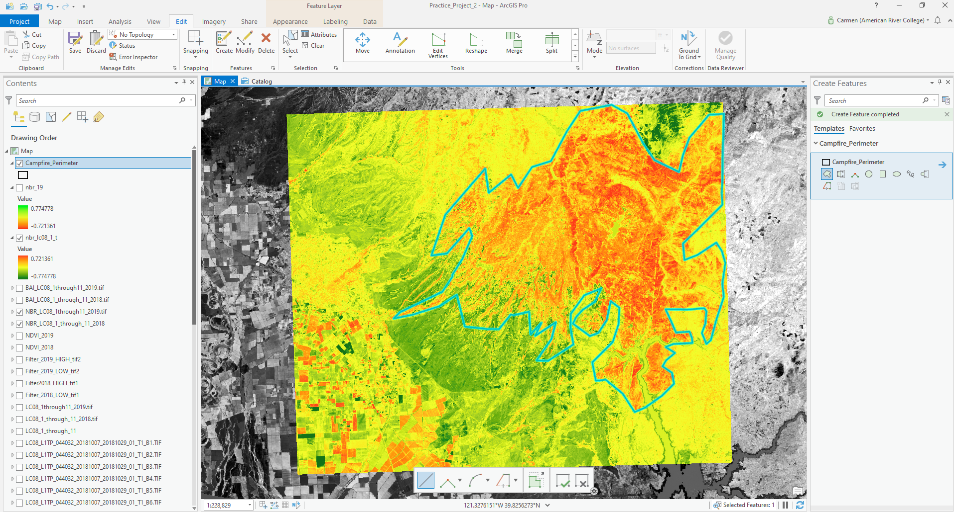

Burnt Area Perimeter
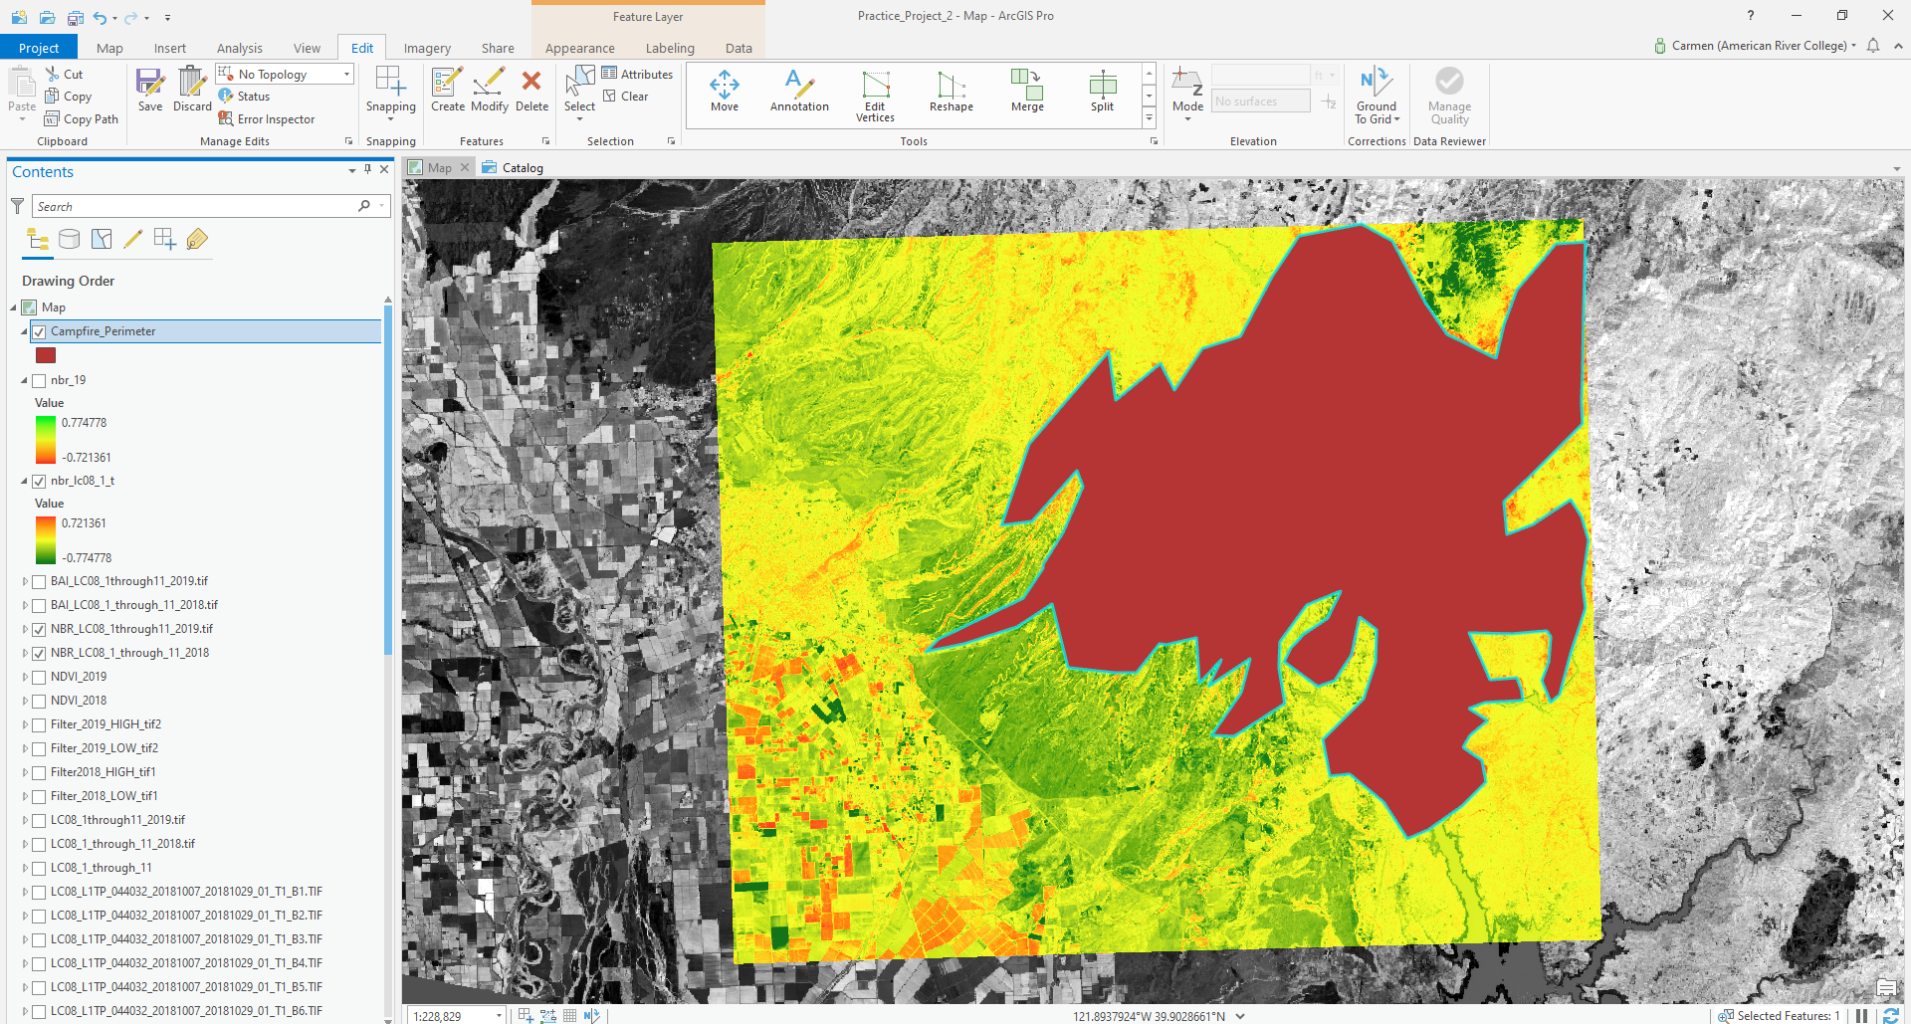

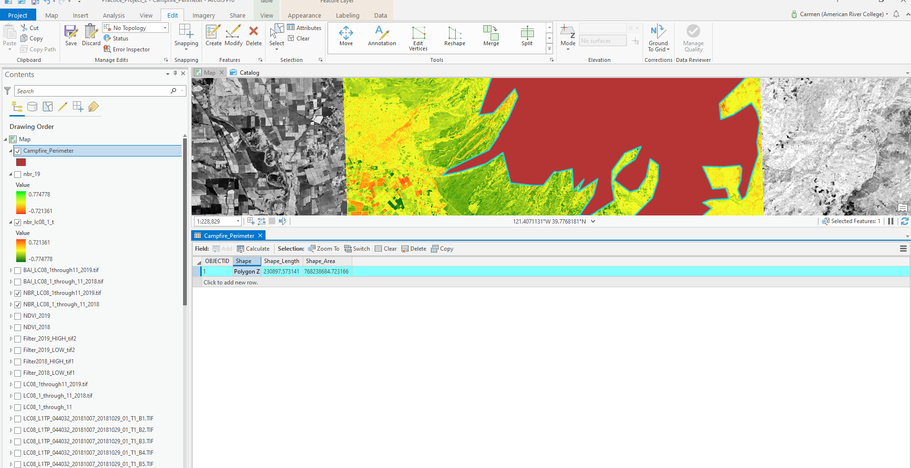

In the Attribute Table the burnt area appears in square meters: 768,238,684.72 m²
768,238,684.72 m²/ 4047 m²/acre=189,836 acres
Official data show an area of 154,000 acres. The difference between the results the author obtained in the project and the real data is considerable and this is because the digitizing was completed as an “exercise”, with few vertices.

Conclusions
The project achieved its intended purpose, to use multiple Landsat image processing tools and methods and compare images before and after the Campfire. Some of the image processing methods used in the project are: crating a composite image, a natural color image, an IR image, NBR (Normalized Band Ratio) image, a BAI (Burn Area Index) image and lastly, an image which shows the change in NBR between the two datasets.
All images emphasize the differences in groundcover before and after the fire.
Some of the Issues I ran into while completing the project were:
- Using the wrong syntax in the raster calculator, while trying to compute NDVI (see below). After carefully repeating the process, I was able to run the tool correctly.

Calculating NDVI 2018
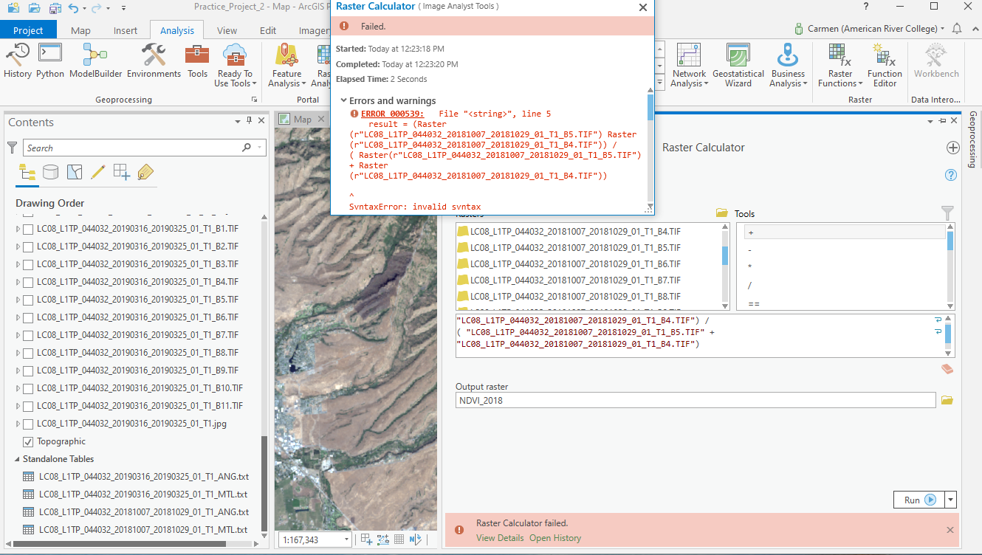

- Using ArcPRO has been a great learning experience but it seems to have issues which will slow down the user. The pointer was stuck multiple times on the “rotate” or panning tool. As I tried the swipe function between two superimposed images, I could never get out of the “swipe” mode. Each time I had to close the project and reopen it or in two instances I had to turn off /on the computer.

Resources:
- Parece, Tammy et al. Remote Sensing with ArcGIS Pro. Virginia Geospatial Extension, 2019
- https://erdas.wordpress.com/2007/12/30/4-band-ratios/
- https://pro.arcgis.com/en/pro-app/help/data/imagery/indices-gallery.htm
- https://www.earthdatascience.org/courses/earth-analytics/multispectral-remote-sensing-modis/normalized-burn-index-dNBR/
- https://www.arcgis.com/apps/MapSeries/index.html?appid=af7e5bb3960a48c096ed910c640a30b3

