Creating a Map Book Series-Exercise

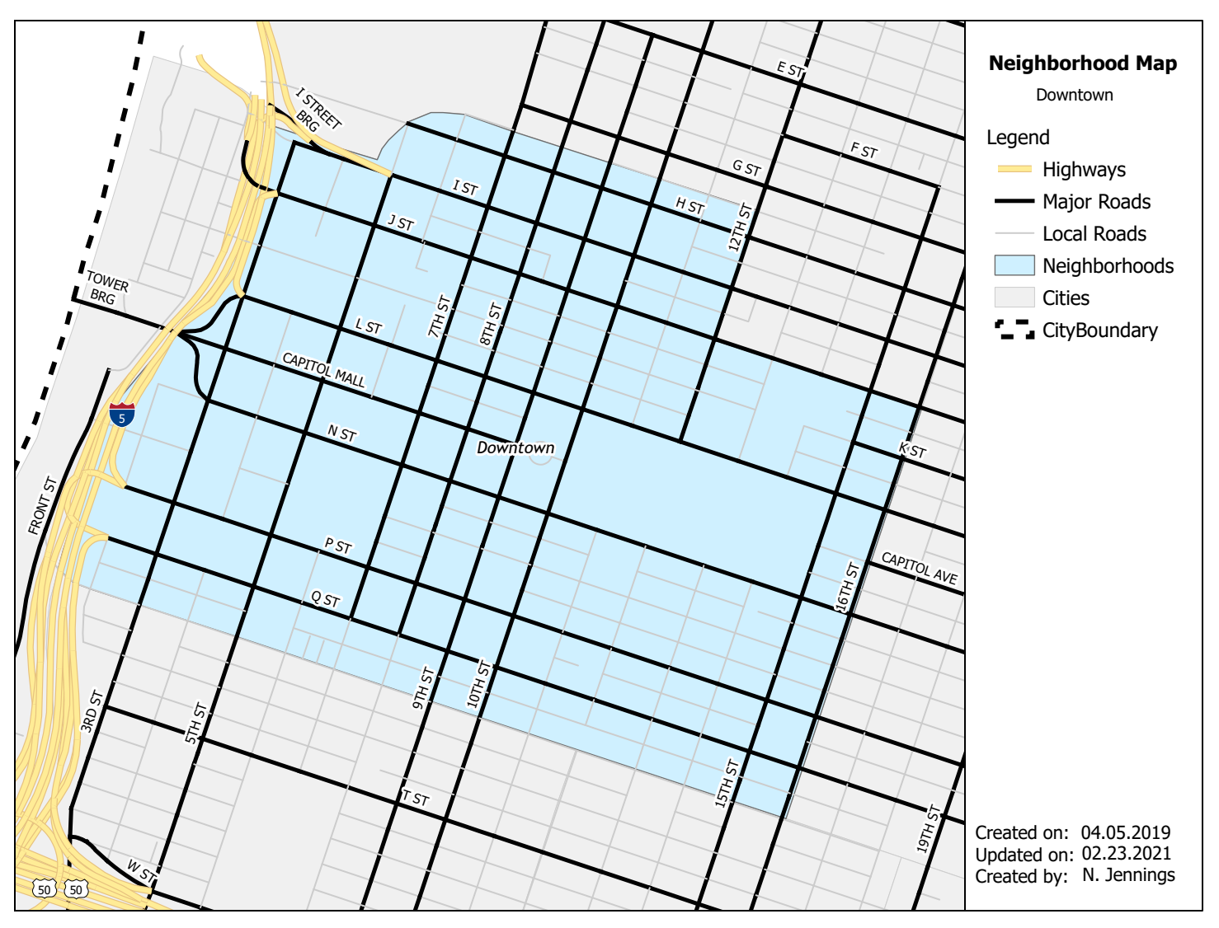

Nathan Jennings
Created on: 02.21.2021
Updated on: 02.23.2021
Contents
Overview 3
Review the Pro Project 3
Create Variables 5
Setup try: Block and other Map Component Variables 6
Set up a Layer List for Processing 6
Bonus Section (optional) – Add the City Boundary Layer File 7
Set up the Search Cursor for the Neighborhoods Layer 7
Setup the Loop to Process each Neighborhood 7
Access the Row and Process the Map Components 8
Get a List of Text Elements to Process 9
Bonus Section (optional) – Modify Additional Text Elements 10
Setup and Export to PDF 10
Add the Exception Block 10

Overview

This exercise will use the MapBookProduction.aprx Pro project file that contains pre-configured data and map elements.
The project file is in the same folder as the ProMapModule.aprx. These are contained in a separate zip file called ProMapModule.zip which can be found within the Chapter9_DemoScriptsandData.zip file.

A map tab and layout tab exist. The layout contains a single map frame.
Using these instructions, the accompanying Jupyter notebook, and Map_Book_Produciton_StumpCode_v3.py stump code file, complete a script that automatically generates a unique Neighborhood Map for each neighborhood from the neighborhood feature layer in the using a pre-configured Pro Project map layout.
Some of the code is already provided. Where comments exist with explanation (in-line), in Jupyter, and/or this document, the code developer will need to add lines of code.

Review the Pro Project

It is recommended to review the MapBookProduction.aprx Pro project file, data, layout, and map elements before writing code. Pay close attention to layer in the map tab (note the Neighborhoods layer is in the Detail Map group layer) and the map elements in the layout tab.

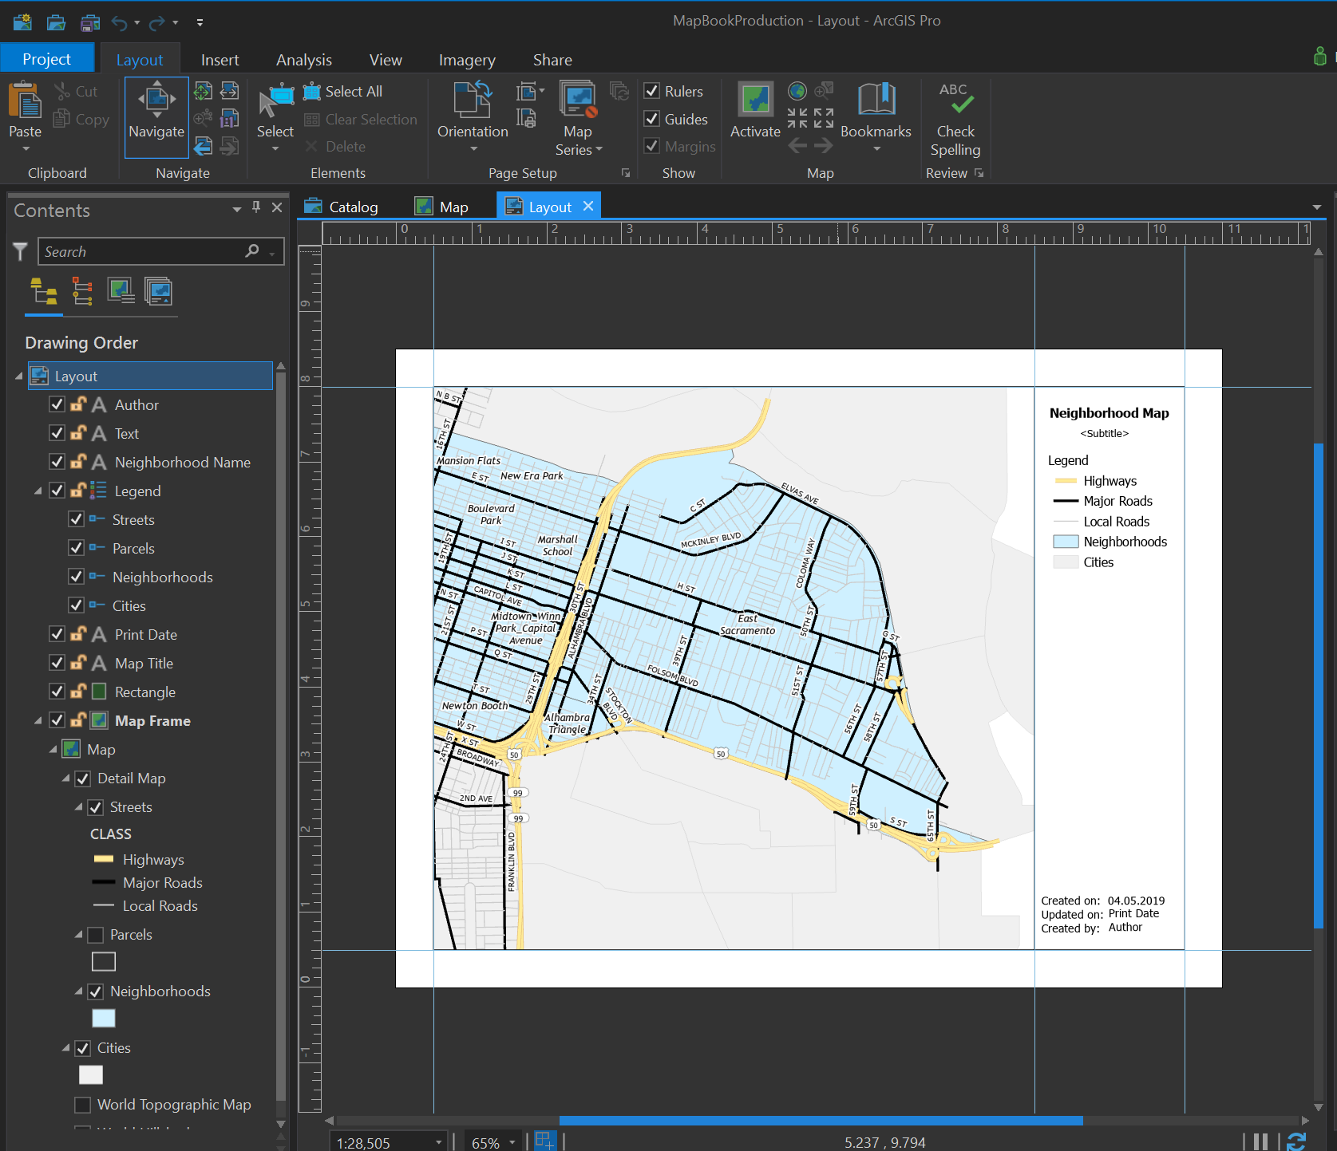

Also, note the path of the City_Boundary.lyrx. This file is used as a “Bonus” section (optional) of the code. The path below may be different than yours. The instructor’s path sis shown below once the ProMapModule.zip file was unzipped.
C:\Users\Nate\Python\Chapter9_DemoScriptsandData\Chapter09\ProMapModule\ProMapModule

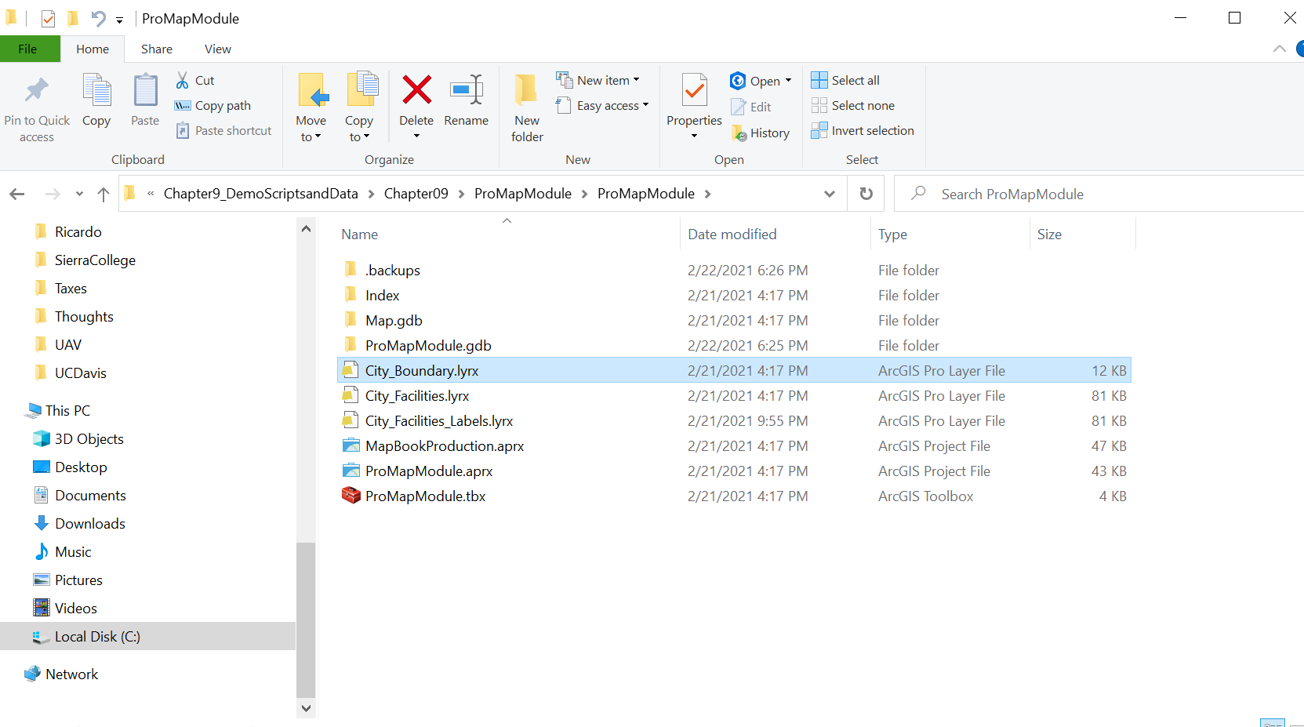

Create Variables

Like other scripts, start with a section of variable definitions. For this exercise, there are only a couple that exist outside of the try: block.
import arcpy, sys, traceback, datetime

author = "N. Jennings" # Change this to your name

# reformat date to MM.DD.YYYY
# NOTE: using a lowercase %y will result in MM.DD.YY format
# See Python.org or text regarding the datetime module

CUR_DATE = datetime.date.today().strftime('%m.%d.%Y')

Setup try: Block and other Map Component Variables

This section shows a few more variables defined within the try: block. These are placed here because I want to check for any errors in the data paths and listing routines, if there are any. As usual, folder paths for input and output locations need to be changed based on the developer’s data locations.

try:

# Use the preconfigured MapBookProduction.aprx Pro project file

# change the paths as needed to run the script form a local system
# Pro project path
ppath = "C:\\Users\\Nate\\Documents\\ArcGIS\\Projects\\ProMapModule\\"

# output for PDFs. Change as desired.

mappath = "c:\\temp\\"

# assign the pro project file to a variable
aprx = arcpy.mp.ArcGISProject(ppath + "MapBookProduction.aprx")

# get a list of Maps that contain layers
# [0] inicates the first (or only map from the map list, in this case)

maplist = aprx.listMaps("Map") [0] # the name of the Map tab is "Map"
layout = aprx.listLayouts("Layout")[0] # the name of the Layout tab is "Layout"

# the name of the map frame in the layout is "Map Frame"
mapframe = layout.listElements("MAPFRAME_ELEMENT", "Map Frame")[0]

Set up a Layer List for Processing

A list of layers needs to be created so that layers can be processed; in particular, the Neighborhoods layer.
# get a list of layers
for TOCLayer in maplist.listLayers():

print ("Layer Name " + str(TOCLayer.longName))
if TOCLayer.longName == "Detail Map\\Neighborhoods":
print ("inside TOC")
NHLayer = TOCLayer # Assigning the specific TOCLayer
# in this case the neighborhood layer to
# the variable NHLayer

Bonus Section (optional) – Add the City Boundary Layer File

A “Bonus” section is provided, for those who care to add the City_Boundary.lyrx file noted above. See the Jupyter notebook and the stump code script for more details.
Only 2 lines are required:
- The full path to the .LYRX file
- Write the line to “add” the layer to the Map (i.e. using the maplist variable)

Set up the Search Cursor for the Neighborhoods Layer

This is provided for you. Note the layer name (which is created above) and the field_name list that contains only one value the “NAME” field.

# Create a search cursor on the NHLayer

field_name = ["NAME"]
with arcpy.da.SearchCursor(NHLayer, field_name) as NHrows:

# !!!! indent here (because of the "with" statement)

Setup the Loop to Process each Neighborhood

Once the Search Cursor is created, a for loop is used to iterate over each neighborhood record.
# Create a for loop to loop through the individual rows
# of the neighborhood layer.

for NHrow in NHrows:

Access the Row and Process the Map Components

Another “indentation” here.
After creating a variable to store the neighborhood name (NAME field) the following will be accomplished. See the Jupyter notebook and in-line commentary.
1. The NAME of the neighborhood will be obtained (read from the neighborhood layer)
2. A query will be created such that

query = """ "NAME" = '""" + NHName + """'"""

3. The query will change the defintionQuery property on the neighborhoods layer
4. The extent of the will be "gotten" (i.e. use the getLayerExtent) from the neighborhoods layer
5. The mapframe will be "set" using setExtent
6. The mapframe scale will be adjusted by a multiplier of * 1.1

Get a List of Text Elements to Process

Once the various map components are processed, the text elements can be processed. They, too, are part of an individual neighborhood map.

Generate a list of “text” elements then use a for loop to process the various text elements. This is a good place to make sure you know what the different map elements are, what their element names are, and the text properties they contain by default. Many of these will be changed programmatically in this section.
Do the following for each text element in the list:

Make sure to use if statements correctly in this section.

- Change the "Map Title" (text element name) text property (i.e. the value that shows up on the map) to 'Neighborhood Map'
  - Set the elementPositionX = 8.7
- Change the "Neighborhood Name" (text element name) text property to the name of the specific neighborhood.
  - Change the elementPostionX = 9.1

(Remember, use the variable NHName...the variable that contains the name for each neighborhood defined above...Also remember, this part of the script is at the same indentation level as the above lines....we are still operating on a given "rown" in the Search Cursor of the neighborhood layer).

- Change the "Author" (text element name) text property to the author variable defined above with "your" name (i.e. the student's name).
- Change the "Print Date" (text element name) text property to the CUR_DATE variable. NOTE: the CUR_DATE will need to be "cast" as a "string" when assigned to the text property.

Bonus Section (optional) – Modify Additional Text Elements

Within section for making changes on the Neighborhood name text element set up a condition that checks if the neighborhood name is:

'Midtown_Winn Park_Capital Avenue' (just as it is spelled out).

If it does, change the elementPositionX to 8.55

# Create a list variable of the layout elements that are "text" elements.

tElements = layout.listElements("TEXT_ELEMENT")

# Within the loop over the search cursor rows, create another
# for loop over the text elements. The following should be used.

for tElement in tElements:

See the Jupyter notebook and in-line commentary in the stump code script file for more details.

Setup and Export to PDF

The last section of the script sets up the process to “export to PDF.”
The script will be “out-dented” to the same level as the text elements for loop.
Like other scripts that produce output, check to see if the output PDF map exists and delete it if it does.
Use layout.exportToPDF() routine to generate the PDF files. NOTE: “layout” is the variable name created to access the “layout tab” in the Pro project file.
See the Jupyter notebook and in-line comments for specific details to create the PDF file names. The location of the PDFs will be the path set with the mappath variable.

Add the Exception Block

Make sure to add the Exception code block. This should already be present in the stump code script file.

