Wade Lewis
Professor Jennings
Geography 90
December 5, 2018

Final Project Paper

My final project consisted of a property map of my family’s disc golf course and the features surrounding it such as fences, waterways and the characteristics of the course such as tee box and basket location. I was inspired to use this idea for my final upon starting this class and knowing that we have no real course map at home, I wanted to use Arc GIS Pro to build an interactive and semi accurate map that could be used and shown to someone who is not familiar with the course or property. This process was full of trial and error and bumps in the road but ultimately, I have a finished product that I can be happy with. The purpose for doing this map is because over the years we have worked on our course and seen many others across a few different states and many of them have some sort of a map to show where their fairways are and directions to the next hole and what not. Although these are helpful, I couldn’t help but think after starting this class that using the ESRI software you could create a very detailed and spatially accurate map that would be much better than a grainy photo with a dotted line. I did not necessarily accomplish all that I wanted however it was my first experience with any sort of program like this so I was proud to have finished a map that I can hopefully build on my skills and use a learning experience.
To begin this project, I had ultimately wanted to use the Placer County Office Assessor’s parcel data to show my families property and use those as my boundary lines however they were not as accurate as I thought they would be and they also had the creek the runs through the property essentially running through where my parents’ house would be. I then decided to use a satellite base map and manually create data by creating a feature class for each individual characteristic of the course and map. I started my creating a new geodatabase and a feature class for the property line. Using the draw line tool, I connected the fence lines together to create a polygon of the property and fences surrounding the course. This is the part of the project where I initially wanted to use a GPS to take coordinates at every other fence post to create a more accurate map as some parts of the property line are completely swallowed by blackberries.

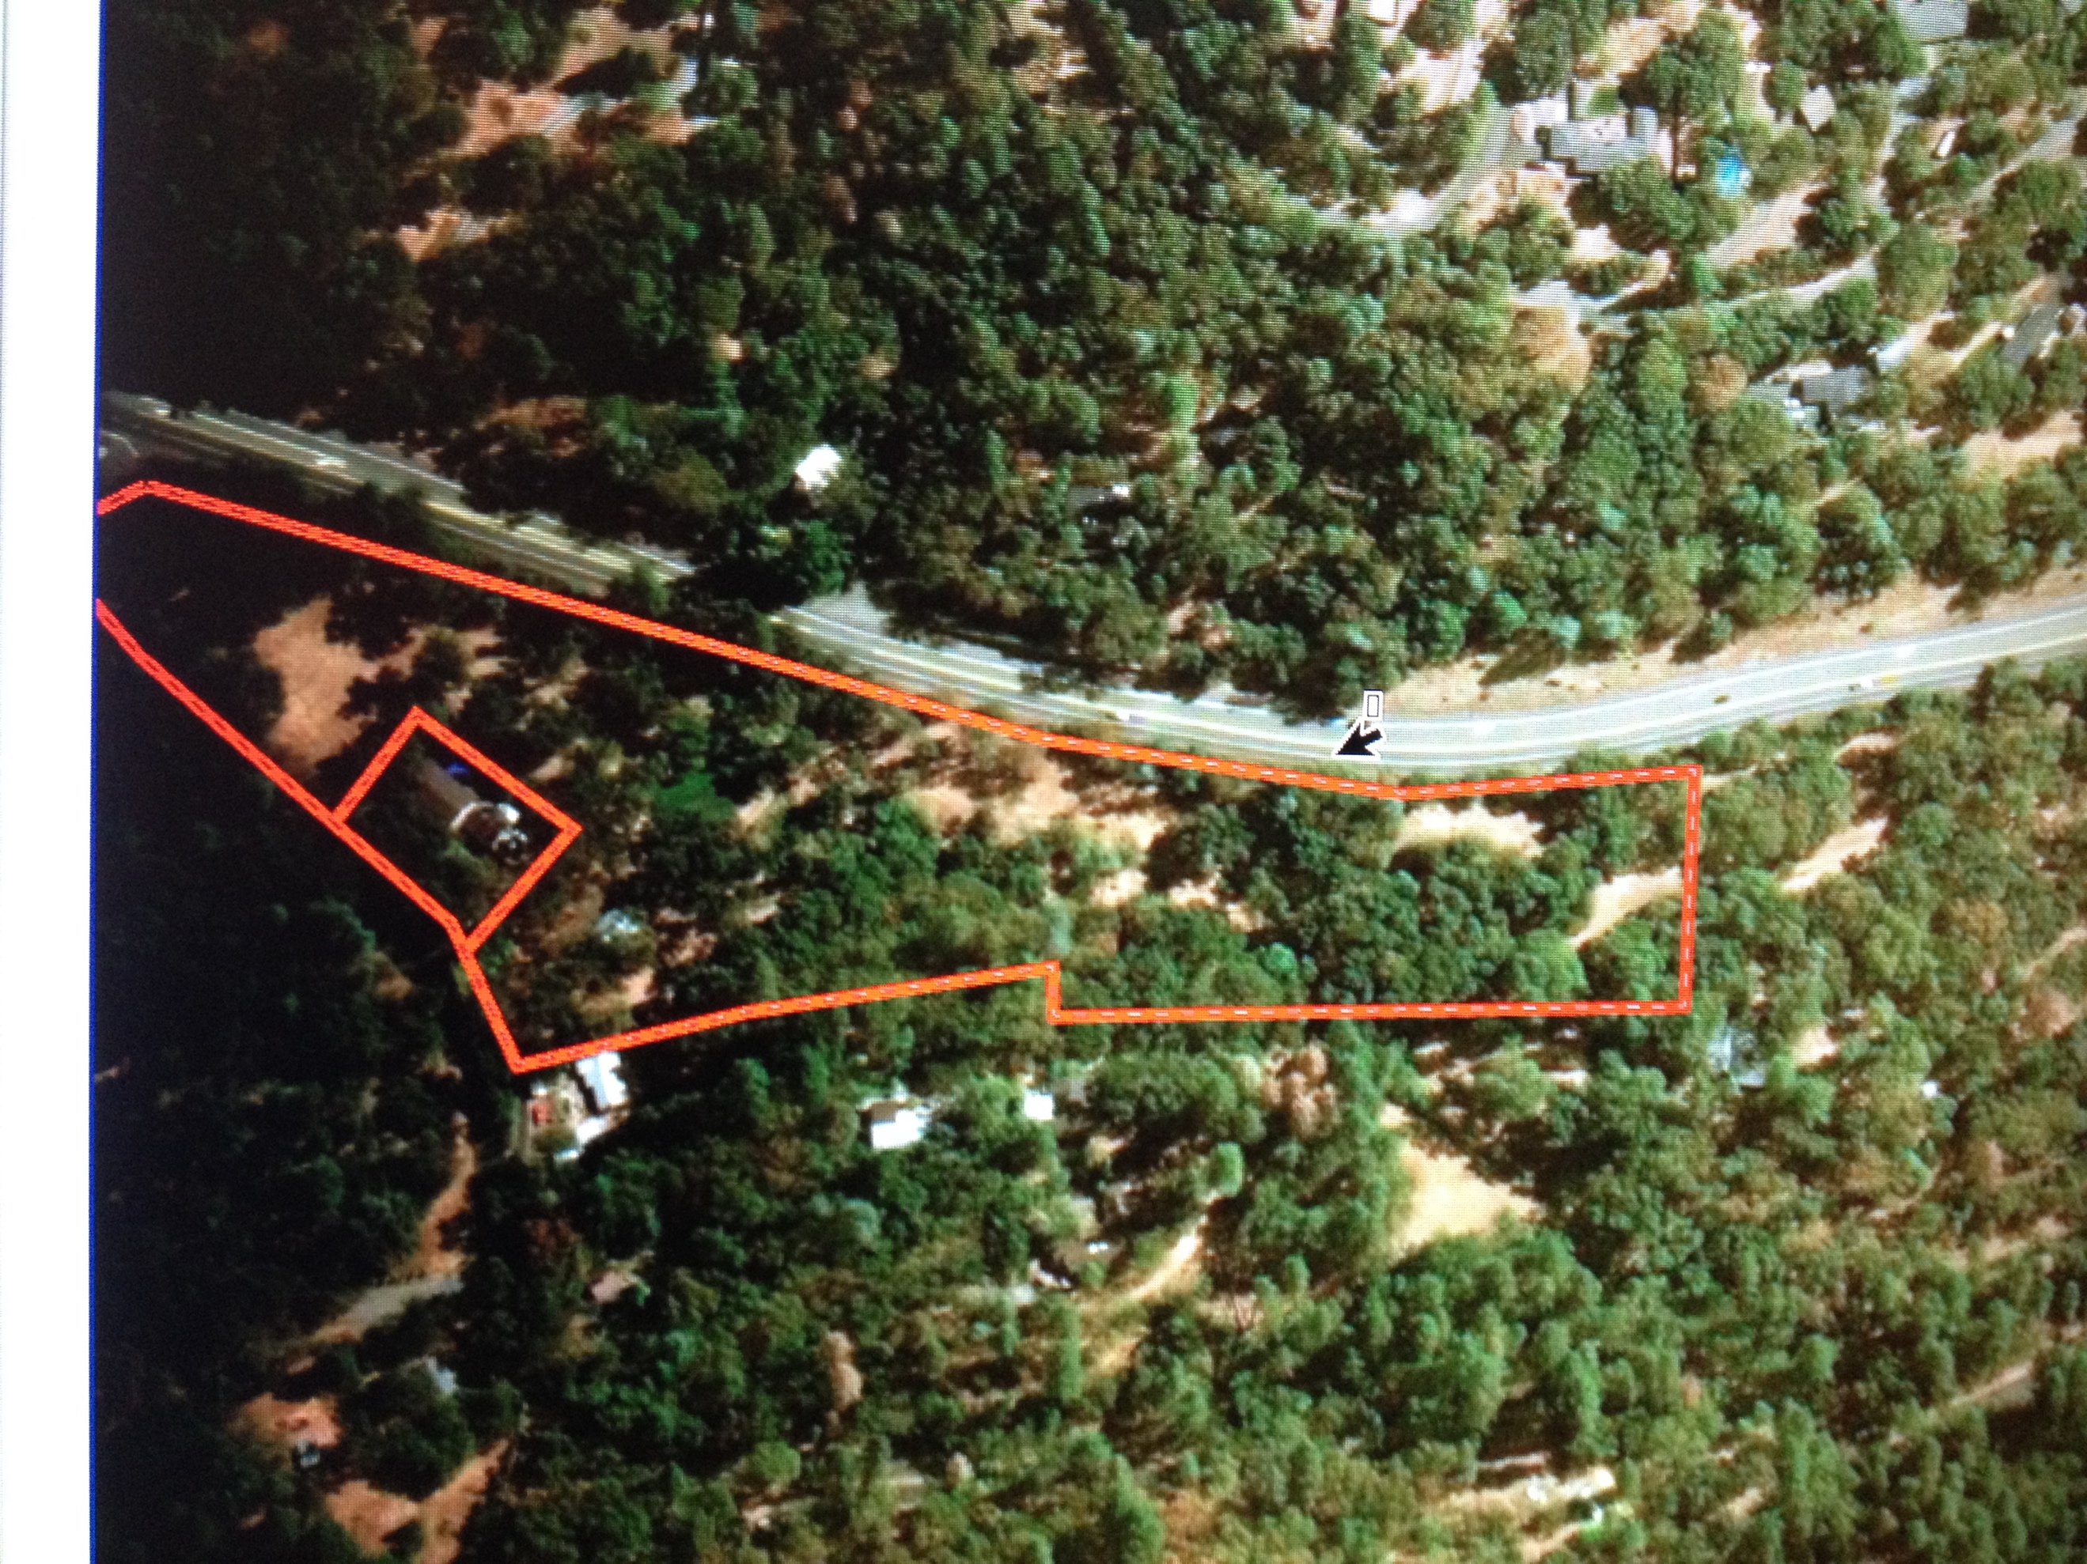

I then created separate feature classes within the geodatabase for a creek, pond and fairways. This was a challenging task because of the small space I had to work with at the north end of the course. For the pond I found the freehand tool extremely useful to draw its boundaries because it is so overgrown that it makes it very hard to see on a satellite image and even harder to get an accurate border for but after a few attempts I got a fairly accurate shape. At this point I had added all boundaries and fences. I had created classes for the water features and each fairway in a point a to b line from tee box to basket but they were all mixed up and similar colors with no way of knowing what is what.

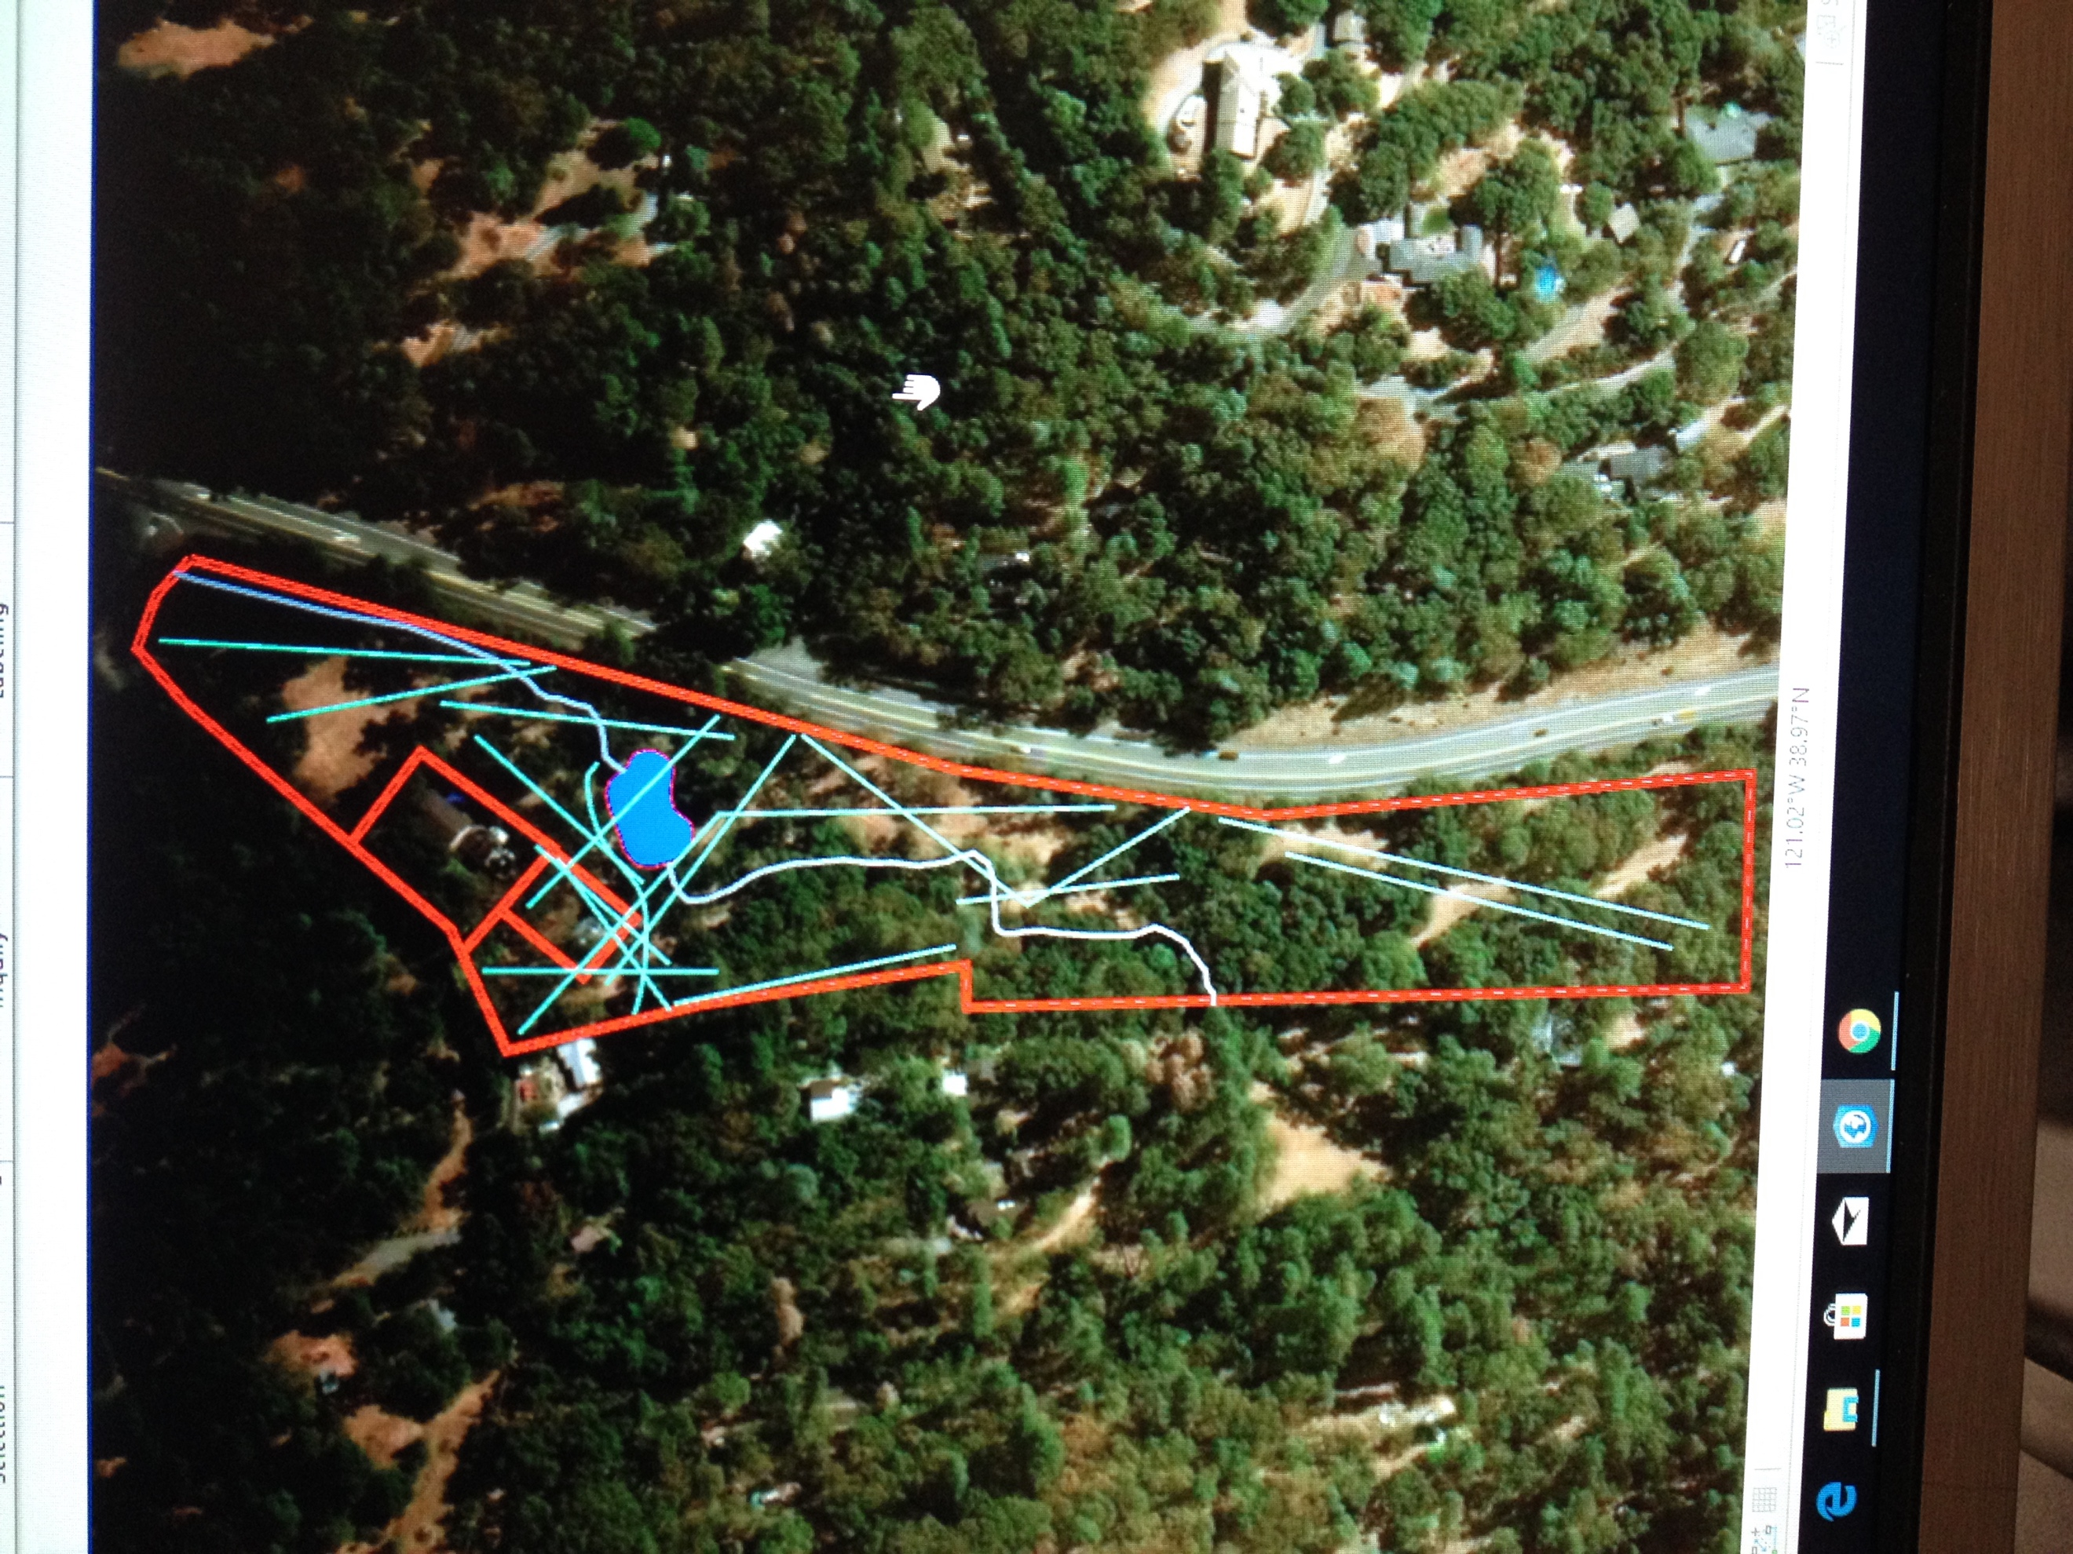

I created a final feature class for tee boxes and used a yellow pin marker in the symbology properties at each point to show the location of the box with the fairway layer connecting it to the basket location. After adding everything that I wanted to put on the map I set up a layout tab using the instructions posted on canvas and prepared to set up my map on a layout with a title, legend and text showing the numbers of each hole. I decided to go with the red border line option in Arc Pro for the fence lines with blue obviously for the pond and water and a bright yellow for the fairways due to the confined space.
This project was certainly not without its challenges as I faced many along way and became quite frustrated with the program. The greatest challenge was not being able to accomplish what I had in mind initially when I set out to work on the map. I had an ultra-detailed map in mind with things that may be a bit outside of my ability right now considering my education and experience with GIS. Another issue which ties into not having what I originally planned was not having access to a GPS. Without the GPS I was not able to complete my original plan of mapping out our fences using the GPS and taking precise locations of each tee box and basket. It would have also been nice to work with a property that is a little larger with more room to experiment with different tools in a more spread out map.
I learned that in addition to the numerous uses for GIS that I was already aware of I discovered several new uses and types of maps that I did not know about. Some of those new uses came from my own classmates which was especially satisfying to learn from. My computer skills were improved over the course of the term as I have not done much computer work aside from writing essays since creating basic CAD drawings in high school. I also learned how to be better organized on my personal and school computer that I may be using by creating folders and storing data in more meaningful and convenient ways. The biggest takeaway from the class I felt was that when working with this software you must be willing to spend time in a trial and error procedure and not try to rush any part of your work. At the beginning of the project I was highly frustrated with my lack of progress and the time it was taking to add the features into my map that in my head thought I would be creating much faster. After spending some time exploring the program and using some online help with teacher instructions I was able to complete a map that wasn’t necessarily what I thought I would end up with but great first step in my GIS experience. This project was highly useful in getting to know the program and skills needed to become successful in the field of GIS.

