Troost GEO385- Project Documentation

- Project Summary

The Voter Engagement Map Application helps political or neighborhood organizing campaigns quickly identify frequent voters based on the last 5 elections held within the City of Davis. The data used are voter records (street address geocoded points) of the complete list of eligible Davis voters for these elections; current City of Davis parcel polygons; and City of Davis Voter Precinct polygons. Web app functionality includes identification by selected characteristics of citizens with a high voter frequency (Influence) scores within each precinct. Once identified, precinct walkers/neighborhood organizers can better focus their voter mobilization and engagement strategies.

- Purpose. Include what you hope/did to accomplish with this project

I have worked on numerous City Council and voter measure campaigns, and neighborhood organizing efforts in the City of Davis. I believe there is a correlation between voter history and civic engagement. Those who vote when there are opportunities to do so tend to be more engaged in civic activities. Frequent voting can be a proxy measure that can help campaigns, political or otherwise. Frequent voters may also be “Influencers”- those who other members of a neighborhood or larger community turn to for suggestions or ideas about critical issues or candidates for office.

The purpose of this project is to create a Web based application for organizers to easily identify citizens who have a high engagement/influencer index. Based on the organizer’s goals, it can help with voter turnout for a candidate or ballot measure or assist in outreach efforts for organizing around neighborhood issues.

The voter database includes individual variables such as party, gender, military, birth date/age; and voting characteristics by election event like whether a person voted absentee or precinct, did not vote, and voter eligibility by election.

- Description of the data development and web application development tasks and methods used to create the web services and web application.

Data Development

Data for the project development was obtained from three sources:

- Voter files (purchased from the Yolo County Elections Office)
- Precinct shape file (obtained from the General Services Department, Yolo County)
- Parcel shape file (downloaded from the City of Davis, GIS Web page)

Voter and parcel data required significant time to:

- Select only Davis voters and precincts
- Review and clean data anomalies
- Align parcel address data with voter address data
- Assign parcels to precincts using a spatial join of Parcels to Precincts in ArcMap

This included:

- Re-creating a street address field in the voter database to align with the format used in the parcel database
- Editing fields in the voter database for how votes were registered for selected elections
- Creating new fields to capture voter engagement

Here is an abbreviated view of some of the fields and data used to create voter frequency/Influence scores:

15 11-06-2012 presidential general election 65 | 22 11-02-2010 statewide general election 57 | Voted Absentee | Voted at Pole | Did not Vote | Blanks- not registered | Total registered to vote | Total votes | Vfrequency
 |  | 0 | 0 | 0 | 5 | 0 | 0 | #DIV/0!
V | V | 0 | 5 | 0 | 0 | 5 | 5 | 100.0%
A | N | 1 | 0 | 4 | 0 | 5 | 1 | 20.0%

Note: Divide by zero *(#DIV/0!) was converted to 0% in database

Web Application Development

The Precinct shape file and Parcel shape file were imported into ArcMap 10.6.1. The two files were uploaded to my ArcGIS OnLine GEO385 account from within ArcMap, and feature layers were created for each shape file. In addition, the newly created *.cvs revised version of the voter database was uploaded to ArcGIS Online.

The cleaned and restructured voter database was then Geocoded using ArcGIS Online with a result of all but one of 37,251 voter addresses being successfully geocoded.

A Web map was created entitled Davis Voter Geocoded, which included the following feature services:

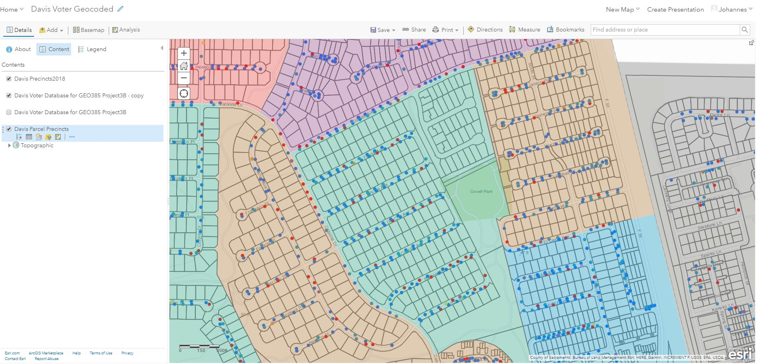

The following modifications were made:

Each voter is represented by address with a color dot representing their party preference.
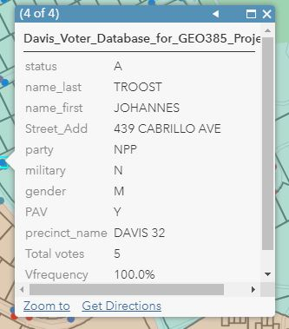
Data files and Pop-ups are restricted in all layers to show essential information only:
A Web Map Application was developed using the Davis Voter Geocoded Web map.
The application at this time features:

- A filter widget that displays voters by precinct, with additional filters for voter frequency by percent and permanent absentee ballot status.
- A chart widget selectable by precinct for voter frequency by % and number.
- A chart widget selectable by precinct for % and # of permanent absentee ballot voters.
- A print widget that will print a map of the selected precinct with associated voters

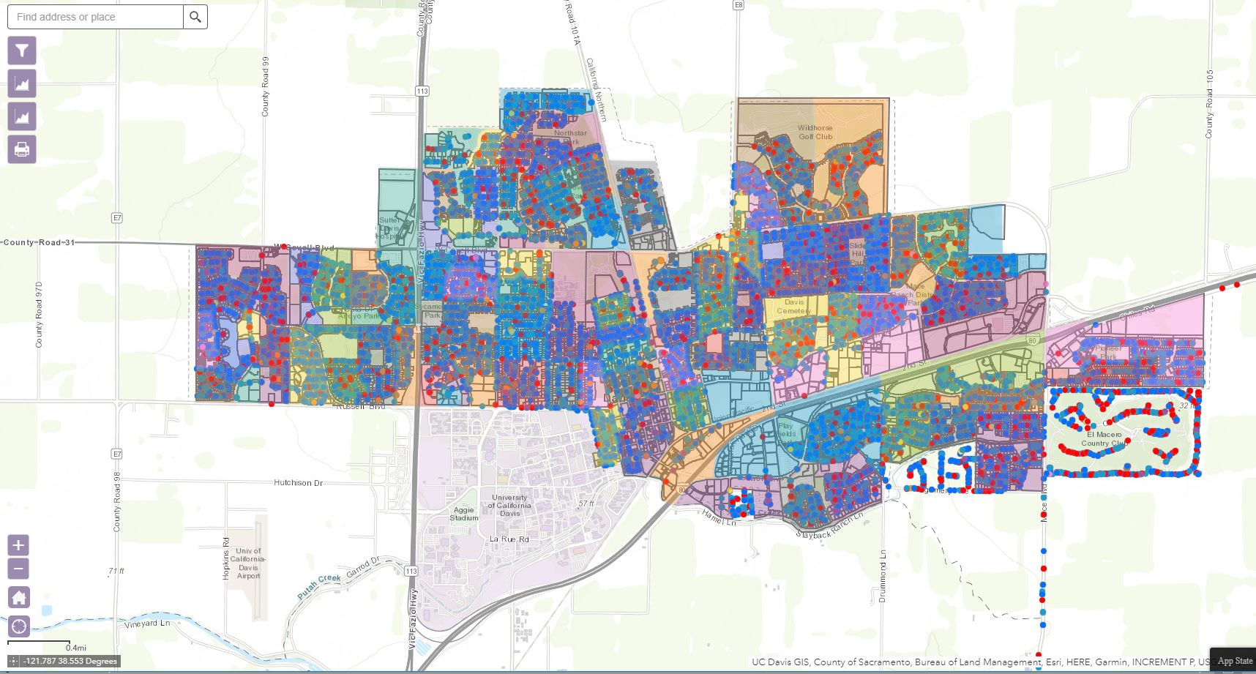

The Web Application can be found at:
https://arc-gis.maps.arcgis.com/apps/webappviewer/index.html?id=290672203b844548ab0f5acda3cc7901

- Difficulties/issues encountered and state of resolution.

There were a number of difficulties in developing this Web application, including, but not limited to:

Obtaining shape/data files from appropriate local sources.
These issues are resolved. I have developed better connections to individuals who are interested in the project and are willing to provide guidance. These are mostly Yolo County employees who work with ArcGIS Online.

Data quality and accuracy

There is no resolution to this issue. The county uses multiple people for data entry and does not have data entry guidelines in place or data accuracy review procedures at this time.

Familiarity with ArcGIS Online

It was difficult moving from years of work with ArcMap to the new format. It will take time to explore the incredible features in this software, and I look forward to using the Holiday season to expand my knowledge of the features and limits of AGOL, and engage my colleagues in critiquing the application.

- Summary of learning and general thoughts on the project, its functionality, any future improvements/enhancements that can be made.

I believe that even though the project is very simple with respect to the widgets and map, it is exactly what I had envisioned in terms of functionality. It selects voters by precinct, and dives into voter frequency, and selected variables that assist in campaign management with a focus on precinct walking/canvassing. I will test the model with colleagues in both the political and neighborhood organizing domains in Davis.

Future improvements/enhancements include:
- moving this into a phone/iPad based format
- providing clearer descriptions for users for each of the widgets
- expanding the filter variables based on campaign needs and user experience
- creating a more visually inspiring application

Thank you for a great introduction to the world of ArcGIS Online!

