Created by: Annette Poole
Created on: 11.26.2019

Project Summary
The goal is two-fold, to create a tool that allows Sheriff Deputies to submit their activities for the day via a tablet/cell phone and to provide the Operations Lieutenant an automated up to date status.
The new automation will benefit the Youth Services Program. In this program the deputies encourage youth to participate in community programs. The Sheriff Deputies will use the Survey 123 App to submit required information regarding their activities for the day. The Operations Dashboard will be used to provide the Lieutenant up-to-date status of the Youth Services Program. Not only will we be tracking the program, but we will be tracking the destination i.e. school, church or park.
The type of program, program destination, and date will be tracked.
There are four programs: Lunch One-Time, Presentation One-Time, Long-Term Visitation, and ride to event.
Lunch One-Time and the Presentation One-Time are programs that bring the deputies to the schools, parks or churches where the youth, staff, and law enforcement promote positive interactions with one another. These two programs are used to introduce what the Sheriff Departments Youth Services has to offer, in the hopes of becoming a Long-Term Visitation program.
Long-term Visitation is a program that occurs after school every Tuesday and Thursday afternoon. This is an established program at the same destination. This offers students an opportunity to hangout and interact with Sheriff Deputies after school. Deputies can help students with homework, play games, or just talk.
Ride to event is a service we offer to take children to the lunch or presentation event. For example, we will bring a van to your school to ride to event children and take to a luncheon.
Purpose
The Sheriff Deputies will use the Survey 123 App to submit required information regarding their activities for the day. The Operations Dashboard will be used to provide the Lieutenant up-to-date status of the Youth Services Program.

Data Development
I received three separate excel spreadsheets of data. One for each location, park, school and church. The park data consisted of only the park name and what program was provided. The school data consisted of the school name and the street address and what program was provided. The church data had several fields, name, address, executive, x, y, district number, and program data. First, I reviewed all the fields to determine similarities, which fields we desired to keep and those that we didn’t need. Second, after finalizing the data required for all destinations, I combined all the data onto one spreadsheet with identical fields. In addition, I had the data for each destination on a separate spreadsheet. Essentially, I had two sets of the same data. I wasn’t sure with web viewer/web map apps what would be better, one layer with all data, or separate layers of data. In the end I used two layers, one layer had. The key is to understand the requirements and data. As the user may have the data but his requirements maybe different.
Added data, had to do a geocode since there were no lat long coordinates except for the churches. This provided me with points on a map. Create a web map. Update to dashboard.
Web Services
I chose to create a dashboard. ESRI provides several base maps to choose from. I chose the streets map as the base map layer. I didn’t use any geoprocessing services. I used the web map to create symbols for my features, and to allow pop-ups on the map. In addition to the dashboard, I used Survey 123 as I felt it was a good complement to my project.
Web App Development
Dashboard Initially I started to create a web app using web app builder to allow the Lieutenant to perform queries on the data. For example, how many presentations have we performed this year. Then I realized I could create a dashboard with automatic updates as to the event and destination. Using the dashboard, the Lieutenant wouldn’t have to do perform any queries. I determined the symbols that would be used for certain features. I created pop-ups and used labels. Turns out I have labels for one feature and pop-ups for another feature. I have updated the map so all features have pop-ups but when I share the map again, the dashboard map doesn’t update with the new pop-ups. Survey 123 I created a simple survey for the deputies to capture their youth services destination, the program and the date. Creating the survey was easier than I expected.

Challenges, Problems, Issues, Resolutions, and Outcomes
Data My first challenge was whether to put all my data into one layer or have each destination in one layer. For example, the schools, the parks and the churches all in one layer or each in their own layer. While it is best to have separate layers, with the separate layers, I wasn’t sure how to do a total count of all events (i.e. lunch, presentation etc) at each destination with separate layer. For example, how many total Presentations were conducted at all destinations. I would have to query all layers and add all Presentation events. It is easier to do this with all destinations and events in one layer. Therefore, I used the data that is in one layer not the most common way to use the data, but it worked in this project.
Data Updates While using web map and after creating the dashboard, I realized that I wanted to make some changes in the data. I recommend publishing the data and working with it before you get to far into the dashboard. I wanted to delete some data and the only way I can see to delete it is to delete from the initial data and then continue the rest of the steps. If I remember correctly, I made an update via web map, and it worked. But I am skeptical of trying to make changes to the initial data at this point as I don’t want to have unwanted changes on my dashboard.
Write It Down If I didn’t know how the gadgets worked, or how to change a font, I googled it. But sometimes I just experimented with the gadgets myself and figured out how to make the changes. But when I would go back and try to make that same change, I couldn’t remember what I did. WRITE it down. Hence, write down what you discover because you will not remember it and you will want to use it again.
Visualization Of course, I had my data, but how does the user visualize the dashboard. Since this is a class project, I discovered there are so many ways to layout a dashboard. The challenge is to meet the user requirements but also provide a viable dashboard. The dashboard could show all the data received but maybe overwhelming. At any rate, there must be communication between the creator and the user of the dashboard.
Other examples I configured for the most part. I put locations in columns but decided it wasn’t easy to read the events.
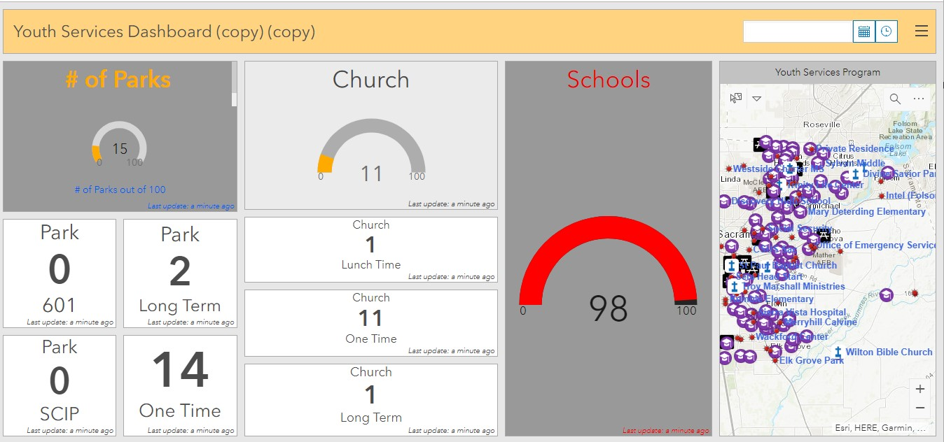
Then I grouped the events, but seemed to look worse on the dashboard.
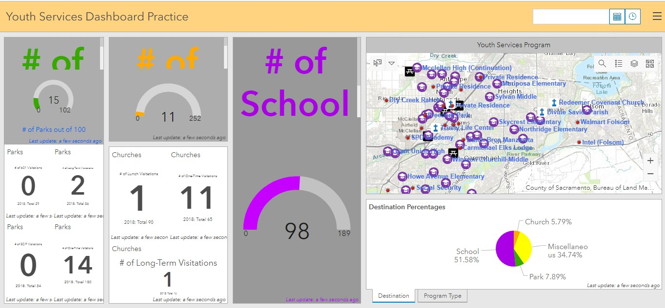
Another challenge was returning to my original display. For example, I couldn’t figure out how to ungroup in this case. I kept saving the dashboards as I went along in the process.
The final dashboard below visually looks the best and easy to obtain other data using the tabs and pop-up displays on the map. 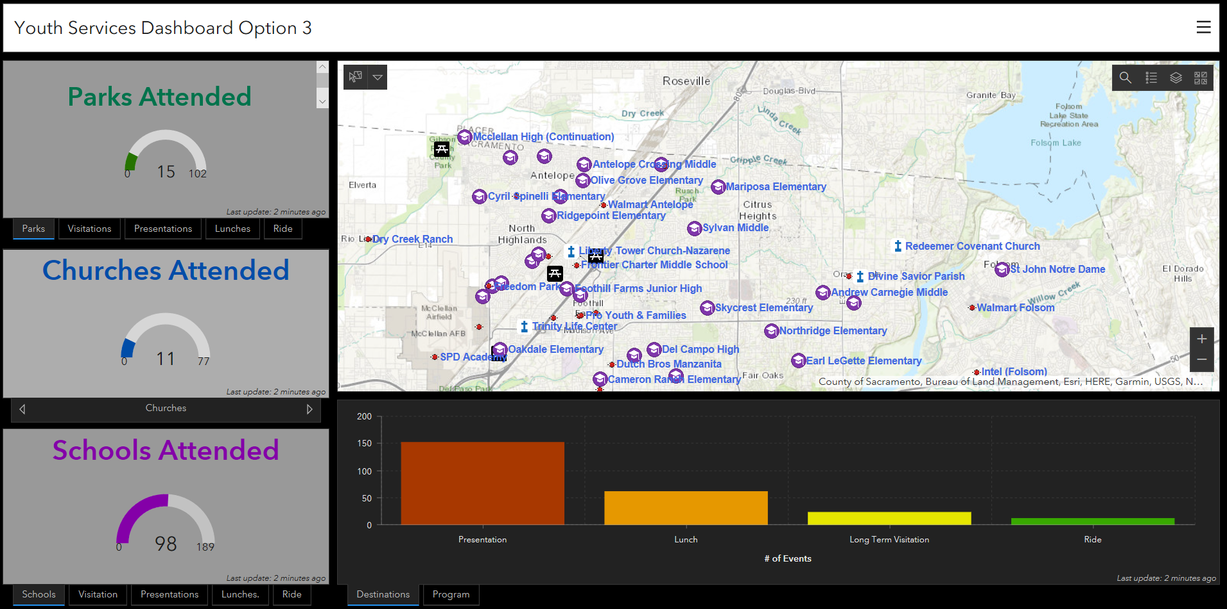

Widgets I found most of the widgets very useful and user friendly for a quick start. However, there are a lot of items I still need to work with such as all the action items and triggers. While working with the serial chart I wanted the numbers to sort by ascending order but it didn’t work. I tried descending but the order would change but not in descending order. I used gauges and indicators. The filters can be a bit tricky. On the gauge widget it looks like the gauge changes size. I am still not 100% sure if it does, but I wanted them to be all the same. I could not figure this out, more time will tell. I used stacking and grouping as well.
Park gauge stacked with event tabs. 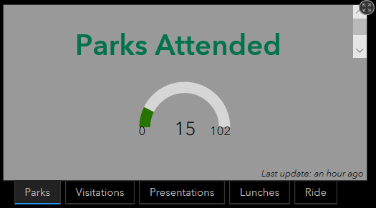

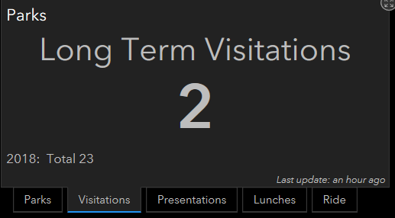Visitations indicator displaying number of visitations to parks, along with 2018 totals.

Final Web Application and Services
Final product is a Youth Services Program dashboard. I also created a Survey 123 app and the intention is for the data from the Survey 123 to update the dashboard. Dashboard The map on the dashboard displays symbols which represent each destination, school, church and park. A pop-up display is also available when selecting the destination symbol. When the symbol (park, church, school) is selected the pop-up displays the events that have occurred such as lunch, presentation, long term visitation and/or ride to event. On the dashboard, we have a gauge of all the destinations. The gauges show the number of times deputies have been to that destination and the goal we want to meet for the destination. I stacked indicators with each destination (gauges). The indicators each represent an event. This allows the user to have the most important item displayed. Also, using the stacking method removed a lot of the busyness from the dashboard. In addition, I stacked a pie chart and a bar chart each representing events and destinations, respectively. Survey 123 I created a simple survey which requires the deputy to input the date of the event, then the deputy chooses what event took place at which destination. That’s it. Picture optional. Click send. What’s awesome is the survey analyzes the data immediately and maps the location. Time saver.
The survey and bar charts on next page.
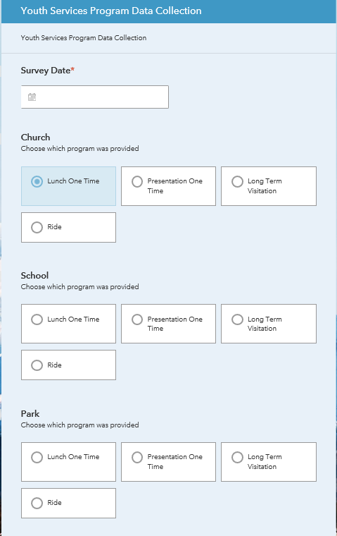
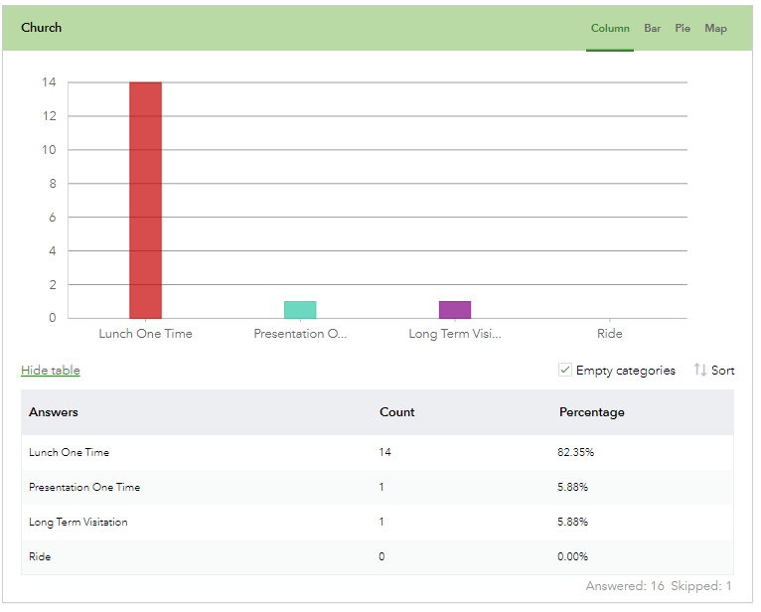

Future Improvements/Enhancements
Change the order on the bar chart from small to large, I have not figured out how to do that. Fix the names in the program tab. I would have to go back to the original data and change them. When I discovered I wanted to change them, I didn’t want to take the chance and mess up what I already had. Also, when I do stacks or groups, I do not know how to go back one step. That is something I need to learn, because I had several saved dashboards and after a while that can be overwhelming. Learn how to use labels better. In my case, I have one layer with all data, and separately each destination has its own layer. My idea was to have labels all on one set and the others with no labels, so the user could remove the labels if the dashboard was too busy.
Over all this was a great project to do. I found working on it a little every day I made more improvements and learned more. When I worked on it for hours at a time, I made little progress due to it being overwhelming or not sinking in. I did learn there is more than one way to do something and usually a workaround.

