Cherilyn Neider
Geog. 90
N. Jennings
06 December 2018

Final Project Description and Process

Project Summary
“Dammed Waterways Intersecting Tribal Lands in the SACOG Area” is a map that explores waterways crossing in or near tribal lands. The area of exploration was narrowed from California as a while to the Sacramento Area Council of Governments (SACOG), which includes El Dorado, Placer, Sacramento, Yolo and Yuba Counties. This map represents Native American tribal boundaries using trust and reservation lands represented through the United States Department of the Interior Bureau of Indian Affairs (BIA). An additional layer was created representing California Recognized Tribes in the SACOG are. California Department of Water Resources (DWR) and US Department of Transportation, Bureau of Transportation Statistics (BTS) layer representing jurisdictional dams was used to represent dams or blockages to waterways. This map represents a theoretical analysis of potential water rights or influence on dams that tribes may take action on through federal and state laws such as the National Environmental Policy Act (NEPA), California Environmental Quality Act (CEQA), and the Clean Water Act.

Purpose
The purpose of creating this map was twofold, with intention in both applying as many possible methods taught through Geog 90 and providing a visual representation of a theoretical analysis of tribal water rights within the SACOG area.
Through federal environmental policy, NEPA, and the California state environmental policy, CEQA, consultation with Native American tribes is a required piece of project permitting. NEPA documents are required for federal projects, such as the Federal Energy Regulatory Commissions relicensing projects. Through consultation with tribes, impacts to cultural resources are assessed in upgrades or work related to hydroelectric facilities under the jurisdiction of FERC. Similarly, the California state law, CEQA, requires consultation with Native American tribes for project permitting at the state and local level. Assembly Bill 52 (AB 52), passed in 2015, adds additional requirements for consultation with federally and state recognized tribes, as well as establishing a specific resource category for analysis, Tribal Cultural Resources. Finally, the United States Environmental Protection Agency’s Clean Water Act also requires tribal consultation and assessment of tribal values in considering waterways within the United States. Application of these policies has allowed tribes throughout the States to address water quality within tribal lands, specifically waters flowing into tribal lands.
It is with these policies in mind that I created a map representing waters flowing into, or immediately adjacent to, tribal lands within the SACOG area. The intent is to represent tribal lands in the area of analysis and to show potential for tribal influence on major waterways within the SACOG boundaries.
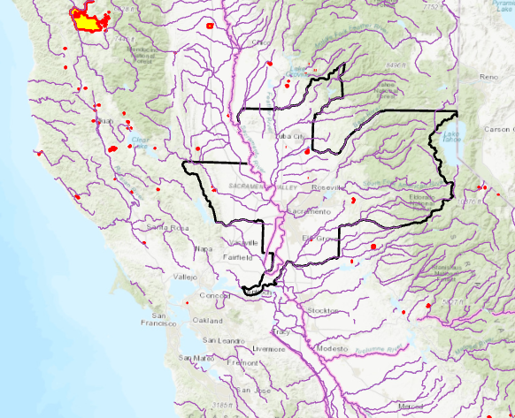
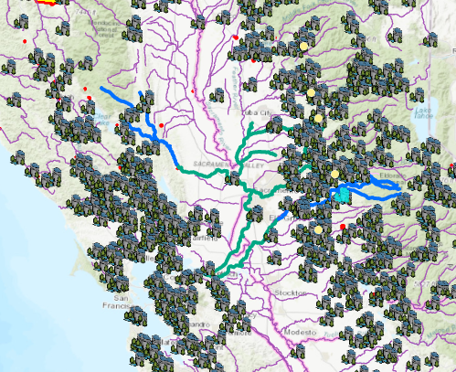

Methods
In thinking around this project, I started by identifying needed data and assessing how to best represent the data and concept visually. Finding accurate and useful data sources was a foundational step in this process. This step was followed by identifying a reasonable area in which to represent. California has over 109 federally recognized tribes and numerous waterways beyond the scope of this project. Settling on the SACOG area allowed for a manageable amount of data and a relevant project. The next step was to find reputable sources with needed data. This included the BIA’s layer representing tribal lands, DWR’s and BTS’s layer representing dams, and a layer representing major water ways within California. Data representing waterways crossing tribal lands and non-federally recognized tribes was unavailable and required creation of new data. I did have challenges finding data representing the detail of waterways desired. This is discussed below in the challenges section.

Data Management and Creation
Because the BIA, BTS and DWR layers are large, covering the state and nation, these layers required clipping to make the data more manageable; both layers were clipped to fit the SACOG area.
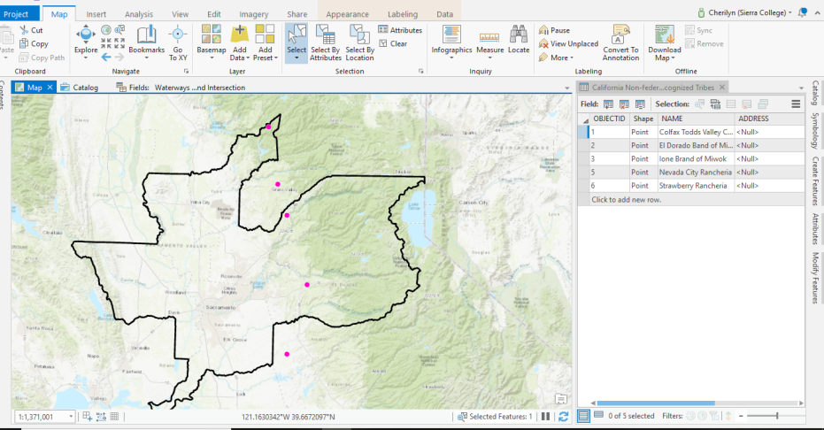
While the BIA represents federally recognized tribes, non-federally recognized tribes are not represented. These tribes do not have trust or reservation lands, but are permitted to consult under CEQA/AB 52 if they have achieved state recognition. Therefore, it was relevant to include them in the map. Because these tribes do not have lands, a point was placed in the city they consult out of. This data was found using a DWR map representing California tribes and by identifying contact information on the tribe’s websites.
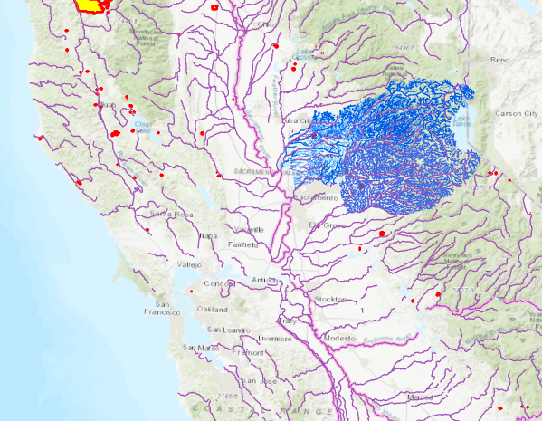
A second layer representing waterways flowing into and out of tribal lands was needed next. This layer was created by identifying tribal lands in the SACOG area then tracing waterways flowing into and away from these lands. Three layers were used in this process: major water ways, El Dorado County Creeks and Rivers, and Placer County Creeks and Streams. In order to represent lands flowing both into and out of, a column was added in the attributes layer to identify if the waterway was before or after the land area. This enabled these differences to be better represented in the final map.
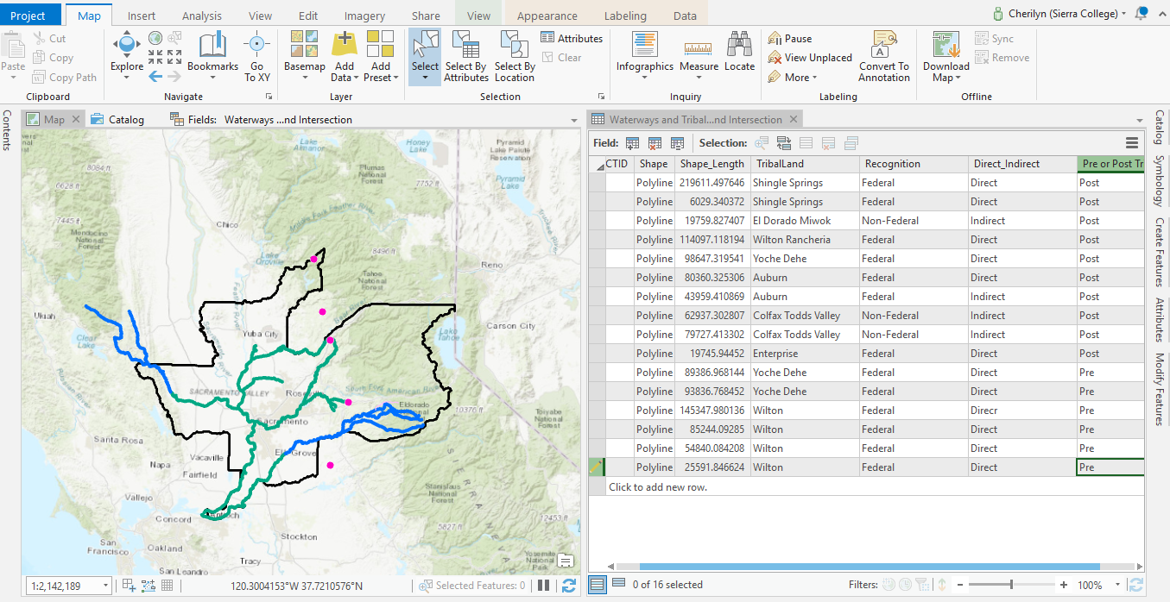

In order to represent dams that were blocking these waterways, a one mile buffer of the water ways was created. Then the intersect feature was used to highlight the dams that intersected with this buffer. Finally, the dam layer was clipped to this buffer layer. Not all dams intersecting with the buffer were relevant, meaning they didn’t cross the waterways in question. These dams were deleted out of the new layer.
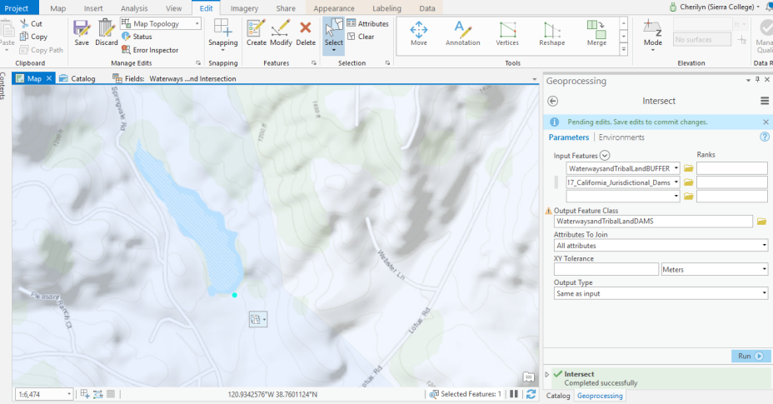
I now had a data showing waterways crossing federally and non-federally recognized tribes within the SACOG area and dams in these waterways.

Cartography
With this data created, it now needed to be represented visually in a way that communicates the intention of the map. Because this map was going to require a significant amount of text identifying tribal lands and dams, I chose to use a subtle base layer that represented terrain with very little text. I chose the gray terrain layer and removed the reference layer showing road and town names. In order to maintain some sense of scale, I added in key place names with the text feature.
Choosing to use the label feature versus adding text was a tedious process. The labels feature, while making representing places by using the data attributes faster and easier, became crowded with the number of layers and proximity of the features. Therefore, the label feature was used only to represent the non-federally recognized tribes while the text feature was used to represent federally recognized tribes and dam names.
In order to make the map less crowded, I chose to change the symbol for the dams. I also chose to change the color to red for dams that were in place on waterways flowing into tribal lands. This is because through the Clean Water Act and other policies, tribes would likely have more influence on waters flowing into their lands rather than away from.
The layer showing waterways crossing tribal lands is represented by two different colors by adjusting the symbology by selecting representation based on a column on the attributes table showing incoming water or exiting water.
The SACOG layer is a light gray and was made transparent so that the terrain layer could be seen behind it. I also chose to include the California hydrology layer to show major waterways that do not intersect tribal lands.
Final steps in creating the map included adding the title, placing the legend, and adjusting symbols and colors to be visually pleasing.

Challenges and Resolutions
Save. Save, save, save. I found that remembering to save, especially in data creation, was at first a challenge. After losing data several times due to the program crashing, I saved after nearly every change. While that may not be a challenge, it was certainly a resolution.
An initial challenge was finding a layer that represented the scale of waterways I was looking to assess. A priority was to show major water ways, creeks and streams to represent the full watershed that potentially encountered tribal lands. In searching for reputable data, I could only find segments of water ways or major water ways. However, I wanted to be able to demonstrate the path of water beginning as close to the headwaters as possible. This required finding large scale maps. However, I was only able to find the scale desired for Placer and El Dorado Counties. This ended up resolved by following larger water ways through tribal lands for Yoche Dehe. Enterprise did not seem to have any waterways intersecting or adjacent to their tribal lands.

Making the data manageable by using the clip feature was a significant help; particularly for improving the loading time and helping bring focus only to the SACOG area. Similarly, creating the data needed, such as the non-federally recognized tribes layer, and the layer showing waterways that intersect or are adjacent to tribal lands addressed the issue of missing data.

A final issue was identifying dams that crossed the water ways in question. When I first ran the intersect process, no data came up. I realized after the fact that this was because the points did not cross directly with the waterways on the overlap of layers, but were slightly offset. A solution was creating the buffer of one mile to capture the data offset. This captured more dams than actually crossed the waterways which I was looking at. Outlier dams were deleted out of the data set.

Learning Outcomes
As stated in the introduction, one of my primary purposes in creating this map was to get as much experience with ArcPro as possible. I wanted to experience the process of making a map, creating data and using geoprocessing tools. A learning outcome that I am most satisfied with is the experience creating different feature classes and attribute data.
My intention in taking this class was to get more familiar with ArcMap and GIS since I am using it more through my employment. I was able to get the experience desired and have a much deeper, though still basic, understanding of how ArcMap and ArcPro work.

