Chris Magda
Geo 90 Th 530-930
Final Project Paper
10 December 2019

Project Summary:
This project was created with the intention of exploring the currently active building permits within a four square mile area around the small city of Newcastle, CA. The map that I produced is an accurate depiction of the building permit locations. The permits shown are both residential and commercial and they are transposed over the parcel data to which they belong. This data can be analyzed to the effect that locations of active building permits and parcels are visible and their proximity to one another is clear. Permits are very expensive to purchase weather a project is residential or commercial and it is a massive source of income for the county. Anyone who might be interested in this data such as an assessor, or an accountant for the county, may be faced with a task of verifying permit data within a certain area. This project was undertaken to answer a simple question: How many building permits are within a four square mile area in Newcastle, CA.
As a carpenter and painter with twelve years of experience, I was interested in taking a simple topic that was related in some way to my profession(s), and I wanted to focus the GIS project around that. I was always curious about how many jobs go on at the same time, this project gave me an opportunity to visually perceive the construction activity with up to date information.
Purpose of Project:
The purpose of this project mainly was to accurately represent active building permits on a map that is visually appealling. The goal that I had in mind was to replicate the mapping excercise that the class produced earlier on in the semester. This was a difficult task for me to accomplish based on my level of comprehension with computers. I knew from the onset that it was going to be a challenge for me to undertake such material in an unfamiliar context. The overall purpose of creating the map was, if nothing else, to elevate my level of proficiency not just within ArcGIS, but within the entirety of the Windows operating system. These goals were met, and new skills were successfully developed and employed.
Data Collection/Management:
The first step that I had to take in the development process was to come up with the actual product design. What kind of a map? How much data will I represent? What should the layout be? For the basemap, I played with a few different styles in order to select the most fitting look. I preferred the real world look. The topographic and road map styles often make the terrain look bland. I liked the visual affect of the landscape being represented with its natural look, so that is the reason that I chose that basemap. Also, in realtime map analysis on site, it helps to have visual markers that are sometimes not very clear without real world visuals. From there, I took the time to search the Placer County GIS data service that they offer on their website and it was surprisingly easy to locate the informtion that I required for the project. I originally started very broadly. I knew I wanted to show permit data, however, I grossly underestimated the sheer number of active permits within the boundaries of Placer County. Or at least what they would all look like once I transferred the data to the basemap. I drag/dropped the permit data onto my basemap and I realized the size of the map must be porportionate to a reasonable amount of data points. Simply because there were too many data points to represent them all in one shot. The screen would have been too cluttered. The attribute table represented 4,458 individual points. So right there I confirmed that a reduction in the data represented was needed. Below I have included an original screenshot of the bare data points of the permit information.
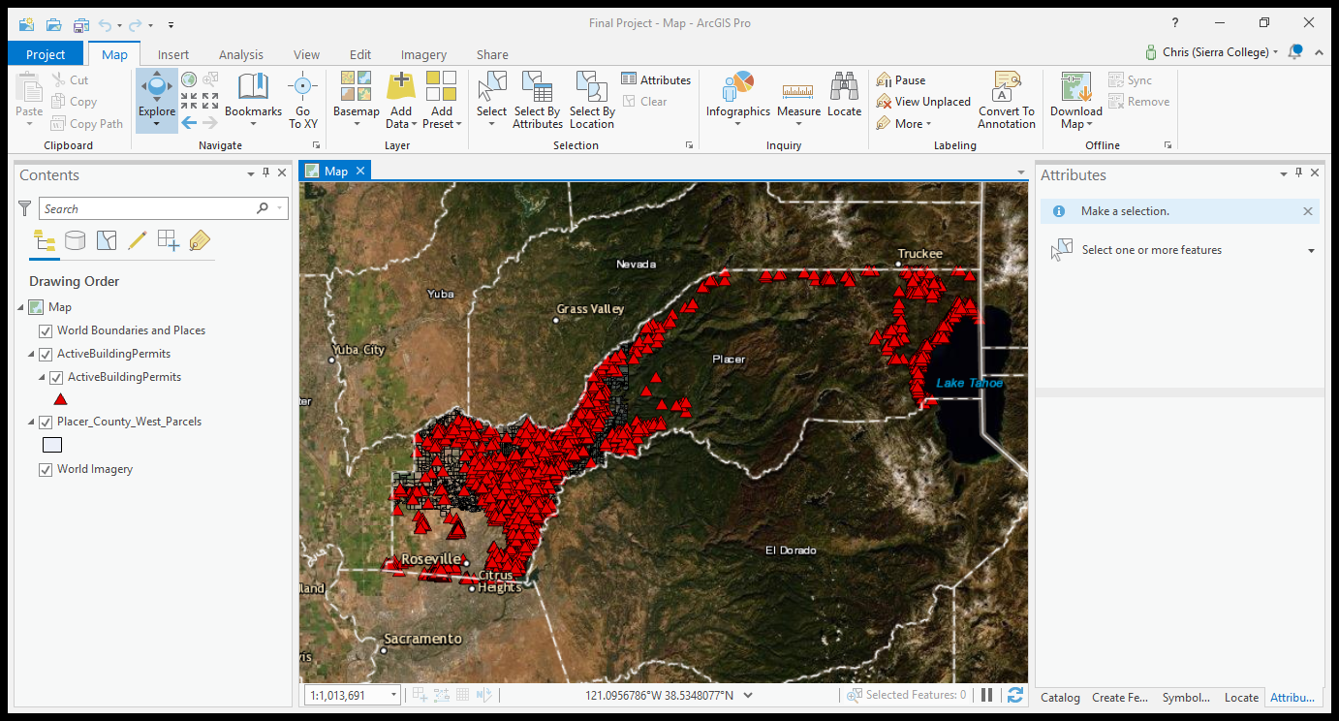
From here, I was faced with a challenge, how do I reduce the scope of my map and still get what I want? I also wanted to provide a bit more depth to the visual appeal of the map. I decided to add a new feature class to the map layer, and that was the parcel data. I again searched Placer County’s website and located the data that I needed. It was actually very lucky that I found the parcels in the way that I did because it allowed me to use them as boundaries for my map. Instead of dealing with the entire county, I was using the parcel data from Western Placer County. This enabled me to decrease the complexity of the map by way of regional depiction. Below I have a screenshot of all the parcel data within Western Placer County.
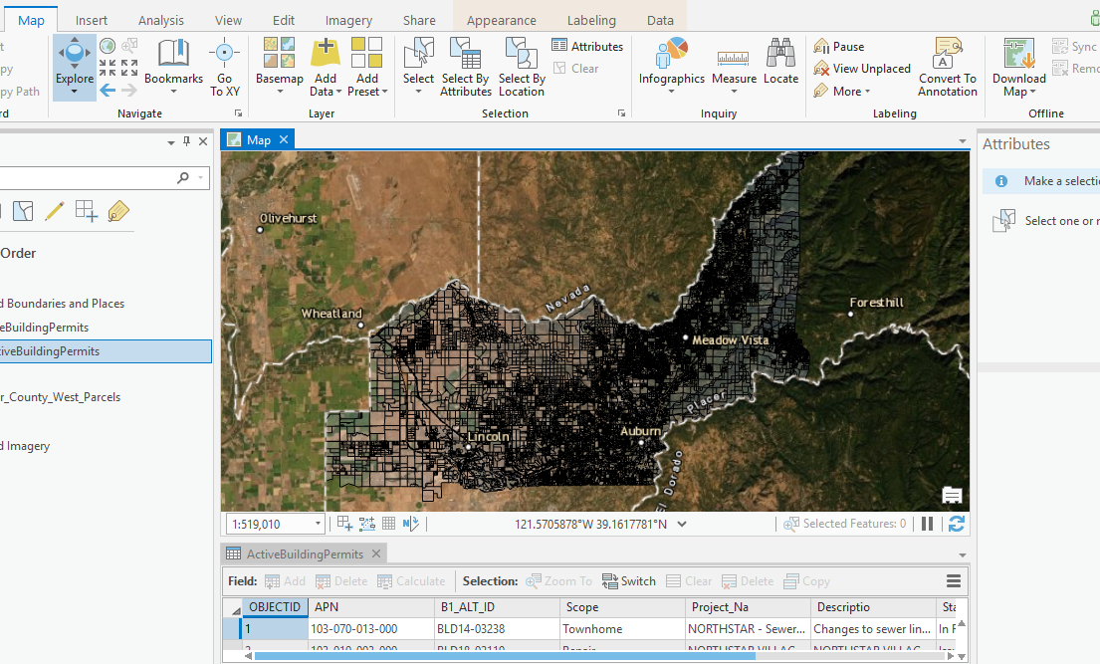

Once I had my parcel feature and my permit feature layered on the basemap, I chose the style of the data, the look that I wanted. The point data was to be a red triangle, and I accessed this choice through the menu because I wanted to have a vivid/bright layer for the point data and I figured a red triangle would be just fine. For the parcel data feature, I wanted to go with something that would go well with the red but not mix. There had to be contrast. So I went with a light blue. When I chose the color and applied it, I found out that it was opaque, to the point that the terrain was invisible through the feature. So I had to go to settings and adjust the transparency of the feature. Once that was negotiated, the labels and the point data could be seen through the parcels.
At this point, I had my two main features represented, the parcels, and the permit data. Still, I had an issue with the size and focus of the map. In an effort to solve this issue, I used the activation icon to focus in on a specific area, Newcastle. I chose this because it is the city limits in which I live. So I thought, why not? With the frame of the final map sized and centered, I then had my final dimensions.
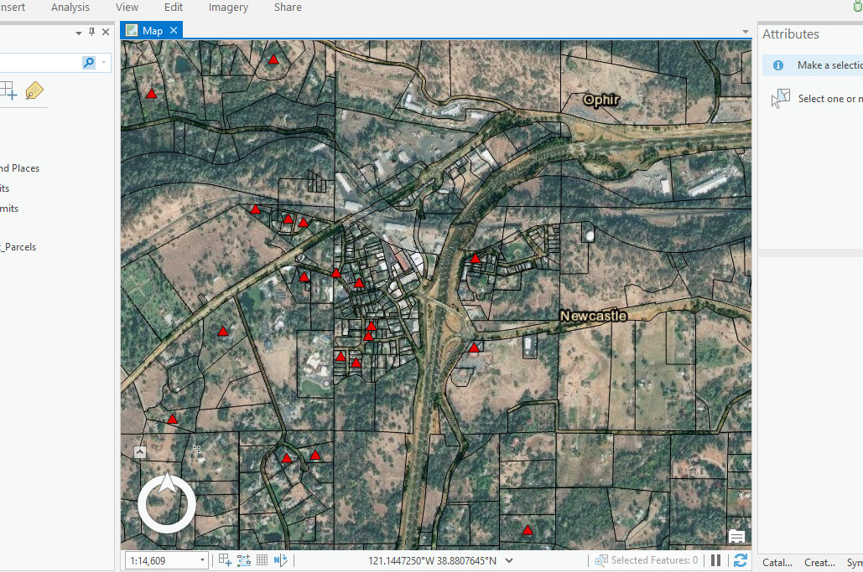

At this point, the map is really starting to take on its final form. The next step was creating the actual map template complete with a legend and compass rose. The legend itself only had two feature to represent so it wasn’t the most complex process. I centered the information the way I saw fit and adjusted the placement through the menu that is used for legend and scale creation. The scale that I used was one that I thought would be the most applicable to the project. Below is a final draft of the map that I produced.

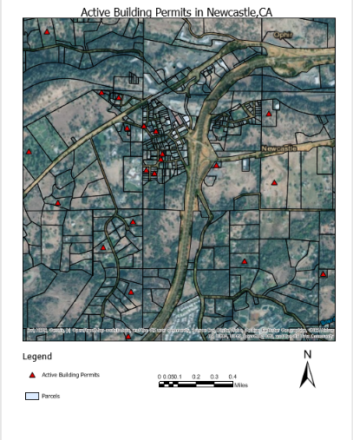
Learning Outcomes:
This class and the assignments herein have given me a great opportunity to expand my horizons. It was very intimidating coming into the course with the level of proficiency (or lack thereof!) with computers. I did surprise myself with a number of tricks that I learned, but none I don’t think were more important than the basic action of saving the material. Saving at the right times in order to protect yourself from loss of data is a huge part of progression in this program. I fortunately didn’t have any issues with my project in that regard. This has been a very enlightening experience and I do appreciate all of your help Nate, as well as the help of my fellow students to get throught the course, because I certainly benefited from it.

