Jon Koenig
GEO 90
12/6/18
Final Project
Mapping Fires in Sacramento
A) Summary
Managing building fires is an important role within a fire department. An important aspect of managing fires would be to know where they are happening most often. A table outlining the locations of each incident would be difficult to quickly understand and not be of much help. This project will collect this information in a map and highlight the areas of high fire frequency, helping to better understand what areas are most important.

B) Purpose
The purpose of this project will be to highlight areas of high ocurances of building fires. This will be accomplished by using 911 response data from the Sacramento Fire Department. This data will be sorted to display only building fires. Then a density analysis will be performed on the data to clearly show areas of high frequency. Along with this the fire stations within Sacramento will be displayed along with the neighborhoods near these stations. This will show not just what areas of Sacramento high high frequencies of building fires but also what fire stations and neighborhoods are nearby.

C) Development process

Step1: Create project and add data to geodatabase
- Data was retrieved from City of Sacramento open data portal
  - http://data.cityofsacramento.org/
  - Sacramento Fire Department 911 Call Response
  - Neighborhoods
  - Fire Stations
  - Council Districts
- On initial addition the data is cluttered, difficult to read and contains points outside project area

Step2: Data clipping
- Used clip tool to remove 911 response point and fire stations outside of council district boundaries.
- Used Attribute query to select only building fires and exported the building fire only points to a new layer.
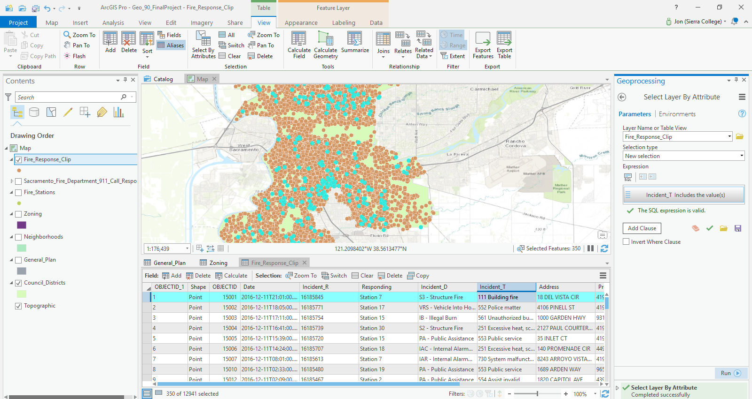

Step 3: Density analysis
- Used kernel density tool to convert building fire points into a heat map showing how dense specific regions of the map are. Used default setting for analysis.
- Changed number of classes to 6 and set natural breaks.
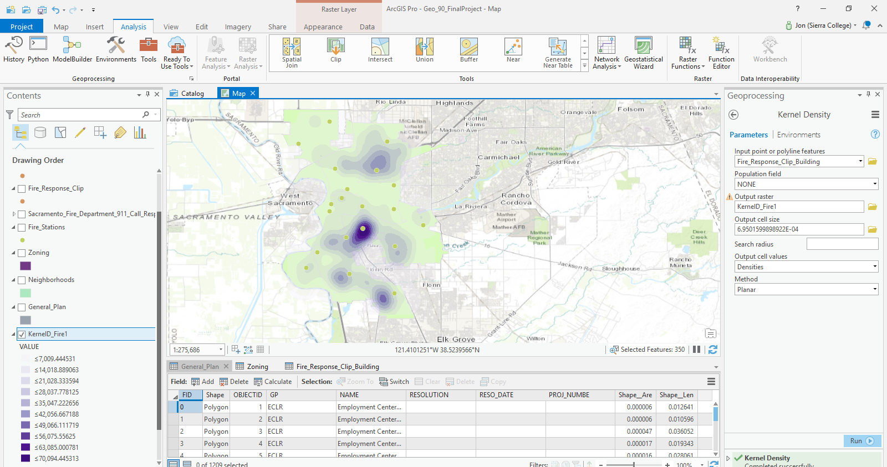

Step 4: Adding stations and nearby neighborhoods
- Added fire stations and neighborhood feature class into the map.
- Created a ½ mile buffer around fire station
- Used Intersect tool on neighborhoods and fire stations to determine what neighborhoods are within ½ mile of a fire station.
- Used query by location on original neighborhood layer to highlight only the intersected ones and exported those to feature class.
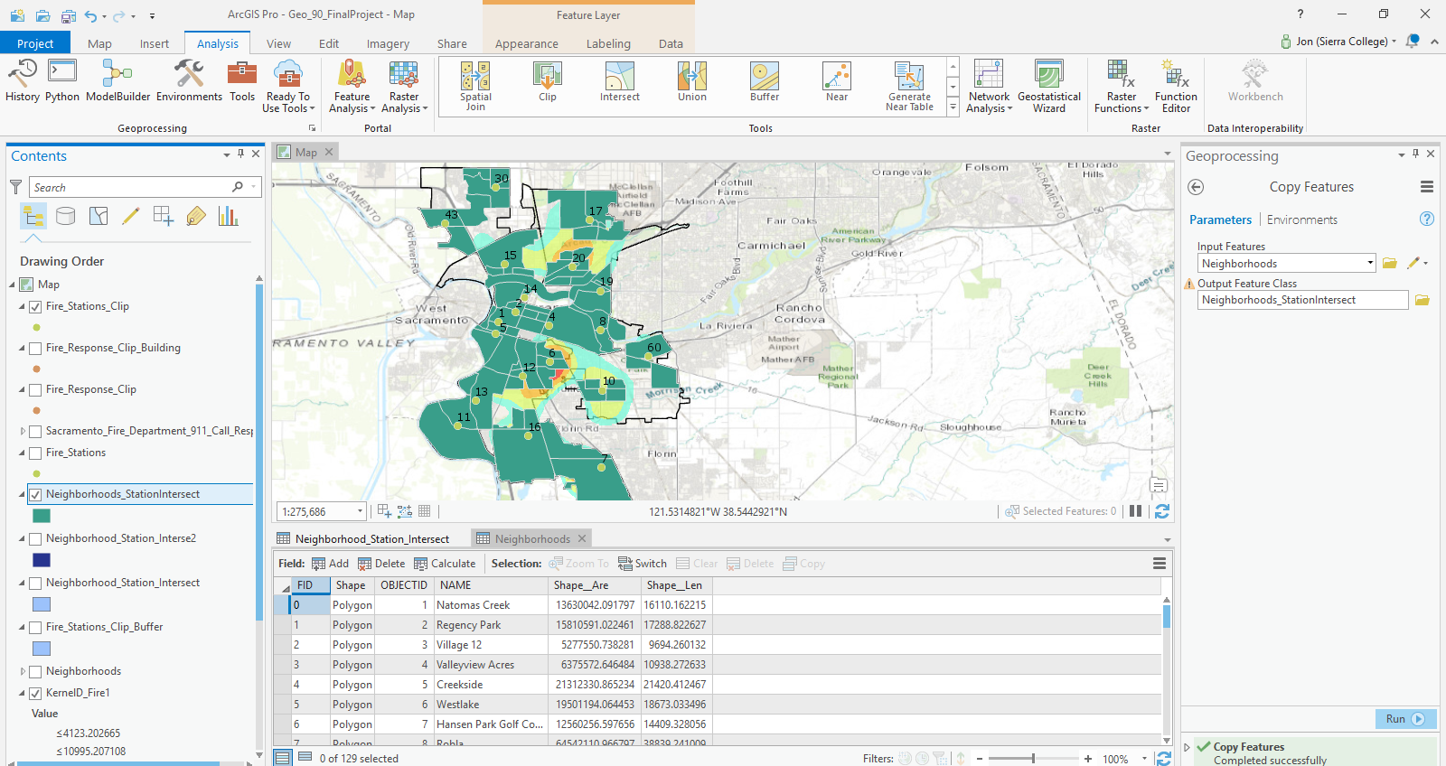
Step 5: Labeling and appearances
- Added labels for fire station number and neighborhoods names, changed size of labels.
- Increased size of council district border so it was more visible.
- Adjusted transparency of heat map and neighborhood adjusted drawing order so heat map displayed on top.
- Removed color display from lowest value classes on heat map and changed color ramp.

Final Map
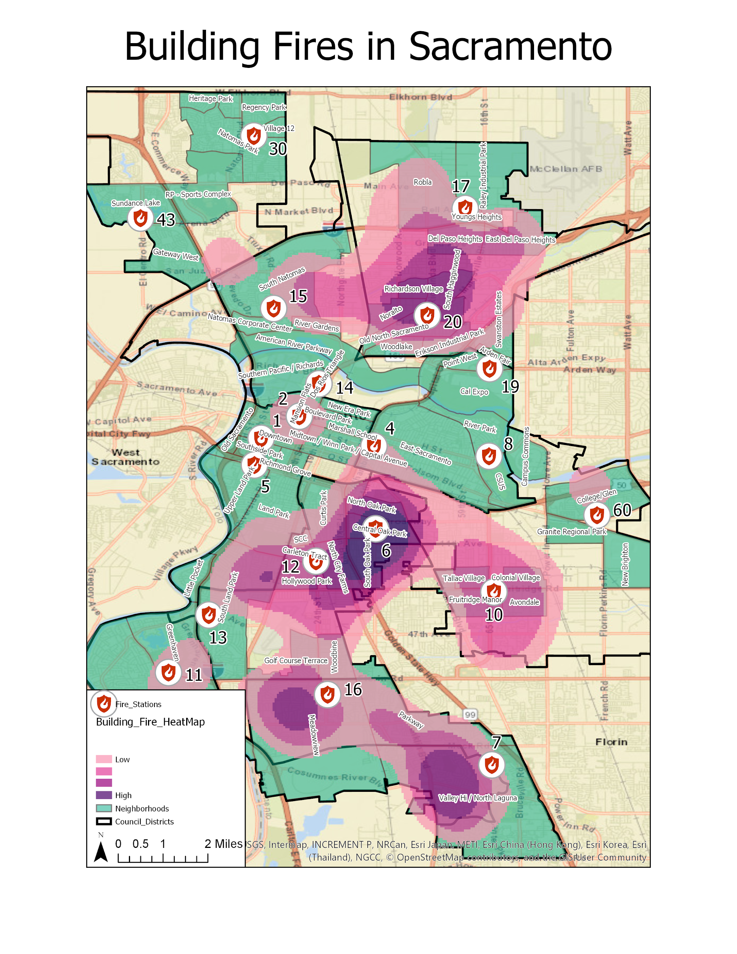
Issues
The biggest issues that I encountered when developing the map was getting familiar with ArcPro. Most of my previous experience has been with ArcMap, so while I knew how to use the various tools I wanted to use in the project I was unsure of how they differed in ArcPro. For example, it took me some time to find where the transparency option was as I was used to it being accessed from right clicking on a layer and going into the properties section. I also had some issue getting the layout frame to zoom to the exact amount I wanted as I couldn’t find the zoom option of dragging a box around the area you wanted to zoom to.

Once I got more familiar with the layout of ArcPro i found this it was in general more intuitive than ArcMap. One example is that the density analysis tool is in an easily accessable ribbon instead of being located within a toolbox that has to be separately opened and navigated through. Having this information in an easier to find place eventually made working on the project go much quicker than it would have with ArcMap.

