My project was to create a map of the City of Citrus Heights and locate the parks within the boundaries.
I started the project by using the Sacramento City Boundaries with Unincorporated Areas and isolating the boundaries to Citrus Heights. A parks layer was added and parks outside of the boundaries were removed to produce a map result:

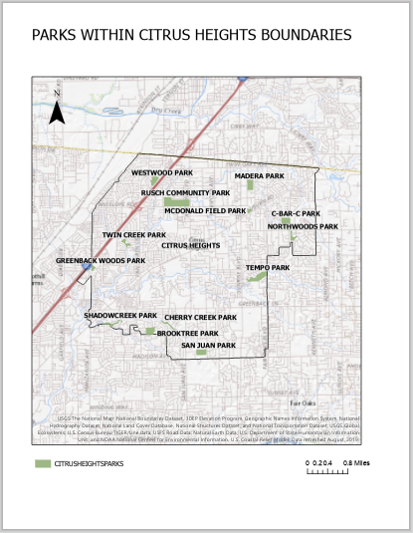

The first challenge was coming up with a viable project based on the data available. Once I settled on a project, I started by using the Sacramento City Boundaries with Unincorporated Areas map and isolating the map to reflect only the boundaries to Citrus Heights. The next step was to bring on the park layer, which resulted in the following map appearance:
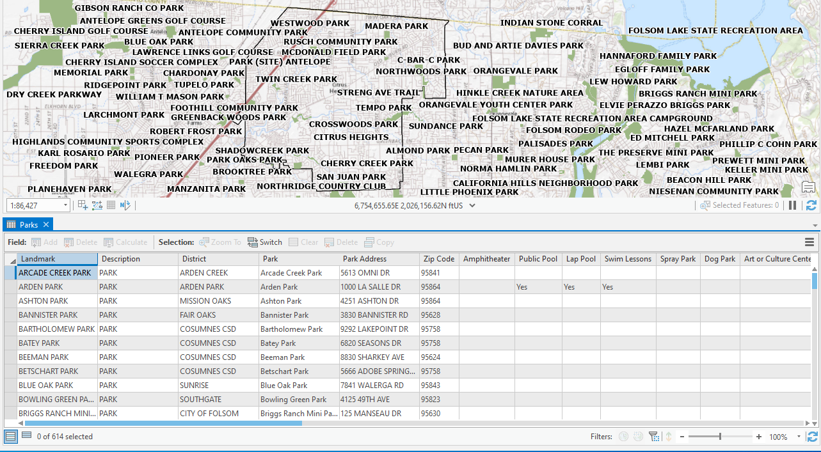

The map that resulted had 614 parks. It was too busy and had too many parks outside of the boundaries. After review and consideration of the fields I could use to narrow my selection, I decided to narrow it by the two zip codes that encompass Citrus Heights and the results were as follows:
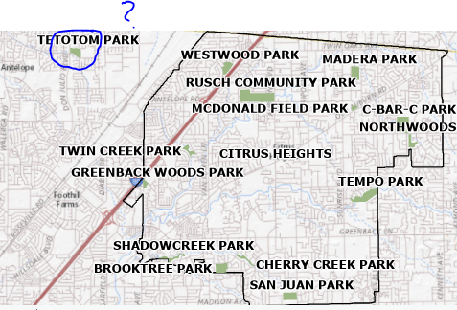
Why was there a park outside the area? A review of the data table showed the problem:
The zip code in the data table was wrong. I thought about a variety of possible solutions to remove the outlier, from editing the table to picking a different method to isolate the parks within the boundaries but before I tried something more involved, I clicked on the outlier park on the map, hit delete and much to my surprise the outlier park disappeared. At this point, I saved where I was in the process and created the map.
In conclusion, I took this class because I was curious. I wanted to know something about GIS and weather it was a skill I could develop to open other job possibilities. It’s clear to me that to become proficient at using the program requires practice. It seems that there are a lot of approaches that could be used to create the desired map. Finally, the accuracy of the product created is only as good as the underlying data.

