Jamie Fearn
Geog 90 Fall 2018
For those who have studied local history is it hard not to run across the story of the Donner party, and the terrible ordeal is generally glossed over with cannibalism referenced and then dismissed. I have been one such person content to know very little about the party even when living in the same county where the horror story drew to its conclusion. After happening upon a podcast about the party and learning more about it, I went in search of a map of their route and was very disappointed by what I was able to find. I wanted to create map that would legibly convey the where and when for the party’s location and have a decent map of the route taken by the Forlorn Hope. As you can see in the maps pictured below there was much improvement to be made both in terms of effective data communication and aesthetics. I also wanted to buck the trend of putting historical data on historical maps. I want to be able to see where in route was located with modern reference points, so that I as a modern person can better appreciate and understand the significant feats these people were able to accomplish while in the harshest conditions ever seen in this area. 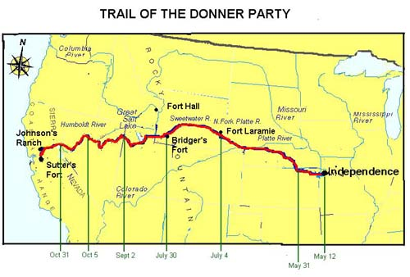
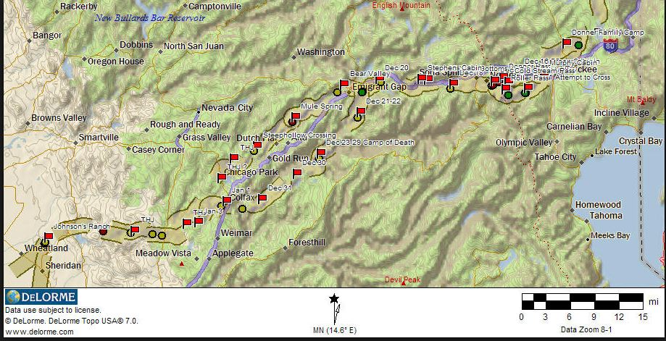

First I obtained emigrant trail data from the National Park Service under the National Historic Trails. The data I obtained contained all known routes taken by emigrants heading West.
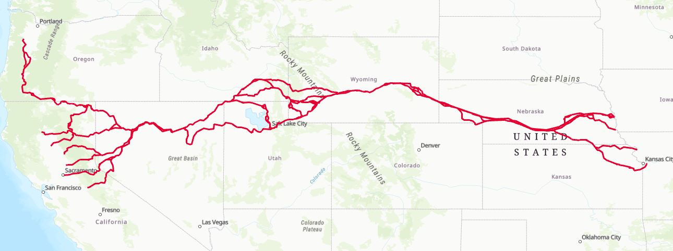
The data was large and cumbersome, I began the laborious task of clipping the data by route name. This proved to be more of an undertaking than I anticipated because the primary route was often replaced by various cutoff names. I first clipped the data to create a Primary route that was take by most emigrants at that time. I then clipped this data to create the Donner Party route. This meant researching which route the Donner Party took. In some cases, the answer was easy to find because the cutoff didn’t exist during the time the Donner Party was travelling. In other instances, the route name was either Primary Route of Alternative Primary Route. In this case if I was unable to ascertain which route the party took, both routes were kept. Also when clipping large amounts of data mistakes happen and one is preserved for you below.
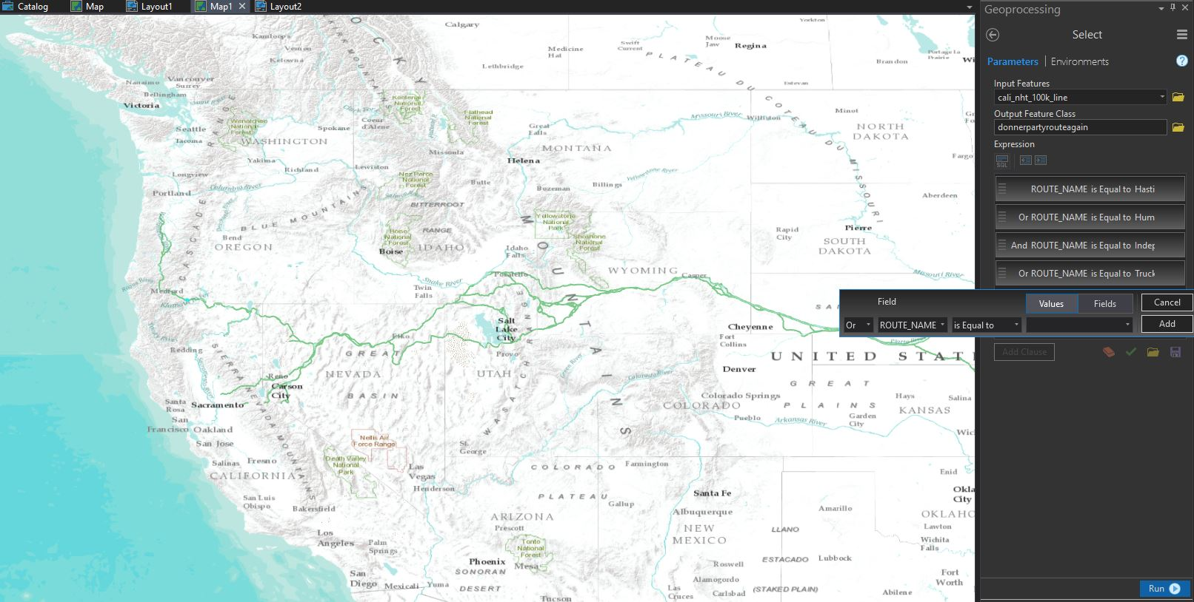

Once the Primary Route and the Donner Party Route had been created, I noticed that the routes had large gaps in them that became obvious when scaled to be able to see the Forlorn Hope. I found a book called Trail of the First Wagons Over the Sierra Nevada by Charles K. Graydon. Using his maps I was able to confidently fill in the gaps of my data.
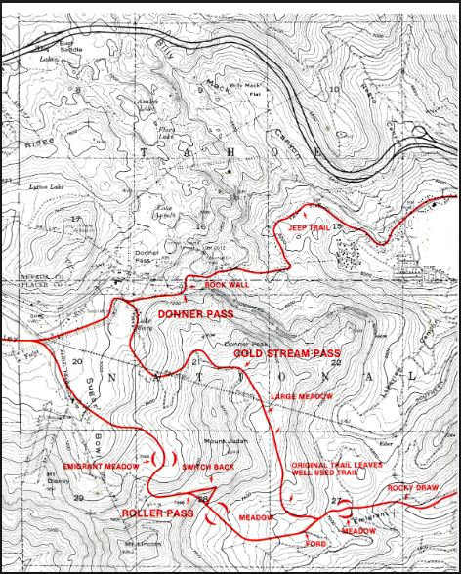
Once my routes were set, I was able to find GPS data with dates from the Open Portal and Michael Rosen. I crossed referenced the data to ensure accuracy. I also added a few key reference points and labeled these settlements for lack of a better term. This data also contained reference points and dates for the route taken by the Forlorn Hope; in conjunction with the first-person accounts from Daniel Rosen’s site donnerpartydiary.com and The Indifferent Stars Above, I approximated the route taken by the Forlorn Hope.
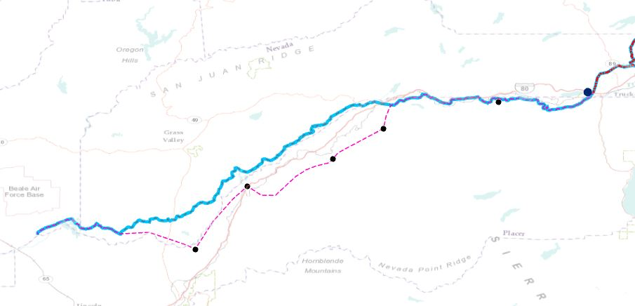

Once all the data had been created, I began the process of making my map aesthetically pleasing. During episodes of frustration with clipping I searched the portal for base maps that had a “rustic” font and modern geography, I then added a hill-shade layer to better communicate the elevation and physical geography. After adding labels, I adjusted the base maps transparency so that the fonts where legible. I figured out how to make certain layer’s labels appear in the smaller scale map area and not in the large-scale map using the outbound parameters. Due to the nature of the map being historical rather than technical I felt that I could get away with fun fonts and layouts.
I am mostly happy with how my map turned out. The labels toward the west end of the trail on the large-scale map are messy and should have been sent to a different layer and made to disappear using the outbound function. I feel this map would better communicate the data as a web map. This would allow user interaction and dynamic scale. Even my small-scale map does not do justice to the enormity of the route and would be better communicated in an even smaller scale.

