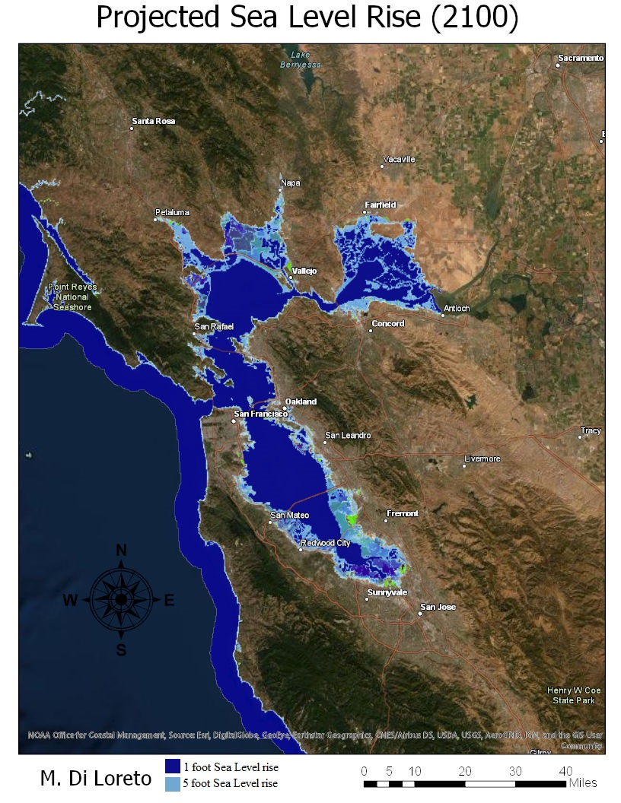
Matthew Di Loreto
Geog 90 Final Project Paper
December 7, 2019

For my project, I was interested in exploring the potential impacts of Sea Level Rise on California’s coast, with an emphasis of focus on the San Francisco Bay Area and elements of the Central Coast. This project sprouted from my background as an Environmental Studies major, and an interest in looking at the areas most likely to be affected over the next century from a combination of melting snow and ice as well as thermal expansion of the water, leading to ocean level rises. As of now, there is debate to what degree the sea level will rise and how drastic the impact will be. The National Oceanic and Atmospheric Administration (NOAA) has compiled data from models that show the areas affected at different levels from 0 feet (current) all the way to 10 feet rises. With current projections, the most likely range that is expected is anywhere from 1 to 6 feet by the end of the Century, however there are other scenarios that could lead to a higher rise if there is a drastic and unforeseen change in the Earths climate.
The aim of my project was to create a simple yet informative map that is easy to understand and doesn’t lead to a feeling of disorientation for the viewer. Ultimately, this project was born from an interest to explore a topic that is often discussed in the Environmental Studies community, but also mixed the ability to apply some of the new GIS concepts I have learned this semester in terms of displaying data as well as elements of map making and cartography. The website that inspired my selection for this as the map project was nice and informative, however was at the same time a bit overwhelming because of the amount of data. Additionally, there was no ‘in-between layer’, as it only showed the areas that would be inundated with water as opposed to showing the difference in area that would be affected by Sea Level Rise.
All of the data that I used on my map was found in the All Portal through ArcGIS Online. The initial data was sourced from the California Land Commission under the Sea Level Rise California search query. When I initially downloaded this file, it was a complete map, however as it loaded there was an excess of elements displayed. It included median lines for rivers, levees, reservoir and lake outlines, dams, hospitals, power plants, government buildings, highway outlines, sea lanes, etc. Because of the massive amount of data, the map had a very ‘crowded’ feel and gave it an overall sense of clutter and disorganization. The first task undertaken was removing all of the excess data displayed, in order to only display sea levels on the map. After this was completed, I had to fragment the sea level data by height, in order to separate it into distinct layers as opposed to a single layover on the map. Once this was completed, as the focus was on the effect of total sea level rise, I gave the layers uniform colors based on range from 1-3 feet, and 3-5 feet in order to distinctly show the areas affected by the various depth, and provide a greater level of contrast between the two study areas. There are some green areas on the map with shading, however since the data is unclear onto which areas affected apply to which level, these are considered to be areas with an unclear impact given the data. The reason for this is because these areas are not explicitly going to be impacted by the exact same event, and is unclear whether they are ‘safe’ or ‘at-risk’ as a result of natural or man made features that makeup these areas of interest.
An interesting element I learned on this project, was that there is no need to ‘reinvent’ the wheel if data already exists. As a result, I had the opportunity to explore the different maps and data through the All Portal in the ArcGIS portal, and developed navigation techniques on how to effectively search for specific data sets. Another element this project taught me, is since I was unable to crop the data itself, is that some data files are uploaded as an image layer as opposed to a data layer, inhibiting my ability to crop the data from the map, or go in and modify the areas displayed under categories since it treats the data as a Map Image File and one complete unit. Ultimately, I succeeded in my ability to create a map that is readable by members of the general public, who do not have to have a specialized background in order to interpret what the data represents on this map. Additionally, it allowed me to practice cartography techniques in making a final map that is balanced and concise in its presentation, without it being too ‘crowded’ or busy, and detracting from the display of relevant information to the viewer.

