Chris Crettol
GEOG 385 – Web GIS
Prof. Jennings
12.16.2019

Purpose:
The purpose of this project is to create a searchable list of licensed California hospitals using an ArcGIS Web Application. Ultimately, this may be able to used as a web product with my job and become available to the public. The Web App will display a legend, listing the different types of Facility License Type. Second, it will include two filters. The first will allow the user to filter by Facility License Type, and the second will filter by County.

Shared with ARC Organization:
CC_Final Web App_GEOG 385_Fall 2019

As a secondary part of the project, I wanted to complete a Web Dashboard that uses the same dataset, but presents it in a different way. For the Dashboard, it has two filters. The first will allow the user to filter by a Health Service Area, and the second will filter by Facility License Type. On the right side of the Dashboard, it will provide a selectable list of the facilities that is automatically updated based on the filters.

Shared with ARC Organization:
CC_Final Web Dash_GEOG 385_Fall 2019

Data Source:
I pulled this data from the California Health and Human Services Open Data Portal. The dataset that I selected is titled, “Hospital Annual Utilization Report & Pivot Tables.” Here is a brief description of the data taken directly from the website:

On an annual basis (individual hospital fiscal year), individual hospitals and hospital systems report detailed facility-level data. The complete Data Set of annual utilization data reported by hospitals contains basic licensing information including bed classifications; patient demographics including occupancy rates, the number of discharges and patient days by bed classification, and the number of live births; as well as information on the type of services provided including the number of surgical operating rooms, number of surgeries performed (both inpatient and outpatient), the number of cardiovascular procedures performed, and licensed emergency medical services provided.

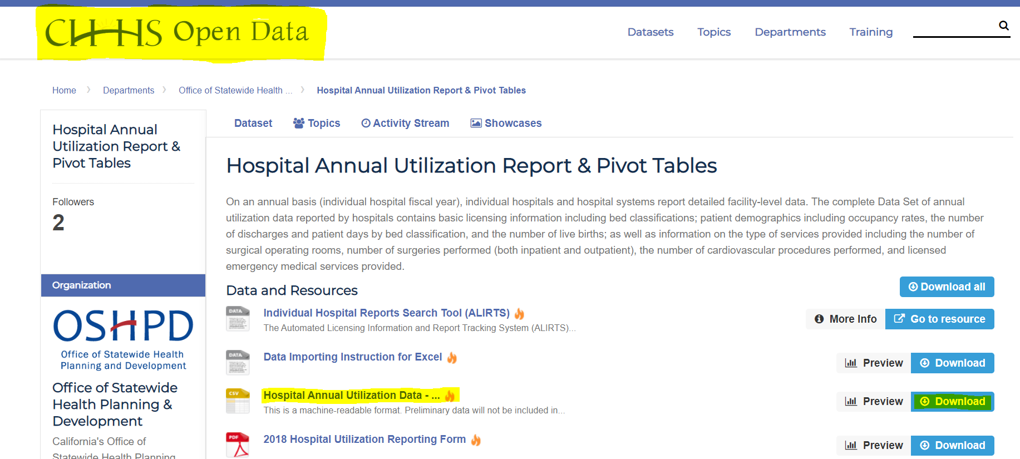

Data Processing:

In Excel:
The dataset was originally published as a .csv file, but I decided to save it as an .xlsx file for some pre- processing before moving it into ArcGIS Pro.

The original dataset contained 49 fields of data, many of which were not relevant to my project. After review, I selected 15 fields to use in my WebApp. Some will be used to filter the data, and other will be used as tooltips.

The original dataset contained 226,903 total records, including data ranging from years 2012 to 2017. For this project I decided to filter out all years except 2017, which reduced the total number of records down to 37,836. This will reduce the total size of the dataset as well as reduce processing time and credit use on my WebApp.

After this first phase of processing, I have reduced the file size significantly, from 35.1MB to 1.95MB.

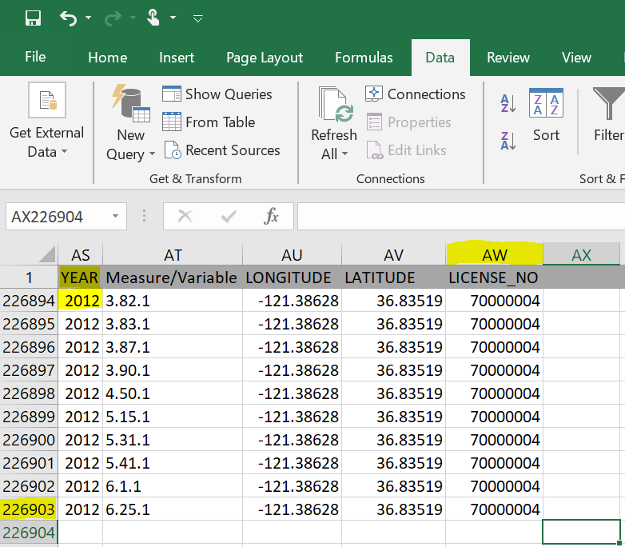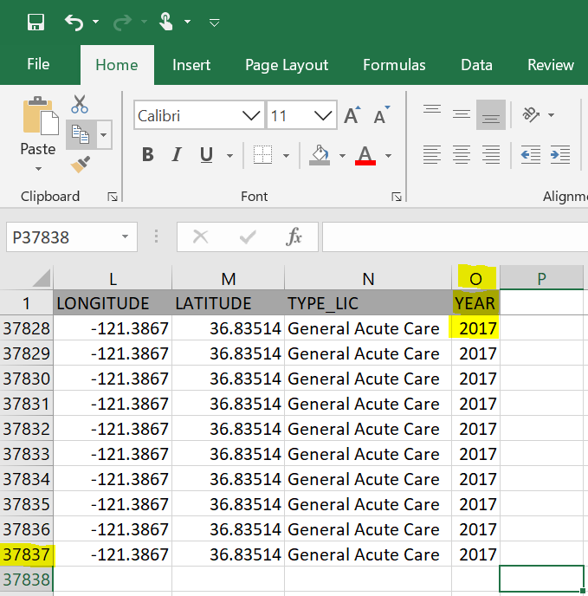

In ArcGIS Pro:

Although I had extracted the data that I wanted from the original dataset, I still had more data processing to do. There were multiple records from the same facility, and my goal was to remove all duplicates before I started to work with it in a WebMap.

The first step was to add the dataset to ArcGIS Pro.

- Open a new map in ArcGIS Pro
- Open Toolbox: Analysis > Geoprocessing > Tools
- Selected Tool: Excel to Table
- Entered Parameters: Added Excel File
- Run

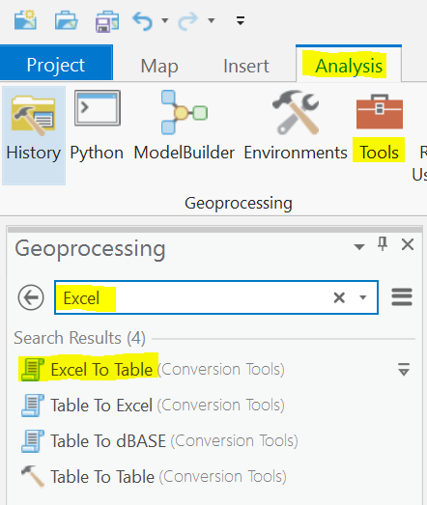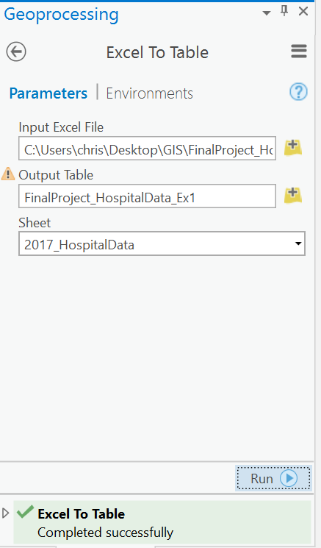

The second step was to remove the duplicate records. I used the Delete Identical tool in the Data Management toolbox. This tool:

“Deletes records in a feature class or table which have identical values in a list of fields.This tool finds identical records based on input field values, then deletes all but one of the identical records from each set of identical records. The values from multiple fields in the input dataset can be compared. If more than one field is specified, records are matched by the values in the first field, then by the values of the second field, and so on.”

Since I am familiar with the data and know that OSHPD assigns a unique ID number to each licensed California facility, I chose to use the OSHPD_ID field to perform the delete on. After running the tool, I was left with 506 unique facilities.

- Open Toolbox: Analysis > Geoprocessing > Tools
- Selected Tool: Delete Identical
- Entered Parameters: Added Dataset and Field: OSHPD_ID
- Run

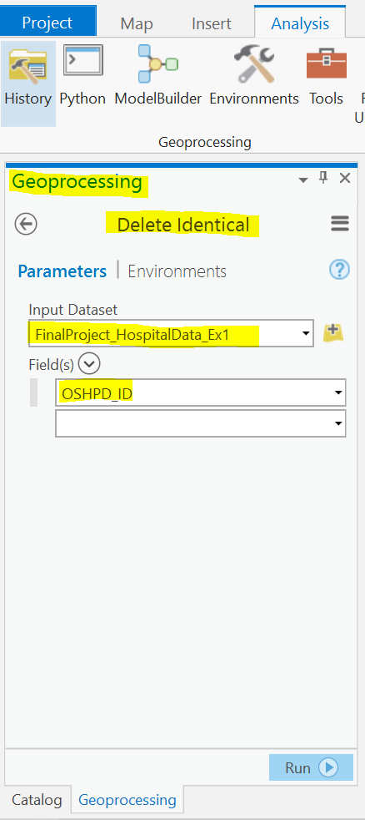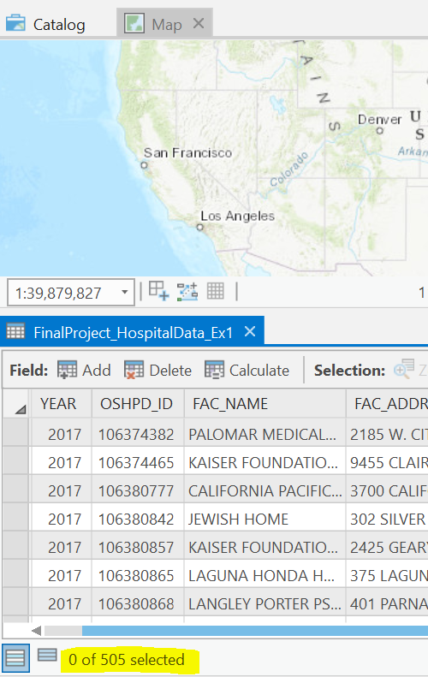

The third step is to convert the table to a feature layer using the longitude and latitude coordinates. Simply right click the table under Contents, and select “Display XY Data.” Next add the Longitude value in the X Field and Latitude in the Y Field, select a Spatial Reference if desired, and click Run. Point will display on the map after it is done processing, and a new layer will be added to the Contents.
Note: Make XY Event Layer Tool can also be found in Data Management Tools.
“Creates a new point feature layer based on x- and y-coordinates defined in a table. If the source table contains z-coordinates (elevation values), that field can also be specified in the creation of the event layer. The layer created by this tool is temporary. The output point feature layer created by this tool is temporary and will not persist after the session ends. You can export this event layer to a feature class on disk using the Copy Features, Feature to Point, or Feature Class to Feature Class tool.”
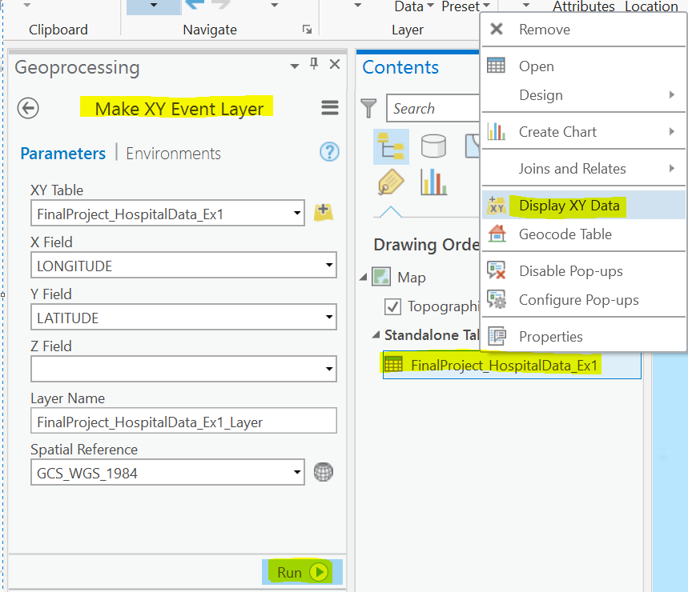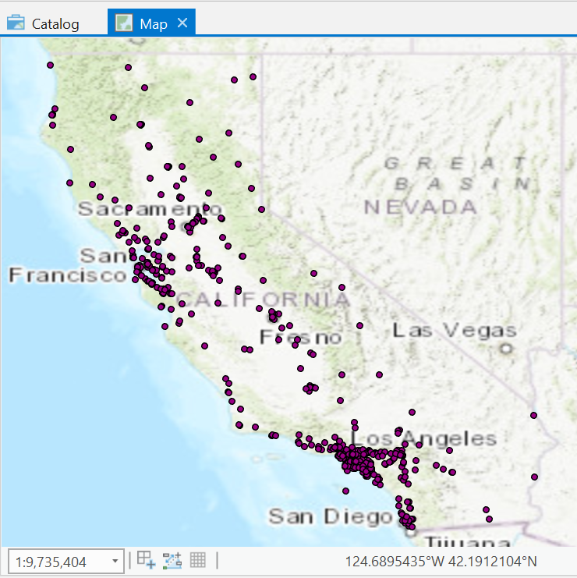

The fourth step was to create a copy of the layer that was created by the “Make XY Event Layer” tool. I started by right clicking the temporary layer file that was created and selected “Save as Layer File.” This created a saved copy that should then be able to upload to AGOL. This was not the case however, and after many errors and failed attempts, I created a second copy using the “Copy Features” tool and that I was able to upload to AGOL. To upload it, I right clicked the second file, selected “Share as Web Layer,” and ultimately Published it to AGOL.
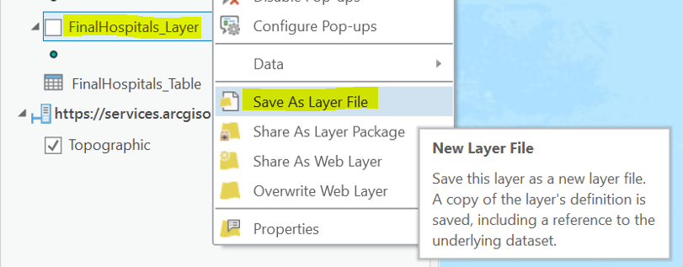
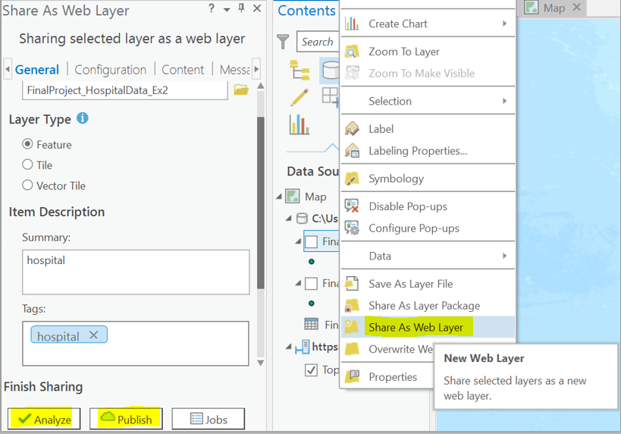

In AGOL:
Once the layer was uploaded into AGOL, I saw that it was saved as a Feature Layer (hosted). With this layer, I am able to open it in a new Map and save it as a Web Map.

When the layer opened in the Web Map the symbology was the same for each facility. In order to distinguish between the different types of facilities, I clicked the “Change Style” tool below the layer name. I chose “TYPE_LIC” as the attribute to show and opened the “Options” button for “Types (Unique symbols).

- Select: Change Style
- Drop Down: TYPE_LIC
- Select: Options (Types Unique symbols)
- Format symbols as necessary: Shape, Fill, Outline
- Select: OK
- Select: Done

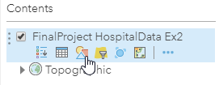
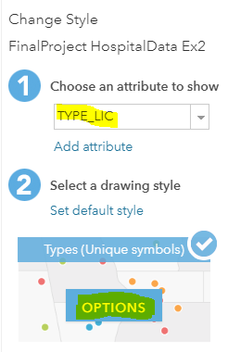

While playing with the symbology, I tried to find shapes that most related to the three types of facilities that would appear in the legend (General Acute Care, Acute Psychiatric, Psychiatric Health Facility), but none were appropriate. Eventually I decided to just use basic circles, and updated the fill, outline and transparency for each. The colors offered enough contrast on the map to be distinguishable from one another, and the transparency helps so that two facilities in proximity will not be hidden.

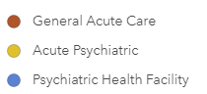

Since 506 facilities is still a lot of data to process, I decided to create another subset of facilities based on counties in the Sacramento Valley: Sacramento, San Joaquin, Sutter, Placer, Yolo, Yuba. To do this, I selected the “Filter” tool below the layer name, which allowed me to enter parameters to select the desired counties. Each county had to be added one at a time.

- Select: Filter
- Drop Down: “Display features in the layer that match any of the following expressions”
- COUNTY IS Sacramento
- Select: Add another expression
- COUNTY IS enter desired county, as many as necessary
- Select: Apply Filter

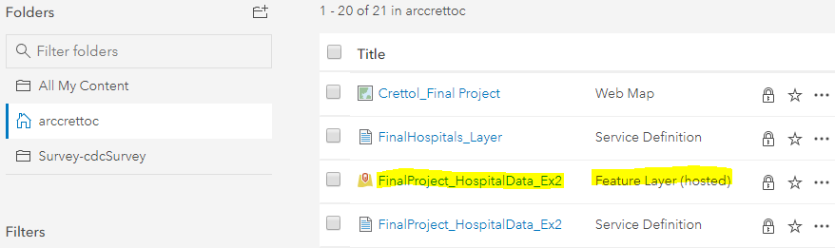
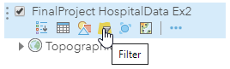
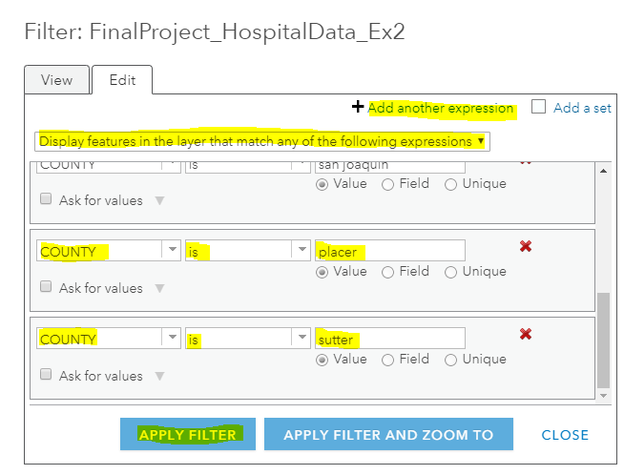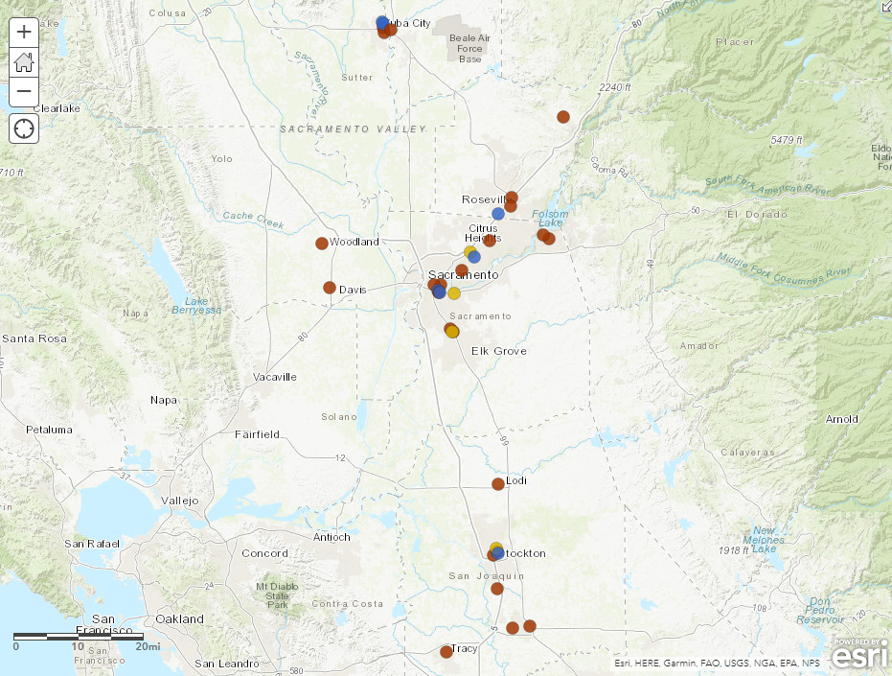

The final step was to configure the information that is displayed when a facility is selected. Before any changes, this pop-up will display all the fields from the data table. By selecting the “Ellipsis” below the layer name and then selected the “Configure Pop-up” tool. After clicking the “Configure Attributes” link, it displayed all the field names with check boxes that allow you to show or hide a field. It also allows you to reorder the fields if desired. Once this step was complete, only the relevant information will be viewable by the user.

- Select: Ellipses
- Select: Configure Pop-up
- Select: Configure Attributes
- Check Box: Select all of the Fields you want displayed
- Click: OK
- Click: OK

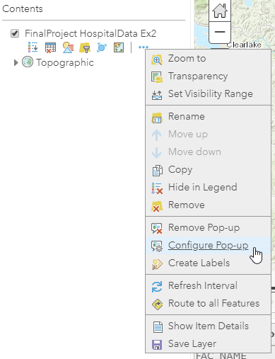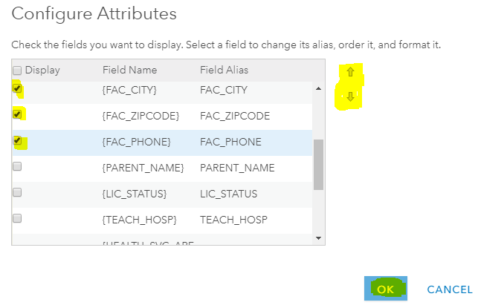
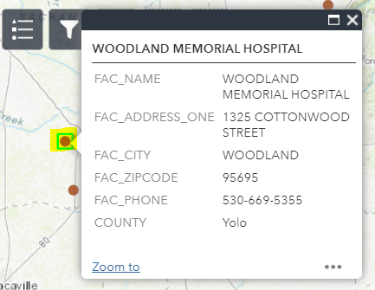

Building Web Application

Once the data was clean, I began to build the web application. I wanted to create an application that displays the three types of facilities. It will have a widget for a legend, a widget to filter between each of the facilities individually or multiple, and finally another widget to filter the facilities by county.

Legend Widget:
The Legend widget was pretty straight forward. Once it is selected there are only a few configurations that can be made. I changed the header of the legend from “Legend” to “License Type.” Unfortunately, there is not an option to hide the layer name when the legend is displayed, but I was able to set a couple of parameters to align the list to the left, and selected for the list to update based on the extent of the
map. Once those edits were made, I selected OK and this widget was complete.

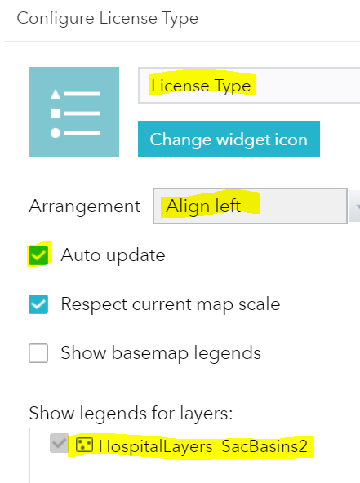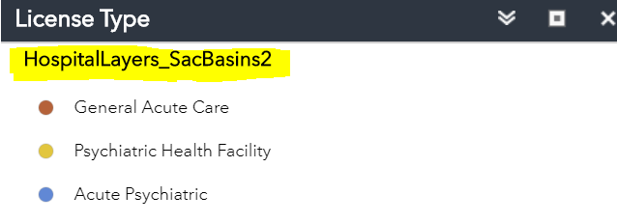

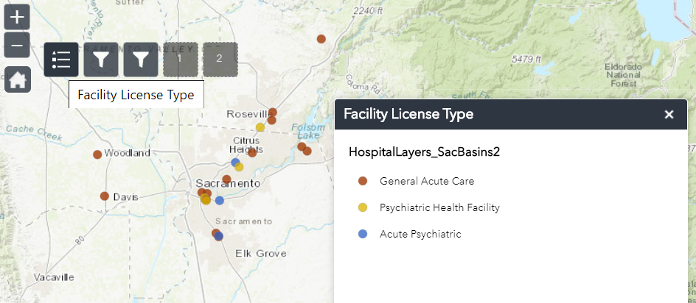

Filter Widget – Facility License Type:
I used to Filter widget to allow the user to make a selection of one or multiple facility license types on the map. To build the widget, I first had to specify the dataset that it relates to and renamed it “Facility License Type – Filter” to make its function more obvious. I also changed the Label for each type and updated the color of the Icon to match the symbology on the map. In the Expressions portion of the filter, I had to create an expression that included the Field (TYPE_LIC (String)), the condition (is), and then type out the exact name of the license.

With the filter complete, once you select the widget, you can toggle on or off each of the types of licensed facilities.

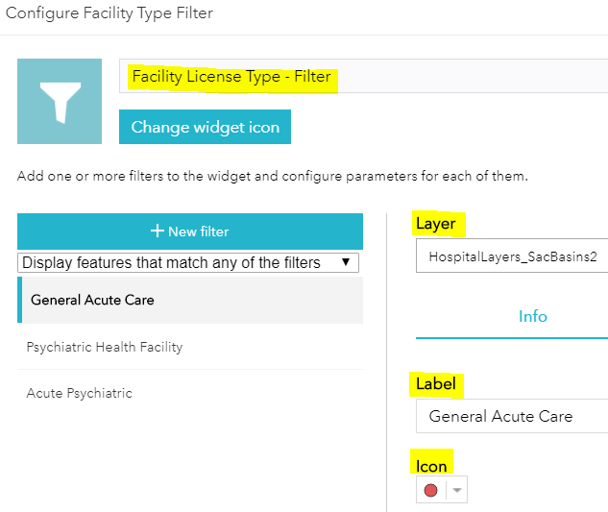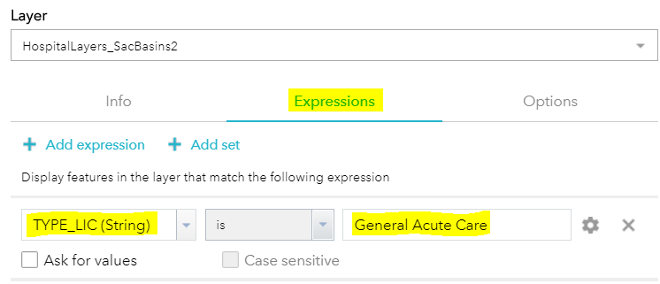
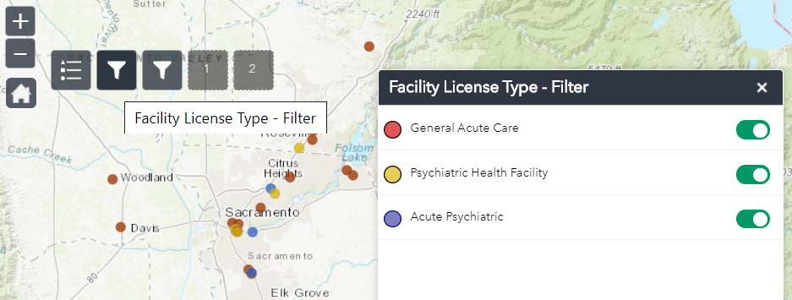
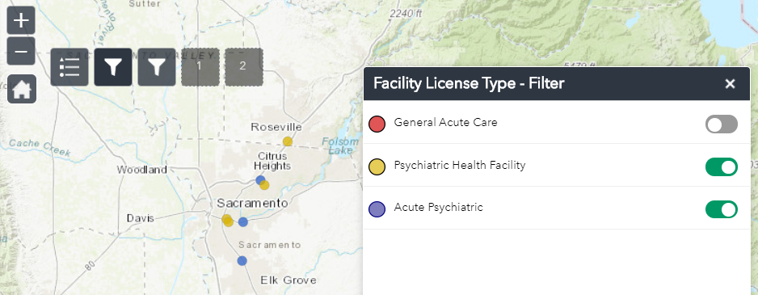
Filter Widget – County:
I created another filter that allows the user to filter the facilities by county. I was much the same as the previous filter. The difference is that instead of having toggle buttons, the user will have to type in the name manually. I created a hint below the text entry box so the user would know which counties are available and also the correct spelling. What is cool about this filter is that it works in tandem with the first filter. In the Expressions section, I selected the “Ask for values” checkbox so that the user can type in the county.

With the filter complete, the user can select facilities by county.

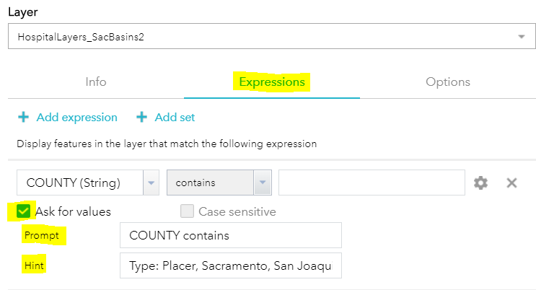
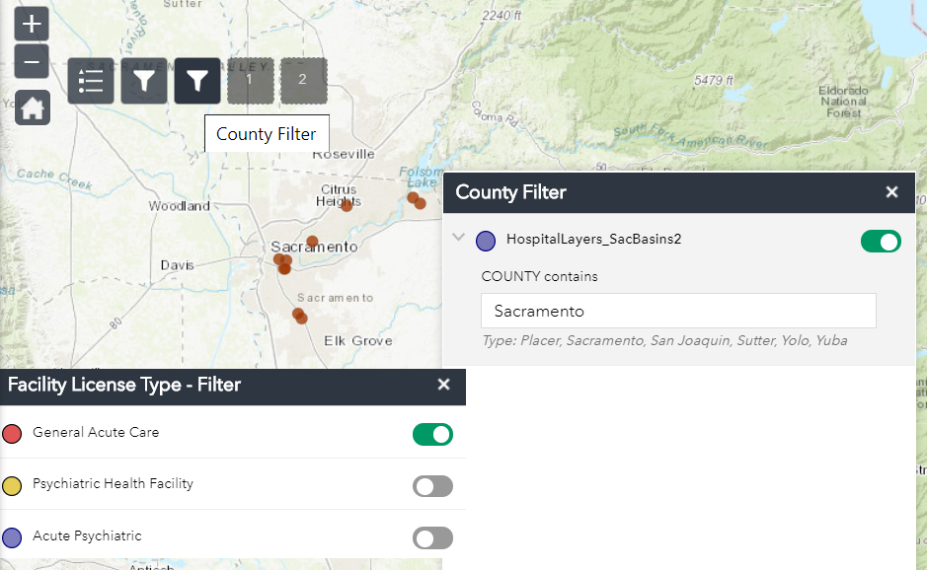

Building the Web Dashboard:

Side Panel – Selector Option for Health Service Area:
The first thing I did was add a Panel to the left side of the map. This will allow me to display the two selectors that can be used as filters by the user. Here I had to specify the dataset, how the data would be categorized (Group Values), and then had to build out a filter for each HAS. For this I selected the Filed “HEALTH_SVC_AREA” from the table, sorted them in ascending order, chose to display by Radio Button, and allowed for a None option if the user wanted all HAS’s to be viewable.

The result allowed the user to select one or all HAS(s).

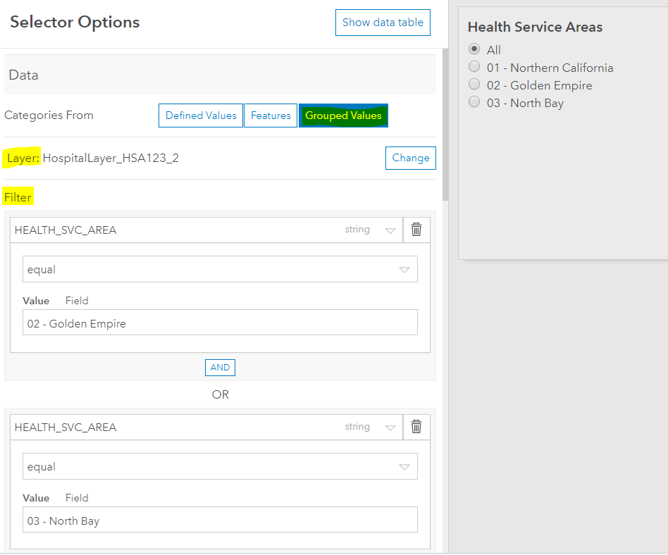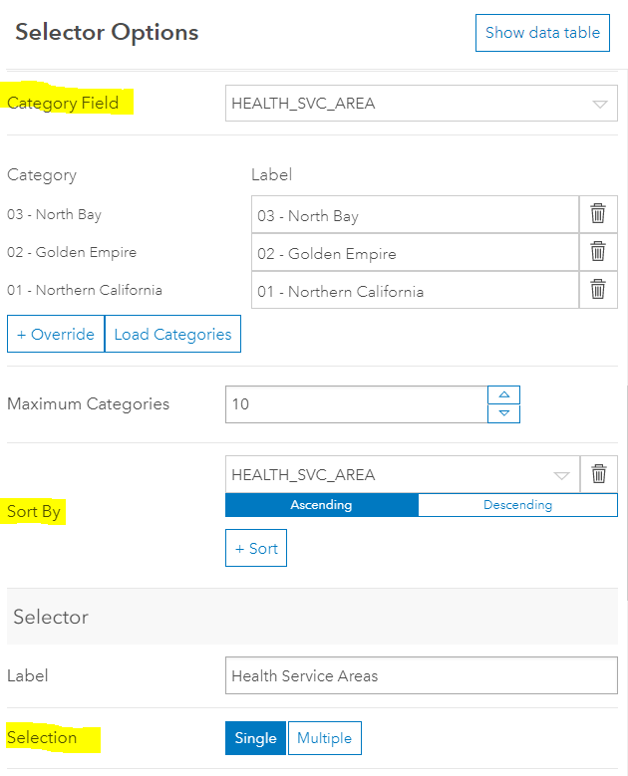
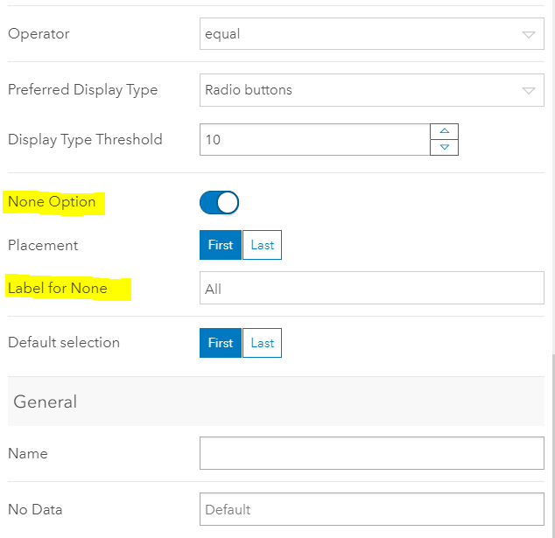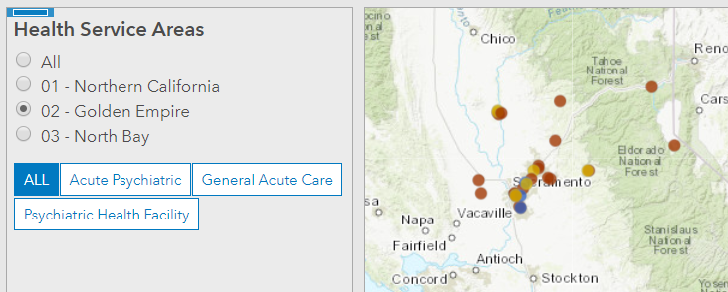

Side Panel – Selector Option for Facility License Type:
The second selector I added will allow the user to select facilities by License Type. This was constructed much like the filter in the Web App.

The result allowed the user to select one Facility License Type at a time, and works in tandem with the HAS selector.

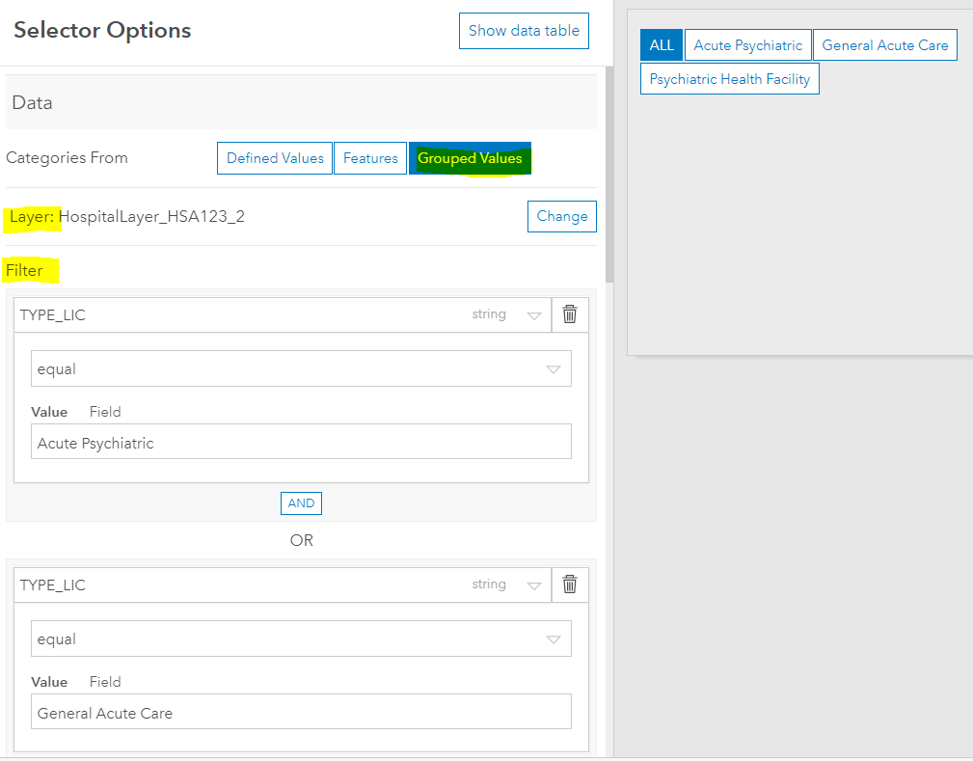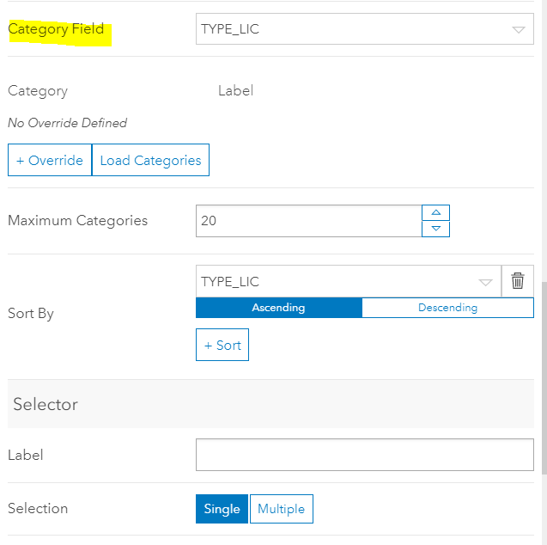
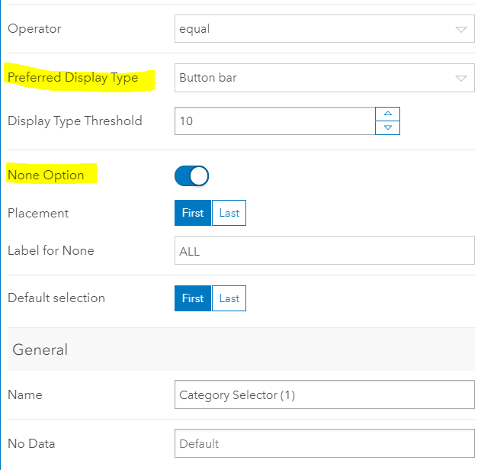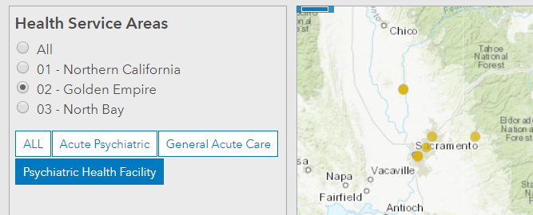

Challenges:

Processing the Data:

Creating 2017 Data:
When I was first cleaning the data in excel, I could not find a simple way to save my filtered data to a new spreadsheet. After some brief searching online, I determined the best way to do it was to filter the data down to what I wanted and then copy and paste it to another worksheet. The first time tried to copy and paste all of the data and it froze the worksheet and I ultimately had to cancel it. I then copied two columns at a time and pasted them to another worksheet. It was not too bad since I only had 15 columns, but depending on the project or the size of the dataset, I may have to find an alternative way in the future.

Share as Web Layer – From ArcGIS Pro to AGOL:
I spent about three hours trying to figure out how to move my Feature Layer in ArcGIS Pro to AGOL. I knew the correct steps and followed them several times. I reloaded the table and performed the calculations several times. I closed out of everything and reopened everything. I tried loading the table in the .xlsx and a .csv format. Here is what finally seemed to be the trick. After using the “Display XY Data” tool on the table, it created a temporary layer. I then clicked on the temporary file and used the “Save as Layer File” tool to make a copy. When I tried to “Share as Web Layer” this file, I would always get a generic “Failed to publish web layer” error, and give no reasons why. So finally, I used the “Copy Features” tool on the first copy to make a second copy. This “Copy Features” file was able to Publish. I read a few posts and some instructions on Esri’s website, but eventually I resolved this through trial and error.

Filtering Final Dataset:
Another challenge was coming up with the final dataset to use for the Web App. Initially I filtered it down to 506 facilities in ArcGIS Pro and uploaded it to a Web Map. After looking at the data on the Web Map, I performed a filter to reduce the facilities based on six Sacramento Basin counties, and that reduced the number down to 39. When I created the Web App suing that filtered data, I thought that the App would only apply to the 39 filtered facilities, but when I looked at the legend it included features that were not present (Chemical Dependency Recovery Hospital). That meant that when I use a widget it is still crunching through the list of 506 facilities.

The solution was to go back to the original .xlsx file and select only the 39 facilities in the Sacramento Basin counties. I then started over from the beginning to rebuild the Web App.

Pop Ups:
On the Web App, the first time I opened the Web App, the Pop Up displayed as I expected. When the user clicks on the facility’s symbol, a table was displayed with all of the Fields that I selected. When I opened the Web App another time, it only displayed the facility name and had an arrow to toggle to the table.
The solution was that my browser was zoomed in to closely for the table to display on its own. Once I zoomed the browser out, it displayed as expected.

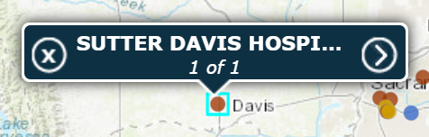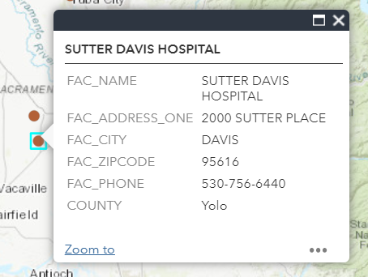

Conclusions:

I believe that the project was a success. I was able to create two different types of visualizations that I may be able to use a product at work. If so, these maps would be embedded into web pages that would be available to the public. I would of course expand the filters in the Web App and the Web Dashboard to include all of the Facility License Types, Counties, and Health Service Areas. I would also take into account any feedback from my colleagues or subject matter experts in case there is some crucial information that I left out. Also, there are many other datasets on the CHHS Open Data Portal that can be linked to this dataset by Facility_ID that can be used to create other data products. The possibilities and potential of ArcGIS Online and Web Apps and Dashboards will greatly help me with my career.

CHHS Open Data Portal, “Hospital Annual Utilization Report & Pivot Tables,” https://data.chhs.ca.gov/dataset/hospital-annual-utilization-report
Esri. ArcGIS Pro – Tool Reference: Delete Identical. https://pro.arcgis.com/en/pro-app/tool-reference/data-management/delete-identical.htm
Esri. ArcGIS Pro – Tool Reference: Make XY Event Layer. https://pro.arcgis.com/en/pro-app/tool-reference/data-management/make-xy-event-layer.htm

