Eva Cordtz
Geography 90 Final Project Paper
Prof. Nathan Jennings

Project Summary
This project shows four national park boundaries, ozone pollution levels, and a select few urban centers to illustrate the relationship between urban centers, pollution levels, and national park boundaries. The deliverable included a map of California with pollution zones, urban centers and 4 national park boundaries, along with an inset of Sequoia and Kings Canyon park with pollution data to illustrate the relationship between pollution and park boundaries. Data was gathered from multiple sources in addition to being manually digitized.

One sentence summary:
The goal was to generate a map that illustrated the relationship between the four most polluted national parks in California, cities, & air quality because unhealthy air impacts national park visitation numbers, & the health of visitors & park employees.

Project Purpose
The project goal was to illustrate the areas of ozone pollution in California overlaid with four national park boundaries. The parks were chosen based off a list of the 10 Most Polluted National Parks in the United States (4 of which are in California). The goal was to generate a map that illustrated the relationship between national parks and air quality because unhealthy air impacts national park visitation and park experiences. The purpose of this map seeks illustrate the relationship between the air quality and park boundaries to educate the public that a day outdoors may very well not be better for your lungs (often the national parks shown in map will experience more bad air quality days than large cities).

Project Idea came from:
https://www.npca.org/articles/527-national-parks-plagued-by-significant-air-pollution-impacts-finds-new

Description of the GIS data management, creation, cartography tasks and methods used to create the data / outputs

Data Management / Creation
The initial data management was done under the geodatabase that is created upon opening a new project folder.
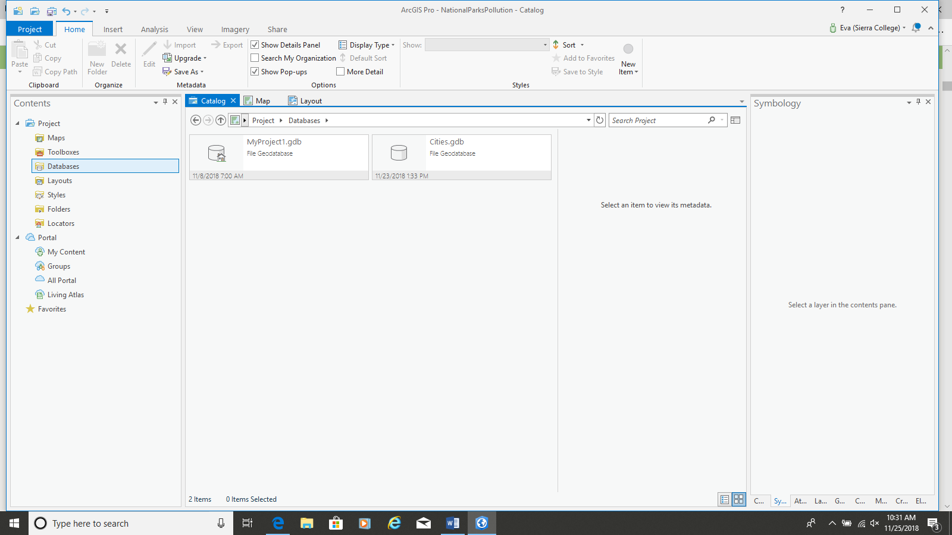

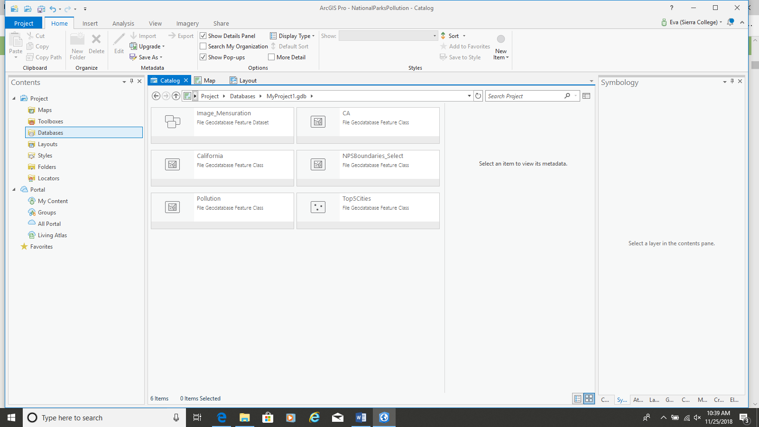
To get data for the ozone pollution levels, I searched through the portal and found a dataset from the EPA, and clicked add to map. This data was added under the geodatabase for the project. This data didn’t need to be edited or geoprocessed.
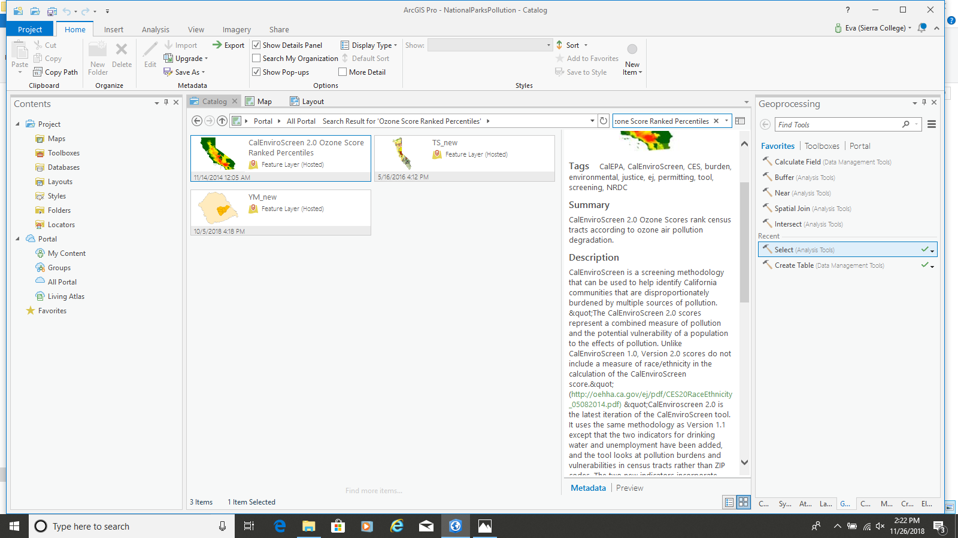

The data for the National Parks Service was managed via geoprocessing, this was exported as a feature class inside the project database.
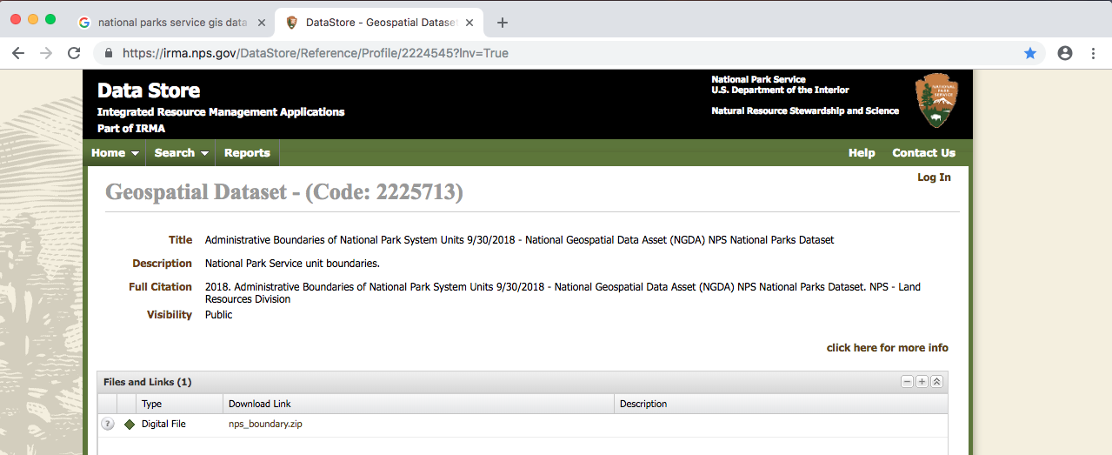

The data for the cities was generated via “digitize feature” as a point. I manually digitized all 10 cities, entered population data as a attribute field, along with percentage of population growth. This feature class was stored inside the main project geodatabase.
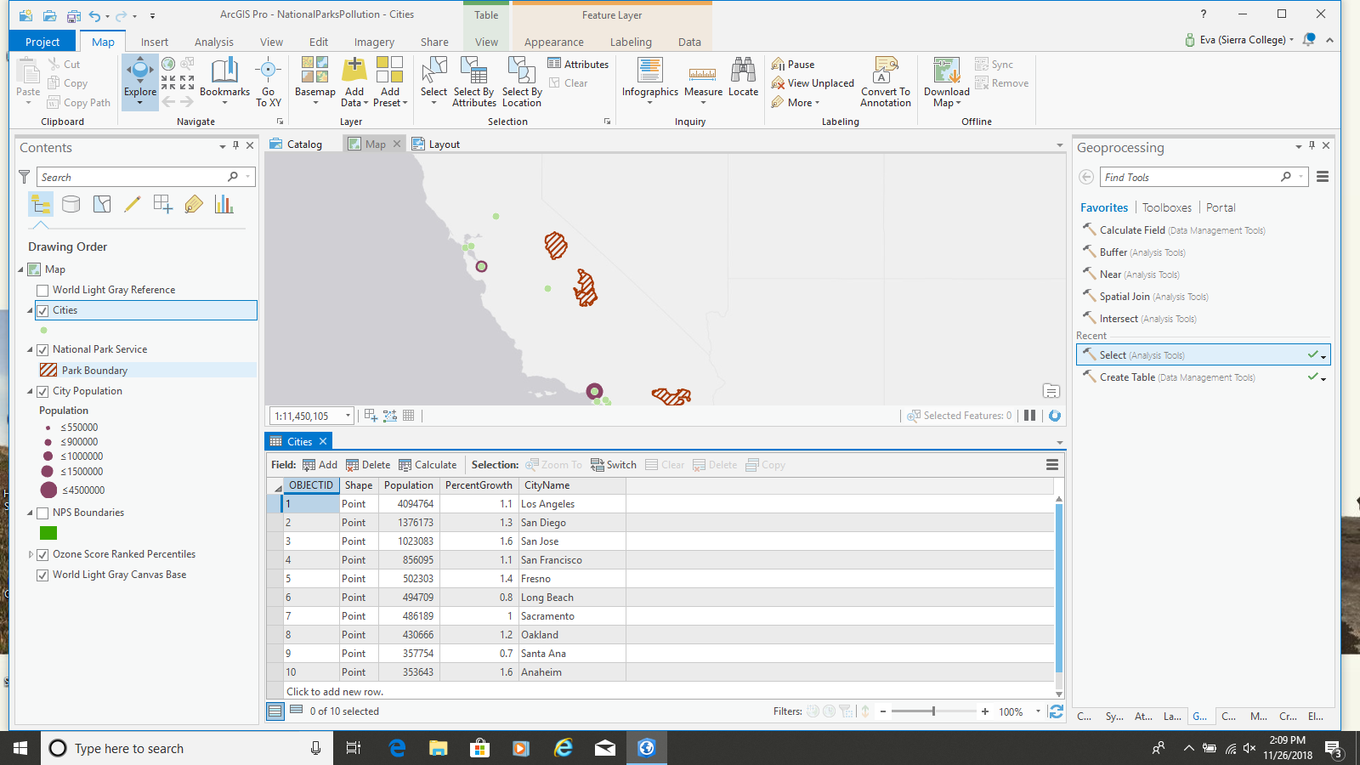

Cartography Tasks / Methods
One of the first cartography tasks was right clicking on park boundary layer and cities layer, then clicking properties and hitting label. After the labels generated, I was able to format the labels, by adjusting placement of the labels, color, leading, the font itself, size and weight.

Next I labeled the data created for the cities. Here I made sure to format the labels in a different weight from the park boundary layer to increase visual contrast and readability.

Then I created symbols for the cities choosing the standard circular symbol. I selected graduated symbols based off the data of population number on a graduated scale for visual scale and contrast. The color purple was selected because it gave enough visual contrast from the pollution dataset without being distracting. The symbols were graduated to give a better sense of the relationship to population and cities generating pollution / proximity to parks.

Next I edited the symbology for the national parks. I knew the park boundary could not be a solid fill for this would overlay and block the pollution data. The hatched lines were created so the pollution data would still be visible. The color brown was chosen to add visual contrast with the pollution color map, and the city symbology.

The next step was to create the map layout or “insert- Insert New Layout” choosing standard 8.5x11 sheet. Next, I clicked “insert map frame, default” to add the map frame to the layout. After the map frame opened, I resized the map frame to include a .25” margin on the map to ensure the map could be printed on a sheet of 8.5x11 without needed to cut to account for bleed. I then added the map to the map frame.

After the margins were set and the data and map were visible in the map / layout frame, I inserted a legend via the insert legend tab. I then formatted the legend, checking the box to make sure the pollution data stayed in one single column (if it overflowed into 2+ columns the legend would be too wide to fit into the designated space). I sized the legend down and arranged it on the map. I edited what labels were displaying on the map, and edited the name of the National Park layer to increase clarity. I increased the leading between the symbols to give the legend some breathing room. Next I added a simple north arrow and scale for reference.

The final step was using the insert>text to add the title for the map, making it a bold and large font.

Note:
It’s important to note that a copy was made of the legend, and one of the legends was outlined and ungrouped, and the graduated symbols were evenly spaced. This needed to be done last because the outlined legend was no longer linked to the map.

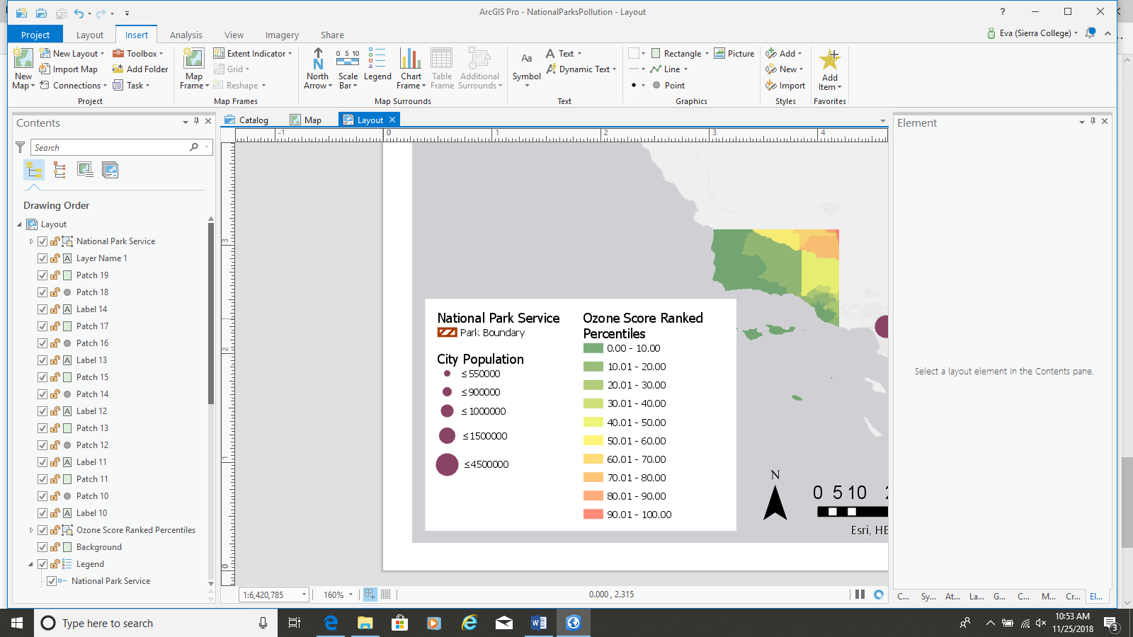

GIS Tasks/ Steps Used in Geoprocessing
The first step was to create a new map project in ArcPro, and save the file.

Next I used the add data button to add and search for data. The data was added mostly from the portal, but the National Park Boundary file was added via a downloadable file from the National Park Service itself.

The layer of data that was added via the portal was the ozone particulate data for the state of California from the EPA. This did not need to be geoprocessed because the data set was already for the state of California.

To add the data from the national parks service, I had to establish a folder connection to where I stored the downloaded data. After that I added the data to the map.

The next step was to make sure the national parks only showed certain parks. This required I use the Geoprocessing > select, select by state with “CA”.
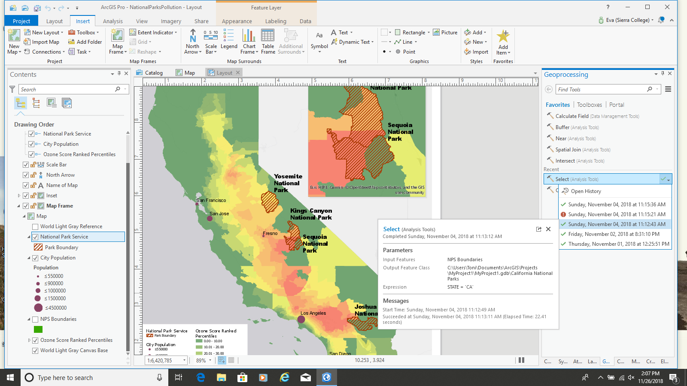
This gave me the ability to see which parks were in the state of California and “National Park and Recreation Area” were listed as well. Next to give myself more practice with geoprocessing tools, I ran geoprocessing> select / select by attribute, using the four park names with definition query “Yosemite / Joshua Tree / Kings Canyon / Sequoia”.
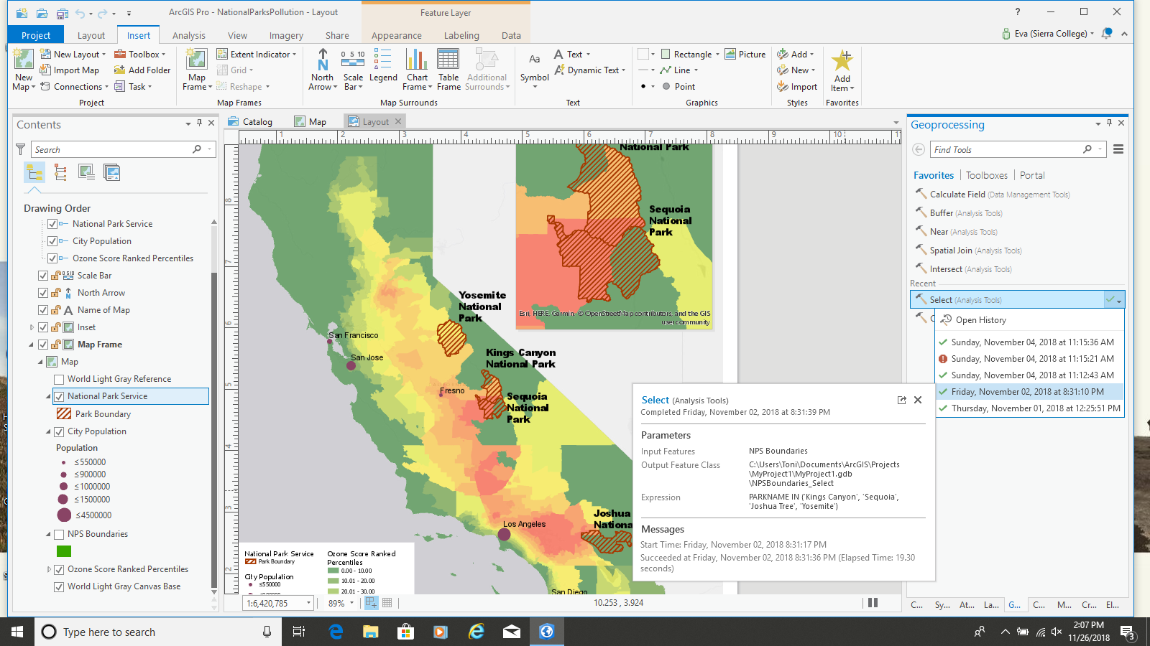
The next geoprocessing step that was ran was after the city data was generated manually. The ten most populated cities in the state were added and digitized manually. After adding these 10 cities to the map it was clear that by displaying all 10, the map wouldn’t be readable, due the proximity of the cities to each other. The next step was to run a geoprocessing > select / select by attribute “<6” for the top 5 cities since the data was inputted by population order. This exported the data as a feature class inside the geodatabase for the project.
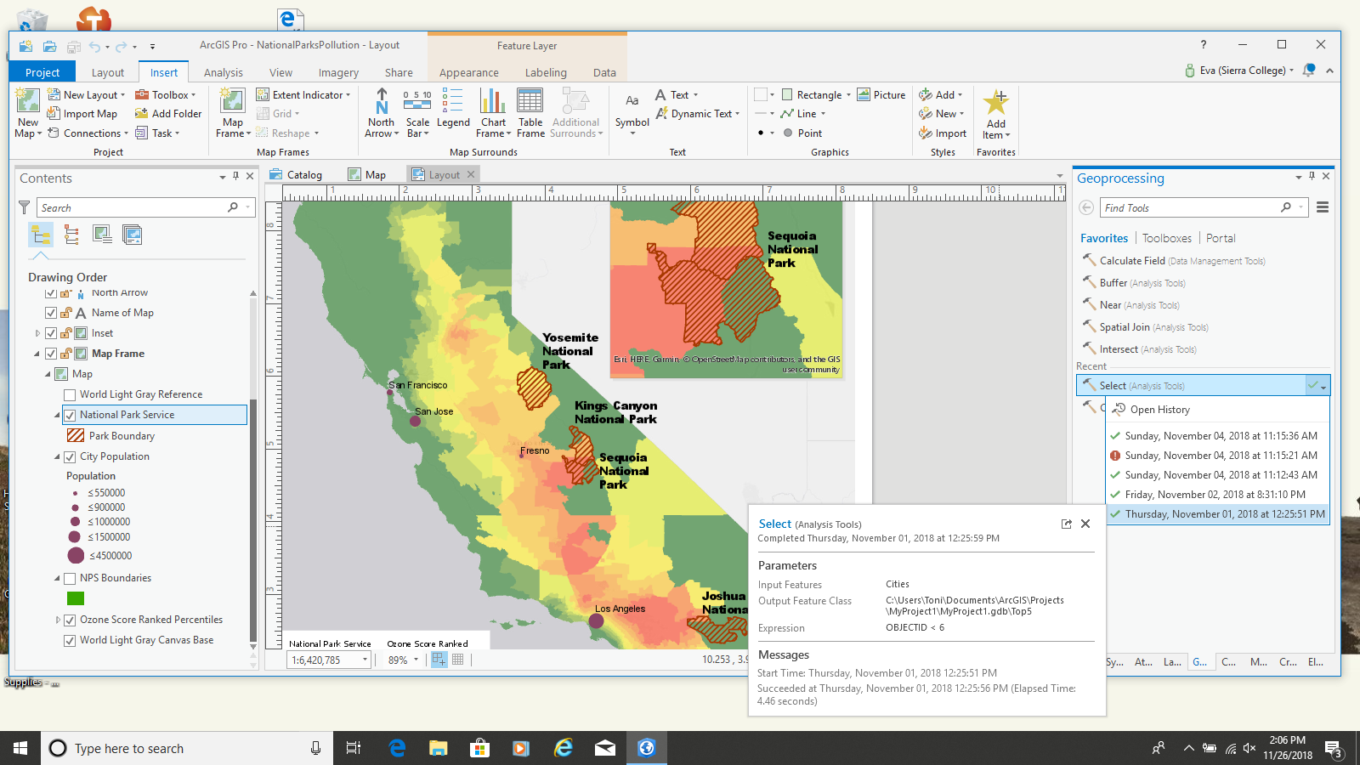

Note:
These geoprocessing results created feature classes inside the existing project geodatabase.

After added the data, I changed the basemap to the light gray reference and turned off the overhead labels to make sure the base map did not interfere with the labels on the map itself.

Next the step was to turn on and format labels and symbols for cities, and park boundaries (this step is elaborated on in the cartography section).

Next I created and placed the legend. I had to edit the population data range so it made more sense to a viewer. After the map was finalized, I outlined the legend itself, and edited the spacing between the graduated symbols.

Discussion of Challenges, Problems, Issues, Resolutions, Outcomes

Labeling
There were multiple challenges / problems that required problem solving. One came about from labeling. Multiple National Parks have parkland separated by other land jurisdictions; when this land is labeled in ArcPro both parcels are automatically labeled creating a double label. This created layout problems, where the double label could confuse a user/ affect readability and usability, cause issues with nearby labels, increase visual complexity of the map. In order to resolve this, turn off double labels needed to be unchecked. This ensured double labels would not be visible, creating a more uniform, readable layout.

One other labeling issue was the placement of labels. In ArcMap you have flexibility to move individual labels without having to outline the text to make it an object. In ArcPro there isn’t the same level of flexibility with label placement, you seem limited on certain label locations. This isn’t ideal because certain labels rest at a location that are not an effective location or the most legible / readable location for a static 2D layout.

Pollution Data
Another problem came from gathering useful data on ozone pollution levels. The first data set downloaded from the EPA had the data split by zone area where air quality was not up to par or what is referred to as Non-Attainment Zones. This data was not able to be displayed as a heat map because the ozone pollution data was not grouped by density, but rather area and polygon shape. This data did not give a good visual sense of what areas had cleaner air for a sense of comparison. This was not the most effective dataset to use. Instead, a dataset was gathered from the EPA on ozone particulate levels to show where ozone pollution is the worst in the state of California. Even though this data set was not able to be presented as a heat map either, it gave a better visual reference on pollution levels. By finding a dataset that was not sufficient, I was able to keep looking for data that enabled a more effective presentation.

Legend formatting
One very frustrating problem was the formatting of the legend. Although you can turn on/off keep in one column there is not a way (or one that I found) to control where you want the column breaks to be. For instance, if I wanted pollution data to break and flow into a new column at a certain break point, I was not able to insert that break myself. You can resize the legend box, but the formatting shifts are not predictable, or do what you want. There was not a high level of layout format flexibility as I was expecting, or as you are able to have in ArcMap.

Another legend formatting item that was I not able to resolve as well I would have liked was to have equal spacing between graduated symbols. You can space out the symbols that are rectangle, but I could not find a way to have equal spacing between graduated symbols. The solution I came to in a pinch was making a copy of the legend and outlining the legend, ungrouping the items, and manually adjusting the spacing between the graduated symbols right before export.

Packaging File
A challenge that may have been a bug was the fact that certain geoprocessing actions were not retained in packaging layout when opened in older version. When packaged files were moved from 2.2 to 1.4 in class certain geoprocessing actions that were used were not retained, and the data table was empty in the feature class. Also, certain labels were not showing up. This did not impact my final map because I operated mostly in the newer version of Pro.

Learning Experiences
Creating this map reinforced concepts we covered in class, and helped solidify aspects that seemed confusing. This project really solidified the relationship between a geodatabase and feature classes through creation and manipulation of feature classes and data. The aspects that I learned and were reinforced by using the software were: data creation and digitization, geoprocessing tools such as: select / select by attribute, and view history, how to create and format labels and symbols, change fonts, turn of double labels, creation of an inset map, the relationship between the map and creating the actual layout in ArcPro, feature classes and their relationship to geodatabases. This project helped solidify many of the concepts we covered in class.

Map is on the following page

