Potential Garden Sites in Sacramento

Ann Cheshinski

Introduction
The purpose of this project is to prepare a map which shows potential sites for a community garden which would benefit the surrounding community by providing accessible “greenspace,” nutritious food, and educational opportunities for underprivileged youth. To determine which sites would be suitable, I will analyze the Sacramento community with GIS data and tools. I will look at factors including population density, locations of local parks, and distances between highly populated neighborhoods and grocery stores which provide healthy food options.

Methods
The first step was to determine where the highly populated areas of Sacramento are located. It was important for the potential site to give access to as many people as possible, so I wanted to consider population density. I decided to utilize the Census 2010 Block Population data made available by The City of Sacramento (Publisher_SacCity). This map was made up of polygons with attributed data on population, such as demographics and population density. Since I wanted to focus on the most highly populated areas, I used the Definition Query process in ArcGIS to filter the data to show blocks which had populations of at least 300 (TOTAL is at least 300), and a density of at least 100,000/sq. mi (POP_SQ_MI is at least 100,000). This left me with a map of specific polygons which I could use to show the highly populated areas of Sacramento (pictured below).

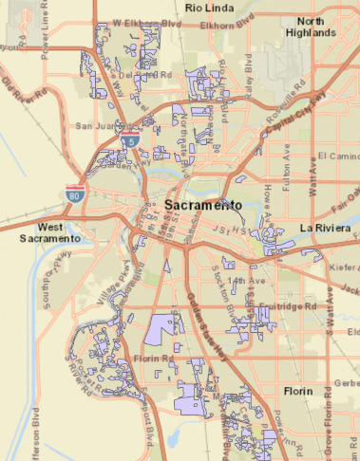

The next thing I wanted to examine was the community gardens and other related outdoor spaces currently available to Sacramento residents. The City of Sacramento (Publisher_SacCity) has a map available with public parks which were organized into Amenity type, which made it easy for me to define which parks to include in my map. Again, I used the Definition Query tool and set Amenity types to “Community Garden,” “Farmer’s Market Area,” and “Group Picnic Area.” At this point, I wanted to also consider community equity, so I wanted to look at data involving the economic status of the Sacramento population. I decided to utilize the Environmental Justice map created by SACOG_Admin, which shows areas identified as low income, of minority-majority population, and other qualifications of vulnerability. These two added layers started to make clear to me the areas to focus on further (pictured below).

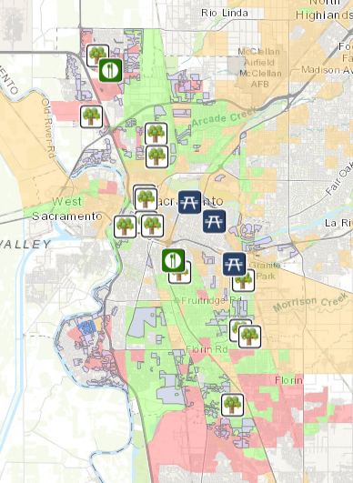

Another important consideration for my map was to include the locations of grocery stores within the City. When searching for a feature layer to use, I found that many were out of date, probably because of the quick rate at which businesses could be constructed and opened. I decided to make a map myself that would show pinned locations of all grocery stores which I knew provided fresh, nutritious food. To do this, I used Google Maps to find the location of each store, then pinned the location on ArcGIS and labeled each with the name of the store (pictured below).

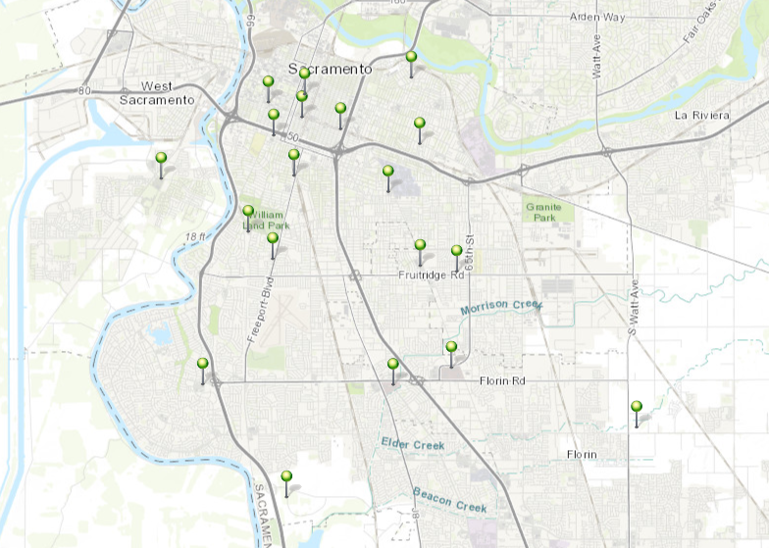

The final thing I wanted to consider in this project was accessibility. Per the Move for Hunger Organization, part of being a food desert is being more than a mile from fresh food. In the case of Sacramento neighborhoods, most fresh food options come from grocery stores. Therefore, I wanted to incorporate a one mile buffer around each grocery store pin on my map. This was an easy step to immediately visualize which communities had a longer trip to get food. Other aspects of accessibility which I would include if this were a professional project, or if time allowed, would include transportation accessibility, such as bus routes, sidewalks and trails, and bike paths. Within the parameters of this project, however, I found that adding those layers only made the map harder to read. The final map is included on the last page of this report.

Discussion and Results
This project presented some interesting challenges for me. Most of the issues I encountered, however, were conceived from my lack of experience with the ArcGIS program. Other problems came from the data I was trying to use. For instance, I originally wanted to work with a layer by Atlas Publisher called USA Poverty Ratio, which gave a clear representation of the communities whose populations were of a poverty-majority. This data was only available as Read Only, which made it impossible for me to even edit the colors of the polygons in the layer, which in turn deemed the data unusable for my project. However, with Professor Jennings’ guidance and further research, I was able to find another layer which was more conducive to a readable map. Another challenge I had dealt with using ArcGIS Online, where I found it difficult to edit the map legend. I could either include or exclude specific layers, however, I couldn’t figure out how to specify which symbols to include from each layer. For example, if I included the Parks layer, which had a multitude of markers, it would take up the entirety of the legend, and it would be including symbols which wouldn’t be found on the map itself. While I could query out what to show on the map, the same query wouldn’t apply to the legend. I was unable to fully resolve this issue. I decided to exclude the Parks Layer from the legend, while knowing that the symbols used were decidedly clear to understand. Despite my research on the topic, I also could not figure out how to include a compass rose or scale. This was highly disappointing and I think I would have been able to include these if I had completed the project on ArcGIS Pro.
The main thing I learned from this project is that ArcGIS is limited only by what we put into it. I spent a lot of time discovering different tools and analyzing only a small fraction of the data available to me. This meant I had to learn how to elect which information was necessary to include, and which information would not supplement but instead distract the viewer from the purpose of the map. While I’m happy with how my map concluded, I understand how much more data could have been presented with more time and work, and how useful this map could be to community members in a decision-making process. Maps have always been used to visualize the world around us, and GIS is the next step to using data to come to a deeper understanding of our world and communities. I hope to keep developing my GIS skills to advance my career by being better informed and being able to spread knowledge on a widely comprehensive platform.

Final Map, available at http://arcg.is/0qqbPv.
