GEOG-90 Final Project Deliverables - Desolation Wilderness

Austin Brown

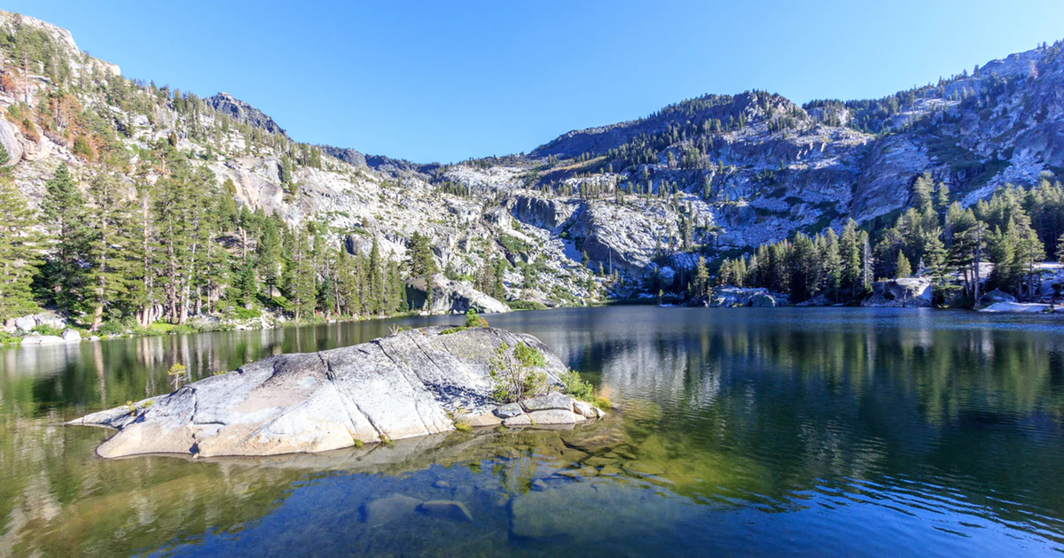

Project Summary:

This project covers and highlights an area of land totalling approximately 63,960-acres referred to as the Desolation Wilderness. This area of land is federally protected and is located in the South Lake Tahoe Basin of the El Dorado National Forest. The Desolation Wilderness has long been a site for outdoor recreation activities such as backpacking and hiking. In this project, popular hiking trails and camping spots have been noted along with trailhead access points and frequented mountains.

Purpose:

The purpose of this project is to highlight areas designated as suitable places to camp throughout the Desolation Wilderness along with the trails to access these spots. In addition, the map includes popular peaks that are frequently hiked and offer picturesque views from the summit. This map is intended for personal use as well as to be shared with friends and family looking for places to recreate in the South Lake Tahoe Basin.

Map Creation:

Various forms of data creation, management and cartography methods were used to create the final map. These methods included data creation through:

- Creating a file geodatabase, adding different types of feature classes and attribute fields
- Data editing through physically creating new data and manual digitizing.
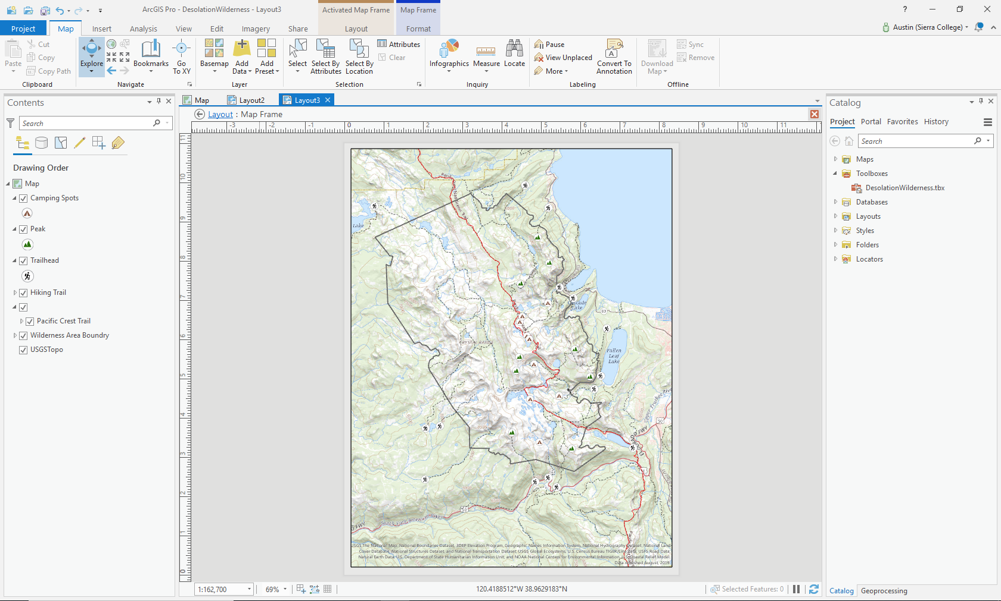

- Using different types of queries to select data, then exporting.

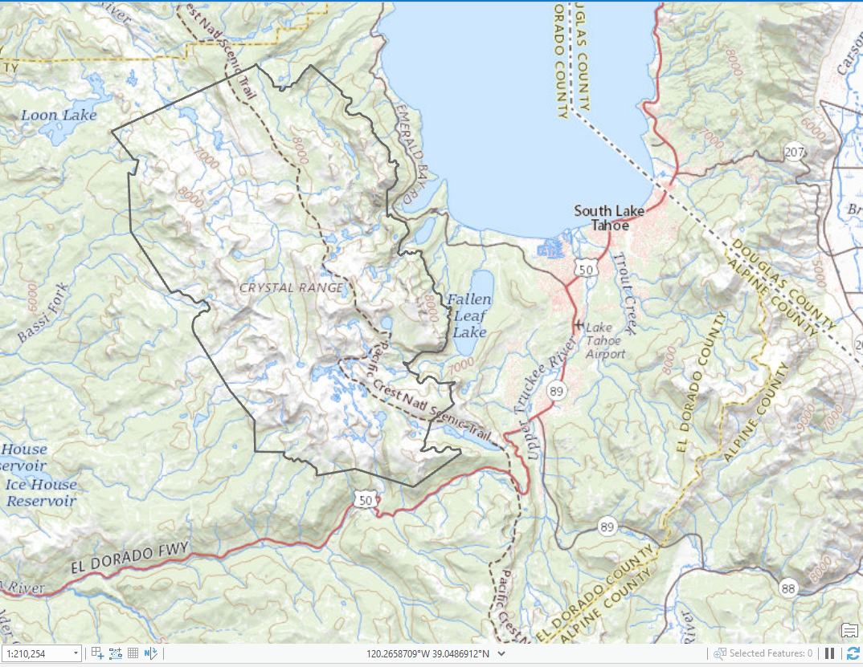

- Created data from GPS locations collected through a GPS device

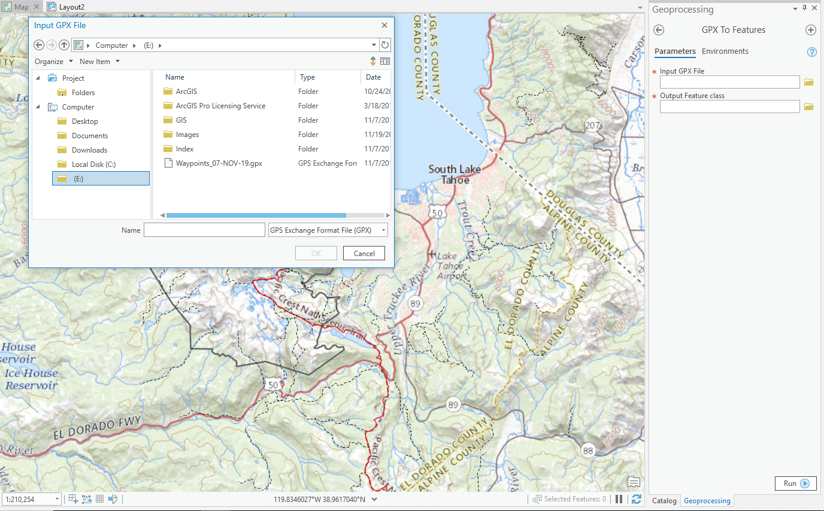

Project Difficulties/Obstacles:

Throughout the creation of the project I faced many setbacks including the original project idea. My first proposed project was to create a map that displayed features of the Folsom Lake State Recreation Area offering points of interest such as parking lots, restrooms, entrances and the overall boundary of the park. After collecting the data points with a GPS device and converting the GPX file to a Feature Class I found that the data points could not display properly on a fixed PDF map as the data points were too close together. After experiencing this setback, I changed my original idea to one that allowed my points of data I was collecting to be further away from each other allowing for an improved result.

Learning Outcomes:

This project offered many learning opportunities as I not only gained experience with the ArcGIS software, but also allowed for experimentation with the use of a handheld GPS system. The overall outcome of this project was positive and has increased my interest in the GIS field.

Final Map

