McClellan Utility Viewer Web App

  - Purpose
The purpose of this project is to create a web application to view, query and locate various utility layers at the former McClellan AFB. The web app was created to help in locating underground utilities to identify locations prior to any construction disturbances. The web app was developed to give access to anyone to help process construction encroachment permits at the former AFB. Currently, access to these utility files are limited to those with access to the feature layers and an understanding of ArcMap applications.

  - Description of Web Application Development
A few months ago I had a project at the Former Castle AFB in Merced County where the Air Force was preparing locations for site investigation of underground contamination. Prior to any work, utilities needed to be cleared and investigated at each of the locations where soil boring was going to be performed. The Castle Airport Manager pointed me to a web application that they use that showed where the underground utilities were located on the former Air Force base. The web app was available to the public and very helpful. The application helped in determining what utilities were of concern in a specific area prior to formal utility clearance operations. This project will provide a similar application for former McClellan AFB.

ArcMap is currently used to review utility conflicts on encroachment permits at former McClellan AFB. Access to this files are limited and require access privileges as well as knowledge of the use of ArcMap to perform reviews. It would be helpful if a web application was available to those interested to help identify utility locations.

The first part of the development was to create a file geodatabase with the following layers:
- Monitoring and Extraction wells
- Soil Vapor Extraction (SVE) Conveyance Lines
- Groundwater Extraction Conveyance lines
- Wetland Features (vernal pools, swales, creeks, etc.)
- Buildings (AF building number IDs)
- Central Plant Heating and Cooling lines
- Compressed Air lines
- Electrical Utilities
- Water Service
- Sewer Service
- Natural Gas
- Storm Drain lines
- Lots with boundaries and number
- Base Boundary

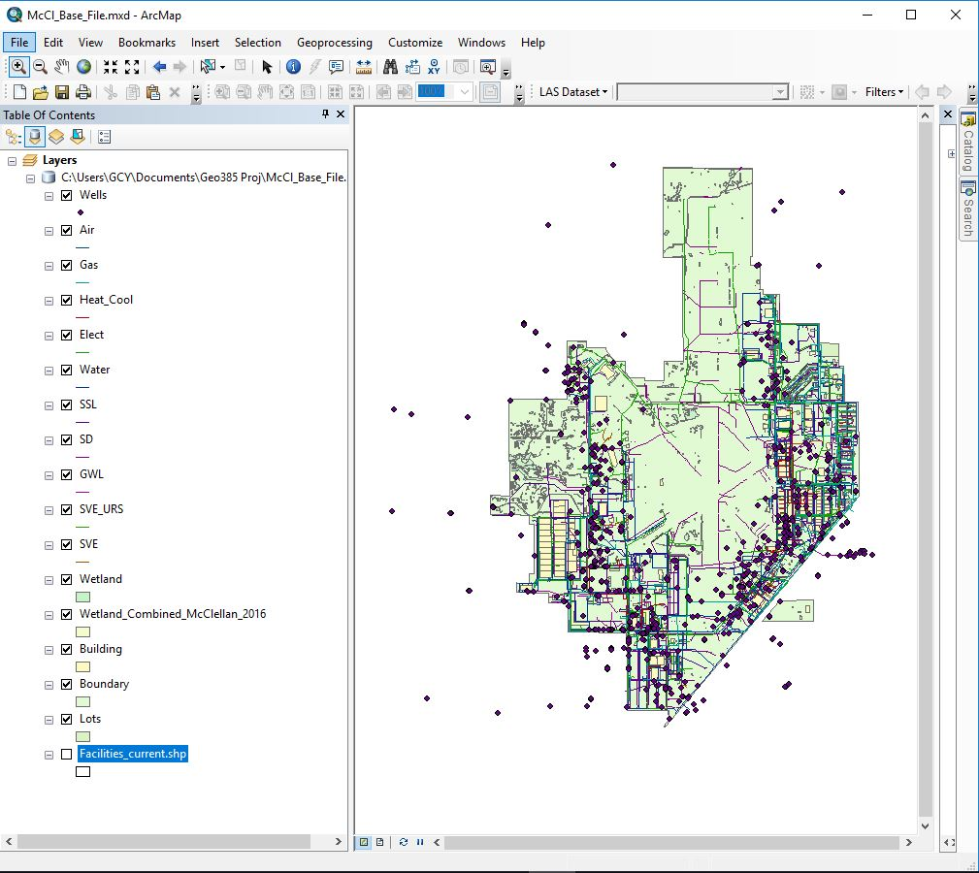

Above is a screen shot of ArcMap and the geodatabase feature classes used.

Each of the feature classes were shared as a service to ArcGIS Online account by sharing as a service.
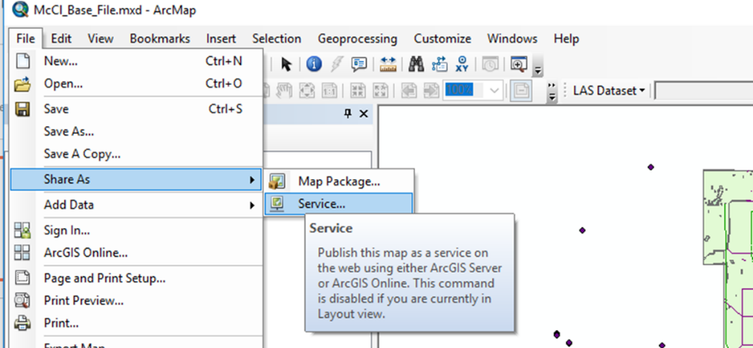

Once the feature layers were shared to the online account, the feature layers were added to the web map.
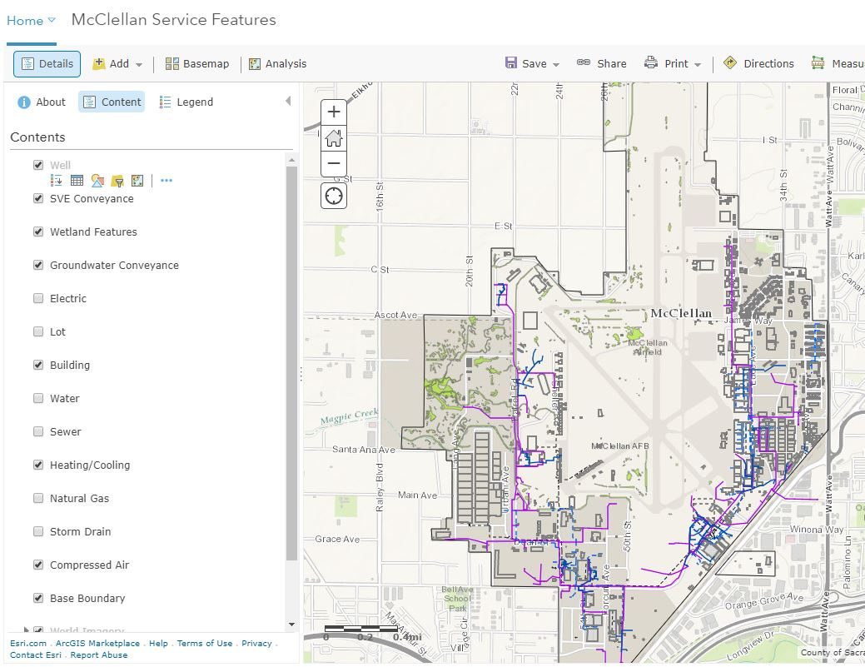

The feature layers were adjusted with basic style changes in color, pop-up configuration, and scale visibility. Two base maps were added. One was a street map only visible at smaller scales. The satellite imagery was added and visible at larger scales.

Web App Builder was opened and the web app was initiated. The “McClellan Service Features” were chosen for the content of this web application. The “Foldable Theme” was chosen as the template.
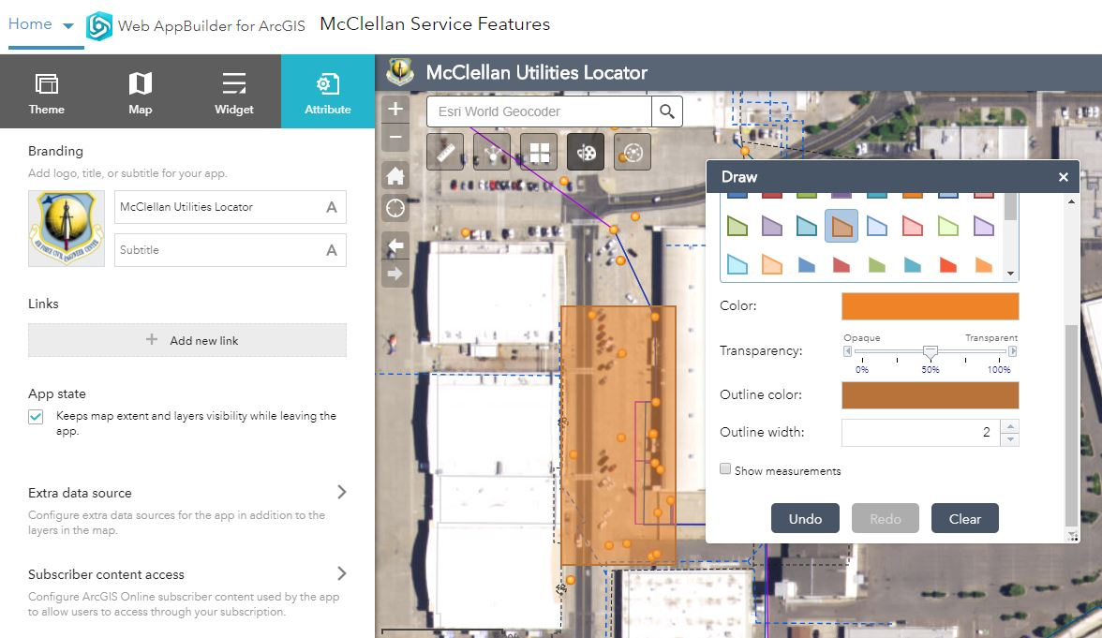

The attributes were edited where the title and branding logo was changed

This web application requirements were straight forward and the in- panel widgets that were required were few. Five widgets were added for customization.
- Measurement widget – measure distances in feet
- Basemap widget – adds options to change the background
- Sharing widget – share web app by creating a link to the application that you can email.
- Draw Tool – Creates ability to draw lines and polygons to highlight areas of interest.
- Analysis Widget (Extract Data) – Used for spatial analysis tool to extract data from an area of interest. Specifically, to be used to analyze the clipped boundary and extract listing of what utilities are within the drawn boundary. This is useful in identifying a list a wells with in a given area. A .zip or .csv file is created for download that identifies features in a table.

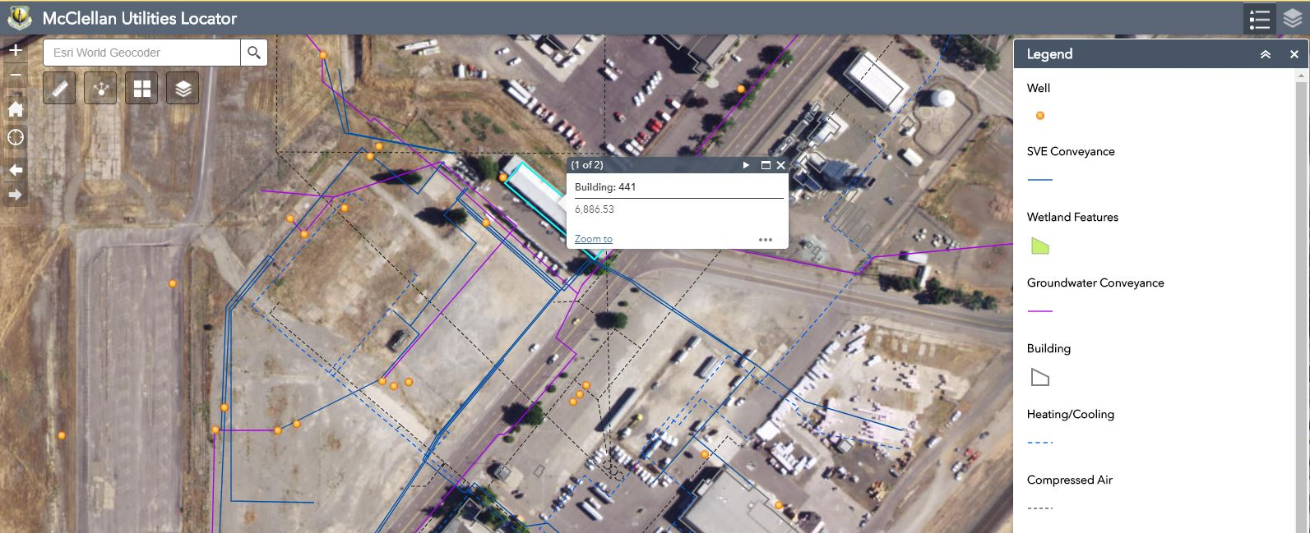

The above is a screen shot of the web app showing the legend of utilities and one of the pop-ups that identifies a building number.

  - Issues
One of the issues encountered was with the Spatial Analysis tool. The description of the function of Extract data tool was that an area drawn with the Draw tool can be used as a clipping boundary for highlighting the analysis area. Otherwise, the analysis is completed on the view extent. I added the Draw Tool widget to create the clipping boundary. It did not appear that the Analysis Widget used this clipping boundary. I ran the tool several times to try to understand why the Analysis widget was not responding as described. (Sorry, I must have burned a few credits trouble shooting this issue!) As it turned out, the drawing tool described in the instructions was not the Drawing Widget but a drawing icon imbedded within the Analysis tool. (See the icon below.) A suggestion to ESRI would be to change the icon to a “Pen” instead.

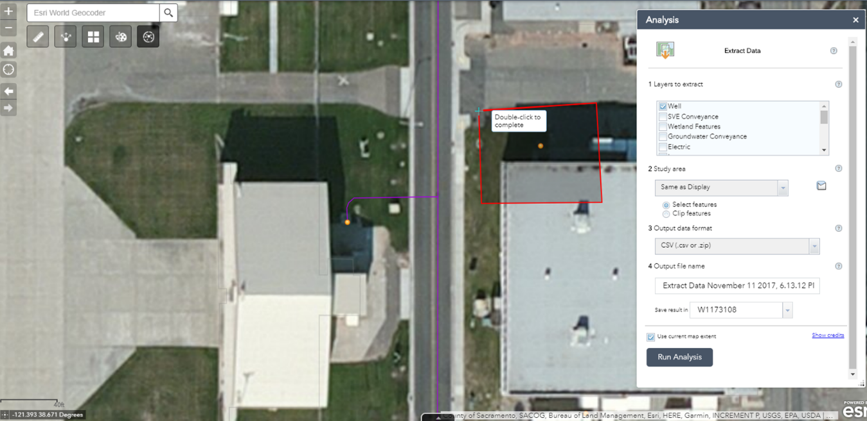

  - When the area was drawn with the imbedded drawing tool it selected the correct features. The example above returned the following table. This table was outputted as a .csv but can also generate a .zip for larger files. These files can but used for reporting and documentation.

Long | Lat | OBJECTID | NORTHING | EASTING | TYPE | STATUS | GRID | WCM_ZONE | LOCID
-121.39254 | 38.67100394 | 555 | 366378 | 2173741 | MNW | Active |  | A | MW-393

  - Summary
A web application was developed specifically to look at infrastructure to assist in reviewing encroachment permits. Arcgis shape file features were imported into the online web application and created a useful tool to review construction encroachment permits and potential conflicts with known underground utilities and wetland features. 14 different shapefiles were imbedded into the web application to give the user a full scope of infrastructure locations. In addition a spatial analysis tool enables users to pick out areas of concern and extract what utilities are in conflict with the proposed construction. An additional feature would allow the user to share the map with others to also view the area of concern and potential issues that may arise when the proposed construction is accomplished.

In general, I found that is project showed that producing a simple web application is much easier than I had originally thought. Following the steps outlined in the class presentations and labs made this task simple and produced an accurate depiction of the locations of utilities at McClellan. I believe a web app to work as a checking tool for encroachment permits is viable option to ArcMap for these functions.

One of the features that could improve this web application is additional data to the lot layer that shows what institutional controls are listed for each of the lots. The data is now manually retrieved from massive spreadsheets. A great deal of work would be needed to reformat the data so that it could be joined with the lot layer to be used within this web application.

