Temporal Study of Suburban Biomass Change – How did the drought affect biomass in the Antelope Neighborhood?

Project Summary:
There appears to be a loose relationship of the biomass vegetation index of vegetated areas identified using Normalized Difference Vegetation index (NDVI) techniques and annual rainfall during the recent drought in California. The area studied was Antelope California from 2009 to 2017. The chart below indicated a dip in the vegetated areas identified by NDVI during California’s recent severe drought.

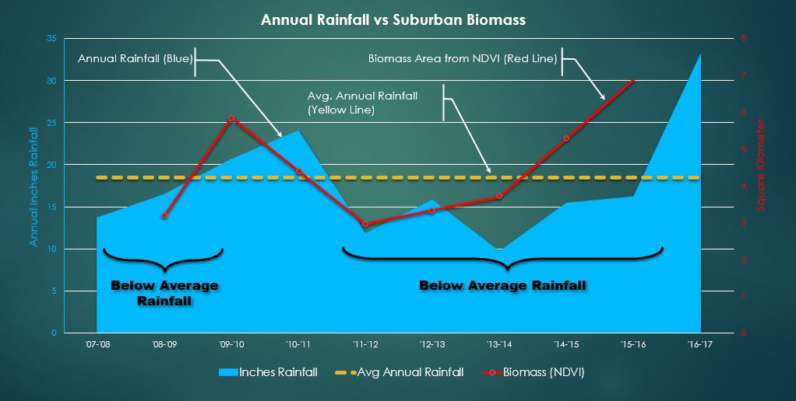

Purpose:
This study quantified biomass areas within the Antelope neighborhood between 2009 and 2016 and compared it with annual rainfall. This study looked at the relationship of the quantity (area) of biomass identified using Normalized Difference Vegetation index (NDVI) with the effects of lower than normal rainfall.

Processing Tasks:
NDVI is a standardized index used to study greenness or biomass of a data set. The index one of the commonly used remote sensing techniques looking at the differences in reflectiveness of Red light and Near-Infrared (NIR) light as it reacts with chlorophyll found in green plants. Red light is strongly absorbed by plants. NIR light is strongly reflected by leaf tissues.
By subtracting Red light from NIR light and dividing by its sum, a number is produced from -1 to 1. In the suburban setting, very low values of less than 0.1 and below indicate buildings, roads, bare ground, and undeveloped land. Index values of 0.2 and 0.3 indicate grass and shrubs. Higher values of 0.4 to 0.6 relate to highly vegetated areas like well-watered lawns and trees. NDVI numbers for this suburban area rarely exceeded 0.7
The imagery used for this study was from the National Agriculture Imagery Program (NAIP). The NAIP acquires imagery during peak growing season or “leaf-on”. The imagery was designed to assist farm programs.
The NAIP imagery is collected in 1 meter pixels in natural color plus a near-infrared band. For Californa, full 1meter coverage started in 2005 with natural color only (3 band). In 2009, imagery was collected with NIR band. Starting in 2010, NAIP started a 2yr coverage cycle for California. The latest available data was collected in 2016. Imagery was typically collected at the end of June through early July.

Image processing tasks and methods used
To begin the study, NAIP imagery was collected from www.atlas.ca.gov. Imagery is available by year and by the selection of the appropriate Digital Ortho Quarter Quads (DOQQ). There were 2 DOQQs that covered the Antelope zip code 95843.
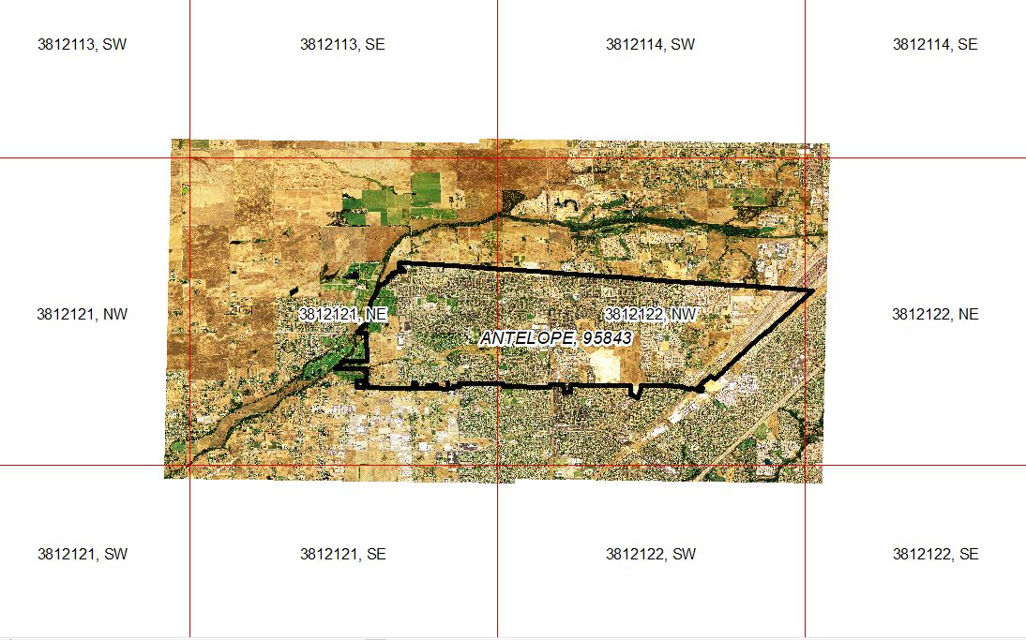
Once the DOQQ for each of the study years were collected they were processed using ArcMap. The panels first were added together using the Image Analysis window using the mosaic tool
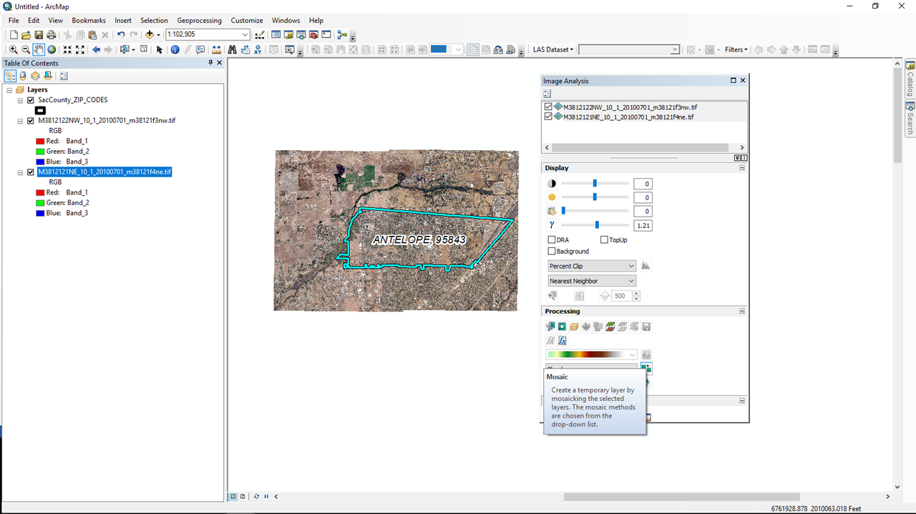

The mosaic was then clipped to the study area. In this case, the US Postal Service ZIP code boundary for 95843 was used as the clipping area.
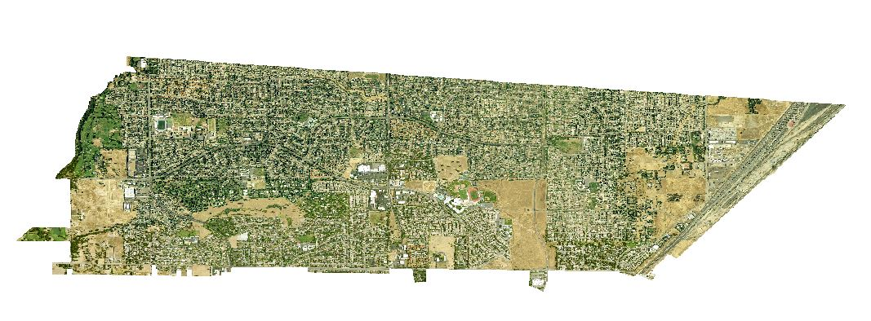

NDVI was created using the Image Analysis widow. Before NDVI was applied the Scientific Output option needed to be check to output pixel values with the proper index numbers. Otherwise, the NDVI will output gray scale numbers from 1-255 instead of the NDVI index numbers of -1 to 1.
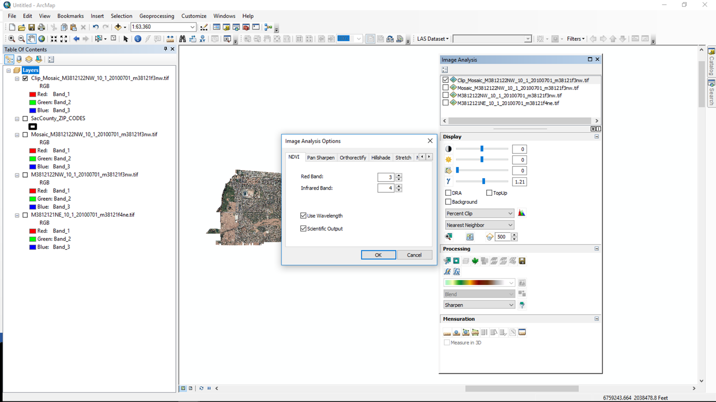

NDVI was performed using the Image Analysis window. The resulting output is a gray scale image with pixel NDVI pixel values.
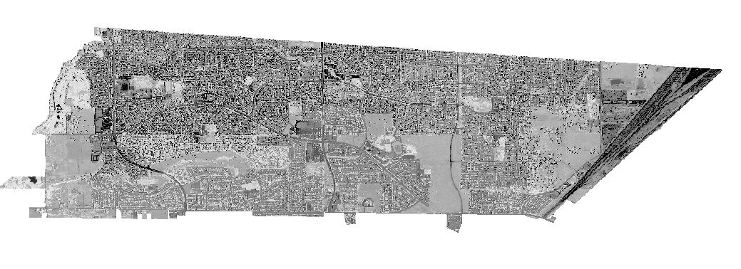

To show the areas of vegetation the layer properties for the NDVI layer was opened. The Symbology tab was opened to classify the image excluding pixels values between -1.0 through 0.2.
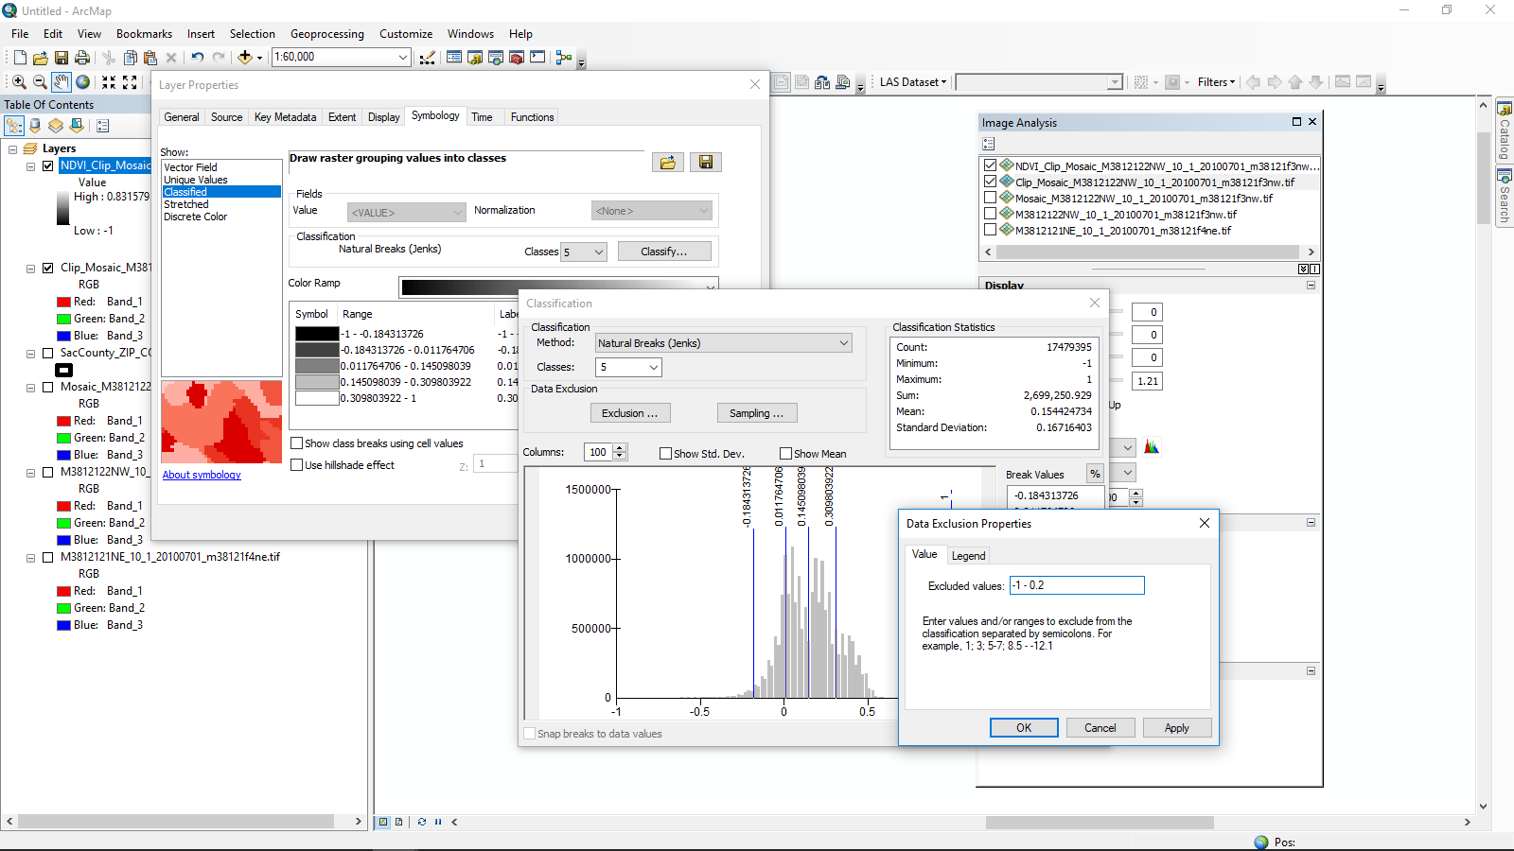
Exclusion…
Once the “Exclusion…” was applied only the pixels with values greater than 0.2 were shown. This could be further classified with colors if desired and overlaid on the natural color image to see which areas had NDVI indexes of greater than 0.2.
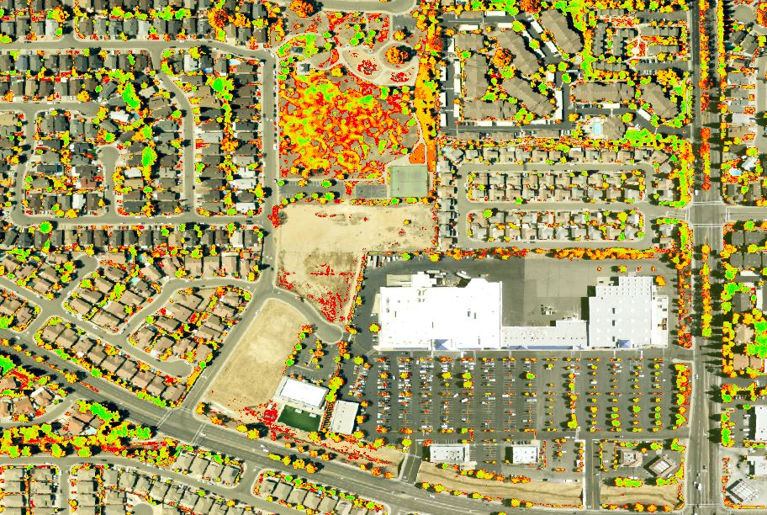
The image above is a close up of the suburban areas that include undeveloped land, shopping centers, single homes, apartments, and parks within the 95843 postal zip code.
Raster Calculator was applied to the NDVI data layer to get a count of 1 meter pixels that had values greater than a 0.2 index value for years 2009 through 2014. 2016 data are 0.6 meter pixels.
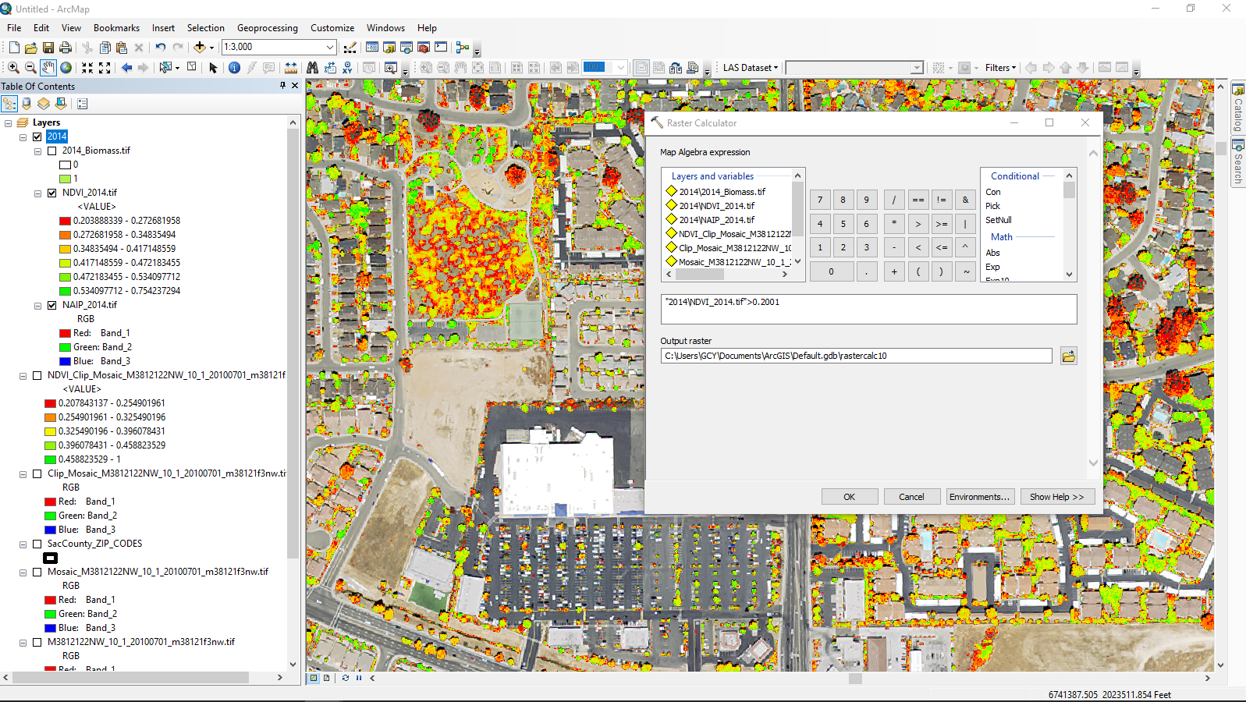

The image below is looking at the raster calculated layer and it’s Layer Properties to retrieve a count of pixels (1meter x 1meter) that have a NDVI index greater than 0.2. This is the data point captured and tabulated for each year for comparison with rainfall totals for the year.
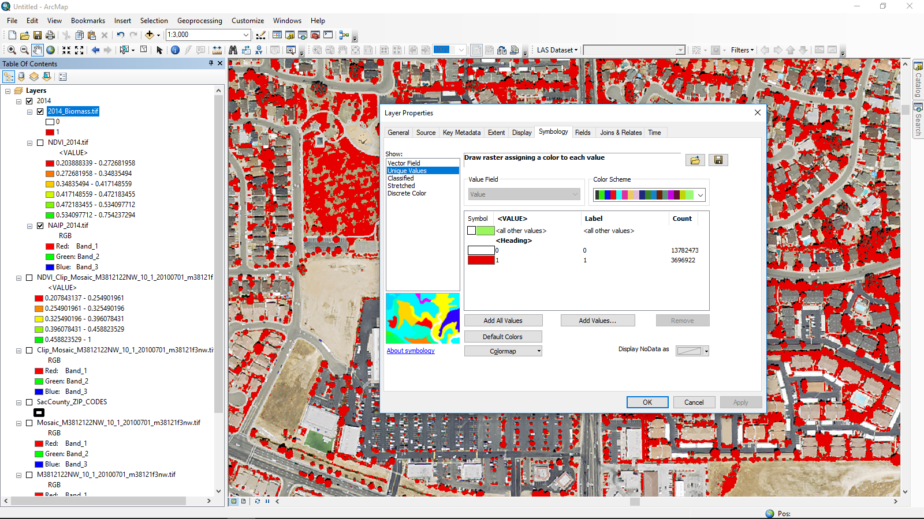
Year | Jan | Feb | Mar | Apr | May | Jun | Jul | Aug | Sep | Oct | Nov | Dec
17 | 9.92 | 8.25 | 2.38 | 2.93 | 0.05 | 0.1 | 0 | 0 | 0 | 0.15 | 0 | 0
16 | 5.4 | 0.82 | 5.07 | 1.03 | 0.39 | 0 | 0 | 0 | 0 | 4.72 | 1.12 | 3.61
15 | 0 | 2.82 | 0.22 | 1.83 | 0.07 | 0.07 | 0 | 0 | 0.04 | 0.12 | 1.57 | 1.75
14 | 0.15 | 4.14 | 1.77 | 1.83 | 0 | 0 | 0.01 | 0 | 0.46 | 0.53 | 1.25 | 8.6
13 | 0.96 | 0.36 | 1.38 | 0.69 | 0.3 | 0.22 | 0 | 0 | 0.59 | 0 | 0.88 | 0.43
12 | 2.43 | 0.55 | 4.06 | 2.42 | 0 | 0.03 | 0.03 | 0 | 0 | 1.14 | 3.97 | 6.15
11 | 1.67 | 3.39 | 6.95 | 0.06 | 1.02 | 1.5 | 0 | 0 | 0.01 | 1.33 | 0.74 | 0.27
10 | 4.79 | 2.29 | 2.98 | 2.65 | 0.75 | 0 | 0 | 0 | 0.01 | 1.43 | 2.39 | 5.55
9 | 1.41 | 5.07 | 2.09 | 1.46 | 1.01 | 0.56 | 0 | 0 | 0.14 | 3.24 | 0.26 | 3.64
8 | 6.67 | 1.81 | 0.05 | 0 | 0.04 | 0 | 0 | 0 | 0 | 0.84 | 2.38 | 1.51
7 | 0.05 | 4.44 | 0.35 | 1.34 | 0.41 | 0 | 0.01 | 0 | 0.06 | 1.05 | 0.85 | 3.17
Annual rainfall totals were gathered from www.usclimatedata.com. Monthly totals were tabulated from 2008 to the present. Annual totals are from October of the previous year through September of the current year.

All the tabulated data was combined for comparison and graphed for presentation in the Project Summary at the beginning of this report.
Year Sep-Oct | Inches Rainfall | Biomass (NDVI) | Avg. Annual Rainfall
’08-‘09 | 13.64 | 3,177,619 | 18.51
'09-'10 | 20.61 | 5,845,467 | 18.51
'10-'11 | 23.97 | * | 18.51
'11-'12 | 11.86 | 2,952,033 | 18.51
'12-'13 | 15.76 | * | 18.51
'13-'14 | 9.67 | 3,696,922 | 18.51
'14-'15 | 15.43 | * | 18.51
'15-'16 | 16.15 | 6,870,843 | 18.51
'16-'17 | 33.08 | * | 18.51
*No NAIP data available

Difficulties/Issues:
One of the issues encountered was with the NDVI tool output. As mentioned above the NDVI tool is normally setup to output pixel values from 1-255. I believe this is the gray scale value of the NDVI data distributed across the gray scale spectrum. This is appropriate if you are visually comparing the layers but it is not easy to compare across different data sets. With a little investigation in the help files for the NDVI tool, it was found that the direct NDVI index values could be seen if the Scientific Output was selected in the NDVI options window. This allowed an easier comparison of the data sets.
The other difficulty was the change in pixel dimensions. The pixel size of the 2016 data set changed to a higher resolution of 0.6 meter x 0.6 meter vs the earlier data sets of 1 meter x 1 meter.

Output Discussion:
The results of charting the data gathered from the NDVI analysis in comparison to annual rainfall is shown in the Project Summary of this report. It indicates that there appears to be some correlation between the rainfall totals and the extent of the biomass calculated by the NDVI process. As annual rainfall decreased, biomass also decreased. As annual rainfall increased biomass index also increased. As much as suburban areas rely on irrigation it seems that perhaps watering restrictions impacted biomass as lawns turned brown and trees were stress with reduced watering. It would be interesting to look at water consumption for the area during this time as well to see how this may have played a role in the changing biomass index.

