GEOG-385
Fall 2017
Joseph Watkins
Final Web GIS Project

Touring Capitol Park Monuments and Memorials

Project Summary
Capitol Park is a 30.5 acre footprint in the heart of downtown Sacramento which offers the education and exploration of over 150 monuments and memorials commemorating significant events in California’s history. For my project, I leveraged a spreadsheet of this data to build an interactive Web Map Application of the features including names, monument ID’s and pertinent detail. I used Collector for ArcGIS to collect and merge imagery with the data to further customize the feature pop up’s for a richer more informative user experience. I enabled time-slider to help visualize the development of the park, along with creating a filter for zone, category and/or material, reducing clutter and distraction. I also included the Measure tool, allowing the user to create and print custom routes between features while seeing the distance. Finally, I added links in the header of my web map app to related state websites, creating a one-stop-shop for all things related to Sacramento’s Capitol Park.

Purpose
I chose this project because I am an outdoor enthusiast who enjoys learning about California’s history and I feel that California’s Capitol Park is one of the State’s under-rated treasures. The park has been evolving for over 145 years and now features over 40,000 trees, shrubs and flowers to explore beyond the monuments and memorials. By building and sharing this app, I not only hope to document the development and preserve the parks history visually, I hope to cultivate curiosity, encourage educational nature walks, and pay tribute to all the men and woman over the years who have worked to make the park what it is today.

Project Development
- Map Creation
The monuments and memorial data used for this project was provided in excel format by the California Department of Parks and Recreation. The data was then formatted and saved as a .csv file. The outlined Capitol Park Zones were hand drawn using heads up digitizing and saved as layers using ArcGIS for Desktop. Both components were uploaded to ArcGIS Online as Feature Layers (hosted) using the “+ Add Items” drop down option from the My Content main page. When uploading the layers, I was prompted to identify the latitude and longitude along with any late specific columns for enabling time. Next I created a new map; Capitol Park Tour Map, and selected a basic topographic map as my backdrop. Then I added my layers and began editing the visibility range, name, pop-up detail, and labeling features. Finally, I returned to the Map settings to protect my map from accidently being deleted, allow other users access to save a copy and add tags to help with searching.

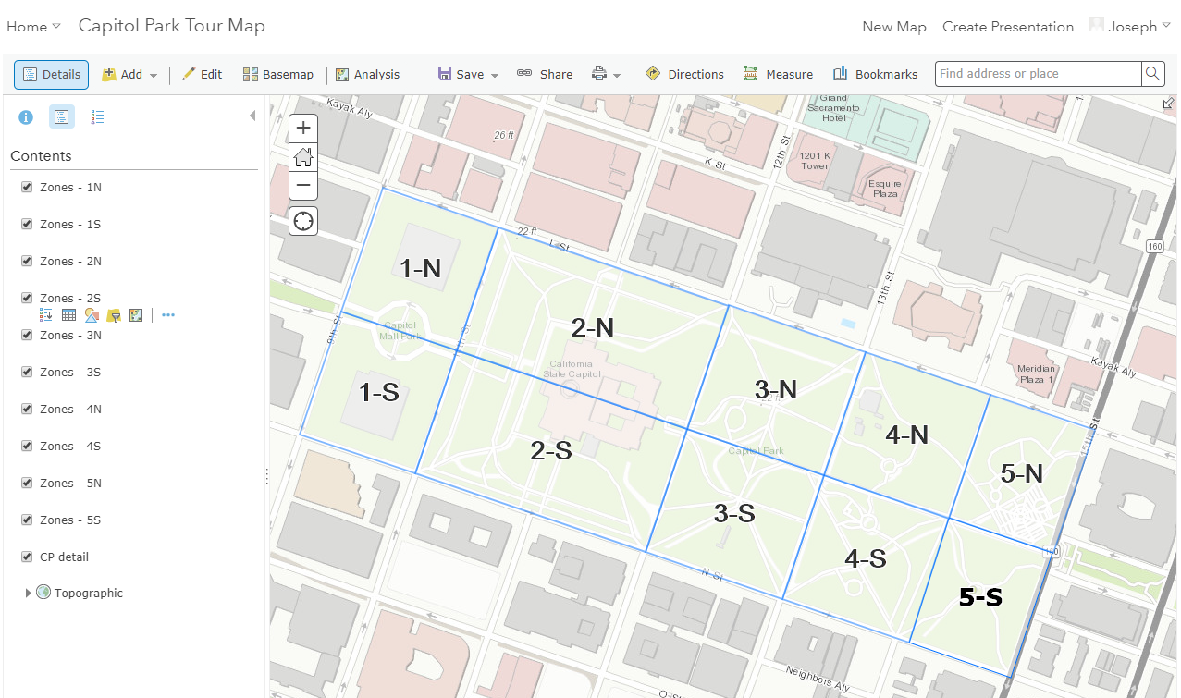
Capitol Park Tour Map being developed.

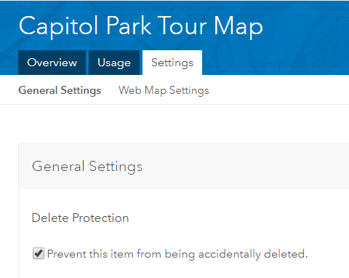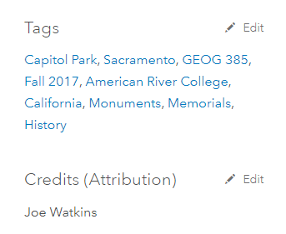
Protecting my map from being deleted. Adding tags to the Capitol Park Tour Map.

- Map App Creation
I created a Web App; Capitol Park Tour App, from the Capitol Park Tour Map by using the Web AppBuilder drop-down option. I chose the foldable theme because the layout is most familiar to me when viewing other apps, it is a simple design with intuitively placed buttons. Under the attribute tab, I changed the logo to a picture of the Capitol and added helpful links to parks.ca.gov (Division of Parks and Recreation), and capitolmuseum.ca.gov /the-museum/capitol-park to offer a more well-rounded delivery of information. Next, I chose the Widgets. Keeping with a simple look and feel, I kept the legend and layer list in the upper right header controller. I customized the filter widget to search for category, material, zone, and/or construction date of a feature. Knowing this limits the search capabilities, I further edited this widget by adding different sets to allow a user to search for multiple categories, materials, or zones. Once a filter has been applied, I included the measure widget so the user will know exactly how far they will walk while exploring his/her favorite features. The print widget was included to offer off-line mapping. Finally, because I enabled time when uploading the data, I included the time slider. This is a fun tool that lets the user see the park come together over the past 145 years.
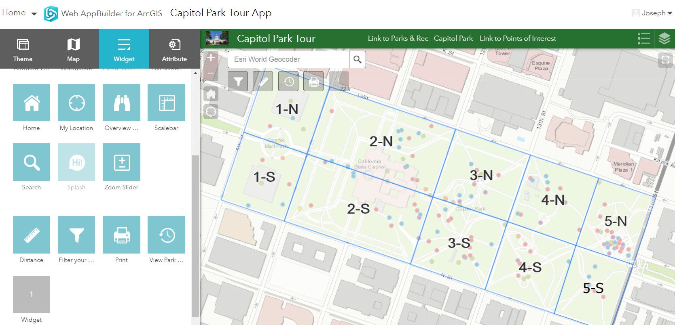
Capitol Park Tour App with custom links and widgets being developed.
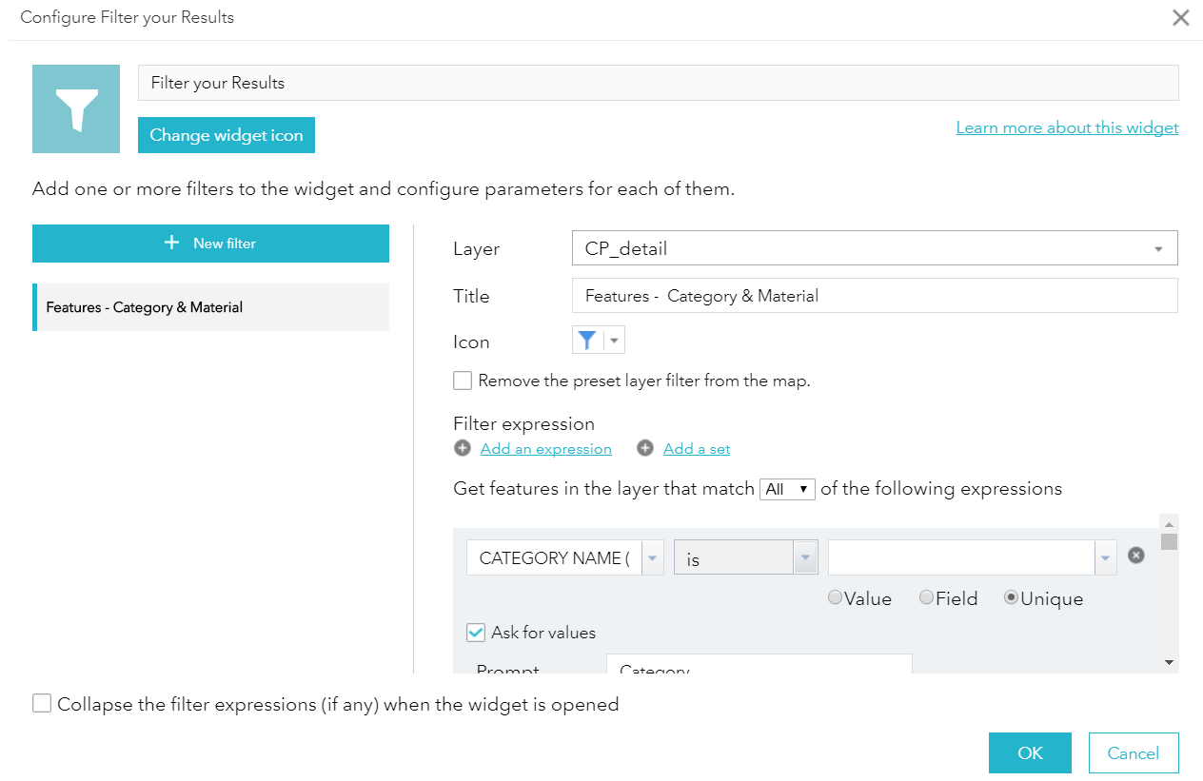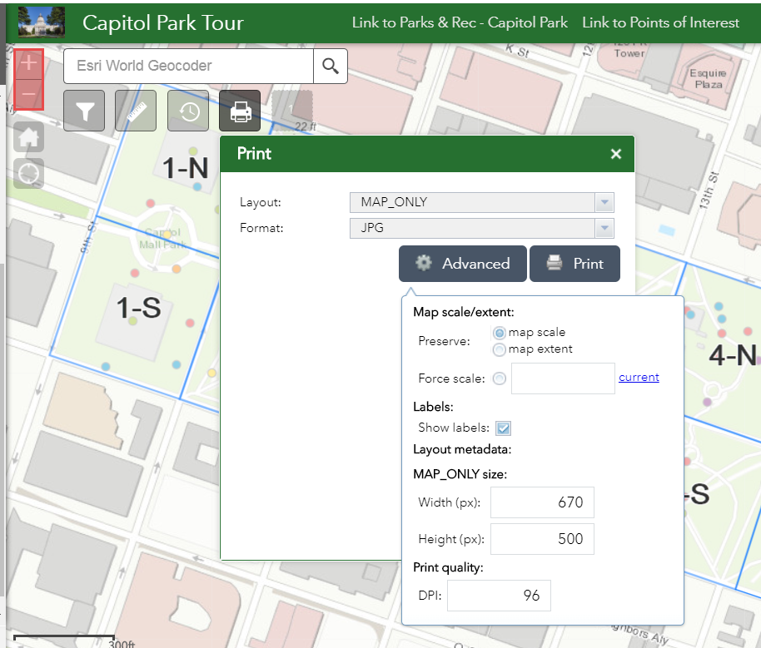
Customizing the Filter widget. Testing the print option.
- Collector for ArcGIS
I first opened my data layer overview in AGO to allow attachments along with adjusting the settings for editing and deletion protection. Having used the ESRI Collector App from my phone during a prior semester, I was familiar with how it functions. Taping on a feature provided the customized pop-up previously developed while creating my map, along with an edit option. I found this process to be vary user friendly. Attaching pictures was accomplished with two simple taps on the screen. When reviewing the results back at my desktop, I found all the pictures had been uploaded, linked to the data and quality was in tacked. I tried using the “Directions to here” option from my phone however, since there are no roads through Capitol Park, this feature was no help.

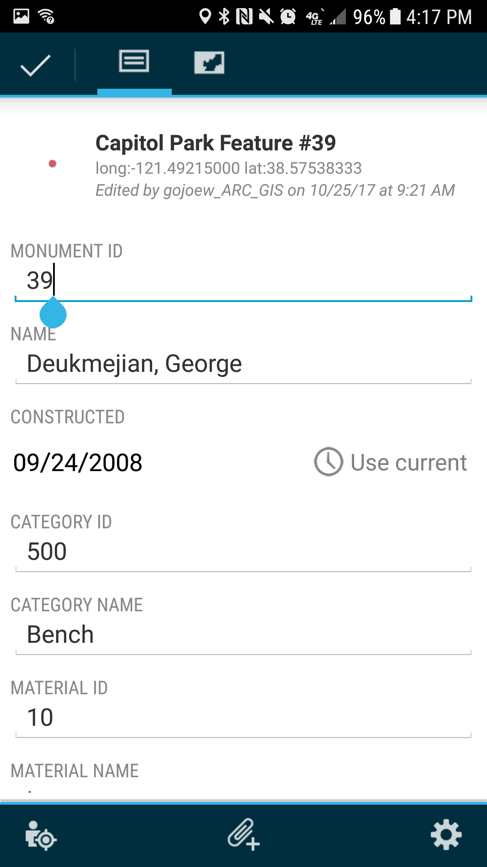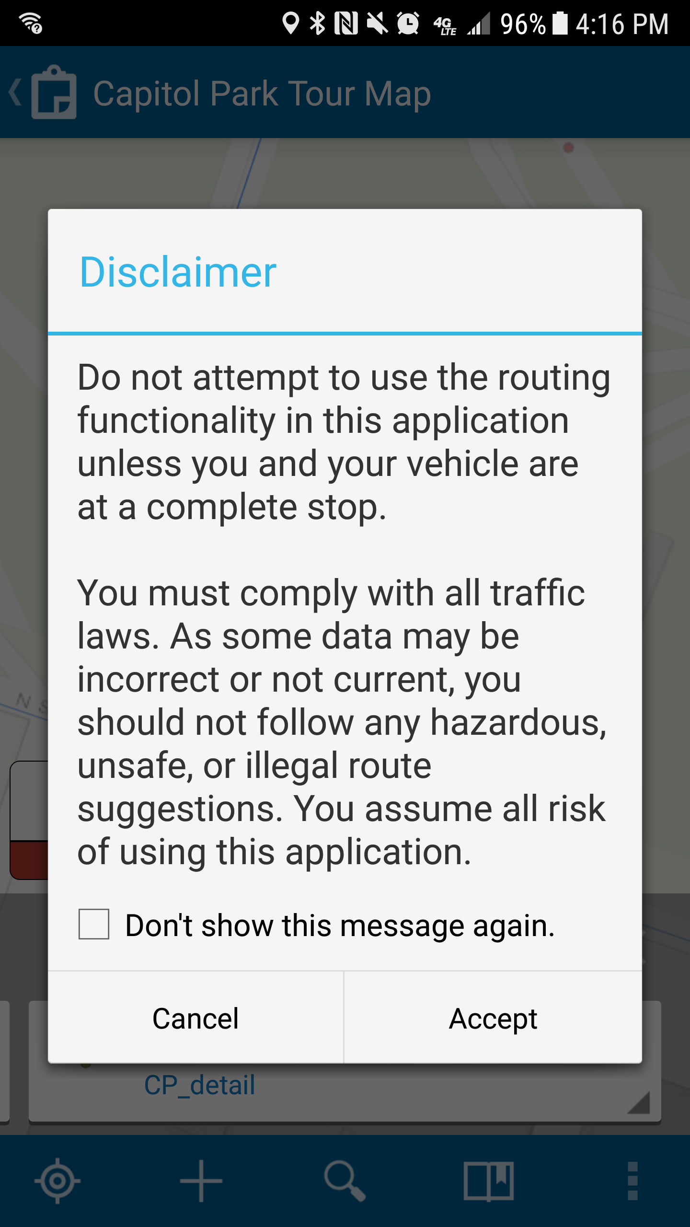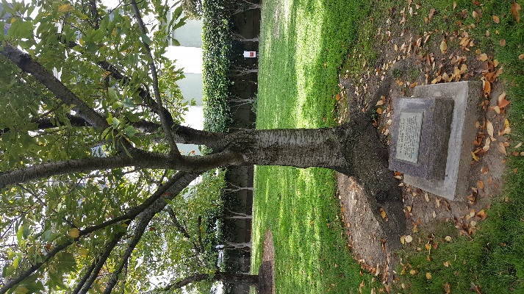
Editing a feature. Disclaimer pop-up while accessing Capitol Park feature #41 attachment.
the “Directions to here” option.

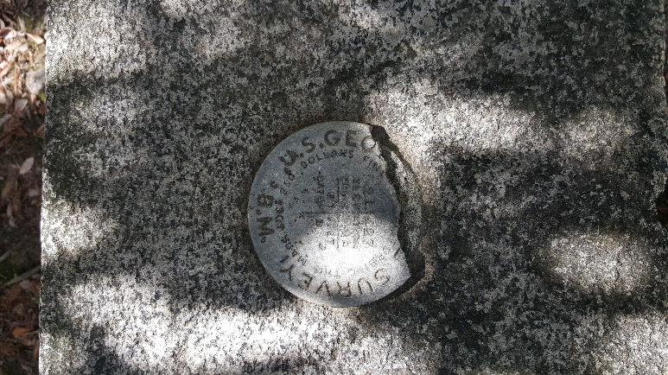
Capitol Park feature #134 attachment.

Discussion
There were only a few setbacks while developing this project. Initially I was not able to upload my excel data to AGO, an error message siting formatting issues would block all progress. After talking with the instructor and changing the file extension from .xlsx to .csv the issue was solved. One final step to the upload process askes that you identify any fields that are Date format along with identifying which fields are latitude and longitude. Clearly labeling your columns prior to uploading the AGO will make for a smoother experience.
The steps to building the map were clear and easy to follow. The real creation comes from changing the pop-up and simplifying the information to make it something the general public would want to use. I removed the majority of the information in my pop-ups, leaving just the key details people would be interested in; Feature name and number, construction date, location, and description. There was some trial and error with finding a good balance of information to include but I found that less is better when building an app used for exploring the outdoors. For the digitized zones, I took a different approach, the layers are turned on and the zones are labeled and whitewashed. I envisioned this being a quick visual for a user of the app to get familiar with the layout of the grounds. To explore the features detail below, the user can turn off the zone layer. Most users would not think to open the layer list and turn off the zones. However, if a user was able to turn these layers off by simply taping on the zone, I think it would be intuitive. A work around that I used was adjusting the visibility of both the zone layer and zone labeling to be visible from a distance only, then as you zoom in close enough to clearly see the individual features, both the labeling and whitewashed zones turn off.
I did not run into any major issues formatting the widgets. I took my time relabeling, organizing and testing the layout for usability, and it payed off in a one-stop widget that allows the user to ask/answer almost any question related to the main components of the data. The measurement, time slider, and print widgets were easy to incorporate and offered limited modification. That being said, I feel they enrich the apps experience and further encourage the core objective; explore Capitol park.

Conclusion
The final product meets my expectations. It is not overly designed or chock-full of useless information. It has an intuitive feel that draws the user in, encouraging him/her to look closer at the detail and ask questions about the monuments and memorials that make up California’s State Capitol Park. Building this app gave me the opportunity to use the skills and knowledge gained through the semester along with the freedom to create something new and experience the unknown challenges encountered. Since there is no app on the market offering a user this type of experience with the Capitol grounds, I feel this app has a place in the real world. With a little more time, beta testing, and fine-tuning, it could be used by the Department of Parks and Recreation for scheduling maintenance, identifying potential locations for new features, or as a fun tool to educate the public on the rich history of our state.

