By: Jason Thorn

Final project:

marijuana production in north san juan ca

Project summary
North San Juan has garnered a local reputation for being a hot spot for ‘medicinal’ marijuana cultivation. From personal experience, I have noticed a lot more ‘hippies with dreadlocks driving Range Rovers’ tend to frequent the area. I will use downloaded aerial imagery in order to digitize and georeference grow sites from several years to determine their locations and areas. I will then convert the georeferenced polygons to a point feature class in order to better depict the cultivation locations on a small-scale map. I will also be looking for sign of environmental damage the grow sites are responsible for.

Purpose of Project
The goal of my project is to create two feature classes of points representing grow sites in 2009 and 2016 respectively. By overlaying these points on top of aerial imagery I hope to show the increase of cultivation sights over time and their locations. I also hope to analyze the effect the creation of these grow sites has upon the natural landscape, mostly through ‘clear cutting’. Hopefully this can call some attention to the local problem of quasi-legal cannabis entrepreneurs establishing grow sites that damage the environment and are magnets for violent crimes like armed robberies.

Description of methods and tools used

Finding 2016 Aerial Imagery and uploading it to ArcMap

I used the USGS Earth Explorer site to find the imagery I needed of North San Juan and downloaded the 2016 raster file in .tiff format. It was large (≈400 MB)

I added the data to ArcMap after creating a File Geodatabase and linking it to my ‘final project’ folder). The imagery files covered a larger area than I needed, and were so large they bogged down my home computer and made things glitchey

I then added a new layer so I could create a new rectangular feature class around my area of interest, which I imaginatively named ‘area of interest’

I then used RASTER CLIP to clip out just the ‘area of interest’. I was left with a much smaller and smoother running layer. I then deleted the original image

Identifying and Digitizing the Grow Sites

The grow sites themselves were very easy to identify (see picture below).

Digitizing them was much harder. I had to add another new layer to create my new ‘Grow sites 2016’ feature class

I used the EDITOR TOOLBAR to start a new EDIT SESSION, then used the CREATE FEATURES tool to select the POLYGON construction tool

I then panned and Zoomed for a couple hours, digitizing 50 grow sites into my ‘Grow Sites 2016 layer’. I saved and ended my edit session

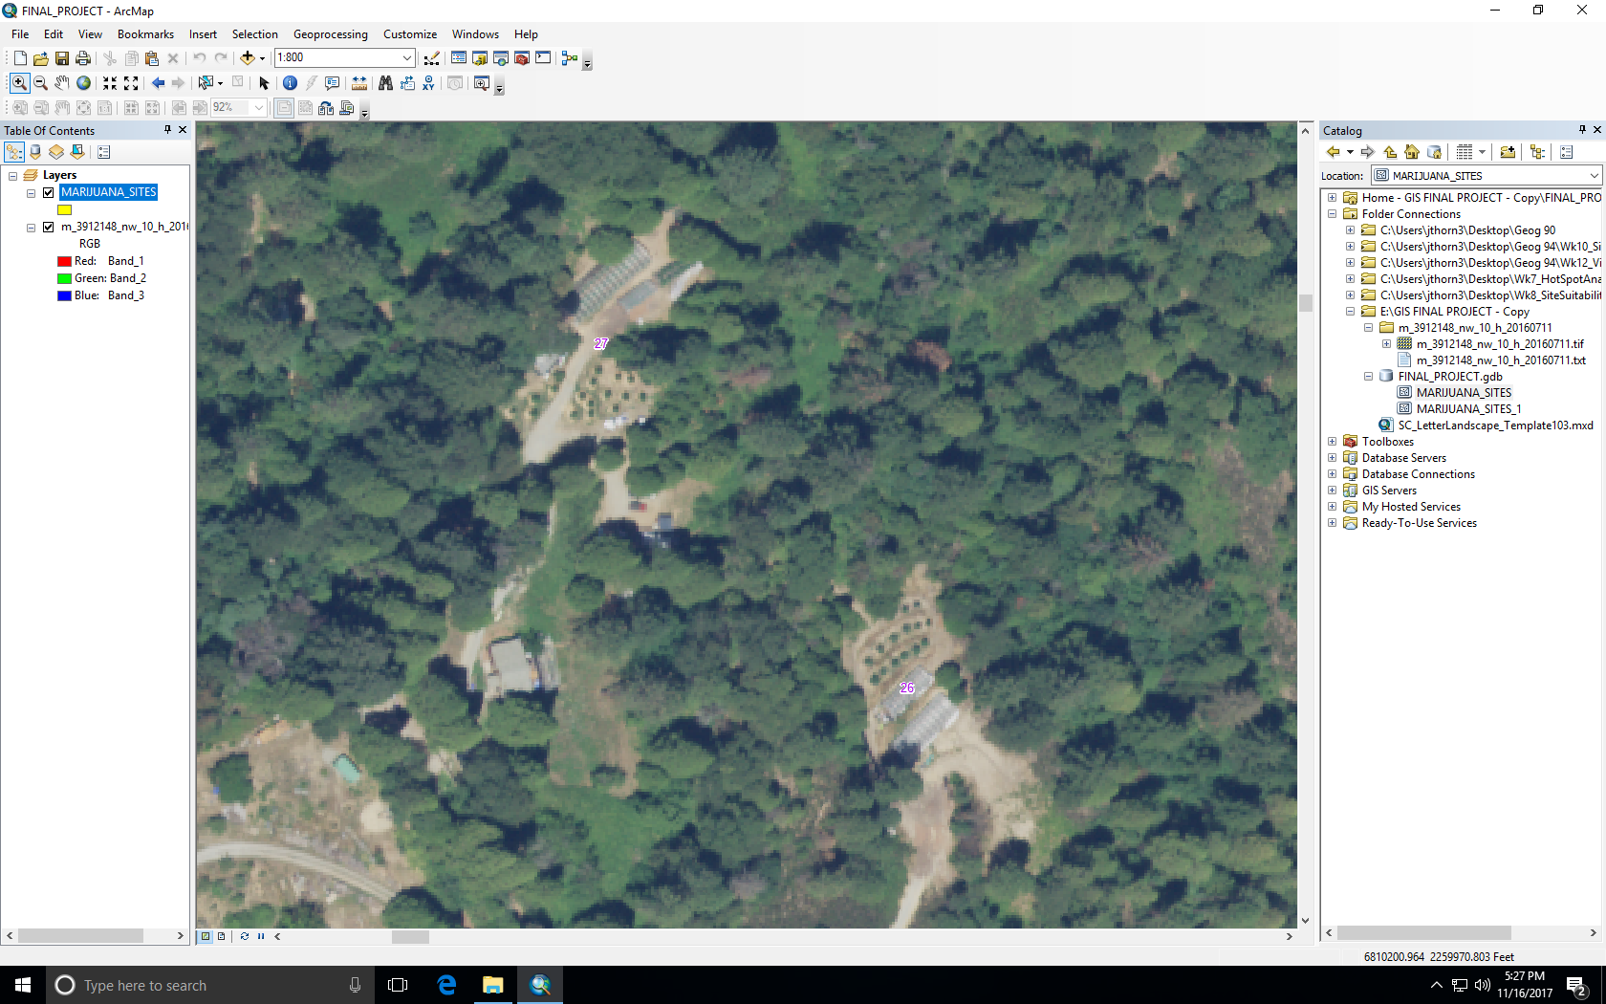
Grow Sites Easily Visible (rows of plants and greenhouses)

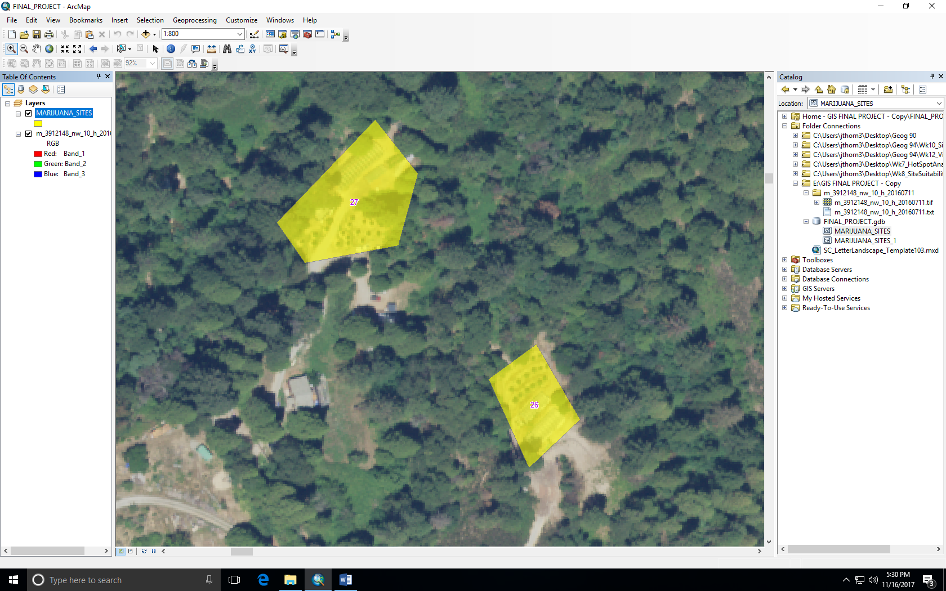
The grow sites after digitalization and some editing

Adding 2009 USGS imagery

Now I needed 2009 imagery so I could make a ‘Grow sites 2009’ feature class, which I also downloaded from USGS Earth Explorer website

I again used RASTER CLIP to clip the 2009 image by my ‘Area of Interest’ feature class

I deleted the original oversized 2009 raster file

Creating ‘Grow Sites 2009” Feature Class

I created a new column in the ATTRIBUTE TABLE of my ‘Grow Sites 2016’ called ‘Existed in 2009?’

I used the ATTRIBUTE TABLE of my ‘Grow Sites 2016’ layer to zoom to each grow site, one by one

I then switched between the 2016 and 2009 rasters in order to determine if the grow site in 2016 existed in 2009 (see pictures below). I then recorded that info into the ATTRIBUTE TABLE of my ‘Grow Site 2016’ layer

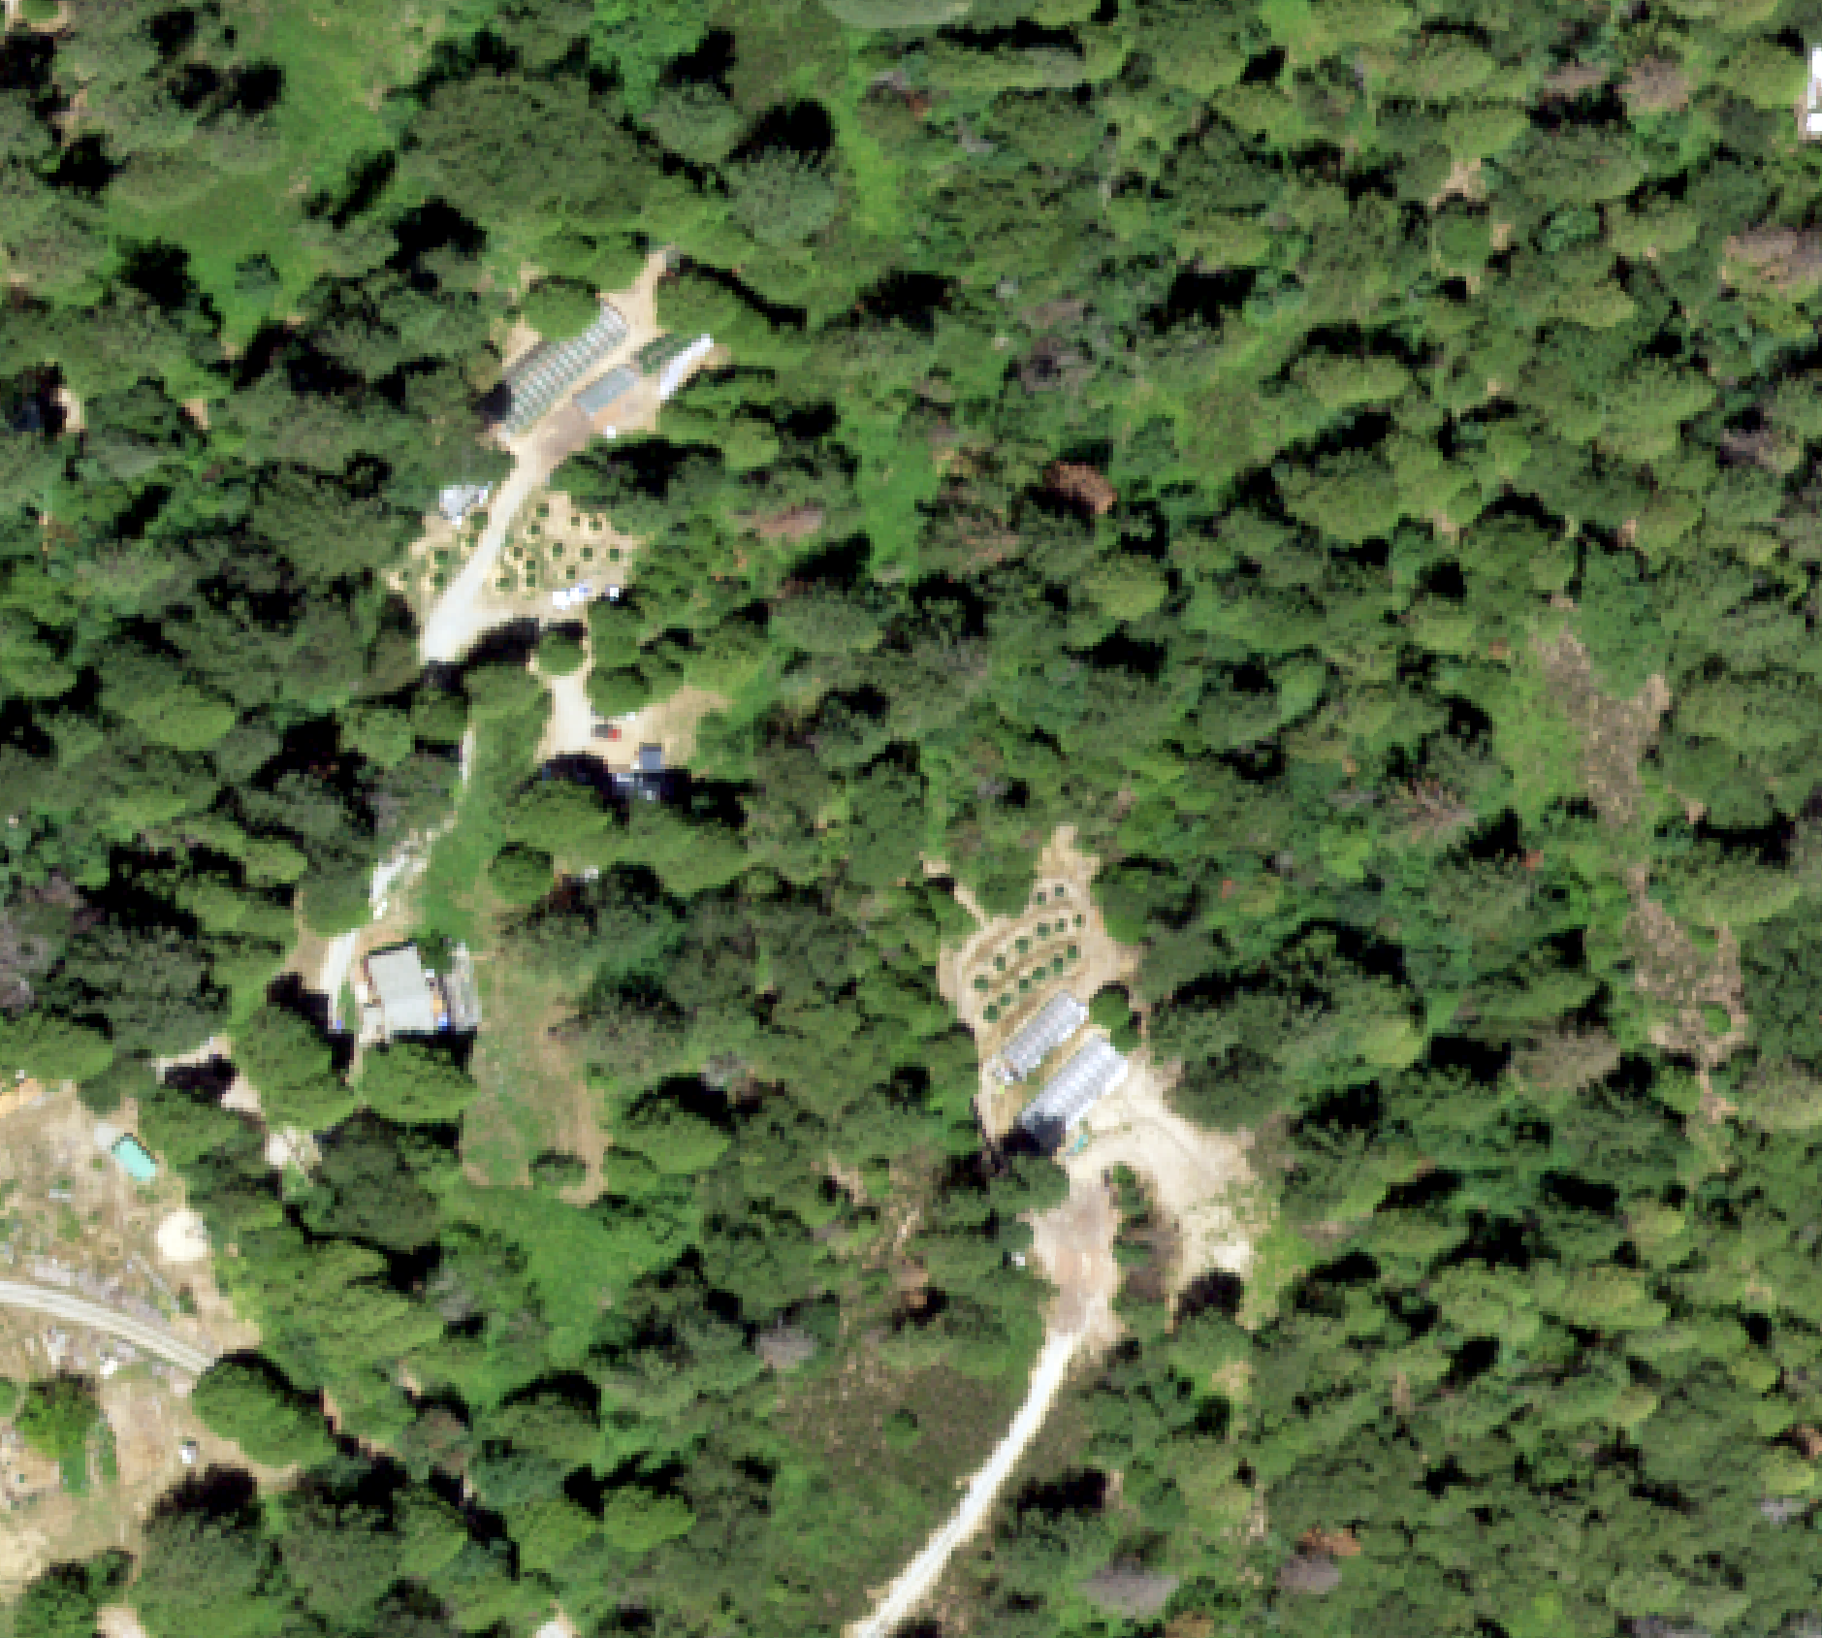
Grow Sites in 2016
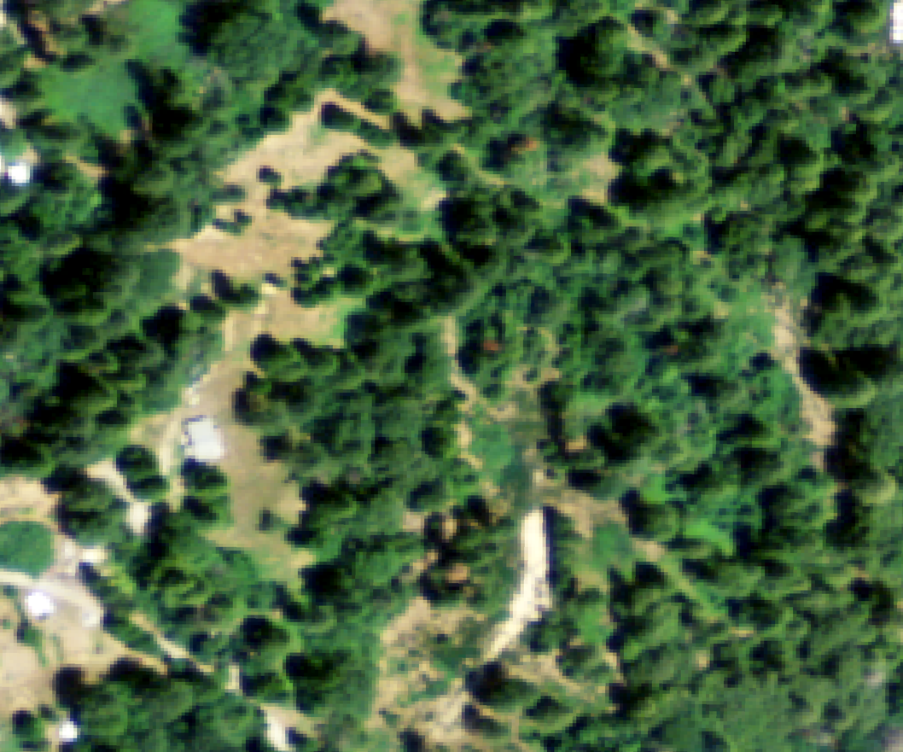
Clearly didn’t exist in 2009

I then performed a SELECT BY ATTRIBUTE of the 2016 grow sites ATTRIBUTE TABLE, where ‘EXISTED IN 2009?=YES’

I then Right-Clicked on the ‘Grow Sites 2016’ layer in order to CREATE FEATURE CLASS FROM SELECTED RECORDS

Converting both Grow Site Feature Classes from Polygons to Points

For the final map, the polygons weren’t showing up very well due to the small scale

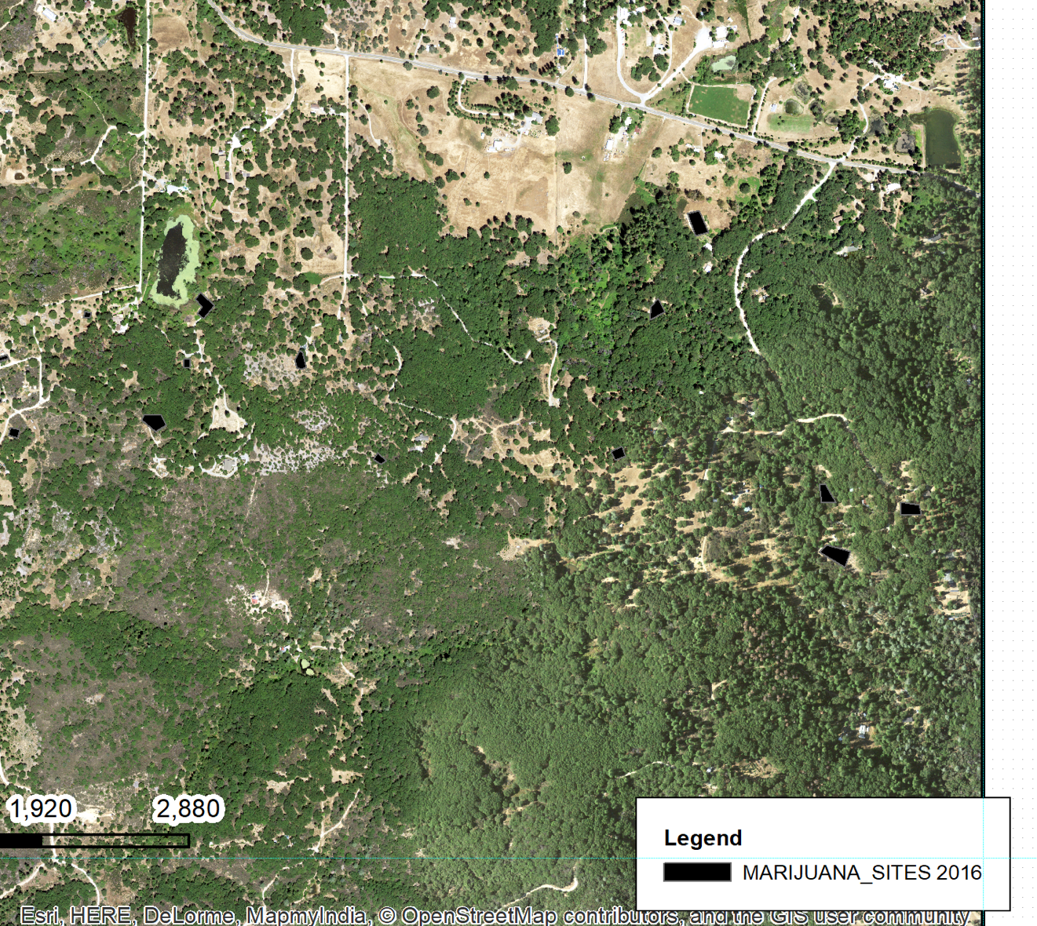

Even in black, polygons just don’t look right or show up well

I tried adding labels and stuff, but eventually ended up using the FEATURE TO POINT tool on the ‘Grow Site 2016’ and ‘Grow Site 2009’ layers (Thanks for the advice on that one Nathan!)

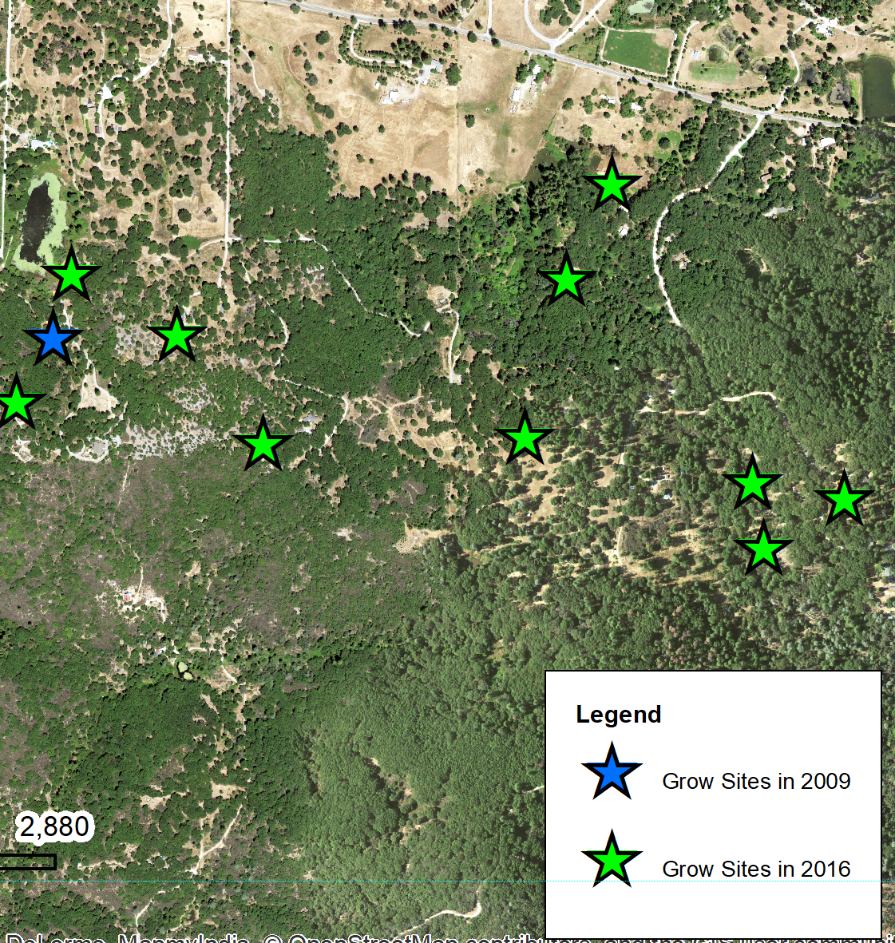

The points worked much better depicting what I wanted them to

Final Touches

I tweaked with the properties of the points to make them visually appealing and easily distinguishable

I altered the Legend to show only the data I wanted it too

I tweaked with the scale bar and the North arrow

I added the class template for my other GIS class

problems encountered

Finding the right data!

I couldn’t find the data I needed for my original idea, so I ended up changing my project to suit the data available.

Getting the EDITING SESSION started wasn’t quite intuitive

I ended up using the book to help through it

Digitizing was a little monotonous

I kept forgetting to double-click on the last point, and was dragging lines everywhere at first

The polygons I created weren’t looking good on final map

I asked my instructor for help, and he suggested using FEATURE TO POINT tool. Great idea, worked well!

General ‘noobie’ mistakes

I kept trying to ‘select’ things when I had the pan or zoom pointer on

I frequently knew what I wanted to do, but it would take me several tries to find the right sub-menu it was hidden within (Damn mask effect especially!)

Remembering to put all my files in the right places

Forgetting to use the underscore symbol to connect words when naming pretty much anything within ArcMap

final map

See Attached PDF file

