“Bald Eagle Territories”

The purpose of the “Bald Eagle Territories” or BET app is to enable the user to go out into the field, survey the BET of interest and report back their findings. Follow this link Go To Bald Eagle Territories.
Let’s start out with the Web Map on ArcGIS Online. The web map has two feature layers that work together when clicked in the right spot. First when clicking or activating the push pin symbol the user gets a pop-up that shows the year discovered, owner/surveyor name, and a link to take the survey at the Survey123 website. The survey is pretty short in nature but has some required items, date of survey and location name come to mind. The other feature layer to the map is called California County Poly. This layer can be activated or deactivated and once the user clicks on a county you get the name of the county.
The Web App is the jewel of this project with the user having access to a multitude of widgets and base maps to choose from. As mentioned above, all the functionality of the web map can be found in the web application. The first widget is the “measure” tool where the user can measure distances in miles from one point to another. The second widget is the “filter” tool, which enables the user to sort by Year Discovered, type in the year range and only those selected will be displayed on the map. The third widget is the “Near Me” tool with an option to type in a county or if you know a Bald Eagle Territory then it will display a radius of what is near the user. I find this tool to be good for dropping a pin by clicking on the map then it will display a radius of what is near the user. The fourth widget is the “Query” tool, which I have set up with three specific queries to ask the app. The first is the “Bald Eagle Surveyor/ Owner” option, this will display all of the owners by name and once clicked will highlight that territory. The second query is “Bald Eagle Territories Water Type”, here you choose from a drop down list the water type, for instance “ocean”, and all of the territories with that type of water will be displayed. The third query is “Bald Eagle Territories Water Elevation”, here the user selects from a drop down list the elevation desired and this territory will be displayed. The fifth widget is the print option for printing the map or filter, query or near me selection from the web. On the bottom of the map there is a tab that once clicked shows the attribute tables for the Bald Eagle Territories and California County Poly for a more in depth understanding of the attributes that make up this web application. There is functionality to zoom in and zoom out and default extent of the map and my location locator on the left side of the application. On the right side the user can find the standard legend and layers list.
Next I will walk the user through all of the widgets and functions of the app.
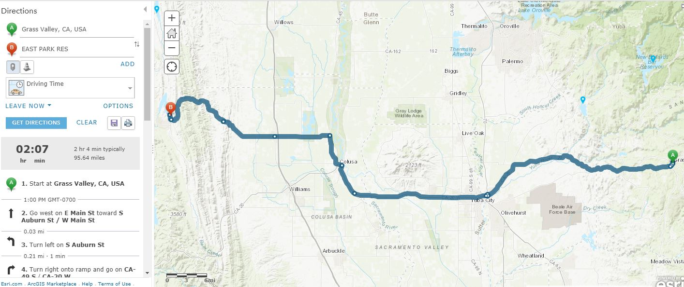
Above is the directions button, found in the pop-up once a location that is recognized by one of the layers is selected. This can show the user how to navigate between locations within the layers of the map. If a user would like to find directions from their house to a bald eagle territory, then select the territory and click on the directions link within the pop-up. All that must be entered are a starting point and an ending point.
Another link within the pop-up is the “Take the Survey” hyperlink. This will take the user to a survey created specifically for users visiting the Bald Eagle Territories and that wish to provide some information about their visit. I should add this type of survey is only available online from survey123 through the pop-up option. Below is an image of the survey; some questions are required while others are not. I have also added an option to add a photo to the survey, this should be a photo of the territory or close proximity of. There are some questions that are not shown in the image which are, “area description” where it has a 100 character limit, “camping nearby”, which is a drop down type selection menu, and “overall rating”, which consists of one through five thumbs up review.

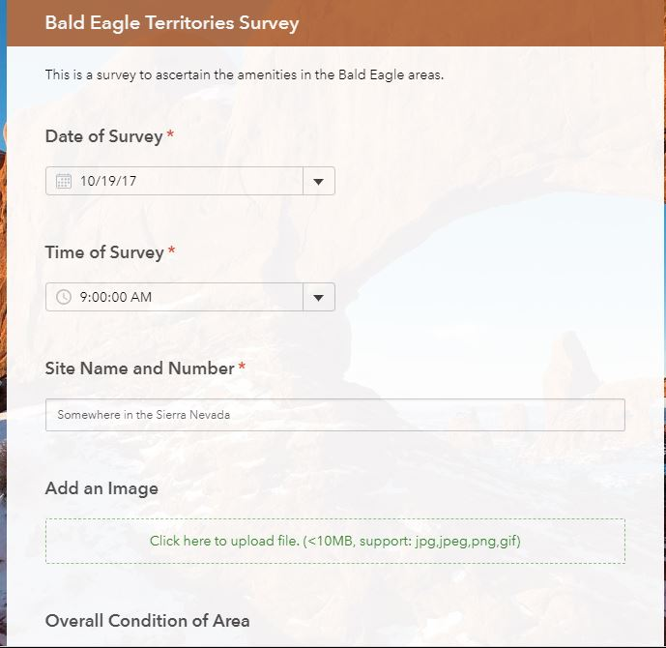
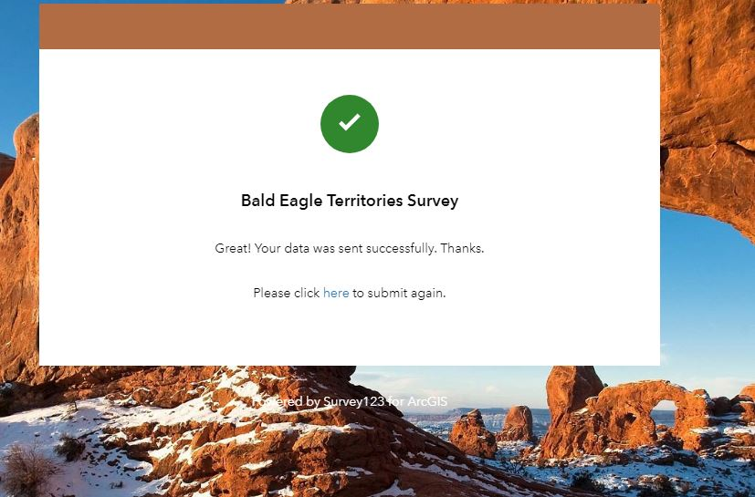
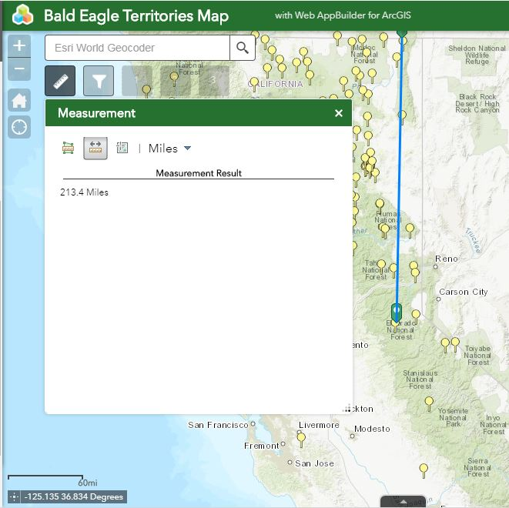
A useful widget is the “Measurement” tool. This can measure area, distance (multipoint), and location, which provides a latitude and longitude starting point with a drop pin. It has the option when setting the widget for meters or miles, I chose miles because we are in the United States. This tool could possibly be used to find distances from one Bald Eagle territory to another or multiple territories if one was planning a weekend trip. The area function could be used to find the footprint of a territory. Location can be used in conjunction with a GPS unit when offline.

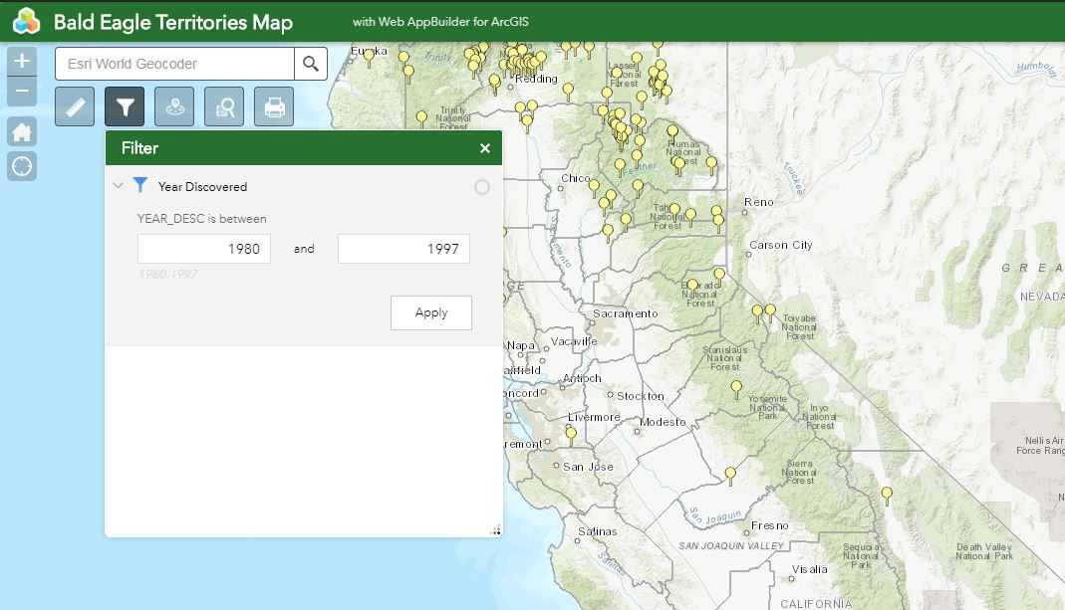
Here we have the “Filter” tool, which is useful for selecting territories by year. To select only one territory, you would type the same year in both spots above. To select multiple territories, you would type a range of years as shown above. This too has a hint below the first year to be typed in, these are the actual years that the territories were discovered in California. 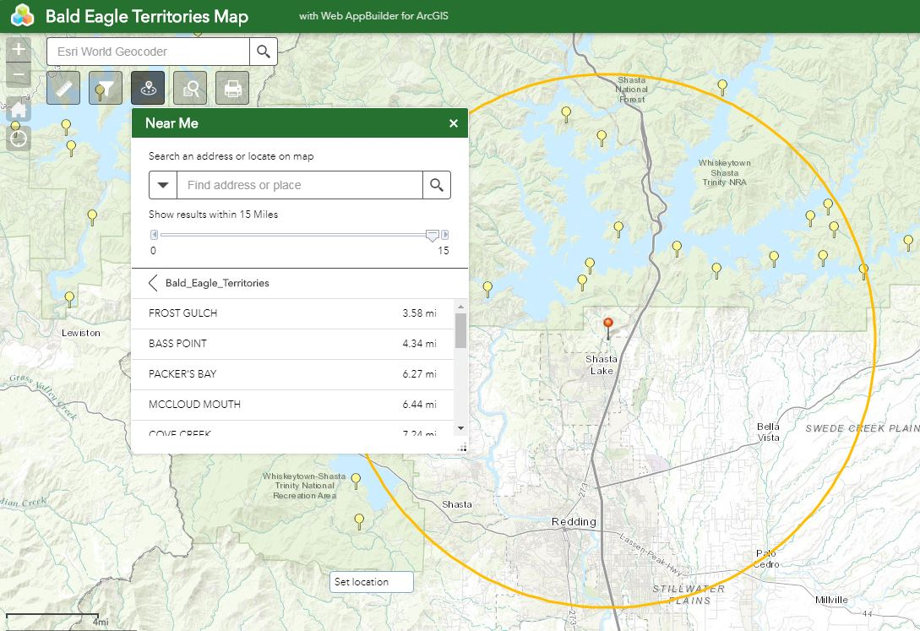
The “near me” tool is handy because it will show you all of the territories close to the location marked by the red pin. This can be adjusted for a certain distance close to the pin up to 15 miles in circumference. As you can see the list is below the miles slider, all you have to do is scroll through the list and select the territory of interest and it will be highlighted on the map. To find a place near you by typing in a name you must be familiar with the data and know exactly how it has been created to find a certain place that way. Familiarity with the data can be achieved by selecting the tab at the bottom of the map and reviewing it there. This area of the map will be discussed later in the report.
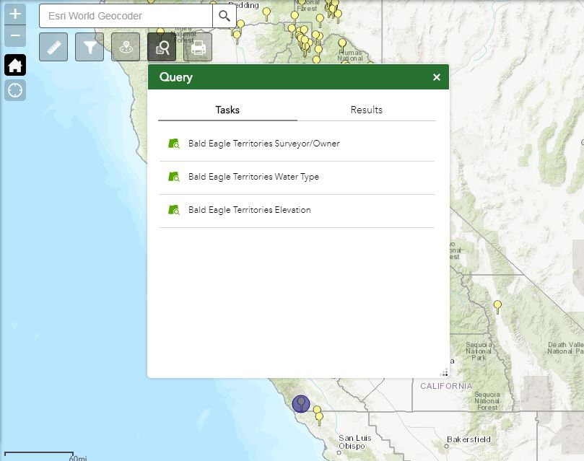
The “Query” tool is useful for finding answers to predetermined questions. I have set up three for us to look at. The first question is “Bald Eagle Territories Surveyor/Owner”, this gives a list of all the owners in California who wish to be identified. From this list you could select an owner and see how many territories they own, it may be only one or many. The second Question that is set up is “Bald Eagle Territories Water Type”, this implies if it is ocean, lake, reservoir, or river. This can be selected via a drop-down menu and the water type and territory will be highlighted on the map. The third question is “Bald Eagle Territories Elevation”, this will select territories for a certain elevation, although the user must know exactly what elevation they are looking for or it can be selected via a drop-down menu. Once used the territories for a certain elevation will be displayed on the map.
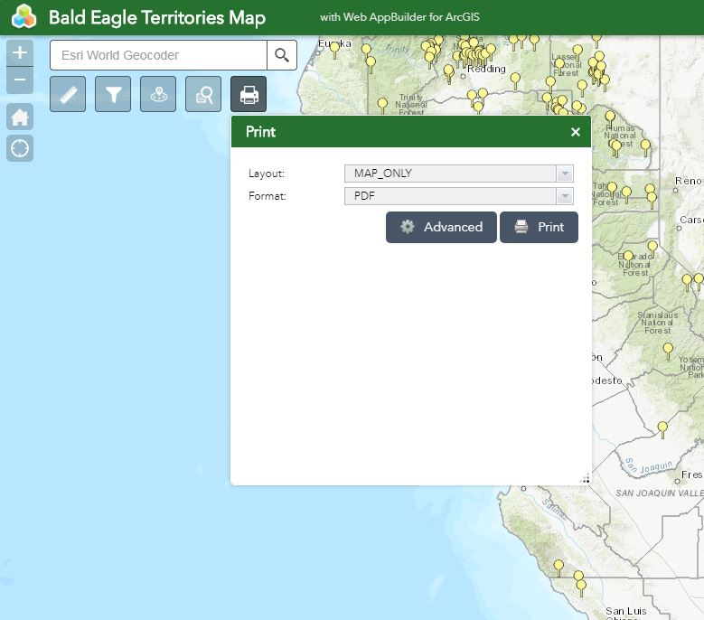
The “Print” tool lets the user print the map or extent of the map with features selected or not. This function enables the user to use a multitude of format options, which I am unable to show here. The Layout is the same thing that you would find in the printer settings menu on your home computer with different paper sizes and settings.
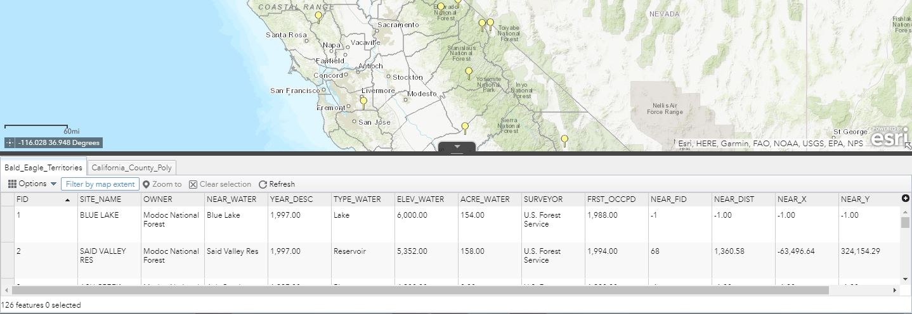
Here is the attribute table tab at the bottom of the app. A user could investigate a territory more here and see the data as it is represented on the map. If desired a territory can be selected through the attribute table and then it will be selected on the map. This would be a good area to select a county in the “County Poly” layer and investigate what Bald Eagle Territories are present.
In closing, I would hope that one or two users would check out this app and use it. This app may be fun and instrumental in finding Bald Eagle Territories that have been already discovered and may help to track and record new discoveries. I can envision a family using the app for a vacation getaway as if someone would visit a historical site.

