Solid Waste Monthly Map by Commodity
By Gabriel Paarmann

The goal was to create a Python script that would take a desired range of time and output individual report maps for each commodity. These maps could then be compared across time. Originally the code was meant to be more unified than its current iteration.

A refined iteration of this script should be automated to run every month and output a report with attached statistics if desired, as well as an additional annual summary report. Many of these aspects did not make it to the final script due to lack of experience and ability to resolve certain conflicting syntax.

The script filters the results from a CIS data dump in order to produce an individual map per commodity during a specified timeframe, (March 01- 31, 2017).

The original goal of the script was to first generate a query table by time range, then after that generate separate table views based on the commodities. However, the table views were not generating any results, so the initial query was reworked to filter out the data dump by both time range and commodity simultaneously.

# Create Query Table BIN
arcpy.MakeQueryTable_management("CIS_DATA", BIN_QUERY, "USE_KEY_FIELDS", "", "CIS_DATA.OBJECTID_1 #;CIS_DATA.OBJECTID #;CIS_DATA.FO_ID #;CIS_DATA.FA_ID #;CIS_DATA.CRE_DTTM #;CIS_DATA.SCHED_DT #;CIS_DATA.SCHED_TM #;CIS_DATA.DISP_GRP_CD #;CIS_DATA.FA_TYPE_CD #;CIS_DATA.INSTRUCTIONS #;CIS_DATA.DESCR254 #;CIS_DATA.REP_CD #;CIS_DATA.FO_STATUS_FLG #;CIS_DATA.WORK_DTTM #;CIS_DATA.EXTRACT_DTTM #;CIS_DATA.SP_ID #;CIS_DATA.PREM_ID #;CIS_DATA.ADDRESS1 #;CIS_DATA.CITY #;CIS_DATA.STATE #;CIS_DATA.POSTAL #;CIS_DATA.APN #;CIS_DATA.CU_XCOORD #;CIS_DATA.CU_YCOORD #;CIS_DATA.OP_AREA_CD #", "(SCHED_DT >= date '2017-03-02 00:00:00' AND SCHED_DT <= date '2017-03-31 00:00:00') AND (DISP_GRP_CD IN ('BINMAINT', 'DEL-CAN', 'RESBIN'))")

Once each commodity was queried into individual table views, XY-event layers were generated. Those XY-events were exported to shapefiles by using Copy features

# Create BIN XY Event Layer
arcpy.MakeXYEventLayer_management(BIN_View, "CIS_DATA.CU_XCOORD", "CIS_DATA.CU_YCOORD", BIN_XY, "PROJCS['NAD_1983_StatePlane_California_II_FIPS_0402_Feet',GEOGCS['GCS_North_American_1983',DATUM['D_North_American_1983',SPHEROID['GRS_1980',6378137.0,298.257222101]],PRIMEM['Greenwich',0.0],UNIT['Degree',0.0174532925199433]],PROJECTION['Lambert_Conformal_Conic'],PARAMETER['False_Easting',6561666.666666666],PARAMETER['False_Northing',1640416.666666667],PARAMETER['Central_Meridian',-122.0],PARAMETER['Standard_Parallel_1',38.33333333333334],PARAMETER['Standard_Parallel_2',39.83333333333334],PARAMETER['Latitude_Of_Origin',37.66666666666666],UNIT['Foot_US',0.3048006096012192]];-115211800 -93821500 36983428.0573515;-100000 10000;-100000 10000;3.28083333333333E-03;0.001;0.001;IsHighPrecision", "")

# Copy Features BIN
arcpy.CopyFeatures_management(BIN_XY, BIN, "", "0", "0", "0")

Once the shapefile for each commodity was created, a template map could be used to export them to pdf.
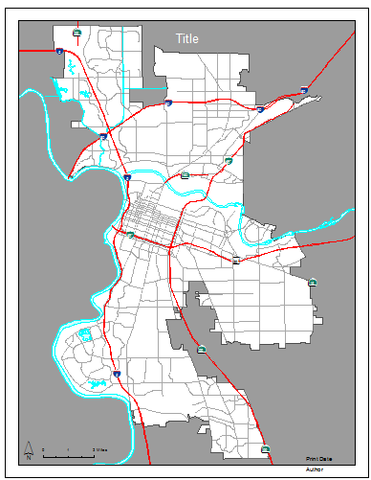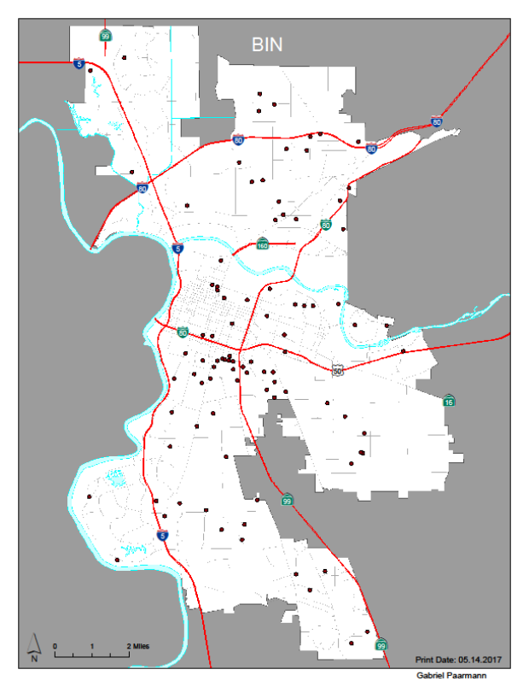

Some design aspects that couldn’t be implemented at this time:
- a text field that would automatically populate with the date range in the first step,
- a single script to add and remove the shapefile layers from the template document, and instead had to build individual scripts for each of the commodities.

Aside from the difficulties, the PDFs exported well, and achieved the ultimate goals of the project. I hope to work further on this script and maybe even automate it to trigger every month at a specified date and time. The two different scripts have two different locations, as they were worked on at two different stations.

I learned many things along the course of this project, as well as reinforced the skills acquired over the course of this class.

