Project Paper
I am a wildlife biologist and over the past several years I have worked in many different states with birds. Throughout that time I used a website called eBird to log the species and number of birds that I saw, either while working or on my own. I wanted to create a map that showed the places that I have been in the continental United States with the number of species that I have seen. At the end of the project I would like to have a map to show my family where I traveled and the number of species that I have seen.
The first thing that I did for this project was to download my data from the website called www.eBird.org. This gave me an excel sheet which I was then able to load into ArcGIS. My next step was to display the XY Data which allowed me to see the point data (Figure 1). Then I was able to export the point data to create a point layer.
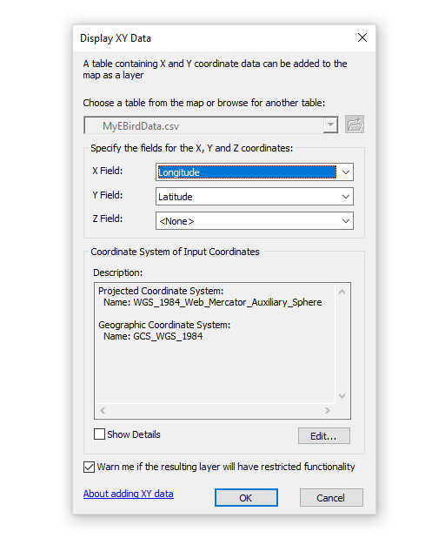
Figure 1 Display XY Data
Since my data from eBird included locations in Australia and Mexico I needed to take those points out. I did this through selecting the points only in the United States and exported the selected data to a new layer. The next step was to find a map to put the points on. I experimented with adding base maps but I needed an attribute table to get the county and state information. This led me to adding data from GIS online (Figure 2). I found a US county map and US state map. Both of those came with Alaska and Hawaii which I didn’t need which led me to exporting out just the continental United States.
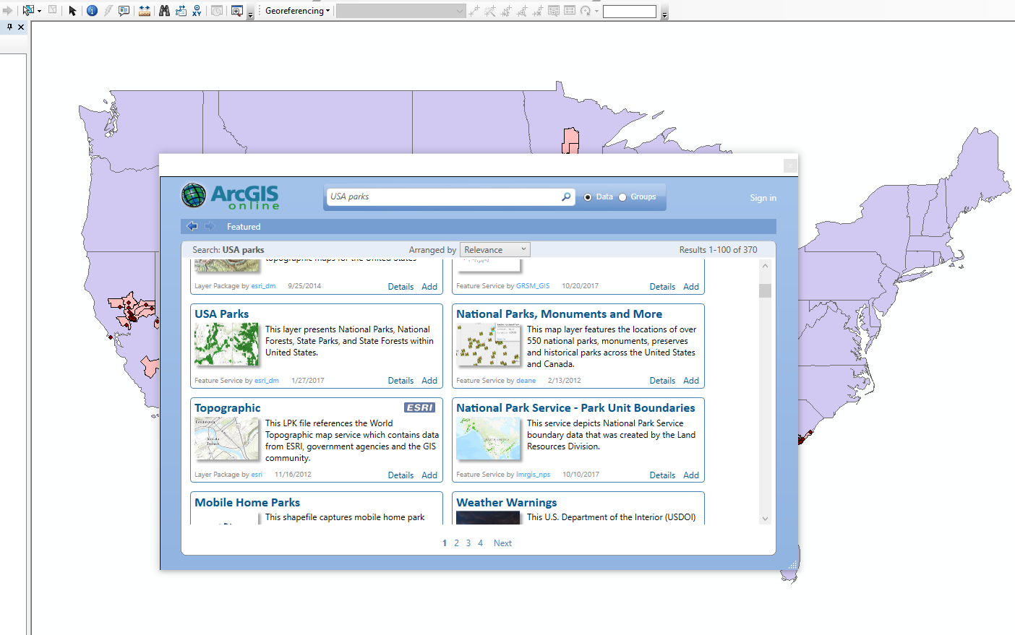
Figure 2 Adding Data from Online
I also added US parks because I experimented with using those in my map but in the end decided not to use that data (Figure 4). The first problem I experienced was my map and my points did not end up in the same location. I eventually realized that the point layer and map layer did not have the same coordinate system which was easy enough to fix.
Having all of the counties for the United States show up on my map made the image very crowded and hard to see. To solve this problem I decided to select only the counties that I had data for. I first tried to use Select by Attributes for the counties that I knew I had. I ran into some problems with this since it was a long expression and I decided it would be easier to use Select by Location (Figure 3). This way I was able to select only the counties I wanted and then export them into a new layer and make the map less cluttered (Figure 4).
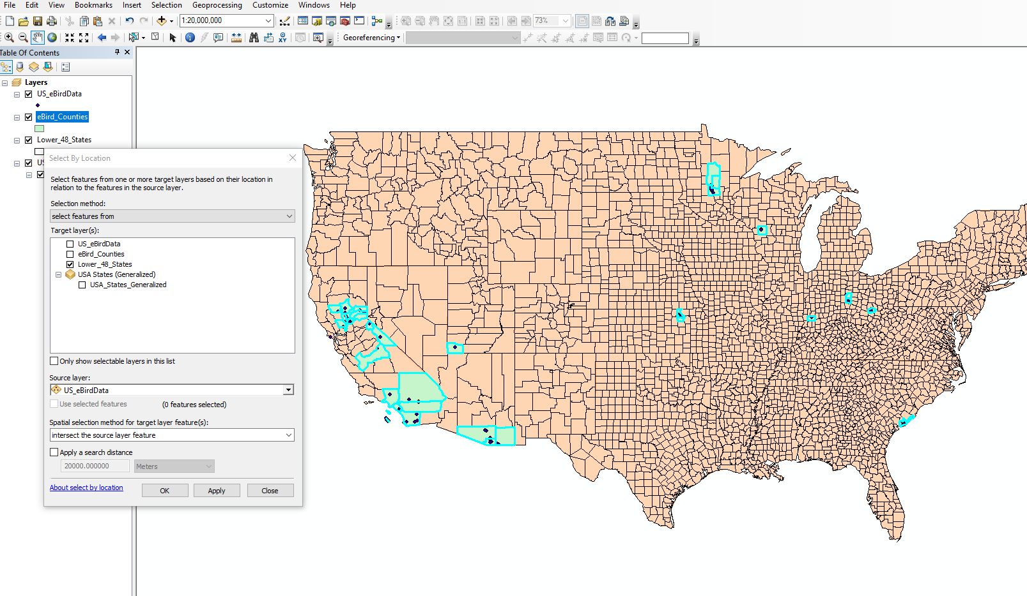
Figure 3 Select by Location

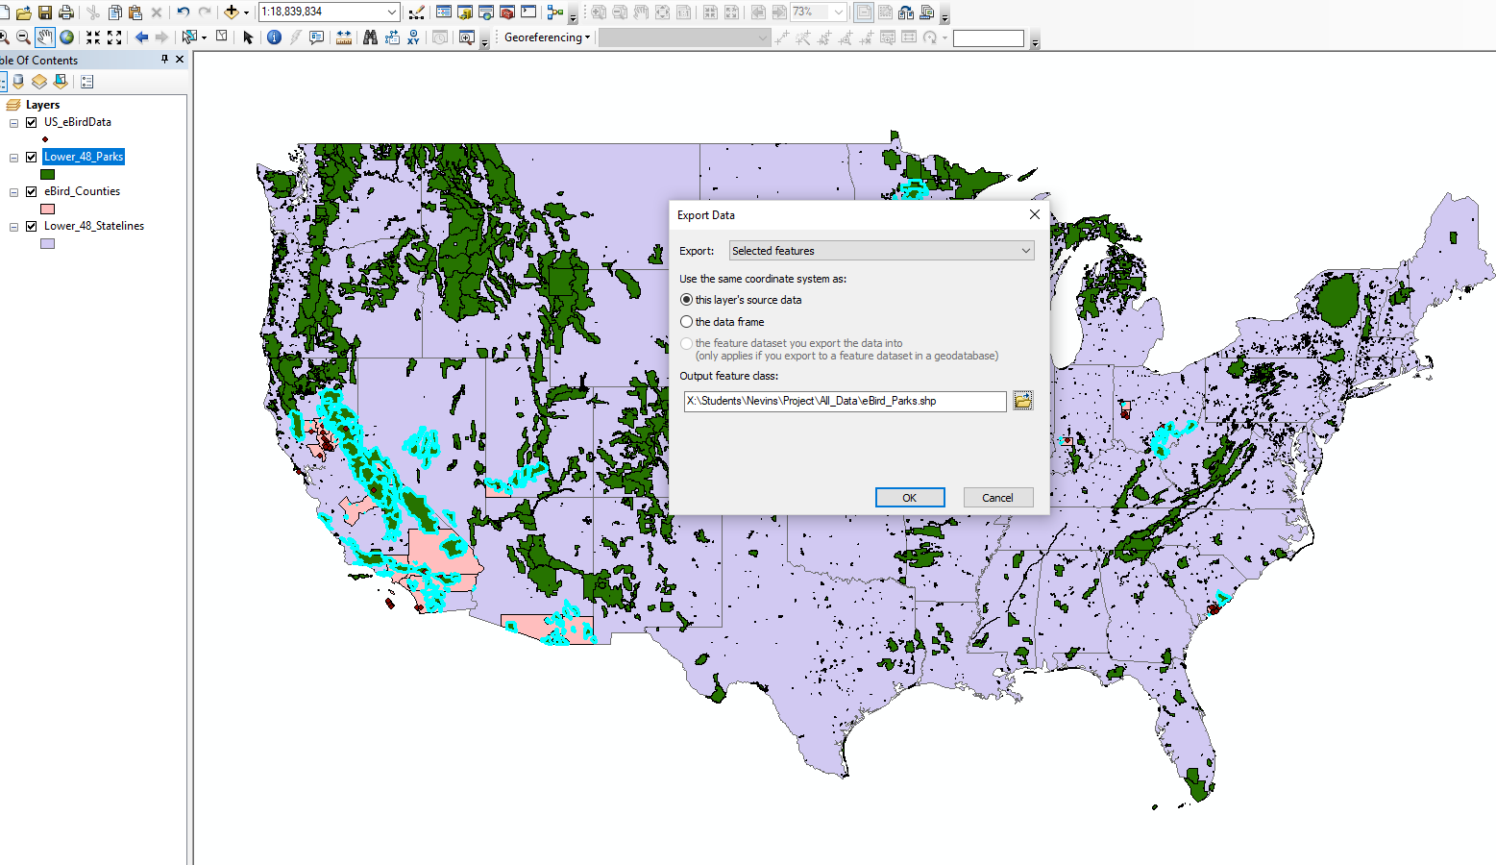
Figure 4 Export Selected Data
The one issue I ran into here was one of my points, the one in Marin County, turned out to not intersect with the Marin county polygon since it was out on a point near the ocean. This resulted in Marin County not being selected, I didn’t realize this until later when I started to combine the eBird data and county data.
My next step was to combine my eBird data and the county/state data. This proved to be the most difficult task. I tried several things before I discovered the best path to take. The first thing that I did was turn off the attribute columns in the county and state tables since I didn’t need them for my map and it made the data easier to work with. After turning off the attribute columns I added a new column called Num_Birds. I was going to type in the number of species by hand but there was too much data to go through by hand.
I then tried an Intersect between eBird data and eBird_counties but that could only return points and I wanted polygons. This is about the time I realized that Marin County was not one of the counties I had selected. In order to fix this problem I re-added the US county layer and exported Marin County and used a Join with the eBird_counties layer.
The next step was to Join the eBird data with the county data for this I used Join by Spatial Location which gave me a count of the number of entries in my eBird data (Figure 5). Of course since Marin County did not touch the Marin point I had to add that number by hand through editing. After looking at the data I realized that eBird data had multiple lines for the same species which led to an inflated number of species, which I checked against my account on the website.
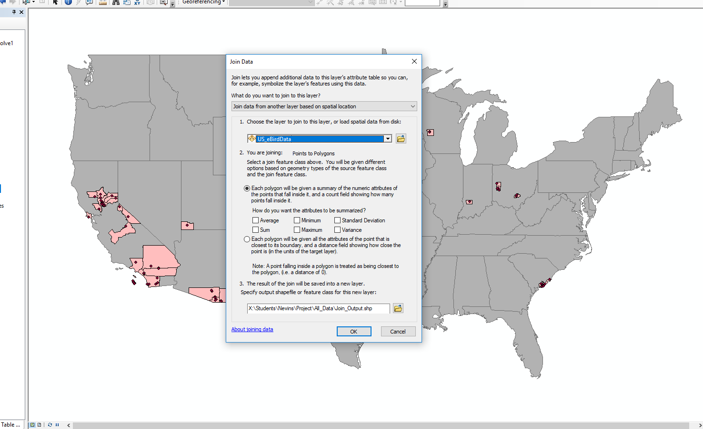
Figure 5 Join by Spatial Location
In order to solve this problem I used a Dissolve on my eBird data which then only showed the unique values in my data set. After that I was then able to join my eBird data with both my county and my state data (Figure 6). Again since the Marin eBird data didn’t intersect I had to add that manually.
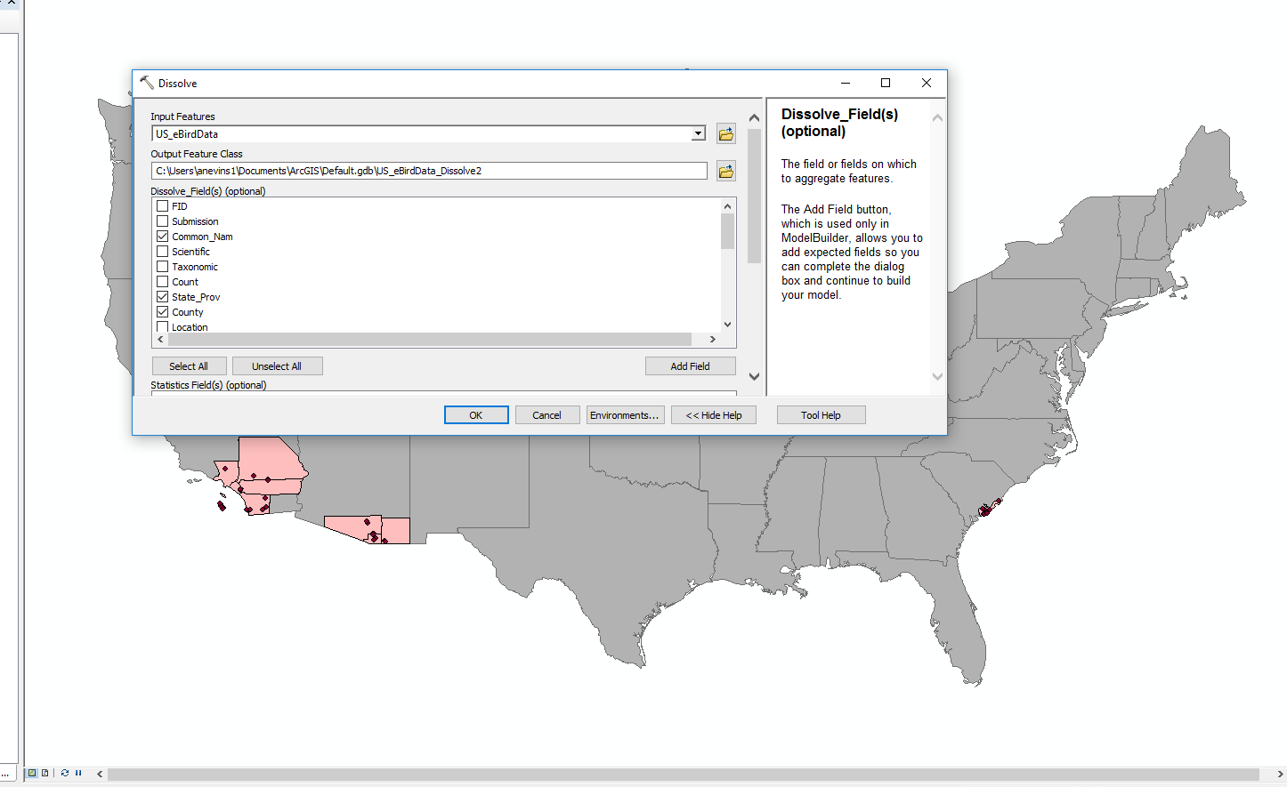
Figure 6 Dissolve eBird Data
The next step for me was to make the counties represent the number of species that I had seen. I did this through the Symbology tab in properties (Figure 7). I used a gradient symbol to get each county and state to show the count of species. For the state data there were many states with a count of zero which made the map look like I had been to every state. Therefore I decided to exclude zero from the gradient so that they just appeared grey instead of including them in the data set.
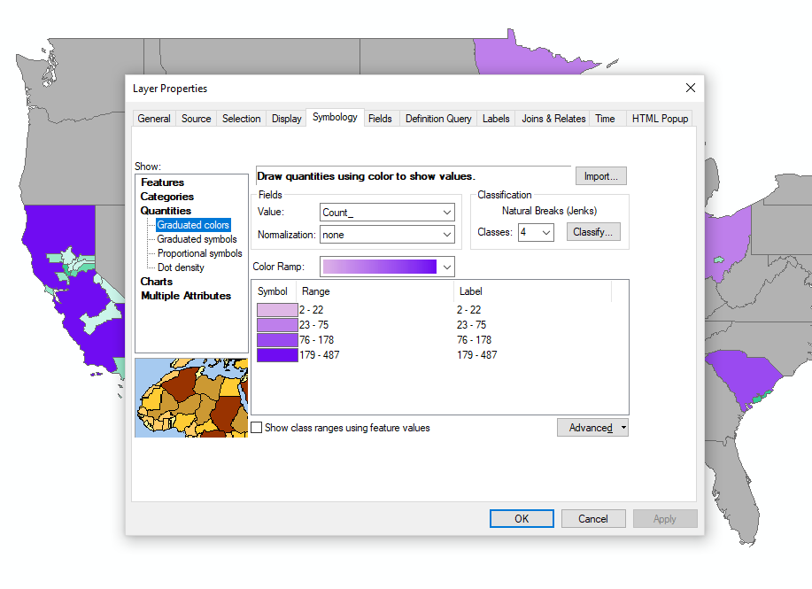
Figure 7 Symbology Tab
After messing around with which colors I liked for both county and state I then had to create a map. In the layout view I first added a legend (Figure 8). I added the legend first and then went back and edited it. I started by putting the labels in two columns (one for each) and then making sure the state data was in a separate column so that the legend fit at the bottom of my map. I also had to make my map show up in landscape version so that I could view the map closer and still have all of the US show up in it. After creating the legend I put a rectangle behind the legend to give it a border. I then added a title and also put a rectangle behind that as well.
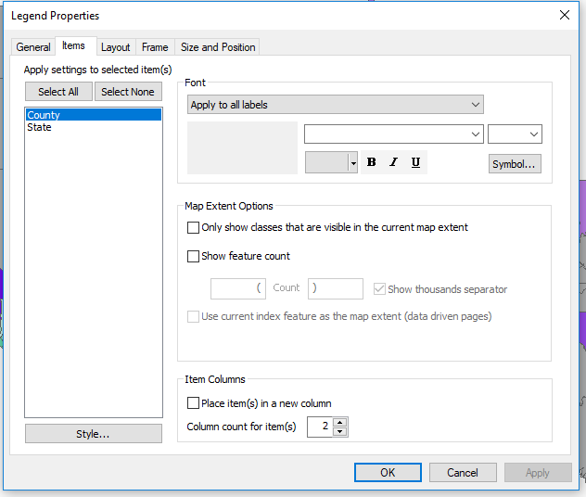
Figure 8 Adding and Editing Legend
All that was left was making sure the map looked like I wanted it to by messing with the colors of the gradient, the font of the title and legend, and various types of borders.

I have worked with GIS before on some of the projects that I worked on so I came into this class knowing some of the basic things that we learned but I had never done much with the different tools in ArcToolbox. This class gave me the opportunity to learn some of those tools such as Dissolve, Join, and Intersect. I also had never used Select by Location before and I found that very useful for this project and probably for the future.

Final Map:
