James Lehmkuhl
11-28-16
GEOG-0090
Central Sierra Backpacking Routes
The purpose of the project is to organize information related to outdoor recreation in a searchable, coherent manner and easily share that information with others. The logistics surrounding the planning of a backpacking trip can be daunting and choosing a location can be difficult. Often, friends will ask me to suggest a backcountry trip for them and while I have a general idea of a good trip, it would be great to have the details on hand for them. By creating data in ArcMap I can easily share with others trail difficulty, mileages, trailhead locations and good campsites along the route. The project also serves as a log of trips I’ve completed and ones that I wish to complete.
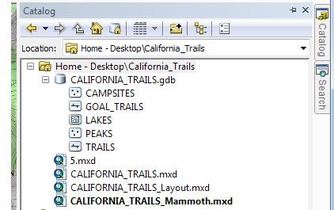
The project almost fully resides in a single geodatabase with several feature classes within it. I initially considered creating individual databases for certain areas of California but ultimately decided to have all areas in one database and then be able to sort trails by the area they are in via an attribute.

Once I decided on the feature classes I wanted to include in the project I had to decide what type of features they would be and what attributes to include for each class. For campsites and peaks, I used point type features, trails are line features and lakes are polygons. Classes were created by right clicking on the geodatabase. Individual fields were created by right clicking on the feature class within the catalog, selecting properties, adding a field name, and selecting a data type.
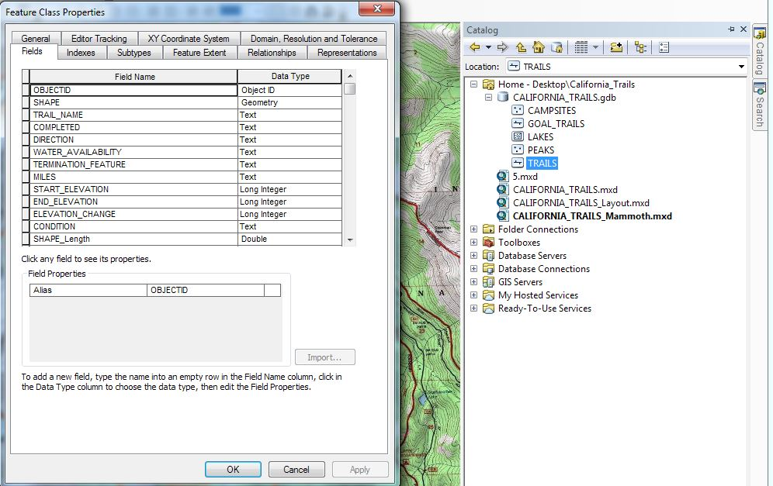

To streamline the data entry process and control syntax of entries to make queries more effective, drop downs were created for many fields. By right clicking the geodatabase, domains could be created containing coded values associated with the field as shown below.
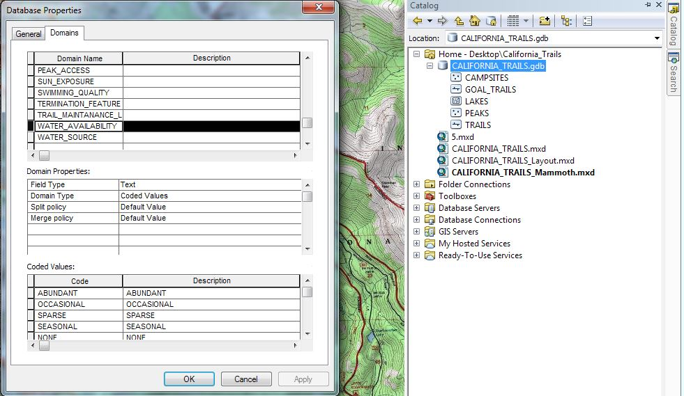
.

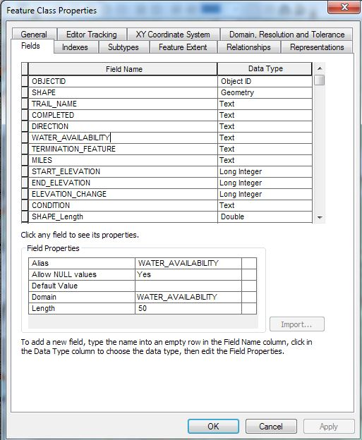
After creating domains for many different dropdowns, the domains had to be associated with the corresponding feature class and field. By right clicking the feature class and selecting properties and then the fields tab we can select a field name and under field properties select the domain we created earlier.

After all the feature classes had been created and all the attribute fields were in place with the proper domains I began digitizing the trails, lakes, peaks, and campsites. This was done by starting an editing session, choosing to create a feature, selecting which feature I wanted to create and using the editor toolbar to trace over a topographical base map to create the geometry. I used thousands of vertices to make the trails and lakes as accurate as possible.
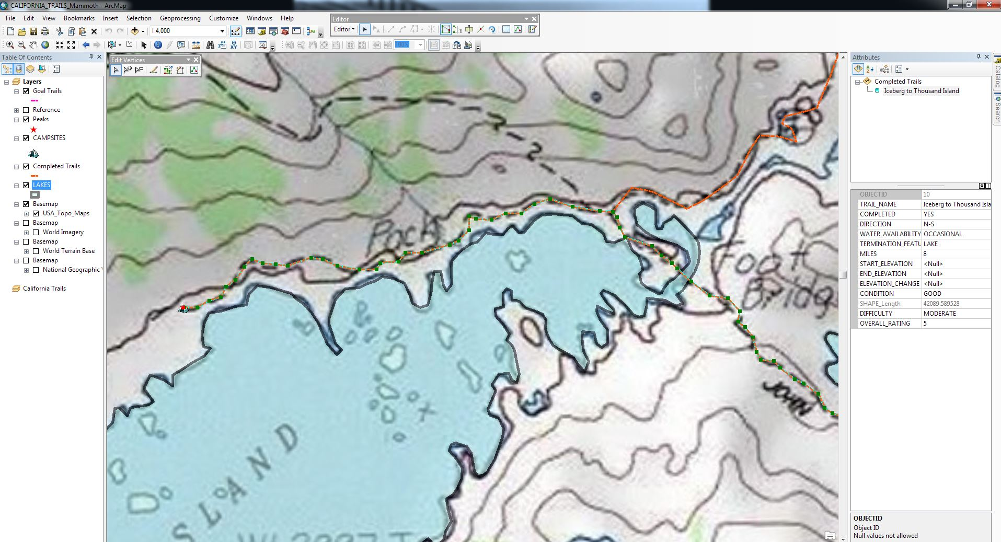

Once a feature was complete (by double clicking), I used the attribute pane on the right to select or enter data about that feature. Below, I am selecting the water availability for the selected section of trail (in blue)
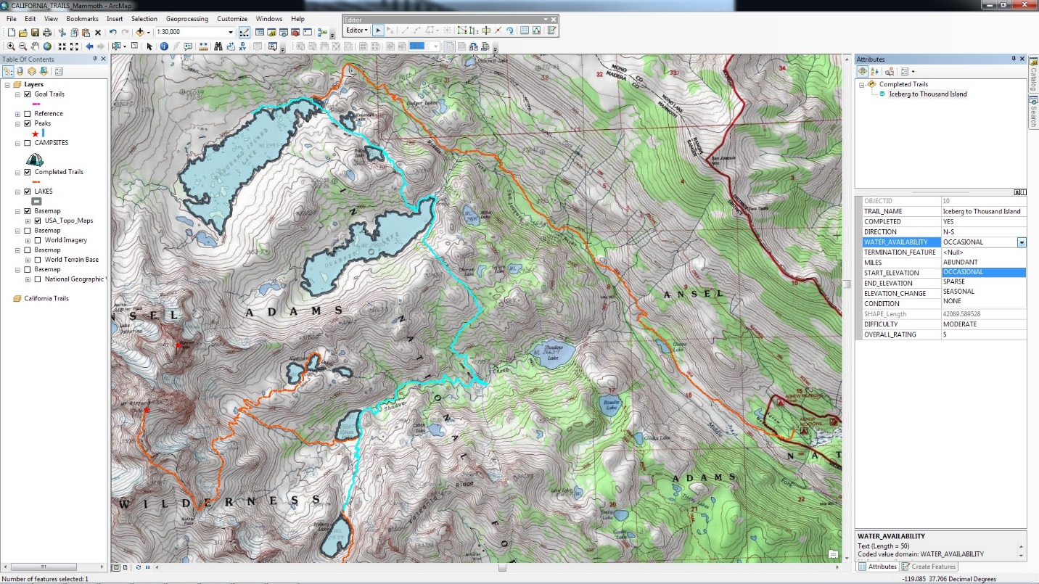

Once the features were created and data entered I could right click on the layer in the contents pane and display the attribute table for an overview of all of features of that type. Below shows all the lakes I digitized organized by how I rated them. Some data is missing since the project is ever evolving.
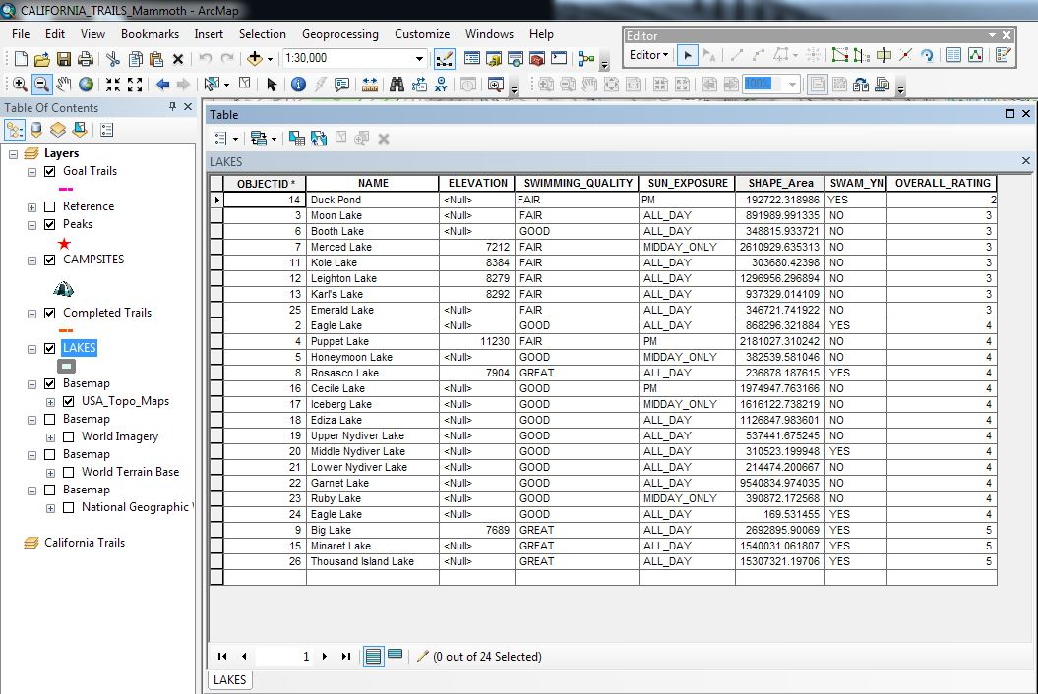

Below is an example of one of the four backpacking trips that I completed including, trail sections, camping locations, optional peaks, and digitized lakes.
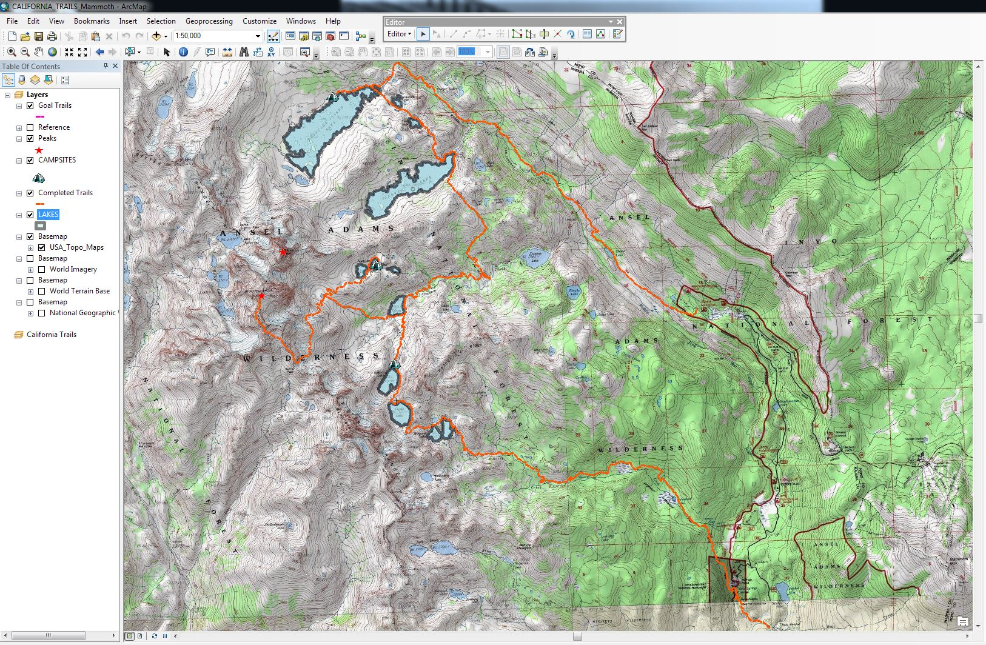

Finally, I added trips that I would like to complete in the future and colored them differently and added attributes. The attributes include information like trip length and whether technical climbing gear is required. Having this information available and querriable allows me to easily identify a trip to do with the free time I have available and how intense or casual of an experience I’m looking for. The image below shows a selected (in blue) purple route which I have not yet completed and displays the style of trip.
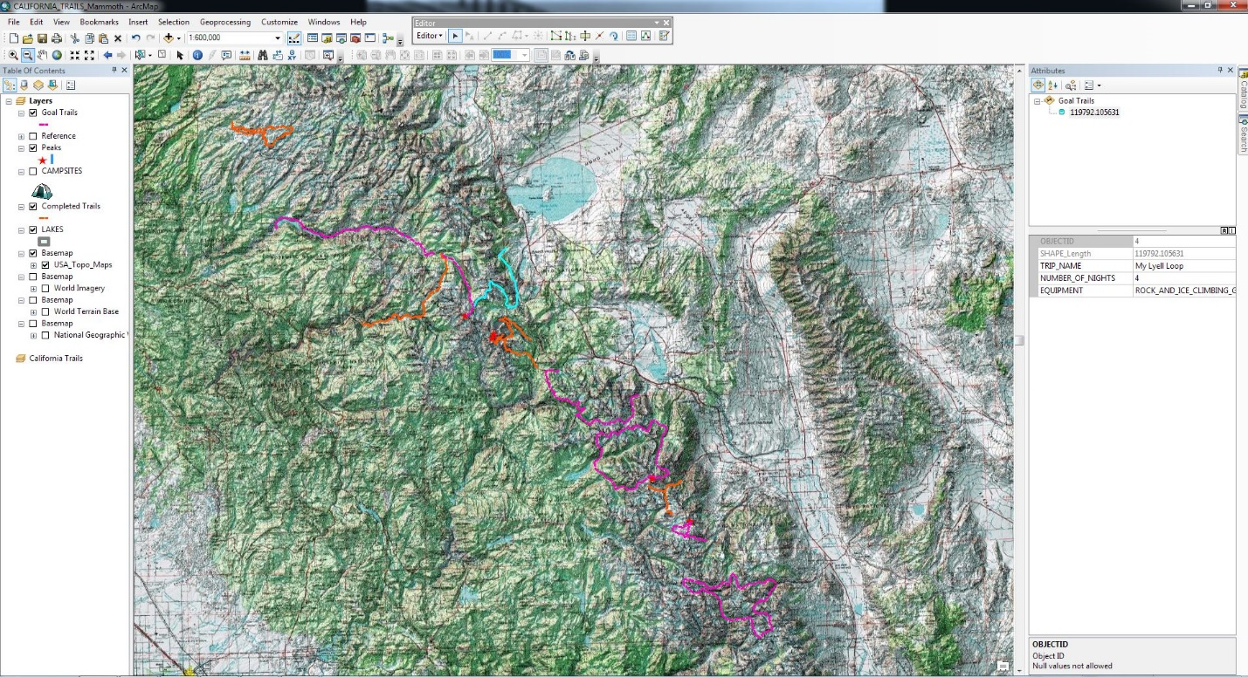

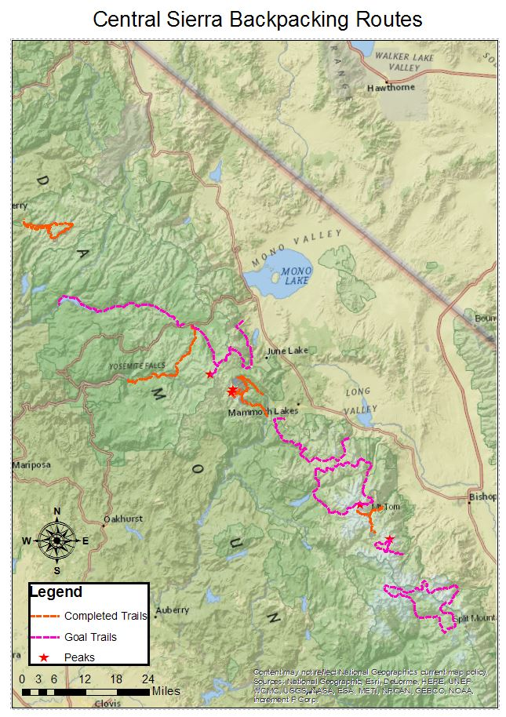
After completing the data creation portion of the project, I created the presentable map in layout view. By creating a data frame around the portion that I wanted to present I was then able to use the Legend wizard tool to create a key for the map based on the feature layers that were turned on. I decided to leave out the campsite icons from the large area map because they jumbled up on the zoomed-out routes. I also added a scale bar which proved difficult because I initially did not have the data frame selected when I added it which caused the scale to be off, troubleshooting this was frustratingly difficult for such a simple solution. I decided to use a different, less detailed, base map for the zoomed-out view in the interest of clarity. I believe the title and the fact that Mono Lake and the town of Bishop are present on the map are enough to orient its intended audience.

Besides the difficulties with the scale bar discussed above, other hurdles included developing a file and database structure that made sense. I landed on what seems to be a very simple style but not having a database background made me want to compartmentalize everything on the file level, as I do with music and photos. Realizing that sorting can be done via attributes in a more flexible way was an epiphany in data management for me. I also had issues with coordinate systems. Initially my geodatabase coordinate system was different from the one associated with the feature classes which hindered the feature creation process. This was ameliorated by going back and switching the feature class coordinate system to the state plane system that the geodatabase was in.
After completing the project (and the course), I’ve learned that GIS is as much, or more, about data than maps. Besides the laborious task of digitizing, the bulk of work involved with GIS happens without even having a map on the screen. I have also realized that it is absolutely essential to have a solid plan of what you wish to create before starting. Also, anticipating the many directions the project may go will save many hours of future work.

