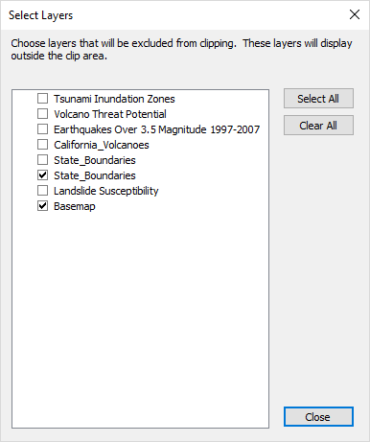
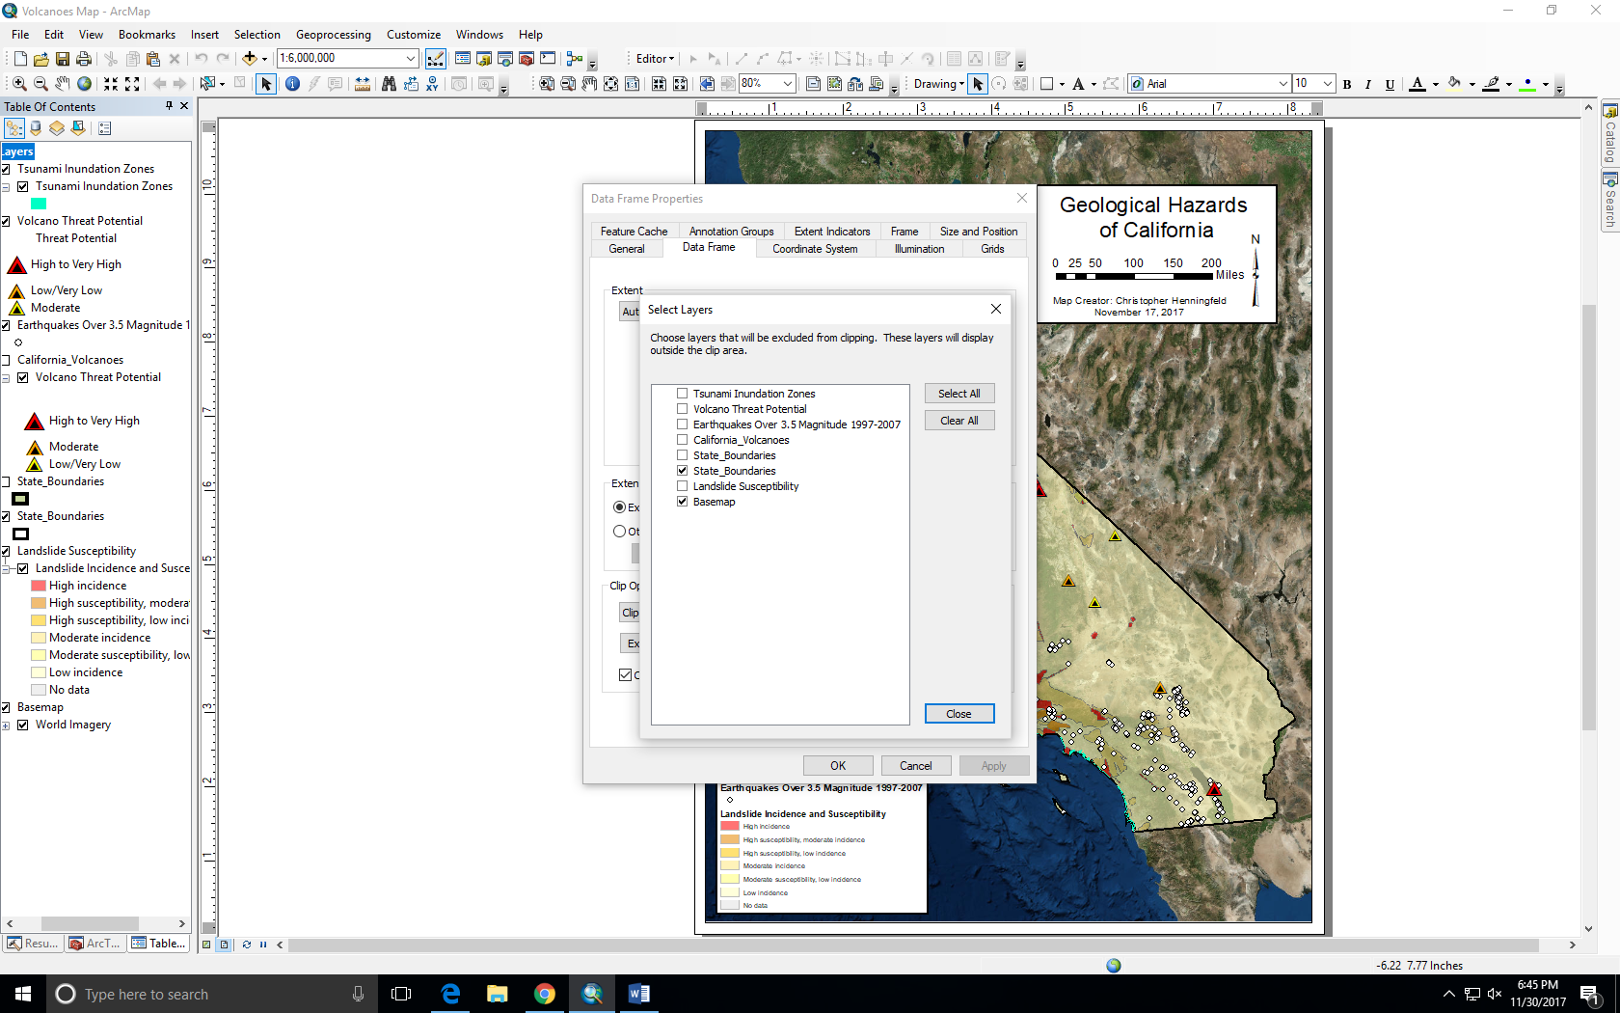
Christopher Henningfeld
Geog 90 Final Project Paper
December 7, 2017

For my project I initially wanted to create a map of the volcanoes of California. However, while finding volcano data on Arc GIS online, I noticed a lot of other interesting geological data, and my project morphed into a “Geological Hazards of California” map. I used Arc GIS online to collect all of the data for my map, with the exception of the basemap. My main focus of the project was to create an easily understandable, aesthetically pleasing map. In other words, cartography was the main focus of my project. My final map contains a tsunami inundation zone layer, a volcano threat potential layer, an earthquakes layer, and a landslide incidence and susceptibility layer.
The purpose of my project was to create a professional looking map that is easy to understand, as well as to create a map that interested me and wasn't beyond the scope of the class or my abilities. By making a map that relates to my major course of study (geology), I hoped to keep the project fun and interesting. I wanted to practice cartography skills in particular, and I also wanted to play around with symbology. Cartography and symbology interested me in particular because I've had a lifelong interest in maps, and I've always wanted to make one. So, my initial hope was to make a map that looked crisp and professional, and that was easy for anyone to understand regardless of their knowledge of or interest in geology.
All of the data I used on my map was found on ArcGIS Online. The first layer I found was a map of all of the active volcanoes of California. Interestingly, my initial idea for the project was to create a map of California that had all of the active volcanoes on it, with a bit of information about each volcano (i.e. type of volcano, last eruption, age, etc.). The volcano layer I found on ArcGIS Online was more or less exactly the map I wanted to make. Whomever created the data named it “Volcano Threat Potential”. This caused me to rethink my original idea. While browsing ArcGIS online for more volcano data, I noticed a lot of other geological hazard data, and so I changed the direction of my project slightly, and I decided to make a map of geological hazards of California. The first layer I brought in from ArcGIS Online was a “state boundaries” layer, because I wanted to have the outline of California visible on my map. I had to isolate the outline of California by clipping out the surrounding state outlines. After clipping out the surrounding state outlines, the next task at hand was to begin bringing in more geological hazard layers. I began experimenting with different layers that are available on ArcGIS Online, as I wanted to find layers that weren't too busy and cluttered, so that I could have several layers of information on the final map. Many layers I experimented with were fantastic, but they had too much information or too many symbols on the layer. By bringing in many different layers in different combinations, I was able to narrow down the layers I used to the four that worked best together. After bringing in the layers, I had to arrange them to present the information in a clean, crisp manner. In other words, I had to figure out which layers worked out best on top of other layers. Part of this process was manipulating the width of the state boundary line and the “tsunami inundation zone” layer. The state boundary line had to be wide enough for the “tsunami inundation zone” layer to cleanly pop out, but not so wide that it looked fat and like it was drawn by a crayon. I also had to play with the width of the line in the “tsunami inundation zone” layer to get it to stand out clearly without looking unrealistically large. I found there were very fine margins with this. If I made the line in the “tsunami inundation zone” too wide, it made it seem as if the areas of Coastal California that would be inundated in the event of a tsunami were far more expansive, and the tsunami would travel much further inland than is actually true. I eventually found a good ratio of state boundary line thickness and “tsunami inundation zone” line thickness. Another thing I had to manipulate was the volcano symbology on the “volcano threat potential” layer. The initial symbology from the original author was the most reasonable to denote the location of volcanoes: triangles. The only thing I changed was the size of the symbols, as well as the type of triangle symbol used. I did this to make the location of the volcanoes on the map stand out more clearly. The next two layers I brought in from ArcGIS Online were earthquake and landslide layers. There were many excellent earthquake and landslide layers available on ArcGIS Online, but many were too busy for my project. The only earthquake layer that would work has data from 1997-2007, which isn't ideal, but was available to be used, and works for my map. All other earthquake layers had far too many symbols and information on them to be used on my map. The landslide layer worked out nicely. It came in a nice color scheme, and is crisp and clean looking. The main problem I had with the two aforementioned layers is that the points and polygons on the layers extended beyond the state boundary, which I didn't want on my map. I tried clipping the layers so that they would just show up within the borders of California, but the clip didn't work right. Weird things happened to my map. It seems that because I imported my data from ArcGIS Online, I had go about clipping in a different way. I had to right click layers, go to properties, go to data frame properties, go to exclude layers, and then choose the layers I wanted to exclude from the clip (see attached screen shot). After I did that, everything came together quite nicely. I was able to clip out any data from the landslide and earthquake layers that extended beyond the boundary of California. The next task at hand was to create the legend. The shape of California presented a problem for me. I realized I would have to have a box for the legend and a box for the title, scale bar, north arrow, etc. It then became a matter of creating both boxes and manipulating their sizes and locations on the map until they looked how I wanted them to look. I got a lot of inspiration for how to tackle this problem from a map of the Tet Offensive during the Viet Nam War I found online. The shape of Viet Nam is not too dissimilar to that of California, save the fact that it “curves” to the east instead of the west. The creator of the map broke the legend and title boxes into two separate areas, which is what I ended up doing. My boxes ended up in the top right and bottom left corners of the map, which keeps the contents of the boxes legible and clean looking. One last thing of note is that I spent a lot of time messing around with the transparency the basemap and the landslide layers. I found it took a bit of experimenting to come up with the right balance of transparency among layers so that everything would be visible and distinct on the map.
One of the things I learned over the course of the project is that ArcGIS Online is an outstanding resource. My map would not have been possible without it. There seems to be a lot of quality data on there, so I'll definitely use it again in the future. ArcGIS Online is also very easy to use, and I was surprised by how diverse the data was. Another thing that I learned is that there is often a way to circumnavigate small problems that pop up along the way when creating a map, such as my issue with clipping on my map. I regards to the cartography process, I came to realize that attention to detail makes a world of difference. It was tedious to mess around with line thickness, transparency, and the position and dimensions of the legend and title boxes, but in the end it made my map look much cleaner, and the efforts were worth it. In the end, I think I accomplished my goal of making a crisp, clean and professional looking map.

